

MASTER OF BUSINESS ADMINISTRATION

INTERNATIONAL BUSINESS CONCEPTS (LCMB7034)

REPORT ON THE DEVELOPMENT OF AN INTERNATIONAL INDUSTRY: EV INDUSTRY IN CHINA

- Lecturer name: DR. GLADIUS DAVID KULOTHUNGAN
- Student name: MAHIPALSINH GOHIL
- Student Id: 2510635
Executive Summary

In this report, the domestic market of EVs in China is analysed with reference to the operations and strategies carried out by Tesla in the fast-developing segment. On the basis of framework like Michael Porters Diamond Model, PESTLE, and SWOT, the report assesses the competitive advantage of China in the production of EV and the effect of government policies, market forces, and technological advancements. Localised manufacturing of Tesla in Shanghai is also highlighted as one of the main strategies of conquering trade barriers and cost reduction. The report then wraps up by evaluating the threats of the domestically existing competition as well as regulatory developments with a view to providing a strategic explanation on the future of Tesla in China.

Table of Contents
Section 1: Report 6
1. Introduction 6
2. Industry and Country Overview 6
2.1 Overview of the EV Industry in China 6
2.1.1 Current Market Dynamics 6
2.1.2 Economic Importance 7
2.2 Major Domestic and Multinational Companies in the EV Industry 8
2.2.1 Domestic Companies 8
2.2.2 Foreign MNCs 9
2.3 Comparative Analysis of Key Players in the EV Industry 10
3. Application of Michael Porter’s Diamond Model of national advantage to critically analyse the global competitiveness of the chosen industry 11
3.1 Factor Conditions 13
3.2 Demand Conditions 14
3.3 Related and Supporting Industries. 15
3.4 Firm Strategy, Structure and Rivalry 15
4. Critical Evaluation of Tesla’s Operations in China 16
4.1 Tesla’s operations in China 16
4.2 PESTLE Analysis of Tesla in China 16
4.3 SWOT Analysis of Tesla in China 19
4.4 Scott’s Three Pillars of Institutional Theory Applied to Tesla in China 20
4.4.1 Regulatory Pillar 21
4.4.2 Normative Pillar 21
4.4.3 Cultural-Cognitive Pillar 21
5. Conclusion 22
Section 2: Reflective Account 22
2.1. Description 22
2.2 Feelings 23
2.3 Evaluation 23
2.4 Analysis 24
2.5 Conclusion 24
2.6 Action Plan 25
References 26

List of figures and tables

Figure 1: Global electric car sales 7
Figure 2: China’s Market Share in the EV industry 8
Figure 3: XPENG Motors 9
Table 1: Comparative analysis of key players in the Chinese EV Industry 10
Figure 4: Porter’s Diamond Model 13
Figure 5: Number of Charging Points in China 14
Table 3: PESTLE Analysis 18
Table 4: SWOT Analysis 20
Table 5: Action Plan 25

Section 1: Report

1. Introduction
China is the largest manufacturer and consumer of electric vehicles (EVs) in the world, which makes the market trends and innovation on the global front. Government incentives and strict environmental guidelines have enabled the rapid uptake of EV technology in the country, making it a clear-cut player in the automotive industry. Tesla is one of the major foreign entrants, with its large investments and Chinese local production. Tesla and its strategic positioning, as well as battery technology and autonomous driving, highlight the importance of Tesla in China in becoming the leading player in the EV business, similar to the increasing importance of foreign MNCs in this essential field.

2. Industry and Country Overview

2.1 Overview of the EV Industry in China

2.1.1 Current Market Dynamics
China has established itself as the leader in the world in terms of electric vehicle (EV) manufacturing and demand. As part of its aggressive campaign in favour of green energy, the government of China has acted to cut its carbon footprint by a large margin; such policies as generous subsidies, tax exemptions, and green energy subsidies have been adopted. Consequently, the EV market of the country has been growing exponentially over the past decade. As shown in figure 1, the electric car sales in China comprised more than 50% of the world in 2024 alone. This reflects almost 4.9 million electric cars being sold, compared to 11 million just 2 years earlier (International Energy Agency, 2025). There is also a target of the country to ensure that new energy vehicles (NEVs) such as electric vehicles should constitute 20% of all car sales by 2025 (Reuters, 2020). The role of such government policies as purchase subsidies, no payment of vehicle purchase taxes, and charging infrastructure development incentives has been vital in this expansion. Also, there is support of the Made-in-China 2025 Plan, which promotes local production of EVs (Kuo, 2025). Development of the Chinese charging infrastructure is another essential element of the development of the country’s EV market, which is the largest globally and consists of more than 2.5 million charging stations, as of 2024 (Dimension Market Research, 2025). By the end of 2021, China had over 7 million EV fleet, which is a symbol of the robust local market and increasing export base (Business-Standard, 2025).
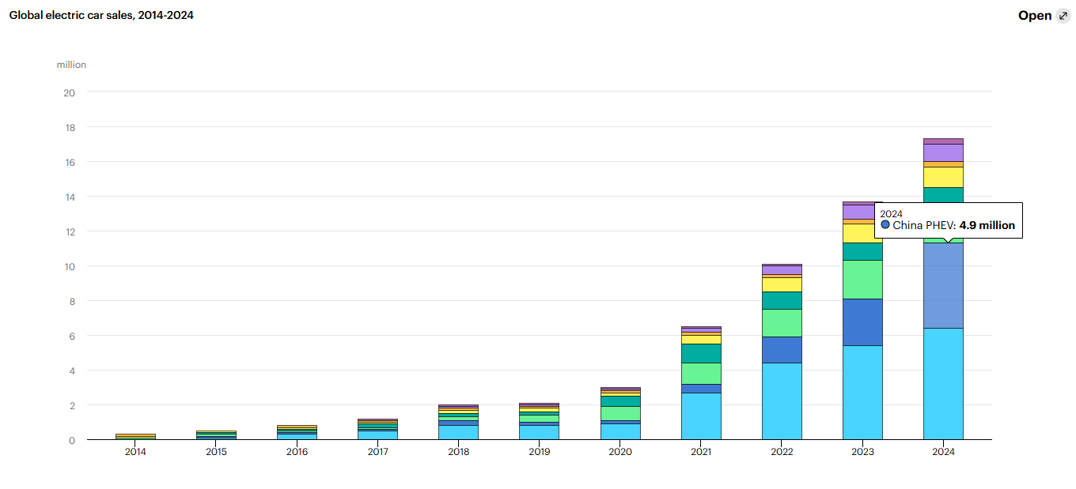

Figure 1: Global electric car sales
(Source: International Energy Agency, 2025)

2.1.2 Economic Importance
Khaleel et al. (2024) found that the car market in EVs is extremely significant to the Chinese economy, especially in advancing technological dominance and job creation in the automotive and technology industries. The development of the EV has provided thousands of jobs in manufacturing, R&D, and other related industries, such as battery production and electric drives development. Moreover, the EV business is consistent with the overall sustainability objectives of China, which helps to make the air cleaner and less reliant on fossil fuels.
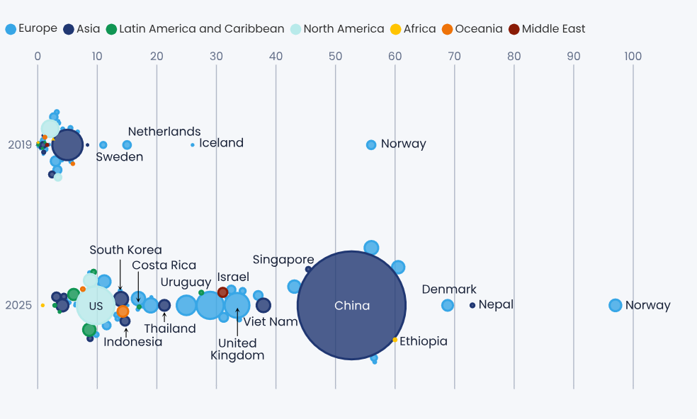

Figure 2: China’s Market Share in the EV industry
(Source: Graham, 2025)
China is the most productive manufacturer of electric vehicles in the world, and domestic giants such as BYD and NIO are in the lead. These firms have become incredibly successful in the domestic and international market, where China is currently a net exporter of EVs, especially to Europe and the developing markets. It is estimated that the market share of the country in the EV manufacturing industry of the world will reach more than 50% by 2025 (Graham, 2025). The dominance of Chinese-made batteries can be seen as one of the indicators of the global EV leadership of China, as CATL (Contemporary Amperex Technology Co. Ltd.) and BYD become the most successful battery producers. These firms provide electric vehicle makers all over the world, powering the process of creating sustainable energy solutions worldwide.

2.2 Major Domestic and Multinational Companies in the EV Industry

2.2.1 Domestic Companies
The local manufacturers of EVs in China have been on the leading edge of this market boom. One of the best-selling domestic manufacturers is BYD (Build Your Dreams), which is a manufacturer of electric cars as well as buses. BYD has experienced phenomenal growth to be one of the leading EV manufacturers in China and the global arena. In 2021, BYD sold more than 700 billion EVs, which has allowed the company to retain the leading position in the local market with more than 25% of the market share (BYD, 2026). Apart from this, NIO, also known as the Tesla of China, has penetrated the high-end EV industry considerably. The fact that it targets premium electric SUVs and has a unique battery-swapping system has also helped it to stand out of the crowd. As of 2021, NIO recorded a total of more than 91,429 vehicle deliveries, which is a 100% improvement on the previous year (NIO, 2021).
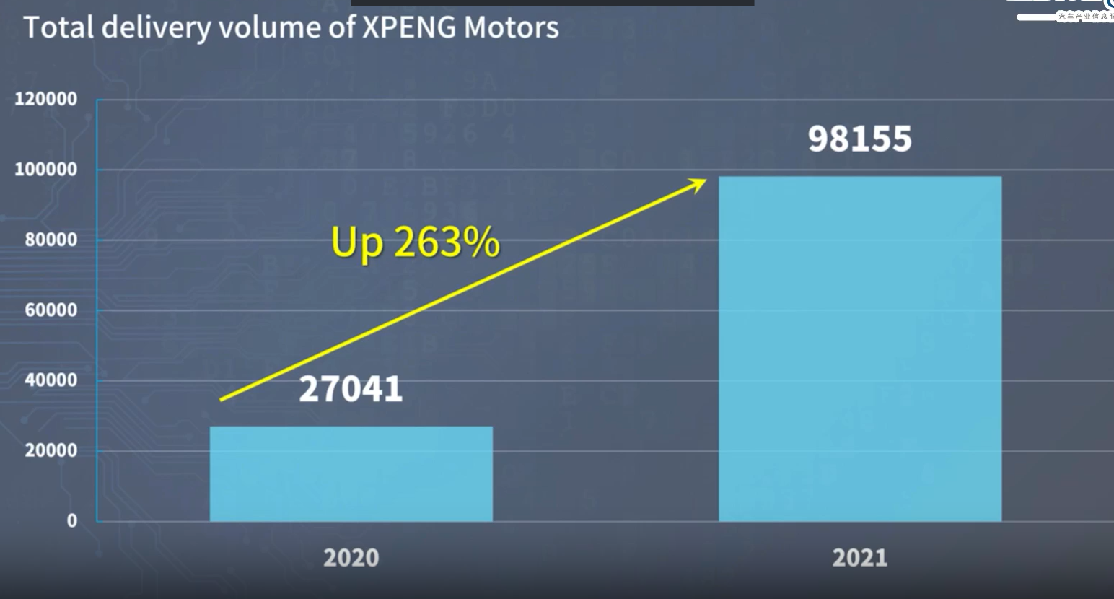

Figure 3: XPENG Motors
(Source: Gasgoo, 2021)
XPeng Motors is another competitor that has been making a lot of ground in the competitive market. The P7 sedan, which is characterised by high autopilot features in the market, has received worldwide and national attention. XPeng was able to compete with bigger domestic players in 2021, when it shipped more than 98,155 vehicles (Gasgoo, 2021b).

2.2.2 Foreign MNCs
Tesla is one of the most notable foreign players in China that has become a leader of the EV market. Its Gigafactory 1 in Shanghai, opened in 2020, enabled Tesla to manufacture vehicles domestically and escape the tariff on imports, which is the major driving force behind the costs of its products in the Chinese market. By 2021, over 450,000 cars had been manufactured at a Shanghai factory, which became part of the overall sales increase of the company in China (Reuters, 2022). In China, Tesla was rated as the 12% market share in 2021, which anchored it as the best-selling foreign brand in the country.
Another area that Volkswagen has highly invested in is the EV market of China. Due to its position as one of the biggest car producers in the world, Volkswagen has committed itself to introducing more than 20 new EVs in China by 2027 in order to take up a large portion of the expanding market (Ludewig, 2025). BMW has followed suit and introduced its iX3 electric SUV and targeted its premium segments in the Chinese market. The company will focus on the high-income shoppers within the urban areas such as Shanghai and Beijing. BMW also sold more than 44,344 BEVs in China in 2022 in China in 2021 continuing to cement their position in the high-end EV market (Car News China, 2023).

2.3 Comparative Analysis of Key Players in the EV Industry
Company | Turnover / Revenue (Latest) | Employees (Latest)
BYD | Revenue reported at ¥777.1 billion in 2024 (BYD, 2025) | 968,900
NIO | Full‑year 2025 revenue ¥87.49 billion in 2025 (NIO, 2025) | 45,635
XPeng | 2025 annual revenue reported ¥76.72 billion in 2025 (Xiaopeng, 2025) | 19,884
Volkswagen Group | Official 2025 global revenue €321.9 billion in 2025 (Volkswagen, 2025) | 663,000
BMW Group | BMW Group financial Revenue €142.4 billion in 2024 (Bekker, 2026) | 159,104

Table 1: Comparative analysis of key players in the Chinese EV Industry
The comparative analysis of BYD, NIO, Xpeng, Volkswagen, and BMW indicate that the range of approaches and market positions of EV in China is very different. BYD has the highest turnover and the highest number of employees due to its production in the country and a good sale of EV (BYD, 2025). NIO and XPeng put their innovations on the center, where NIO is concentrated on the higher end of the market, and XPeng is concentrated on autonomous driving. Volkswagen and BMW ride on a powerful international brand, as Volkswagen continues to dominate the world revenue as a leading Schwart and BMW specializes in luxurious cars. Such companies use different tactics to fit into the competitive EV market in China (Bekker, 2026).

3. Application of Michael Porter’s Diamond Model of national advantage to critically analyse the global competitiveness of the chosen industry
As per KULOĞLU (2023), the Diamond Model, as a model of international competitiveness, by Michael Porter, is an encompassing approach that helps to describe competitive advantage that nations possess based on factors available. Subsequently, it has helped to analyse the reason why a country, such as China, has managed to acquire a global competitive edge in a strategic area like electric vehicles (EVs). The four pillars of the model, factor conditions, demand conditions, related and supporting industries, and firm strategy, structure and rivalry, combined with government and chance factors, helped in explaining the dominance of China in the production and uptake of EVs. When it comes to the electric vehicle (EV) industry in China, major industry players such as BYD, NIO, XPeng, Volkswagen, and BMW capitalize on the benefits to enhance competitiveness in the global market. The comparison of these companies in the Diamond Model provided by Porter is as below:
Company | Factor Conditions | Demand Conditions | Related & Supporting Industries | Firm Strategy, Structure & Rivalry
BYD | Well-established local supply chain, batteries fabrication, cheap labor. | Desire of middle-income segment to acquire affordable EVs. | Powerful battery and solar energy, local EV components. | Vertical control of costs- It is challenged by local companies such as XPeng.
NIO | Having skilled workers, state-of-the-art battery technology. | Raise the bet on high-quality EVs, targets high-income buyers in urban areas. | Partnerships for autonomous driving and battery | Competes with Tesla, BYD, and differentiates with luxury and battery-swapping technology.
XPeng | Domestic networks of heavy technology vehicles. | Consumers that are tech savvy require affordable smart EVs. | Focus on autonomous driving & battery supply | Targets tech innovation, rivals with BYD, NIO and Tesla.
Volkswagen | Local manufacturing, strong supply chain | Affordable and premium EVs for middle-class consumers (Volkswagen, 2025) | Partnerships in EV parts, electrical networks. | Specializes in domestic manufacturing with low-cost leadership, competes with BYD and XPeng.
BMW | Availability of local engineering and high-tech. | High income urban consumers of luxury EVs. | Connection with local resources of luxury materials. | Emphasized on high-end branding, it competes with NIO and XPeng in the high-end market.
Table 2: Michael Porter’s Diamond Model
This table demonstrates how every company is drawing on the factor conditions available in China, including skilled labour and battery manufacturing to establish a better standing in the market. As an example, BYD can be singled out through its vertical integration, whereas NIO and XPeng are over-innovative and specialized in the autonomous driving and luxury markets. It further indicates that the foreign players, Volkswagen and BMW, have localised production in China to exploit the cost leadership strategies.

3.1 Factor Conditions
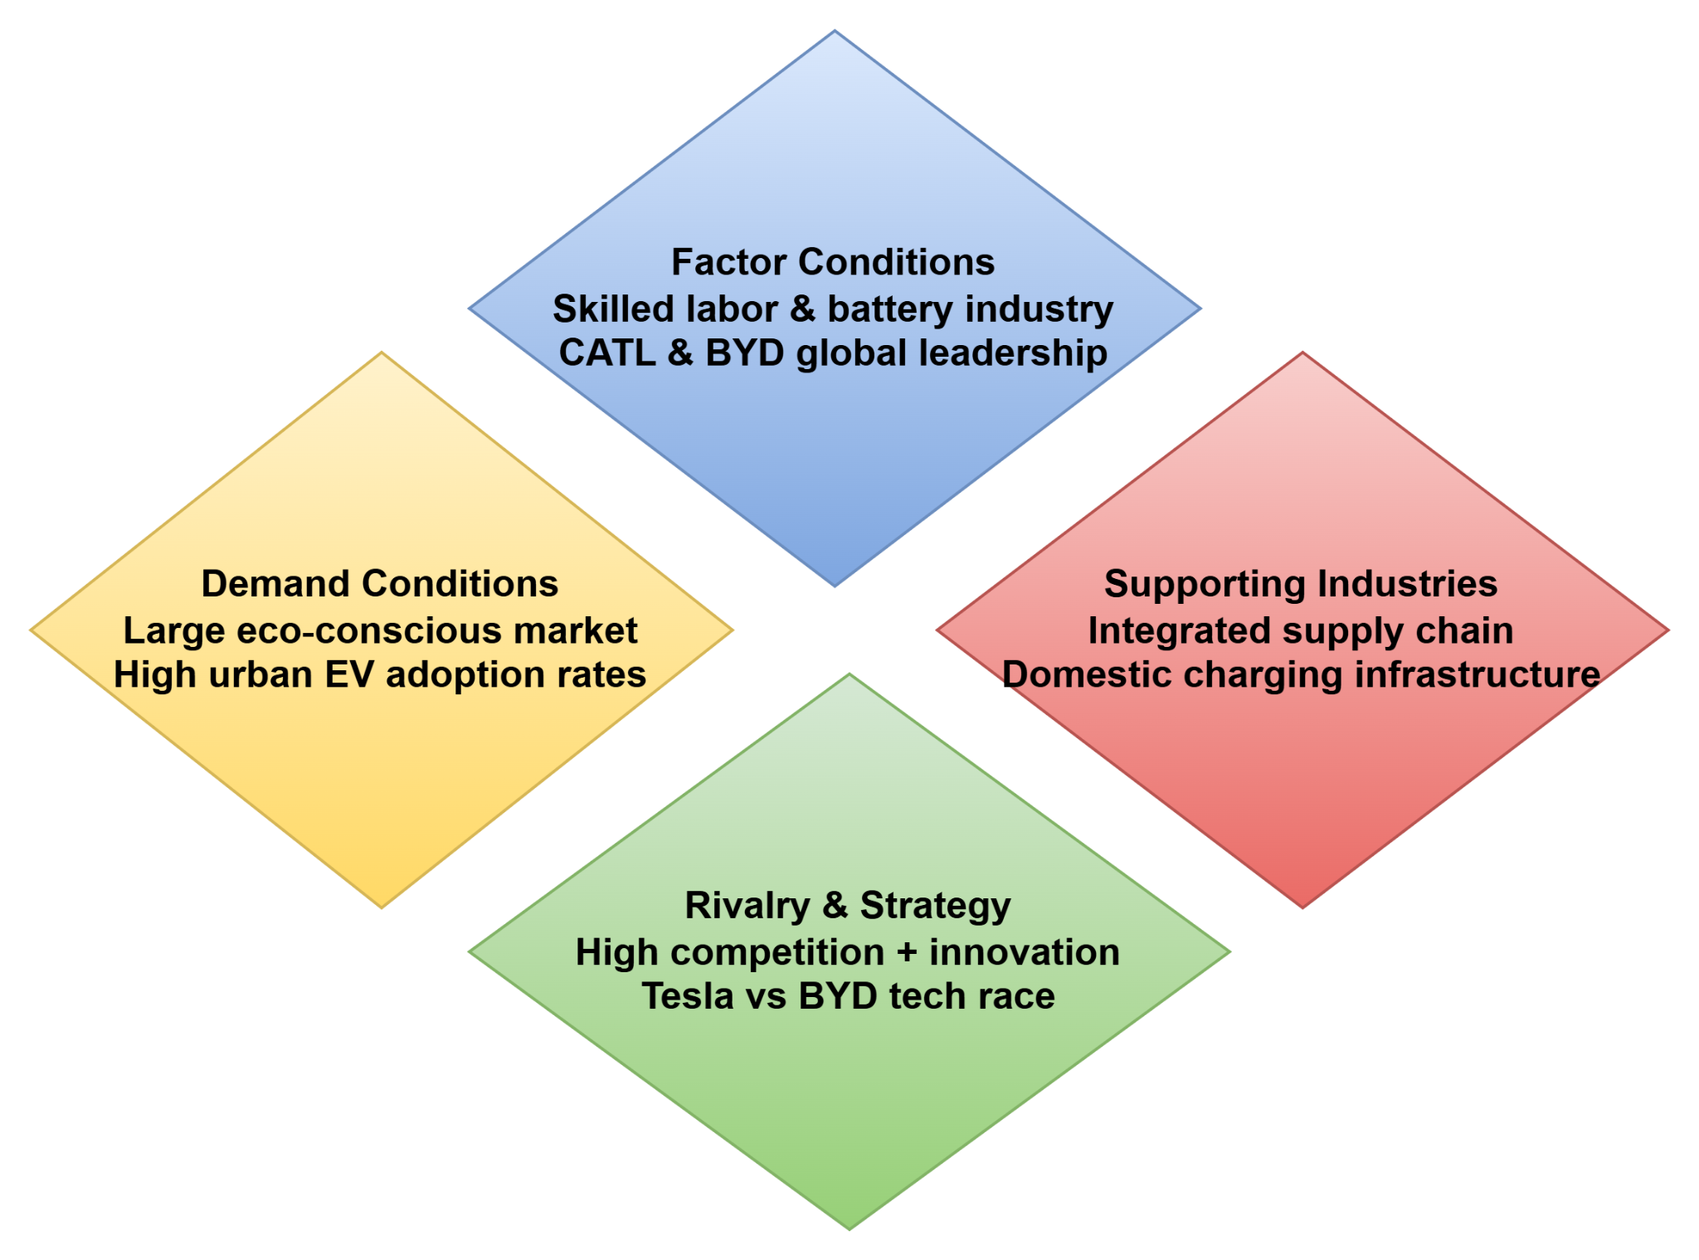

Figure 4: Porter’s Diamond Model
(Source: Inspired by the ideas of KULOĞLU, 2023)
The competitive advantage that China has in EVs is founded on a strong foundation of manufacturing resources and unique human capital. The huge education sector and engineering ecosystem have resulted in a vast supply of quality labour that can facilitate advanced electric vehicle production and research and development (R&D). He and Hao (2023) found that Tesla enjoys the advantages of local engineering and a high-level EV supply chain in China, which means that it can make cars in large quantities and compete with domestic brands in terms of cost. Most importantly, China has significant EV battery capabilities on the global level. According to Wuttke and Whitfield (2025), Chinese companies such as CATL and BYD are market leaders in the battery industry, with almost two-thirds of the global EV battery output. This combined battery supply chain reduces the price and the production increase in the country-core factor conditions as found in Porter's model.
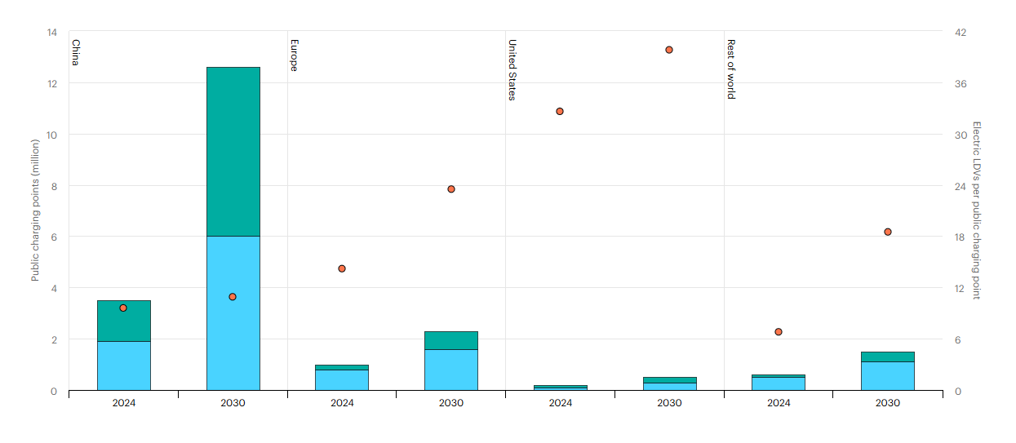

Figure 5: Number of Charging Points in China
(Source: IEA, 2025)
High-end infrastructure also contributes to the strength of China. Figure 5 has confirmed that by 2024, the number of charging stations in China will reach more than 12 million in the largest formula globally (IEA, 2025). It directly facilitates the adoption of EVs and the comfort of consumers regarding the range and convenience.

3.2 Demand Conditions
The huge and fast-moving Chinese market creates extremely advanced consumer demand that puts a strain on companies to be innovative and scale. City consumers are becoming more interested in green mobility, technological aspects and long-range features of EVs, which are also important in their purchasing decision. According to Ling et al. (2021), in a stated preference survey conducted in Beijing, the findings showed that the level of income and environmental concerns are the key factors that lead to the adoption of EVs among consumers. EVs are also a national priority in China to fight pollution and meet carbon objectives, and demand has been encouraged with tax benefits and purchase subsidies. Zhao et al. (2024), demonstrate that policies of incentives in industries have contributed significantly to the growth of EV sales, which have allowed China to become the largest market for EVs, with the remarkable growth in the sales of EVs in the past couple of years. Also, an analysis of the Tesla expansion into China revealed that it grew the general EV market demand by raising consumer awareness and the value of EVs, which even indirectly boosted the local producer (Hu et al. 2024).

3.3 Related and Supporting Industries.
The level of the ecosystem is a key factor contributing to the competitiveness of China with regard to battery and renewable energy industries. As stated by Wuttke and Whitfield (2025), firms such as BYD and CATL sell into domestic EV manufacturers, but they also sell internationally to strengthen the competitive advantage of China in terms of EV components and technology. In addition to batteries, China is the leader in the production of charging infrastructure and renewable integration. A fully developed domestic EV system chain, including the extraction of raw materials and the production of vehicles, expresses the decreased reliance on imports, greater product quality, and decreased innovation periods (Zhao and Luethje, 2024). That is a special so-called cluster effect that Porter concentrates on when focusing on national advantage.

3.4 Firm Strategy, Structure and Rivalry
The Chinese EV market is highly competitive, with the fierce rivalry of both local hero brands and international market newcomers such as Tesla. The Tesla strategy was to achieve the competitiveness of prices and seek new technology differentiation, such as Autopilot and battery innovations to conquer the market share (Ma et al. 2025). Vertical integration and quick assimilation by BYD to adopt blade batteries placed the company as a viable threat (BYD, 2026). Studies state that the accelerating pace of innovation and efficiency, important Porter characteristics of global competitiveness, is occurring in the EV market of China due to competitive rivalry. The government of China has played a leading role in determining the competitiveness of EVs, providing purchases, subsidies, tax breaks, and infrastructure investments. Policy incentives by China have played a central role in increasing EV adoption and national champions. Risk events, such as disruptions of global supply chains and the pandemic have, however, unconsciously put an advantage on the domestic ability of China (Zhao et al. 2024). The local production switch by Tesla during trade tensions is an excellent example of how companies can survive in uncertainties of the external environment by capitalising on national opportunities.

4. Critical Evaluation of Tesla’s Operations in China

4.1 Tesla’s operations in China
Tesla Inc. was strategic in entering the Chinese market of electric vehicle (EV) production and positioning, as China is the largest EV market in the world. As the first entirely foreign-owned car factory in China, the company has set up its Gigafactory in Shanghai to cater to the domestic as well as export consumption markets. As of late 2019, the Shanghai plant has been Tesla’s largest manufacturing plant outside the U.S., producing more than 4,000,000 units by the end of 2025, almost half of the total output of Tesla worldwide (Just-Auto, 2025). The Gigafactory serves as a hub of models specific to China, including the Model 3 and Model Y, which can be manufactured in large volumes and are price-competitive against local competitors. During the last few years, Tesla cars that were produced in China had a significant portion of the overall sales, and domestically, the country sold and exported over 58,000 vehicles at the time of February 2026 (Reuters, 2026).

4.2 PESTLE Analysis of Tesla in China
Factor | Key Insights
Political Factors | - The products of Tesla are even less expensive due to governmental assistance in the form of subsidies and tax exemptions on EVs.  - The Shanghai Gigafactory of Tesla is privately owned by foreigners (Gasgoo, 2021a).  - There has been a political conflict between the US and China that has brought uncertainty to trade, Tesla was allowed to evade importation tariffs as a result of local production.
Economic Factors | - The EV market in China is the biggest in the world comprising over 50 percent of the EV sales globally (International Energy Agency, 2025).  - Tesla is increasing its share in China  - Tesla enjoys the cost efficiency achieved due to the localisation of production in Shanghai to exploit the cheaper labour force and other local supply chains  - The emergence of the middle class is one of the major motivators of the demand of the EVs of premium quality in China
Social Factors | - The Chinese consumers are becoming more inclined to value, and they want high quality and high-tech products. The model 3 of Tesla is within this framework  - The brand of Tesla appeals to the Chinese customers as a luxury, eco-friendly and innovative product. This is in line with the Chinese priorities of sustainability  - Other localisation measures by Tesla incorporate the customisation of its software as well as the incorporation of Chinese cultural attributes, which may take place in the form of the Mandarin language preferences, and participation of local suppliers.
Technological Factors | - The Market size of the China Electric Vehicle Market is likely to become USD 493.7 million bigger (Technavio, 2025)  - New technological development at Tesla, such as autonomous driving and battery management systems  - Implementing AI and battery technology in Tesla will optimize the performance of Tesla vehicles and the use of energy
Legal Factors | - The foreign investment laws in China favour Tesla having the full ownership of the Shanghai factory (Harwit, 2022)  - The enhanced intellectual property protection in China can help Tesla to protect battery technologies and autonomous driving patents  - Local vehicle safety and environmental requirements will make Tesla ensure that it does not lose the image of a green company as well as obeys the requirements set by the governments
- The Chinese aims on carbon neutrality by 2060 and focus on renewable energy sources provide a good environment in which to apply electric mobility solutions (McGrath, 2021).
- As per Bradsher (2023), the green picture of Tesla can be promoted in China as it does not contradict the environmental regulations of China. This stimulates the use of clean technologies wherein EVs of Tesla will offer a low-carbon solution to normal cars.
- The creation of EV charging points and incentives that support green energy will more contribute towards Tesla in the sustainability agenda in China.
Environmental Factors

Table 3: PESTLE Analysis
In China, Tesla stands a chance to succeed, particularly due to the favourable government policies related to the industry of electric vehicles (EV). Tax exemptions and government subsidies have allowed EVs to be more affordable, hence Tesla can access more customers. Shanghai Gigafactory also enjoys lax foreign investment policies that enable Tesla to operate without a local joint venture company. It grants Tesla more control over its operations and a better competitive edge over competitors that rely on the partnerships. Moreover, the intention of China to become carbon-neutral by 2060 has now pushed the demand of EVs to a significantly higher level (McGrath, 2021). This is a direct advantage of Tesla. Xiong et al. (2022) emphasized the fact that these policies have made it easier to enter the market by foreign firms, and the growth of the EV industry has been faster.
The largest EV market in the world, China is the country which provides more than one-half of the global EV sales in 2021 (International Energy Agency, 2021). The localisation strategies in the Shanghai Gigafactory have contributed to the increment in market share of Tesla. Local manufacturing has facilitated economies of scale by reducing labour expenses and local logistic networks which have enabled Tesla to sell relatively cheaper cars (Bradsher, 2023). Moreover, the growth of the middle-income earnings of Chinese and rising demands of high-quality and eco-friendly products offers tremendous growth opportunities. Nonetheless, conditions on the market are quite competitive with the presence of powerful local companies like BYD.
As per the analysis of Harwit (2022), legal changes in China have also enhanced the presence of Tesla, as it has been able to own it fully and also enhance the protection of intellectual property. The developments are beneficial in protecting the battery and autonomous driving technology of Tesla. In terms of culture, Tesla would fit well into the preferences of Chinese consumers who prefer high-quality and advanced technology and sustainable products especially in mega cities like Shanghai and Beijing. Its market acceptance has also been improved by localisation initiatives such as Mandarin interfaces and local supplier collaborations among others. The increase in environmental consciousness and the development of EV charging networks also contribute to the long-term development of Tesla (Hu, 2025). This will make the EV more convenient for Tesla and will help underpining its objectives in helping China to achieve sustainability.

4.3 SWOT Analysis of Tesla in China
Strengths | Weaknesses
- Leader in battery and autonomous driving technology (Tesla, 2025)  - Shanghai Gigafactory provides cost-efficiency (Tesla, 2021)  - Tesla as a premium, eco-friendly product | - Vulnerable to supply chain disruptions, such as battery safety and brake failure issues  - Potential misalignment with some local consumers  - A strong impact of major Chinese players on Tesla in the Chinese Market (Dai and Zhang, 2022)
Opportunities | Threats
- Growing middle class demands for premium EVs  - China’s emphasis on sustainability boosts Tesla’s market  - Supportive incentives and subsidies for EV adoption | - U.S.-China political uncertainties could increase costs (Weforum, 2025)  - Strong local rivals like BYD and XPeng  - Potential tightening of policies on foreign firms  - Increasing number of domestic EV manufacturers

Table 4: SWOT Analysis
The strong aspect of Tesla in China is its innovations, such as autonomous driving and battery management technologies. Its Gigafactory in Shanghai contributes to high cost-efficiency, allowing the local manufacturer to decrease costs to offer competitive prices. The superior, environmentally friendly brand image of Tesla has established its strength and popularity in urban areas, such as Shanghai and Beijing, where the urban affluent population seeks high-level technology. As found by Dai and Zhang (2022), Tesla is, however, experiencing intense competition with the local brands like BYD and XPeng, which enjoy the support of the locals and the established network. Furthermore, Tesla can also face the challenge of cultural differences in some of the markets. In second-tier cities, Tesla has sufficient resources, as the market for high-quality EVs is growing. Also, the sustainability approach in China and the incentives given by the central government towards EV adoption give it a way to grow even more (Wu et al. 2021). Nevertheless, there are always threats related to trade tensions and changes in regulations, as the local competition is intensifying.

4.4 Scott’s Three Pillars of Institutional Theory Applied to Tesla in China
According to the Three Pillars of Institutional Theory, the ideas of regulation, normative and cultural-cognitive conditions are essential in influencing the behaviours and choices of organisations (Risi et al. 2023). Using this framework on the operations of Tesla in China, a critical analysis of how these pillars of institutions can affect the success of Tesla in China can be achieved.

4.4.1 Regulatory Pillar
The regulatory pillar is a formal set of rules and policies, as well as legal frameworks under which business operates. The policies of the government on EVs in China are important factors in the development of the market. Subsidies, tax exemptions, and carbon-neutral targets are some of the direct impacts of the Chinese government to compete with Tesla by reducing the price of vehicles and promoting the use of EV vehicles (China-briefing, 2022). As an example, localised production of Tesla in Shanghai will enable Tesla to take advantage of lax foreign investment laws, where Tesla has full ownership of its Gigafactory, unlike many competitors who use joint ventures to set up their operations. This has enabled Tesla to remain on top of its rivals, such as BYD and XPeng, who are still constrained by joint venture models.

4.4.2 Normative Pillar
Normative pillar concerns the mutual expectations, values and social norms of a certain society. Tesla's green brand image and innovation are also aligned with new Chinese consumer trends towards sustainable technologies that are environmentally friendly and sustainable. The technology-led brand, such as Tesla, has been perceived as receiving a warm welcome in urban centres such as Shanghai, where affluent customers tend to appreciate high-quality products that will fit their emerging environmentalism (Luo et al. 2026). This cultural change towards being sustainable has helped Tesla to consolidate its market in the high-end EV market of China.

4.4.3 Cultural-Cognitive Pillar
The cultural-cognitive pillar is based on similar belief systems, which in turn affect how individuals and organisations perceive their surroundings. In China, Tesla has effectively applied its international image as innovative and quality to reach out to the Chinese customers, who prefer technology and luxury. The fact that Tesla implemented localised models such as the Model 3, which address the preferences of the Chinese market, is an indication that the company is flexible enough to adhere to the cultural norms (Reuters, 2020). The aspect of localisation and innovation of products offered by Hyundai has helped Tesla gain success in the Chinese EV market.

5. Conclusion
From above discussions, it can be concluded that Tesla has succeeded in China due to its potential to strategically align with the political, economic, legal, and cultural factors in the country. Tesla has also been offered the needed base to grow its operations and make them affordable to consumers due to the positive policies, including subsidies and tax remissions, and the commitment to achieving carbon neutrality by 2060. The localisation in Shanghai not only helps in reducing the risks associated with tariffs but also helps the company to save costs as well as enhance its competitive power. The rising numbers and the rising middle-income group in China have also contributed to Tesla entering China in numbers, and it has made Tesla one of the prime stakeholders in the high-end EV market. Tesla has successfully analysed the needs of the eco-conscious consumer among the large cities in China, such as Shanghai and Beijing, through its innovative technology and strong brand name.
Although the environment is favourable, Tesla is likely to experience a high level of local competition with companies like BYD and XPeng, and the company risks facing negative economic factors, including global trade tensions and alterations in its supply chain. In order to sustain its leadership, Tesla should keep responding to the changing regulatory and consumer trends in China as it moves through the competitive market. Tesla's activities in China can be seen as a well-thought-out strategy, exploiting institutional opportunities and market opportunities in the country, which can guarantee its sustained growth in one of the largest EV markets in the world.

Section 2: Reflective Account

2.1. Description
In my reflective account, I am employing the Reflective Cycle by Gibbs that incorporates the following stages: Description, Feelings, Evaluation, Analysis, Conclusion and Action Plan. The model will inform my self-reflection about the research process and effectively assess the conceptualizations that were applied and how it led to my perception of the industry. The project included gathering information of different sources, the analysis of the industry in terms of existing frameworks of Michael Porters Diamond Model, PESTLE and SWOT, and comparison of Tesla strategies and positioning. The resources I consulted included the articles in the academic journals, industry report on the same, government report on the same, and all of them gave some insight into the economic, political, social and technological forces that influence the EV market in China. China has become one of the core electric vehicle players as the global demand is shifting towards EVs (Wang et al. 2024). I have applied the Diamond Model to examine the factors that led to the competitive advantage of China in the production of EVs, whereas PESTLE and SWOT models were used to assess the market environment of Tesla and its possible problems.

2.2 Feelings
Before the process, I was quite confused by the enormity of the topic. The Chinese EV market is highly volatile, as there are quick changes in technologies, the policy of the government and the changing nature of the market requirements. It was overwhelming to compress the research to the role of Tesla in this grand picture. Nevertheless, I started to feel more confident about the frameworks and their role in delivering the analysis to my attention as I got deeper into the resources. Wu et al. (2021) stated that the rising commitment toward green technologies and the very rapid move towards sustainable mobility demonstrated how one of the most important markets is the EV one to the global economy and the further progress of China. I sometimes get really upset when I read that there was conflicting data available somewhere. Indicatively, the varying market share and various economic outlooks of the future of Tesla in China were reported by various sources. Nevertheless, I also understood that this inconsistency created a chance to think critically about the consistency of the sources and evaluate them depending on credibility, which also ultimately allowed to narrow down my analysis.

2.3 Evaluation
The learning process of the research was exciting especially when I applied such frameworks as Michael Porters Diamond model. I have found it very useful in organizing my review of Chinese global competitiveness of EV industry. Diamond Model enabled me to critically evaluate the opportunities and threats of the EV industry in China, especially conditions of factors such as infrastructure and technological capabilities in battery production. With the globe moving towards the sustainable energy supply, the role of China as an EV producer has become more and more apparent with the domination of the country in manufacturing, and R&D becoming a solid base in achieving future competitiveness (He and Hao, 2023).
Nevertheless, a difficulty that I faced was making sense out of all the intricate information and connecting it into a story. My challenge was to strike a balance between giving adequate details and ensuring that the contents were also brief so as to address the word limit. I could have improved in one aspect in which I did not use very recent data on the expansion of electric vehicle sales in China. After using data of the International Energy Agency, I might have also extended my research on the emerging market trends and government policies after 2024.

2.4 Analysis
The models that I used were helpful, and the analysis also revealed the significance of the contextual understanding. As an example, the ability of Tesla to succeed in China does not just rely on its technology, but it also relies on the political climate and the political frameworks that govern the market. The positive effect of government subsidies and tax exemption was identified in the PESTLE analysis, but it also suggests the presence of the risk of U.S.-China trade friction and the complicated legal situation. Due to the further shift towards electric mobility initiated by China, the regulatory environment stands as one of the increasingly significant influences on any foreign or domestic investment in the EV market (Konda, 2023). Among the insights that were important to me was how the localisation of Tesla products in Shanghai assisted it in overcoming trade barriers and cutting costs which ultimately allowed Tesla to compete with local manufacturers such as BYD and NIO. It was seen that the strategy of Tesla was not only about technological innovation but also modifying to the Chinese regulatory environment and the preferences of the local consumers.

2.5 Conclusion
The experience has led me to conclude that this experience of researching, analysing and preparing this assessment was of immense enrichment even in face of the challenges. The assignment has enhanced my capability to perform detailed analysis in the industry especially with regard to the application of the various framework in scrutinizing the status of a firm in a complex and dynamic market. It has also taught me to be more critical in sourcing and analysing data as this is an important ability of any international business analyst.

2.6 Action Plan
Action | Target Date | Resources Needed
Engage more critically with data | Ongoing | Access to updated industry reports and journals.
Improve integration of emerging trends | Next Assignment | Research on emerging trends and recent government policies.
Balance depth and conciseness | Immediate | Review guidelines on word limits and synthesis techniques.
Enhance understanding of local consumer behaviour | 6 months | Consumer research reports and case studies.
Develop stronger synthesis of conflicting data | Ongoing | Training on data synthesis techniques.

Table 5: Action Plan

References
Bradsher, K., 2023. Elon Musk Says Tesla Will Build Shanghai Battery Factory. The New York Times (Digital Edition), pp.NA-NA. https://go.gale.com/ps/i.do?id=GALE%7CA748998596&sid=googleScholar&v=2.1&it=r&linkaccess=abs&issn=15538095&p=AONE&sw=w
Business-Standard. (2025). EV boom drives 21% surge in China car exports, but domestic demand slows. Available at: https://www.business-standard.com/world-news/ev-boom-drives-21-surge-in-china-car-exports-but-domestic-demand-slows-126011400617_1.html [Accessed on: 05.03.2026]
BYD, (2025). BYD reports its financial results in 2024: revenue hits 777.1 billion yuan, up 23% year on year Available at: https://bydukmedia.com/en/news-articles/byd-reports-its-financial-results-in-2024-revenue-hits-777.1-billion-yuan%2C-up-23-year-on-year.html [Accessed on: 05.03.2026]
BYD. (2026). About BYD. Available at: https://www.byd.com/en/about-byd [Accessed on: 03.03.2026]
Car News China. (2023). BMW delivered more than 40,000 pure EVs in China in 2022, up 95%. Available at: https://carnewschina.com/2023/01/25/bmw-delivered-more-than-40000-pure-evs-in-china-in-2022-up-95/ [Accessed on: 05.03.2026]
China-briefing, (2022). China Considers Extending its EV Subsidies to 2023 (updated). Available at: https://www.china-briefing.com/news/china-considers-extending-its-ev-subsidies-to-2023/[Accessed on: 05.03.2026]
Dai, X. and Zhang, H., (2022, April). The Opportunities and Challenges of Tesla’s Entry into Chinese Market. In 2022 7th International Conference on Social Sciences and Economic Development (ICSSED 2022) (pp. 823-829). Atlantis Press. https://www.atlantis-press.com/article/125973738.pdf
Dimension Market Research, (2025). China EV Charging Infrastructure Market. Available at: https://dimensionmarketresearch.com/report/china-ev-charging-infrastructure-market/ [Accessed on: 05.03.2026]
Gasgoo. (2021a). Tesla sets up wholly-owned subsidiary in Shanghai. Available at: https://autonews.gasgoo.com/articles/news/tesla-sets-up-wholly-owned-subsidiary-in-shanghai-70014631 [Accessed on: 08.03.2026]
Gasgoo. (2021b). XPENG Motors: Tesla’s Closest Counterpart Among EV Startups in China (Part 2). Available at https://autonews.gasgoo.com/articles/news/xpeng-motors-teslas-closest-counterpart-among-ev-startups-in-china-part-2-70035372 [Accessed on: 05.03.2026]
Graham, E. (2025). The EV leapfrog – how emerging markets are driving a global EV boom. Available at: https://ember-energy.org/latest-insights/the-ev-leapfrog-how-emerging-markets-are-driving-a-global-ev-boom/[Accessed on: 08.03.2026]
Harwit, E., (2022). Tesla Goes to China. Asia-Pacific Issues, (152), pp.1-8. https://search.proquest.com/openview/4b1da26de55385cd3b1b8ddcbfbfcc03/1?pq-origsite=gscholar&cbl=2031867
He, W. and Hao, X ., (2023). Competition and welfare effects of introducing new products into the new energy vehicle market: Empirical evidence from Tesla’s entry into the Chinese market. Transportation Research Part A: Policy and Practice, 174, p.103730. https://www.sciencedirect.com/science/article/pii/S0965856423001507?casa_token=urKlZmdr9HQAAAAA:i7Z8S9nIWMLYbbpYOKeg1WTeM-LQ8wzS9SmNPiaKFj-RM83-R-FvPm-99kWR8GcPQve8OCv8GQ
Bekker, H. (2026). 2025 (Full Year) Global: BMW and Mini Worldwide Car Sales. Available at: https://www.best-selling-cars.com/brands/2025-full-year-global-bmw-and-mini-worldwide-car-sales [Accessed on: 05.03.2026]
Hu, Y., (2025). A comprehensive analysis of Tesla’s development in China. Finance & Economics, 1(3). https://lseee.net/index.php/fe/article/download/265/FE004872.pdf
Hu, Y., Yin, H., Zhao, L. and Luo, X ., (2024). How has Tesla’s entry affected China’s electric vehicle market?. Applied Economics Letters, 31(6), pp.503-507. https://www.tandfonline.com/doi/pdf/10.1080/13504851.2022.2139798?casa_token=r4KQqaOkiNkAAAAA:t3CHOtAZVmGflB-tHAdTum6ZKfIwoSedi_62qQURv8NPMZ3lKUhS6aTzsgDMlXFgaUzUbLpOzf5n
IEA (2025). Electric vehicle charging. Available at: https://www.iea.org/reports/global-ev-outlook-2025/electric-vehicle-charging [Accessed on: 08.03.2026]
International Energy Agency, (2025). Trends in electric car markets. Available at: https://www.iea.org/reports/global-ev-outlook-2025/trends-in-electric-car-markets-2 [Accessed on: 05.03.2026]
Just-Auto, (2025). Tesla’s China production passes four million units. Available at: https://www.just-auto.com/news/teslas-china-production-surpasses-4-million-units [Accessed on: 04.03.2026]
Khaleel, M., Nassar, Y., El-Khozondar, H.J., Elmnifi, M., Rajab, Z., Yaghoubi, E. and Yaghoubi, E., (2024). Electric vehicles in China, Europe, and the United States: Current trend and market comparison. Int. J. Electr. Eng. and Sustain., pp.1-20. https://ijees.org/index.php/ijees/article/download/70/36
Konda, P ., (2023). Domestic deployment in the formative phase of the Chinese Electric Vehicles Sector: evolution of the policy-regimes and windows of opportunity. Innovation and Development, 13(3), pp.493-516. https://www.tandfonline.com/doi/pdf/10.1080/2157930X.2022.2053806?casa_token=KzHnVXDIFpkAAAAA:Nh6eOUR4lb5qdGHgGTzfYCOL_b73CXem8Fd3izGUDu9Uyd19XuQJcQVLwP3hyqb_EpZcGNvlUzUf
KULOĞLU, A., (2023). Approaches to Competitiveness and Porter Diamond Model1. International Academic Research and Reviews in Social, Human and Administrative Sciences. https://www.seruvenyayinevi.com/Webkontrol/uploads/Fck/martsocial2023.pdf#page=301
Kuo, K. (2025). Made in China 2.0: The future of global manufacturing? Available at: https://www.weforum.org/stories/2025/06/how-china-is-reinventing-the-future-of-global-manufacturing/ [Accessed on: 03.03.2026]
Ling, Z., Cherry, C.R. and Wen, Y ., (2021). Determining the factors that influence electric vehicle adoption: A stated preference survey study in Beijing, China. Sustainability, 13(21), p.11719. https://www.mdpi.com/2071-1050/13/21/11719
Ludewig, C. (2025). Volkswagen Group launches a major product offensive at Auto Shanghai 2025, offering intelligent, fully connected vehicles for the growing China market. Available at: https://www.volkswagen-group.com/en/press-releases/volkswagen-group-launches-a-major-product-offensive-at-auto-shanghai-2025-offering-intelligent-fully-connected-vehicles-for-the-growing-china-market-19186 [Accessed on: 02.03.2026]
Luo, Y., Bazi, S., Ul-Durar, S., De Sisto, M. and Damij, N., (2026). Can sustainable technology features of products stimulate market performance? The perspective of consumer engagement in climate change. Journal of Business Research, 208, p.116079. https://www.sciencedirect.com/science/article/pii/S014829632600113X
Ma, Y., Duan, S., Zhang, P. and Zhang, T ., (2025). Multi-scale analysis of the co-movement between China's new energy vehicle industry and Tesla: Evidence from capital market. Energy & Environment, 36(4), pp.2027-2048. https://journals.sagepub.com/doi/pdf/10.1177/0958305X231204025?casa_token=KNPRhYylA1cAAAAA:4HAt__B5WjHhem4Rz0epGQmJDNUggLphoSTCJ0nnBM2xYy3jvKs6skzUg6NKrAyP9dN_ljuH1J8
McGrath, M. (2021). Climate change: China aims for 'carbon neutrality by 2060'. Available at: https://www.bbc.com/news/science-environment-54256826 [Accessed on: 05.03.2026]
NIO (2021), News Release. Available at: https://ir.nio.com/news-events/news-releases/news-release-details/nio-inc-provides-december-fourth-quarter-and-full-0/ [Accessed on: 10.03.2026]
NIO, (2025). NIO Inc. Reports Unaudited Fourth Quarter and Full Year 2025 Financial Results Available at: https://ir.nio.com/news-releases/news-release-details/nio-inc-reports-unaudited-fourth-quarter-and-full-year-2025 [Accessed on: 05.03.2026]
Reuters, (2020). China's NEV sales to account for 20% of new car sales by 2025, 50% by 2035. Available at: https://www.reuters.com/technology/chinas-nev-sales-account-20-new-car-sales-by-2025-50-by-2035-2020-10-27/ [Accessed on: 02.03.2026]
Reuters, (2020). Tesla delivers first China-made Model 3 sedans in just under a year. Available at: https://www.reuters.com/article/technology/tesla-delivers-first-china-made-model-3-sedans-in-just-under-a-year-idUSKBN1YY03S/ [Accessed on: 08.03.2026]
Reuters, (2022). Tesla to expand parts production in Shanghai to meet export demand -document. Available at: https://www.reuters.com/business/autos-transportation/tesla-expand-parts-production-shanghai-meet-export-demand-document-2022-02-23/ [Accessed on: 10.03.2026]
Reuters, (2026). Tesla's China-made EV sales jump 91% in February on low comparison. Available at: https://www.reuters.com/business/autos-transportation/teslas-china-made-ev-sales-jump-91-february-2026-03-11 [Accessed on: 05.03.2026]
Risi, D., Vigneau, L., Bohn, S. and Wickert, C ., (2023). Institutional theory‐based research on corporate social responsibility: Bringing values back in. International Journal of Management Reviews, 25(1), pp.3-23. https://onlinelibrary.wiley.com/doi/pdf/10.1111/ijmr.12299
Technavio, (2025). China Electric Vehicle Market Size 2026-2030. Available at: https://www.technavio.com/report/china-electric-vehicle-market-industry-analysis [Accessed on: 05.03.2026]
Tesla, (2025). About Available at: https://www.tesla.com/about [Accessed on: 01.03.2026]
Volkswagen, (2025). Interactive Key Figure Comparison. Available at: https://www.volkswagen-group.com/en/key-figures-18842 [Accessed on: 05.03.2026]
Wang, Y., Xu, W. and Hu, Q ., (2024). Integration and coordination in the development of China’s electric vehicle industry: Mechanisms and policy implications. China Econ, 19, pp.2-30. http://www.chinaeconomist.com/pdf/2024/2024-11/Xu%20Wan.pdf
Weforum, (2025). US companies cut investments in China to record lows. Here's why. Available at: https://www.weforum.org/stories/2025/07/tariff-impacts-us-companies-cut-investments-china-record-lows/ [Accessed on: 05.03.2026]
Wu, Y.A., Ng, A.W., Yu, Z., Huang, J., Meng, K. and Dong, Z.Y ., (2021). A review of evolutionary policy incentives for sustainable development of electric vehicles in China: Strategic implications. Energy Policy, 148, p.111983. https://www.sciencedirect.com/science/article/pii/S0301421520306947?casa_token=ZxHQc1gxkjUAAAAA:FmEI9Ze_nGVUAbcazcMf7tDs4Lo_JiRyH8LlDDu6bm4_RN97qgoC7KcElgSRG7UWFME0gnUV0Q
Wuttke, T. and Whitfield, L ., (2025). China’s technological catch-up and leapfrogging in electric vehicles: A firm-level study of BYD and CATL. Progress in Economic Geography, p.100054. https://www.sciencedirect.com/science/article/pii/S2949694225000197
Xiaopeng, (2025). XPENG Reports Fourth Quarter and Fiscal Year 2025 Unaudited Financial Results Available at: https://ir.xiaopeng.com/news-releases/news-release-details/xpeng-reports-fourth-quarter-and-fiscal-year-2025-unaudited [Accessed on: 05.03.2026]
Xiong, J., Zhao, S., Meng, Y., Xu, L. and Kim, S.Y ., (2022). How latecomers catch up to build an energy-saving industry: The case of the Chinese electric vehicle industry 1995–2018. Energy Policy, 161, p.112725. https://www.sciencedirect.com/science/article/am/pii/S0301421521005917
Zhao, W. and Luethje, B ., (2024). Manufacturing Competency: Roots of Competitive Advantage of Chinese Electric Vehicle Battery Industry. https://www.preprints.org/frontend/manuscript/8572a97c579fe5586459a35f4c35af9b/download_pub
Zhao, X., Li, X., Jiao, D., Mao, Y., Sun, J. and Liu, G ., (2024). Policy incentives and electric vehicle adoption in China: From a perspective of policy mixes. Transportation Research part A: policy and practice, 190, p.104235. https://www.sciencedirect.com/science/article/pii/S0965856424002830

