

International Business Communications

Module code: LCBB6001

Lecturer: Charles Nwaogwugwu

Assignment Title: Component 1 coursework: Essay

Student Name: Daniela Ivanova Krasteva

Student Number: 2124368

Table of Contents
Introduction 3
Company Overview (Unilever Plc) 4
Evaluation of Two EU Country Identify Cultural Differences in Spain and Italy 5
Hofstede’s Culture Dimension Model of Spain and Italy 7
Analysis of the Communication Barrier the British Business 9
Recommendation on Spain Should the British Business Expand 11
Conclusion 13
Reference List 13

Introduction
Currently, international business communication is related to the sharing of information in the middle of said culture (Hylland et al., 2024). It also creates effectiveness among the populace from diverse civilizations within a business. The essay has demonstrated the brief details of an organization named Unilever Plc. Unilever is the leading consumer goods company that is headquartered in London, the United Kingdom. The company provides good quality products that help them sustain the loyalty of the customers. The essay has explained the fact of understanding the cultural differences, language, and diverse backgrounds within the workforce for organizational success. It also showed an evaluation of the two EU nations Spain and Italy for further expansion. Moreover, the essay has provided suggestions that Spain is the best place to expand and overcome communication challenges effectively.

Company Overview (Unilever Plc)
Unilever is included as a high-ranked and leading FMCG business organization. The company has more than around 387 brands throughout the globe. It further has a range of product segments in the global markets. More adding to the previous, Unilever was incorporated in the year 1930 and currently, the company has become one of the most famous as well as oldest business firms that manufactures and offers consumers goods in a range of markets (Unilever, 2024). It frequently manufactures daily products for consumers and offers them daily. Unilever has developed a variety of product brands considering beauty and personal care, cleaning agents, food and beverages, personal care, home care, refreshments, and so much more. Further mentioned previously, $15 billion worth of top brands of Unilever consider Knor, Dove, Sunsilk, Rexona, Lipton, etc. which can allow it to grow by more than 50% and conclude more than around 55% share in its ultimate growth in the overseas markets.
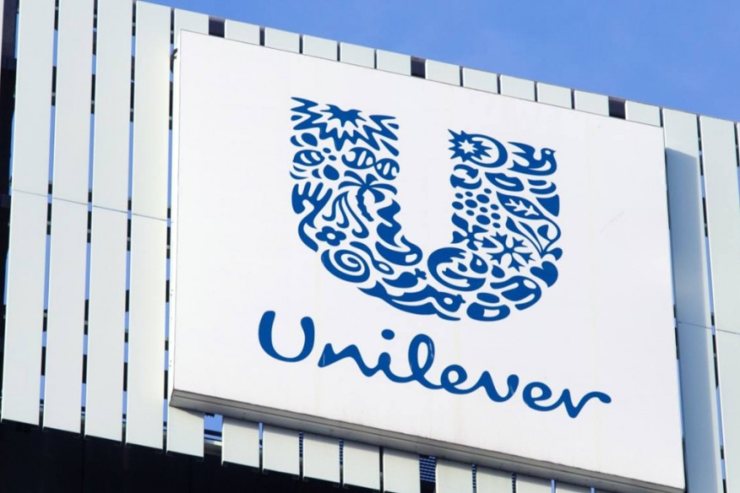
Source: (Unilever, 2024)

Evaluation of Two EU Country Identify Cultural Differences in Spain and Italy
Global Management Consultant of Unilever Plc to understand cross-culture differences plays a significant role in distinct fields of life (Hylland et al., 2024). Therefore, the firm mainly focuses on cross-cultural management that emphasizes relationships among underlying assumptions like values, norms, and beliefs. Cultural differences need to be considered in selecting effective administration practices in subsidiaries of cosmopolitan business associations (Fernández et al., 2023). A consultant of Unilever Plc mainly focuses on recognizing differences within the country as under:
Social Context: It is the biggest reason that creates differentiation linking Italy and Spain is an approach to promptness (Iglesias et al., 2023). Punctuality is very crucial for Italy, while they are meeting with friends or family, whereas Spain delays part of everyday life that negatively impacts organizational growth. In Spain, preparation events in advance are less amongst people. People know that searing with their associates and family is too up inside three weeks. Spain has a collective culture and family as well as tradition is very important for future success. On the other hand, Italian people are dominated by Roman Catholics. Italian people celebrate to rise of several styles, and other to improve culture by living together.
Labour Market: Traditionally, Italian people dominate toward Catholic nation, while Spain has a culture of communism and tradition is very significant. In Spain, there is the highest share of fixed-term or provisional contracts with insignificant firing costs (Hu and Zeng, 2024). Moreover, it is related to marginal employment, and it is known as mini-jobs with low-paid jobs with a maximum number of hours. Several relationships among temporary or mini-jobs raise the unemployment rate. Presently, Spain mainly focuses on job opportunities for local people to improve organizational effectiveness. Apart from this, the Italian Labor market is highly diverse, and industrial activities are concentrated in the North.
Language: Spain speaks dissimilar languages and thus, nations for all time converse in a dissimilar way in these nations (Shaoping, 2023). Therefore, the grammatical structure, rudiments, vocabulary, and pronunciation are completely different. Spanish uses a grammatical structure like the English language while local people do not follow these languages for organizational growth. The major difference between the Spanish languages is distinct from others to improve organizational performance (Halawi, 2023). Italian is an official language in Italy, and 93% of the population are native Italian speakers. Additionally, Italian is spelled differently from the way they are written on paper.
Diversity: In the EU, Spain is considered to be a safe country. In the global ranked for safety and peace, Spain ranked 32nd while ranked 15th (Martínez et al., 2023). Moreover, people should be extra attentive while living in big cities. The healthcare systems in Spain are excellent for organizational success. International businesses may easily access mandatory health insurance and facilities in both Spain and Italy for future success effectively. Italy is a country of rich diversity across its 20 regions. Both countries follow distinct traditions, dialects, and flavors to share.

Hofstede’s Culture Dimension Model of Spain and Italy
It shows the work culture of Spain and Italy on dimensions and exposed that score lower on person and higher on doubt avoidance in Spain (Fernández et al., 2023). Unilever Plc shows a cultural difference may act as a barrier to communication and affect team building. Global Management Consultant of Unilever Plc mainly focuses on understanding local culture to work effectively with people from different cultures. Since then, it’s become globally acquainted with as ordinary to sympathetic culture differentiation.
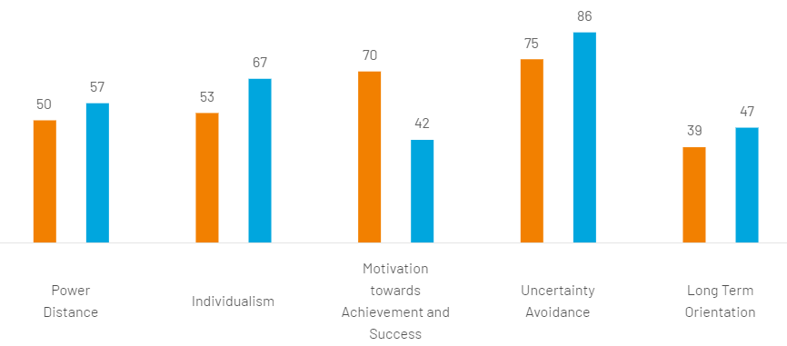
Source: (Hylland et al., 2024)
Power Distance: It measures the degree to which disparity and authority are tolerated. High power distance shows civilization accepts unfairness and power differences among those nations. Italy tends to prefer a 50 score for equality and decentralization. This dimension deals with the information that all persons in societies are not equal and expresses attitudes and culture toward these inequalities (Iglesias et al., 2023). It is defined as a less powerful member of an institution and organization within the nation. For instance, Spain has a high score of 57 on this measurement.
Individualism: It shows an individual versus collective approach to society. Spain with a score of 67 insecure social structure in that individuals are predictable to take the minds of the populace and their families (Barrett and Kanoria, 2022). Unilever Plc mainly focuses on self-image among customer mindset. On the other hand, the firm focuses on creating self-image through an emphasis on relationships and loyalty. It tends to belong to fewer groups while defining membership for organizational growth effectively. The score of Italy, 53 shows a degree of independence in society maintained among people while creating a self-image for future success. For Italians, it has their idea and objective of life to get motivating and route of happiness for organizational growth.
Motivation: These dimensions refer to tough vs tender and are considered as the preference of social achievement. Spain scores 42 motivations toward achievement and society growth effectively (Shaoping, 2023). Spanish children are cultured in search of agreement and say no to taking sides. This measurement shows that culture will be driven by opposition, attainment, and triumph in the marketplace. Italian people mainly focus on the development of a comfortable working environment for people to improve performance effectively. Otherwise, score 70, Italy is a decisive society highly oriented and signs to improve the quality of life of people.
Uncertainty Avoidance: It is considered as the extent to of hesitation and vagueness are tolerated. This dimension deals with unknown situations and unexpected events in an overseas nation’s negative impact on organizational performance (Martínez et al., 2023). As per this dimension, Spain reflects a far above-the-ground achievement of 86. Spain is considered a rule for everything like complex environments, stress, and others to improve organizational effectiveness. This dimension score of 75 in Italy is to avoid uncertainty that is lower than in Spain. Moreover, Italian people mainly focus on complications and uncomfortable situations in the marketplace.
Long-Term Orientation: Culture has different expectations or assigns meaning to deal with situations (Malin et al., 2020). Global management consultants of Unilever Plc mainly focus on managing current and past more than future. Spain indicates 47 a pragmatic nation, and people believe depending on the situation. It shows an ability to adapt to tradition easily change conditions, and a strong predisposition to save in achieving outcomes. To get better results, Unilever Plc emphasizes traits like perseverance, insistence, and long-term growth for organizational success. The Company focuses on quick results and responds to social pressure smoothly. On the other hand, Italy's score of 39 on the dimension shows Italian culture with great respect and tradition for future growth.

Analysis of the Communication Barrier the British Business
As a constant need to communicate, the Global Business Consultant of Unilever Plc can communicate effectively for organizational success (Unilever, 2024). The firm mainly focuses on finding an effective way and proper communication channel to deal with the global marketplace. Effective communication is the best way to share information in exchange among individuals involving sender and recipient. There is an effective communication barrier of the British Business as Unilever Plc as under:
Semantic Barriers: Commonly known as language barriers, semantic barriers are developed with ineffective communication between the sender and receiver. Some instances of this barrier could be stated as poor quality of message when the information conveyed does not carry a clear understanding and technical language (Hylland et al., 2024). Furthermore, Unilever Plc focuses on clarity or complexity as a way of providing information to improve organizational value. In Spain, Employees of Unilever Plc faced challenges to understand what was being conveyed to the manager.
Culture Force: Unilever Plc tends to value civility, circuitousness, and irony in its communication style. The use of humor is also a common business communication barrier that negative impacts on organizational performance (Fernández et al., 2023). Global Management Consultants of Unilever Plc need to be aware of cultural differences and not offend anyone.
Loss by Transmission: The manager of Unilever Plc transfers information from one person to a series of persons then the information becomes less accurate (Martínez et al., 2023). Poor choice of the medium during international communication or shocking encoding negative impact on information transmits. Moreover, the essential information is transmitted through the oral model, so the chance of elevating the message might be interrupted or lost the information.
Goal Disputes: In global business, Unilever has units and sub-units to internalize their own goals for organizational success. The Company mainly focuses on sub-unit goals that lead to disputes while communication is used as a dispute resolution mechanism (Barrett and Kanoria, 2022). When two parties are in dispute, communication is minimal while completing the completion of their thin section attention. Global management consultant of Unilever Plc focuses on dividing goals as per interest and focus of people to improve organizational success.
Legal Compliance: When a business organization starts its trade activities and consolidates in a particular territory, it generally has extensive knowledge and information of all the legal compliances in the local market. In consideration of the respective aspect, while expanding in Spain, Unilever must critically focus on keenly analyzing all the legal compliances and effectually complying with them in the potential market (Iglesias et al., 2023). Likewise, a lack of successful legal compliance of the potential or targeted market can potentially harm the brand position of the company. In addition, it further impacts the brand image of Unilever pessimistically. Considering this, the respective retail corporation must pay considerable attention to competently complying with all the legal compliances in the market of Spain.

Recommendation on Spain Should the British Business Expand
The Global Management consultant of Unilever Plc should deal with issues with an added dimension of complexity (Risager, 2023). Culture when it comes to face-to-face interaction and tacit assumption to deal with difficult situations. A Consultant of Unilever Plc focuses on cross-culture communication for business transformation and considers the different perceptions of those initiating change within the organization.
- Create Collaborative Team: In global expansion, the Manager of Unilever Plc focuses on the challenges and characteristics of high high-performing team (Malin et al., 2020). In modern organizations, The Company mainly focuses on hierarchical organizational structure, high-impact teams, more agile, and individual specialization. Unilever Plc designed a highly efficient team to constantly change the environment and organization for resistance to change.
- Increase Productivity: With good communication, the Manager of Unilever Plc shares valuable information with team members that brings a positive organizational climate. The Company's main purpose is to invest resources to arouse and transmit the corporate identity to all levels (Martínez et al., 2023). Effective communication is the best point to hold up action toward suitable managerial goals and create an open conduit where cooperation prevails. It is the best way to share valuable information with team members to improve organizational productivity at the global level.
- Flow of Information: The manager of Unilever Plc mainly focuses on procedures for the flow of knowledge and information is emerging as an ideal way for each employee (Unilever, 2024). It is very likely to know the flow of information flanked by different departments to take correct action for organizational success. Global management consultant of Unilever Plc giving out that information and receiving efforts to get ahead of opposition (Hu and Zeng, 2024).
- Strong Work Culture: The Company develops an organizational culture based on transparency, strategies, and hard work to complete tasks effectively (Fernández et al., 2023). Unilever Plc talks about issues in the context of communication and improvement, creating a positive environment to value staff members. Unilever Plc steps toward constant, fluid, impartial, transmission of information to accomplish a desired outcome.
- Crisis Management: Unilever Plc mainly focuses on expansion in the fastest-growing markets like the EU areas. The Company concentrates on the preparation of a strategy for translation services in the competitive marketplace (Hylland et al., 2024). On the other hand, Spain is an attractive EU nation to expand business internationally, while translating content into comprehensible words. Moreover, the firm mainly focuses on attractive nations to expand business internationally without any hindrance in operation.

Conclusion
The essay has concluded that EU countries apply country facts to understand cultural changes in Spain and Italy. Moreover, it examines Hofstede's model of culture to understand the differences among distinct nations to improve organizational effectiveness. The essay has evaluated communication barriers Unilever Plc could experience. Therefore, it showed a suggestion that Spain is the best country for further expansion. The essay has discussed strategies to overcome communication barriers and develop a positive environment for future success.

Reference List
Barrett, S. And Kanoria, S., 2022, November. Dismantling Stereotypes: Taking an Inside‐Out Perspective to Building Better Representation in Advertising for Unilever. In Ethnographic Praxis in Industry Conference Proceedings (Vol. 2022, No. 1, pp. 164-175).
Fernández-Reino, M., Di Stasio, V. and Veit, S., 2023. Discrimination unveiled: a field experiment on the barriers faced by Muslim women in Germany, the Netherlands, and Spain. European Sociological Review, 39(3), pp.479-497.
Halawi, L., 2023. Harnessing the Power of Culture and Cultural Intelligence within Knowledge Management Sytems.
Hu, Y. and Zeng, Y., 2024. Achieving Sustainable Operations: Challenges, Countermeasures, and the Case of Unilever. In SHS Web of Conferences (Vol. 181, p. 01036). EDP Sciences.
Hylland, O.M., Burri, M., Lindblad Gidlund, K., Handke, C., Rodríguez Morató, A., Oakley, K., Primorac, J. and Uzelac, A., 2024. Pandemic cultural policy. A comparative perspective on Covid-19 measures and their effect on cultural policies in Europe. International Journal of Cultural Policy, 30(1), pp.81-100.
Iglesias, O., Mingione, M., Ind, N. and Markovic, S., 2023. How to build a conscientious corporate brand together with business partners: A case study of Unilever. Industrial Marketing Management, 109, pp.1-13.
Malin, J.R., Brown, C., Ion, G., van Ackeren, I., Bremm, N., Luzmore, R., Flood, J. and Rind, G.M., 2020. Worldwide barriers and enablers to achieving evidence-informed practice in education: what can be learned from Spain, England, the United States, and Germany?. Humanities and Social Sciences Communications, 7(1).
Martínez-González, A.E., Rodríguez-Jiménez, T., Riaño-Hernández, D., Alexandra-Atehortúa, P., Ramírez-Conde, A. and Ramírez-García, L., 2023. Cross-cultural differences in autistic characteristics: a comparison between Spain and Colombia. International Journal of Developmental Disabilities, pp.1-10.
Risager, K., 2023. Analysing culture in language learning materials. Language Teaching, 56(1), pp.1-21.
Shaoping, L., 2023. Unilever Global Sourcing and Purchasing Strategies: A Case Study of Trade and Logistics between the EU and UK Post-Brexit. Industrial Engineering and Innovation Management, 6(10), pp.124-131.
Unilever PLC (2024) Unilever, Unilever. Available at: https://www.unilever.com/our-company/ (Accessed: 04 March, 2024).

