Design, conduct and report a research study to explore predictors of work motivation.

Abstract
This report outlines the analysis of a small group of UWTSD university students, who are currently in part or full-time employment, using an online questionnaire via the Qualtrics system. The aim was to explore the main predictors of work motivation among the youth at the university. The independent variables explored were conscientiousness and Neuroticism, with work motivation being the dependent variable. We hypothesised for this study that higher levels of conscientiousness and lower levels of neuroticism were predictors of work motivation. These were chosen from the Big-five inventory scale, and the data was interpreted using the multi-dimensional work motivation scale, furthermore SPSS software was used to analyse results further with multiple regression. The results showed F (2, 67) = 1.03, P < .05. R² = .001. suggesting a link to our original hypothesis, however there were limitations to this study and data, which are discussed further in this report.

Introduction
The purpose of this study was to explore if certain aspects of one’s personality (conscientiousness and neuroticism) can act as predictors towards work motivation. More specifically, all participants were university students who were currently employed, as the ‘work motivation’ aspect was referring to the work place and not university work. There have been several articles/journals of interest, which have investigated the same topic area. One journal looked at how intrinsic and extrinsic incentives act as predictors of work motivation, the study was a longitudinal, large scale cross-lagged field study. The results showed how the relationship between intrinsic motivations and increased work efforts were high among those with specific, focused goals, suggesting those who are more goal orientated will have a more positive outlook with work efforts (Dysvik, A., & Kuvaas, B., 2013). This links in with this report as this study looks at conscientiousness being a work predictor (alongside neuroticism) which means someone is eager to set goals and hit targets well and thoroughly. So, it was interesting to read this article and see a similar theme being explored, it can be said that conscientiousness is one of the most important factors which drives work motivational efforts. A further article which supports this was one which looked at the big five personality dimensions and job performance, with results showing consistent relationships with all job performance criteria (eg; job proficiency), across many occupations (Barrick, M. R., & Mount, M. K. 1991). Based on these two articles, it was clear that the hypothesis for this study had to be based around an individual having high conscientiousness rather than low and compare this with a similar but somewhat more intense predictor, like neuroticism. This was to prove if conscientiousness really was the leading pull for work motivation, as neuroticism and conscientiousness can be seen to be similar in ways. The similarity being individuals wanting to apply their best efforts to a task, but with neurotic individuals, this feeling is far more drastic.

Methods
Participants
10 participants were recruited through a convenience sample, this was done so by administering an email to all psychology students at the University of Wales Trinity Saint David, SA1 campus. This was to make them aware that the study was available to sign up to via the EMS system. The questionnaire to be completed was an online format, on the programme ‘Qualtrics’. The sample size consisted of (10 females, 0 males) ranging from age 18 to 47 (M = 5, SD = 7.07) All who took part were currently in either full or part time employment.
Design
The design of this study was a quantitative, online (structured) questionnaire. This was displayed on the programme ‘Qualtrics’, for students of UWTSD to sign up to via the EMS experimental system. In doing so, students would gain 1 credit for their participation. Data was obtained from the Qualtrics system, and then inputted into the programme SPSS ready for analysis. In the analysis of the data, multiple regression was used to depict further the relationship between the dependent variable and the two-independent variable’s (Aiken, L. S., West, S. G., & Reno, R. R. 1991).

Materials
The first material used in this study was the consent form (Appendix A), these were completed and put into the Qualtrics programme in an online format, to be read and understood before the questionnaire commenced. The Qualtrics programme itself was the next material used (Appendix B), this software was used to create the questionnaire for this study, and in turn obtain the relevant data. The questions included which were linked to each independent variable, respectfully, and were selected from the Big Five questionnaire (John, Donahue & Kentle, 1991). To have more insight into what motivated the students to work, the multi-dimensional work scale was used for reference (Gagne et al, 2014). The questionnaire set up was in order of; work motivation, neuroticism and conscientiousness. Furthermore, the SPSS system was used through the analysis stage of the study, this was to input the data and gain overall results to state whether the study was significant or not. Following this, allowed for the creation of tables based off these results. The final material used was the debrief form, which again was included in the online format for the Qualtrics programme. Multiple regression was the form of analysis used to break down the results obtained from SPSS, to give a final result of significance or non-significance. The debrief was shown at the very end of the study and reinforced that any questions could be asked now or at a later stage via contact with the researchers themselves or their supervisor, through email.
Procedure
This study commenced with the completion of an ethics form to be approved, before the questionnaire was designed and available to collect the data. Once any appropriate changes had been made and the form was approved, it was decided as a group, the appropriate predictors of work motivation to be explored. These were chosen from the big five questionnaire (John, Donahue & Kentle, 1991). Conscientiousness was one that was chosen as it has been said that people with this trait set goals or have ambitions and work hard to meet them (Barrick, M. R., Mount, M. K., & Strauss, J. P. 1993). The independent variables were therefore measured using the ‘Big five’ scale, whilst the dependent variable of work motivation, was decided to be measured using the multi-dimensional work motivation scale (Gagne et al, 2014).
The consent form (Appendix A) was then designed and added to the beginning of the Qualtrics form. Following this, the questions for the questionnaire itself were inputted and the Qualtrics programme (Appendix B) layout was designed between the group members. This was then made live and available to UWTSD university students, who were in employment currently. Should they click the option of not being in employment currently, they would be reverted to a page to say they are not eligible to take part in the study. An example of the questions included for work motivation were as follows; “I don’t know why I’m doing this job, its pointless work”. For neuroticism “Can be moody” and finally conscientiousness “is a reliable worker”. Participants were given options on answering the questions, based on the seven-point Likert scale for work motivation and a five-point Likert scale for the Big Five questions. The seven-point scale for work motivation was ranked under the following; 1= not at all, 2= very little, 3= a little, 4= moderately, 5= strongly, 6= very strongly, 7= completely (see Appendix B). The five-point Likert scale for the big five questions were as follows; 1= strongly disagree, 2= disagree a little, 3= neither agree nor disagree, 4=agree a little, 5= agree strongly (see Appendix B). Once the student had completed the questionnaire, they were thanked for their participation and presented with an online debrief form which explained the purpose of the study and told them what predictors were being explored throughout. Following this, participants were granted 1 credit via the experimental system.
When the data was obtained from the participants, SPSS software was used to input the data for analysis, where the results can be viewed in table form. Multiple regression was then used for a full analysis of the relationship between the variables, and too ultimately state if the result was significant or not.

Results
The hypothesis for this study was that higher levels of conscientiousness and lower levels of neuroticism are predictors for work motivation. Using SPSS, the data obtained from Qualtrics was entered and multiple regression was used to clarify what the data states. The mean and standard deviation were also collected from the analysis, along with a table showing a breakdown of the coefficients. The table below has used the data from SPSS but was created via Microsoft word.
Table 1
Descriptive statistics for all variables
 | Mean | Standard deviation | N
Work motivation | 2.29 | 1.42 | 70
Neuroticism | 2.20 | 60 | 70
Conscientiousness | 2.39 | 62 | 70

The table above shows the mean and standard deviation result for all three variables. Its clear to see that the mean scores between the conscientiousness and neuroticism are different, with conscientiousness being visibly higher. However, at the same time, both variables can be seen to be linked to work motivation with scores being close in range. These results would suggest that the original hypothesis can be accepted, that higher levels of conscientiousness and lower neuroticism levels are linked to or can predict work motivation levels. The results support this statement by proving significant, as the sig value was greater than .05 as F (2, 67) = 1.03, P < .05. R² = .001.
Table 2
ANOVA results table for all variables
 | Sum of squares | df | Mean Square | F | Sig.
Regression | 4.126 | 2 | 2.063 | 1.030
  .362^{b}
Residual | 134.160 | 67 | 2.002
Total | 138.286 | 69

The table above displays the regression significance overall, as can be seen it is notably high, somewhat too high to state it is a strong relationship not caused by chance alone. This can be assumed based on the amount or lack thereof, of participants who took part in this study. This is obviously a limitation to the reliability of the overall results, however as the significance was higher, the hypothesis originally set can be accepted.
Discussion
This study has proven to show some interesting results, with the data echoing the studies of previous interest to this research. The first point to note is that the hypothesis stated that higher conscientiousness and lower neuroticism would produce work motivation, due to the interest from other reports around conscientiousness, it further supported this decision. The Results from this study show what was expected from the outset, which is positive, along with the fact that both predictors were seen to link with work motivation.
When considering limitations to this study, it’s easy to see the set back with the data. The goal number of participants was 30, and this obviously was not reached. The smaller scale makes it difficult to say this study was reliable, even though it supports our hypothesis and original thoughts. Another consideration to the data reliability points to the gender, being that no males participated. This obviously doesn’t equate to an easily generalisable sample as the thoughts and actions of women may not always echo those of a man. With regards to the study itself, it’s often viewed ‘harder’ to implement the same ethical considerations with an online study, as the researcher/s are not present to answer any prying questions about the study, or just to clarify any concerns there and then. However, it was made sure that consent was fully gained before the questionnaire commenced, and on completion that the participant knew their data would be kept confidential. Also, they were reminded, as normal, that should they have any questions to email the researcher or alternatively the supervisor of the study, with any concerns. Overall, the study was designed and executed according to plan, it was just the lack of participants that let the data down slightly. If there had been an even proportion of men to women who took part, the analysis would be a lot more reliable than with it just being completed by women. The fact that the results support our original hypothesis could be because those predictors really are able to assume work motivation, however this would need to be confirmed with a larger sample size and an even ratio of men to women taking part. Due to this its fairly easy to assume that the results gained were more likely due to chance, than not.
To conclude, even though the results showed significance and support for our hypothesis, the number of participants isn’t great enough for the overall outcome of the study to be positive. Replication would have to be completed, for further depth and analysis into if the hypothesis can be applied to everyone, so generalised.

References
Aiken, L. S., West, S. G., & Reno, R. R. (1991). Multiple regression: Testing and interpreting interactions. Sage.
Barrick, M. R., Mount, M. K., & Strauss, J. P. (1993). Conscientiousness and performance of sales representatives: Test of the mediating effects of goal setting. Journal of applied psychology, 78(5), 715.
Barrick, M. R., & Mount, M. K. (1991). The big five personality dimensions and job performance: a meta‐analysis. Personnel psychology, 44(1), 1-26.
Chemolli, E., & Gagné, M. (2014). Evidence against the continuum structure underlying motivation measures derived from self-determination theory. Psychological Assessment, 26(2), 575.
Dysvik, A., & Kuvaas, B. (2013). Intrinsic and extrinsic motivation as predictors of work effort: The moderating role of achievement goals. British Journal of Social Psychology, 52(3), 412-430.
John, O. P., Donahue, E. M., & Kentle, R. L. (1991). The big five inventory—versions 4a and 54.

Appendices
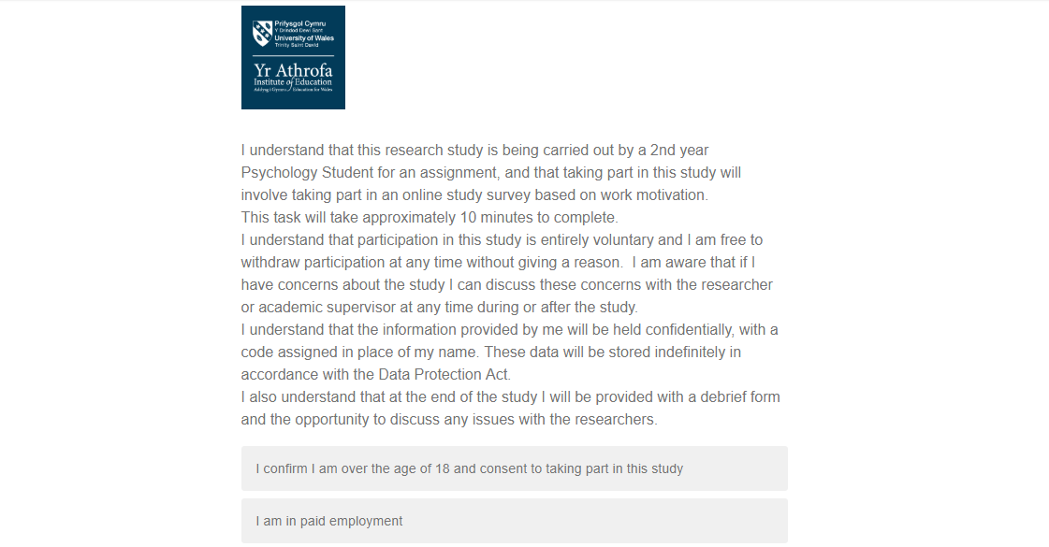
Appendix A- Consent form (via Qualtrics)
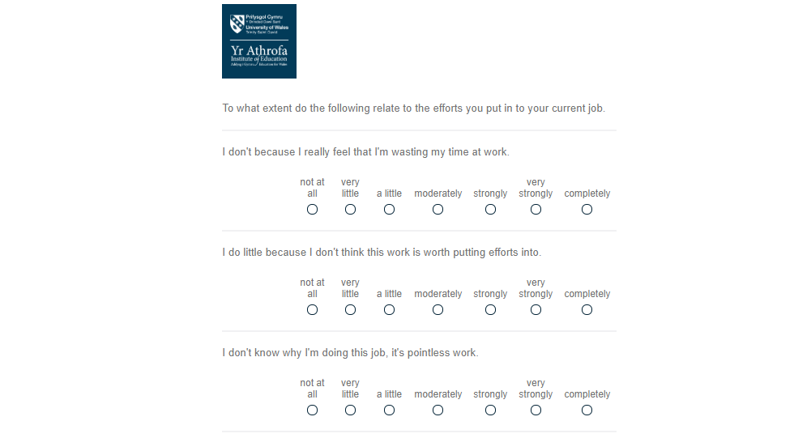
Appendix B- Qualtrics questions examples
The picture above is an example of Work motivation questions.
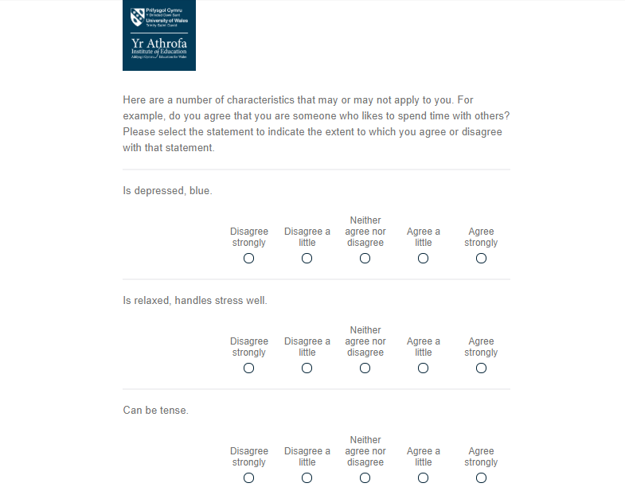

The picture above is an example of the questions for neuroticism.
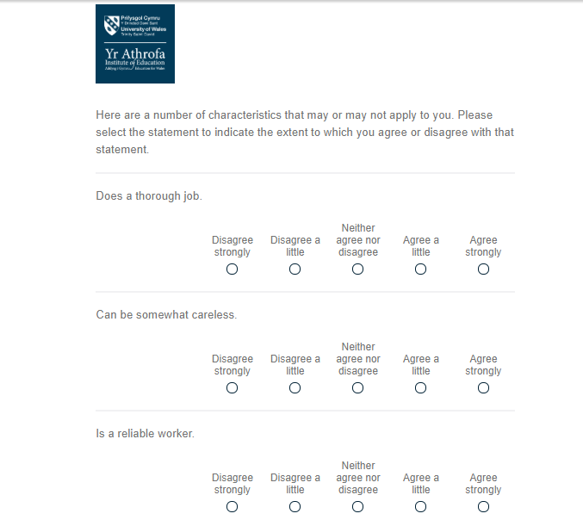

The picture above is an example of conscientiousness questions.

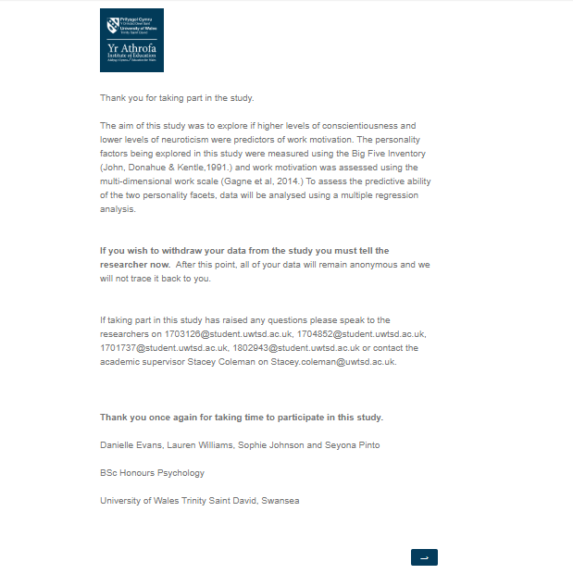
Appendix C- Debrief form

