BA LEADERSHIP AND MANAGEMENT SKILLS FOR THE WORKPLACE
WORKPLACE CULTURE AND ITS IMPACT ON ORGANISATIONAL EFFICIENCY
BMSK5005_SWAN
JULIE THOMAS
RECOMMENDATIONS TO FURTHER ENHANCE THE CULTURE, USING EXAMPLES FROM OTHER ORGANISATIONS
ANGELA ANDRADA VISCIUN 1709566

ADMIRAL Swansea- Recommendations
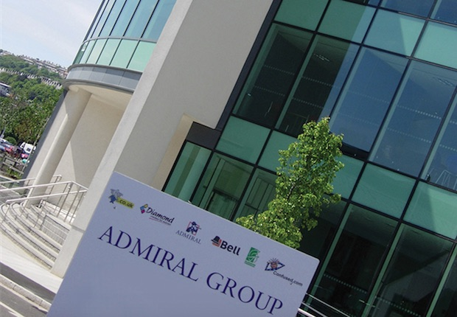
After researching and going through the reviews on Admiral Page, the organisation is one of the UK’s top three car insurance companies and officially one of the nation’s very best companies to work for. With a passionate, profitable and fast-growing financial services company with operations in eight countries, grown from a small start-up, reaching 250,000 policy holders in June 1996( 3 years after launches in Cardiff) in present (25 years later) being one of the largest UK car insurance group on the market reaching over six million customers worldwide, sourced from Admiraljobs.co.uk.(2019). 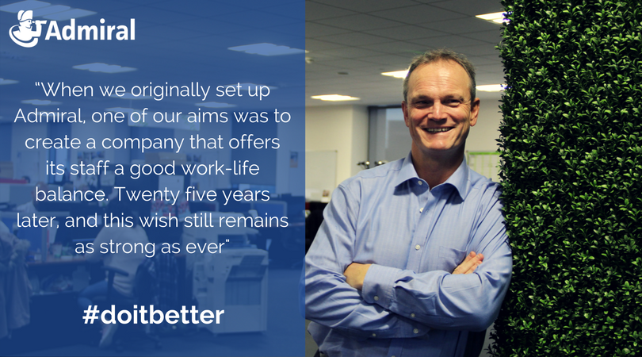
Before to start up on my reccomendations I would like to give you a briefly SWOT analysis about Admiral Group PLC, from my understanding and research.
As a STRENGHTS:
ADMIRAL has got a “Cost Structure”: which mean low cost structure helps it produce at a low cost and sell its products at a low price, making it affordable for its customers. Also, products have kept same quality over the years and still valued by customers, who find it as good worth for the amount of money that they pay. Admiral has a “diversified workforce”, with individuals of many geographical, racial, cultural and educational backgrounds that help the business by bringing in diverse ideas and procedures of doing things.
“Skilled Labor force”,it’s also a strenghts for Admiral, company being investing widely in the training of its employees and resulted a large number of skilled and motivated employees.
As a WEAKNESSES:
Admiral has got few weaknesses, researched from different sources I would like to just point few of them, the ones that I considered much more important.
“Research and Development”: Even though Admiral Group Plc is spending more than the average research and development spending within the industry, it is spending way less than a few companies within the industry that have had a significant advantage as a result of their innovative products.
“High Day Sales Inventory”, the time it takes for products to be purchased and sold are higher than the industry average, meaning that the company builds up on inventory adding unnecessary costs to the business.
“Cash flow problems”,there is a lack of proper financial planning at Admiral in concern with the cash flows and “ Quality Control”,Admiral Group Plc has a lower budget for its quality control department than competitors. This leads to lack of consistency and the possibility of damage to quality across its various vents. Also, a high proportion of property in use by Admiral Group Plc is on rent, and rental charges need to be paid.
As a OPPORTUNITIES:
” Technological developments”, I mean that technology comes with numerous benefits among many departments, those days. Technology enables better data to be collected on customers and improves on marketing efforts.
“E-commerce”there has been a new trend and a growth in sales of the e-commerce industry, means that a lot of people are now making purchases online. Admiral can earn revenue by opening online stores and making sales through these, also social media platforms worlwide.
THREATHS:
“ Suppliers”: The trading power of suppliers has increased over the years with the reduction in the number of suppliers. This means that the costs of inputs could increase for Admiral and also, new entrants, such as numerous companies that have entered the market and are gaining market share by gaining existing companies’ market share. This is a threat to Admiral Group Plc as it can lose its customers to these new entrants. Rivalry within the industry is growing every day. Sourced from (Essay48, 2019)
As a conclusion, Swot analysis is a vigorous strategic planning utensil , Admiral managers can analyse the present strenghts, weaknesses, opportunities and threats that company are facing in its current situation, helping them to develop four strategic types, such as
SO (strengths-opportunities) Strategies, this involves using internal strengths to take advantage of opportunities.
WO (weaknesses-opportunities) Strategies, this involves improving on the company’s weaknesses by making use of the opportunities.
ST (strengths-threats) Strategies, this involves the using of strengths to minimize the weaknesses.
WT (weaknesses-threats) Strategies, this involves the elimination of weaknesses to combat the threats. Sourced from Fern Fort University. (2019)
As an example I’ve used ADMIRAL against DIRECT LINE INSURANCE, Admiral’s biggest competitor.
As I’ve mentioned before, Admiral was created in 1993, with a small start-up,starting with 57 employees,according to (Fool.co.uk, 2019), headquartered in South Wales, but grown rapidly and expand worldwide. The appeal of this firm is that it’s an incredibly lean and efficient organisation. Admiral’s low cost base means that it can pay out a big amount of its incomes as shareholder bonuses. The share price has been trending progressively upwards ever since the lows of the Eurozone crisis, and the stock now stands at a trailing P/E ratio of 21, with a bonus profit of 2.12%,according to Prahbat,S.(2016)
DIRECT LINE INSURANCE started from scratch in 1985 with only car insurance and only via telephone,doesn’t have Admiral’s international spread but it’s represent the UK’s car insurer leader and provide more than 13,000 care insurance quotes every day,selling a directline policy every 10 seconds, state by (Directline.com, 2019)
Direct Line Group has always been one of Britain’s premium insurance companies, and this has given the business pricing power that it has used to increase profitability. 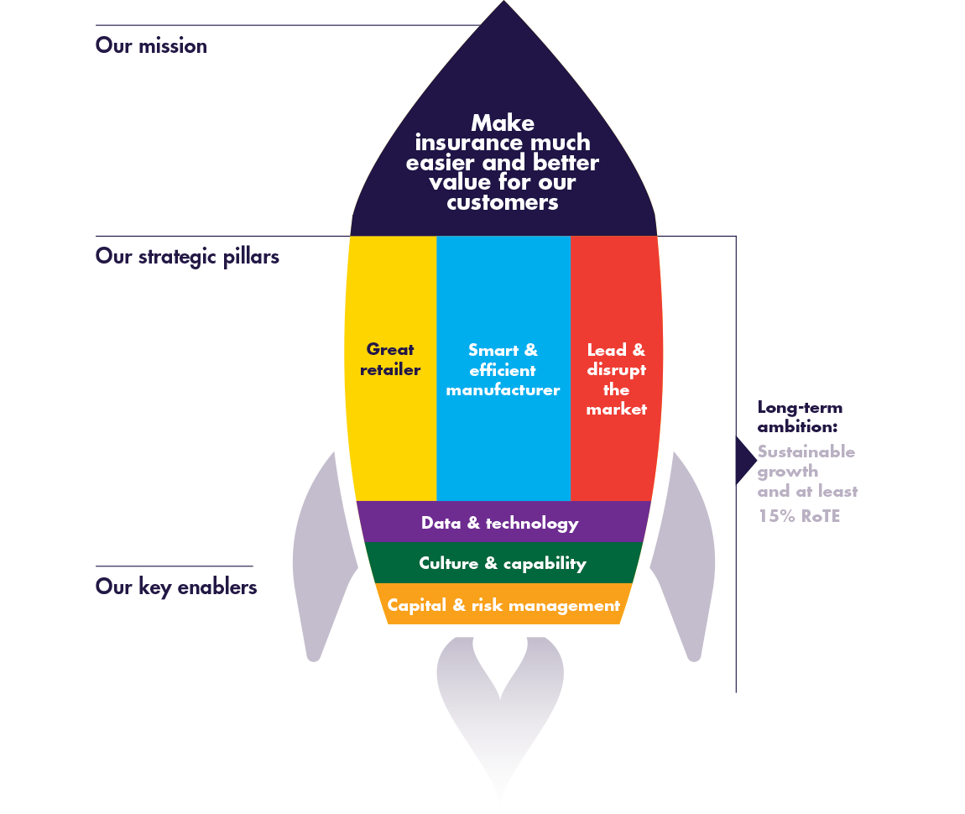DLI strategic pillars are “ great retailer”, “smart and efficient manufacturer”, “lead and disrupt”, according to (DLG Corporate Corporate Website, 2019) against ADMIRAL’S one : “communication”, “equalitty”, “rewards and recognition”, “fun”.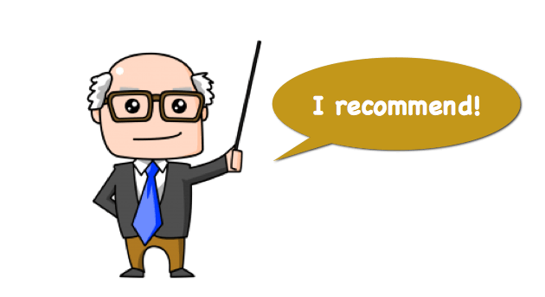

As a recommendation, finance ownership of the property through low interest rate to increase the proportion of owned property to rented property, because as a weakness most of the offices are rental charges. Use its innovative teams to find cheaper alternatives to fuel so that these could be used, thereby reducing costs, because they got a diverse labour force and competition within the industry is increasing.

Reference list :

- About us. Find out more about Admiral's history, commitments, and culture... [online] Available at: https://admiraljobs.co.uk/about-us/ [Accessed 22 Jun. 2019].
- Admiral Group Plc [SWOT Analysis] Weighted SWOT Matrix. [online] Available at: http://fernfortuniversity.com/term-papers/swot/nyse/6956-admiral-group-plc.php [Accessed 22 Jun. 2019].
- Essay48. (2019). Admiral Group Plc SWOT Analysis / SWOT Matrix. [online] Available at: https://www.essay48.com/term-paper/9170-Admiral-Group-Plc-Swot-Analysis [Accessed 22 Jun. 2019].
- Fool.co.uk. (2019). Are Admiral Group plc and Direct Line Insurance Group plc 2 dividend dynamos? | The Motley Fool UK. [Online] Available at:
https://www.fool.co.uk/investing/2016/08/12/are-admiral-group-plc-and-direct-line-insurance-group-plc-2-dividend-dynamos/ [Accessed 22 Jun. 2019].
- Directline.com. (2019). About us - Direct Line. [online] Available at: https://www.directline.com/about-us [Accessed 22 Jun. 2019].
- DLG Corporate Website. (2019). Strategy. [online] Available at: https://www.directlinegroup.co.uk/en/who-we-are/strategy.html [Accessed 22 Jun. 2019].

