A critical evaluation and the identification of next teaching and learning steps
focusing on a case study of an individual learner or a group of learners, based on an
observed critical incident.

INTRODUCTION
Within this assignment I aim to critically evaluate a critical incident extracted from a case study undertaken within a year six classroom. Referring to relevant literature and research I will discuss the advantages and disadvantages of a critical incident observed and the effects this may have on pupils. It is important to note here that the critical incident within the context of this assignment is on the surface perhaps to some an insignificant event, however critical evaluation and interpretation of such events will reveal the importance of small and common occurrences. For a true critical incident to be formed it must have been broken down and analysed to disclose its importance to the experiences obtained within a classroom (Tripp, 1993). Teachers in the field often use critical incidence to “embark on a diagnostic understanding of their teaching” (Tripp, 2011). I too like the teachers noted by David Tripp (2011) was uncertain of what type of incident to consider critical. Upon reading his literature it became apparent that making note of anything that is alerted to your attention is an effective commencement. The fact the occurrence was noticeable is undeniable in the sense that there will be sufficient layers to the incident to unpick and investigate making it then a critical incident. Following BERA (2018) guidelines, the school and pupils involved within the observation for this assignment will remain confidential and unnamed. All ethical values and BERA code of conduct have been respected throughout this assignment and during on field observations.
OBSERVATION
School & Class context
As stated above the school and pupils will remain anonymous with all BERA (2018) guidelines honored and followed throughout. The pupil spoken about directly in the assignment will be named child ‘X’ to accommodate anonymity.
The study took place at a primary school located in North West Swansea. The local authority estate in which the school is situated has seen major re-development. When the school was initially built in 1954 its infants and juniors were separate schools. In the year 1979 both schools amalgamated into the school it is now. It is quite a large school with two main halls and 2 reception classes. In 2010 the Flying start project was welcomed to the school by two classrooms and surrounding areas having a refurbishment to accommodate the scheme. Estyn rewarded the school 5 ‘good’ judgements in the June inspection 2019. This information was obtained from the student information pack received from the school.
The observations for this assignment were undertaken in a year 6 classroom of mixed ability children. The pupils were clearly comfortable within their classroom and had built strong relationships with both the teacher, TA, and each other. The class was made up of twenty-five children both boys and girls aged between 10 and 11. I would also like to include that upon visiting the school it was clear that all children and staff valued their work and each other. The children would open doors and greet you politely and staff would welcome you into their classrooms. The school ethos made it a pleasure to visit and excited me to teach.

Methodology
Within this study observational methods were used to conduct relative research into what a critical incident is and their relevance to teaching. There are many different forms of observational methods with distinctive differences. Controlled Observations, Naturalistic Observations and Participant Observations (McLeod, S 2015). It is also important to note that observations can either be “overt/ disclosed (the participants know they are being studied) or covert/ undisclosed (the research keeps their real identity a secret from the research subjects acting as a genuine member of the group” (McLeod, S 2015). The observations within this study were overt.
A controlled observation is usually conducted where and when the researcher decides. The observations are usually recorded on charts or through codes. Contradictory to this the Naturalistic Observation which studies participants in “natural surroundings” (McLeod, S 2015) with the researcher recording what they see “in whatever way they can”. Combining these two methods concocts the third method: Participant Observation. This method observes participants within their natural environment but joins the group to gain a deeper understanding of the participants they are studying i.e. being a part of the classroom and observing potential critical incidents. There are however, like all methods some disadvantages. Having to observe at only specified periods observations will be limited (McLeod, S 2015). If, like the observation undertaken for this assignment, researchers are only there for a short period of time it is difficult to make fair assumptions on why the incident may be critical as there can be many variables i.e. home life, change in behaviours having a new person in the classroom etc. It is important to be aware that what we observed within this study was based on a snippet in time.
Case study research was also used to investigate how and why (Morgan et al., 2016), in this case, an incident is considered critical and was conducted in a real life environment this being “crucial to understanding real-world cases” (Morgan et al., 2016). Strengths of using this observation method provided a direct examination of the participants where observations could be made in real time and within their natural environment (Morgan et al., 2016). However, it was difficult to note down every potential incident due to being involved with the class and the children.
Critical incidences here were used to gain a deeper understanding of seemingly unimportant occurrences in the classroom and how through evaluation they can in fact be of great importance to understanding how a child or group of children learn and or experience school and teaching. Although critical incidences are a good way of evaluating your teaching and understanding your pupils it becomes problematic as we are only assuming that we know why that incident is critical (Brookfield, S 2017).

Critical incident linked to Donaldson’s Four Purposes
During this snippet in time the lesson began with the teacher placing three colour coded learning objectives on the interactive white board. The class was split into three groups: green, red, and blue. The children would work in these groups for every lesson except for ‘slot drillio’ which they worked on as a class. Throughout the day the green group would work in the rainbow room where the TA would lead their learning after their class teacher introduced the lesson. The red group would work independently, and the blue group would work with the class teacher. Upon conversing with the class teacher, she noted that it was important for the blue group to be guided and challenged to achieve their best. The red group would work independently to encourage their confidence and independence and the green group would be supported by their TA and taken into a class where they have less distractions and a space to get focused. Preparatory to visiting the school I was under the assumption that leaving a group to work independently would encourage distractions and little to no completion of work and having sent a group to another room would promote isolation from the rest of the class. This could not have been a more inaccurate and unfair assumption to this class. The teacher was clear in her introduction to each lesson and engaged the children in their learning from their arrival into the classroom, and throughout the day. The children were tuned into learning and happy.
The purpose for the differentiated groups within this class has strong links to the Successful Futures (2015) a summary of Professor Graham Donaldson’s report. The four purposes within Donaldson’s vision for the curriculum that strive for young people and children to become “ambitious, capable learners ready to learn throughout their lives, enterprising, creative contributors ready to play a full part in life and work, healthy, confident individuals ready to lead fulfilling lives as valued members of society, and ethical, informed citizens ready to be citizens of Wales and the world” (Successful Futures 2015) is exemplified in this class. It is evident that the teacher did not group the children at random. The teacher used this opportunity to implement Donaldson’s four purposes strategically. The green group working with the TA are working on both their confidence and ambition. Having a playful and soothing experience in learning allows them time to build their well-being, confidence in their academia and their social development. The red group working independently were also given the learning opportunity to use their ambition and confidence effectively. Working as an independent group will naturally develop their initiative and problem solving. Having the class teacher to guide the blue group enables them to delve deeper into their understanding of the task and use that drive to excel their ambition.
Asking child X the purpose of the individual learning objectives they said “blue is really really hard they get loads of work, red is a bit hard and green gets easy work. I like being in green it’s fun. I feel sorry for my sister in blue” (see Appendices 2). It became apparent that the class were aware of their groups and their abilities.

LITERATURE REVIEW
Through reading and researching literature it is apparent that there are many benefits to differentiation within a classroom. Carol Ann Tomlinson (2014) explains that for many years teachers have been in search of a more valuable way of teaching. It is indisputable that all children are unique and have an array of learning styles. The best way for one child to learn will not necessarily be the same for another. The importance then for children to access the best learning approach for them would be to have a catered approach, where children of similar learning styles and capabilities will work best together, rather than having a whole class approach to learning. Carol Ann Tomlinson (2014) further explains that teachers will then inevitably need to vary their approach on how they introduce and instruct the lessons relevant to their children. This was evident in observation taken at the school I attended. The class teacher did in fact use this approach effectively as all lessons were introduced clearly and efficiently to all groups and children responded favourably. “In the very simplest terms, differentiation is about using different approaches with, our learners, so that they can make the maximum progress in their learning” (COWLEY, S 2018). Upon reflection, many will have a preconception that using differentiation within a classroom would be more of a burden than anything else. Having to provide multiple worksheets, having to explain perhaps twenty different tasks to twenty children who all learn differently, creating a unique learning environment for each individual to provide the best learning experience for them would be unrealistic and time consuming (COWLEY, S 2018). However, it is the everyday listening, engaging and stimulation that provides the learners with the opportunity to learn effectively. It is the instinct and responsive approaches of the teacher that will ensure the effectivity of differentiation. Practical adaptions that teachers will often make daily relevant to the children in their class will have a positive outcome (COWLEY, S 2018). This
Having said this there has been extensive research arguing that mixed ability groups are far more effective to the academic development of children than perhaps groups of children with similar abilities are. One positive of having a mixed ability group is providing the opportunity for children of different abilities to work together. Higher ability children will be able to support and help lower ability learners. This will also provide an opportunity for the children to develop socially giving the children a chance to work on important life skills, such as patience and tolerance (OSVΆTH, E, DUDLEY, E,. 2016). This however could negatively affect how lower ability children view themselves in comparison to the higher achievers within the group.
From delving into literature, it has become apparent that it is most common to see differentiation in subjects like Maths and Science. This is likely to be because of the conceptual understanding children must have in these areas. Placing high achievers with low ability in these areas could create a situation where higher ability are anchored down by children who are not at that level of understanding therefore making it impossible for the lower ability learners to access any of the learning. This is where self-esteem and confidence could also be affected. It could however be beneficial for students to collaborate in mixed ability groups for lessons in humanities for example. Creatively working together could enhance their learning by using each pupils’ skills effectively. Working as a mixed ability group on a project, for example, could allow the children to play to their strengths. Lower ability children may be more artistic and creative, and ideas could bounce off pupils in the group making for a successful collaboration. Here as the lessons are less structured it provides opportunity for the children to flow more freely in their ideas. Giving the pupils more flexibility in showcasing their individual skills. Perhaps if a task were to build a model of a Tudor house in History the pupils stronger in Maths could work out the circumference and the pupils with creative strengths could design it. Having children work in mixed ability groups allows for children to develop their speaking and social skills in a lifelike context (OSVΆTH, E., DUDLEY, E., 2016). It is also important to note that children will all have different interests and personalities. As children spend a lot of time outside of school these areas of their character will be built at home (COWLEY, S 2016). Therefore, placing them in mixed ability groups could complement these differences but this could also positively impact them through placing them in same ability groups. Their abilities may be similar put their social skills will still develop as they are still engaging with other members of their group.
It was not only the use of differentiation the classroom that was reflected within the critical incident observed. The use of questioning in the introduction of the lesson is something else needing to be explored for the incident to be critically evaluated. Child X as stated above was placed in the lower ability group and therefore their learning was influenced by the introduction they had into the lesson. Although the class was differentiated through grouping of abilities the questioning at the begging of the lesson, interestingly, was a whole class experience. Using a questioning strategy in teaching allows for the children to reflect on and access prior knowledge. Doing this as a whole class provides opportunity for the pupils to intake ideas from other students and add this to their own thoughts (FUSCO, E 2012). It creates a place where the children discuss and focus on the relevant task bringing their attention back to the subject they are working on at that specific time. It is also an opportunity for all children to gain a deeper understanding of the topic (FUSCO, E 2012).
Being a teacher, it is natural for you to question your students, what feels like infinite times a day. It is how to use this strategy efficiently and effectively that will make it a successful strategy (WORLEY, P 2019). When questions are used sufficiently within teaching the “questions build memory, focus attention, create emotions, hook the learning and build imagination” (FUSCO, E 2012). The teacher participating within this observation practiced this. Thus, linking to Donaldson’s successful futures in building ambitious, capable learners, and healthy confident individuals (Successful Futures 2015). The teacher would use open/ inferential questioning. They listened to what the children thought and said and then thought about and questioned why they thought those things (WORLEY, P 2019). There is however a way that questioning can have a less proactive effect on the children’s learning. The mindset you have before asking questions will have a profound effect on how the questions are used, this then being helpful or harmful to the students you teach. Questioning the children with a specific and definite answer in mind is contradictory to the positive effect that open questions will have. As the teacher you would be expecting a specific answer in turn leaving questions that could spark learning unacknowledged and thus meaning you are “not on the lookout for learning possibilities” (WORLEY, P 2019). Expanding on this further Esther Fusco (2012) states there are three types of questioning within the classroom. Inferential questioning or open questioning as stated earlier: this is hoping to encourage pupils to think beyond the literate answer and form their own ideas and thoughts. The teacher used this effectively in class by asking “What does it mean?” regarding a propaganda poster on World War II. This got the children thinking about it and having to process and express their own ideas and thoughts. Another form of questioning is literal questioning where it is asked only to get an answer back that is fact (FUSCO, E 2012). These are also known as closed questions as mentioned previously. The mindset is still paramount here, although literal questioning is in fact looking for a specific answer your mindset still needs to be on the look out for learning possibilities. The third form of questioning is metacognitive questioning. This is where you ask questions with the intention to allow students to find the answer to their own questions. This is a highly effective way for children to really dig deep in their cognitive understanding and develop their thinking skills.
Upon reflection it is evident that both differentiation and questioning strategies within the classroom is of high importance. It is clear that there are advantages and disadvantages to both strategies. However, the commonality in both is how the teacher uses these strategies will no doubt influence the effectiveness of these in the classroom. It is important that the teacher understands her pupils and is always prepared to ignite discussions and act upon every learning possibility.

REFLECTION / EVALUATION & NEXT STEPS
Throughout this assignment reflections have been made on a critical incident and observations along with advantages and disadvantages of the strategies recognised within the incident. It is now essential to discuss why reflection in practice is an important part of teaching.
Reflective practice is essentially used to develop yourself as a teacher and allows you to continue to change and develop your strategies and pedagogy for the most effective form of teaching. Working with colleagues and other teaching professionals allows you to share and compare your reflections collaborating to develop and use strategies that work (Getting started with Reflective Practice, 2020). By using reflective practice teachers become more confident and develop professionally. This in turn will help “create confident students” (Getting started with Reflective Practice, 2020). Teachers become more able to problem solve effectively when reflecting on their practice. By adapting and changing your delivery of lessons you become more flexible in your approach and can easily find new solutions (Getting started with Reflective Practice, 2020). John Dewey (1960) explains the importance of questioning and revising the way you think. He uses the example of the men who thought the world was flat. It was not until Columbus questioned this a made a conscious effort to explore this for himself that he embarked upon the curvature of the earth (Dewey, J 1960). He has inspired many people to develop models exploring the most effective way to use reflective practice efficiently.
Kolb’s Experiential Theory is one. This is a four-stage reflective model which uses a cycle of concrete experience, reflective observation, abstract conceptualization, and active experimentation to “influence the development of learner-centred pedagogy” (University of Greenwich, 2010). The aim of his cycle was to “gain conclusions and ideas from experience” (Getting started with Reflective Practice, 2020). Using this model practitioners begin by focusing in on a ‘concrete experience’ i.e. a new experience within a classroom such as “an active one, used to test out new ideas and teaching methods” (Getting started with Reflective Practice, 2020). Reflecting then on this experience teachers need to consider what things went well during the experience and what things could have been better. This then develops into concluding what you have reflected upon and learning from the experience (Getting started with Reflective Practice, 2020). The cycle ends with the teacher using what they have learnt developing it and then planning and testing how your developments work within the classroom. How it is different this time and how it has improved (Getting started with Reflective Practice, 2020).
Similarly, Graham Gibbs in 1988 had also developed a reflective cycle “to give structure to learning from experiences” (Gibbs' reflective cycle, 2020). Unlike Kolb’s four-stage reflective model Gibbs uses six; firstly, he describes the experience, followed by thinking about what his thoughts and feelings were, thirdly he evaluated the experience, like Kolbe, what went well and what needs developing. Gibbs then attempts to clarify his findings through analysing his findings them. To finish Gibbs again, like Kolb concludes what he has learnt and finishes with a plan on how he can act upon the findings in order to improve (Gibbs’ reflective cycle, 2020).
Schӧn (1991) has developed another approach: reflection in action; “reflecting as something happens” and reflection on action; “reflecting after something happens” (Getting started with Reflective Practice, 2020). Questioning is reflected within all reflection models discussed. By exploring and implementing them “you will have a questioning approach to teaching” (Getting started with Reflective Practice, 2020). It will allow you to continuously question your methods and how you can develop them (Getting started with Reflective Practice, 2020). It will not only clarify your thoughts and make your understanding of teaching deeper, but it will also make you more organized, focused and your logical thinking will develop, according to Cambridge (2020).
It can however be seen as a negative experience. Analysing and self-evaluation could be seen as time consuming, and harmful to self-esteem and confidence. Again, it is in the mindset of the practitioner. When it comes to self-evaluation and reflecting on experiences it is important to admire and give time to the things that went well and view the parts that require development as building blocks to a more successful classroom.
It is evident that reflection is an important part of being a great practitioner and has been a strategy for developing our minds for nearly one hundred years, since John Dewey “articulated his concept of how we think” (Rodgers, C 2002).

CONCLUSION
To conclude it is evident that the approaches taken to form this assessment have been beneficial. Using a case study to develop an understanding of how and why this incident was made critical and using the participant observation model was effective. This was due to being a part of the class and being involved in the groups of children and whole class experience. This allowed me to observe within a natural and real-life context providing a sufficient way of receiving the information required for the analysis.
It has been made apparent that the discussions within this assignment have allowed me to conclude that becoming a reflective practitioner is not only important to your own professional development but to the quality of your teaching. As stated in the New Deal for the Education Workforce (Welsh Government 2015) “to become a reflective practitioner requires motivation, open-mindedness and a genuine belief in its value”. It is important to note that reflection can take place at any time or day wherever feels best for you, this could be in the car on the way home or a quiet space set up in school (Welsh Government 2015).
As a newly qualified teacher it is important to implement the professional standards for teaching and leadership into your teaching (Professional standards for teaching and leadership, 2019). Through undertaking these observations and exploring literature it is evident that reflective learning will allow me to adapt my approaches to teaching to meet these standards and become the best I can be. Using the five professional standards I will be able to implement questioning, differentiation, mixed ability, and effectively use reflective practise.

APPENDICES

Appendices 1
Date and time, year group: 30.09.20 - ALL DAY - YEAR 6

Lesson details: (Context and focus -/AoLE/subject- is it near start of end of unit of study? Indoors/outdoors? Ability range? Any particularly relevant information).

Literacy – Goodnight Mr Tom

Writing with purpose. Preparing for Fridays writing task (to write a letter home to mum acting as Willy)

Green group (LA) drew map of Weirwold in rainbow room (year 6 common room opposite classroom) with TA.

Red group: drew map of Weirwold independently.

Blue group (HA) worked with class teacher used inference and deduction skills to assalys and infer from GNMT novel describing Willy’s friend Zack.

Week 4 of topic. Indoor classroom. Mixed Ability groups.

Classroom culture
(What is the classroom ‘vibe.’? What do attitudes, dispositions, behaviors towards learning seem like at this point in time?)

The overall vibe of the classroom was extremely positive. It was clear that both the Teacher and TA had built strong relationships with each child and that was evident in how the classroom was managed and how they were with each other and the children. Everyone was happy. There were some slight behaviors, but they were quickly dealt with and moved on ensuring the children were all engaged and on task throughout even the children who seemed distracted at times. All expectations of the classroom and the children were clear from start to finish. The display boards also instantly got everyone into the zone there was a clear theme throughout.

All children on task and had complete understanding of the task they were asked to do. 2 children in the Blue group seemed distracted but when I asked them what they were supposed to do they could tell me in depth their task, explaining their inferences and that deductions were quotes taken from the novel to support their thinking. All children hooked on the topic and task.

Objectives
(What happens in the environment that communicates the purpose of the experiences? What can be observed regarding the way lesson activities relate to these purposes?

Topic this term is the ‘Blitz’

All displays are related to the 6 areas of learning and designed to represent the theme of the topic (black and white and grey backgrounds with black airplane, evacuee children and air raid light silhouettes). Topic themed story books surrounding each display. Welsh board had a bright and colorful display with up to date patterns. All tasks were centered around the theme of the blitz.

Direction
(What can be observed that helps learners understand what they are engaging in? What in the environment helps them understand how to achieve well)?

Teacher spent some time activating prior knowledge at the start of the session questioning continuously to remind/ ignite thinking about the topic/ task they were about to do(“What is next door to Toms house? What other things are described in the village?)Teacher also asked what Willy’s new teachers name was in preparation for their writing task Friday children didn’t remember so were asked how they’d find out (by searching for it in the novel). Reiterating what each task were doing. Activating prior knowledge of the skills they’d be using during the task (If you’re using deduction skills you are? Inference is?). Display boards mirroring their tasks and keeping a theme.
Teacher drew example of a map on white board for red and green groups. Clear and relevant instructions for all children ensuring understanding and full engagement. Constant questioning as she was drawing the example children were telling her what to draw why did they have vegetable patches? Why were they important? etc
Each LO is colour coded to the relevant group green, blue, red.

Access and challenge
(What can be observed in the environment that enables engagement of learners? What can be observed regarding levels of challenge? Is it accessible to all learners?

3 different groups had 3 different LO’s making all tasks accessible to every learner. Display boards again making the classroom part of the topic so when the children enter the classroom the learners are ready and engaged knowing what theme their lessons will be around. It was important for the teacher to make the tasks for each group challenging but acceptable and the children were all on task and enthused by their tasks.

Assessment
(Can anything be observed about how student’s existing knowledge is used? Can anything be observed regarding the development of knowledge during or after the experience)?

Continuous questioning around their tasks to begin the lesson activating prior knowledge got the children instantly engaged and ready to learn. Teacher used live marking with blue group to expand their learning as they were writing. Would highlight words she thought they could expand on and children would expand and correct in purple pen. When LO is reached teacher would double tick relevant parts to evidence them achieving the LO.

Specifics / Critical Incidents
(Are there moments which cause you to consider aspects of practice when you come across them in future teaching)?

Questioning to activate prior knowledge and develop the children’s understanding of the task. The questioning seemed to engage and enthuse them into the task. The questions led into clear instructions and clarified the expectations of the teacher. The children were also told that this work was important as it was preparation for their writing tasks on Friday. I would have thought that this might put unnecessary pressure on pupils and could have a negative effect on quality of work/ engagement, however it had the opposite effect. All children completed their work and were on task and fully engaged for a high percentage of the lesson.

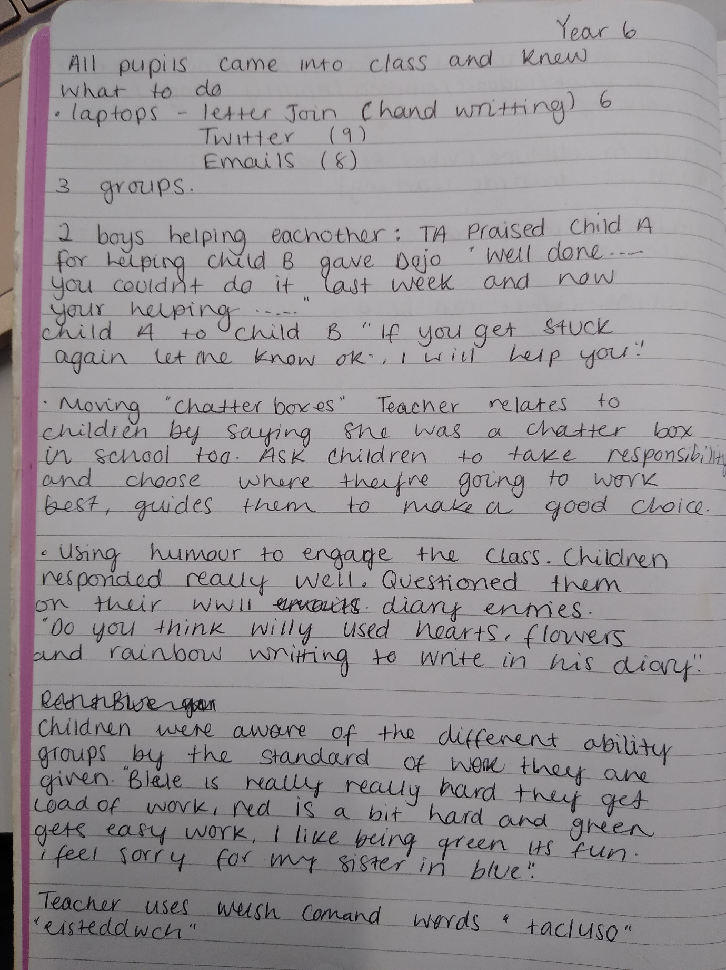
Appendices 2

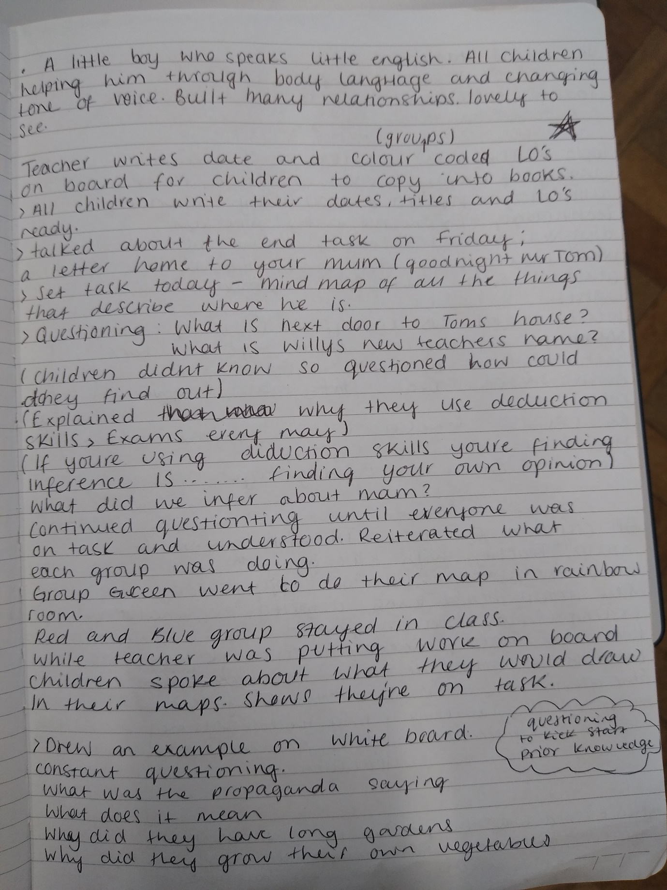
Appendices 3
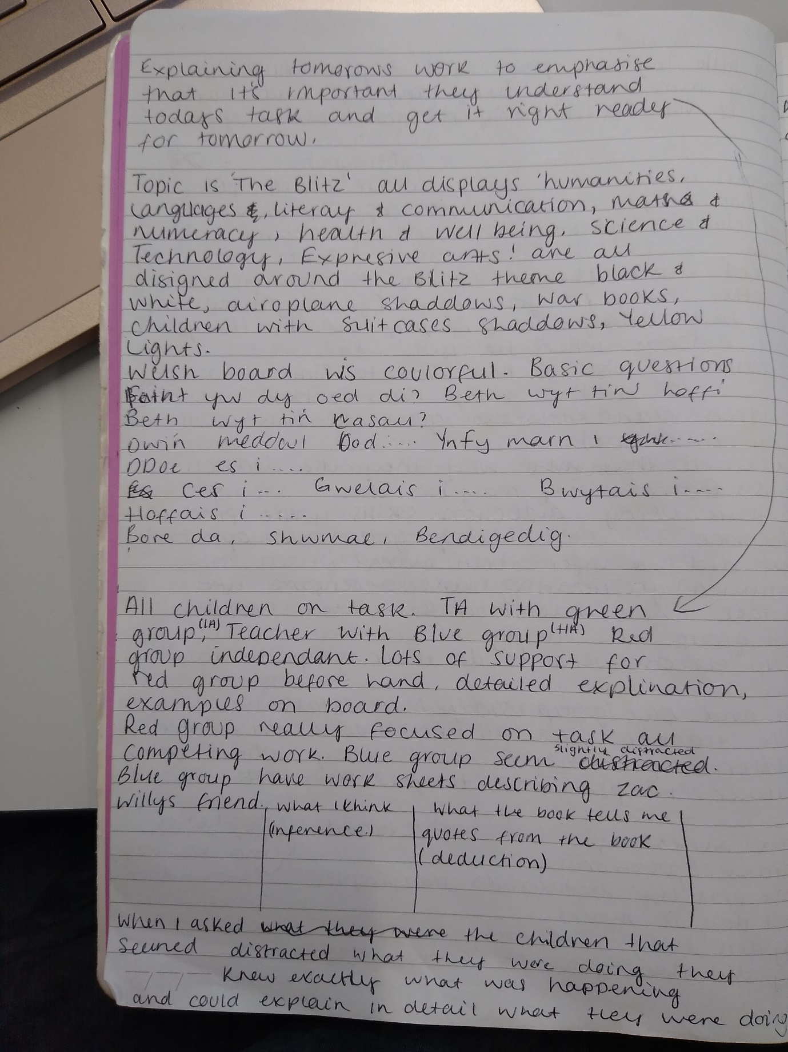
Appendices 4

Appendices 5

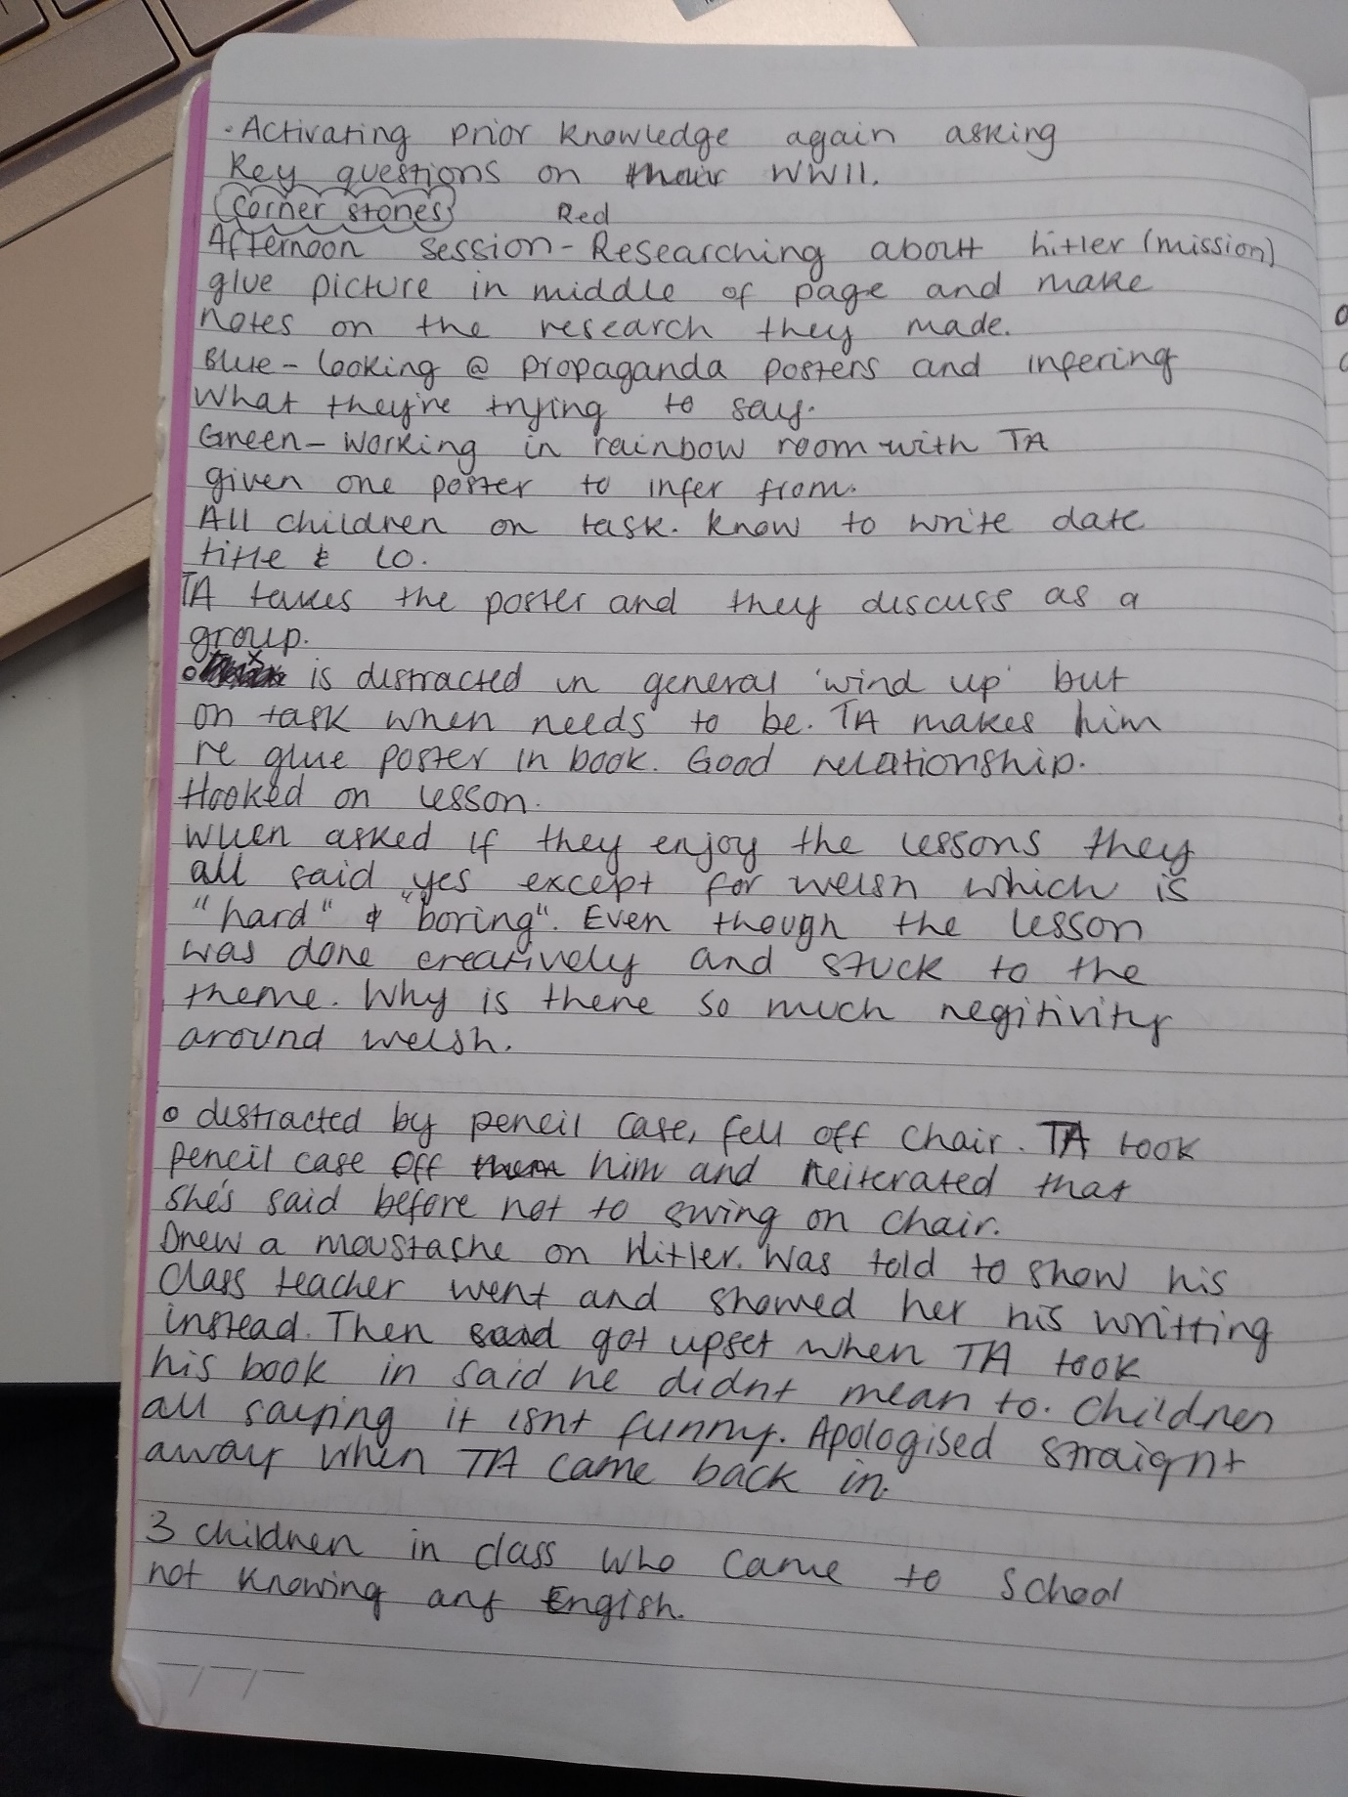

Appendices 6

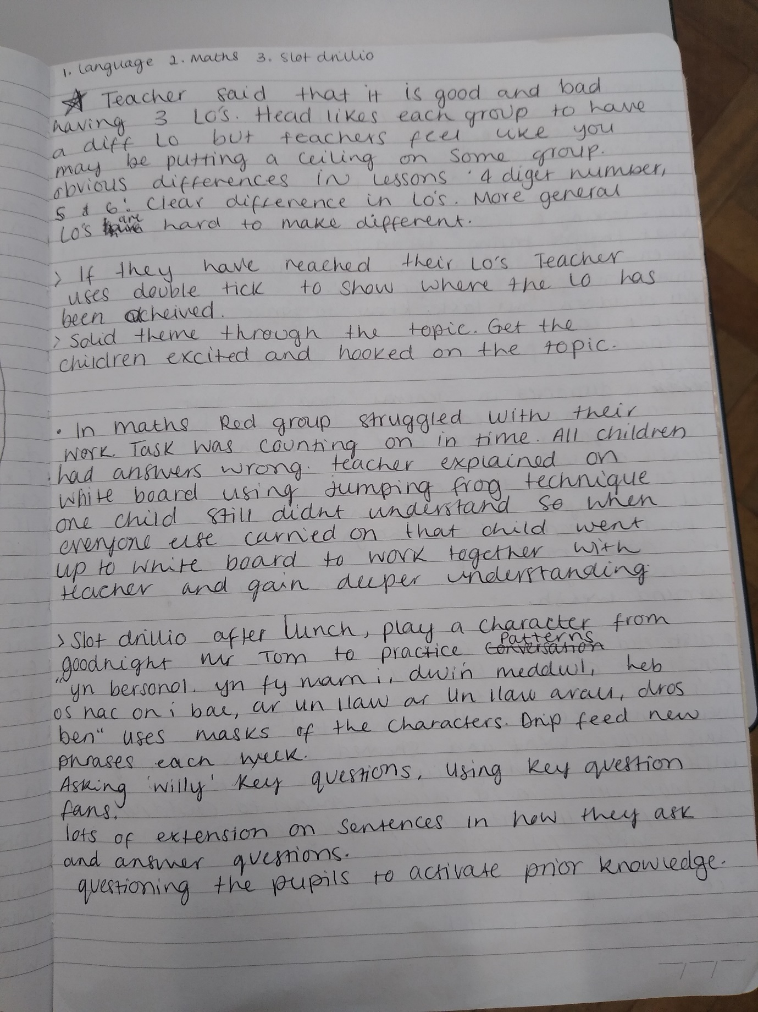
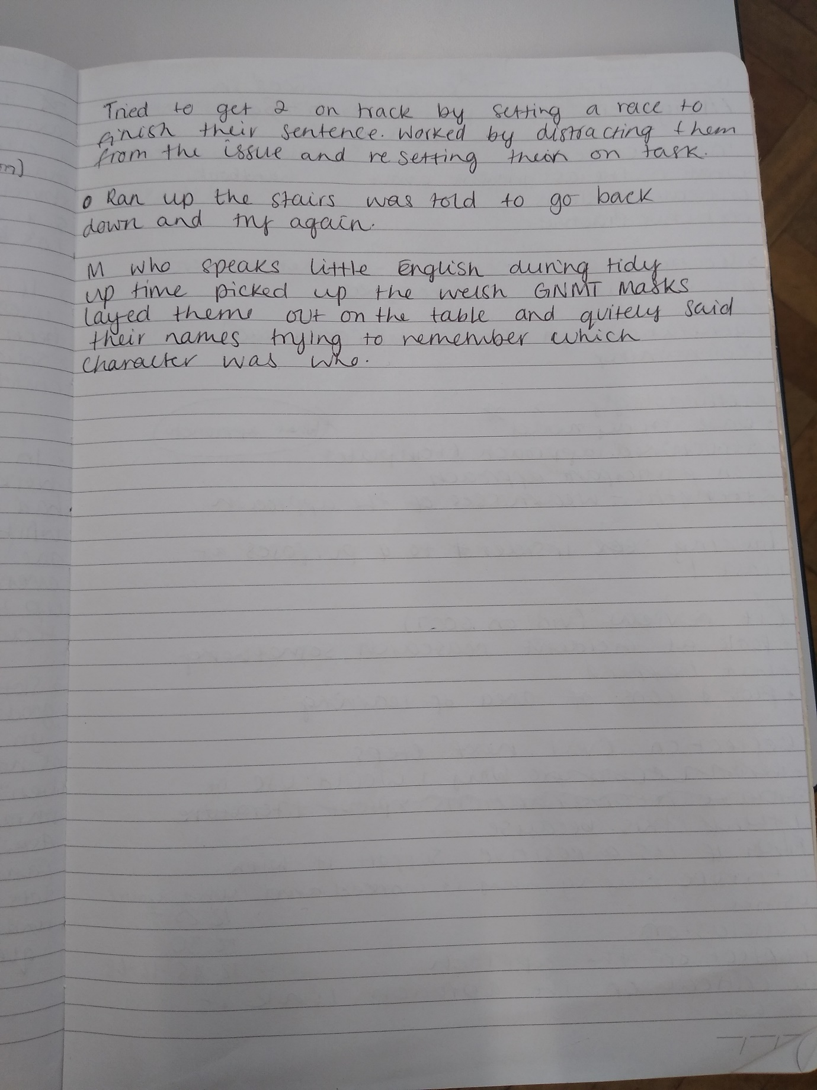
Appendices 7

Bibliography
British Educational Research Association [BERA] (2018) Ethical Guidelines for Educational Research, fourth edition, London.
Brookfield, S., 2017. Becoming A Critically Reflective Teacher. San Francisco: John Wiley and Sons inc.
Cambridge-community.org.uk. 2020. Getting Started With Reflective Practice. [online] Available at: <.https://www.cambridge-community.org.uk/professional-development/gswrp/index.html#:~:text=Each%20model%20of%20reflection%20aims,'%20and%20the%20'thinking'.&text=David%20Kolb%2C%20educational%20researcher%2C%20developed,and%20ideas%20from%20an%20experience.> [Accessed 18 October 2020].
Cowley, S., 2018. The Ultimate Guide to Differentiation: Achieving Excellence for All. Bloomsbury Publishing Plc.

Dudley,E., Osváth, E., 2016. Mixed Ability Teaching - Into the Classroom. Oxford University Press.

Finlay, L., (2008). Reflecting on ‘Reflective practice’. Practice-based Professional Learning Paper 52, The Open University
Fusco, E,. 2012. Effective Questioning Strategies in the classroom: A Step-by-step Approach to Engaged Thinking and Learning K-8. Teachers College Press.
Dewey, J., 1960. How We Think. Library of Alexander.
McLeod, S., 2015. Observation methods. Simply Psychology. <https://www.simplypsychology.org/observation.html> (Accessed 17/10/2010)
Morgan, S., Pullon, S., Macdonald, L., McKinlay, E. and Gray, B., 2016. Case Study Observational Research: A Framework for Conducting Case Study Research Where Observation Data Are the Focus. Qualitative Health Research, 27(7), pp.1060-1068.
Rogers, C., 2002 Defining Reflection: Another Look at John Dewey and Reflective Thinking. Teachers College Record.
Tripp, D., 1993. Critical incidents in teaching: developing professional judgement. London: Routledge.
Tripp, D., 2011. Critical Incidents In Teaching (Classic Edition). Hoboken: Taylor & amp.

Tomlinson, A, C., 2014. The Differentiated Classroom: Responding to the Needs of All Learners (2nd Edition). Library of Congress Catalogue In Publication Data.

University of Greenwich., 2010. Compass: The Journal of Learning and Teaching at the University of Greenwich. Issue 1. Educational Development University of Greenwich.

Worley, P., 2019. 100 Ideas for Primary Teachers: Questioning. Bloomsbury Publishing Plc.

