ACADEMIC AND EMPLOYABILITY SKILLS

Student Name: Liviu-Petrica Schipor
Student Number: 1909070
Module Name: Academic and Employability Skills
Module Number: BMSW4001
Lecturer Name: Anita Nan
Date: 25.08.2020

Table of Contents

INTRODUCTION ……………………………………………………………………………………………….3
GIBBS REFLECTIVE CYCLE ………………………………………………………………………………...4
KOLB’S EXPERIENTIAL LEARNING CYCLE ……………………………………………………..……6
DRISCOLL’S MODEL ………………………………………………………………………………………….8
CONCLUSION ……………………………………………………………………………………………......10
REFERENCES ……………………………………………………………………………………………………11

INTRODUCTION

The academic and employability skills are essential for effective working at the workplace as various skills are required to perform the task and activities of the organisation well and help in achieving the goals of the company. The academic and employability skills include various skills like critical thinking, decision making, oral and written communication and many ore that help the employees to enhance their performance and productivity by effectively utilizing the skills. The skill of employment are essential to bring effective performance which leads to the growth of the company as well as personal development of the employees.
The report focuses on the reflective learning that I learned while working in the Marriott hotel using models of reflection. While working at the hotel I learned various things that are very useful for me in my personal as well as professional development. Working in Marriott hotel was good experiences and this report focuses on my learning which helped me in improving my working and experiences that I can utilize in future my growth and development (Bhagra and Sharma, 2018).

GIBBS REFLECTIVE CYCLE

Gibbs's reflective cycle is very effective to reflect my learning at the workplace and reflect my experience of working at the Marriott hotel.
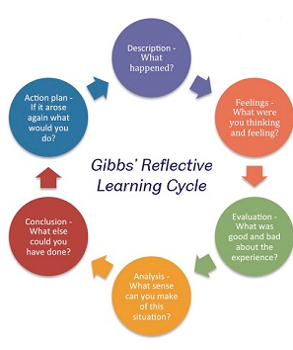
Figure: Gibbs model
Source: (Vasyukov and Zaitseva, 2016)
DESCRIPTION
When I started working in the Marriott hotel at first I was very nervous as I didn't work in such a place before. While working over there I interacted with various people like my seniors, colleagues, and customers and learn to interact with others effectively. At my work, I utilize my academic learning and also learned new things while interacting with the customer.
FEELINGS
I was feeling great to become part of a leading hotel as the platform provided me various opportunities to learn and I enjoyed my work as the work environment of the hotel is very effective. Working in the Marriott hotel provided me an understanding of the world of work to serve the needs of the customers (Vasyukov and Zaitseva, 2016).
EVALUATION
At the starting of my work at the Marriott hotel, I have some bad experience because the working environment was new for me and I faced some difficulties in understanding my work. Working with others was difficult for me at starting because everyone has different styles, attitude, and opinion and which result in a lack of coordination. But after some time when I learned the work and understand the working style of others I started enjoying my work. One good experience is that I learned to paraphrase over there as all the employees and superiors used to make use of new words retaining the original meaning. I was of paraphrasing but I didn’t make use of this very effective previous before working in Marriott and I also started practicing the paraphrasing which improved my communication (Roy and Grangier, 2019).
ANALYSIS
Working in the Marriott hotel made me experience the working-life and work management. In my work, Things go well because of some of the employability skills that I already have which I used in my working. In starting when I faced some difficulties due to lack of some skills than I searched through some literature on employability skills and I learned critical analysis to manage the work. Once when I searched about it I started observing my seniors who use this well and I experienced effective use of this analysis as I also started questioning and learning with an open mind to resolve any problems (Cottrell, 2017).
Another thing that I learned is analytical thinking as in my working I used to break down the complex information of the customer into smaller parts to satisfy their needs for which I needed analytical thinking. I learned this skill by my seniors who always used to involve in solving complex problems and I also learned to solve the problems efficiently which helped in effective working (Nuroso et al., 2018).
CONCLUSION
I learned to make effective utilization of information to perform the task and also observe the working of others to learn new things to manage the work. Moreover, I will continue to work on my skills to enhance my strength. Lastly, I learned to work with the people while maintaining coordination in working and learn to adopt a new style as per the requirements.
ACTION PLAN
When I will work in such an environment next time, I will talk with my seniors first about the working and skills that I needed to perform the job. I will talk with my colleagues to understand them in the first meeting by using my paraphrasing skills which gives a better impression on them so that I will work with them effectively. I will make use of my learning and experiences of current working to avoid any complex situation and I will make effective use of analytical and critical thinking if I have to deal with the complex problems. I am confident that this work experience is enough to manage my work effectively in the future (Vasyukov and Zaitseva, 2016).

KOLB’S EXPERIENTIAL LEARNING CYCLE

Kolb's model is to create a learning cycle that values the process and ongoing nature of learning and highlights the importance of the components of reflection in the learning cycle.
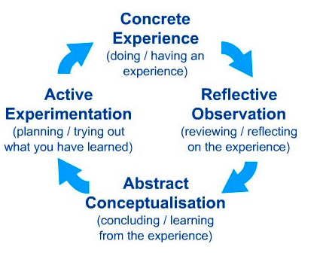
Figure: Kolb’s model
Source: (Morris, 2019)
CONCRETE EXPERIENCE
My working in the Marriott hotel gives me new experience as that is the first time I worked in such organisation where I experience both good and bad situations and learned various new things that will be helpful in my work. While working at the hotel I faced some difficulties in starting due to lack of understanding about the work and lack of some knowledge and skills. But while working over there I learned to manage my work and learn to work effectively with others. Consumer satisfaction is the first priority in Marriott for which I have to provide them their required things on time. For my effective working, I need to timely manage all my tasks as I already used to work on time but large number of work created difficulty in managing work on time. While working in a hotel I enhance my time management by observing my colleagues and seniors who always used to perform their tasks on time. By adopting their style I also learned to effectively complete my all work on time by scheduling each work on the basis of urgency and this time management helped me in my effective working at the hotel (Tsitskari et al., 2017).
REFLECTIVE OBSERVATION
In my working, I perform various tasks and learn to manage the new task, as to work in Marriott hotel different employability skills like communication, interpersonal, personal, numeracy and general skills are required and I already had some knowledge of all these skills that helped me to perform my task well. While working I enhanced all my skills as I used to communicate with others and build networks with the customers to understand them. In starting I observed the way my senior communicate with us or with the customers and adopt their style which leads to improvement in my skills. I had done my job well by utilizing my skills and continuously learning by working with my subordinates and I had good experiences of working in Marriott (Morris, 2019).
ABSTRACT CONCEPTUALISATION
While working at the hotel I had to learn too many things to manage my work effectively and for which I analyzed my personal skills and find that in which skills I am lacking behind and needed to improve so that I perform well. For this, I made a development plan to enhance my working styles, skills, and ways. I worked on that plan and took the guidance and support of my seniors to learn new skills that helped me in performing my job well. I made a plan and work on it according to the required time and using resources like reviewing literature for employability skills, observing the working of others, inviting feedback, etc. that helped me in improving my working. Overall I engaged myself in improving my working by observing the others, excepting new tasks, and putting my efforts to perform the job well (Morris, 2019).
ACTIVE EXPERIMENTATION
The development plan that I made for myself helped me in improving my skills and provided me new styles of working which I effectively used in my work. While working I used to discuss my problems with my seniors openly so that I get resolve them on time and learn how they tackle the problem easily which motivated me to adopt critical analysis to deal with any problem of working. At Marriott hotel, I learned to deal with the customers and experienced the importance of customers and their satisfaction that helped me in achieving the objective of my work as I used my paraphrasing and critical analysis to resolved customer problems and provided them good experience (Omer et al., 2017).

DRISCOLL’S MODEL

This model is based on asking questions to oneself to analyze the experience and learning. This model gives me a clear idea of my learning. The model is based on stages of what, so what and now what (deBraga et al., 2019).
WHAT
When I started working in Marriott hotel my purpose is to learn and grow myself in the field of professional working. While working various things happened with me as in starting when I was unclear about by working and ineffective in my work I faced many problems. My superiors guided me throughout my work. I saw that all the employees over there had various employability skills and I also staring learning new skills and enhancing my existing skills by working with others. I learned the skills of summarizing to make someone clear about the information who hasn’t read the orginal. Summarizing skills enhanced my writing skill as well and through effective summarizing I am able to create condensed version from a lot of information by covering its main point which helped in providing clear and accurate information. I learned to set smart goals for my effective performance as my seniors set clear goals that are measurable and reliable and by using their style I learned to set my personal goals to manage my work effectively. Along with this, I experienced dealing with consumer problems by observing the behavior and working of my seniors that how they resolved the consumer problems (deBraga et al., 2019).
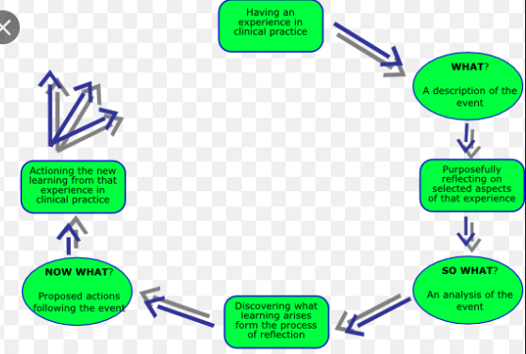
Figure: Driscoll’s model
Source: (Smith, 2016)

SO WHAT
While working when I was less confident in starting due to fear of a new work environment, lack of skills, and working with new people. But as time passed I adjust myself in the work environment and I feel great to be a part of a leading hotel. Now, I feel that I enhanced my skills and I am able to manage my work. I was scolded by my manger in starting due to mismanagement in my work and the manager advises me and provided me guidance to effectively manage the work. I had a different experience while working in Marriott hotel I learned to manage my work, time, enhanced my personality, and build a strong relationship with my colleagues and seniors (Smith, 2016).

NOW WHAT
While working I experienced that I need to improve my time management, interpersonal skills, critical thinking, and analytical thinking for performing my job well as well as for my personal development. In my work, I observed the way my colleagues, seniors, superiors, and manager deal with any situation, resolve the problems of customer and organisation, the way they manage their working all these motivates me to learn and improve my skills. In future if I get chance to work in a similar situation I will make use of learning and working experience of Marriott to provide effective service to the customers, I will manage any problems well in future by utilizing my analytical and critical thinking by making effective use of information and analyzing the reason of any problem to resolve it effectively (deBraga et al., 2019).

CONCLUSION

The reflective report presented my working experience and learning in the Marriott hotel. Gibbs's reflective model, Kolb's model, and Driscoll model is presented in this report which reflects my working experience, learning, the problems I faced in my working and action that I will be going to adopt in my future work to make my work more effective. The reflective report presented my learning of new skills such as critical thinking which helped in effective decision making and effective problems solving by analyzing the problems and proving all the possible solution to resolve the problem, paraphrasing and summarizing enhanced my writing skills, time management helped in performing all my task on time and learning this skills helped in my growth. The overall report presented my working experience in the Marriott hotel and the skills that I learned while working over their which helped me my personal and professional growth. By making use of the learning from the Marriott hotel and my working experience I can enhanced my working in future and this learning will help in further growth and development.

REFERENCES

Bhagra, A. and Sharma, D.K., 2018. Changing paradigm of employability skills in the global business world: A review. IUP Journal of Soft Skills, 12(2), pp.7-24.
Cottrell, S., 2017. Critical thinking skills: Effective analysis, argument and reflection. Macmillan International Higher Education.
deBraga, M., Sonne de Torrens, H. and Evans-Tokaryk, T., 2019. Reflective Practice–A Model for how best to implement it?.
Morris, T.H., 2019. Experiential learning–a systematic review and revision of Kolb’s model. Interactive Learning Environments, pp.1-14.
Nuroso, H., Siswanto, J. and Huda, C., 2018. Developing a learning model to promote the skills of analytical thinking. Journal of Education and Learning (EduLearn), 12(4), pp.775-780.
Omer, S., Choi, S., Brien, S. and Parry, M., 2017. Log in to Experiential Learning Theory: supporting web-based faculty development. JMIR medical education, 3(2), p.e16.
Roy, A. and Grangier, D., 2019. Unsupervised paraphrasing without translation. arXiv preprint arXiv:1905.12752.
Smith, K., 2016. Reflection and person-centredness in practice development. International Practice Development Journal, 6(1).
Tsitskari, E., Goudas, M., Tsalouchou, E. and Michalopoulou, M., 2017. Employers’ expectations of the employability skills needed in the sport and recreation environment. Journal of hospitality, leisure, sport & tourism education, 20, pp.1-9.
Vasyukov, V.N. and Zaitseva, A.Y., 2016, June. Segmentation of textured images described by hierarchical Gibbs model. In 2016 11th International Forum on Strategic Technology (IFOST) (pp. 452-455). IEEE.

