COMPONENT 2: PRACTICAL: REPORT
Name of the student: Diana Sharbanova

Student’s ID:2131741
Module code: LCBB5001
Module Title: Entrepreneurship
Lecture: Mohammad Rahman

Executive summary
The report provides an overview of entrepreneurship as a skill. First, the business idea has been discussed along with the motivational factors that led to the choice. Next, five entrepreneurial skills have been described along with the reasons as to why they are important for business. An evidence based self-assessment has been done through a SWOT analysis and an Individual Skills Audit to illustrate the skills needed to become an entrepreneur. Finally, extensive market research has been done to analyse the PEST factors of the consumer goods industry in the United Kingdom.

Contents
Introduction 4
Evaluation of my business idea and the motivational factors leading to my choice 4
Identification and explanation of five entrepreneurship skills, traits, and behavior, and why these are important for business 6
Evidence-based self-assessment to Become an entrepreneur 8
Extensive market research including PEST analysis of the UK 11
Conclusion 12
References 13

Introduction
The report will provide an overview of entrepreneurship. First, it will evaluate my business idea and the motivational factors leading to the choice. Five entrepreneurship skills will then be explained with a discussion of why they are important for business. Subsequently, an evidence-based self-assessment will be done in which there will be a skill audit and a SWOT analysis. Finally, extensive market research will be done including a PEST analysis of the United Kingdom. The report will help the reader to evaluate their knowledge of entrepreneurship, apply the methods and techniques for the same, and apply their understanding to carry out a Business Plan.

Evaluation of my business idea and the motivational factors leading to my choice
My business idea to open a consumer goods company called Thamestech Innovations in the UK can be evaluated by assessing its strengths and challenges.
Strengths:
- Integration of innovative technology: Thamestech Innovations is unique because it aims to combine advanced technologies into consumer goods, offering premium and advanced products (Teece, 2020).
- Focus on sustainability: The emphasis on eco-friendly practices matches with the growing demand of consumers for environmentally conscious products.
- Digital Wellness Solutions: The company will address digital wellness needs which shows that it understands contemporary consumer concerns.
- Community Engagement: The company aims to engage the community through events to gain customer loyalty.
- Personalization and customization: The company aims to provide personalized products improving the brand's appeal.
Challenges:
- Competition: The company will face intense competition from established technology and lifestyle brands and needs to adopt effective differentiation strategies.
- Capital requirements: Thamestech Innovations will need substantial funding which is a challenge (Flores et al., 2020).
- Supply Chain Management: Adopting a sustainable supply chain will bring logistical challenges.
The motivational factors leading to this choice of mine are:
- Drive for entrepreneurship: I possess a strong entrepreneurial spirit which drives the desire to create and establish a successful business in the consumer goods sector.
- Passion for Innovation: I am passionate about combining technology with consumer goods and believe in its positive effect on consumers (Hernandez‐Ortega and Ferreira, 2021).
- Desire to attend to consumer needs: I identify the changing consumer needs and intend to focus on personalized experiences and digital wellness.
- Commitment to sustainability: I am committed to environmental sustainability and want to use sustainable practices to serve the consumers.
- Vision for a unique brand: I possess the aspiration to create a unique brand because it combines technology, personalization, and sustainability (Kim et al., 2020).
- Motivation for community engagement: I want to create a community that is positively impacted by the goods of the company.

Figure 1: Motivational factors for my choice
(Source: Kim et al., 2020)

Identification and explanation of five entrepreneurship skills, traits, and behavior, and why these are important for business
The five entrepreneurship skills are explained below:
- Creativity and Innovation: The consumer goods market is highly competitive. Therefore, innovation and creativity are vital for Thamestech Innovations to constantly develop its technology-integrated products and stand out to its customers.
- Flexibility and adaptability: The consumer goods industry is subject to changing customer demands and preferences. Thus, the entrepreneurial success of Thamestech Innovations will be possible only with the ability to adapt to technological advancements, changing customer needs, and market shifts.
- Customer-centric mind frame: Adopting a customer-centric mind frame will ensure that the company offers products that match the target audience's expectations and lead to customer loyalty and satisfaction, and positive brand perception (Addis, 2020).
- Strong networking and communication: Constructing and maintaining positive relationships is crucial for the consumer goods industry. Strong communication skills will help in brand building and customer engagement through effective marketing strategies. Networking with retailers, suppliers, and stakeholders will allow strategic collaborations.
- Effective decision-making and risk management skills: Entrepreneurship is not free from risks (Williams et al., 2021). Effective decision-making and risk-management skills are vital for Thamestech Innovations to withstand uncertain circumstances. Evaluating the potential risks, making correct decisions, and adopting strategies after conducting market feedback will help in making the business resilient and successful in the long run.
These entrepreneurial skills and traits are important because of the following reasons:
- To gain a competitive edge over its rivals: Innovation and creativity will give Thamestech Innovations the ability to constantly offer new and technologically advanced products. This novelty will give the company a competitive advantage over its potential rivals in the market and make it stand out to its customers.
- To gain resilience in the market: Adaptability and flexibility will help the company withstand changes in the consumer goods industry and stay resilient and relevant in the market. The company can pivot in case of necessity.
- To gain customer loyalty: Adopting a customer-centric mind frame will make sure that the products are in alignment with the changing consumer needs and preferences, and encourage customer loyalty and positive word-of-mouth marketing (Fornell et al., 2020).
- To improve brand influence: Strong networking and communication skills will increase Thamestech Innovations' brand influence by encouraging partnerships and collaborations and expanding the overall market reach. It will lead to positive brand perception among consumers.
- To mitigate risks in case of unforeseen circumstances: If the decision-making process and risk management capacity of the company are effective, it will prevent the company from experiencing potential dangers and contribute to the long-term success and prosperity of the company (Dias et al., 2021).
Therefore, the skills and traits mentioned are necessary for the company to not only exist in the competitive consumer goods market, but also to ensure that it remains customer-focused, innovative, and resilient in case of challenges.
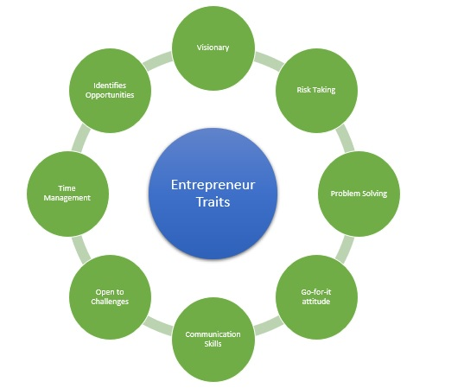
Figure 2: Importance of Entrepreneurial Skills
(Source: Dias et al., 2021)

Evidence-based self-assessment to Become an entrepreneur
SWOT Analysis
Strengths (My advantages)  - Innovative vision  - Passion for sustainability  - Drive for entrepreneurship  - Tech-savvy background  - Customer-focused approach | Weaknesses (Areas for improvement)  - Financial limitations can be improved through funding initiatives and effective financial planning.  - Limited business experience which can improve through mentorship or partnering with experienced professionals.
Opportunities (Situations to apply my advantages)  - Satisfying the increasing consumer demand for sustainable and technology-integrated products  - Forming partnerships and collaborations with retailers and technology providers | Threats (Where I am at risk)  - Intense competition from established rivals  - Economic downturns  - Fast-paced  technological advancements
Table 1: SWOT analysis
(Source: As created by the author)
Individual Skills Audit
Skills I have | Example from personal life or university
Creativity and innovation | I developed and worked on a new product idea during a personal project
Technology Proficiency | I created and managed an E-Commerce website for a small online business
Interpersonal Skills and Communication | I led a workshop on product benefits for a local community
Customer focus | I received positive feedback in a customer service role for ensuring customer satisfaction
Skills I would like to improve | How? Example?
Digital Marketing | Enrolling in online courses on digital marketing. Example: Applying the knowledge to online campaigns for Thamestech Innovations
Negotiation skills | Taking negotiation courses and practicing negotiating deals. Example: Seeking feedback to refine negotiation skills for business collaborations
Leadership and team management | Attending leadership development programs. Example: Implementing team management strategies in the new company.
Table 2: Individual Skills Audit
(Source: As created by the author)

Extensive market research including PEST analysis of the UK
Recognizing the market threats, trends, and growth needs a lot of research. They may arise from political situations, micro or macroeconomics, competition, change in customer preferences, or popularity (Theseus, 2023). To get valid information, the researcher should review available information, take customer surveys, and discuss with experts in the industry. Keeping up with the trends and predicting what will come next would involve observing competitors' behaviors, conducting interviews and webinars by industry influencers, listening to the customers, preparing a long-term strategy for the products, and assessing and overlooking the maturity of the technology and network infrastructure in the selected market to comprehend digital product adoption readiness.
PEST Analysis of the UK consumer goods industry
The PEST analysis assesses the political, economic, social, and technological factors affecting the business in the consumer goods sector.
- Political factors: The UK has a stable political environment, providing a favourable setting for businesses (Fildes and Goodwin, 2021). Strict regulations and laws govern consumer goods in areas like environmental sustainability. Post-Brexit trade policies may affect export/import tariffs and procedures.
- Economic factors: The UK has a developed economy, but post-Brexit, global economic conditions, and uncertainties can affect consumer spending. Recent economic recovery patterns may present opportunities for targeted consumer goods.
- Social factors: Understanding the income levels, age groups, and cultural differences in the UK is important for comprehending consumer preferences. Trends in digitalization, sustainability, and health consciousness affect consumer preferences. Increasing focus on wellness and health affects product choices, creating scope for health-conscious consumer goods.
- Technological factors: Since the UK is technologically advanced, consumer goods with the latest technologies will prevail. E-commerce plays a significant role in the marketing and sales of products. Automation in manufacturing processes will improve efficiency but may need adaptation to changing workforce dynamics.
Considering these PEST factors will allow the company to meet with sustained success.

Conclusion
Therefore, the above report allows the reader to gain an idea about entrepreneurship. First, the business idea of Thamestech Innovations has been evaluated with the motivational factors leading to the choice. Next, five entrepreneurial skills have been discussed with the reasons why they are important. A self-assessment has been done using a SWOT analysis and an Individual Skills Audit. Finally, extensive research has been done on the UK consumer goods market along with a PEST analysis of the same. However, this report is not conclusive and further research will provide deeper insights into the concept and components of entrepreneurship.

References
Addis, M., (2020). Engaging brands: A customer-centric approach for superior experiences. Routledge.
Dias, G.C., de Oliveira, U.R., Lima, G.B.A. and Fernandes, V.A., (2021). Risk management in the import/export process of an automobile company: A contribution for supply chain sustainability. Sustainability, 13(11), p.6049.
Fildes, R. and Goodwin, P., (2021). Stability in the inefficient use of forecasting systems: A case study in a supply chain company. International Journal of Forecasting, 37(2), pp.1031-1046.
Flores, E., Xu, X. and Lu, Y., (2020). Human Capital 4.0: a workforce competence typology for Industry 4.0. Journal of Manufacturing Technology Management, 31(4), pp.687-703.
Fornell, C., Morgeson III, F.V., Hult, G.T.M. and VanAmburg, D., (2020). The Reign of the Customer: Customer-Centric Approaches to Improving Satisfaction. Springer Nature.
Hernandez‐Ortega, B. and Ferreira, I., (2021). How smart experiences build service loyalty: The importance of consumer love for smart voice assistants. Psychology & Marketing, 38(7), pp.1122-1139.
Kim, M., Yin, X. and Lee, G., (2020). The effect of CSR on corporate image, customer citizenship behaviors, and customers’ long-term relationship orientation. International Journal of Hospitality Management, 88, p.102520.
Teece, D.J., (2020). Hand in glove: Open innovation and the dynamic capabilities framework. Strategic Management Review, 1(2), pp.233-253.
Theseus, (2023). The growth of e-commerce and its impact on the fast fashion ... - theseus. Available at: https://www.theseus.fi/bitstream/handle/10024/148582/Cao_Hien.pdf?sequence=2 (Accessed: 21 November 2023).
Williams, A.M., Rodriguez Sanchez, I. and Škokić, V., (2021). Innovation, risk, and uncertainty: A study of tourism entrepreneurs. Journal of Travel Research, 60(2), pp.293-311.

Appendix
Presentation Slides
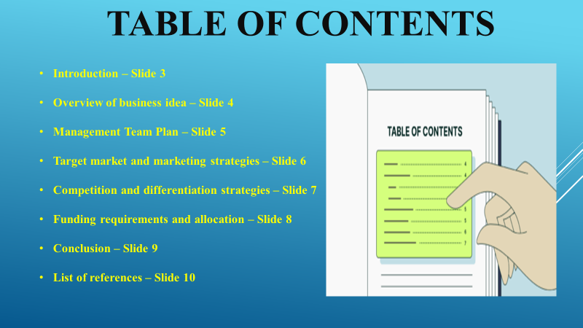
Introduction
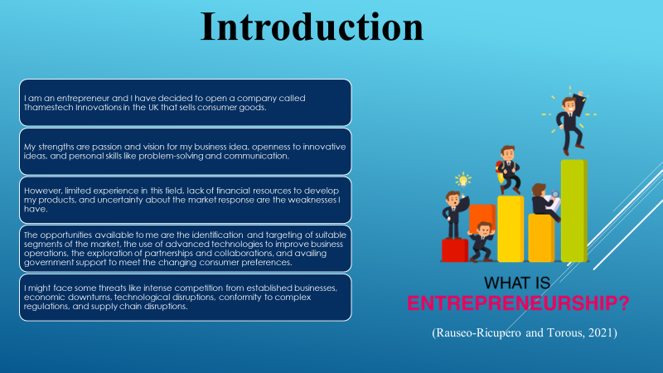

Overview of my business idea
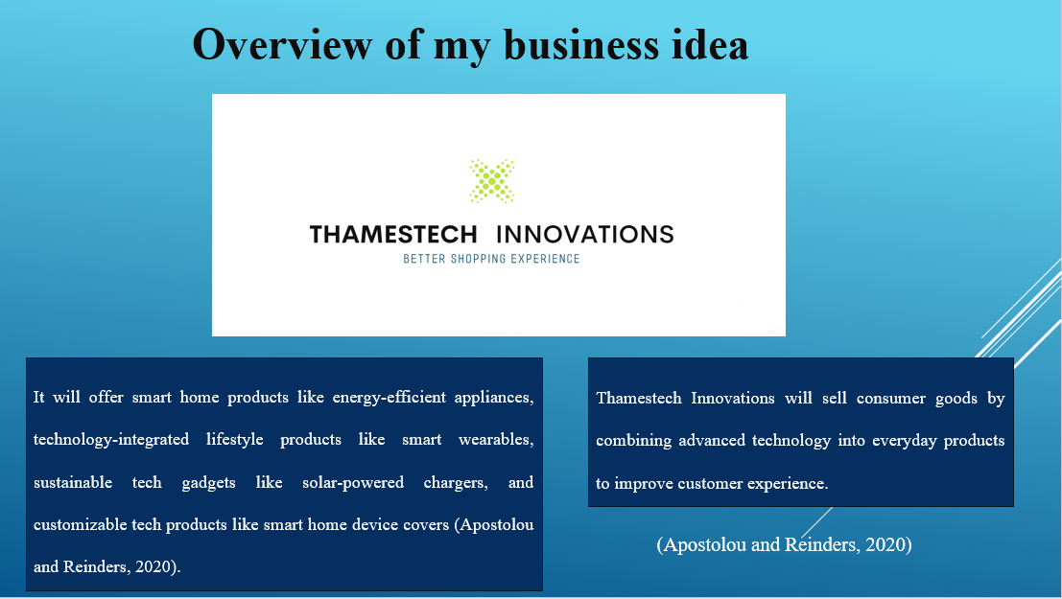

Management team plan
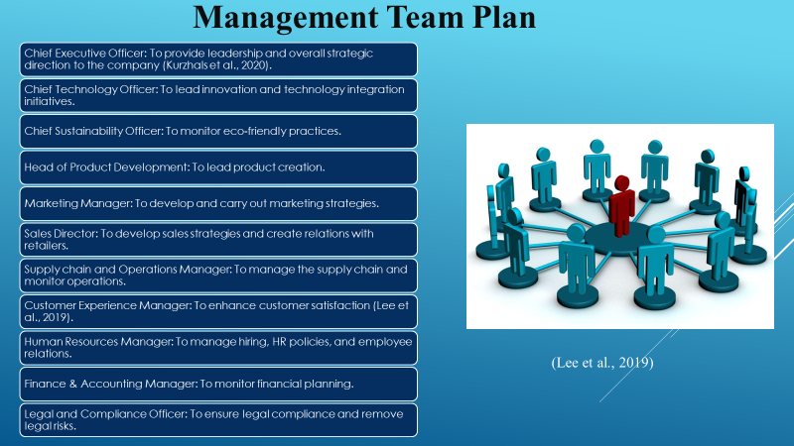

Target market and marketing strategies
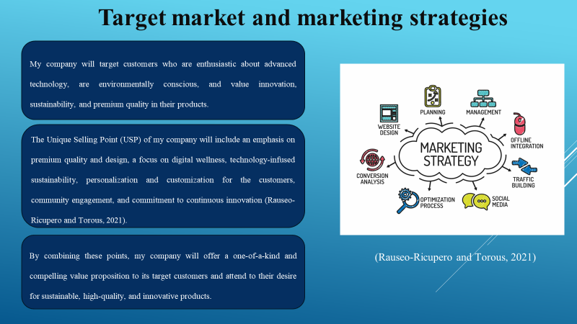

Competition and differentiation strategies
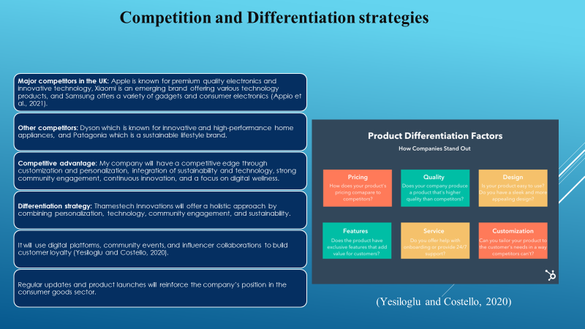

Funding requirements and allocation
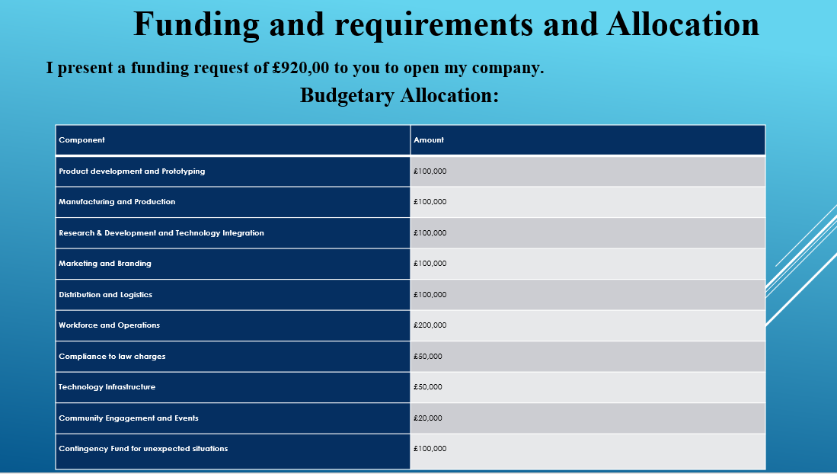

Conclusion
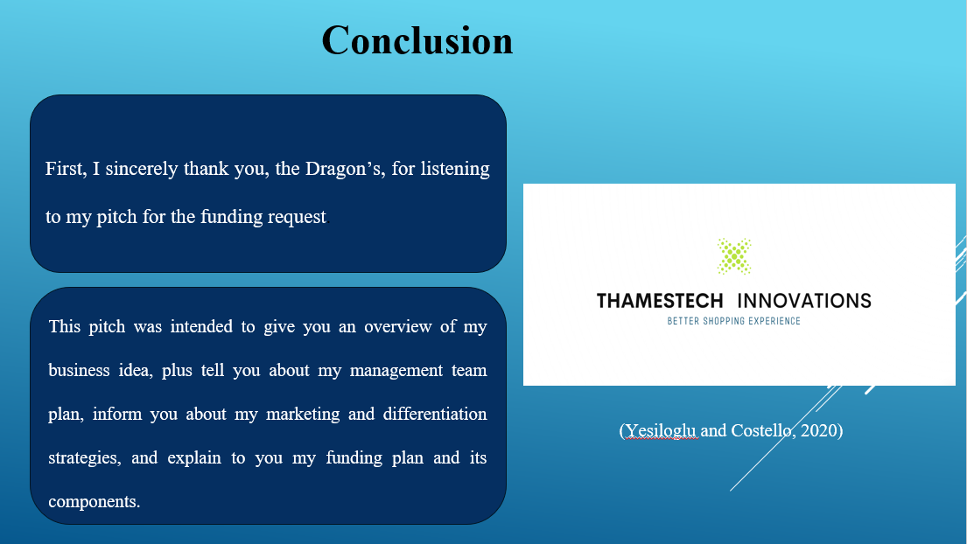

References


