Manufacturing Design & Technology

ACMA5002

Design for X Project

13th January 2025

Garin Mann

2115399

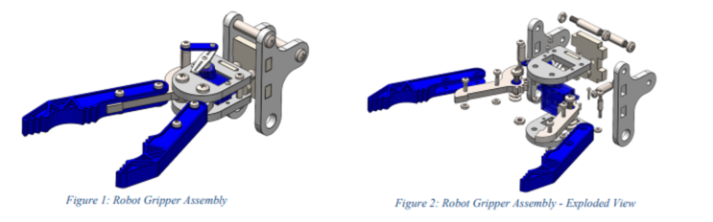

Contents
Introduction 3
Design Methodology 4
The Need 4
Design Brief 5
Clients 5
Product Design Specification 6
Concept Solutions 7
Design Isolation 9
Synthesis/Adaptation 9
Detail Design 9
Evaluation 9
Prototypes/Models 9

Introduction

As part of the Manufacturing Design & Technology module, I’ve been given an assignment that tasks me with redesigning the components/assembly for a robot gripper that has been produced in small volumes, and to enhance the design to allow it to be mass produced. The initial market research that was carried out suggests that production volumes of 1000+ units per week will be required to satisfy the demand of the customer.
Throughout the module I have learned numerous techniques that will allow me to carry out a successful redesign where I will take the following into account:
- Concept Design Appraisal.
- Manufacturing Process Proposal.
- Design & Development Work.
- Environmental & Product Life Cycles.
The Design Methodology diagram below was taken from one of Richard Morgan’s lecture slides that was taught throughout the MD&T module. I will be following parts of this design methodology to meet the points listed above. I feel that this format is easily applied and ensuring that all points of a successful redesign are touched upon in detail.

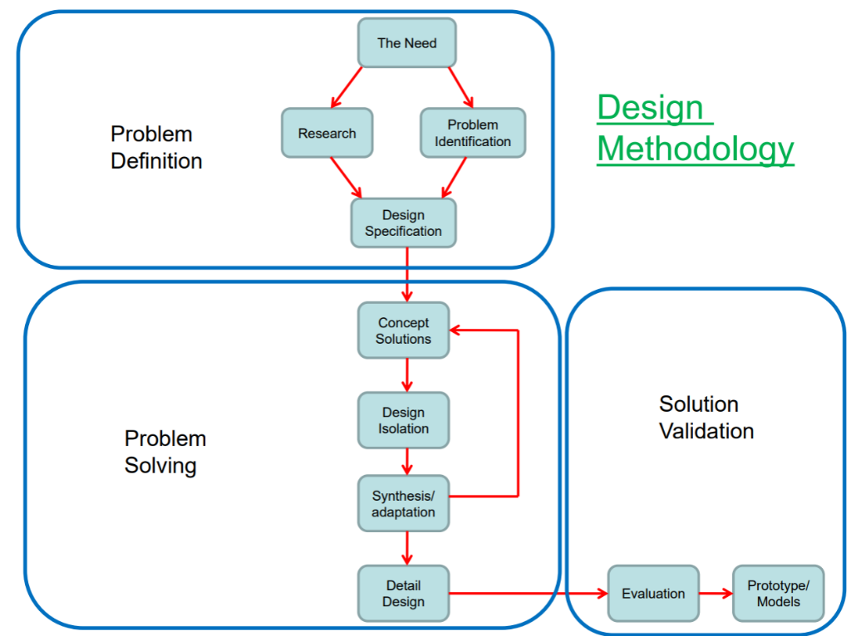

Design Methodology

The design methodology’s main purpose is to gather ideas through tools such as brainstorming. This allows the project supervisor to cover as many areas as possible with highlighting ideas from other suggestions along the way. The main outcome of this is to ensure that the project can be carried out to a high standard and that the combination of components can be added together where the prototype/model is completed.
The first task is to define what the problem is, this is going to be done by highlighting the need of the customer and then carrying out some research into identifying and improving the problem. The final part of this section will be the design specification, where I can target the customer’s needs and ensure that with the design specification that they are all met.
The second task is to then solve the problem, this is going to be done by producing some concept solutions, considering the design specification. I’ll then isolate the designs and then adapt them further if required. I’ll then detail the design so that it matches the customers’ requirements.
Finally, I’ll move onto the third stage where the solution will be validated and evaluated against the design specification and then produce prototypes/models on CAD to meet the requirements.

The Need

The need for this project has been highlighted in the brief of the assignment. “A robotic tooling manufacturer has commissioned you to undertake a review of one of their mechanical gripper solutions. Until recently, the gripper has been produced in small volumes, but the company has tasked you with redesigning the components/assembly for mass production. Initial market research has suggested production volumes of 1000+ units per week will be required to satisfy demand.
The initial design has already been generated (model files provided on Moodle). You are required to undertake further development work to consider and optimise the design efficiency and manufacturability of the gripper.”
From this is I can gather some vital information such as the initial designs and most importantly what the customer requires. The customer requires that the product can withstand production volumes of 1000+ units per week. This will be considered when producing the component.

Design Brief

Clients | UWTSD  Production & Maintenance employees at UWTSD
Designer | Garin Mann
The Problem | The problem that has occurred is that the robotic tooling manufacturer would like to increase the production volume of their gripper to meet the demand of their market that was identified in their research.
The Solution | The solution of the problem is going to be assessed and then implemented. I’m going to assess the current output of the machine and highlight where improvements can be made. The solution is going to make the process more effective and efficient.
End Goals | The end goals of the solution are:  - To design an improved gripper  - To apply with all H&S Regulations  - To keep the costings of the replacement low  - To improve unplanned maintenance downtime  - To remove as much human intervention as possible  - To ensure that the component doesn’t get unnecessarily damaged.
Target Market & Stakeholders | The target market for this project is the same as the clients. They are looking to integrate an improved collaborative robot into their production process.
Budget | The budget is going to be kept as low as practicably possibly without jeopardising the quality of the final product.
Completion Date | The project will be completed by the 13th January 2025.
Constraints | There are a few constraints with the project, they are:  - The product must be user friendly.  - The product must be light enough to safely move by means of manual handling.  - The product must have no burrs or sharp edges (Production & Maintenance Safety Requirements).  - The product must be able to fit into the production line with as little adjustments to the production line as possible.

Product Design Specification

Specification | Requirement
Price | Less than £1200 to manufacture and install  A relatively low maintenance cost based off of the initial cost.
Material Specification/Requirements | Readily available materials.  Environmentally conscious materials (Recyclable materials to be used wherever practicably possible).  Soft material to be used with contact to item being gripped to reduce damage of said part.  A rigid material which isn’t easily manipulated.
Work Environment | Material to be non-reactive to any lubricants/hydraulics.  Must be able to safely operate at room temperature and withstand any heat that’s induced during operation. (Specific temperature to be highlighted after the final design has been decided).
Maintenance | Readily available replacement parts (To be sourced upon agreement with supplier).  Breakdown timeframe to be no more than one hour per event, regular observations to be carried out during maintenance downtime to try and improve stoppages).
Durability | Must be practicably lightweight due to speed of operation, will be assessed during final choice of materials.  Will grip said component for desired operations with failures being kept to a minimal after rigorous testing.  Will release said component for desired operations with failures being kept to a minimum after rigorous testing.
Operational service | Spare parts to be readily available as mentioned previously.  Thorough inspection to be caried out before application as well as rigorous testing.

Failure Mode Effect Analysis

Failure Mode and Effect Analysis (FMEA) is a systematic approach used to identify potential failures in a design. Failure modes refer to the various ways failures or defects may occur in relation to customer needs, while effect analysis focuses on understanding the consequences of these failures. FMEA helps to prioritize which potential failures to address first by evaluating their severity, likelihood of occurrence and detectability. To be most effective, FMEA should be implemented by the early stages of the design and continue throughout the product life cycle.
The process begins by identifying the main functions of the process, such as picking up and transferring the components. After defining these functions, potential failure modes are identified and rated for severity on a scale from 1 to 10. Then, the causes of these failures are explored and rated on a scale of 1 to 10 based on the likelihood of the occurrence. Finally, the existing processes or controls are reviewed, and the detectability of these failures is rated. These three ratings are used to calculate the Risk Priority Number (RPN), which provides an overall score. A higher RPN indicated swich areas should be prioritized for improvement.

Severity Rating |  |  | Occurrence Rating |  |  | Detection Rating
10 | Critical |  | 10 | Certainty |  | 10 | Uncertainty
9 | Major |  | 9 | Very high |  | 9 | Very remote
8 | Very high |  | 8 | High |  | 8 | Remote
7 | High |  | 7 | High |  | 7 | Very low
6 | Moderate |  | 6 | Moderate |  | 6 | Low
5 | Low |  | 5 | Moderate |  | 5 | Moderate
4 | Very low |  | 4 | Low |  | 4 | Moderately high
3 | Minor |  | 3 | Very low |  | 3 | High
2 | Very minor |  | 2 | Remote |  | 2 | Very high
1 | None |  | 1 | Minor |  | 1 | Certainty

Attached to the Assignment submission is the FMEA filled out containing examples of the Process Function, with a FMEA table filled out highlighting the improvements that should be prioritized.
From completing the attached FMEA, the key areas that require extra focus are now clearly identified and will be prioritized when designing the product for the supplied brief.
The area that requires extra focus are “Cobot crashing” (Decreases production output and damaging the component), and “Misalignment” (Cobot crashing). All other aspects will be targeted with careful consideration. Eisner (2021) backs this up by suggesting that aspects with the hights servery score should be priorities first.

Ishikawa Diagram

An Ishikawa diagram is a tool used to clearly display a cause-and-effect analysis of a given problem, this type of analysis will enable an engineer to reveal the root cause of a problem or defects in a complex situation. According to Safety Culture (2022) the most effective times to use an Ishikawa diagram are:
- When identifying the root causes of a problem
- When brainstorming solutions to a problem
- When developing or improving a process
- When analysing data from customer surveys
- When evaluating the results of a marketing campaign
- When troubleshooting an issue with a product or service
- When planning future projects or initiatives
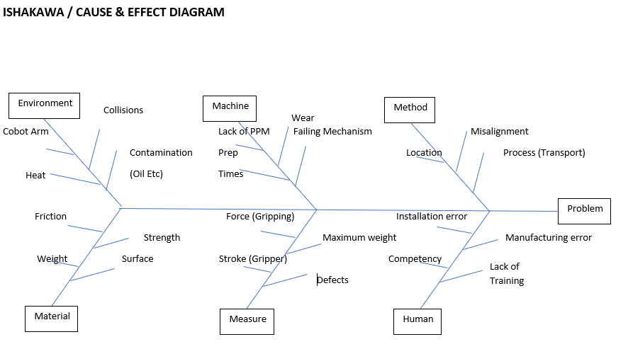
In this cause the Ishikawa diagram will be used to brainstorm solutions to a problem and developing and a process. this cause and effect diagram will allow root cause problems to be highlighted as well as display ideas clearly and effectively but organising complex information into an easy to understand diagram. It will also give a clear scope of the direction and future of the project.

The Ishikawa diagram is made up of six main headings as seen in figure 2, each heading has subheadings which are the possible causes. This diagram will show possible road blocks the gripper will face, each heading and subheading will need to be considered when designing the gripping mechanism, for example under “measure” the possible roadblocks the product might face are stroke of the gripper being insufficient, griping force being too high and damaging the phone or the end effector not being able to carry the required load.

Detail Design

Evaluation

Prototypes/Models

Task One – Robot Gripper Redesign (2500 words)
A robotic tooling manufacturer has commissioned you to undertake a review of one of their mechanical gripper solutions. Until recently, the gripper has been produced in small volumes, but the company has tasked you with redesigning the components/assembly for mass production. Initial market research has suggested production volumes of 1000+ units per week will be required to satisfy demand.

The initial design has already been generated (model files provided on Moodle). You are required to undertake further development work to consider and optimise the design efficiency and manufacturability of the gripper.

Your study should include the following areas:

Concept Design Appraisal
This should include the consideration of expected customer, and end-user needs, public perception and aesthetics. This could include the development of a Quality Function Deployment and the development of a design specification.

Manufacturing Process Proposal
This section should include references to business/company needs and cost drivers as well as an explanation and justification for the manufacturing processes selected for mass production.

Design and Development Work Undertaken
This should include any techniques or methods which you has used to generate new designs or features. You should also clearly document any design for ‘X’ evaluation techniques or considerations. These could include the application of assembly analysis techniques, SCAMPER, as well as any risk management techniques (such as Failure Modes Effect Analysis) that you have applied.

You should also document any environmental or product life cycle factors which you have considered.

Task Two – Design for Additive Manufacturing (2500 words)

The trend towards the growing utilisation of Additive Manufacturing (AM) processes has become apparent across a diverse range of industrial domains in recent years. Leveraging additive technologies, intricate design features and complex geometries can be achieved, overcoming the limitations of conventional subtractive and formative manufacturing methods. This increased design freedom has prompted many manufacturers to explore the potential optimisation opportunities facilitated by these technologies. This practice is commonly known as Design for Additive Manufacturing (DfAM).

Task Description
You are tasked with redesigning a component of your choice using Design for Additive Manufacturing (DfAM) tools/principles. The aim of this assessment is to evaluate your understanding of DfAM concepts and your ability to apply them effectively in a real-world design scenario. You should also identify an appropriate AM process and material selection for your case study, justification of your selections should be presented in a written report (2500 words).
You must carefully consider the choice of component for your case study; it should be sufficiently complex to effectively demonstrate a range of DfAM principles/concepts and design tools. It is recommended that you chose a component with which you have a baseline familiarity, such as an example from your discipline, workplace, previous projects, or a specific area of interest.
All design and development activity and any design tools or techniques used, including those used to digitally appraise your solutions, should be documented within your report. In addition, 3D solid models should be produced, using CAD software, to detail your final design. You may include (but are not limited to) the following tools/techniques:
- DfAM principles – component consolidation, internal structures (lattice or cellular), multi-material design, tessellation, mass customisation, build volume optimisation etc.
- Finite Element Analysis (FEA)
- Topology optimisation
- Generative design tools
- Design Failure Modes & Effects Analysis (DFMEA)
- Quality Functional Deployment (QFD)
You should aim to demonstrate a sound appreciation of the constraints imposed by the chosen AM process within your report. Where appropriate, you should consider factors such as:
− Anisotropy and inhomogeneity
− Shrinkage, porosity & distortion
− Residual stresses & stress concentrations
− Material & post-processing considerations
− Support structure requirements
− Cost & environmental implications
General Guidance:
1. Select a component that you believe could benefit from additive manufacturing techniques. 2. Analyse the existing design of the component and identify potential areas for improvement or optimization through the use of additive manufacturing.
3. Utilize CAD / CAE software to redesign the chosen component, taking into consideration its functional requirements, manufacturability, and performance enhancements.
4. Document the redesign process, including your rationale for design decisions, any challenges encountered, and the iterative steps taken to arrive at the final design.
5. Present your work in a written report that outlines the original component's limitations, the redesigned component's improvements, the potential benefits of additive manufacturing and an evaluation of the manufacturing feasibility.
Your work must be submitted via Turnitin (link available on Moodle)

Image 1 – Richard Morgan’s lecture slides (MD&T module).

