2021
Software Development
assignment 1
GRI19845230 (Dewi Griffiths)

Essential Knowledge 2
Variables 2
IF / Else Statements 2
Loops 2
Variable Demonstration – Program 1 3
Analysis for Success 3
Variables: Purpose of Declaration 3
Pseudo-Code 4
User Input Tests 5
Geometric Math – Program 2 10
Analysis for Success 10
Variables: Purpose of Declaration 10
Pseudo-Code 11
User Input Tests 12
Weekly Mileage Costs – Program 3 14
Analysis for Success 14
Variables: Purpose of Declaration 14
Pseudo-Code 15
User Input Tests 16
Matching Game – Exercise 4 17
Analysis for Success 17
Variables: Purpose of Declaration 18
Pseudo-Code 19
Main Program 19
Function: User Interface 21
User Input Tests 22
References 25
Appendix 26

Essential Knowledge
The following programs are developed using C#, a programming language developed by Microsoft using their .NET Framework Libraries [1] which aid programmers and app developers in creating applications.

Variables
A variable is one of the ways of storing data in most programming languages. The data stored in variables is text, numbers and instructions. Variables aid programmers in creating projects that require a memorable and efficient method of calling and manipulating data for generating outputs in their app.

Classic examples of explaining variables are to use a name and age. A name will most likely use a string as it is text, an age would most likely use a byte as it is a small number that will not yield the answer above its maximum value [2], this is due to the context or expected data size of the variable, this assists the CPU (Central Processing Unit and RAM (Random Access Memory) in freeing processing power and memory as the instructions are smaller. [3] This is why the purpose of the chosen variable and its data type is important to the programmer and their project. [Appendix 1]

IF / Else Statements
An if and else statement are used to carry out blocks of code based on the parameters given to the statement itself. These statements can contain equations and algorithms. IF statements are used for when decision making is required in the program.

An example can be the gender input of the user, their pronouns could be altered based on their gender, “Male”, “Female” and “Other”. Three if statements for each gender and an ELSE statement will be used if an incorrect input has been given for validation of the program. ELSE will be executed if none of the parameters have been met to utilise the defined IF statements.

An IF ELSE statement can be carried out after an IF statement which is not carried out due to the parameters not being met. Each IF ELSE statement is read and carried out if the parameters are met in a linear fashion. The IF ELSE statement below another may not be carried out even if the parameters are met due to the previous statement containing parameters which are met for it to be executed. [4] [Appendix 2]

Loops
Loops within a program are used to carry out instructions’ multiple times, this is useful for decreasing the number of lines of code, but at the cost of processing power. There are DO, WHILE and FOR loops which serve a similar result with a different purpose. Loop[ conditions are read every time the code is ran to check whether the requirements are met, depending upon the loop this is done at the start of the loop, during each iteration or after the code has been ran. [5]
A FOR loop is used to carry out a piece of code multiple times until its iteration requirements have been met. [Appendix 3]
A WHILE loop is used to carry out pieces of code until the statement parameters used to initialize is false. [Appendix 4]
A DO loop is a carried out once, and then the statement parameters are read, and if they are false the loop is exited.

Variable Demonstration – Program 1
For the completed program see [Appendix 5]

Analysis for Success
The program of which has been requested to be developed – with validation. The user’s name, age and height will need to be entered and shown at the end of the program without errors. Three variables are the minimum that is required to get this program working, two of them being numbers and one alphabetical.
The name variable will be assigned as a string, the age as an integer, and height as a float.
Possible invalid inputs for the name:
- Numbers.
- Whitespace.
- Overly long.
Possible invalid inputs for the age:
- Alphabets.
- Below zero.
Possible invalid inputs for the height:
- Alphabets.
- Below zero.
- Too high.
The validation will require one or two more variables to prevent the user from entering false values and displaying messages.

Variables: Purpose of Declaration
Variable Type | Variable Name | Example Input | Purpose
STRING | name | “John”, “Gabe”, “Abigail”, “Joe” | For storing the user’s input when being asked their name.
INTEGER | age | 19, 12, 23, 53 | For storing the user’s input when being asked their age.
FLOAT | height | 1.32, 2.0, 1.73, 1.5 | For storing the user’s input when being asked their height.
BOOLEAN | check | FALSE, TRUE | For assisting with data validation with keeping the user inside of the loop.
INTEGER | count | 0,1,2,3,4,5 | For assisting with displaying error messages.

Pseudo-Code
[START PROGRAM]
PRINT “What is your name?”
Name User Input # User prompt to enter their name.
While TRUE #While loop for validation.
If Name == “” or name == “ ” or name == nothing
PRINT “Please enter a valid name.”
End If
If Name length > 32
PRINT “First name is too long.”
End If
Else If Name contains any number
PRINT “Please do not use numbers as your name”
End Else-If
Else # If there are no errors
Exit loop
End Else
END OF LOOP
Check FALSE # Boolean type
Age 0
Count 0
While Check is FALSE
If Age <= 0
PRINT “Enter a value above zero please.”
End If
Else If Count > 0
PRINT “Do not use alphabetical characters please.”
Count - 1
End Else-If
Check FALSE # To keep the value false for the next loop if there are errors.
PRINT “How old are you?”
Age User Input
Count + 1
END OF LOOP
Height 0
Check FALSE
Count 0
While Check is FALSE or Height > 2.1
If Height > 2.1
PRINT “Enter a realistic value, please.”
End If
Else
PRINT “Do not use alphabetical characters, please.”
End Else
Check FALSE
PRINT “Enter your height in metres”
HEIGHT User Input
END OF LOOP
PRINT “Your name is [Name] who is [Age] years old and is [Height] metres tall.”
[END PROGRAM]

User Input Tests
Screenshot | Explanation
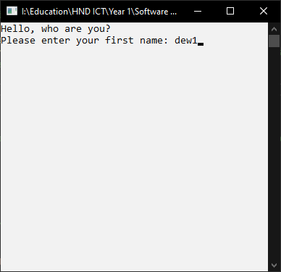 | User entering their name with alphabetical characters.
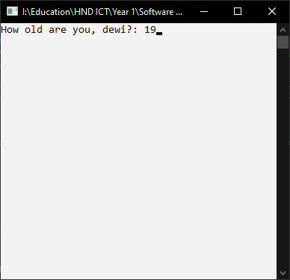 | After user has entered their name correctly their age is asked for.  The user enters 19 as their age.
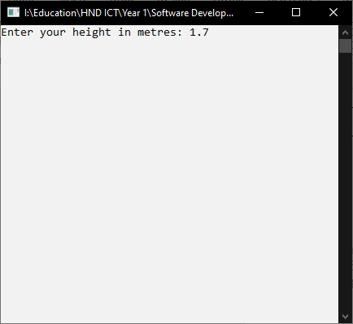 | This screen shows up after the user has entered their age.  The user has entered 1.7 as their height.
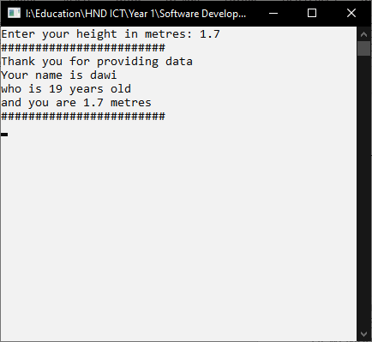 | This is the final screen after the user has entered their information correctly.
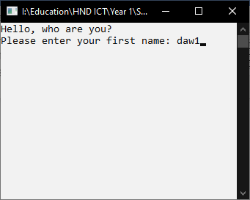 | This is the user running the program and entering “daw1” as their name.
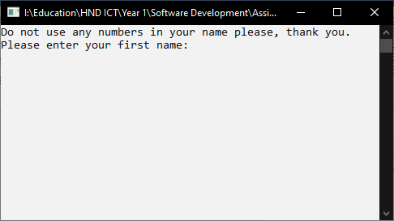 | This is the screen that shows up once the user has entered their name with a number.
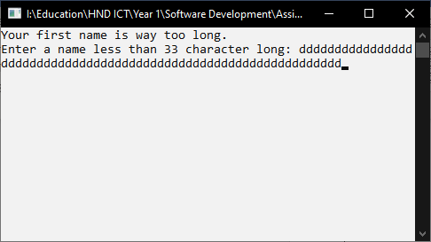 | This is the screen that shows up once the user has entered their name that is over 32 characters long.
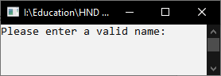 | This is the screen that shows up once the user has entered whitespace.
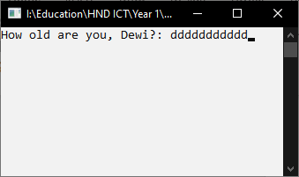 | This is a screenshot showing the user entering alphabetical characters as their age.
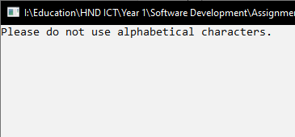 | This is what happens when the user enters an alphabetical character as their age.
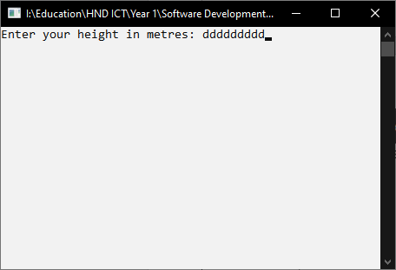 | This is a user entering alphabetical characters as their height.
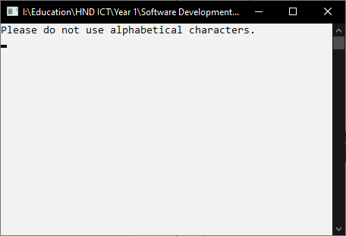 | This is what happens when the user enters alphabetical characters as their height.
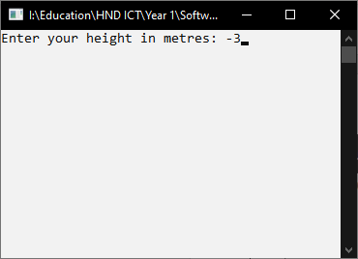 | This is demonstrating a user entering their height below the value 0.7 and 0.
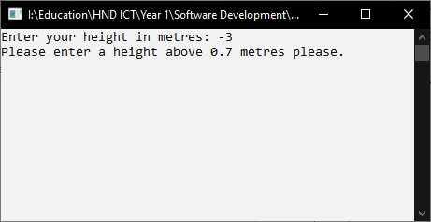 | This is what happens when the user enters a value below 0.7 or 0.

Geometric Math – Program 2
For the completed program see [Appendix 6]

Analysis for Success
This program requires the user to enter the radius of a circle and the side of a square along with the length and height of a rectangle. These objects are within the circle which take up space and reduces the size of the circle’s area / shaded area. This program is used to calculate the shaded area with the object’s areas being considered.
Most of the variables will be assigned as a double-type variable due to large numbers being possibly used which may require a decimal as their value. Other variables will be Boolean for data validation and a constant float for Pi as this is required for calculations.
Possible invalid inputs for the number type variables:
- Alphabetical characters being entered.
- Numbers below zero.
Possible invalid inputs for variables which are not related to the circle:
- The input must not be above the entered radius of the circle.
The validation will require only one extra variable known as the Boolean value to assist with loops.
The equation for working out the shaded area requires the area of the square and rectangle to be worked out, so these shapes should have their values entered after the circle has received its value. This avoids issues with validation.

Variables: Purpose of Declaration
Variable Type | Variable Name | Example Input | Purpose
CONST FLOAT | Pi | 3.14159 | For assisting with the equations regarding the circle’s area.
DOUBLE | radius | 4, 12, 6, 32 12.23 | For storing the radius of the circle.
DOUBLE | circle | 321, 184, 121.32, 3452, 96 | For storing the calculated area of the circle.
DOUBLE | squareSide | 6, 2, 12, 4.3, 5.2, 3 | For storing the side of a square.
DOUBLE | square | 24, 9, 52, 64, 13.5 | For storing the area of the square.
DOUBLE | height | 23.42, 12, 4, 6 | For storing the height of the rectangle.
DOUBLE | width | 7, 3, 2.53, 7.3, 3, 1.4 | For storing the width / length of the rectangle.
DOUBLE | rectangle | 43.23, 74.23, 23.4, 20 | For storing the calculated area of the rectangle.
BOOL | check | FALSE, TRUE | For assisting with data validation within loops.

Pseudo-Code
[START PROGRAM]
Pi 3.14159 # Constant variable
Check FALSE # Boolean variable.
Radius = 0
While Check is FALSE # Loop for validation.
Check FALSE
PRINT “Enter the circle’s radius”
Radius User Input
If Radius <= 0
Check FALSE # Prevents the loop from ending.
PRINT “Please enter a value above zero.”
End If
END OF LOOP
Circle (Radius * Radius)* Pi # Area of circle.
PRINT “The area of the circle is [Circle]”
Check FALSE
Square 0
squareSide 0
While Check is FALSE # Loop for validation.
Check FALSE
PRINT “Enter the square’s side”
squareSide User Input
If squareSide >= Radius
PRINT “Please enter a value below the radius”
End If
If squareSide < 0
PRINT “Please enter a value that isn’t below zero.”
End IF
END OF LOOP
Square squareSide * squareSide # Area of the square
PRINT “The area of the square is [Square]”
Check FALSE
While Check is FALSE # Loop for validation.
Check FALSE
PRINT “Enter the rectangle’s height”
height User Input
PRINT “Enter the rectangle’s length”
width User Input
If Height >= Radius
PRINT “Please enter a value below the radius.”
End If
If Width >= Radius
PRINT “Please enter a value below the radius.”
End If
If Width < 0
PRINT “Please don’t enter a value below zero.”
End If
If Height < 0
PRINT “Please don’t enter a value below zero.”
End If
END OF LOOP
Rectangle Height * Width # Area of the rectangle.
PRINT “The area of the rectangle is [Rectangle]”
PRINT “The area of the circle of which is shaded is [Circle – quare - Rectangle] centimetres”
[END PROGRAM]

User Input Tests
Screenshot | Explanation
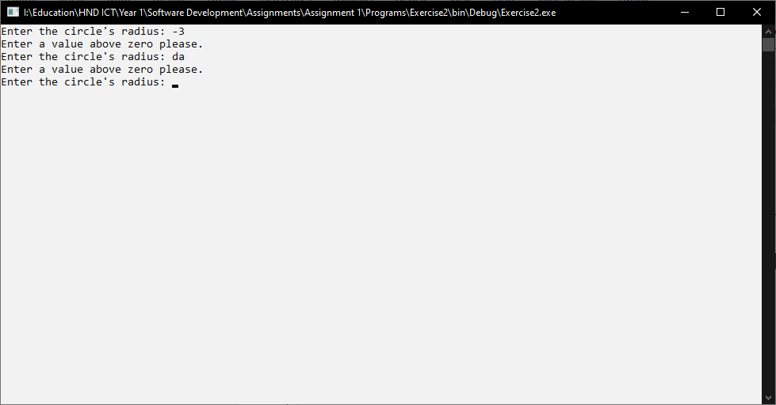 | Screenshot demonstrates the user entering values below zero and alphabetical characters as the circle’s radius.
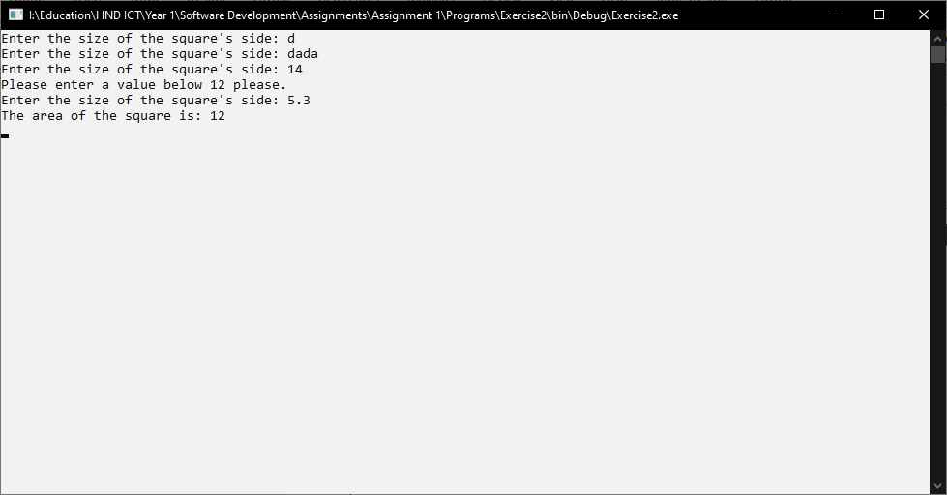 | This demonstrates the user entering the square’s side with incorrect values of which are alphabetical and above the radius.
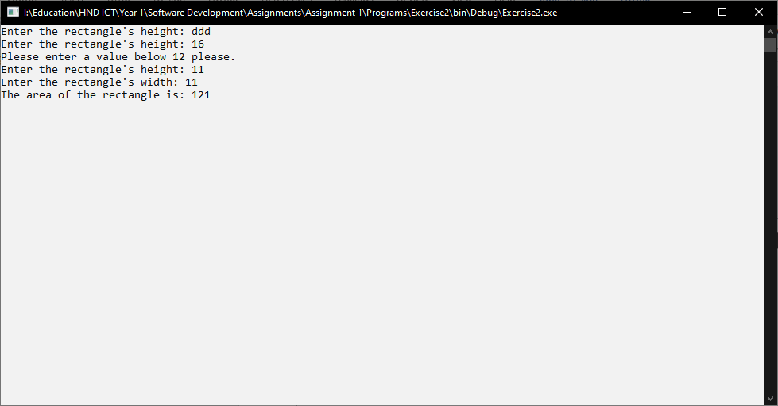 | This demonstrates the user entering the rectangle’s height and width with incorrect values of which are alphabetical and above the radius.
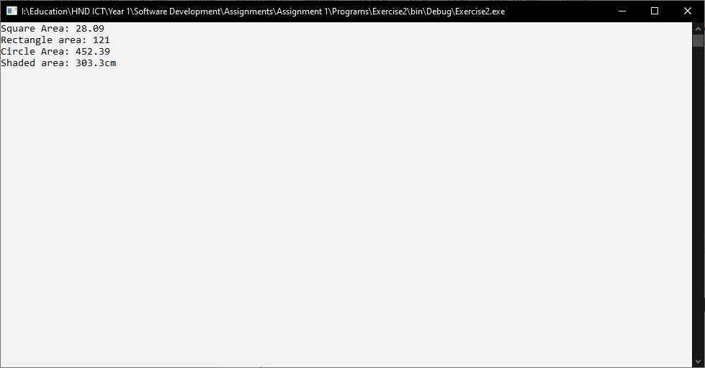 | This is where all of the values are shown along with the calculated shaded area for the user to see.

Weekly Mileage Costs – Program 3
For the completed program see [Appendix 7]

Analysis for Success
This program requires the user to enter their mileage for each day of the week to calculate their total cost using the current costs of their mile per litre and the cost of each litre per mile.
This program will require two arrays, one for the days and another for mileage which allows the inputs to be stored without the need for declaring many variables and hard coding the days of the week.
Possible invalid inputs for the number type variables:
- Alphabetical Characters.
- A value below zero.
There may be numerous loops used for calculating the total, for user input and displaying the results. At least one foreach loop and one for loop will be used.
The equation for the total cost of petrol requires some knowledge on gas prices and cars, this can be tricky as our team does not drive cars. There are equations online which can assist us. [6]

Variables: Purpose of Declaration
Variable Type | Variable Name | Example Input | Purpose
STRING ARRAY | days | “Monday”, “Tuesday,” “Wednesday”, “Thursday”, “Friday”, “Saturday”, “Sunday” | For displaying the day for each input within a loop for efficiency.
FLOAT ARRAY | mileage | 64.2, 12.3, 0, 42.34 | For the user to store their mileage on the day that is shown, such as Monday.
CONST FLOAT | litrePer | 1.35f | This is used for the calculations for showing the total cost of petrol.
CONST FLOAT | milePer | 11.2f | This is used for the calculations for showing the total cost of petrol.
INT | count | 0, 1, 2, 3, 4, 5, 6 | This is used for going through arrays within a foreach loop.
FLOAT | total | 321.32, 123.23, 1063.85 | This is the sum of miles throughout the week.
BOOLEAN | check | FALSE, TRUE | For assisting with data validation within loops.

Pseudo-Code
[START PROGRAM]
ARRAY Days [Monday to Sunday] #Array of days of the week
ARRAY Mileage [0 to 6] # Array for each day of the week, user input.
litrePer 1.35 #Constant
milePer 11.2 #Constant
Check FALSE
For i < 7, i +1
CHECK FALSE
WHILE Check is FALSE # Data Validation
PRINT “Enter your mileage for Days[ i]” # i is the day in the array.
Mileage[ i ] User Input # i is the mileage for the day
END OF LOOP
If Mileage[ i ] < 0 # For correct data to be entered.
PRINT “Please enter a value above zero.”
i – 1 # To go back a day for correction
End If
END OF LOOP
Count 0
Total 0 #Float variable
Foreach object in Mileage # For calculating the total.
Total Mileage[Count] + Total #Adds mileage to total.
Count++
END OF LOOP
Count 0
PRINT ”The total mileage is [Total] miles.”
PRINT “The total cost of petrol is £[Total / milePer * litrePer]”
[END PROGRAM]

User Input Tests
Screenshot | Explanation
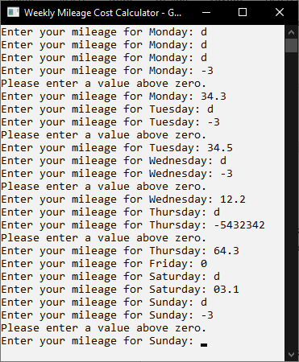 | The user has entered a string value for each day of the week along with a value below zero and exactly equal to zero.
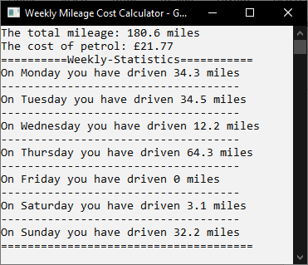 | This is the outcome after the user has entered all of the values correctly.

Matching Game – Exercise 4
For the completed program see [Appendix 8]

Analysis for Success
The player of this game is ceasing drugs from being imported into other countries, and this is done by searching suitcases.
This program / game requires the user to enter two values, one being their item of choice and another being the box or suitcase with that item inside. If the item is corrected but not the box, then no points are awarded and vice-versa unless both items are correct. To prevent abuse of the same guess validation will be in place and the score will be reduced to punish the user.
One array will be required for storing the items and at least one to four lists will be required for adding guesses and randomly generated numbers to compare values and prevent the same outcome each time the program is ran.
This game will contain a few loops for calculating the random numbers and the user interface, and one while loop for the main game and two loops for preventing possible invalid inputs.
Possible invalid inputs for the two user inputs:
- Alphabetical Characters.
- A value above the number of items within the array.
- A value below the number of items within the array.
The user interface will be used as a function / method to prevent clutter from the main calculations and to be called more than once anywhere within the program. This function may contain numerous loops, one being a foreach loop and another as a for loop.
The most difficult part of this program we presume is comparing values from arrays and lists, there are no complicated equations to take note of.

Variables: Purpose of Declaration
Variable Type | Variable Name | Example Input | Purpose
STRING ARRAY | Drugs | “Cocaine”, “Coffee”, “Ketamin”, “Melatonin” | For storing the items which are being chosen by the player to guess the suitcase.
LIST<INT> | usedNum | 6, 4, 2, 8, 1, 3, 9, 10, 0 | For storing the randomly generated numbers.
LIST<STRING> | usedDrugs | “Melatonin”, “Coffee”, “Cocaine”, “Ketamin” | For storing the randomly generated strings which will be used within foreach loops when the user is guessing.
INT | randomNum | 6, 4, 2, 8, 1, 3, 9, 10, 0 | For temporarily storing a random number to be added to a list.
INT | score | 0, 1, 2, -3, 10, 4 | For displaying a number if the guess is correct.
INT | guesses | 0, 1, 2, 3, 4, 5, 6,7, 8 | For displaying a number after a guess.
LIST<STRING> | guessedCorrectly | “Melatonin”, “Coffee”, “Cocaine”, “Ketamin” | For adding the item from the usedDrugs list for identifying whether the item has been guessed again – assists with identifying that all items are found.
INT | chosenCard | 0, 1, 2, 3, 4, 5,6 7,8, 9, 10 | The user input for their chosen item.
INT | hiddenCard | 0, 1, 2, 3, 4, 5,6 7,8, 9, 10 | The user input for the guessed item.
INT | windowWidth | 30, 20, 16, 32 | For adjusting where elements within the CLI are located, helps prevent overlapping.
INT | windowHeight | 30, 20, 16, 32 | For adjusting where elements within he CLI are located, helps prevent overlapping.
INT | randomNum | 11, 4, 6, 1, 0, 3 | Generates random numbers
RANDOM | numGenerator | 2, 4, 6, 1, 4, 3, 2, 10, 3 | Generates non-unique numbers.
BOOL | check | TRUE, FALSE | For assisting with data validation within loops.

Pseudo-Code

Main Program
[START PROGRAM]
ARRAY Drugs[“Coffee”, “Ketamin”, “Cocaine”, etc.] # String Array
RANDOM numGenerator # Generates random numbers
NEW LIST usedNum # Stores randomly generated values.
NEW LIST usedDrugs # Stores randomly generated drugs for an index order.
FOR i 0, i < Drugs Array Count, i +1
randomNum numGenerator(Random Value) #Add random number to variable
If usedNum DOES NOT CONTAIN randomNum
usedNum Add randomNum to list # Add unique number to list.
End If
Else if usedNum DOES CONTAIN randomNum
i -1 # Stay on same iteration if number is already within the list.
End Else If
END OF LOOP
Check FALSE # Boolean
Score 0
Guesses 0
NEW LIST guessedCorrectly # Logs correct guesses.
WHILE TRUE
chosenCard 0
hiddenCard 0
User Interface(Score, Guesses, Drugs, usedNum, chosenCard, guessedCorrectly, usedDrugs) # Parameters for user interface function.
Check FALSE
WHILE CHECK IS FALSE
PRINT “Select a key for the suitcases”
chosenCard User Input
Check FALSE
If chosenCard > Drugs Count OR chosenCard < 0
PRINT “Enter a value within range, please.”
Check FALSE
End If
END OF LOOP
Check FALSE
WHILE CHECK IS FALSE
CHECK FALSE
PRINT “Choose a case that fits the key”
hiddenCard User Input
If hiddenCard > Drugs Count OR hiddenCard < 0
PRINT “Enter a value within range, please.”
Check FALSE
End If
END OF LOOP
Guesses +1
# If random numbers are equal to the chosen options and it has been guessed before.
If usedNum CONTAINS hiddenCard AND Drugs[hiddenCard] == usedDrugs[chosenCard] AND guessedCorrectly CONTAINS usedDrugs[chosenCard]
PRINT “You have already tried this combination.”
Score -1
End If
Else If usedNum CONTAINS hiddenCard AND Drugs[hiddenCard] == usedDrugs[chosenCard]
# If random number is equal to chosen card and the text is equal to the chosen text.
PRINT “You have found [usedDrugs{chosenCard}] in suitcase #[hiddenCard].”
guessedCorrectly ADD usedDrugs[chosenCard] TO THE LIST
Score = +1
End Else If
ELSE
PRINT “You haven’t found any drugs.”
END ELSE
If gussedCorrectly’s COUNT == Drugs’s COUNT
PRINT “YOU WIN!”
PRINT “This run took you [guesses] guesses and obtained a score of [score]”
EXIT OUT OF LOOP
End If
END OF LOOP
[END PROGRAM]

Function: User Interface
[START PROGRAM]
windowWidth THE WINDOW’S WIDTH
windowHeight THE WINDOW’S HEIGHT
SET POSITION windowWidth / 2 + 20, 1
PRINT Score
SET POSITION windowWidth / 2 + 20, 2
PRINT Guesses
FOR i 0, i < Drugs COUNT, i +1
If i < 10
SET POSITION i * 4 + 1, 1
PRINT i
End If
Else If i >= 10
SET POSITION I * 4, 2+I
PRINT i
End Else If
SET POSITION usedNum’s COUNT*4 + 3, 2 + i
PRINT ”Look for [{i}] [usedDrugs{i}]”
END OF LOOP
FOR EACH ITEM IN usedNum
If ITEM == 0 AND guessedCorrectly CONTAINS Drugs[ITEM]
BACKGROUND COLOR GREEN
PRINT item #Change colour of the correct box.
BACKGROUND COLOUR TO DEFAULT
End If
Else If ITEM IS NOT EQUAL 0 AND guessedCorrectly CONTAIN Drugs[ITEM]
BACKGROUND COLOR GREEN
PRINT item #Change colour of the correct box.
BACKGROUND COLOUR TO DEFAULT
End Else If
Else If usedNum CONTAINS ITEM
BACKGROUND COLOUR TO DEFAULT
FOREGROUND COLOUR TO DEFAULT
PRINT “[ X ]”
End Else If
BACKGROUND COLOUR TO DEFAULT
FOREGROUND COLOUR TO DEFAULT
END OF LOOP
[END PROGRAM]

User Input Tests

Screenshot | Explanation
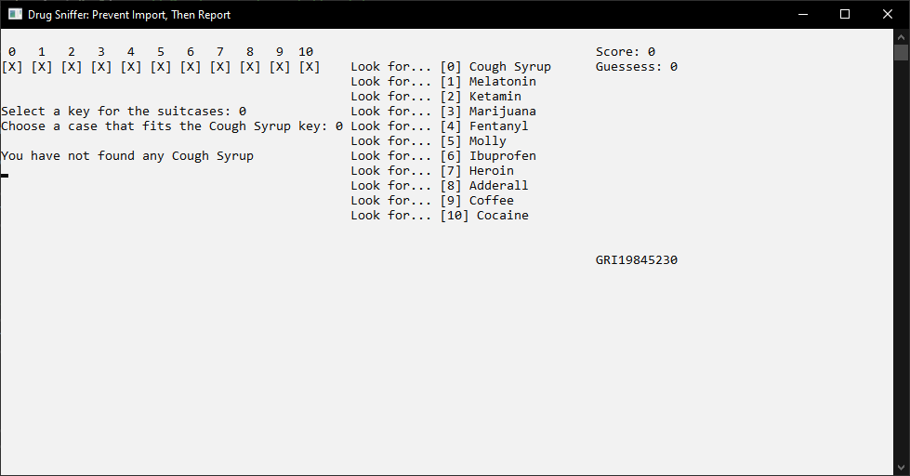 | This is the outcome when the user enters valid numbers which are not equal to the pairs.
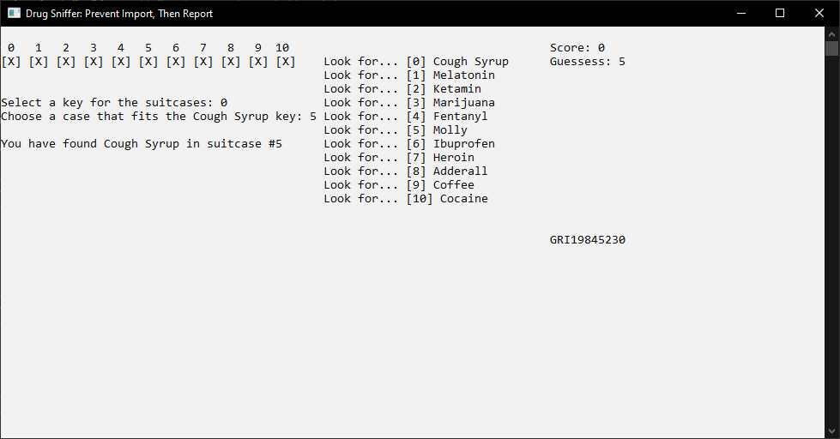 | This is the outcome when the user makes a correct assumption and guesses the pairs.
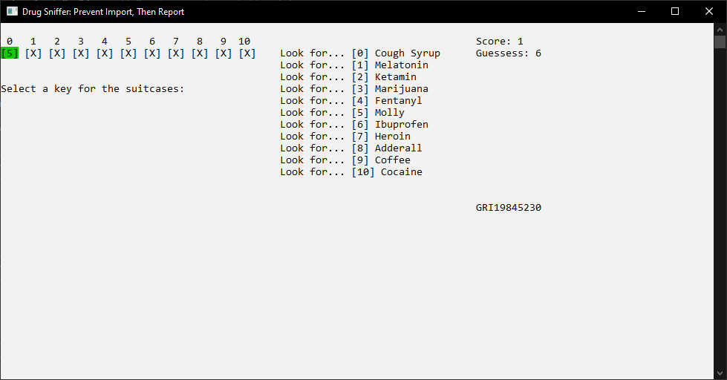 | After guessing correctly the user’s drug box is filled with the case number and is highlighted in green.
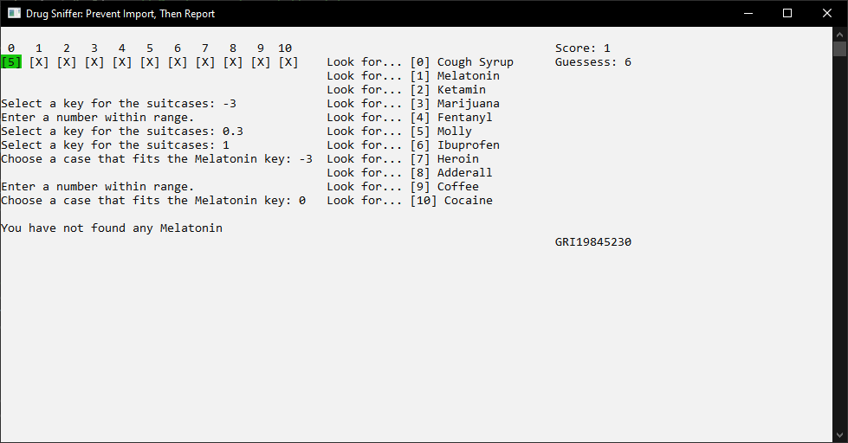 | The user has attempted to enter invalid numbers which are below zero.
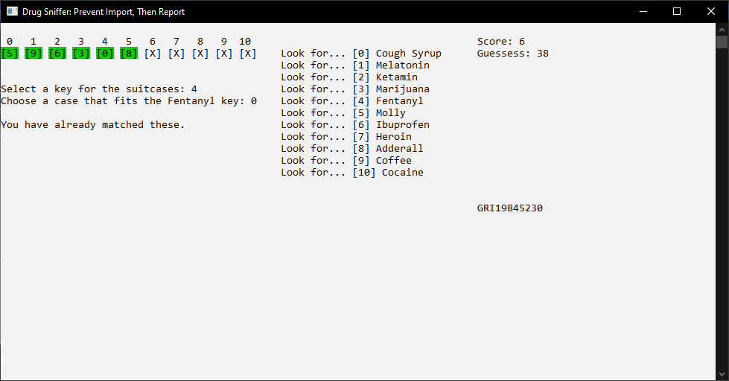 | The user has attempted to maximize their score by entering an already guessed matching pair.
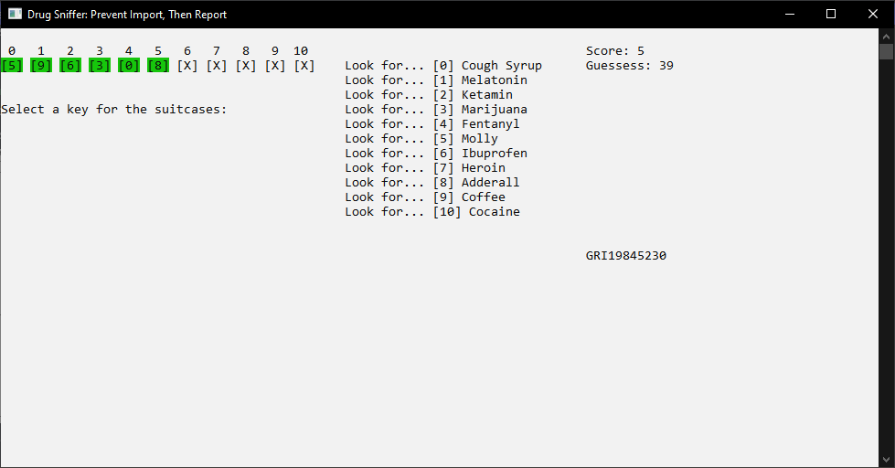 | The user’s score has been reduced due to making an already previously made guess.
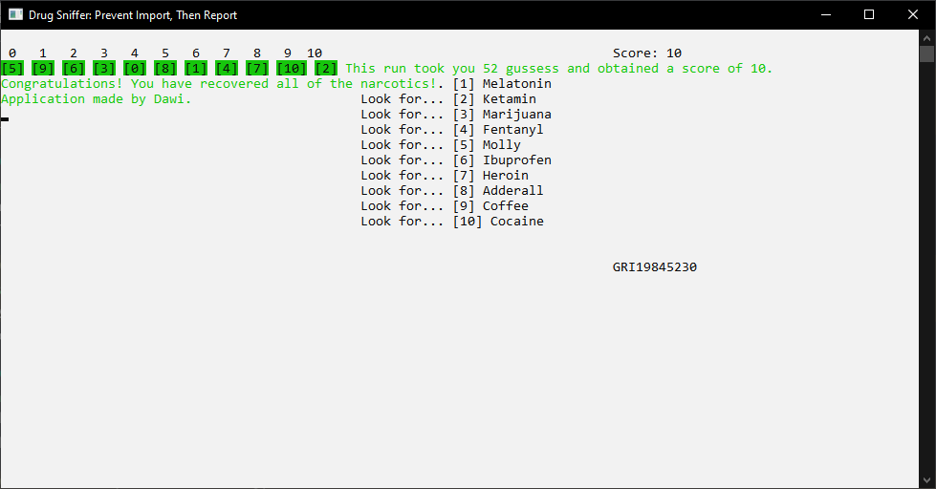 | The user has completed the game with successfully pairing each drug key with a suitcase that contains that drug.
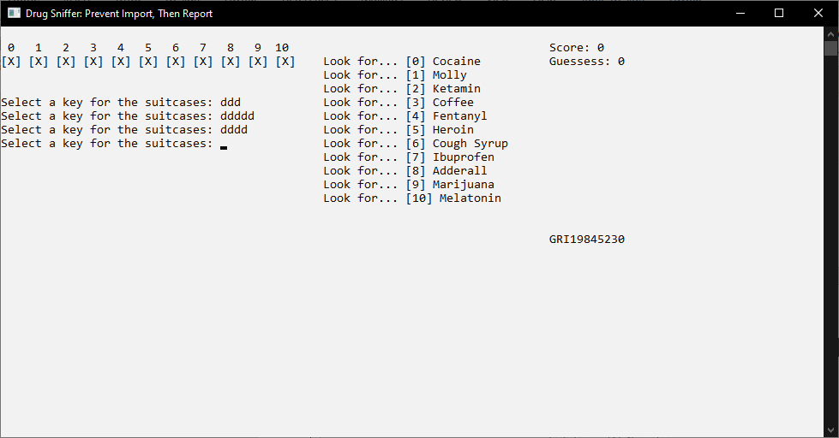 | The user has entered alphabetical characters which do not get entered as real answers.

References

[1] | Microsoft, “Framework libraries,” Microsoft, 12 12 2021. [Online]. Available: https://docs.microsoft.com/en-us/dotnet/standard/framework-libraries. [Accessed 27 01 2022].
[2] | GeeksforGeeks, “C# | Byte.MaxValue Field,” GeeksforGeeks, 23 04 2019. [Online]. Available: https://www.geeksforgeeks.org/c-sharp-byte-maxvalue-field/. [Accessed 27 01 2022].
[3] | S. Allen, “C# int.MaxValue, MinValue (Get Lowest Number),” DotNetPerls, n/a n/a n/a. [Online]. Available: https://www.dotnetperls.com/int-maxvalue. [Accessed 27 01 2022].
[4] | Lithmee, “Difference Between if and if else,” DiffernceBetween.com, 01 03 2018. [Online]. Available: https://www.differencebetween.com/difference-between-if-and-vs-if-else/. [Accessed 28 01 2022].
[5] | Vedantu, “What are Loops?,” Vedantu, N/A N/A N/A. [Online]. Available: https://www.vedantu.com/coding-for-kids/what-are-loops. [Accessed 29 01 2022].
[6] | YouTube, “How to calculate miles per galon km per liter,” Tech & Wheels with Pat, 16 06 2017. [Online]. Available: https://youtu.be/A1WACrNcueY?t=149. [Accessed 16 01 2022].

Appendix
Appendix Number | Referred Item | Item Description
1 | String name = “dewi”;  byte age = 18;  int totalSteps = 4,343
2 | Console.Write("What is your gender?: ");  char gender = Console.ReadKey().KeyChar; // gender is the key that the user selects.  byte count = 0;  while (true)  {  if (gender == 'n' || gender == 'N' && count >= 1)  {  Console.WriteLine("Genders Availalbe\n(M)ale\n(F)emale\nPress any key for other...");  Console.Write("What is your gender?: ");  gender = Console.ReadKey().KeyChar;  count--; // take one away from the count.  }  // if user has selected the listed genders.  if (gender == 'm' || gender == 'M') // if the gender is a male with a capital letter or lowercase  {  Console.Clear();  Console.WriteLine($"The user has entered, {gender}.\nYou are male, and your pronouns are he/him.");  Console.ReadKey();  break;  }  if (gender == 'f' || gender == 'F') // if the gender is a female with a capital letter or lowercase  {  Console.Clear();  Console.WriteLine($"The user has entered, {gender}.\nYou are female, and your pronouns are he/him.");  Console.ReadKey();  break;  }  // The IF statements with a count in their parameteres are executed within the second loop.  else if (gender == 'y' || gender == 'Y' && count > 0)  {  Console.Clear();  Console.WriteLine($"The user didn't specify their gender.\nYour pronouns are they/them.");  Console.ReadKey();  break;  }  else if (gender == 'n' || gender == 'N' && count > 0)  {  Console.Clear();  Console.WriteLine("We assume you mistyped your character, please enter your gender based on the options.");  Console.ReadKey();  }  // if another character has been pressed.  else if (gender != 'f' || gender != 'm' || gender != 'M' || gender != 'F') // if the two genders are not selected, ask if they are another gender.  {  Console.Clear();  Console.WriteLine("Do you identify as another gender which has not been listed? (y/n): ");  gender = Console.ReadKey().KeyChar;  count++; // add one to the count.  }  // this is for validation.  else  {  Console.Clear();  Console.WriteLine("Please enter a valid key.");  Console.ReadKey();  }  }
3 | int burgers = 15;  for (int count = 0; count < burgers; count++)  {  Console.Clear();  Console.WriteLine($"Burger Eating Contest\n----------------\n{burgers - count} Burgers left to eat.");  Console.ReadKey();  }  Console.Clear();  Console.WriteLine("All the burgers have been eaten.");  Console.ReadKey();
4 | int age = 13;  while (age >= 13)  {  Console.Clear();  Console.Write("Welcome to our application\nTo continue you must be over the age of 13.\nHow old are you?:");  age = int.Parse(Console.ReadLine());  Console.Clear();  Console.WriteLine($"You are {age} years old.");  if (age >= 13)  {  Console.WriteLine("You are allowed to use this application.");  Console.ReadKey();  }  if (age < 13)  {  Console.WriteLine("You are NOT allowed to use this application.");  Console.ReadKey();  }
5 | static void Main(string[] args)  {  Console.BackgroundColor = ConsoleColor.White;  Console.ForegroundColor = ConsoleColor.Black; // Changes the colours of the text and background.  Console.Clear();  Console.Write("Hello, who are you?\nPlease enter your first name: ");// Ask user for their first name.  string name = Console.ReadLine(); // Prompt to enter name.  while (true) // Validation  {  if (name == "" || name == null || name == " ")  {  Console.Clear(); // Clear text above.  Console.Write("Please enter a valid name: "); // User prompt to enter name.  name = Console.ReadLine();  }  if (name.Length > 32) // If the character length is greater than 32 characters.  {  Console.Clear();  Console.Write("Your first name is way too long.\nEnter a name less than 33 character long: ");  name = Console.ReadLine();  }  else if (name.Contains ("1") || name.Contains ("2") || name.Contains("3") || name.Contains("4") || name.Contains("5") || name.Contains("6") || name.Contains("7") || name.Contains("8") || name.Contains("9") || name.Contains("0"))  {  Console.Clear();  Console.Write("Do not use any numbers in your name please, thank you.\nPlease enter your first name: ");  name = Console.ReadLine();  }  else  {  Console.Clear();  break; // If there are no errors exit out of the loop.  }  }  bool check = false; // Used for validation.  int age = 1; // For user entering their age.  int count = 0;  while (!check)  {  Console.Clear();  Console.Write($"How old are you, {name}?: "); // Asking the user to prompt.  check = int.TryParse(Console.ReadLine(), out age); // Prompt to enter a value for age, byte requires an explicit conversion.  if (age <= 0) // If the user enters a number that is equal to or below the age of zero.  {  Console.Clear();  Console.WriteLine("You aren't a newborn and you do exist, enter a value above 0 please.");  Console.ReadKey();  count--;  check = false;  }  if (count > 0) // Shows once invalid data has been given.  {  Console.WriteLine("Please do not use alphabetical characters.");  Console.ReadKey();  count--;  check = false;  }  count++; // Causes a message to show if invalid characters have been entered.  }  float height = 0f;  check = false;  count = 0;  while (!check || height > 2.1) // if check is false or the height is greater than 2.1 for entering invalid values.  {  if (height > 2.1)  {  Console.WriteLine("Please enter a realistic height below 2.1 metres.");  Console.ReadKey();  }  Console.Clear();  Console.Write("Enter your height in metres: ");  check = float.TryParse(Console.ReadLine(), out height); // Prompty top enter a float value for height, requires a parse / conversion.  if (height < 0.7)  {  Console.WriteLine("Please enter a height above 0.7 metres please.");  check = false; // Prevents breaking of the loop with invalid data.  Console.ReadKey();  }  else // If invalid data has been entered.  {  Console.WriteLine("Please do not use alphabetical characters.");  Console.Clear();  }  }  Console.WriteLine("########################");  Console.WriteLine($"Thank you for providing data\nYour name is {name}\nwho is {age} years old\nand you are {Math.Round(height,2)} metres");  Console.WriteLine("########################");  Console.ReadKey();  }
6 | static void Main(string[] args)  {  Console.ForegroundColor = ConsoleColor.Black;  Console.BackgroundColor = ConsoleColor.White;  Console.Clear();  bool check = false; // For validation.  const float Pi = 3.14159f;  // This is the circle equation.  double radius = 0;  while (!check)  {  check = false;  Console.Write("Enter the circle's radius: ");  check = double.TryParse(Console.ReadLine(), out radius); // Enter the circle's radius & Area of Circle calculated  if (radius <= 0)  {  check = false;  Console.WriteLine("Enter a value above zero please.");  }  }  double circle = (radius * radius) * Pi;  Console.WriteLine($"The area of the circle is: {circle}");  Console.ReadKey();  Console.Clear();  // This is the square equation.  check = false;  double square = 0;  double squareSide = 0;  while (!check)  {  check = false;  Console.Write("Enter the size of the square's side: "); // Enter the square's side.  check = double.TryParse(Console.ReadLine(), out squareSide); // Square's side.  if (squareSide >= radius) // If the shape is bigger than the circle.  {  check = false;  Console.WriteLine($"Please enter a value below {radius} please.");  }  if (squareSide < 0)  {  Console.WriteLine("Enter a value that isn't below zero please.");  }  }  check = false;  square = squareSide * squareSide;  Console.WriteLine($"The area of the square is: {radius}");  Console.ReadKey();  Console.Clear();  // This is the Rectangle equation.  double height = 0;  double width = 0;  while (!check)  {  check = false;  Console.Write("Enter the rectangle's height: "); // Enter rectangle's height.  check = double.TryParse(Console.ReadLine(), out height);  if (height >= radius) // If the shape is bigger than the circle.  {  check = false;  Console.WriteLine($"Please enter a value below {radius} please.");  }  if (height < 0)  {  Console.WriteLine("Enter a value that isn't below zero please.");  }  }  check = false;  while (!check)  {  check = false;  Console.Write("Enter the rectangle's width: "); // Enter rectangle's width.  check = double.TryParse(Console.ReadLine(), out width);  if (width >= radius) // If the shape is bigger than the circle.  {  check = false;  Console.WriteLine($"Please enter a value below {radius} please.");  }  if (width < 0)  {  Console.WriteLine("Enter a value that isn't below zero please.");  }  }  double rectangle = height * width; // Rectangle area.  Console.WriteLine($"The area of the rectangle is: {rectangle}");  Console.ReadKey();  Console.Clear();  // Conclusion of the equations.  Console.WriteLine($"Square Area: {Math.Round(square,2)}\nRectangle area: {Math.Round(rectangle,2)}\nCircle Area: {Math.Round(circle,2)}");  Console.WriteLine($"Shaded area: {Math.Round(circle - square - rectangle, 2)}cm"); // The area of the shaded area.  Console.ReadKey();  Console.Clear();  }
7 | static void Main(string[] args)  {  programStartup();  /**Ask user for approrpriate inputs for each string variable in the array.  If user enters number below 0 ask again for input on the same day.  Show the total of the inputs.  Show the cost using an equation.  Output the values.  total = monday + tuesday + wednesday + thursday + friday + saturday + sunday  total divided by the mile per litre (11.2)  the mile per litre is the multiplied by the cost per litre*/  string[] days = {"Monday","Tuesday","Wednesday","Thursday","Friday","Saturday","Sunday"}; // Days of the week.  float[] mileage = { 0, 0, 0, 0, 0, 0, 0 }; // Storage for the user's mileage for the whole week.  const float litrePer = 1.35f;  const float milePer = 11.2f; // const variable type because it doesn't change.  // int tempNum = 0;  for (int i = 0; i < 7; i++)  {  bool check = false;  while (!check) // While check is false.  {  Console.Write($"Enter your mileage for {days[i]}: "); // Ask for user input.  check = float.TryParse(Console.ReadLine(), out mileage[i]); // TryParse for a float variable that outputs the value to the current mileage.  }  if (mileage[i] < 0) // If below zero ask again.  {  Console.WriteLine("Please enter a value above zero."); // This is for values below zero.  i--;  }  }  int count = 0;  float total = 0f; // total defined.  foreach (var item in mileage)  { // Loop for working out the total.  total = mileage[count] + total;  count++;  }count = 0;  Console.Clear();  Console.WriteLine($"The total mileage: {Math.Round(total,2)} miles"); //Math.round for data validation.  Console.WriteLine($"The cost of petrol: £{Math.Round(total / milePer * litrePer,2)}"); // The equation.  Console.WriteLine("==========Weekly-Statistics===========");  foreach (var item in days) // For each item in days repeat.  {  Console.WriteLine($"On {days[count]} you have driven {Math.Round(mileage[count], 2)} miles"); // This prints the name of the day and the mileage.  if (count == 6)  {  break;// This is to avoid the line shown below.  }  else  {  Console.WriteLine("------------------------------------"); // To separate the items.  }  count++;  }  Console.WriteLine("======================================");  Console.ReadKey();  }  static void programStartup()  {  Console.Title = "Weekly Mileage Cost Calculator - GRI19845230";  Console.SetWindowSize(60,23); // To prevent distractions.  Console.BackgroundColor = ConsoleColor.White; // To brighten their screen up.  Console.ForegroundColor = ConsoleColor.Black; // For text to be read.  Console.Clear(); // Applies this to everywhere.  }
8 | static void Main(string[] args)  {  Console.ForegroundColor = ConsoleColor.Black;  Console.BackgroundColor = ConsoleColor.White;  Console.Title = "Drug Sniffer: Prevent Import, Then Report";  Console.Clear();  /*int windowMiddle = Console.LargestWindowWidth / 5; // Gets size based on the window.  //menu  MainMenu(windowMiddle); */  string[] Drugs = { "Fentanyl","Ibuprofen","Cocaine","Marijuana","Heroin","Cough Syrup","Ketamin","Adderall","Molly","Melatonin","Coffee"};  Random numGenerator = new Random(); // Initialise random number generator.  List<int> usedNum = new List<int>(); // For storing random numbers.  List<string> usedDrugs = new List<string>(); // For storing used drugs.  for (int i = 0; i < Drugs.Count(); i++) // Per item in the Drugs array.  {  int randomNum = numGenerator.Next(Drugs.Count()); // Randomly pick a number.  if (!usedNum.Contains(randomNum)) // If the random number does not contain the used number.  {  //Console.Write($"{Drugs[randomNum]} "); // Print the list based on the random number.  usedNum.Add(randomNum); // To avoid duplicates being stored in the list.  usedDrugs.Add(Drugs[randomNum]); // Add the string to list from the random number array.  }  else if (usedNum.Contains(randomNum)) // Or else If the random number does contain the used number  { // Else if to being stuck in a loop as when all numbers are used this would repeat.  i--;  }  }  bool check = false; // For validating input and output.  int score = 0; int guesses = 0; List<string> guessedCorrectly = new List<string>();  // WHERE THE USER PLAYS THE GAME  while (true)  {  int chosenCard = 0;  int hiddenCard = 0;  GameUI(score, guesses, Drugs, usedNum, chosenCard, guessedCorrectly,usedDrugs);  Console.SetCursorPosition(0, 5);  check = false; // to enter the while loop after running both for the second time.  while (!check)  {  Console.Write("Select a key for the suitcases: ");  check = false; // to stop from exiting the loop if successful.  check = int.TryParse(Console.ReadLine(), out chosenCard); // Convert user answer to a 32bit integer.  Console.Beep();  if (chosenCard > usedNum.Count || chosenCard < 0)  {  Console.WriteLine("Enter a number within range.");  check = false;  }  }  check = false; // To enter the next while loop.  while (!check) // For data validation.  {  Console.Write($"Choose a case that fits the {usedDrugs[chosenCard]} key: ");  check = false;  check = int.TryParse(Console.ReadLine(), out hiddenCard); // The card that chooses a random number  Console.Beep();  if (hiddenCard > usedNum.Count || hiddenCard < 0)  {  Console.WriteLine("\nEnter a number within range.");  check = false;  }  }  guesses++;  if (usedNum.Contains(hiddenCard) && Drugs[hiddenCard] == usedDrugs[chosenCard] && guessedCorrectly.Contains(usedDrugs[chosenCard]))  { // if the guess is the same as the previous one.  Console.WriteLine("\nYou have already matched these.");  score--;  }  else if (usedNum.Contains(hiddenCard) && Drugs[hiddenCard] == usedDrugs[chosenCard])  { // if the random number is equal to the user's key, and the randomly placed drug is equal to the chosen drug.  Console.WriteLine($"\nYou have found {usedDrugs[chosenCard]} in suitcase #{hiddenCard}");  guessedCorrectly.Add(usedDrugs[chosenCard]); // Add to correct guesses.  score++;  }  else  {  Console.WriteLine($"\nYou have not found any {usedDrugs[chosenCard]}");  }  /* if (guessedCorrectly.Contains(usedDrugs[chosenCard]) && item == hiddenCard)  { // If the guess is correct and the item card is correct too.  }*/  if (guessedCorrectly.Count == Drugs.Count()) // This is if you win the game.  { // If the amount of correct gussess is equal to the amount in the Drugs array.  Console.Clear();  GameUI(score, guesses, Drugs, usedNum, chosenCard, guessedCorrectly, usedDrugs); // For updating the last box before the success message is displayed.  Console.ForegroundColor = ConsoleColor.Green;  Console.Beep(); // Congratulations!  Console.WriteLine($"This run took you {guesses} gussess and obtained a score of {score}.");  Console.WriteLine("Congratulations! You have recovered all of the narcotics!\nApplication made by Dawi.");  Console.ReadKey();  break;  }  Console.ReadKey();  Console.ForegroundColor = ConsoleColor.Black;  Console.Clear();  }  }  static void GameUI(int score, int gussess, string[] Drugs, List<int> usedNum, int chosenCard, List<string> GuessedCorrectly,List<string>usedDrugs)  {  int windowWidth = Console.WindowWidth;  int windowHeight = Console.WindowHeight;  Console.SetCursorPosition(windowWidth /2 + 20, 1);  Console.WriteLine($"Score: {score}");  Console.SetCursorPosition(windowWidth /2+20, 2);  Console.WriteLine($"Guessess: {gussess}");  Console.SetCursorPosition(windowWidth /2 + 20, windowHeight-15);  Console.WriteLine("GRI19845230");  for (int i = 0; i < Drugs.Count(); i++) // Ran inside of a while loop to stay on the screen.  {  if (i < 10) // Position before the the loop is ran nine times.  {  Console.SetCursorPosition(i * 4 + 1, 1); // For numbers to be equal to the boxes.  Console.Write(i); // Print numbers starting at 1.  }  else if (i >= 10) // For numbers to be greater than and equal to nine aka 10 and 11.  {  Console.SetCursorPosition(i * 4, 1); // Positioning for a better fit.  Console.Write(i); // Print numbers starting at 0.  }  Console.SetCursorPosition(usedNum.Count*4+3, 2+i);  Console.WriteLine($"Look for... [{i}] {usedDrugs[i]}");  }  Console.SetCursorPosition(0,1);  Console.WriteLine();  foreach (var item in usedNum) // For each item in the list print...  {  if (item == 0 && GuessedCorrectly.Contains(Drugs[item]))  { // If the score is zero and correct, show green and the number.  Console.BackgroundColor = ConsoleColor.Green;  Console.Write($"[{item}]");  Console.BackgroundColor = ConsoleColor.White;  Console.Write(" ");  }  else if (item != 0 && GuessedCorrectly.Contains(Drugs[item]))  { // If the the score is not zero and correct green.  Console.BackgroundColor = ConsoleColor.Green;  Console.Write($"[{item}]");  Console.BackgroundColor = ConsoleColor.White;  Console.Write(" ");  }  else if (usedNum.Contains(item))  { // This is the last thing to do if no answers are correct.  Console.BackgroundColor = ConsoleColor.White;  Console.ForegroundColor = ConsoleColor.Black;  Console.Write("[X]");  Console.Write(" ");  }  Console.BackgroundColor = ConsoleColor.White;  Console.ForegroundColor = ConsoleColor.Black;  // Console.Write($"[{item}]"); // Print the number if the user's number is equal to it.  // Console.Write();  }  }

