
2026249

APPENDIX GA36b

Student name: | Daniel Stoican | Student ID number: | 2228042
Programme: | BA (Hons) Leadership and Management Skills in the Workplace
Module: | Project Management
Module code: | LCLM5003 | Contribution to Overall Module Assessment (%): | 100%
Module Leaders: | Rexon Nting  Sharin Mcdowall-Emefiele | Internal Verifier: | Md Kalam  Samuel Ofori
Assignment Title: | A Project portfolio. | Word count or equivalent.
Submission deadline: | Submit parts A, B & C as a single portfolio document using the template provided  21st November 2025  14:00 (2PM) | Return date for provisional marks and written feedback: | 19th December 2025

Contents
PART A POSTER 3
PART B: REFLECTIVE REPORT — FEEDBACK FROM TUTOR AND PEERS 4
Introduction 4
What Went Well 4
Areas for Improvement 5
Updates to the Last Version of the Plan 5
Conclusion 5
References 6
PART C — PROJECT MANAGEMENT PLAN 7
Introduction 7
Project Description 7
Scope 8
In-Scope 8
Out of Scope 9
Project Constraints and Assumptions 9
Work Breakdown Structure (WBS) 10
Quad Chart 11
Gantt Chart 13
Stakeholders' Involvement 15
Allocation of Resources 17
Budget Allocation 17
Human Resources 19
Risk Analysis 20
Conclusion 24
References 25

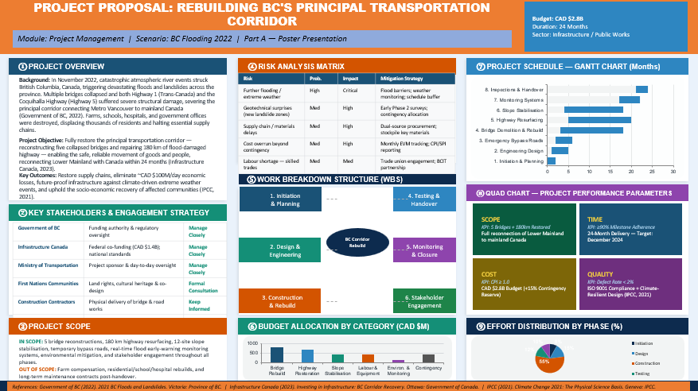
PART A POSTER

PART B: REFLECTIVE REPORT — FEEDBACK FROM TUTOR AND PEERS

Introduction
Sharing the project idea through a poster (Part A) opened space for dialogue with classmates and instructor alike - focusing on restoring B.C.’s main transport route after flood damage in 2022. Input gathered carried weight; it pointed clearly to what stood strong, where gaps lived. Because of that, reviewing progress felt grounded, less about opinion more about real adjustments. Strengths surfaced naturally during conversation, yet weaknesses emerged just as fast. Instead of defending choices, listening shaped how thoughts shifted forward. Now, ahead of the full plan submission (Part C), changes take form slowly, built on observation rather than impulse. Clarity grows when voices beyond your own enter the room.

What Went Well
Clear reactions pointed to the poster’s organisation making sense at a glance. A split-layout design, paired with tinted blocks, helped guide attention naturally across sections. One visual - the Gantt-style bar sequence - stood out by turning dates into something easier to follow. Colour-tagged zones showed how likely problems might hit, which reviewers found straightforward. Mapping six main participant types revealed thoughtful planning behind who matters in the process. This lined up with broader principles tied to structured oversight in group efforts.
One way to look at it: breaking the work into six clear stages showed solid grasp of how projects get split up properly, matching what experts say works well (APM, 2022). The chosen project was of great importance since it needs to fix a key transport route. Delays were making situations worse by costing an expense of around £54.1 million daily, leading to making trade hard (Infrastructure Canada, 2023). However, they kept a good sum of money aside £1.51 billion, with an extra 15% so that it could be used if there comes any for surprises.

Areas for Improvement
Despite having these advantages, some upgrades stood out. There were many loopholes in team planning and resource allocation. Staff needs to be utilised properly and effectively as it is of utmost importance because people management highly relates to success of the project (Kerzner, 2022).
Analysing the Quad Chart depicts how time, scope, cost, and quality connect. However, they were kept separate depicting ill management. Moreover, clarity in the layout was also missing because citations were present only in the footers. As a result, missed opportunities to support ideas.

Updates to the Last Version of the Plan
Changes were done in part C, catering the the feedback, clarifying each and every person’s responsibilities so that each task can be done timely and properly. Likewise, Gantt chart represents the milestones needed to be done for timely completion of project. Furthermore, stakeholders were mentioned precisely that helped in knowing who actually is interested and who can ditch. Likewise, risks were also mentioned properly with a comprehensive list for mitigating them.

Conclusion
Above all else, sharing work through the poster made clear how vital it is to communicate ideas simply and thoroughly. Because of what people pointed out, the next version of the Project Management Plan grew stronger, richer in detail. Thanks to those insights, the plan now fits better with current ways of managing projects.

References
APM (2022). APM Body of Knowledge (7th ed.). Princes Risborough: Association for Project Management.
Infrastructure Canada (2023). Investing in Infrastructure: BC Corridor Recovery. Ottawa: Government of Canada.
Kerzner, H. (2022). Project Management: A Systems Approach to Planning, Scheduling, and Controlling (13th ed.). Hoboken: Wiley.
PMI (2021). A Guide to the Project Management Body of Knowledge (PMBOK® Guide) (7th ed.). Newtown Square: Project Management Institute.

PART C — PROJECT MANAGEMENT PLAN

Introduction
The severe flooding and landslides which British Columbia faced during November 2022 occurred because of an atmospheric river that resulted in bridge collapses and extensive damage to Highway 1 and Coquihalla Highway. The routes function as essential links between Metro Vancouver and the rest of Canada, but their closure caused supply chain disruptions which resulted in daily financial losses of approximately CAD $100 million (Government of BC, 2022; Infrastructure Canada, 2023). The disaster created a widespread crisis through its destruction of homes and farms and public infrastructure (Henstra and Thistlethwaite, 2022). The Project Management Plan aims to rebuild the main transportation corridor by using PMBOK and APM methodologies to manage project delivery according to its established scope and time and cost and quality targets.

Project Description
Project Title: Rebuilding BC's Principal Transportation Corridor — Highway 1 and Key Bridge Structures
Project Sponsor: Ministry of Transportation and Infrastructure, Government of British Columbia
Project Duration: 24 Months (January 2023 – December 2024)
Estimated Budget: CAD $2.8 Billion (inclusive of 15% contingency reserve)
Project Manager: Qualified PM appointed by the Ministry of Transportation
The project aims to stop theft which occurs at Highway 1 and Coquihalla Highway because it will rebuild five collapsed bridges and repair 180 kilometers of road which suffered flood damage and install flood monitoring systems and conduct slope stabilization work. The project will establish climate resilient infrastructure which protects against extreme weather events according to IPCC (2021) recommendations and Government of Canada National Adaptation Strategy (Government of Canada, 2022) guidelines.
The project will use a hybrid project management approach which combines PRINCE2 milestone-based frameworks with PMBOK® adaptive planning methods to enable project teams to manage unexpected challenges which include flooding and material shortages and geotechnical issues. The dedicated project management office (PMO) will manage all governance activities together with reporting processes and quality assurance operations during the entire project duration (Turner, 2020).

Scope

In-Scope
The following deliverables and activities are involved within the project scope
The project will rebuild five collapsed bridge structures which include the highway 1 and highway 5 bridges and the Nicola River Bridge and the Coldwater River Bridge.
- The project will restore approximately 180 kilometers of road surface which suffered flood damage and landslide damage through sub-base repair work and asphalt resurfacing and lane marking activities.
- The project will create slope stabilisation systems at 12 landslide sites which will use rock anchoring and retaining walls and drainage channel systems.
- The project will build emergency bypass roads which will provide temporary access to the area during reconstruction work.
- The project will install real-time flood monitoring systems and early warning systems at six high-risk locations which are situated along the corridor. Environmental impact mitigation measures include river bank reinforcement and habitat restoration (Government of BC, 2022)
- The program will engage stakeholders through consultations that include First Nations communities and local authorities.
- The organisation will conduct quality assurance activities to confirm compliance with Transport Canada and BC Ministry of Transportation standards.

Out of Scope
- The process of restoring agricultural land together with farm facilities and residential areas which suffered from flood damage
- The construction activities needed to restore educational institutions and medical facilities and all other government properties
- The Highway 5 (Coquihalla) reopening will proceed as a distinct project which Ministry program handles separately
- The organisation will maintain the project for 24 months which extends beyond the two-year project delivery time.

Project Constraints and Assumptions
The project has three main budget limitations which include: (1) The budget total reaches CAD $2.8 billion because it includes all emergency funds (2) The project needs to complete all corridor work within 24 months to reduce economic disruptions (3) All construction work needs to follow Canadian environmental standards together with First Nations consultation procedures which exist under the BC Declaration on the Rights of Indigenous Peoples Act (Government of BC, 2019). The project team expects to receive federal co-funding from Infrastructure Canada within three months after project start while geotechnical surveys will determine existing major landslide risk areas which already exist beyond the twelve identified locations.

Work Breakdown Structure (WBS)
The Work Breakdown Structure (WBS) divides the project into distinct phases and work packages which enable teams to monitor their progress through established responsibility assignments. The WBS system divides its content into six main sections which correspond to the different stages of the project lifecycle as defined by PMI in 2021.
WBS Phase | Key Work Packages | Duration | Responsibility
1. Initiation | Project charter, stakeholder register, risk register, feasibility study | Weeks 1–4 | PMO / Ministry
2. Planning & Design | Detailed engineering design, procurement plan, environmental assessment | Weeks 3–10 | Engineering Consultants
3. Emergency Bypass | Construct temporary access routes, public communications | Weeks 5–12 | Contractor A
4. Bridge Reconstruction | Demolish damaged structures, fabricate and install new bridges | Weeks 10–60 | Structural Engineers / Contractor B
5. Road & Slope Works | Road resurfacing, slope stabilisation, drainage installation | Weeks 14–80 | Civil Contractor C
6. Monitoring & Closure | Install early warning systems, final inspections, handover, lessons learned | Weeks 78–96 | PMO / Ministry

The WBS creates a complete work breakdown which serves as the foundation for estimating costs and planning project timelines (Kerzner, 2022). Each work package receives a distinct ID which allows earned value management (EVM)to monitor project expenses and timeline progress from project initiation to completion.
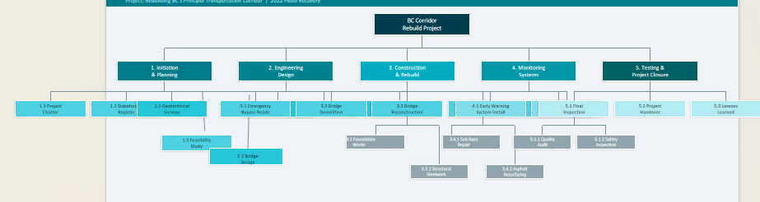

Figure 1: WBS

Quad Chart
The Quad Chart displays an executive summary of four essential project dimensions which include Scope Time Cost and Quality together with their mutual dependencies. The triple constraint model shows that any modification to one element will result in changes to all other elements (PMI 2021).

Parameter | Target | Key Performance Indicator | Risk if Not Met
SCOPE | Reconstruct 5 bridges + 180km highway | % work packages completed | Incomplete reconnection of corridor
TIME | 24 months (by Dec 2024) | Milestone adherence rate ≥ 90% | Extended economic disruption
COST | ≤ CAD $2.8 Billion | Cost Performance Index (CPI) ≥ 1.0 | Budget overrun → reduced scope
QUALITY | ISO 9001 & TC Standards | Defect rate < 2%; 0 safety incidents | Structural failure; regulatory non-compliance

The steering group meetings which occur monthly assess the Quad Chart to check whether the project progresses according to its scheduled timetable and three other project dimensions. The Project Sponsor must approve all necessary trade-offs which include using budget resources to speed up project completion (Turner, 2020).
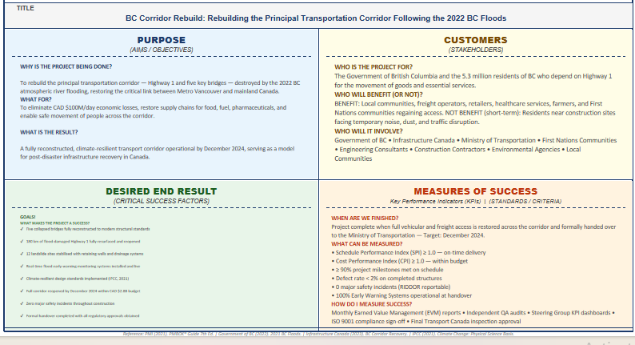
Figure 2: Quad Chart

Gantt Chart
The Gantt Chart below shows the project timeline which extends through a 24-month period of 96 weeks and displays important project stages and milestones and their relationships to each other. The project team uses a phased approach which allows them to open partial access routes during ongoing reconstruction work (APM 2022).
Phase / Milestone | Start (Week) | End (Week) | Duration | Key Milestone
1. Initiation & Planning | 1 | 8 | 8 weeks | ✓ Project Charter Approved
2. Engineering Design | 5 | 20 | 16 weeks | ✓ Design Drawings Signed Off
3. Emergency Bypass Roads | 8 | 24 | 16 weeks | ✓ Partial Access Restored
4. Bridge Demolition & Rebuild | 12 | 72 | 60 weeks | ✓ 5 Bridges Operational
5. Highway Resurfacing | 20 | 80 | 60 weeks | ✓ 180km Road Restored
6. Slope Stabilisation | 16 | 72 | 56 weeks | ✓ 12 Sites Secured
7. Monitoring Systems Install | 68 | 88 | 20 weeks | ✓ Early Warning Systems Live
8. Final Inspections & Handover | 84 | 96 | 12 weeks | ✓ Full Corridor Reopened

The Bridge Reconstruction phase which lasts from Weeks 12 to 72 stands as the most extended work period of the project because it demands the highest resource consumption which functions as the primary constraint that restricts project timelines. The project completion date will experience direct delays whenever there is a setback in bridge procurement or construction work. This phase requires the team to report their progress every week while they monitor risks throughout the entire duration of the project (Heagney 2022).

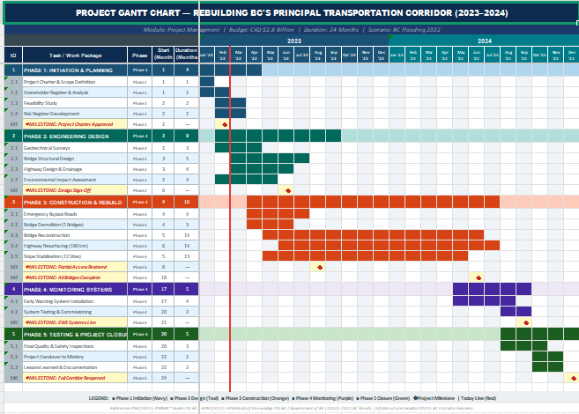
Figure 3: Gantt Chart

Stakeholders' Involvement
Stakeholder management serves as the essential element which determines whether infrastructure projects will succeed or fail according to Freeman and his colleagues 2020. The project team conducted a full stakeholder analysis which used the power-interest grid to classify stakeholders and determine their engagement priorities.
Stakeholder | Role / Interest | Power | Interest | Engagement Strategy
Government of BC (Ministry) | Funding authority; regulatory oversight; project sponsor | High | High | Manage closely — monthly steering group; formal reporting
Infrastructure Canada | Federal co-funding (CAD $1.4B); national standards | High | High | Manage closely — quarterly reviews; MOU governance
Ministry of Transportation | Day-to-day project oversight; technical approvals | High | High | Manage closely — weekly project board meetings
First Nations Communities | Land rights; cultural heritage; environmental concerns | High | High | Consult formally — dedicated liaison officer; co-design sessions
Engineering Consultants | Design, surveys, and technical specifications | Medium | High | Keep informed — weekly technical briefings
Construction Contractors | Physical delivery of bridge and road works | Medium | High | Keep informed — KPI-based performance reviews
Local Communities | Affected residents; access disruption; safety concerns | Low | High | Keep informed — public consultation sessions; project website
Environmental Agencies | Environmental compliance and habitat protection | High | Medium | Keep satisfied — Environmental Impact Assessment reports
Media and Public | Reputational risk; public confidence in recovery | Low | Medium | Monitor — regular press releases and social media updates

A person focused on connecting with stakeholders will join the project team to handle updates and keep track of who needs what. These monthly summaries go out to key individuals whose influence and interest shape decisions (Freeman et al., 2020). Conversations with First Nations communities follow rules set by British Columbia law from 2019, making sure their voices help guide plans right from the start through completion.

Allocation of Resources

Budget Allocation
Spending the full CAD $2.8 billion means money goes where it's needed most throughout every stage. Each part of the work gets what it requires, shaped by how far along things are. Funds shift based on demands at different points. Money flows into areas that matter right now.

Cost Category | Budget (CAD $M) | % of Total | Notes
Bridge Reconstruction (5 bridges) | $840M | 30% | Steel fabrication, foundations, structural works
Highway Resurfacing (180 km) | $680M | 24% | Asphalt, sub-base, drainage, lane marking
Slope Stabilisation (12 sites) | $420M | 15% | Rock anchors, retaining walls, drainage
Labour and Equipment | $420M | 15% | Civil engineers, project staff, plant hire
Environmental & Monitoring Systems | $140M | 5% | EWS installation, habitat restoration
PMO & Professional Services | $112M | 4% | Project management, consultants, QA
Contingency Reserve (15%) | $420M | 15% | Risk buffer; requires formal approval to release
TOTAL | $2,800M | 100%

Human Resources
Around 1,200 people will be needed when work hits high between Weeks 20 and 72 - this effort pulls together experts from different fields
Role | No. of Personnel | Phase(s) | Supplier
Project Manager | 1 | All phases | Ministry of Transportation
Deputy PM / Planning Manager | 1 | All phases | Ministry of Transportation
Structural Engineers | 45 | Phases 2–4 | Engineering Consultancy
Civil Engineers | 80 | Phases 3–5 | Civil Contractor C
Site Supervisors / Foremen | 30 | Phases 3–5 | Contractors A, B, C
Skilled Construction Labour | 900 | Phases 3–5 | Trade Unions / Sub-Contractors
Environmental Officers | 12 | Phases 1–6 | Environmental Agency
Stakeholder Liaison Officers | 5 | Phases 1–6 | PMO
QA / Safety Inspectors | 18 | Phases 3–6 | Independent QA Firm
The project partners have established resource levelling to prevent resource over-allocation during the project's highest delivery demands. The project has established a resource management plan which tracks resource usage according to Kerzner (2022) and helps identify resource shortages before they occur. The project will begin its subcontracting relationship with pre-approved companies through a procurement process which Infrastructure Canada procurement standards will oversee.

Risk Analysis
The success of risk management functions as an essential requirement for every intricate infrastructure project according to Ika and his colleagues who published their findings in 2020. The team has created a complete risk register which uses a 5×5 probability-impact matrix to determine risk priorities and suitable response methods. The assessment process assigns three different priority levels to risks which include High (H), Medium (M), and Low (L) priority levels based on their overall risk score (probability × impact) assessment.
# | Risk Description | Probability | Impact | Priority | Response Strategy | Owner
R1 | Further flooding / extreme weather events disrupting construction activities | High | Critical | H | MITIGATE: Install temporary flood barriers; monitor weather forecasts; include weather downtime in schedule buffer | PMO / Site Manager
R2 | Geotechnical surprises — additional landslide zones discovered during surveys | Medium | High | H | MITIGATE: Commission Phase 2 geotechnical surveys early; allocate contingency for additional stabilisation works | Lead Geotechnical Engineer
R3 | Supply chain disruptions — delays in steel and materials procurement | Medium | High | H | MITIGATE: Dual-source procurement strategy; early ordering; stockpile critical materials on-site | Procurement Manager
R4 | Cost overrun exceeding contingency reserve | Medium | High | H | MITIGATE: Monthly EVM tracking; CPI/SPI reporting to steering group; formal change control process | PMO / Finance
R5 | Labour shortages in skilled construction trades | Medium | Medium | M | MITIGATE: Early engagement with trade unions; apprenticeship partnership with BCIT; incentive packages | HR Manager
R6 | Delays in First Nations consultation and approval processes | Medium | High | H | MITIGATE: Engage First Nations liaison officer from Week 1; integrate consultation into planning schedule (Government of BC, 2019) | Stakeholder Manager
R7 | Regulatory or environmental compliance failure | Low | High | M | MITIGATE: Dedicated environmental officer; monthly environmental audits; proactive liaison with DFO and Environment Canada | Environmental Officer
R8 | Contractor performance failure or insolvency | Low | High | M | TRANSFER: Performance bonds and liquidated damages clauses in all contracts; prequalification of contractors | Procurement Manager
R9 | Public opposition or media pressure causing reputational damage | Low | Medium | L | ACCEPT / MONITOR: Regular public updates; transparent progress reporting; community liaison programme | Communications Lead
R10 | Scope creep — requests to include out-of-scope items (e.g., farm compensation) | Medium | Medium | M | AVOID: Robust change control process; formal written scope change requests required; PMO review and approval | Project Manager

The Project Board will conduct monthly risk register reviews, which will lead to the escalation of high-priority risks to the Project Sponsor. New risks identified during delivery will be assessed and added to the register using the same probability-impact framework (Ika et al., 2020). The CAD 420 million contingency reserve which equals 15 percent of the project budget serves as financial protection against risks which have become actual, but all expenditures need official change control authorization.
Risk Heat Map Summary: Four out of ten known risks rank high - specifically R1, R2, R3, R4, and R6 - and demand swift countermeasures. Meanwhile, R5, R7, R8, and R10 sit at medium level, needing steady oversight instead. Then there's R9, which falls into low concern, acknowledged but still watched. Given how big and intricate this kind of infrastructure rebuild tends to be, such a breakdown makes sense (Heagney, 2022).

Conclusion
The 2022 British Columbia floods caused extensive damage to infrastructure and supply chains which resulted in major economic losses and forced communities to become isolated. This Project Management Plan establishes a systematic method for reconstructing the main transportation route within a 24-month period and a budget of CAD $2.8 billion. The project develops essential project components through established project management methods which include PMBOK® and PRINCE2 and the APM Body of Knowledge. The design process focuses on including all stakeholders while giving special consideration to First Nations participation and implementing climate-resilient design (IPCC, 2021; Government of Canada, 2022).
Successful outcomes require organisations to maintain efficient governance systems while building collaborative relationships with stakeholders and implementing comprehensive risk management procedures. The project will restore transportation links to Canada while demonstrating how to build infrastructure that can withstand future challenges.

References
APM (2022). APM Body of Knowledge (7th ed.). Princes Risborough: Association for Project Management.
Freeman, R.E., Harrison, J.S. and Zyglidopoulos, S. (2020). Stakeholder Theory: Concepts and Strategies. Cambridge: Cambridge University Press.
Government of BC (2019). Declaration on the Rights of Indigenous Peoples Act. Victoria: Province of British Columbia.
Government of BC (2022). 2021 BC Floods and Landslides — Recovery Response. Victoria: Province of British Columbia.
Government of Canada (2022). Canada's National Adaptation Strategy: Building Resilient Communities and a Strong Economy. Ottawa: Environment and Climate Change Canada.
Heagney, J. (2022). Fundamentals of Project Management (6th ed.). New York: AMACOM.
Henstra, D. and Thistlethwaite, J. (2022). Canada's Flooding Problem: Rethinking Disaster Risk Management Policy. Canadian Public Policy, 48(1), pp. 1–16.
Ika, L.A., Love, P.E.D. and Pinto, J.K. (2020). Moving Beyond the Project Management Institute's Code of Ethics and Professional Conduct: Toward an Integrated Model of Ethical Decision-Making in Project Management. Project Management Journal, 51(1), pp. 15–26.
Infrastructure Canada (2023). Investing in Infrastructure: BC Corridor Recovery. Ottawa: Government of Canada.
IPCC (2021). Climate Change 2021: The Physical Science Basis. Contribution of Working Group I to the Sixth Assessment Report. Geneva: IPCC.
Kerzner, H. (2022). Project Management: A Systems Approach to Planning, Scheduling, and Controlling (13th ed.). Hoboken: John Wiley & Sons.
PMI (2021). A Guide to the Project Management Body of Knowledge (PMBOK® Guide) (7th ed.). Newtown Square: Project Management Institute.
Turner, J.R. (2020). The Handbook of Project-Based Management (4th ed.). New York: McGraw-Hill Education.

