Name – Rosie M Fox
Student Number – 150541
Course – Illustration
Title – Nature, Life and Illustration
Word Count (Excluding Bibliography) – 1816 Words
Tutor – Louise Burston

Nature, Life and Illustration

Intro –
The natural world has always been a main aspect of my life, spending summers down on Cornish beaches and seaside’s, it’s difficult to think of anything else. I will always remember spending time in the sand dunes rummaging around while trying to avoid my brother showing me a new insect he’d “discovered”. When we weren’t in Cornwall, weather permitted, I was in the garden with my father. Helping out in the veggie patch or cutting back the ever-growing honeysuckle. These memories are what have stuck with me and I feel they show through when I draw and Illustrate. In this proposal, I will be looking at Nature, Life and how they’ve been Illustrated through history. I will be choosing key artists and, or thinkers to support my investigation and will hopefully conclude with a question that I will look into answering in my dissertation.

Nature –
The natural world is one that still has many undiscovered secrets. It can teach us that if you plant a seed in healthy soil and that seed grows it can bloom to feed the bee’s which in turn feeds another creature, and when the plant dies it decomposes down into the earth making food for another plant to grow in it’s place. The natural world is ever growing and fighting for food, light and room to live. It is in my opinion a beautiful thing to see and understand.
One artist that I think appreciates the natural world is Emile Galle, he was a French artist who celebrated the natural world by way of the movement “Art Nouveau”, which translates as “new art”. He is thought to be one of the main artists behind the movement, and his work being describes as “poetry in glass” (Macklowegallery.com, 2018). He later became the first President of an alliance that stood to protect other artists involved in the movement, this was called the “Alliance Provinciale des Industries d’Art” (Macklowegallery.com, 2018), or the Provincial Alliance of Art Industries in English.
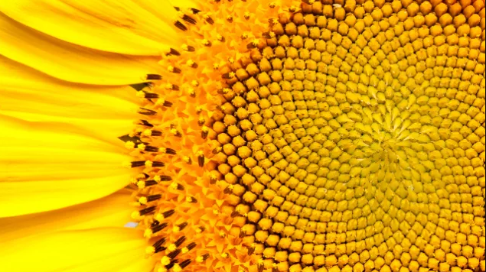
The Golden Ratio is a theory that has always fascinated me. It turns up in nature numerous times.
In fact, it is probably fair to say that the Golden Ratio has inspired thinkers of all disciplines like no other number in the history of mathematics. (Livio, 2008)
Figure 1
This ration is based off the Fibonacci sequence, named after Leonardo Fibonacci after he discovered a series of numbers while calculating the expansion of a rabbit population over the course of one year. The sequence consists of a series of numbers in which each number is the sum of the two numbers before it. The sum of this equation equals 1.618 or “Phi”.
An example of the sequence found in nature is the flower like the lily (three petals) or the buttercup (five petals), as well as others with many petals. These show signs on the ratio when you look at the strategic angle of each petal, as explained by a prosses outlined by Darwin. He explained that petals grow in such a way so that they get the maximum amount of exposure to the elements, each with an angle of 1.618034. Helping them grow a healthy strong plant and making them more attractive to insects like bee’s and butterflies, which in some plants, are essential for baring fruit or going into seed.
Also known as the Golden Ratio, its ubiquity and astounding functionality in nature suggests its importance as a fundamental characteristic of the Universe. (Dvorsky, 2013)
This is an interesting quote as it implies there is a higher cause or system that we don’t yet understand, this sequence shows up in so many places whether it’s in the way that stars move around its epicentre or in the proportions of the human face. It’s interesting to think about what possibilities lie in the future of discovery.

Life –
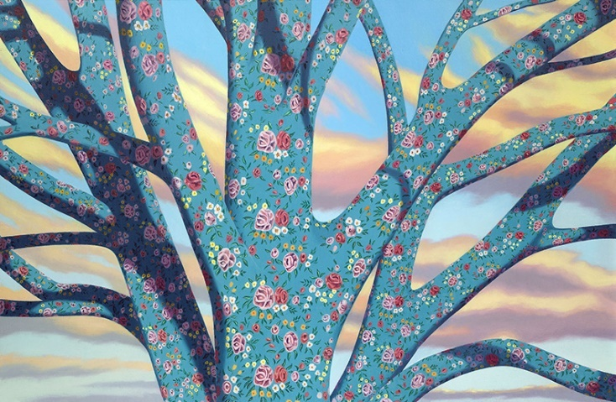
There is a collection of paintings I like called “Antroposcenes” by Jon Bentley, it’s is a collection made up of paintings of trees covered in what looks like wallpaper. Bently is an artist based in Bristol who works in a variety of different media’s although he has a very clear style. His work appears to be quite surrealistic and is described in his own words to make the audience ask questions-
Figure 2
"My paintings come from the same place as my dreams and rarely have a rational explanation thus tending to ask more questions than provide answers" (Bentley, n.d.)
It’s said the trees were painted in response to the recent global, ecological crisis we have entered as a direct consequence of our own doing as a human race. The tree’s representing the natural environment whilst the wallpaper represents the human effect on it by covering it up or essentially killing it. This unfortunately seems to be very accurate.
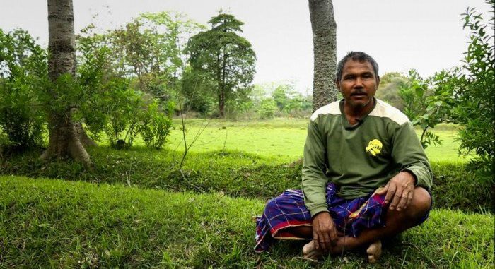
Below is a picture of a man called Jadav ‘Molai’ Payeng (Figure one), also known as the “forest man” due to the incredible mission he undertook at the age of 16 when an island was decimated by erosion in 1979. After noticing dead snakes that had washed up on the sandbar, Jadav set off to seek help from government officials but he was told that nothing could live in those conditions. However, Jadav thought that if there was once life on the Majuli island, there could be life again. Armed with the knowledge he gained from working as a forestry worker he set out to plant 1200 acres of trees on the sandbar next to the Brahmaputra River, this he achieved in 5 years. Now, due to this, a new world of life has been established in this new forest as a herd of 110 Indian elephants now call the forest “Molai” (named after him) home, as well as other animals such as Tigers, Rhinos, Apes and many species of birds.
Figure 3
Payeng believes that people are the cause of the destruction we see in the world, “there are no monsters in nature except for humans” (Payeng, 2012) and has many idea’s on how to help the problems we face with global warming, which he tells anyone who will listen, however, it seems no-one want to help. This man has proven that if one man can plant his own forest bigger than Central Park in America by planting a tree a day, then there is something we can all do to save the planet we live on.
Scientists have estimated that in years to come the erosion on the Majuli island will become so bad that one day there won’t be anything left of it. One man asked Payeng if he thought the Majuli Island could be saved, he simply replied “yes” (Payeng 2012).

Illustration –
Illustration is an artists interpretation of text shown by way of drawing, painting, printing etc. It is mostly known for picture books but more recently it has expanded across the visual world into posters, flyers, animation, video entertainment, reportage as well product packaging and many more medias. In my opinion, illustration has a big part in the things happening in the world, whether you’re trying to get the word out about saving the population of an endangered animal through the media of a picture book or you could be illustrating the next big animation that every child wants to see. Illustration has a way of making things real for the audience, text is one dimension but when you add image to that you not only have a visual but depending on the media can also give you the texture. A real feel for what is being said.
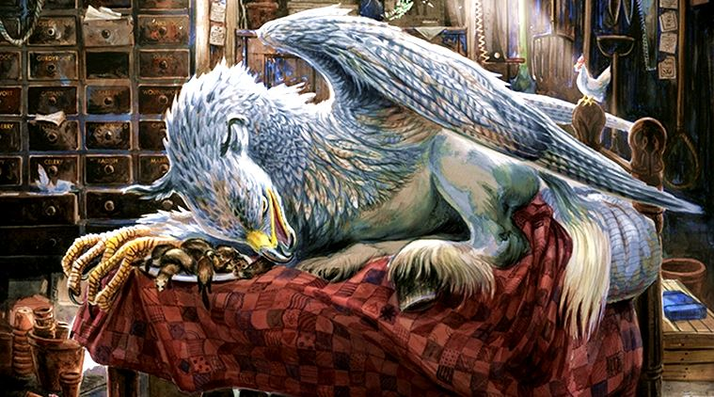
Below is am image of “Buckbeak the Hyppogrif” from Harry Potter and the Prisoner of Azkaban, illustrated by Jim Kay, released last year (2017). Jim Kay has been working for the past few years to bring life to the words of J.K Rowling to all those young book worms and older lovers of the magical world out there. So far, he has only finished the first three books as each one has more than 100 illustrations in them. Unfortunately, this came out after the original books and films but for those who have never seen them and only read these first three have no doubt been enchanted by the beautiful detail in the charming artworks. Even though I grew up with the films and had the books read to me as a child, my love of art and the stories make these illustrations come to life for me, especially as “Buckbeack” is my favourite being in the whole series.
Figure 4

Philip Bannister is one of my favourite illustrators, my favourite medium to use is watercolour so seeing his work is a big inspiration.
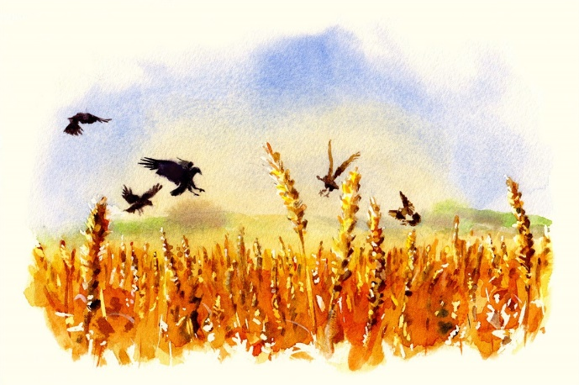
Nature is clearly a big influence in Bannister’s artwork, born in Yorkshire he must have had unlimited access to this beautiful world he’s depicted so well. He has a very distinctive and breath-taking style but still likes to experiment within the watercolour media. Often using a monochrome pallet, he manages to accentuate the contrast of his subject with a clear use of light and shadow whilst capturing decisive features, almost like poetry.
Figure 5
His has a large clientele includes the Daily Telegraph, Country Life and National Geographic as well as large branded products such as Wittards Teas, Badger Beer and Hancocks Jewellers.

Conclusion
The two examples I talked about under the illustration title are based on children but often on not it’s what is aimed at the children that makes the parents look up and change the way they do something, after all, children are the future. In the section that I talked about nature, in my research I found that although Jadav Payeng believes humans are the reason for the global crisis we face, he also stated that
“Children are not taught to plant trees, they are taught to cut down trees. If every child were to plant a tree, then they would be responsible for that tree and would be responsible for helping to save the planet.” (Payeng, 2012)
I think children’s minds are so open to learn about anything that, if done right, they can bring us out of the current crisis our past generations have created.
I think the key is to look at nature, it holds so many secrets to be discovered, then get the children involved. Get them excited about it then see what they come up with, children have the best imaginations because they’re not scared of being wrong. Nothing holds them back, so if we give them the tools to create and build instead of filling their heads with equations and literacy that they really aren’t interested in.
The Question?
Given the state of the current ecological crisis in the word, investigate the effect of a different approach on children’s education that could have an impact. You should include artists/thinkers in your investigation that support any findings.
Bibliography

Websites and Video’s
- http://www.bbc.co.uk/homes/design/period_artnouveau.shtml
- Macklowegallery.com. (2018). Emile Gallé - Decorative Artists - Artist Biographies - Macklowe Gallery. [online] Available at: http://www.macklowegallery.com/education.asp/art+nouveau/Artist+Biographies/antiques/Decorative+Artists/education/Emile+Gall%26%23233%3B/id/8 [Accessed 4 May 2018].
- Youtube (2018). Forest Man. [image] Available at: https://www.youtube.com/watch?v=HkZDSqyE1do [Accessed 9 May 2018].
- INSH, Youtube (2018). The Indian Man Who Planted a Forest to Save an Island. [video] Available at: https://www.youtube.com/watch?v=L4EehKslx90 [Accessed 9 May 2018].
- Dvorsky, G. (2013). 15 Uncanny Examples of the Golden Ratio in Nature. [online] Io9.gizmodo.com. Available at: https://io9.gizmodo.com/5985588/15-uncanny-examples-of-the-golden-ratio-in-nature [Accessed 9 May 2018].
- Bentley, J. (n.d.). Jon Bentley fine art, sign making and public art. [online] Jonbentley.co.uk. Available at: http://www.jonbentley.co.uk/index.html [Accessed 9 May 2018].
- Mylifeinart.com. (n.d.). Jon Bentley | My Life in Art. [online] Available at: http://mylifeinart.com/2013/jon-bentley/ [Accessed 9 May 2018].
- L. Smith, H. (2018). Illustration. [online] Illustrationweb.com. Available at: https://www.illustrationweb.com/about#team [Accessed 9 May 2018].
- Pryde, J. (2017). Peek Over Our Shoulders: What Rioters are Reading on September 14, 2017. [online] BOOK RIOT. Available at: https://bookriot.com/2017/09/14/rioters-reading/ [Accessed 9 May 2018].
Books-
- Livio, M. (2008). The Golden Ratio. [Place of publication not identified]: Crown Publishing Group, p.6.

Images-
- Figure 1 - Dvorsky, G. (2013). 15 Uncanny Examples of the Golden Ratio in Nature. [online] Io9.gizmodo.com. Available at: https://io9.gizmodo.com/5985588/15-uncanny-examples-of-the-golden-ratio-in-nature [Accessed 9 May 2018].
- Figure 2 - Bentley, J. (n.d.). Jon Bentley fine art, sign making and public art. [online] Jonbentley.co.uk. Available at: http://www.jonbentley.co.uk/index.html [Accessed 9 May 2018].
- Figure 3 - DreamcatcherReality (2018). This Man Single-Handedly Planted A Forest Bigger Than Central Park. [image] Available at: http://dreamcatcherreality.com/man-single-handedly-planted-forest/ [Accessed 9 May 2018].
- Figure 4 - Chakrabarti, P. (2017). Fantastic Drawings and Where To Find Them: A sneak peek into Jim Kay’s ‘Harry Potter’ illustrations. [online] The Indian Express. Available at: http://indianexpress.com/article/lifestyle/art-and-culture/fantastic-drawings-and-where-to-find-them-a-sneak-peek-into-jim-kays-harry-potter-illustrations-4933139/ [Accessed 9 May 2018].
- Figure 5 - L. Smith, H. (2018). Illustration. [online] Illustrationweb.com. Available at: https://www.illustrationweb.com/artists/PhilipBannister/view [Accessed 9 May 2018].

