Workshop TimeValue

1. Albert will retire in 15 years. If he wants to withdraw a lump sum amount of $150,000 at the time when he retires, how much does he have to deposit now into a pension plan earning 6% annually? (Assuming that he does not invest or withdraw any money from the account within the next 15 years).
2. Albert will retire in 15 years. If he deposits now of $150,000 into a pension plan earning 6% annually, how much can he withdraw as a lump sum amount at the time when he retires? (Assuming that he does not invest or withdraw any money from the account within the next 15 years).
3. Albert will retire in 15 years. If he deposits $10,000 every year into a pension plan earning 6% annually until he retires, how much can he withdraw as a lump sum amount at the time when he retires? (Assuming that the first deposit he will make is at the end of year 1).
4. Albert will retire in 15 years. If he deposits $10,000 every year into a pension plan earning 6% annually until he retires, what is the total present value of all the deposits he make for the next 15 years? (Assuming that the first deposit he will make is at the end of year 1).

Use formulas on the lecture notes OR use present/future value (of single amount and annuities) tables
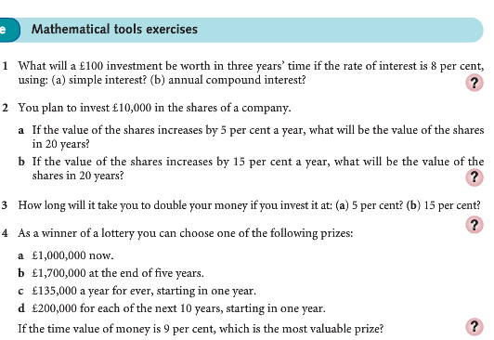
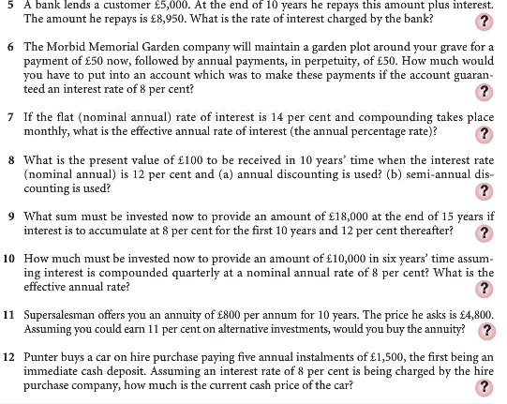

Solutions to Workshop TimeValue

1. Albert will retire in 15 years. If he wants to withdraw a lump sum amount of $150,000 at the time when he retires, how much does he have to deposit now into a pension plan earning 6% annually? (Assuming that he does not invest or withdraw any money from the account within the next 15 years).

Solution: finding the present value of a single amount:

- Or from table 1: n=15, r=0.06 to get 0.4173
Present value=150,000*0.4173=62595.

Note: solutions from a) and b) should be the same, the difference being the rounding. a) is more accurate, while b) works as a simple approximate.

2. Albert will retire in 15 years. If he deposits now of $150,000 into a pension plan earning 6% annually, how much can he withdraw as a lump sum amount at the time when he retires? (Assuming that he does not invest or withdraw any money from the account within the next 15 years).

Solution: finding the future value of a single amount:

- Or from table 3: n=15, r=0.06 to get 2.3966
future value=150,000*2.3966=359,490.

3. Albert will retire in 15 years. If he deposits $10,000 every year into a pension plan earning 6% annually until he retires, how much can he withdraw as a lump sum amount at the time when he retires? (Assuming that the first deposit he will make is at the end of year 1).

Solution: finding the future value of an annuity:

- $FV of Annuity=PV of Annuity*(1+i)^n=[(1/i-(1/i)/(1+i)^n )*A]*(1+i)^n=[(1/0.06-(1/0.06)/(1+0.06)^15 *10000]*(1+0.06)^15=232,760$
- from table 4: n=15, r=0.06 to get 23.2760
future value=10,000*23.2760=232,760.

4. Albert will retire in 15 years. If he deposits $10,000 every year into a pension plan earning 6% annually until he retires, what is the total present value of all the deposits he make for the next 15 years? (Assuming that the first deposit he will make is at the end of year 1).

Solution: finding the present value of an annuity:

- $PV of Annuity=(1/i-(1/i)/(1+i)^n )*A=(1/0.06-(1/0.06)/(1+0.06)^15 *10000=97122$
- from table 2: n=15, r=0.06 to get 9.7122
present value=10,000*9.7122=97,122.



