M4x01003 Information Engineering Assignment 1
Pembrokeshire College

James Long

Contents
Introduction 2
Entity Relationship Diagram (ERD) 3
Level 0 DFD 4
Level 1 DFD 5
Conclusion 7

Introduction
Throughout this document I will be providing screenshots and evidence to support the decisions I have made when making the diagrams that I have provided. In this document there will be supporting information for an Entity Relationship Diagram (ERD), a Level 0 Data Flow Diagram (DFD) and also a Level 1 Data Flow Diagram (DFD).

Entity Relationship Diagram (ERD)
Suitable conventions used, PKs identified – not sure about Staff_Name, Parent_Name, Lunch_Paid as PK. FKs identified – not sure about staff_name as FK. You appear to have limited parents to one child. Some attributes may be missing (Contact Information). Some of your relationships you have taken your PK FK the wrong way – Parent, Lunch, Child.
In this section I will be writing about the ERD I created along with any assumptions and why I have decided to relate tables together etc.
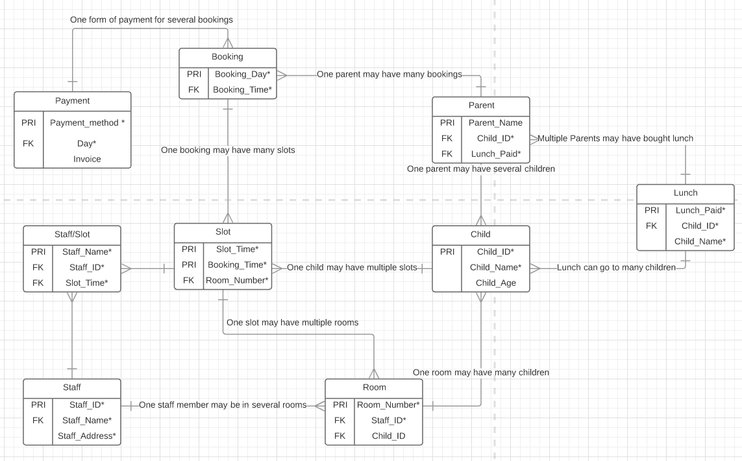
Starting with the “Parent” table, I have decided to make the “Parent_Name” a primary key due to the significance of that information what if 2 Joe Bloggs?. Also linked into the “Parent” table is the foreign key known as ‘”Lunch_Paid”, this is because it is the primary key of the lunch table and several parents can buy lunch for their children. In the “Lunch” table there is a foreign key which comes from the “Child” table and that is the “Child_ID” because the children who have had lunch paid for by the parents will be populated into this table.
In the “Staff” table the primary key here is the “Staff_ID” entity, this will then be used again as foreign keys in both the “Room” and “Staff/Slot” Tables to identify which room that staff member is in along with what slots they have been allocated. In the “Slot” table the primary key is “Slot_Time” this is then used again in the “Staff/Slot” table.

Level 0 DFD
Appropriate data flows included, but more could perhaps have been identified at this level. You could perhaps show different types of staff handling different data.
In this section I will be talking about the Level 0 DFD I have created and any assumptions I have made here.
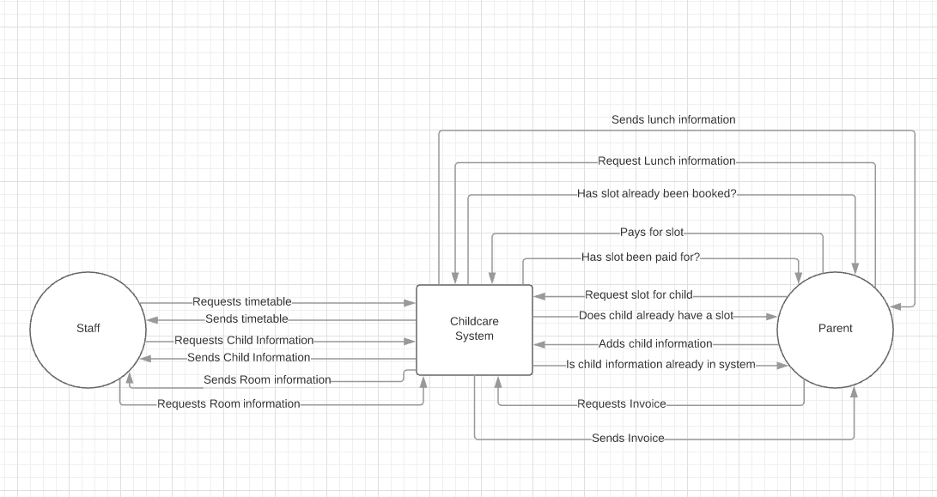
Firstly I have made the assumption that the child has no access to any of the system and it is only dealt with between the parents and the staff, this is because the children are all under the age of 18 and therefore should not be able to alter any information.
Here, the only external entity is the “Childcare System”, this controls all of the data going in and out to either members of staff or to the parents. Parents are able to request slots for children, invoices, lunch information and also they can add in children information. The system will then either send them the required information that they have requested or check if the information has already been entered in the past. The staff are able to request their timetables along with room information and the children’s information. The system will then send them the information for any requirements.

Level 1 DFD
Appropriate data flows included, but more detail could have been included – eg process 2, child info into process, current child info to parent, data to update from parent into process, etc. Some additional processes could also have been included – print out record diary, on screen invoice, etc. Some of your processes may require additional data store inputs – rooms, teachers and children for timetables.
In this section I will be talking about the Level 1 DFD I have created and any assumptions I have made here.
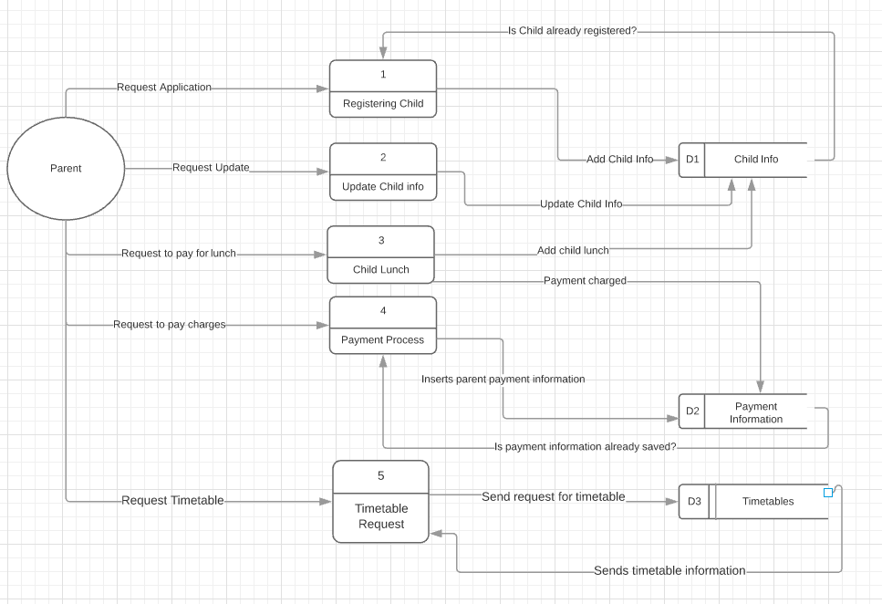
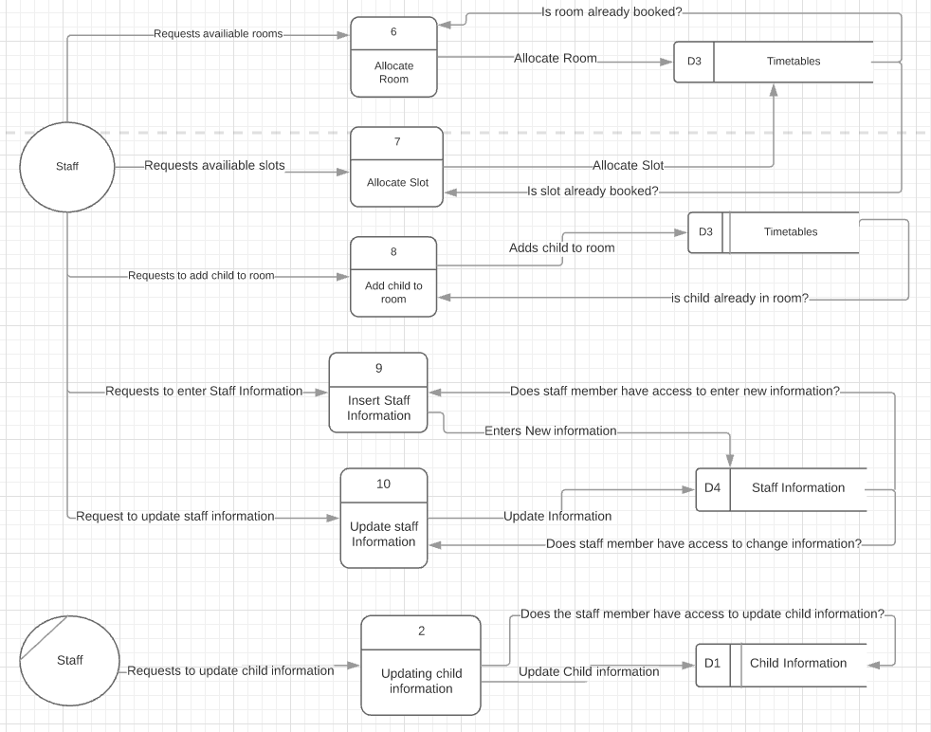
Pictured above is the Level 1 Data Flow Diagram that I have created. Here again I have assumed that the only people who can change information regarding to the children is members of staff and also parents which makes them the only 2 external entities.
For the “Parent” external entity I have made it so that they can request a registration form so that they can input the child’s details, this is stored inside the Child Information data store. The system will check if this information has already been inputted, if not then the parent will be able to insert the child’s details. The parent is also able to update the child’s information. The parent is also able to pay for the child’s lunch if they want to and this will then be stored inside a separate data store titled “Payment Information” it will also check to see if the information has already been saved in the past so that they wouldn’t need to input the information again. Finally they are also able to request a timetable which would be stored inside the “Timetables” data store.
For the “Staff” external entity they would be able to request available slots and then allocate slots based off of this information, this would also be stored inside the timetables data store. Next they would request to add a child to a room, if they are already in the room then they will be unable to do this. This information is also inside the “Timetable” data store. The staff will also be able to insert new staff information as well as updating old staff information, the system will check their access levels before allowing them to do this and will store this information inside the “Staff Information” data store. Finally the staff will also be able to update child information if they have the correct access level. This is then stored inside the “Child Information” data store.

Conclusion
Overall this is the sort of system I have decided to put in place for the requirements that Holiday Club West has asked for. The Entity Relationship Diagram shows the tables that I think should be implemented into the database they will have along with how they are related whereas the Data Flow Diagrams give a visual image of how data should flow between the external entities, process and data stores.

