

UNIVERSITY OF WALES TRINITY SAINT DAVID
MSc Financial Management
Corporate Governance Issues in Financial Reporting:
A Critical Analysis of Carillion PLC
Module: Corporate Governance (BMMB7018)

Student ID: 2506443
Student Name: Protick L Gomes

Abstract
This report is a critical analysis of the Carillion PLC corporate governance and earnings management failures that caused the company's collapse in January 2018. Carillion was a listed company that was amongst the largest construction and outsourcing firms in the United Kingdom based in London on the Stock Exchange. The report applies the agency theory and stakeholder theory as discussed by Freeman to discuss how aggressive accounting practices, poor board oversight, and inadequate independent audit enabled a lack of financial reporting over a period of years. The discussion has appraised the ethical factors about such failures, as well as their impacts to a significant proportion of stakeholders. The report provides the reaction of regulatory and institutional, which followed and provides future recommendations on how to have better corporate governance, financial reporting transparency and accountability of stakeholders within such like organizations.
Table of Contents
Abstract 2
1. Introduction 4
1.1 Defining Earnings Management 4
1.2 Introducing the Carillion Case 4
2. Conceptual Background: Earnings Management, Incentives, and Governance 5
2.1 Types of Earnings Management 5
2.2 Why Managers Engage in Earnings Management 5
2.3 Agency Theory as the Theoretical Lens 6
3. Case Analysis: Carillion's Earnings Management and Governance Failure 7
3.1 Background and Timeline of the Collapse 7
3.2 The Reverse Factoring Mechanism 7
3.3 Board Oversight Failures 8
3.4 External Audit Failure 10
4. Ethical Evaluation: Applying Stakeholder Theory 10
4.1 The Stakeholder Theory Framework 10
4.2 Ethical Violations Mapped Against Stakeholder Expectations 10
4.3 Could Ethical Decision-Making Have Prevented the Problem? 12
5. Impact on Stakeholders and the Market 12
5.1 Overview of Stakeholder Harm 12
5.2 Impact on Shareholders and the Market 13
5.3 Impact on Employees, Pensioners, Suppliers, and Communities 13
6. Regulatory and Audit Failure 14
6.1 Violations of the UK Corporate Governance Code 14
6.2 KPMG's Audit Failure and Regulatory Sanctions 15
7. Actions Taken and Recommendations 15
7.1 Institutional Responses 15
7.2 Recommendations for Future Practice 16
8. Conclusion 20
References 21

1. Introduction

1.1 Defining Earnings Management
Earnings management is a concept that lies at the boundary between accounting, corporate governance and business ethics. In its simplest definition, it is the intentional manipulation of financial outcomes by the preparers or approvers of financial statements. According to Healy and Wahlean (1999), it is the application of judgment in financial reporting that leads to transactions that distort financial reporting to either deceive some stakeholders about the true economic performance or affect contractual results. It is an earlier and related formulation as given by Schipper (1989), who outlines it as purposeful intervention in external financial reporting process with the main aim of gaining private benefits. All the definitions underscore the intentionality as the difference that lies between legitimate accounting judgment and manipulation.
It is also notable that not all the earnings management is illegal. It may exist within the parameters of accounting standards, and this vagueness makes it especially hard to identify and control. According to Thu Hien Bui (2024), research interest in earnings management has increased significantly, and over half of the published works on this topic are dated after 2016. Such interest in the academic literature can be attributed to the increasing practical applicability of the subject, especially after high-profile corporate crashes in the United Kingdom.

1.2 Introducing the Carillion Case
Carillion PLC has grown into one of the most recognized construction and facilities management companies in the UK through acquisitions since its incorporation in 1999. At its height, the company had more than 43,000 employees in the United Kingdom and abroad and held contracts with major government agencies such as the National Health Service and the Ministry of defense. Carillion began compulsory liquidation on 15 January 2018 and became the largest trading liquidation in the history of the UK corporate sector.
The magnitude of the collapse was phenomenal. According to Patil (2023), Carillion left behind about £ 2.6 billion in pension liabilities and around £2 billion in its supply chain. The subsequent parliamentary investigation witnessed the company as an unsustainable corporate time bomb (House of Commons, 2018). To illustrate the combination of governance failures, aggressive accounting, and ethical deficiencies that lead to disastrous results, the story of Carillion is used in this report as a detailed and well-documented example.

2. Conceptual Background: Earnings Management, Incentives, and Governance

2.1 Types of Earnings Management (EM)
Earnings management can broadly be grouped into two categories, each with distinct mechanisms and implications. Table 1 below summarizes these types and their key characteristics.

Table 1: Types of Earnings Management Definitions and Mechanisms (Self-made, adapted from Roychowdhury, 2006 and Yang et al., 2025)
Type | Definition | Common Mechanisms | Detection Difficulty
Accrual-based EM | Manipulation of accounting estimates within GAAP | Adjusting provisions, delaying expense recognition, changing depreciation methods | Moderate - detectable through accrual models
Real activities EM | Altering actual business operations to influence reported results | Overproduction, cutting R&D, reverse factoring reclassification of liabilities | High - often disguised within normal business decisions

The framework through which Roychowdhury (2006) defines the real activities manipulation is that managers distort the timing or the structure of real business decision-making so that they can report superior financial results. This type is quite dangerous, as it has the potential to cause long-term damage to a firm's operational capacity despite generating short-term reporting gains. Yang et al. (2025) goes further to demonstrate that managers will the tendency to trade-off between the activity manipulation of accruals and real activities basing on the degree of supervision. At a time when audit scrutiny is intensifying, real activities manipulation is more appealing as it is less evident. In the case of Carillion, as discussed in Section 3, the reverse factoring was the primary mode of this form of manipulation.

2.2 Why Managers Engage in Earnings Management
Any serious consideration of governance requires understanding of the motivations that lead to earnings management. Based on a systematic review of more than three hundred articles, Lonwabo Mlawu et al. (2025) find the following list of motivational factors. Three of them are especially applicable to the case with Carillon.
1. Financial distress and debt covenants. As companies begin hitting the boundaries of their borrowing facilities, managers are under intense pressure to show performance that will keep them within agreed covenants. The debt ratio of Carillion increased significantly in the years preceding the collapse, and this pressure was one of the main factors driving top management's accounting decisions.
2. Bonus and incentive-linked performance targets. Sheikh and Ali Shah (2016) provide empirical evidence that the likelihood of CEO compensation being associated with short-term financial performance is very high when compensation is closely related to it. Executive bonuses received by Carillion were dependent on a so-called cash conversion ratio that, as explained in Section 3, could be easily manipulated by using supply chain finance agreements. The bonus scheme, as such, left management with a direct financial incentive to exaggerate that ratio, irrespective of the firm's underlying performance.
3. Capital market pressure. Listed companies are under constant pressure by analysts and institutional shareholders and managers can manipulate income to match analyst projections, maintain dividend policies or to uphold share price. Gajdosikova et al. (2022) affirm that earnings management that boosts income is particularly prevalent in large firms with publicly listed stocks, which also perfectly matches the description of Carillion. In the case of Carillion, the need to keep up the pretence of financial well-being was also pertinent to its capacity to keep procurement contracts in the public sector, which also provided another business aspect to the pressure that its management experienced in the capital market.

2.3 Agency Theory as the Theoretical Lens
The most relevant theoretical framework that can be used to explain the failure of the governance of Carillion is the agency theory that was initially developed by Jensen and Meckling (1976). The agency theory implies that a firm is a nexus of contracts between the agents (managers) and the principals (shareholders), and the agents have both the motivation and the possibilities of executing actions that can benefit themselves at the cost of the principals. The solution to this tension lies in the efficiency of the monitoring systems like independent boards, external auditors, and transparent reporting systems. When all these three mechanisms do not work at the same time, as it happens in the case of Carillon, the outcome may be disastrous, as demonstrated in the case.

3. Case Analysis: Carillion's Earnings Management and Governance Failure

3.1 Background and Timeline of the Collapse
In 1999, Carillion was formed by demerging the services division of Tarmac and expanded rapidly using an acquisitions strategy. By the mid 2010s, it had acquired large government contracts in the construction, healthcare facilities management and defence sectors. There was however, something wrong under the carpet whereby the business was mounting up severe financial problems. According to Yang (2025), the fall of Carillion cannot be reduced to the misbehaviour of certain individuals but was more to do with deeper structural flaws in the composition of the company board and the UK governance system in general. The major events leading to liquidation have been put down in a visual timeline as shown in figure 1 below.
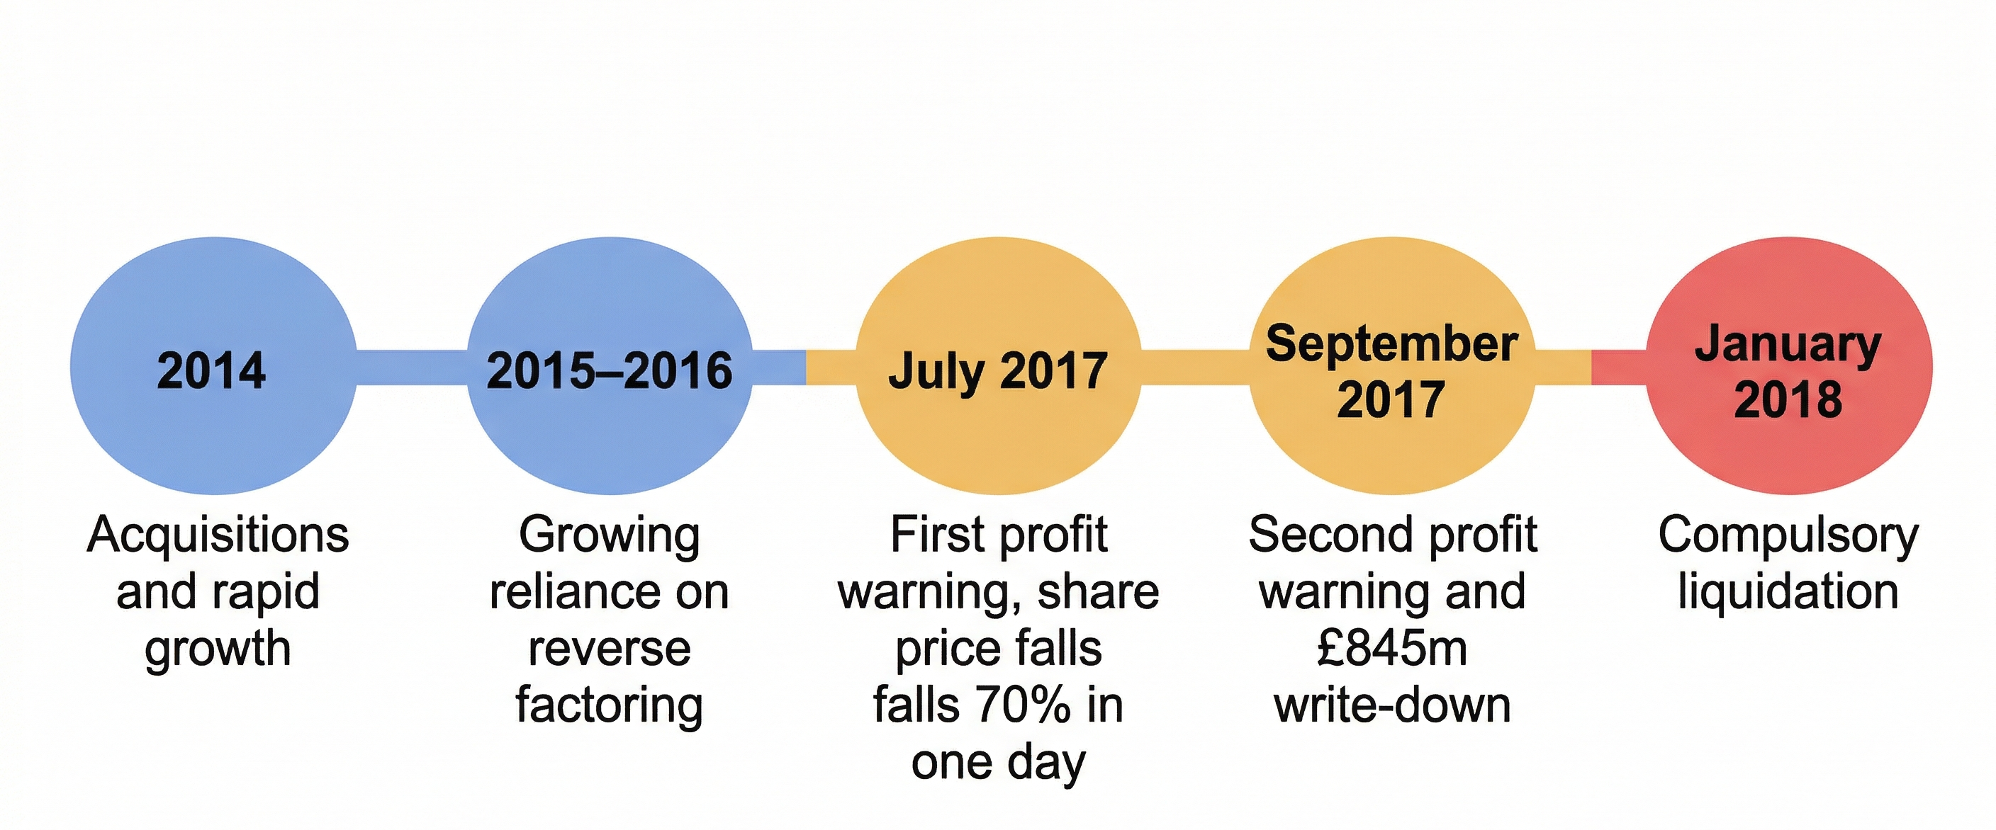

Figure 1: Timeline of Carillion's Path to Collapse (2014–2018) Self-made.

3.2 The Reverse Factoring Mechanism
The most technically important aspect of the earnings management by Carillion was that Carillion utilized the technique of reverse factoring, which was also referred to as the supply chain finance. According to Higson (2018), this programme allowed Carillion to pay suppliers late instead of on time due to the long terms under which the financing bank paid the invoices on behalf of Carillion. The accounting issue that caused concern was that the resulting liability on the bank was not considered a borrowing but a trade payable.
A maximum £498 million bank liabilities were misclassified in this manner to result in a material distorting effect on critical financial ratios relied upon by investors and analysts to determine the health of the company. This also bloated the cash conversion ratio which was the foundation on which the executive bonuses were based. According to Filatotchev and Allcock (2010), remuneration systems designed with performance metrics on a narrow basis generate systematic incentive to the manager to concentrate on these metrics at the expense of actual underlying performance. In the case of Carillion, it seems that this dynamic had been functioning for several years until the company's troubles became visible to the public.

3.3 Board Oversight Failures
The involvement of the board of directors in letting this situation go so long is a core issue of this report. Hsu and Yang (2022) find that board size and composition are critical in limiting earnings management, especially during periods of financial strain. Table 2 below aligns the board governance of Carillion with the provisions of the UK Corporate Governance Code (FRC, 2018).
Table 2: Carillion Board Composition Weaknesses vs. UK Corporate Governance Code 2018 Requirements (Self-made, based on FRC (2018) and House of Commons (2018))
Governance Dimension | UK Code 2018 Requirement | Carillion's Position | Assessment
Board independence | At least half the board should be independent non-executives | Long serving members; senior independent director role poorly defined; potential conflicts of interest | Weak
Audit committee | At least three independent members; one with financial expertise | Lacked sufficient sector-specific financial expertise in construction and services | Deficient
Remuneration structure | Should promote long-term success; avoid rewarding failure | Bonuses linked to cash conversion ratio susceptible to manipulation via reverse factoring | Problematic
Risk oversight | Board responsible for robust risk management | No dedicated risk committee: board did not adequately challenge management's projections | Absent
CEO/Chair separation | Roles of chair and CEO should be formally separate | Formally separate but chair failed to exercise sufficient independent challenge of executive decisions | Nominally compliant

The empirical analysis by Farzaneh et al. (2023) reveals that audit committee independence and expertise are negatively linked with earnings management. The audit committee of Carillion failed to conform to the standard outlined by FRC (2018), especially in terms of expertise in specific financial matters within the sector. This is important since the arrangements of reverse factoring were technically difficult to an extent that a committee which lacked the relevant knowledge may not have been aware of the accounting risk involved.

3.4 External Audit Failure
KPMG (Klynveld Peat Marwick Goerdeler) had been the external auditor to Carillion over a nineteen-year long period prior to the collapse, including accounts where it issued unqualified audit opinions which, as it was subsequently discovered, materially misstated the financial position of the company. According to Burlacu et al. (2024), discretionary accruals largely misrepresent the value relevance of financial statements and that misrepresentation ought to be possible to detect through a comprehensive audit procedure. Duboisee et al. (2025) focus on the ways in which the blame-shifting after the collapse blurred the scope of how the oversight mechanisms had fallen short together. In Section 6, it is explained how the FRC sanctioned KPMG again.

4. Ethical Evaluation: Applying Stakeholder Theory

4.1 The Stakeholder Theory Framework
In terms of assessing the ethical aspects of Carillon behavior, this part relies on the stakeholder theory developed by Freeman because it is the main analytical tool. According to Freeman (2007), maximisation of returns to shareholders is not the sole purpose of a firm but rather creating value to all groups of stakeholders who are legitimately interested in the operations of the firm. These are the employees, suppliers, customers, lenders, pensioners and the communities that the firm operates in. The managerial ethical responsibility in this opinion is to level these competing interests in a fair manner.
Freeman et al. (2004) go on to claim that economic goals and ethical requirements cannot be separated. A company that makes financial gains at the detriment of one of the stakeholder groups in favor of another has merely passed the costs onto them instead of making true value. Mahajan et al. (2023) offer a systematic review of the stakeholder theory that validates three fundamental research clusters, which include sustainability, performance, and stakeholder management. The behavior of Carillion applies to all of them, but stakeholder management and sustainability clusters are especially applicable to the case.

4.2 Ethical Violations Mapped Against Stakeholder Expectations
The moral malpractices in Carillion can be explained at two levels. The former involves the option of adopting aggressive accounting methods. The second one is about whether to keep paying dividends and executive bonuses as the company's underlying financial troubles became evident. The stakeholder group maps these violations as in Table 3 below.
Table 3: Ethical Violations by Stakeholder Group - A Stakeholder Theory Analysis (Self-made, based on Freeman (2007), Freeman et al. (2004), and NAO (2018))
Stakeholder Group | Legitimate Expectation | What Carillion Did Instead | Ethical Breach
Shareholders | Accurate financial information for investment decisions | Published misleading accounts; inflated cash conversion ratio to sustain dividends | Violation of transparency and accountability
Employees | Job security and fair treatment | 43,000 jobs put at risk; pension promises left unfulfilled | Violation of duty of care
Suppliers | Timely payment for goods and services rendered | Extended payment terms to 120 days; £2bn owed at collapse | Exploitation of supply chain power imbalance
Pensioners | Pension entitlements as per contractual obligation | £2.6bn pension deficit accumulated without adequate remediation or disclosure | Breach of contractual and ethical duty
Government and Taxpayers | Reliable delivery of contracted public services | Contracts abandoned at liquidation; taxpayers bore costs of £148–223m | Failure of public accountability

As Abdulaziz (2024) notes, when the principal-agent gap increases due to weak governance, a more likely behaviour is the promotion of managerial self-interest rather than benefiting the larger stakeholder welfare. This is what was evident at Carillion: dividend payments and executive bonuses continued even as the pension deficit kept increasing, and suppliers were pushed to unreasonable commercial limits. Freeman and Velamuri (2008) believe that companies owe ethical duties to all stakeholders beyond what is required by law. Carillion failed miserably on this measure.

4.3 Could Ethical Decision-Making Have Prevented the Problem?
This is a logical question to be posed. On the one hand, had senior management conducted a proper stakeholder test of their accounting choices, they would have seen the damage that the reverse factoring reclassification would inflict on investors and creditors who depended on accurate leverage information. Freeman et al. (2021) turn the argument around and argue that ethical governance must be supported by a structure: personal ethical intentions will hardly outweigh incentive systems that support short-term monetary achievement. At Carillion, both dimensions were lacking. Jensen and Meckling (1976) would interpret such decisions as the foreseeable performance of an agency organisation where monitoring failed: the agents (managers) would adopt strategies that would benefit them in the short run and pass on the long-run risks to shareholders, employees, and the state.

5. Impact on Stakeholders and the Market

5.1 Overview of Stakeholder Harm
The collapse of Carillion affected virtually all the stakeholder groups outlined by Freeman's theory. The visual view of these impacts is presented in Figure 3 below and followed by a more detailed analysis presented in the subsections below
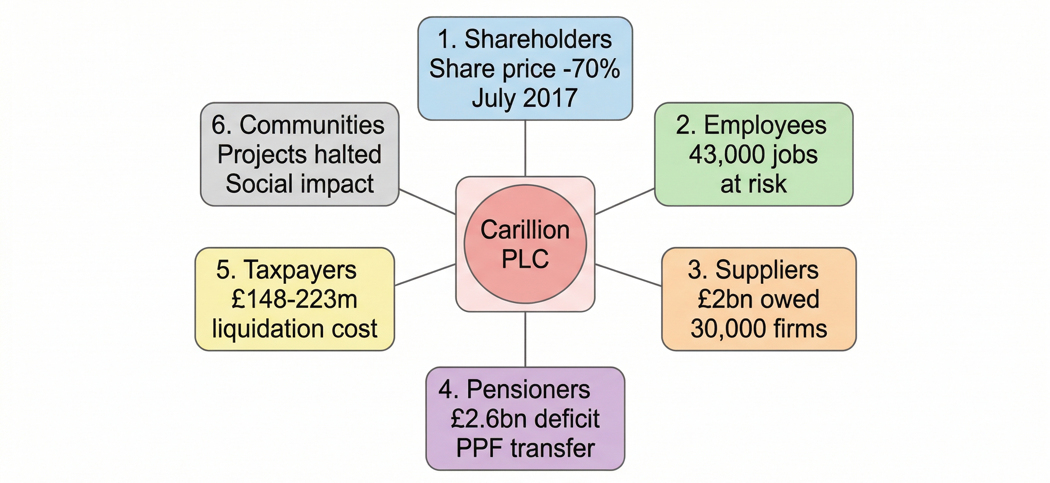

Figure 3: Stakeholder Impact Map Carillion Collapse (2018) Self-made. See detailed analysis in Sections 5.2 and 5.3.

5.2 Impact on Shareholders and the Market
The stock market's response to Carillion's initial profit warning in July 2017 was swift and harsh. The company's market share dropped by almost 70 per cent in a single trading day, demonstrating how much the reported financial position had fooled the market. Elsayed et al. (2022) suggest that, through corporate governance failures such as those exhibited by Carillion, there is a loss of market confidence in the company in question and in the quality of financial reporting in general amongst similar companies. The following chart holder shows share price trend of Carillion between 2015 and liquidation in January 2018.
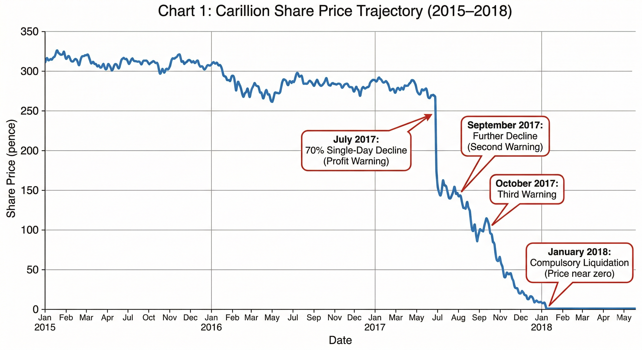

Chart 1: Carillion Share Price Trajectory (2015–2018). Source: London Stock Exchange / Macrotrends.net.

Velte (2021) surveys 98 archival studies on corporate financial misconduct and finds that firms with weaker board expertise and less diversity are much more likely to commit the type of sustained misreporting that Carillion did. This is an important finding, as it implies that the market damage was, to some extent, predictable given what was known about Carillion's governance structure.

5.3 Impact on Employees, Pensioners, Suppliers, and Communities
The collapse of Carillon had a significant human impact. It left 43,000 employees in immediate uncertainty, and many were laid off in the months after the liquidation. The PS2.6 billion deficit in the pension scheme was transferred to the Pension Protection Fund, resulting in many pensioners receiving lower benefits than they would have under their contracts. Angsoyiri et al. (2026) also raise an important point: that formal governance structures should be backed by real-world expertise and accountability. At Carillion, paper-based formal forms were absent until they were given substance, enabling these groups to safeguard against the effects of managerial actions.
The size of the pension deficit is a particularly ethical concern. That decision to maintain dividend payments even as the deficit increased is a clear example of prioritising the short-term interests of shareholders over the long-term liabilities to scheme members. It also affected about 30,000 supplier businesses, most of which are small and medium-sized enterprises that lacked the capacity to withstand the financial shock. As noted by Singh (2025), established board networks can create a space where external challenges are successfully muted, and in this example, they may have deterred suppliers from expressing concerns about their payment experiences. The National Audit Office estimated that the cost to taxpayers of managing the liquidation was between £148 million and £223 million (NAO, 2018), and around 420 public contracts were disrupted at the point of collapse.

6. Regulatory and Audit Failure

6.1 Violations of the UK Corporate Governance Code
The FRC (2018) UK Corporate Governance Code establishes five principles to evaluate the actions of boards of listed companies: board leadership and company purpose; division of responsibilities; composition, succession, and evaluation; audit, risk, and internal control and remuneration. Table 2 in Section 3.3 shows that Carillion's governance was wanting across all five dimensions. The greatest failures were in areas related to audit and risk management, where no special risk committee existed, and compensation, where bonuses and incentives gave active impetus to the management of short-term metrics.
Empirical evidence on this subject is provided by Yahaya (2025), who conducted a study of 153 listed companies over 10 years, and the results show that increased board independence is negatively and significantly associated with earnings management. One issue with the Carillion board was that some members had served long terms, casting doubt on whether long-term service affected their ability to exercise the independent thinking needed in governance. The independent audit committee status of the financial institutions studied by Jameel et al. (2024) confirms the independent audit committee's avoidance of earnings management as a significant strength, which supports the idea that the audit committee's vulnerability in Carillion was a critical governance failure.

6.2 KPMG's (Klynveld Peat Marwick Goerdeler) Audit Failure and Regulatory Sanctions
The practice of KPMG as the auditor of Carillion is worth attention. Defond and Zhang (2025) state that auditors fail audits when they are under pressure to become more independent due to long-term client relationships, because they are paid on fees, and because their cultures encourage client service rather than professional scepticism. The presence of all three factors has persisted throughout the KPMG-Carillion relationship over the nineteen-year history of unbroken interaction.
According to FRC (2023), KPMG did not have enough evidence to give unqualified audit opinions, and that the failure continued in several audit periods. The PS21m sanction imposed then was the largest ever by the FRC. According to Defond and Zhang (2025), however, this amount of a fine constitutes a minor percentage of the audit fees that auditors would make after a span of nineteen years and this prompts the question of whether financial penalties can change auditor behaviour of such a large firm.

7. Actions Taken and Recommendations

7.1 Institutional Responses
The institutional reaction to the collapse of Carillion was very large-scale, but there are doubts about whether it was comprehensive enough. The overall responses of the regulatory bodies and institutional actors in the post-collapse years are summarised in Table 4 below.
Table 4: Regulatory and Institutional Responses Following Carillion's Collapse (Self-made, based on FRC (2023), FRC (2024), House of Commons (2018), NAO (2018), and Patil (2023))
Responding Body | Action Taken | Outcome / Status
Financial Reporting Council | Investigated and sanctioned KPMG; £21m fine | Largest FRC fine at the time; two former partners also disciplined
House of Commons Joint Committee | Parliamentary inquiry report published (2018) | Recommended audit market reform and governance code revision
National Audit Office | Published an investigation into the government management of the collapse | Highlighted procurement weaknesses: taxpayer cost estimated at £148–223m
Insolvency Service | Investigation into the conduct of former directors | Criminal and civil proceedings were initiated against multiple individuals
Financial Reporting Council (FRC) | Revised UK Corporate Governance Code (2024 edition) | New requirement: boards must explicitly confirm the adequacy of internal controls
Pension Protection Fund (PPF) | Assumed responsibility for the Carillion pension scheme | Members received reduced benefits under the PPF statutory compensation cap

The revised FRC (2024) UK Corporate Governance Code placed a new requirement on boards to expressly confirm that they have reviewed the effectiveness of their material internal control frameworks. This is an immediate reaction to reports that the Carillion board lacked sufficient control over financial reporting risks. Comparing the experience of governance reforms across various jurisdictions, Paganou et al. (2025) find that a combination of enhanced requirements for audit committee strength, the mandatory requirement to implement board independence, and clearer enforcement of regulations is associated with a lower incidence of financial misconduct.

7.2 Recommendations for Future Practice
This section presents six recommendations for the future that directly address the identified governance failures in the Carillion case. The recommendations are based on the academic support discussed in previous parts of this paper and are supported by explaining the change these specific recommendations are intended to implement, why they should be implemented, and the extent to which they would have produced a material difference in the case of Carillion.
1. Strengthening board expertise and independence. The board of Carillion permitted the reverse factoring reclassification to continue for several years, in part due to the lack of knowledge of the different sector financials that non-executive directors of a company would need to challenge management accounting judgements. Velte (2021) concludes that, across 98 archival studies, board expertise and diversity are among the most powerful predictors of reduced financial misconduct. Yahaya (2025) offers direct empirical evidence that the greater the level of board independence, the lower the earnings management. The change suggested is a compulsory skills matrix disclosure in the annual report that certifies that at least one non-executive director possesses up-to-date skills in the business's main operating sector.
2. Reforming the audit relationship. KPMG audited Carillion for over nineteen years, and it did not recognise the material misclassification of supply chain finance liabilities. As Defond and Zhang (2025) demonstrate, long-term auditor-client relationships pose a major risk of diminished professional scepticism, especially when fee revenue from an individual client is commercially significant. The proposed reform has two elements. To start with, there must be a requirement that firms listed on the Financial time stock exchange (FTSE) have their audit firm rotated every 10 years, with a 5-year cooling-off period before they can be re-appointed. Second, the amount of audit fees paid to the incumbent company must be disclosed alongside those of at least two similar audit firms, thereby building a market transparency mechanism.
3. Restructuring executive remuneration frameworks. The Carillon case has one of the closest causal relationships between the design of the executive bonus scheme and the manipulation of the cash conversion ratio. Since the bonuses were pegged to that ratio, managers were strongly motivated to inflate it through supply chain finance arrangements that are not counted as debt on the balance sheet. According to Filatotchev and Allcock (2010), remuneration frameworks based on limited performance indicators risk systematic manipulation. The proposed change is that, in the remuneration report, annual certification by remuneration committees should state that the external auditor reviewed the respective bonus metrics for the risk of manipulation. In the cases where there are supply chain finance arrangements, the pertinent metrics would need to be reported on an adjusted basis that eliminates such effects. This would have required the remuneration committee of Carillion to question the cause-and-effect between the cash conversion ratio and reverse factoring and would have eliminated the financial incentive to inflate the ratio. This argument is supported by Sheikh and Ali Shah (2016), who demonstrate that an incentive structure aligned with short-term measures yields greater earnings management.
4. Improving supply chain finance accounting standards. The reclassification of reverse factoring at Carillion was not possible without a clear accounting rule for its classification. The proposed modification is the following: the International Accounting Standards Board in agreement with the FRC, should provide some specific guidance according to which it is stated that the supply chain finance arrangements are to be reported in the notes to the financial statements and classified as financial debt where the economical substance involves bank funding obligations of the buyer. Under this standard, the misrepresentation of the liabilities of PS498 million of Carillion would have been disclosed and auditors, analysts and the board would have been aware of the appropriate leverage position of the company long before the profits were announced in July 2017.
5. Embedding stakeholder accountability into governance structures. The payments were still being made to shareholders and executives by Carillion when the pension shortfall was growing and the suppliers were already in unsustainable payment conditions. One of the most vital failures of the ethical governance structure, according to Freeman (2007), is the shift in priorities that gives stockholders priority over other stakeholders. According to Mierlita et al. (2025), such form of misreporting can be prevented only by the means of multi-layered transparency. The proposed reform is a mandatory annual stakeholder engagement report of companies of a specific size threshold, which not only presents what was disclosed but also the content issues of each category and how the board responded to them. Colak and Sarioglu (25) conclude that the quality of integrated reporting is higher when the board is more independent, and that reform will further extend these results, making the responsiveness of stakeholders a requirement of auditable, reported governance. Having this requirement in place at Carillion, the growing tension between the dividend policy and the pension requirements would have been an issue on the board's record, and whether to disclose it or otherwise, rather than in the background.
6. Strengthening government procurement oversight. By the time it went into liquidation, Carillion had some 420 public contracts, and the government was still contracting, despite its financial position worsening. The reform mandates that government departments that award contracts with a specified amount above a specified value limit conduct formal financial health assessments of bidders in a standardised framework that includes adjusted leverage ratios that account for supply chain financing arrangements. The trigger mechanisms must be designed so that a contractor's financial deterioration triggers an automatic review of current contract exposure. The results of Amer et al. (2025) indicate that the quality of governance, such as independence of the board and the institutional ownership structure is linked to reduced earnings management, which is why it can be argued that the quality of governance standards should be included in the key assessment criteria of major procurements along with prices and delivery capacity. This is a long term policy: they are not intended to punish contractors who have financial difficulties but to guarantee that clients in the public sector have ready, relevant, and effective information on the financial health of those to whom they are dependent on to provide vital public services.
Omenihu and Nwafor caution that governance reforms must be contextualised to the national governance environment in which they operate (2025). In the case of the United Kingdom, a strong FRC, the revisions to the code in 2024, and the subsequent parliamentary scrutiny provide a more favourable setting for the type of reforms that will be suggested here than at the time of Carillion's collapse. Al-Absy et al. (2017) found that higher levels of earnings management are associated with greater chairman engagement in audit committee activities. The finding underscores the importance of ensuring that the board chair does not exercise informal control over the audit committee's agenda. This aspect of governance would be significantly enhanced by establishing a very specific protocol for the audit committee to report to shareholders without passing through the chair.

8. Conclusion
The collapse of Carillion PLC in January 2018 was neither a spontaneous nor an unexpected event. It was a consequence of years of earnings management, lax board oversight, a collusive external auditor, and an incentive scheme that compensated short-term financial results and not actual business performance. This report has analysed these dimensions using agency theory and Freeman's stakeholder theory, which are complementary theories that can help explain both the economic and ethical aspects of the failure.
The case also comes alive to confirm that the earnings management, particularly when performed by manipulating the actual operations, including reclassification of reverse factoring, could be long before it is realised when control mechanisms are compromised to restrain it. There was no intellectual harm that this caused. The real consequences of the efforts of certain top management whose conduct was not exactly ethical based on the stakeholder theory were experienced by tens of thousands of employees, suppliers, pensioners, and communities.
The regulating pay-off has not been futile: the revised FRC code of governance, the penalties of KPMG, and the charges against the ex-directors represent a true re-evaluation of what had gone wrong. However, the recommendations in Section 7.2 say that structural change does not end. Basic reforms of the way listed companies are governed are compulsory audit rotation, supply chain finance accounting reform, expertise requirements of boards, and internalized mechanisms of stakeholder accountability. The long-term effects of Carillion can be the alterations that it has produced with regular usage.

References
Abdelhak, E.E. and Hussainey, K. (2025). The impact of audit quality and corporate governance on financial segment disclosure in Egypt. International Journal of Financial Studies, 13(2), p.57. doi:10.3390/ijfs13020057.
Abdulaziz, M. (2024). Agency theory, corporate governance and corruption: an integrative literature review approach. Cogent Social Sciences, 10(1). doi:10.1080/23311886.2024.2337893.
Al-Absy, M., Ku Ismail, K.N.I. and Chandren, S. (2017). Board chairpersons's involvement in audit committees and earnings management practices. SSRN Electronic Journal. doi:10.2139/ssrn.3063845.
Amer, A.M.M., Azimli, A. and Adedokun, M.W. (2025). Earnings management and IFRS adoption influence on corporate sustainability performance: the moderating roles of institutional ownership and board independence. Sustainability, 17(17), p.7981. doi:10.3390/su17177981.
Angsoyiri, D., Alkaraan, F., John, J. and Al Bahloul, M. (2026). When governance fails to govern: rethinking audit quality and firm value in weak institutional environments—Journal of Risk and Financial Management, 19(3), p.225. doi:10.3390/jrfm19030225.
Burlacu, G., Robu, I.-B. and Munteanu, I. (2024). Exploring the influence of earnings management on the value relevance of financial statements: evidence from the Bucharest Stock Exchange. International Journal of Financial Studies, 12(3), pp.72–72. doi:10.3390/ijfs12030072.
Colak, M. and Sarioglu, M. (2025). The effect of corporate governance on the quality of integrated reporting and ESG risk ratings. Sustainability, 17(11), p.4868. doi:10.3390/su17114868.
Defond, M. and Zhang, J. (2025). Audit failures: why they occur and some suggestions for reducing them. Accounting and Business Research, 55(5), pp.483–506. doi:10.1080/00014788.2025.2516269.
Duboisée, A.J., Maroun, W., Cerbone, D. and Zijl, W.V. (2025). Accounting for inertia: political framing following the collapse of Carillion PLC. SSRN Working Paper. doi:10.2139/ssrn.5111282.
Elsayed, M., Elshandidy, T. and Ahmed, Y. (2022). Corporate failure in the UK: an examination of corporate governance reforms. International Review of Financial Analysis, 82, p.102026.
Farzaneh Nassir Zadeh, Davood Askarany, Shirzad, A. and Mahdi Faghani (2023). Audit committee features and earnings management. Heliyon, 9(10), pp.e20825–e20825. doi:10.1016/j.heliyon.2023.e20825.
Filatotchev, I. and Allcock, D. (2010). Corporate governance and executive remuneration: a contingency framework. Academy of Management Perspectives, 24(1), pp.20–33. doi:10.5465/amp.24.1.20.
Financial Reporting Council (FRC) (2018). The UK Corporate Governance Code. London: FRC. Available at: https://www.ecgi.global/sites/default/files/codes/documents/2018-uk-corporate-governance-code-final.pdf.
Financial Reporting Council (FRC) (2023). Sanctions against KPMG LLP, KPMG Audit Plc and two former partners. London: FRC. Available at: https://www.frc.org.uk/news-and-events/news/2023/10/sanctions-against-kpmg-llp-kpmg-audit-plc-and-two-former-partners/.
Financial Reporting Council (FRC) (2024). UK Corporate Governance Code 2024. London: FRC. Available at: https://www.frc.org.uk/library/standards-codes-policy/corporate-governance/uk-corporate-governance-code/.
Freeman, R.E. (2007). Managing for stakeholders. SSRN Working Paper. Available at: https://papers.ssrn.com/sol3/papers.cfm?abstract_id=1186402.
Freeman, R.E., Dmytriyev, S.D. and Phillips, R.A. (2021). Stakeholder theory and the resource-based view of the firm. Journal of Management, 47(7), pp.1757–1770. doi:10.1177/0149206321993576.
Freeman, R.E. and Velamuri, S.R. (2008). A new approach to CSR: company stakeholder responsibility. SSRN Electronic Journal. doi:10.2139/ssrn.1186223.
Freeman, R.E., Wicks, A.C. and Parmar, B. (2004). Stakeholder theory and 'the corporate objective revisited'. Organisation Science, 15(3), pp. 364–369. doi:10.1287/orsc.1040.0066.
Gajdosikova, D., Valaskova, K. and Durana, P. (2022). Earnings management and corporate performance in the scope of firm-specific features. Journal of Risk and Financial Management, 15(10), p.426. doi:10.3390/jrfm15100426.
Healy, P.M. and Wahlen, J.M. (1999). A review of the earnings management literature and its implications for standard setting. SSRN Electronic Journal, 13(4). doi:10.2139/ssrn.156445.
Higson, C. (2018). Two lessons from the failure of Carillion. London Business School Think. Available at: https://www.london.edu/think/two-lessons-from-the-failure-of-carillion.
House of Commons Business, Energy and Industrial Strategy and Work and Pensions Committees (2018). Carillion: Second Joint Report, HC 769. London: HMSO. Available at: https://publications.parliament.uk/pa/cm201719/cmselect/cmworpen/769/769.pdf.
Hsu, Y.-L. and Yang, Y.-C. (2022). Corporate governance and financial reporting quality during the COVID-19 pandemic. Finance Research Letters, 47, p.102778. doi:10.1016/j.frl.2022.102778.
Jameel, S.Z.M., Al-Sendy, A.M. and Hamoudi, K.M.T. (2024). The impact of audit characteristics on earnings management: evidence from Dubai banks—Journal of Risk and Financial Management, 17(6), p.249. doi:10.3390/jrfm17060249.
Jensen, M.C. and Meckling, W.H. (1976). Theory of the firm: managerial behavior, agency costs and ownership structure. Journal of Financial Economics, 3(4), pp.305–360. doi:10.1016/0304-405X(76)90026-X.
Lonwabo Mlawu, Matenda, F.R. and Mabutho Sibanda (2025). Incentives for accrual-based earnings management in emerging economies: a systematic literature review with bibliometric analysis. Administrative Sciences, 15(6), pp.209–209. doi:10.3390/admsci15060209.
Mahajan, R., Lim, W.M., Sareen, M., Kumar, S. and Panwar, R. (2023). Stakeholder theory. Journal of Business Research, 166(1). doi:10.1016/j.jbusres.2023.114104.
Mierlita, S., Tiron-Tudor, A. and Stanca, L. (2025). Transparency and financial governance: possible ways to enhance corporate transparency. Palgrave Studies in Financial Services Technology, pp.267–281. doi:10.1007/978-3-032-03523-3_11.
National Audit Office (NAO) (2018). Carillion. London: NAO. Available at: https://www.nao.org.uk/wp-content/uploads/2018/06/Carillion.pdf.
Omenihu, C.M. and Nwafor, C. (2025). Board structure and firm performance: the moderating role of national governance quality. Administrative Sciences, 15(8), p.314. doi:10.3390/admsci15080314.
Paganou, S., Antoniadis, I., Panagiota Xanthopoulou and Vasilios Kanavas (2025). Strengthening corporate governance and financial reporting through regulatory reform. Journal of Risk and Financial Management, 18(8), pp.426–426. doi:10.3390/jrfm18080426.
Patil, N. (2023). Carillion PLC: a case of failed corporate governance, awry risk management and obfuscated construction contracts. engrXiv [Preprint]. Available at: https://engrxiv.org/preprint/view/2772.
Roychowdhury, S. (2006). Earnings management through real activities manipulation. Journal of Accounting and Economics, 42(3), pp.335–370. doi:10.1016/j.jacceco.2006.01.002.
Schipper, K. (1989). Commentary on earnings management. Accounting Horizons, 3(4), pp.91–102.
Sheikh, M.F. and Ali Shah, S.Z. (2016). Executive compensation, corporate governance and earnings management in an emerging market. SSRN Electronic Journal. doi:10.2139/ssrn.2865726.
Singh, D. (2025). Corporate governance, board networks and firm performance. Journal of International Management, pp.101261–101261. doi:10.1016/j.intman.2025.101261.
Thu Hien Bui (2024). Past, present, and future of earnings management research. Cogent Business and Management, 11(1). doi:10.1080/23311975.2023.2300517.
Velte, P. (2021). The link between corporate governance and corporate financial misconduct: a review of archival studies and implications for future research. Management Review Quarterly, 73, pp.353–411. doi:10.1007/s11301-021-00244-7.
Yang, Y. (2025). Carillion's collapse and corporate governance. CSR, Sustainability, Ethics and Governance, pp.123–151. doi:10.1007/978-981-96-9666-6_6.
Yang, Y.-J., Hsu, Y., Qian Long Kweh and Asif, J. (2025). Accrual vs. real earnings management in internationally diversified firms: the role of institutional supervision. Journal of Risk and Financial Management, 18(7), pp.404–404. doi:10.3390/jrfm18070404.

