Problem Solving and Decision Making
Student Id:2127866
Student Name:FLORENTIN DANIEL CIOBANU

Executive Summary
This report has described the adverse impacts of Covid19 on the organisation and employees of the UK. It has especially highlighted the issue faced by a UK-based company named T M Lewin. The company mainly produces men's formal shirts which were restructured at the beginning of the pandemic. The company has 150 offline shops worldwide and incurred heavy losses due to the coronavirus. This report aims to highlight all the factors that have influenced higher expenditure and lower sales. The company did not earn revenue during the pandemic due to certain issues. Several issues will be described with the help of a fishbone diagram to understand the problem of the company. In the end, the report will provide some recommendations for the growth of the business.

Table of Contents

Task 2 4
1. Introduction 4
2. Discussion on the nature, impact on the complex problem of employees and their organisation. 4
3. PESTLE analysis 6
4. Evaluation of the Problem 11
5. An evaluation of alternative solutions to the problem. 13
6. Conclusion 15
References 16
Appendices 19
Appendix 1: Task 1 19

Task 2

1. Introduction
This report will discuss the adverse impact of Covid19 on the organisation and employees of the UK. It will highlight all the factors that have increased the expenses of the organisation and reduced its annual revenues. The report will also analyse the different issues faced by the business sectors, mostly a company named T M Lewin. The issues will be analysed with the help of a fishbone diagram. In the end, some solutions are identified for T M Lewin to overcome their incurred losses.

2. Discussion on the nature, impact on the complex problem of employees and their organisation.
Covid19 has played a vital role in changing the entire business sector of the UK. All the business sectors starting from retail and wholesale market to entertainment were affected impact of the pandemic. The pandemic has changed the total operation of the business sectors. Most of the big companies offered work-from-home facilities to their employees. During the period several companies also reduced their employee salaries and preferred employee cutoffs due to their high expenses. Job insecurity and the financial crisis have created an impact on employees which created stress and as a result, their work performance has deteriorated. Employees are one of the most important factors in a company because they contribute a lot in order to increase a company's productivity and growth. Employees help a company to achieve its goal and ensure the growth of the company depending on efficiency of the employees. The pandemic has directly or indirectly affected all the employees of the organizations severely. About 24% of the workforce in the UK suffered from high risk due to constant lockdowns (Mckinsey, 2020). Many workers suffered from poverty because of low incomes and high costs of living. According to the report of National Statistics in 2020, about 23% of businesses were temporarily closed. 60% of the companies reported that their revenues decreased abruptly during the lockdown (Mckinsey, 2020).

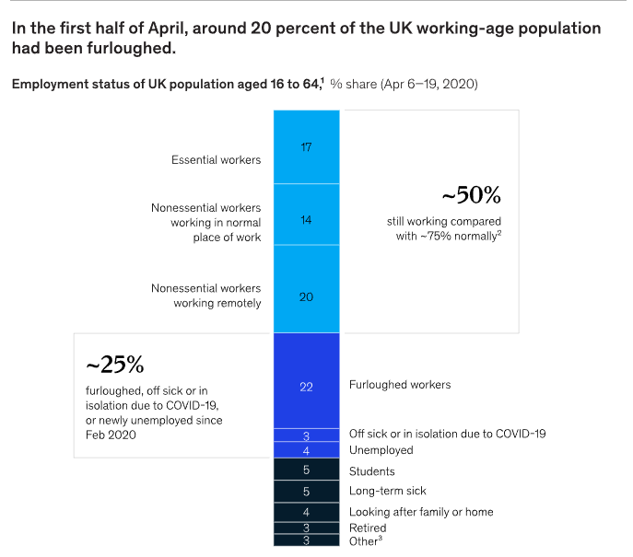
Figure 1: Employment status of the UK population in the first half of the pandemic.
(Source: Mckinsey, 2020)
Employees from different business sectors were at job risk and were suffering from mental stress. Due to remote working employees have to spend a long time in front of digital devices. Employees lacking technological knowledge suffered from job losses and lower incomes. The companies were suffering from a huge financial crisis and lower profits due to higher expenses and lower sales. Due to several factors such as high tariffs, inflation, lockdown norms, social distancing, and low customer spending the sale of the companies decreased.
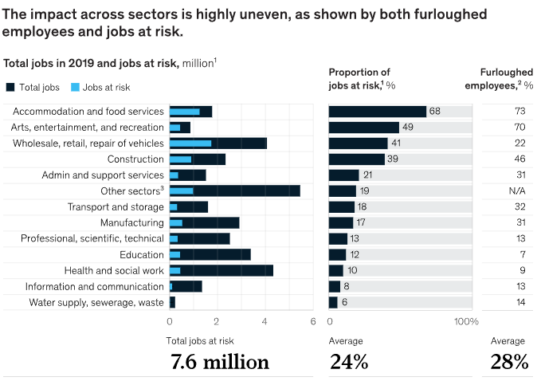
Figure 2: Impact on different sectors.
(Source: Mckinsey, 2020)

The retail and wholesale industries in the UK also suffered huge losses due to lower sales. The companies having offline shops were mostly affected by the pandemic norms. Several companies continued to expand their business with the help of online platforms. People preferred to buy products through online platforms and online transactions which were convenient for them at that period. Companies like T M Lewin, having only online shops, had to stop their production and close their shops. The sale of Lewin's was entirely stopped and they did not generate any revenue during that period. 50 employees of the company badly suffered from the job crisis. Covid19 pandemic has triggered a job crisis which increased the poverty level and inequalities throughout the world.

3. PESTLE analysis
This analysis will describe all the macroeconomic factors that affected the organisation during the pandemic. The change in political, economical, social, technological and legal factors affected T M Lewins to earn revenue during Covid19.
 | Description | Effect
Political Factors | - The political stability of the UK has helped the business sectors to grow their business.  - The pandemic has triggered the job crisis and simultaneously raised the poverty and inequality level throughout the world.  - Many retail and wholesale industries in England suffered from a lack of materials, high cost of materials and low availability of labourers during this period.  - The government implemented several trade tariffs and import restrictions during the period which increased the cost of materials.  - Mostly the companies selling non-essential goods were highly affected such as T.M Lewin’s company.  - Lewin’s company is a shirt-making company which manufactures formal shirts.  - The sale of their products was highly reduced because of work-from-home measures and social distancing norms (Sian and Smyth, 2021). | Medium
Economical Factors | - The pandemic has affected the economic condition of all the business sectors of the UK as well as the population.  - The companies suffered from high costs of production due to high tariffs, high transportation costs and inflation around the world.  - Most of the employees were not paid properly and some industries were totally shut down. Many companies had to terminate their employees and lowered the salaries of the existing employees to minimise the cost.  - Lewin was restructuring at the beginning of the pandemic therefore it was affected very badly by the adverse effects of the pandemic. The rising inflation and low consumer spending cause huge reductions in the profit for the company (Archer et al., 2020).  - Some of the loan and employee benefit schemes announced by the UK government helped the employees and the companies during this period (Parliament, 2022). | High
Social Factors | - During Covid19, people were mostly aware of their health issues.  - They maintained all the social distancing norms and other restrictions. Therefore, the UK markets were mostly closed and the industries could not sell their products. The retail companies producing fashionable items faced huge decreases in their sales.  - .Job retention schemes (JRS), Kickstart Schemes, Traineeship Schemes, and Apprentice schemes are some employment-related schemes (KPMG, 2022).  - Coronavirus Business Interruption Loan Scheme, CCFF are a scheme implemented by the government for the economic stability of the industries (KPMG, 2022). | Medium-High
Technological Factors | - Due to constant lockdowns, people find online shopping platforms most convenient to buy their necessities.  - The companies that opted for online selling products earned profit during the period. The employees also did not suffer from lower salaries.  - The offline companies stopped their production because of lockdowns. Many products were damaged in the warehouses and they could not reach customers due to a lack of technology.  - Lewin’s company could not reach proper suppliers as well as consumers.  - The company suffered from low sales due to the lack of product variety. People were not ready to buy formal men's shirts and apparel due to work-from-home norms. | High
Legal Factors | - The lockdown laws were categorised into three different parts such as for movements, gatherings, and business restrictions (UK Parliament, 2022).  - There were also some movement restrictions for the people. They could not move out of their homes on any simple excuses.  - Some areas were totally sealed and people were allowed to visit some local areas only. People could not visit the large markets and most of the malls and big shops were closed.  - The retailers having shops in the different markets of the UK were not allowed to open their shops to avoid crowds (UK Parliament, 2022). Mostly, the daily used products and medicinal shops were opened for the convenience of the people.  - Lewin’s products were also kept unsold because the shops were not allowed to open. 50 workers working in Lewin’s company earned very low wages and suffered from poverty. | Medium -High
Environmental Factors | - The lockdown showed reduced levels of nitrogen which was a good sign for patients suffering from asthma and other respiratory diseases.  - The scientists compared the air pollution level with the previous years and found a reduction in population levels.  - It was also proved that the noise level in the UK reduced by 50% during this period (UK Research and Innovation, 2022).  - The decrease in air and noise pollution improved the quality of the environment and the health of the population (UK Research and Innovation, 2022).  - There are no environmental factors that affected the sales of Lewin’s company. | No effect
Table 1: PESTLE Analysis

4. Evaluation of the Problem
The fishbone analysis highlights all the major issues that were faced by the organisations especially T M Lewin during the pandemic. Due to all these issues, the company could not produce and sell its products in the market.

Working from home
Customer spending issues
ECONOMIC
COVID
Lockdown
PROFIT DECLINE
Logistic
Brexit
SUPPLY CHAIN

Inflation

Cost of living

Product diversification

Online Presence

PRODUCT NATURE

COVID
Lockdown issues: According to the view of the British Foreign Policy Group, (2020), from 23rd march 2020 UK government has announced a lockdown in the country. Due to that, non-essential retail businesses like T M Lewin, have temporarily suspended their offline business. In addition to that, people's mobility had been restricted as well during the lockdown. Due to that, the business of T M Lewin has been significantly impacted.

Working from home: TM Lewin represented one of the strongest before the pandemic, having a very difficult period since all workers work from home. The increase in working from home as well as the relaxation of office dress codes eliminated many products from the customers' basket. Working from home means a reduced need for suits and shirts, and this gave the company T.M. Lewin (Onita, L., 2022)

Customers spending habit issues: During the pandemic, 11.7 million people have lost their jobs in the UK (Powell et al., 2022). As a result of that, the flow of money in the market has been reduced. Additionally, people's purchasing habits have changed. They have stopped spending on costly products. T M Lewin is a famous brand that is known for its premium quality products. The price of their products is quite high and that makes them unreachable for every economic class of people.

ECONOMIC
Inflation issues: According to the report of the Office for National Statistics (2022), in September 2022, the inflation rate of the UK, was 8.8% higher than in previous years, economists have reported that currently, the country is facing the highest inflation issues as compared to the last few decades. Due to the injection cost of raw materials, the cost of production, labour charges, and transportation costs have increased significantly. It increases the business expenses which directly affects the profit percentage of T M Lewin.

SUPPLY CHAIN
Logistic: In order to make the business more appealing, the administration has decided to restructure the business. According to that, they have tried to redesign their supply chain process. According to the change management model described by Kurt Lewin, people take time to get accustomed to the change (Channell, 2021). As T M Lewin was unable to provide adequate time, the company is facing supply chain issues.

Customers Service: Customers want great transparency when it comes to where they buy products (Logistics Management, 2017). According to Hughes (2022), he emphasized the fact that some of the problems of the companies are management, meaning that the quality of the inventory or the experience it offers to customers is not so good

PRODUCT NATURE

Online presence issues: The UK has the most advanced e-commerce market. It has been reported by Statista, (2022), that there are almost 60 million people in the UK who significantly invest in online shopping. T M Lewin is an organisation that has a significant offline presence, but the online presence of the company is limited. As a result of that, the company is unable to access the huge amount of online-based customers. As a result of that, their online sales and profit percentage are getting affected.

Product diversification issue: During the lockdown, most of the commercial establishments were managing their operations through online platforms. Work-from-home facilities have been provided to the employees so that they can safely contribute to their professional responsibilities. This provision has reduced the need for professional wear among people significantly. T M Lewin is an organisation that specialises in professional wear like formal shirts and suits (Refer to the case study). Due to the lack of product diversification the company is facing sales issues.

5. An evaluation of alternative solutions to the problem.
This analysis will describe all the macroeconomic factors that affected the organisation during the pandemic. The change in political, economical, social, technological and legal factors affected T M Lewins to earn revenue during Covid19.
Make online presence: The success rate of online business in the UK is 98% (‌Awwad et al., 2022). Most business organisations in order to secure their existence started online trading during the pandemic. T M Lewin needs to focus on that to mitigate their issues of profit declination. Making an informative and user-friendly website will help the company to attract a huge amount of customers who prefer quality over price.
Invest in marketing: According to Awwad et al., (2022), marketing is one such operation that helps people to know about the existence of a business. Digital marketing can successfully distribute the knowledge about T M, Lewin, to its targeted customers within no time. Additionally, the expenses of this marketing are lower which will suit the company's current conditions. It will also improve the customers' loyalty towards the brand as T M Lewin has a considerable number of brick-and-mortar stores throughout the different parts of the world.
Bring change in their leadership style: A change in leadership style is required in the company to mitigate the effects of change (Baraniuk, 2021). T M Lewin can use transformational leadership in this aspect. This approach will help the company to inspire every employee to understand the reason and effect of change in the organisation. As a result of that, they will become dedicated towards their responsibilities.
Manage business expenses: In order to manage the inflation effects from the company. The business management approach needs to be improved in the organisation. T M Lewin can implement a total quality management approach in this aspect (Baraniuk, 2021). Application of this approach will help the company to minimise unnecessary expenses. As a result of that, the company can manage their product prices as well. Doing that will enhance their customers as other people can purchase the products from the brand as well.
Product diversification: Besides formal wear the company needs to launch other types of products such as casual wear or informal wear depending on the trend of the market. Investment in marketing will help the company to understand market trends (Batool and Sahi, 2019). Using that knowledge if T M Lewin diversifies their product range. They can attract trendsetters and other customers to their business.
The indicators that will help T M Lewin to measure success
Increase website traffic: Using appropriate online business methods will improve the website traffic of the company. T M Lewin will get maximum searches on the internet and the brand will start to trend among customers (Bassen and Kovács, 2020). Additionally, people will start to recognise the brand by its name.
Maximise selling: Once people start to invest in T M Lewin their online and offline sales percentage will be improved. The company with the help of the finance department can measure the growth in sales and profit (Bassen and Kovács, 2020). Eventually, the sales decline issue will be mitigated in the company.

6. Conclusion
The report has studied the adverse effect of Covid19 pandemic on the organisation and employees of the UK. It has especially highlighted a retail company named T M Lewin. The report has covered the issues faced by the company during the pandemic. It has also identified some solutions that will help the company to increase its revenue.

References
Archer, S., Holch, P., Armes, J., Calman, L., Foster, C., Gelcich, S., MacLennan, S.J. and Absolom, K., (2020). “No turning back” Psycho‐oncology in the time of COVID‐19: Insights from a survey of UK professionals. Psycho-oncology.
‌Awwad, K.A., Shibani, A. and Ghostin, M., (2022). Exploring the critical success factors influencing BIM level 2 implementation in the UK construction industry: the case of SMEs. International journal of construction management, 22(10), pp.1894-1901.
‌Bassen, A. and Kovács, A.M., (2020). Environmental, social and governance key performance indicators from a capital market perspective. In Wirtschafts-und Unternehmensethik (pp. 809-820). Springer VS, Wiesbaden.
Batool, A. and Sahi, A., (2019). Determinants of financial performance of insurance companies of USA and UK during global financial crisis (2007-2016). International Journal of Accounting Research, 7(1), pp.1-9.
Baraniuk, C., (2021). Covid-19: How the UK vaccine rollout delivered success, so far. Bmj, 372. Available at: https://scholar.archive.org/work/qlea3kdgzfaz5f7fmmpe2rrp2u/access/wayback/https://www.bmj.com/content/bmj/372/bmj.n421.full.pdf [Accessed on 22.10. 2022]
British Foreign Policy Group. (2020). COVID-19 Timeline. Available at: https://bfpg.co.uk/2020/04/covid-19-timeline/ [Accessed on 22.10. 2022].
‌Channell, M. (2021). Lewin’s change management model: How to implement organisational change. Available at: https://www.tsw.co.uk/blog/leadership-and-management/lewis-change-model/ [Accessed on 22.10.2022]
Evans, S.M., (2020). Digging the dirt: An archaeology of stories of change, history and identity in a transforming organisation (Doctoral dissertation, University of Birmingham).
Hughes, H. (2022). TM Lewin MD on website relaunch and post-pandemic formalwear. [online] FashionUnited. Available at: https://fashionunited.uk/news/business/tm-lewin-md-on-website-relaunch-and-post-pandemic-formalwear/2022062963843 [Accessed 27.11.2022]
KPMG, (2022). United Kingdom. Available at:https://home.kpmg/xx/en/home/insights/2020/04/united-kingdom-government-and-institution-measures-in-response-to-covid.html [Accessed on 22.10.2022]

Mckinsey, (2020). COVID-19 in the United Kingdom: Assessing jobs at risk and the impact on people and places. Available at: https://www.mckinsey.com/industries/public-and-social-sector/our-insights/covid-19-in-the-united-kingdom-assessing-jobs-at-risk-and-the-impact-on-people-and-places [Accessed on 22.10. 2022].
Office for National Statistics. (2022). Inflation and price indices. Available at: https://www.ons.gov.uk/economy/inflationandpriceindices#:~:text=Consumer%20price%20inflation%2C%20UK%3A%20September%202022&text=The%20Consumer%20Prices%20Index%20including,returning%20to%20July’s%20recent%20high. [Accessed on 22.10. 2022].
Onita, L. (2022) TM Lewin collapses for second time in two years. [online] The Telegraph. Available at: https://www.telegraph.co.uk/business/2022/03/17/tm-lewin-collapses-second-time-two-years/ [Accessed 27.11.2022]
Parliament, (2022). Written evidence submitted by Make UK. Available at: https://committees.parliament.uk/writtenevidence/5627/pdf/ [Accessed on 22.10. 2022].
Powell, A., Francis-Devine, B. and Clark, H. (2022). Coronavirus: Impact on the labour market. Available at: https://commonslibrary.parliament.uk/research-briefings/cbp-8898/ [Accessed on 22.10. 2022]
Statista. (2022). E-commerce in the United Kingdom (UK). Available at: https://www.statista.com/topics/2333/e-commerce-in-the-united-kingdom/#topicHeader__wrapper [Accessed on 22.10.2022]
Sian, S. and Smyth, S., (2021). Supreme emergencies and public accountability: the case of procurement in the UK during the Covid-19 pandemic. Accounting, Auditing & Accountability Journal.
UK Parliament, (2022). Coronavirus: the lockdown laws. Available at: https://commonslibrary.parliament.uk/research-briefings/cbp-8875/ [Accessed on 22.10.2022]
UK Research and Innovation, (2022). Impact on the environment. Available at: https://www.ukri.org/news-and-events/tackling-the-impact-of-covid-19/researching-the-impact-of-coronavirus/impact-on-the-environment/ [Accessed on 22.10.2022]

‌

Appendices

Appendix 1: Task 1

