
APPENDIX GA36c

LEVEL 6 ASSESSMENT SPECIFICATION

Student name: | Borys Sekulski | Student ID number: | 2321808
Programme: | BA (Hons) Leadership and Management Skills for the Workplace
Module: | Leading and Implementing Change (LIC)
Module code: | LCLM6003 | Contribution to Overall Module Assessment (%): | 100%
Module Leaders: | Nadeem Mirza  Sujeewa Herath | Internal Verifier: | Md Kalam  Samuel Ofori
Assignment Title: | A Strategic Change Plan | Word count (or equivalent): | 4,000 ±10%  words
Submission deadline: | Weekdays/Weekends  20/07/2026  14:00 (2pm) | Return date of provisional marks & written feedback: | 18/08/2026
Submission method: | All written assessments, where practical and possible, must be submitted via Turnitin unless otherwise instructed by the Lecturer. (Please DO NOT put this assessment specification into Turnitin or it will match many similarities with other students’ submissions.)  Alternative submission method (if applicable):  Late submission of the assessment will result in a late penalty mark:  Work which is submitted up to 1 week late will be capped at 40% for the first attempt and will be awarded a mark of 0% for re-assessment. Late submission penalties may be lifted only if there is an approved extenuating circumstances claim.  Work submitted more than 1 week late will be considered as a non-submission and will not be marked. The work may be considered as a submission for reassessment if offered by an Examining Board or if there is an approved extenuating circumstances claim.
Academic honesty / referencing: | Academic honesty is required. In the main body of your submission you must give credit to authors on whose research and ideas your work is based. Append to your submission a reference list that indicates the books, articles, etc. that you have used, cited or quoted in order to complete this assessment.

Executive Summary
This report serves as a strategic change plan for Rolls-Royce Motor Cars as it faces digital disruption, an electric vehicle transition, development of artificial intelligence, pressures and expectations of a sustainable luxury vehicle market. It's clear that Rolls-Royce has tremendous organisational ability thanks to its tradition, craft culture, expertise and faithful customers around the world. These strengths can pose challenges, however, if the business doesn't accelerate enough with electric luxury client experience and AI-enabled internal efficiency. In the report, the assessment of the internal and external pressures using SWOT and PESTLE is followed by the evaluation of Kotter's change model and Russell and Russell’s Journey Through Change. It contends that Rolls-Royce requires to be “organised and sensitive on the cultural aspects”. The proposed Bespoke Electric and Intelligent Craft Programme is designed as a way to keep human craftsmanship safe while advancing and augmenting digital capacity, employee readiness and supplier resilience and client experience. Clear goals and objectives, financial priorities, communication activities and evaluation criteria are included.

Table of Contents
Executive Summary 3
1. Introduction to Rolls-Royce 5
2. Recent history and internal and external environment analysis 6
3. Evaluation of change management models 8
4. Leadership, culture and management of change 11
5. Proposed change management plan 15
6. Conclusion 18
7. References 19
8. Appendix A 24
9. Appendix B 26

1. Introduction to Rolls-Royce
Rolls-Royce Motor Cars is the selected organisation for this strategic change plan. It should be split off from Rolls-Royce Holdings plc, which is in the aerospace and defence industry. The Rolls-Royce Motor Cars brand is owned by the BMW Group and all its vehicles are designed, engineered and hand-built at Goodwood in West Sussex (Rolls-Royce Motor Cars, 2026a; BMW Group, 2026). It opened in 2003 and today is one of the most significant luxury manufacturing companies in the UK automotive industry.
The organisation is a useful case because, as a successful organisation, it is exposed to pressures for change. Rolls-Royce recorded 6,032 cars delivered in 2023, 5,712 cars delivered in 2024 and 5,664 cars delivered in 2025, demonstrating the company's strength but also its inability to rely on unlimited growth in volume (Rolls-Royce Motor Cars, 2025). So the key strategic question isn't necessarily whether they can sell more cars, it's whether they can cling to their exclusive position, boost their value per customer and build their future capability. This is evidenced in the Company's custom strategy where an average content value car has increased by 10% in 2024, the highest accuracy to date in the company's history (Rolls-Royce Motor Cars, 2025). This is healthy for profitability but adds complexity and skills requirement along with leader pressure.
The challenge is more serious because of external changes. The Zero Emission Vehicle mandate for the UK mandates that 80 percent of new car sales be zero emission by 2030 and 100 percent by 2035 (Department for Transport, 2023; Department for Transport, 2026). Rolls-Royce has already acknowledged with the release of its first fully electric model, Rolls-Royce Spectre, and have explicitly stated that they will be 100% fully electric by end of 2030 (Rolls-Royce Motor Cars, 2022). It's not just a technical change. Rolls-Royce is associated in the minds of consumers with a strong combustion engine, craft, silence and prestige, so it in damages the brand culture. While the electric drive contributes to silence and smoothness, it also alters the emotional landscape of luxury driving.
The broader car industry picture in the UK is indicative of the need for change. Production levels in the UK dropped 15.5 per cent in 2025 to 764,715 units, while electrified vehicle production accounted for 41.7 per cent of total production (Reuters, 2026). This indicates the sector is under pressure, but also that it's taking a step towards electrification. Despite its super-luxury status Rolls-Royce is not immune to regulation, supply chain risk, digital disruption, skills shortages or sustainability as expectations. The company has thus to have a strategic change plan that is aimed at safeguarding craft and heritage, while also developing capabilities in electric mobility, AI supported operations, client experience in digitalisation and sustainable luxury.

2. Recent history and internal and external environment analysis
Rolls-Royce Motor Cars has become a luxury technology company and its primary threat is not limited brand strength, it's a gradual failure to renew capabilities. Goodwood started in 2003 with a base of around a single car made per day to a bespoke operation with the firm able to produce nearly 28 cars a day (Reuters, 2025). It's a history that matters because growth has been achieved through craft, through exclusivity and a close bond with the client, and because the future unfolds in the shape of electric platforms and digital services, along with a new set of data skills and quicker learning rates without affecting the brand's promise of perfection.
Table 1: SWOT Model
SWOT factor | Critical point
Strength | Heritage, Goodwood craft skills, BMW ownership and bespoke pricing power support high value creation.
Weakness | Low-volume production, specialist labour dependence and limited public evidence of mature AI use reduce agility.
Opportunity | Private Offices, Whispers, Coachbuild and electric luxury can deepen client relationships.
Threat | Policy uncertainty, softer luxury EV demand, cyber risk and supply chain disruption can weaken control.

Internally, Rolls-Royce's strength lies in not being a scale-based value, as revealed by the analysis. It has an advantage related to ‘symbolic significance’, ‘artisanship' and ‘individual transformation of the car into a personal artefact'. Dubai, Shanghai and Goodwood are also introducing Private Offices in 2024, indicating a trend for designers to be brought closer to high-net-worth interest owners while relying on conventional dealerships (Wise, 2025). However, this is also an indication that the operating model is shifting. Bespoke growth is not as easy to manage as a standard growth mindset in production, as each individual detail creates coordination issues, quality risk and is pressured by a shorter lead time. The firm's advantage is that they can sense the change in their client and reconfigure Goodwood around more complex work from a dynamic capability perspective (Wibisono and Supoyo, 2023).
Thanks to digital disruption, luxury service now is defined differently. Rolls-Royce's Whispers platform enables its owners to track their car's production process and enjoy a range of carefully selected brand content, as well as gain access to an exclusive online community (Rolls-Royce Motor Cars, 2020). As digitalisation, therefore, does not supplant craft, it alters the experience of craft. For a client, who can trace a commission and be a part of private experiences is getting a data-enabled luxury. The downsides are higher privacy expectations, cyber security, system reliability. The 2025 cyber breach experienced by Jaguar Land Rover demonstrates how an automotive cyber disaster can impact company production centers confidence throughout the industry (Martin, 2025). Digital therefore must not be viewed by Rolls-Royce as an add-on to the marketing.
Table 2: PESTLE Framework
PESTLE factor | Critical point
Political | UK EV policy is less predictable, making long-range product planning harder.
Economic | Ultra-luxury demand is resilient, but regional shocks and high input costs still matter.
Social | Younger wealthy clients expect personalisation, sustainability and digital access.
Technological | Electric drivetrains, connected services and AI-supported operations are changing capability needs.
Legal | ZEV rules, data protection and product compliance increase pressure for disciplined governance.
Environmental | Sustainable luxury is becoming part of legitimacy, not only brand image.

The outside world is more contradictionary than just an electric change. Spectre was a startlingly ambitious electric offering from Rolls-Royce, and as a result the company soon retreated from its previously announced policy of only selling electric cars by 2030 amid shifting legislation and a continuing appetite for V12 engines among customers (The Times, 2026; Almeida, 2026). However, this shouldn't be seen as a sign of the failure of electrification. It is a regulation vs identity/customer preference conundrum for the company. The UK ZEV mandate still pushes manufacturers towards rising zero-emission sales targets, with reported headline targets moving from 28 percent in 2025 to 33 percent in 2026 (Josephs, 2026). Managers need to take care and not rush into Electric Purity or cite Customer Preference as a reason for neglecting the capability building.
With AI comes another strategic tension. Transforming Goodwood through the use of AI is a modest suggestion given that there isn't a great deal of evidence in production or client systems that it has been taken up in a meaningful way by Rolls-Royce Motor Cars. The better case is that AI has shifted the capability bar. AI might enhance demand forecasting, multiple configuration management, quality prediction and monitoring of supply risks, but it also may put at risk the human authenticity a bespoke manufacturer offers (Nweje and Taiwo, 2025). The challenge is to use AI things behind the scenes in planning and operation without seeing it and value in signage centred on craft and designers clearly.
But Rolls-Royce is not, as such, in decline. The danger with it is delay. The company has made the necessary adaptation when entering the e-mobility sector, which includes digital client platforms, Global Design Spaces, and electric coachbuild work, including Project Nightingale, with 100 individually commissioned examples on offer (Rolls-Royce Motor Cars, 2026). But it takes a culture to protect heritage whilst allowing experimentation. The board should thus think of change as a programme for building capability, rather than a project for EV or an expansion of a factory.

3. Evaluation of change management models
A change model that addresses strategic direction and employee transition is necessary at Rolls-Royce Motor Cars. It is not just a single issue with the operations as the change agenda of the company includes Electric luxury, Digital client experience, Bespoke expansion & potential AI supported operations. Technology, culture, skills and brand identity transformation all happen simultaneously. A purely technical model would be too limited in scope, as would a purely emotional model, as it would not offer sufficient structure for the board-level implementation (Engbers and Khapova, 2024). Kotter's 8 Step Change Model and Russell and Russell's Journey Through Change model are models relevant to this context.
Table 3: Comparison between Change Management Models
Model | Main value for Rolls-Royce | Main limitation
Kotter’s 8 Step Model | Provides a structured route from urgency to embedding change, which is useful for a strategic programme involving electrification, digital systems and operating capability. | It can appear too linear for a luxury business where customer demand, regulation and technology are changing at different speeds.
Russell and Russell’s Journey Through Change | Explains the emotional movement from comfort and control to resistance, experimentation and commitment, which is useful for protecting craft culture during change. | It gives less detail on governance, finance, milestones and accountability, so it cannot guide the full strategic plan alone.

In the case of Rolls-Royce, Kotter's model is valuable because Rolls-Royce can't afford fragmented innovation, it requires focused, disciplined leadership. Kotter believes that the first step in successful change is feelings of urgency, followed by the formation of a coalition, creation of a vision, communication, empowerment, short-term gains and institutionalisation (Carreño, 2024). This is why it resonates with Rolls-Royce, which needs to convince a myriad of other people that change is required: its engineers, its craftsmen, its designers, its suppliers, its dealers and clients. Both electrification and digitalisation are not possible without focused work by project teams, and thus the logic is solid. They are to be translated to a common strategic path with a knotted line in the middle of product development, manufacturing, client service and brand meaning.
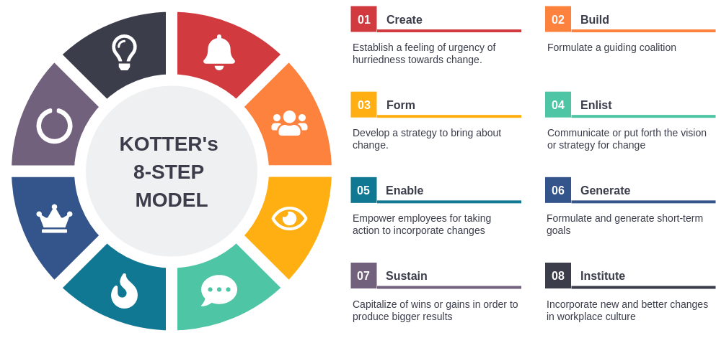
Figure 1: Kotter's 8-Step Model
Source: (Ozero, 2023)
However, Kotter’s model also has weaknesses in this case. It rests on the assumption of leaders creating a sense of urgency and then taking the organisation through definite steps. Rolls-Royce's reality is more ambiguous as the company has already demonstrated both a commitment to luxury in the age of e_vehicles and caution to not move too fast in discarding combustion models (Pond, 2026). This is NOT a failure of leadership. What it does reveal, however, is the fact that moves in the ultra-luxury end of the market are not always linear. Acing too fast and taking a hard-line Kotter approach might see the business make symbolic decisions and overlook the mixed messages sent by clients and regulators. Because of this, Kotter is helpful for ‘structure’ but not enough on its own to understand lived experience of change.
The Russell and Russell model of Journey Through Change is very applicable because Rolls Royce is facing cultural as well as technical change (Russell and Russell, 2023). According to the model, in order to engage in inquiry, experimentation, discovery, learning and commitment, people must first go from comfort and control to fear and anger and resistance. It is a tool which allows to gain a better understanding of what makes it difficult for staff in a heritage organisation to embrace change, even if there is a compelling business case for it. Skilled craftspersons don't necessarily complain that electric technology and digital systems are irrational. Change may threaten their feeling of mastery, their identity and pride in traditional ways of working, so they may resist.
This model proves to be particularly relevant when applying to the management of change at Rolls-Royce. Building cars from the ground up wasn't the company's first option, with it starting out making a traditional luxury car. It tried out something similar before with the 102EX Phantom Experimental Electric which was a learning experience and not an immediate commercial launch (Sanchez, 2026). This indicates that the change approach will be cautious, inquiry-driven, and with client feedback as against disruptive solutions. It was later followed by Spectre, the first generation production electric Rolls-Royce, though more a seamless progression of 'noise', smoothness and easy handling. In this regard, Rolls-Royce dealt with change here by turning new tech into familiar brand-speak.
What Rolls-Royce should do is not pick one whole model, but pick Kotter as a strategic architecture, and Russell and Russell as a lens towards people. Kotter should get the board to see how urgent the change is, to form a “coalition,” and to include the change in the systems, roles, investment and performance measures (Kotter et al., 2021). Managers should be led by Russell and Russell during employee uncertainty, resistance, experimentation and commitment (Russell and Russell, 2023). Hence the recommended model of strategic change would be the blending of Kotter and Russell model. For instance, instead of fear of decline, the urgency stage shouldn't be seen as fear of decline. It must be presented in terms of the need to preserve the future sense of luxury of Rolls-Royce.
This blended model is likewise more aligned with level 6: critical analysis for its acknowledgement of the challenges theory. Kotter provides structure, and can fail to raise emotional opposition. Russell/emotion and Russell/implementation are not disciplined enough (Hubbart, 2025). Because both are necessary to Rolls-Royce, which is facing a challenge to change without giving the impression they are discarding that which created value. But, if change dilutes the brand, the real strategic question will be if Rolls-Royce can successfully convince employees and clients that change is an improvement.

4. Leadership, culture and management of change
Continuity and renewal have been the operative factors in managing change at Rolls-Royce Motor Cars. The firm not only is modifying the products and processes, but is safeguarding a luxury brand identity based on trust and on craft and emotional change. A hasty transition to electric mobility, digital services or AI-based operations could have a negative impact on the brand, a slow transition the competitiveness (Rudolph et al., 2023). Leadership has thus had to deal with the change as a change in culture, as well as just a change in technology.
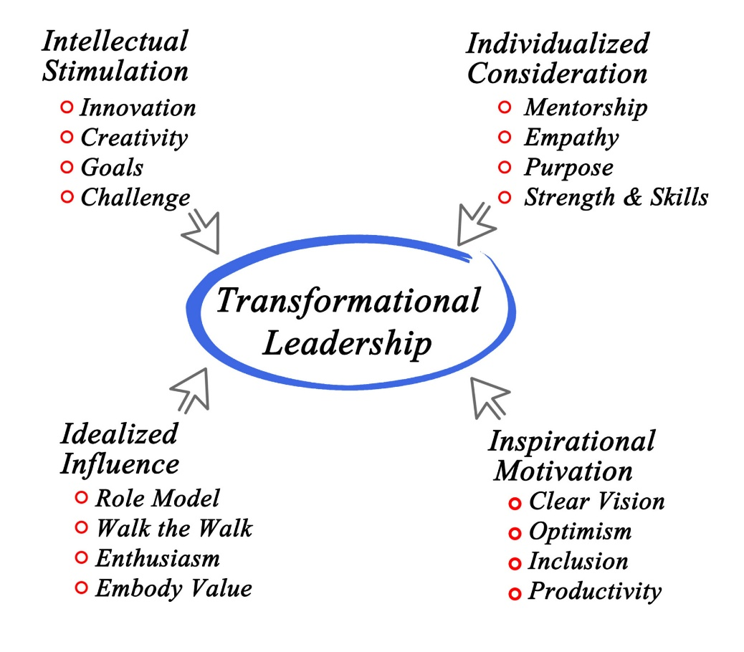
Figure 2: Transformational Leadership
Source: (Ugochukwu, 2026)
This process can be assessed using the transformational leadership. Bass and Riggio (2006) claim that transformational leaders establish vision, inspire others to make commitments and to think outside the box. This can be seen in the management of Torsten Müller-Ötvös, within whom led Rolls-Royce Motor Cars for practically nearly 14 years and helped position the luxury home amongst cars just like a car maker (Brownridge, 2023). This shifted the firm's focus from making bespoke cars to crafting luxury experiences. The transfer made it easier in hindsight to change later, as the electric technology and digital communities would be sold as extensions to luxury, not threats to tradition.
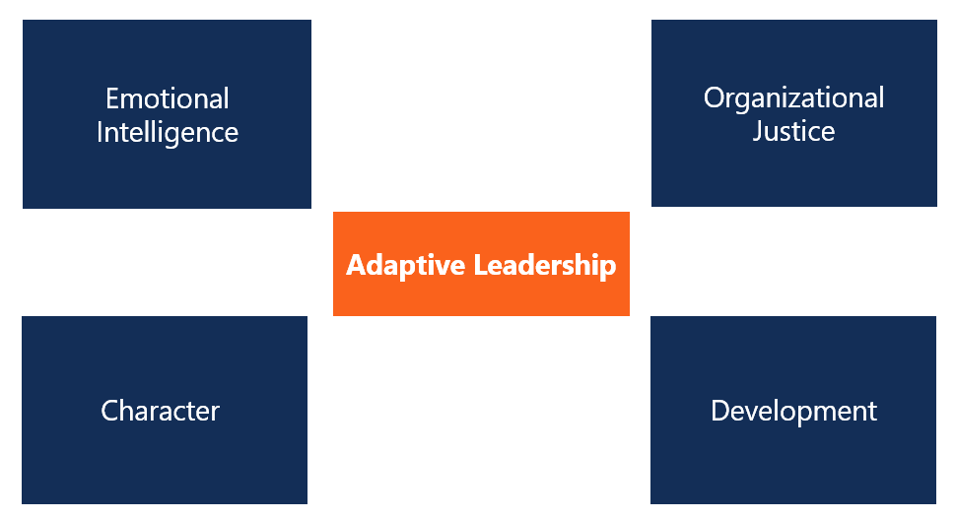
Figure 3: Adaptive Leadership
Source: (Wale, 2018)
But this is not, by itself, an answer to the case, since Rolls-Royce has not completely transformed itself. The company has also followed the adaptive leadership model in which leaders, instead of offering one right solution, sense, test, learn, and adjust as they listen to complex dynamics. Dunn (2020) suggest that when a problem cannot be fixed on their own with the necessary skillset, adaptive leadership is required. This is because certain customers appreciate the absence of emissions and environmental impact from electric power, while others may equate status with a classic, by-the-handcrafted engine. The lesson for Rolls-Royce, however, is that it has learned to deal with change by picking and choosing, instead of by introducing a massive disruption.
The changes continue to signal a planned continuity with Müller-Ötvös being replaced by Chris Brownridge (Gibbs, 2023). The significance of Brownridge's BMW UK background is that luxury customer insight is also critical to the next step, which is dependent on engineering capability (Jolly, 2023). This is a sensible but not risk-free as a marketing-driven business leader would need to safeguard engineers, designers and craftspeople against overly "marketing" things to customers, i.e. the business would need to remain ultimately customer service-oriented.
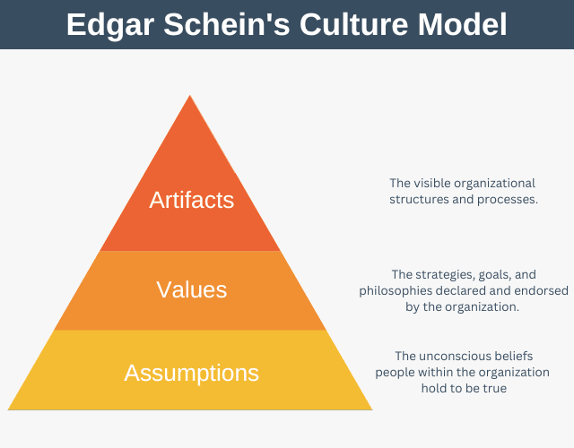
Figure 4: Schein’s Organisational Culture Model
Source: (Denis, 2026)
Change at Rolls-Royce needs careful handling, as described by Schein's model of organisational culture. According to Schein (Naylor, 2025), culture is manifested through the visible components, such as artefacts, and through stated values and deep underlying assumptions. Multiple Rolls-Royce components are visible and manifest as Goodwood, hand finishing, quiet workshops, client spaces and language of perfection. It is said to offer the values of excellence, exclusivity, personalisation and respect for heritage. The further prior expectation, which is also met, is that luxury has to seem rare, natural and simple. This culture breeds change with the marriage of technology to silence, quality and personal service. Resists change when digital tools/automation supplant human judgement.
Culture has two sides to it. On the other hand, Rolls-Royce already has a solid starting point for changes as their culture is built on having high standards in their employees, detail and long-term relations with customers (Gibbs et al., 2025). Precision and trust are essential for these values and are both required in the worlds of electric luxury and digital personalisation. If employees don't value their skills, the strategic change of the craft-based company is unlikely to work.
On the other hand, the same culture can be stifling as perfection can be caution. Protecting tradition can hinder quicker experimentation, particularly in AI and digital workflows and data-driven production planning (King, 2025). Strong leadership can lead to employees feeling change is diminishing the craft. When leaders overhangen tradition, the organisation likely can be left trailing behind quicker learning opponents. The right solution is to present the question of how innovation can safeguard the heritage in the face of the extra challenge of personalising luxury, making it sustainable and resilient.
This change is best managed when it finds echo in familiar brand meaning, as builds by leaders. Electric mobility with silence and easy performance, digital client platform with privacy and exclusiveness, bespoke expansion with artistry instead of production complexity (Lempp and Siegfried, 2022). This is an indicator of transformational because you've created meaning, but it's an indicator of adaptive because you made an adjustment to the speed of change that happened given what your customers want and what your culture is ready for.
One weakness is that Rolls-Royce illustrates its luxury vision better than its internal journey. While there is comparatively high visibility around the story of the brand through public communication, there is less detail regarding the preparation of employees for AI, software capability, cyber resilience, and digital manufacturing (Pinto and Bhadra, 2024). Future changes will be needed with measurable skill building and better integration of craft and technology teams. In the big picture, there is a need for transformational vision, judgmental flexibility and culturally intelligent execution at Rolls-Royce.

5. Proposed change management plan
The proposed change is the Bespoke Electric and Intelligent Craft Programme, which will rollout at Rolls-Royce Motor Cars over the next three years. The programme will integrate electric luxury, digital client experience and AI-assisted internal planning all while maintaining the human element which is a hallmark of the brand. That is appropriate as Rolls-Royce are a brand that competes on the back of rarity, personalisation, trust and technical excellence, not on manufacture numbers or low price. Technology should simplify it, boost client trust and preserve uniqueness, not packaging the brand in technology.
A managed transition of the programme should be used based on the blended change model. Taking the formal process of change based on Kotter's model allows for the need for urgency, sponsorship, milestones, and accountability directions that are required for change by the board (Kotter et al., 2021). The people side should be influenced by Russell and Russell's Journey through Change as the employees may transition from comfort to resistance before finally accepting a new way. It is fitting, as Rolls-Royce is in need of discipline and cultural sensitivity. You can take an entirely technical plan and employees don't matter anymore, you can do something purely emotional, but that's no governance.
The first is to enhance their electric luxury capability at Goodwood by increasing their knowledge and awareness of EVs, digital commissioning and sustainable materials. The second objective is to make available AI-powered planning tools for forecasting, configuration checks, and parts availability and quality risk identification. The third is to make digital commissioning better, make it a better experience for the client, but keep it comprehensive, and private and make sure people dealing with it are experts. The fourth goal is to preserve craft culture by maintaining the support of technology to human judgment, and not yet relying on technology to replace designers, engineers and craftspeople. The fifth objective is to increase resilience by minimising cross team delays, rework and communication gaps.
Table 4: Financial Plan
Cost area | Proposed allocation | Purpose
Workforce development | £12 million | EV skills, digital training, AI awareness, cyber hygiene and leadership coaching
Digital infrastructure and AI tools | £10 million | AI-supported workflow tools, configuration checks, forecasting systems and data governance
Supplier readiness | £8 million | Support for specialist components, sustainable materials and electric platform requirements
Client experience improvements | £7 million | Secure digital commissioning spaces, Private Office integration and prototype feedback sessions
Risk reserve | £5 million | Regulation, software risk, supply shortages and changing client expectations
Total indicative budget | £42 million | Three-year ring-fenced change programme

The financial plan should use a ring-fenced change budget. An indicative budget of £42 million for three years is proposed. Approximately £12m will fund workforce development initiatives, such as EV skills, digital skills, AI awareness and leadership coaching. An investment of approximately £10m should be provided to cover digital infrastructure and digital workflow tools, AI enabled, whilst maintaining robust governance policies for data quality, privacy and client confidentiality. Approx £8 m should help propping up supplier readiness for specialist components and sustainable materials. Secure Digital Commissioning Spaces and Private Office integration should cost around £7m, and enhance client experience. There should probably be about five million pounds of such a risk reserve for regulation, software risk, supply shortages and changing client expectations.
Judged by volume alone, this investment may not make much sense as growth in volume is not necessarily the Rolls-Royce way of thinking. Value protection and capability building is a stronger measure. Aspirated Outcome Areas are e.g., reduced late specification changes, faster design approval, increased readiness of the staff, higher level of client satisfaction, and reduced reputational risk (Ahmed and Jahan, 2022). The board should have a well-balanced scorecard which includes cost control, margin protection, rework, client satisfaction, configuration precision, supplier dependability, skills completion, and employee confidence.
Communication plan should be split into phases, as stakeholders have various concern areas. The first thing people need to know at work is that the change is about safeguarding craft, that it is not taking it away. This will be delivered in a leadership briefing, Goodwood team workshops and small group discussion. Managers need to strive to understand resistance, and do not assume that employees are being disloyal. Pilot groups are necessary at the intersection between designers and craft makers to influence the use of digital and AI tools (Gmeiner et al., 2023). It is important to set the scene for clients to understand that Rolls-Royce isn't getting automated, but the way to personalise it is much more accurate, private and seamless thanks to an advanced system. Clear technical expectations and timelines should be provided to the suppliers. Reporting to board on cost, risk, milestones and capacity building should be quarterly.
The use of milestones across three years should be implemented in the evaluation plan. Success can be determined by skills audits, pilot teams and governance approval of and selection of digital tools in the first six months (Edgar et al., 2020). At the end of year one, completion of training, employee confidence, learning from the pilot and from early clients feedback should be reviewed. Reduced rework, faster design approval, supplier readiness and planning supported by AI evaluation by the end of year two. The board should evaluate, at the end of year 3, the scale of adoption rates, quality results, scores of client experience and employee trust, as measures to assess if the programme has become normal practice.
The primary danger can be that the programme focuses too much on the technological aspects, compromising the brand's emotional appeal (Lee et al., 2025). This should be controlled in a governance forum including craft leaders and such tests should be performed on all digital/ai interventions versus one question only. Does it enhance the Rolls-Royce client experience without compromising the human capability? Otherwise, it should not be adopted. The proposed strategy is thus tailored plan in the form of a controlled programme to be carried out through the use of technology to secure the future of bespoke luxury.

6. Conclusion
Rolls-Royce Motor Cars demonstrates that change is more than moving to electric cars, AI or digital platforms in the automotive market. It's about safeguarding organisational ability and reacting to environmental pressures. The conclusion from the analysis is that Roll Royce has great heritage and culture to own and serve their clients, but at the same time it can be a limitation if they act non-innovative. There can, therefore, be no one-size-fits-all method, a blended change approach is required structured implementation and sensitivity to employee feelings and organisational culture. The Bespoke Electric & Intelligent Craft Programme is a realistic way to nurture resilience, maintain luxury value and ready the company for future competition.

7. References
Ahmed, I., and Jahan, N. (2022). A Panel Data Econometric Analysis on the Impact of Digital Payment Adoption on Small Business Revenue Growth in Global Business. American Journal of Interdisciplinary Studies, 3(04), 500-536.
Almeida, L. (2026). Rolls-Royce scraps goal to go all-electric by 2030. The Guardian. Available at: https://www.theguardian.com/business/2026/mar/18/rolls-royce-scraps-all-electric-car-company [Accessed: 14 June 2026].
BMW Group. (2026). Rolls-Royce Motor Cars Plant Goodwood. Available at: https://www.bmwgroup-werke.com/goodwood/en.html [Accessed: 14 June 2026].
Brownridge, C. (2023). Rolls-Royce CEO Torsten Muller-Otvos announces retirement after 14 years, successor named. Bloomberg. Available at: https://www.thenationalnews.com/business/2023/10/05/rolls-royce-ceo-torsten-muller-otvos-announces-retirement-after-14-years-successor-named/ [Accessed: 14 June 2026].
Carreño, A. M. (2024). An analytical review of John Kotter's change leadership framework: A modern approach to sustainable organizational transformation. Available at SSRN 5044428.
Denis, G. (2026). Edgar Schein’s Organizational Culture Model. Expert Management Programme. Available at: https://expertprogrammanagement.com/2022/09/edgar-schein-culture-model/ [Accessed: 14 June 2026].
Department for Transport. (2023). Government sets out path to zero emission vehicles by 2035. Available at: https://www.gov.uk/government/news/government-sets-out-path-to-zero-emission-vehicles-by-2035 [Accessed: 14 June 2026].
Department for Transport. (2026). Forthcoming changes, electric vehicle mileage share updates. Available at: https://www.gov.uk/government/publications/forthcoming-changes-and-previous-versions-of-tag [Accessed: 14 June 2026].
Dunn, R. (2020). Adaptive leadership: Leading through complexity. International studies in educational administration, 48(1), 31-38.
Edgar, L., McLean, S., Hogan, S. O., Hamstra, S., and Holmboe, E. S. (2020). The milestones guidebook. Accreditation Council for Graduate Medical Education, 2024(24), 154.
Engbers, M., and Khapova, S. N. (2024). How boards manage the tension between cognitive conflict and cohesiveness: Illuminating the four board conflict climates. Corporate Governance: An International Review, 32(1), 63-88.
Gibbs, E., Mackenzie, E., McKinlay, A., McNulty, D., Phillips, J., and Procter, S. (2025). Rolls-Royce engineers and deindustrialization in Scotland from the 1950s to the 2020s. Modern British History, 36(2), hwaf002.
Gibbs, N. (2023). Rolls-Royce CEO Torsten Müller-Ötvös to retire. Automotive News. Available at: https://www.autonews.com/executives/rolls-royce-ceo-torsten-muller-otvos-step-down/ [Accessed: 14 June 2026].
Gmeiner, F., Yang, H., Yao, L., Holstein, K., and Martelaro, N. (2023, April). Exploring challenges and opportunities to support designers in learning to co-create with AI-based manufacturing design tools. In Proceedings of the 2023 CHI conference on human factors in computing systems (pp. 1-20).
Hubbart, J. (2025). Leading Through Change: Overcoming Resistance and Building Trust in Organizations. Ethics International Press.
Jolly, J. (2023). Chris Brownridge: behind the wheel of a greener image for BMW. The Guardian. Available at: https://www.theguardian.com/business/2023/apr/04/chris-brownridge-behind-the-wheel-of-a-greener-image-for-bmw [Accessed: 14 June 2026].
Josephs, J. (2026). UK electric car sales target to be weakened. BBC. Available at: https://www.bbc.com/news/articles/cx2dmwmj4dmo [Accessed: 14 June 2026].
King, K. (2025). AI strategy for sales and marketing: Connecting marketing, sales and customer experience. Kogan Page Publishers.
Kotter, J. P., Akhtar, V., and Gupta, G. (2021). Change: How organizations achieve hard-to-imagine results in uncertain and volatile times. John Wiley & Sons.
Lee, S. M. F., Wong, A. K. F., and Kim, S. (2025). The impacts of technology-led event sustainability consumption values on personal social responsibility and collective psychological outcomes. Journal of Travel & Tourism Marketing, 42(4), 415-438.
Lempp, M., and Siegfried, P. (2022). Automotive Disruption and the Urban Mobility Revolution. Springer International Publishing.
Martin, J. (2025). JLR cyber-attack caused UK car production to hit 70-year low for September. BBC. Available at: https://www.bbc.com/news/articles/cvgmp1prnv0o [Accessed: 14 June 2026].
Naylor, R. (2025). Enacting transition pedagogy at a school level: An action research analysis of institutional change using Schein's model of organisational culture. Student Success, 16(3), 93-104.
Nweje, U., and Taiwo, M. (2025). Leveraging Artificial Intelligence for predictive supply chain management, focus on how AI-driven tools are revolutionizing demand forecasting and inventory optimization. International Journal of Science and Research Archive, 14(1), 230-250.
Ozero, T. (2023). The Kotter model: an 8-step model to manage change. Inkstrategy. Available at: https://www.inkstrategy.com/post/the-kotter-model-8-steps-for-managing-change/ [Accessed: 14 June 2026].
Pinto, R., and Bhadra, A. (2024). Smarter public relations with artificial intelligence: Leveraging technology for effective communication strategies and reputation management-A qualitative analysis. REDVET-Revista electrónica de Veterinaria, 25(1), 2024.
Pond, A. (2026). Why Rolls-Royce is Scrapping All-Electric 2030 Commitment. EV Magazine. Available at: https://evmagazine.com/news/why-rolls-royce-is-scrapping-all-electric-2030-commitment [Accessed: 14 June 2026].
Reuters. (2026). UK vehicle production drops nearly 16 percent in toughest year in a generation, SMMT says. Available at: https://www.reuters.com/world/uk/uk-vehicle-production-drops-nearly-16-toughest-year-generation-smmt-says-2026-01-29 [Accessed: 14 June 2026].
Rolls-Royce Motor Cars. (2020). rolls-royce whispers: a digital world of curated luxury. Available at: https://www.press.rolls-roycemotorcars.com/rolls-royce-motor-cars-pressclub/article/detail/T0305941EN/rolls-royce-whispers:-a-digital-world-of-curated-luxury?language=en [Accessed: 14 June 2026].
Rolls-Royce Motor Cars. (2022). Spectre unveiled, the marque’s first fully-electric Rolls-Royce. Available at: https://www.press.rolls-roycemotorcars.com/rolls-royce-motor-cars-pressclub/article/detail/T0404820EN/rolls-royce-spectre-unveiled%3A-the-marque%E2%80%99s-first-fully-electric-motor-car [Accessed: 14 June 2026].
Rolls-Royce Motor Cars. (2025). Landmark investment crowns record year for Bespoke at Rolls-Royce Motor Cars. Available at: https://www.press.rolls-roycemotorcars.com/rolls-royce-motor-cars-pressclub/article/detail/T0447359EN/landmark-investment-crowns-record-year-for-bespoke-at-rolls-royce-motor-cars [Accessed: 14 June 2026].
Rolls-Royce Motor Cars. (2026). Rolls-Royce Motor Cars, Inspiring Greatness. Available at: https://www.rolls-roycemotorcars.com/en_GB/home.html [Accessed: 14 June 2026].
Rolls-Royce Motor Cars. (2026a). How Rolls Met Royce. Available at: https://www.rolls-roycemotorcars.com/en_US/inspiring-greatness/values/how-rolls-met-royce.html [Accessed: 14 June 2026].
Rudolph, J., Tan, S., and Tan, S. (2023). War of the chatbots: Bard, Bing Chat, ChatGPT, Ernie and beyond. The new AI gold rush and its impact on higher education. Journal of Applied Learning & Teaching, 6(1), 364-389.
Russell, L., and Russell, J. (2023). Change basics. Association for Talent Development.
Sanchez, R. (2026). These Rolls-Royce Concepts Changed Luxury Cars Forever. Yahoo Finance. Available at: https://autos.yahoo.com/ev-and-future-tech/articles/rolls-royce-concepts-changed-luxury-141500471.html?guccounter=1&guce_referrer=aHR0cHM6Ly93d3cuZ29vZ2xlLmNvbS8&guce_referrer_sig=AQAAAN585S9IOl5MCta1lbx5a_sVOZKmG0nbCLXT8oMPO48m3z7bjQvEg2ECcD4W-jQxYqMGbwp5YhcxdtNixvaYsN9FgUllUX-fNKBmSWIC5OmrQwgfeMG2Kvgw0oiFFPmT6yHdL4Vf2gnxtJ6wm3qWxIDNcrF1M6-Bg6OTKws8NU-L [Accessed: 14 June 2026].
The Times. (2026). Rolls-Royce scraps 2030 all-electric target. Available at: The Times Accessed 15 June 2026. https://www.thetimes.com/business/companies-markets/article/rolls-royce-electric-target-spectre-m2c59b0jl [Accessed: 14 June 2026].
Ugochukwu, C. (2026). Transformational Leadership Style: How to Inspire and Motivate. Simply Psychology. Available at: https://www.simplypsychology.org/what-is-transformational-leadership.html [Accessed: 14 June 2026].
Wale, H. (2018). Adaptive Leadership. CFI. Available at: https://corporatefinanceinstitute.com/resources/management/adaptive-leadership/ [Accessed: 14 June 2026].
Wibisono, H., and Supoyo, M. (2023). Business transformation: exploring dynamic capabilities, technological innovation, and competitive advantage through the lens of resource-based view in construction services companies. Journal of Contemporary Administration and Management (ADMAN), 1(3), 263-270.
Wise, A. (2025). Luxury carmaker Rolls-Royce to expand Goodwood factory with £300m investment. Yahoo Finance. Available at: https://uk.finance.yahoo.com/news/luxury-carmaker-rolls-royce-expand-114825562.html [Accessed: 14 June 2026].

8. Appendix A
Table 5: Leadership and Culture Evaluation
Area of evaluation | Application to Rolls-Royce Motor Cars | Critical judgement
Transformational leadership | Leadership has helped frame electric luxury, digital client experience and bespoke expansion as part of the future of Rolls-Royce rather than a rejection of its past. | This approach is strong because it creates meaning and confidence, but it may become too symbolic if it is not supported by measurable skills, systems and operational change.
Adaptive leadership | The company has adjusted its pace of change around client expectations, regulation and technology rather than forcing one rigid route towards electrification. | This is suitable for an ultra-luxury brand because customer trust matters, but excessive caution could delay capability building in EVs, AI and digital operations.
Role of senior leadership | Senior leaders have protected brand identity while introducing change through electric models, digital platforms and expanded bespoke services. | The leadership approach has been careful and brand-sensitive, but future success will depend on whether leaders can integrate craft employees, digital teams and client-facing teams into one shared change agenda.
Organisational culture | Rolls-Royce culture is based on craft, perfection, exclusivity, heritage and personal service. | This culture supports quality and trust, but it can also create resistance if employees see digitalisation or AI as a threat to human skill.
Employee response to change | Employees may accept change when it is presented as a way to improve craft, quality and client experience. | Resistance should not be treated as negativity because it may reflect pride in existing standards and concern about losing the human character of the brand.
Main leadership risk | The organisation may rely too heavily on heritage and controlled evolution. | The key risk is strategic comfort, where the company protects tradition so strongly that it underinvests in future capability.
Best leadership approach | A combined transformational and adaptive leadership approach is most suitable. | Transformational leadership gives vision, while adaptive leadership allows learning, adjustment and cultural sensitivity during uncertain market conditions.

9. Appendix B
Table 6: Change Management Plan
Plan element | Proposed action | Expected outcome | Evaluation measure
Proposed change | Introduce a Bespoke Electric and Intelligent Craft Programme over three years. | Rolls-Royce can strengthen electric luxury, digital client experience and AI-supported planning while protecting craft identity. | Programme milestones achieved across skills, digital tools, supplier readiness and client experience.
Objective 1 | Train design, production and client-facing employees in EV knowledge, digital commissioning, sustainable materials and AI awareness. | Employees become more confident in future technologies and less resistant to change. | Training completion rate, employee confidence surveys and manager feedback.
Objective 2 | Use AI-supported tools for demand forecasting, bespoke configuration checks, parts availability and quality risk monitoring. | Internal planning becomes more accurate without making the client experience feel automated. | Reduced rework, fewer specification errors and improved planning accuracy.
Objective 3 | Improve the digital commissioning journey through secure platforms and stronger Private Office integration. | Clients receive a smoother, more personalised and more private luxury experience. | Client satisfaction scores, repeat client activity and feedback from commissioning meetings.
Objective 4 | Protect craft culture by keeping designers, engineers and craftspeople involved in tool selection and pilot testing. | Technology is seen as support for human excellence rather than a replacement for it. | Employee adoption rates, pilot feedback and qualitative staff comments.
Financial plan | Allocate an indicative £42 million over three years across training, digital tools, supplier readiness, client experience and risk reserve. | Investment is controlled and linked to strategic capability rather than short-term volume growth. | Budget variance, cost control reports and benefits tracking through a balanced scorecard.
Communication plan | Use phased communication for employees, clients, suppliers and the board. | Stakeholders receive messages that match their concerns and responsibilities. | Attendance at briefings, feedback quality, issue logs and stakeholder confidence levels.
Evaluation plan | Review progress at six months, one year, two years and three years. | The board can judge whether change is moving from pilot activity into normal practice. | Milestone completion, adoption data, client feedback, rework reduction and quality outcomes.
Main risk | The programme may become too technology-led and weaken the emotional value of the brand. | The brand could lose its human and craft-based distinctiveness. | Governance review asking whether each tool strengthens the Rolls-Royce client experience without weakening human excellence.

