University of Wales Trinity Saint David
School of Engineering
Modelling Industrial Control Systems in Matlab
Michael Corish
2115171
Advanced Manufacturing Operations
26/07/2024
L6 – Control Technology ACMA6001



Table of Contents

1 Task 1 - Industrial Control System 1
1.1 Introduction to Coil Handling Walking Beam 1
1.2 Actuators 1
1.3 Sensors 2
1.4 Control Algorithm 3
1.5 Communication Protocols 4
1.6 Software/Tools for Control System Development 5
1.7 Potential Control System Enhancements 5
1.7.1 RXi Controller Upgrade 5
1.7.2 Additional Sensors for Quality Defect Detection 6
2 Task 2 – PID Controller of Cruise Control System 8
2.1 Encoding and Decoding Functions for Demand, Actuator and Sensors 8
2.2 Feedback Controller Code 9
2.3 PID Controller Gains 10
2.4 Number of Bits Performance 12
2.5 Sampling Times 14
2.6 Communication Network Delay 15
3 References 16

Table of Figures
Task 1 – Industrial Control System
Figure 1 - Overview of coil transport system from Hot Mill to Coil Processing Bays. 1
Figure 2 - The relationship between force and cylinder stroke when adjusting current supply to solenoid. (Parr, 2011) 2
Figure 3 - HMI Walking Beam 1 operating pulpit screen displaying proximity sensor conditions. 2
Figure 4 - Operating principle of retro-reflective sensor used in Coil Handlin (Omron, 2024). 3
Figure 5 - Operator input settings to control system and their outcomes. 3
Figure 6 - Data table of industrial communication protocols comparing Frequency, Data Rate and Security (Tapia, et al., 2023) 4
Figure 7 - Scenario of increasing tank temperature and how the modern HMI alerts employees (Rockwell Automation, 2020) 5
Figure 8 - RXi industrial PC (GE Intelligent Platforms, 2015) 6
Figure 9 - Integrating RXi control equipment with IIoT to create a modern control system (Santora, 2022). 6
Figure 10 - Schematic diagram of Laser Ultrasonic Detection of surface defects (Chen & Zhang, 2021). 7

Task 2 – PID Controller of Cruise Control System
Figure 11 - Binary to Decimal Number Calculation. Figure 12 - Decimal to Binary Number Calculation. 8
Figure 13 - Velocity Raw to Velocity decoding. 8
Figure 14 - Demand Raw signal to Demand signal through decoding. 8
Figure 15 - PID calculations for Control signal. 9
Figure 16 - Control/Error signal and encoding into Control Raw. 9
Figure 17 - Control Command signal sent back to Engine Control Unit. 9
Figure 18 - Function created for Control and Error signal. 9
Figure 19 - Previous and current Integral value code and Control signal boundaries. 9
Figure 20 - 'if' and 'else' statements for simulation runs. 10
Figure 21 - Increasing Proportional gain until system oscillation displayed. 10
Figure 22 - Integral gain increase to reduce Steady State Error. 11
Figure 23 – Derivative gain tuning. 11
Figure 24 – Final selected PID controller gains. 12
Figure 25 - Results of reducing Actuator signal value to 10-bit 12
Figure 26 - Results of 8-bit for all Signals – Affecting performance 13
Figure 27 - 10-bit signal producing reasonable performance across all feedback. 13
Figure 28 - Results of 0.3 seconds sampling time producing a change in results. 14
Figure 29 - The unchanged effect of reducing sampling times to 0.01 seconds. 14
Figure 30 - Effect of 0.25 second network delay on performance. 15

Task 1 - Industrial Control System

Introduction to Coil Handling Walking Beam

The Coil Handling walking beam is a transport mechanism for transferring coils from Tata Steel’s Hot Mill department to dispatch areas in coil processing bays. The whole process consists of multiple walking beams, tilters and coil cars to ultimately move the product to its designated area. During this report, the Walking Beam 1 control system will be critically evaluated and key components to operational performance will be identified and analysed. The control system currently used for this piece of equipment is the Programmable Logic Controller (PLC) GEM80. Digital Automation Training (2024) briefly explain the history of the GEM80 controller as, first developed in the late 1970’s and became a popular choice for major manufacuring companies leading to implementation across mutliple sectors of industry such as Metals, Automotive and Power Generation. During the 1980’s this controller was in operation, covering 25% of the United Kingdom’s PLC market.
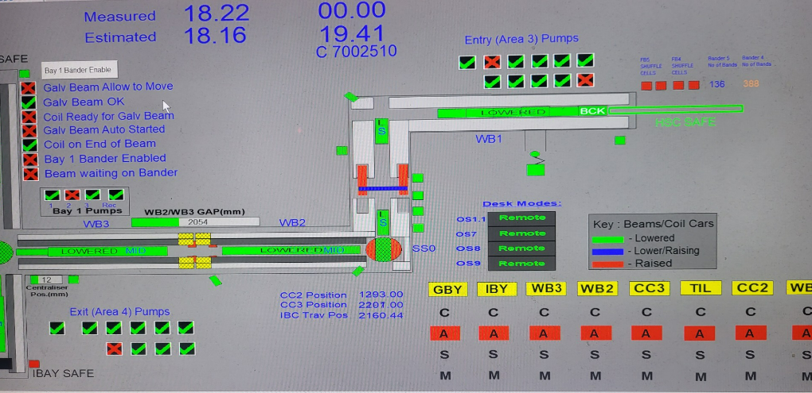
Figure 1 - Overview of coil transport system from Hot Mill to Coil Processing Bays.

Actuators

The use of hydraulic fluid actuators are one of the key elements of the operating sequence of Walking Beam 1. The beam consists of seven cars, each individual car has their own personal lift cylinder. Also, a larger traverse cylinder is required for forwards or backwards motion of the beam. Hydraulic actuators are elements converting the energy of the working fluid into mechanical energy related to the reciprocating motion. The pressure of the working fluid acts on the piston and creates a force causing the piston assembly to move (Skowrońska, et al., 2021). To control the fluid from the entry hydraulic pumphouse, proportional valves with an electromagnetic solenoid controller are used to regulate fluid control for raise, lower, forward and backward motions. Although when traversing, the beam is required to decelerate before reaching end point to protect equipment from unnecessary damage. The use of proportional valves allow this to happen through manipulating hydraulic fluid pressure. Parr (2011) re-iterates the previous point made by describing the proportional valve as having a different design requirement. The spool position can be set anywhere between 0% and 100% stroke by varying the solenoid current (Figure 1).
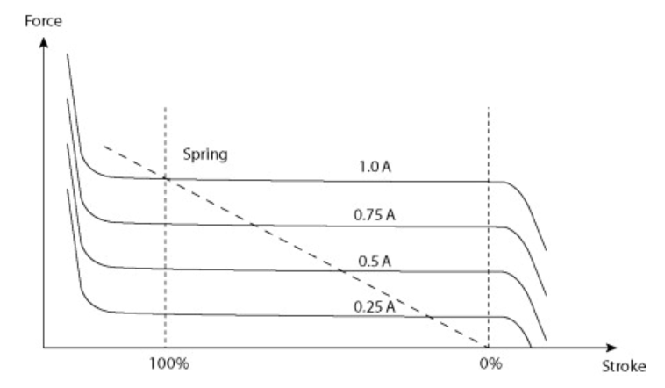

Figure 2 - The relationship between force and cylinder stroke when adjusting current supply to solenoid. (Parr, 2011)

Sensors

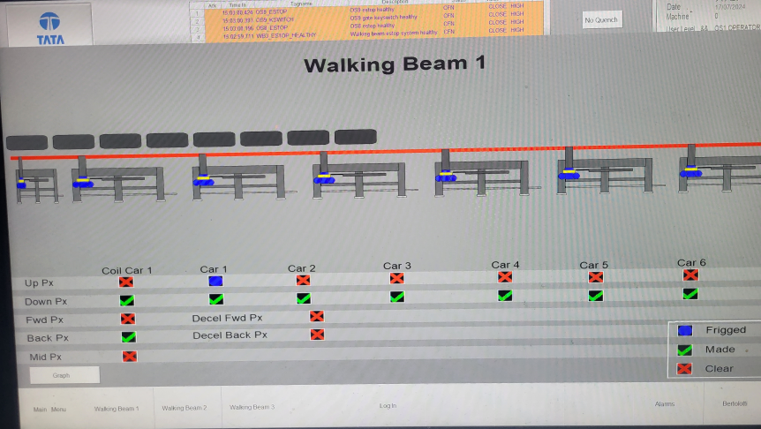
A sensor can be defined as devices that transform or transduce physical quantities into output signals, which in turn provide input signals for the control system (Fleming, 2001). The proximity sensors are essential to capture beam position for operational performance. These sensors are situated on each lift cylinder, while also used to detect fully forward and backward on traverse motion. Also, decel forward and backward proxy’s are utilised for capturing beam position when deceleration is required before reaching end proximity position. Every proximity sensor on Walking Beam 1 can be viewed below in (Figure 2). This schematic is used within the operator’s pulpit on the Human Machine Interface (HMI) system, to allow employees to easily identify proximity sensor performance.

Figure 3 - HMI Walking Beam 1 operating pulpit screen displaying proximity sensor conditions.
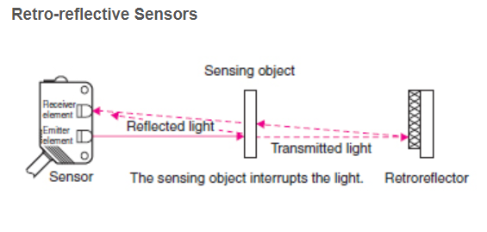
To create a continuous flow of product transportation, industrial photocell sensors are used to identify a steel coil then create an action for inputs into control system. The main operating principle for these sensors, are to reflect light back to the sensor from the positioned reflector on opposite side of coil path (Figure 3). When the steel coil breaks the reflection, Walking Beam 1 is automatically actioned to take the product from this position. These sensors are vital for the control algorithm used within the control system.

Figure 4 - Operating principle of retro-reflective sensor used in Coil Handlin (Omron, 2024).

Control Algorithm

An algorithm can be regarded as consisting of a logic component, which specifies the knowledge to be used in solving problems, and a control component, which determines the problem-solving strategies by means of which that knowledge is used. The logic component determines the meaning of the algorithm whereas the control component only affects its efficiency (Kowalski, 1974). The control algorithm used for Walking Beam 1 varies due to operator inputs from the control desk. Each applied setting communicates different commands to the control system depending on operational requirements. The table below (Figure 4) highlights each of these commands and the control system actions taken for each.
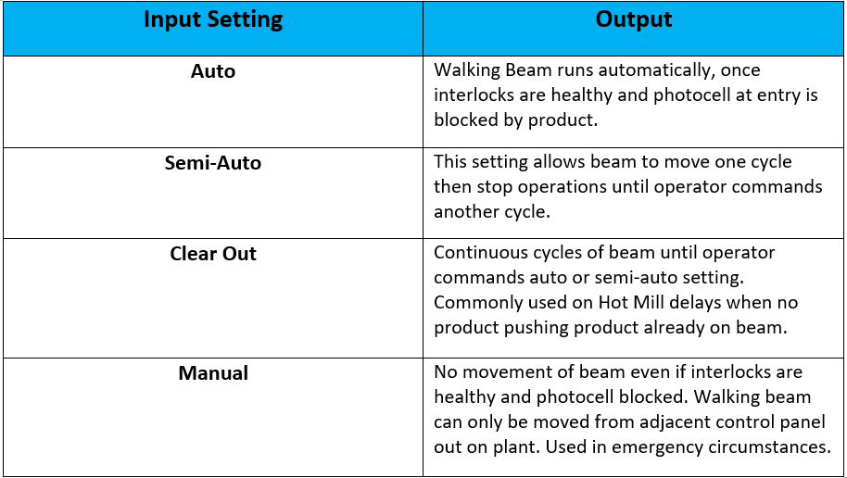
Figure 5 - Operator input settings to control system and their outcomes.
The control algorithm used for the basic operation of the Walking Beam 1 cycle can be viewed as straightforward. The beam has a base position of fully lowered and backward. When actioned by the photocell or operator input, the beam raises until limits are reached and then traverses forward until end point. Once forward limit has made, the beam fully lowers and traverses back to the original base position. Before the actioning of a cycle there are interlocks in place for equipment protection of processes to the north and south of Walking Beam 1 – High Speed Conveyor and Coil Car 2. The control system requires each of these to reach their ‘safe’ position for authorisation of beam movements. Also, the GEM80 is required for coil identification tracking, each product has its own personal identification number. When coil tracking, control system communication is vital for transporting product to customer dispatch areas through data exchange.

Communication Protocols

The GEMCAN I/O Scanner module resides in the host PLC and provides an interface between the PLC and the module’s two CAN communication ports. Typically before the host PLC Ladder Scan, data is transferred between the GEMCAN I/O Scanner module and the host Data Table memory (ConverTeam, 2009). The areas of communication protocol for effective data exchange can be broken down into three categories – Serial, Ethernet and Wireless. The serial protocol is the oldest type of data exchange application and through the use of wiring, hardware is minimal but low bandwidth and noise interference can effect reliability and efficiency. The use of ethernet communication requires an increased complexity to software and hardware installation. Although, this benefits the bandwidth and speed of data exchange between process sensors and actuators. The most modern application for communication protocols is the wireless connection, the use of Wi-Fi or Bluetooth can wirelessly exchange high amounts of data between actuators, sensors and control system. Wi-Fi provides the highest data exchange rates through Wireless Local Area Network (WLAN) with minimal delays (Control Engineering, 2023). Although, this communication protocol relies on high network speeds for optimal performance.
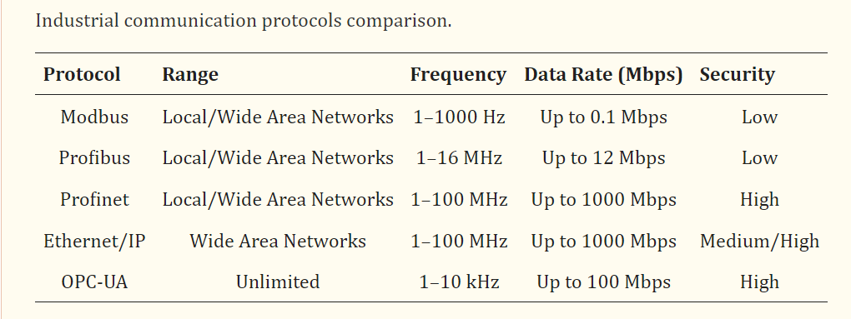
Figure 6 - Data table of industrial communication protocols comparing Frequency, Data Rate and Security (Tapia, et al., 2023)

Software/Tools for Control System Development

There are several PLC simulation tools available. These can be divided into PLC System Simulators, PLC Core Simulators, and PLC Network Simulators. PLC System Simulators e.g. S7-PLCSIM and RSLogix Emulate can simulate an entire PLC system, ranging from internal behaviours, the programming to network communications (Cui, et al., 2024). Currently GEM80 PLC systems are becoming obsolete, the use of simulation software during PLC upgrades can be essential to control system upgrade transition. The upgrade in HMI development can provide more in-depth feedback to operators and inspectors. By supplying more information to the employee will provide benefits to operational delays, equipment life cycles and improved safety by removing the employee from the work area. The modern HMI can provide an escalation of alerts in a given scenario, which can be seen below in (Figure 6):
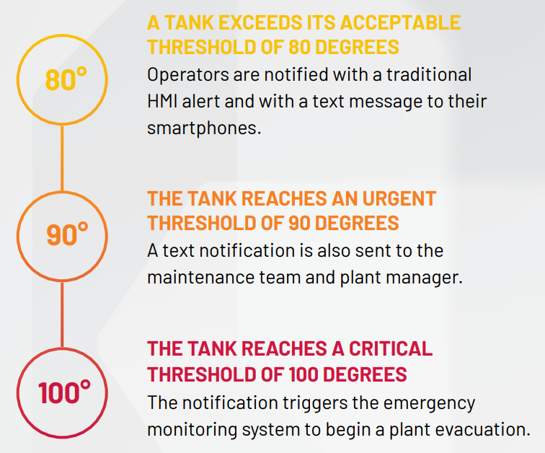

Figure 7 - Scenario of increasing tank temperature and how the modern HMI alerts employees (Rockwell Automation, 2020)

Potential Control System Enhancements

RXi Controller Upgrade

As previously mentioned in the report, GEM80 PLC’s have reached their end of life cycle. Therefore, spares are becoming difficult to source and the control system components are obsolete. Recently, GE who manufactured the GEM80 control system, have produce a modern modular designed control system called RXi-042 (Figure 7). The solution is built around the proven HPCi high-performance controller system running on the RXi-042 platform (Banks, 2020). When fitted with the GEM80 Scanner I/O, the upgraded system can use the GEM80 I/O previously used with minimal changes. This creates a smoother transition while improving overall performance. The process map in (Figure 8) shows a modern RXi control system when integrated with the Industrial Internet of Things (IIoT).
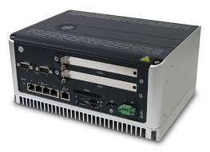

Figure 8 - RXi industrial PC (GE Intelligent Platforms, 2015)
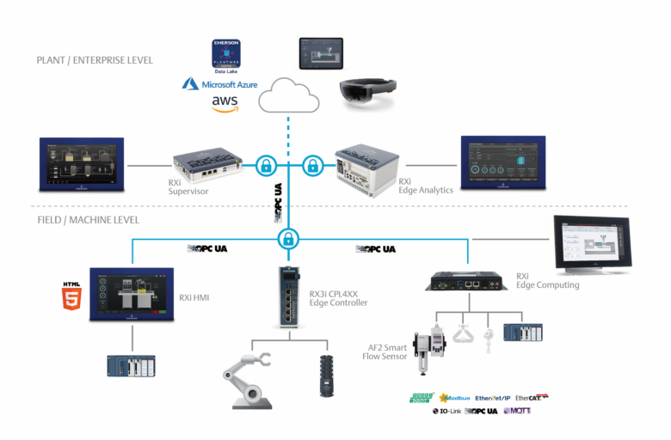
Figure 9 - Integrating RXi control equipment with IIoT to create a modern control system (Santora, 2022).

Additional Sensors for Quality Defect Detection

As Walking Beam 1 is the first mode of transport to dispatch areas, there is an importance to capture any potential quality surface defects to the steel coil product. The possible enhancement to this control system, could be through the implementation of a laser ultrasonic detection device (Figure 9). This sensor would be linked to the control system, while any alerts to defect identification being communicated from the control system to an operator HMI.
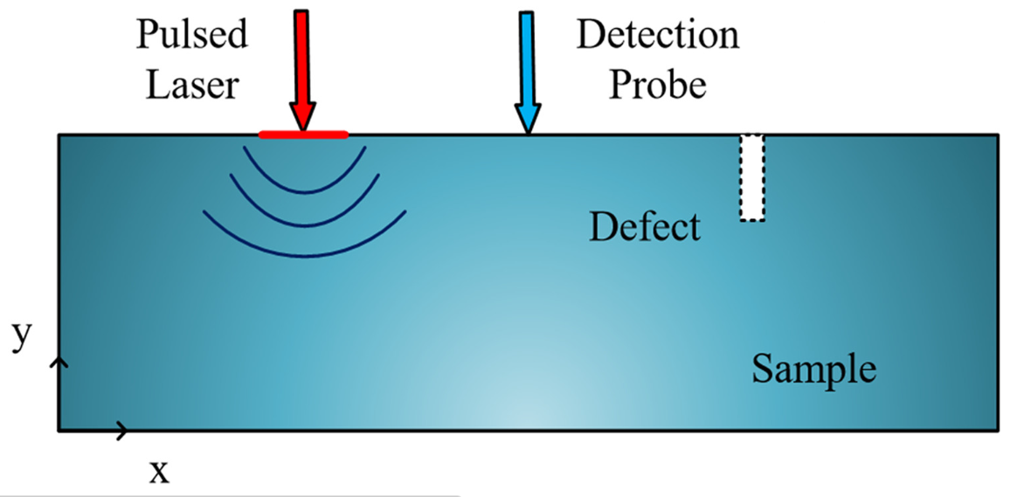

Figure 10 - Schematic diagram of Laser Ultrasonic Detection of surface defects (Chen & Zhang, 2021).

Task 2 – PID Controller of Cruise Control System

Encoding and Decoding Functions for Demand, Actuator and Sensors

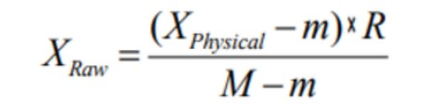
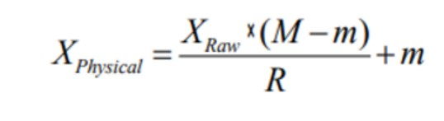
The area of the main control script for cruise control encoding and decoding functions can be found between lines 77-92. This part of the code runs on the ‘if’ statement meaning that every 0.05 seconds these functions are run through the script. The main purpose for these functions is calling on external functions to produce a speed response, then calculating the error for these speeds, followed by determining from the error the amount of control required to ultimately reduce the scale of error. Throughout this code, conversions from x-bit binary numbers to decimal and also, decimal to binary numbers by the following calculations (Figure 10 and 11).
Figure 11 - Binary to Decimal Number Calculation. Figure 12 - Decimal to Binary Number Calculation.
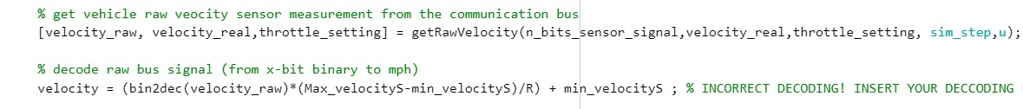
To determine the velocity response, raw velocity sensor measurement is taken from the engine control unit. This raw velocity is a binary measurement and must be converted into miles per hour, through decoding (Figure 12).
Figure 13 - Velocity Raw to Velocity decoding.
The demand raw code is when the driver sets the speed required on cruise control system, the communication signal is being sent to the engine control unit. Similarly to the velocity decoding, this signal is an x-bit binary number and requires converting into miles per hour through the bin2dec function for demand (Figure 13).
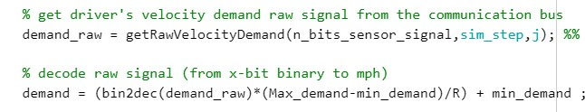
Figure 14 - Demand Raw signal to Demand signal through decoding.
To enable the speed control, a function was required to be built to interpret the error from actual and demanded speed. Therefore, determining required control signal through Proportional, Integral and Derivative calculations and summing these together. These calculations were carried out in the CalcControl script (Figure 14). Following this, encoding was required to convert the control signal into a x-bit binary number to communicate with the engine control unit, otherwise known as control raw (Figure 15).
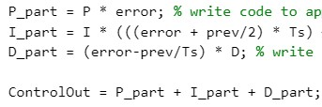

Figure 15 - PID calculations for Control signal.
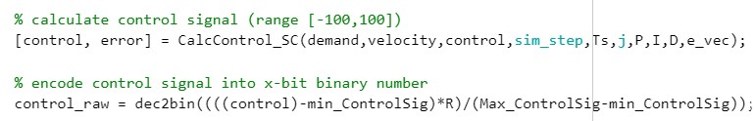
Figure 16 - Control/Error signal and encoding into Control Raw.
The final command of this piece of code comes from the variable ‘u’. This code ultimately sends the binary number from the control signal back to the car control unit (Figure 16). This command simulates the throttle position required, either through opening the butterfly valve for increased speed or applying the brake for reduction.
Figure 17 - Control Command signal sent back to Engine Control Unit.

Feedback Controller Code

The code used for the feedback controller can be found within the CalcControl script. This code defines a function for the control and error signal, through using data collected from multiple inputs in the Main Control script and applying PID control. (Figure 17).
Figure 18 - Function created for Control and Error signal.
Within this code, the previous calculation for the integral value is stored and the current integral value calculated together, through the ‘persistent’ function. This calculation is used to calculate the area under the error within the time graph feedback, by integrating between the previous and current values. The variables Max_ControlSig and Min_ControlSig are part of the code to set control signal boundaries for the feedback controller (Figure 18).
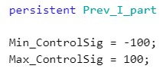

Figure 19 - Previous and current Integral value code and Control signal boundaries.
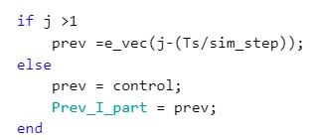
The next piece of code uses the ‘if’ and ‘else’ statements to create actions depending on the amount of runs in simulation. Basically, if the simulation run is greater than one then the error vector (e_vec) and time variables (Ts)(sim-step) will be used. Otherwise, as there is no error signal before the first simulation run, the previous values for control and integral will be used (Figure 19).

Figure 20 - 'if' and 'else' statements for simulation runs.
Finally, as previously mentioned in the previous report section (Figure 14), the P,I and D parts of the controller were calculated and summed together to create a control action for the error signal.

PID Controller Gains

To begin setting PID controller gains, the proportional element of the controller was inputted with a low number then slowly increasing this figure until oscillation was present for the real velocity trend line. The proportional gain was increased to 2.2, producing trace oscillation (Figure 20). The oscillation observed displayed the system instability, so figures were reduced to 2.1 or until system was stable.
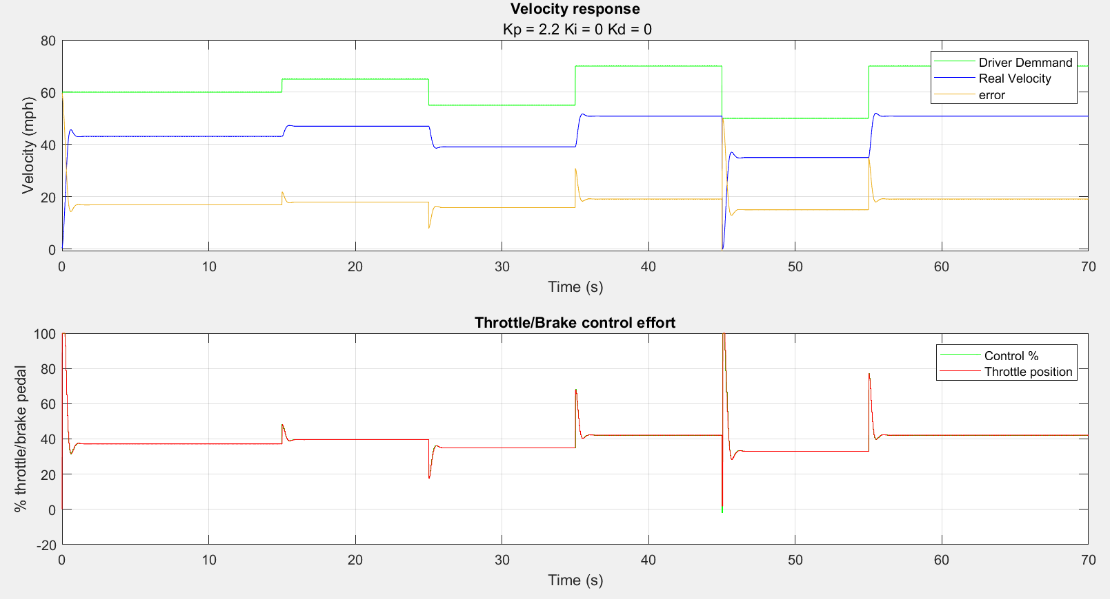
Figure 21 - Increasing Proportional gain until system oscillation displayed.
The next stage of tuning required an inputted figure for integral gain. This was increased until the real velocity trend line followed driver demand trace closely therefore reducing the amount of steady state error (Figure 21). The issue while implementing PI controller gains, was the settling time on initial change of speed was not compatible with driver demand.
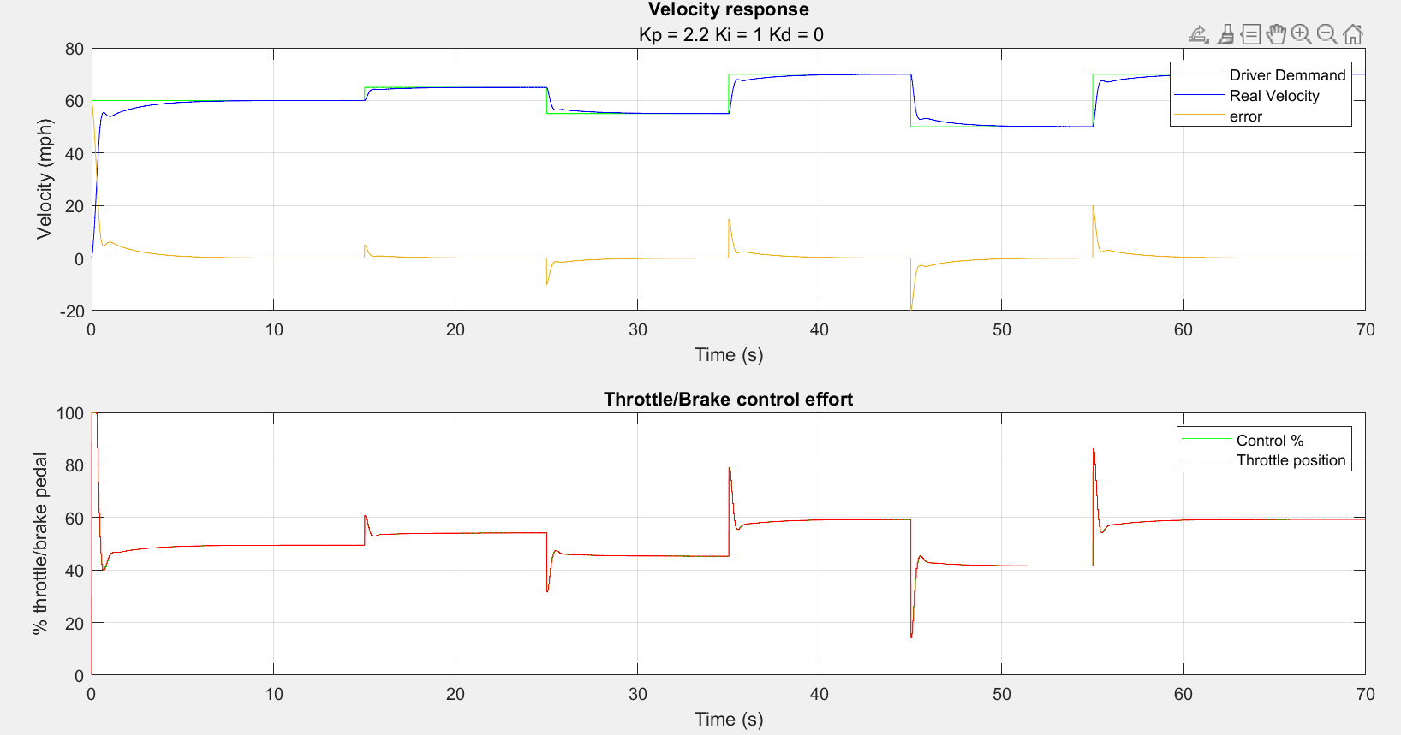
Figure 22 - Integral gain increase to reduce Steady State Error.
The issue displayed in (Figure 21), required further tuning through derivative control to produce an improved settling time. Although, this was gradually increased but the compatibilty between real velocity and driver demand worsened, and throttle position variability increased (Figure 22).
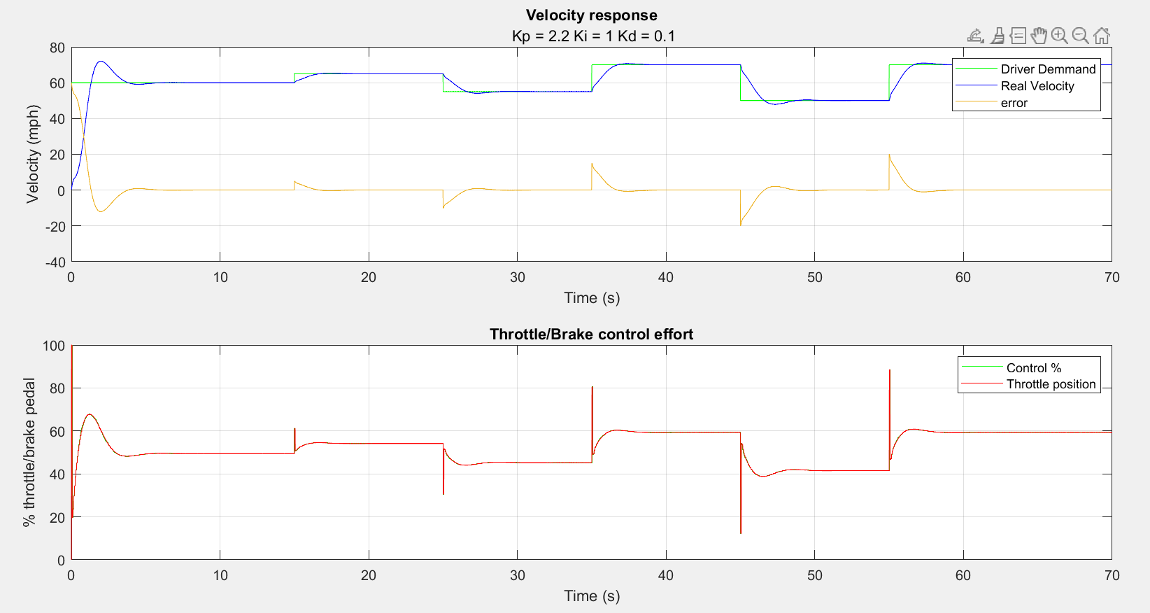
Figure 23 – Derivative gain tuning.
Several attempts were made to reduce area between driver demand and real velocity by extra tuning of PID controller gains. As can be seen below in (Figure 23), proportional gain was decreased to 1 to improve settling time on speed change, while also removing derivative gain to counteract the trace variability. The integral gain tuning became very temperamental, anything over 1Ki would produce large errors and decreasing to 0.99Ki reduced real velocity below driver demand.
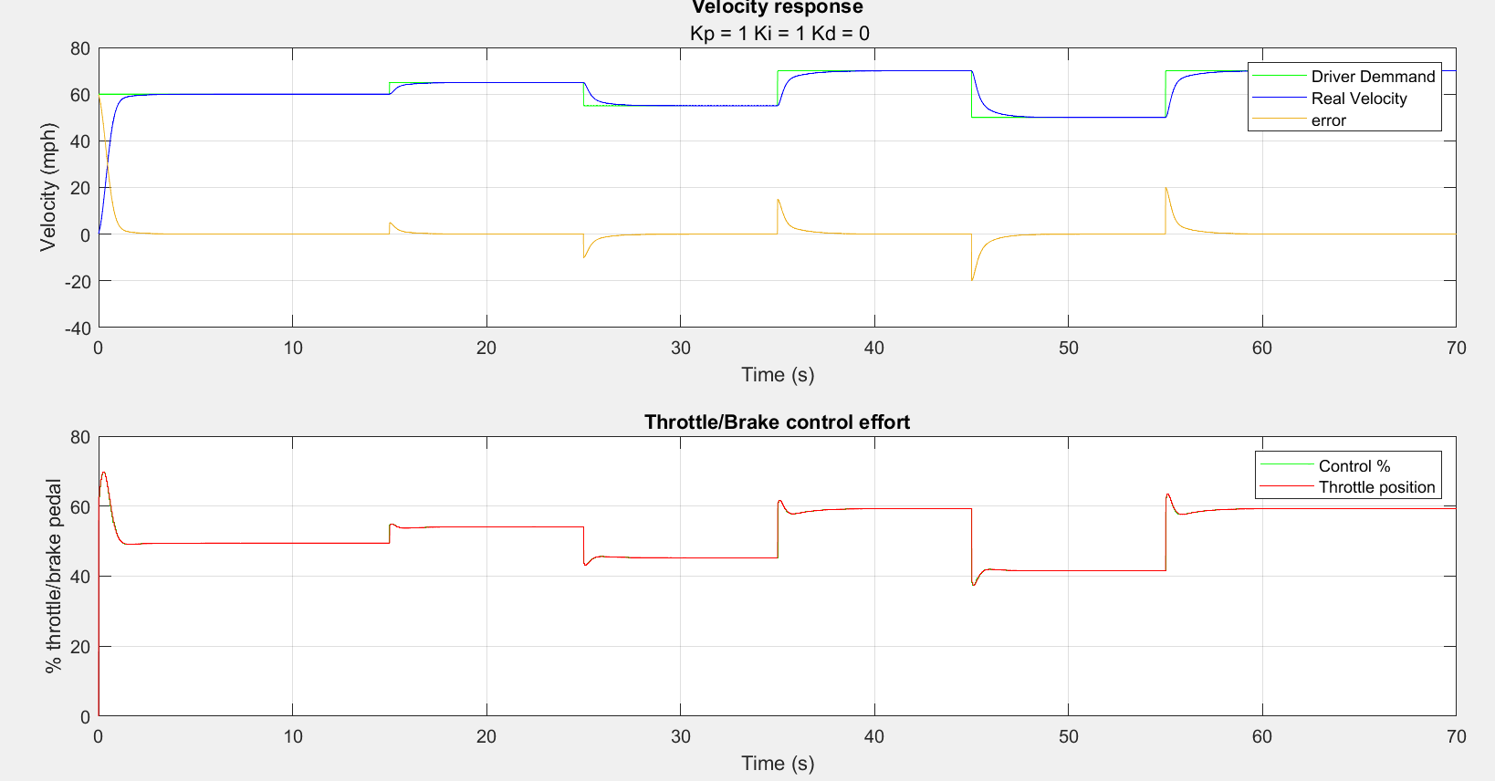
Figure 24 – Final selected PID controller gains.
Evaluating the data in (Figure 23), the final PID controller feedback has minimal steady state error when increasing or decreasing cruise control speed. (Figure 23) visually looks compatible with driver demand and meets expectations after approximately 3 seconds. From a logical viewpoint, when decreasing velocity this gradually reaches the driver demand set points under control. Also, the throttle or brake control effort has minimal oscillation when changing velocity, creating a smoother ride for the driver when using the cruise control system. This resulting in (Figure 23) being the controller gains of choice for this system.

Number of Bits Performance

To determine the effects on closed loop performance, the number of bits for actuator, demand and sensor signal were manipulated for experimentation. Firstly, each signals bit figure was increased or decreased individually while others were unchanged at 16-bit. The feedback from this process produced large scale errors as can be seen in (Figure 24). This scenario applied a 10-bit signal to the actuator.
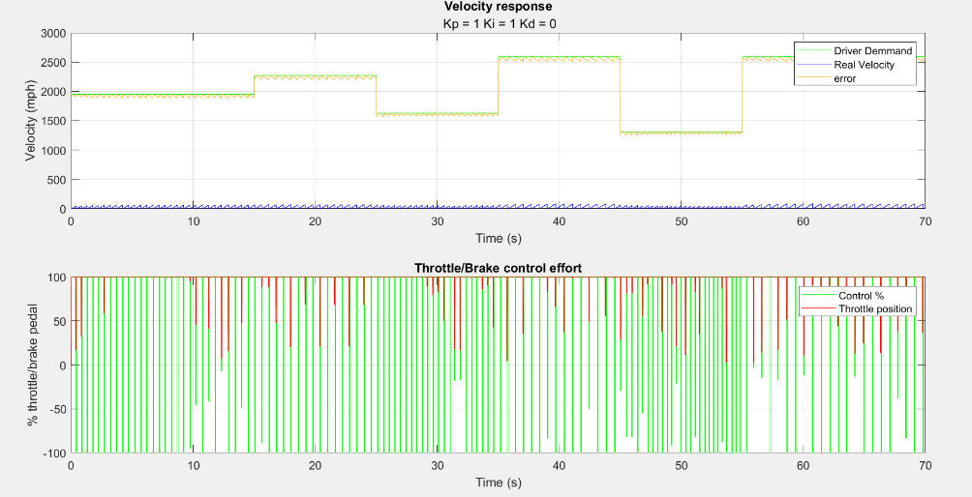

Figure 25 - Results of reducing Actuator signal value to 10-bit
Sampling the three signals with a common figure was decided for the reduction of bits while analysing performance. This created more stable feedback from the closed loop system. The overall number of bits were reduced to discover the minimal amount required for reasonable performance. Reduction was taken to 8-bit for all three signals, the feedback displayed obscurities in the throttle position but also, started to show trace movement to real velocity (Figure 25). By increasing the bit signal to 10-bit, produced stable feedback for throttle position, real velocity and demand performance (Figure 26).

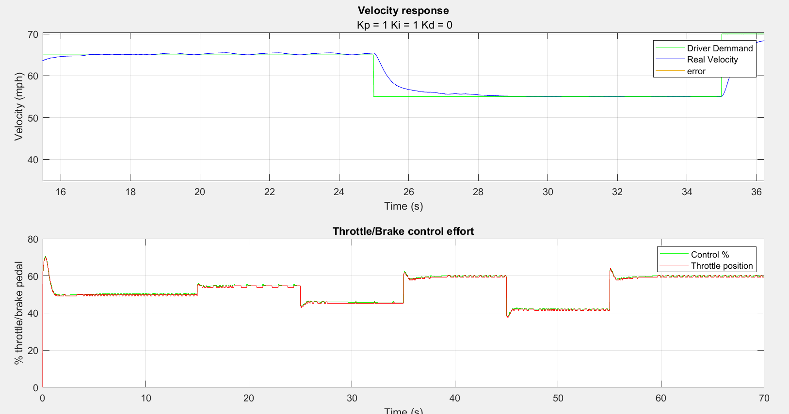
Figure 26 - Results of 8-bit for all Signals – Affecting performance
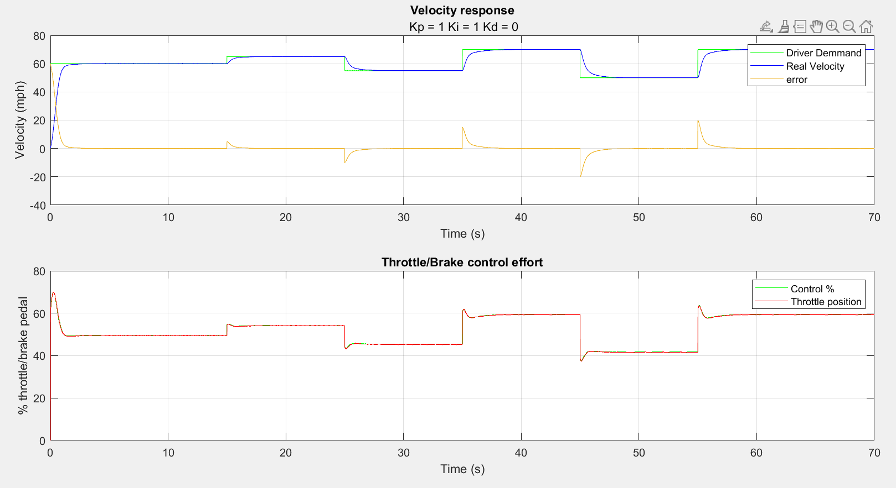
Figure 27 - 10-bit signal producing reasonable performance across all feedback.

Sampling Times

To understand the effects of manipulating sampling times (Ts) on controller feedback, experimentation was carried out through increasing and decreasing values. Current sampling time was set at 0.05 seconds. To begin, decreasing the value to 0.01 seconds produced an unchanged response to system performance result. Afterwards, the value was gradually increased to 0.3 seconds where reduced performance results were displayed to initial velocity and throttle position response (Figure 27). The maximum sampling time found to produce reasonable performance was 0.2 seconds.
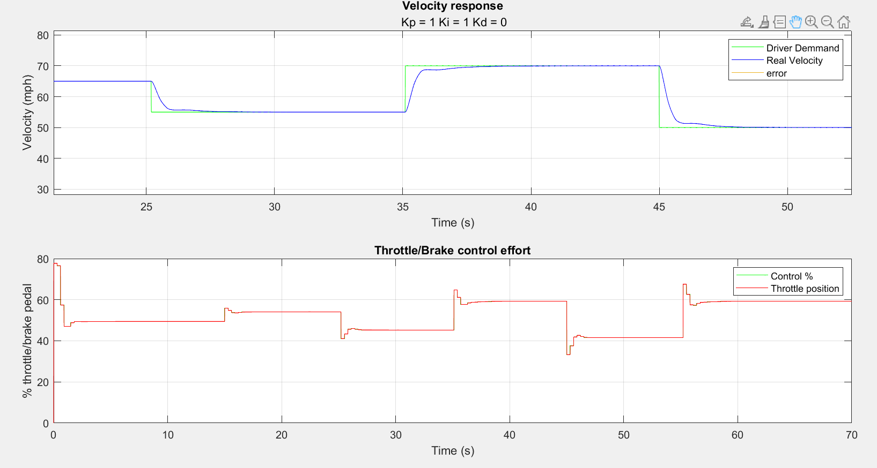
Figure 28 - Results of 0.3 seconds sampling time producing a change in results.
The constraints associated with sampling time selection can be related to the effect of time. Depending on the amount of time available for sampling, will determine the precision and accuracy of data feedback. Also, the amount of data that can be stored within the system would have an effect on the overall frequency of sampling times, as data retention is essential for system feedback. By reducing sample times, a more defined controller feedback will be presented for the signals (Figure 28).
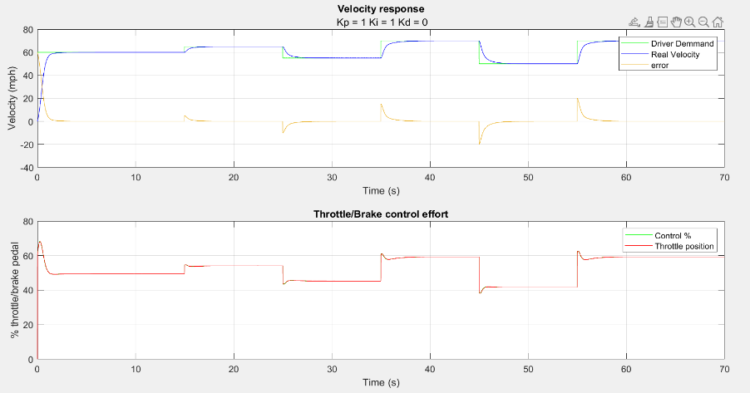

Figure 29 - The unchanged effect of reducing sampling times to 0.01 seconds.

Communication Network Delay

Coomunication network delay is the time taken to transfer data over a specific network. The larger the delay, the increased chances of slower reponse time, decreased efficiency and variability in demanded results.
To determine the maximum network delay to maintain reasonable performance, the actuator signal delay was increased gradually from 0 to 0.25 seconds. This final inputted value of 0.25 created an unreasonable performance feedback, by variability of real velocity control response when driver demanded a change of speed (Figure 29). Resulting in 0.2 seconds being the maximum communication delay allowed.
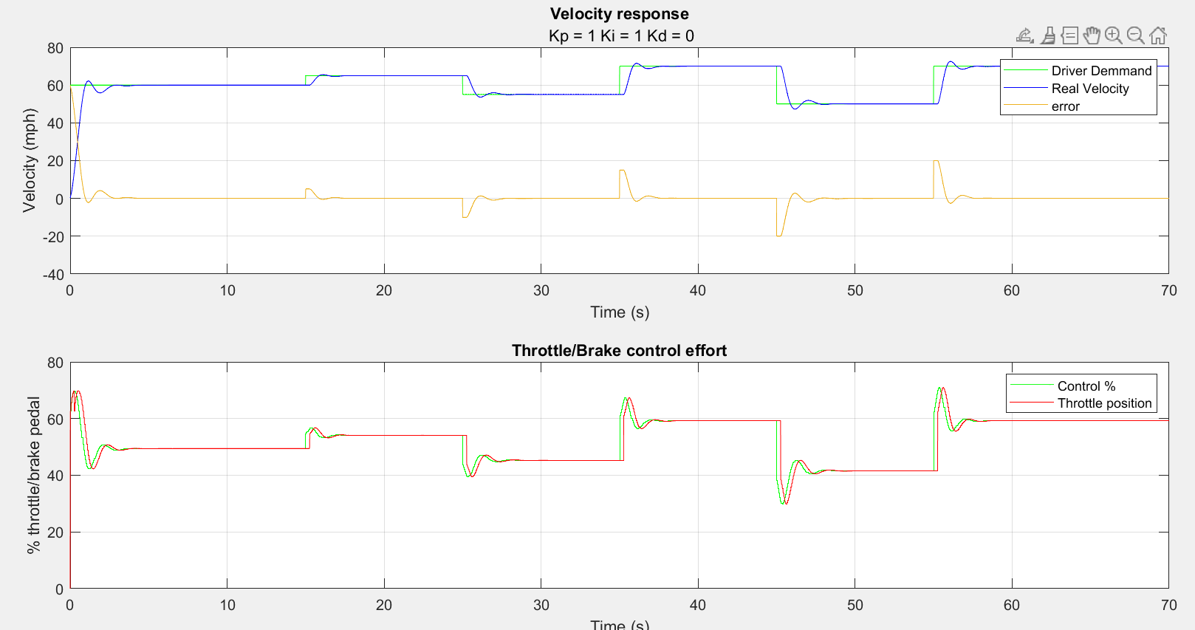
Figure 30 - Effect of 0.25 second network delay on performance.
Through adjusting the PID gains of the controller, larger delays were inputted to clarify if the change in gains could control network delay errors. After experimentation, a change in gains was attempted on a 0.3 second network delay but due to the current controller set up, improvements were not possible. The changes to PI control already in place, failed to make any improvements on changes. Also, due to derivative control already at zero, increasing the gain increased swing in the trace. Resulting in no scope to tune in the opposite direction to potentially provide improvement.

References
Banks, P., 2020. GEM80 Migration: HPCi System on RXi, Rugby: LinkedIn.
Chen, C. & Zhang, X., 2021. Research on laser ultrasonic surface defect identification. Science Progress, 104(4).
Control Engineering, 2023. What Communication Protocols are best for Sensor and Actuator Integration in Industrial Control Systems?. [Online]
Available at: https://www.linkedin.com/advice/3/what-communication-protocols-best-sensor-actuator-8xx9e
[Accessed 22 07 2024].
ConverTeam, 2009. GEMTEQ I/O Technical Manual (T2031En) , Stoke-on-Trent: ConverTeam.
Cui, H., Hong, J. & Louden, R., 2024. An Overview of the Security of Programmable Logic Controllers in Industrial Control Systems. Encyclopedia , 4(2), pp. 874-887.
Digital Automation Training, 2024. GEM80 PLC Systems. [Online]
Available at: https://dat.co.uk/gem80_information/
[Accessed 17 07 2024].
Fleming, W. J., 2001. Overview of automotive sensors. IEEE Sensors Journal, 1(4), pp. 296-308.
GE Intelligent Platforms, 2015. Highly Versatile, Ruggedized Computing. [Online]
Available at: https://cadenceautomation.ca/wp-content/uploads/2017/06/rxi-xp-industrial-pc-ds-gfa1985c.pdf
[Accessed 22 07 2024].
Kowalski, R., 1974. Algorithm = Logic + Control. Communications of the ACM, 22(7), p. 424.
Omron, 2024. Photoelectric Sensors: Technical Support. [Online]
Available at: https://www.ia.omron.com/support/guide/43/introduction.html
[Accessed 20 07 2024].
Parr, A., 2011. Hydraulics and Pneumatics: A Technician's and Engineer's Guide. 3rd ed. London: Elsevier.
Rockwell Automation, 2020. Modern HMI Software. [Online]
Available at: https://literature.rockwellautomation.com/idc/groups/literature/documents/br/ftalk-br012_-en-p.pdf
[Accessed 22 07 2024].
Santora, M., 2022. Emerson’s new edge solutions simplify advanced IIoT applications. [Online]
Available at: https://www.designworldonline.com/emersons-new-edge-solutions-simplify-advanced-iiot-applications/
[Accessed 22 07 2024].
Skowrońska, J., Kosucki, A. & Stawiński, Ł., 2021. Overview of Materials Used for the Basic Elements of Hydraulic Actuators and Sealing Systems and Their Surfaces Modification Methods. Materials (Basel), 14(6), p. 1422.
Tapia, E., Sastoque-Pinilla, L. & Lopez-Novoa, U., 2023. Assessing Industrial Communication Protocols to Bridge the Gap between Machine Tools and Software Monitoring. Sensors (Basel), 23(12), p. 5694.

