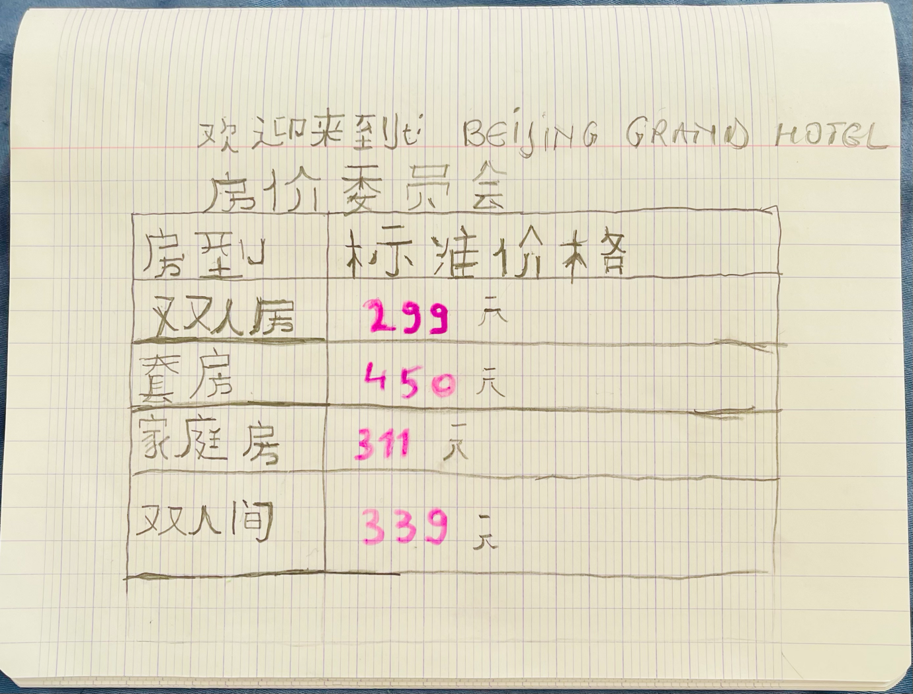

Name : Corina Iordan
Student id:2021277
Lecturer: Jinping Li

