 | Student No:
 | Module Title: | Operating Hotel Facilities
 | Module Code: | BMIH4006
 | Lecturer:
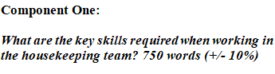
The housekeeping crew is responsible for serving the hotel's functions, and their necessary abilities and qualities are crucial to upholding the standard benchmark of a prestigious hotel such as Premier Inn. The core competencies of Premier Inn's housekeeping service will be covered in this reflection report. To analyse my experiences as a housekeeper at the Premier Inn Hotel, I will use Gibbs' reflective approach (Pizam et al., 2016).

Discovering the Skills Critical for Premier Inn Hotel’s Housekeeping Team
For the Premier Inn Hotel's cleaning staff to function efficiently, they need a few essential competencies. A few essential competencies include (Stephenson et al, 2018).
Efficiency: Especially when dealing with high occupancy rates, housekeepers must operate with efficiency. Because of its well-known brand, Premier Inn's housekeeping staff must be very good at managing their time while cleaning guestrooms quickly to avoid sacrificing the standard of care (Pizam et al, 2016).
Precisions: To preserve every nook and cranny and the hotel's high level of cleanliness, housekeeping at Premier Inn requires extra attention to detail and precise attention to detail. Maintaining the brand image may be achieved by cleaning and examining each component (Pirani et al, 2016).
Flexibility: The atmosphere at hotels is very changeable and dynamic. For guests to be as satisfied as possible, housekeepers must be adaptable enough to accommodate last-minute requests from visitors or to adjust schedules in order to fully use guestroom amenities (Oskam et al, 2016).
Communication: Interaction with co-workers, interacting with employees of other hotels, and reporting any information to the front desk or supervisor are all part of the job description for cleaning personnel. Effective communication is a crucial ability for every staff member, whether they are interacting with visitors or requesting fresh supplies for guest services.
Team Collaboration: Teamwork is the key to achieving hotel operations, and cleaning employees at Premier Inn are required to work together in order to correctly complete each assignment. According to Marasco et al. (2018), teamwork guarantees that jobs are allocated properly and that maximum customer service is achieved via group effort.

Reflecting on the Housekeeping Experience Utilising the Gibbs Model
The Premier Inn Hotel's cleaning experience may be thoughtfully evaluated using Gibbs' reflective methodology (Gomezelj, 2016).
Description: At the Premier Inn Hotel, my primary responsibility as a housekeeper is to maintain the guestrooms tidy. This involves performing various cleaning tasks like vacuuming, sweeping, disposing of trash, inspecting the room amenities again, and setting up the beds with fresh linens to guarantee prompt guest service (Marasco et al, 2018).
Feelings: I experience a range of emotions while doing daily cleaning tasks. I consider myself successful when the rooms are spotless and the visitors are completely satisfied. But sometimes, I feel worn out by my workload and the unstable environment. This implies that the efforts need to be more efficacious (Tuomi et al, 2019).
Evaluation: The superior quality of the Premier Inn Hotel guarantees that every attempt is made with complete focus and accuracy to provide client service. The visitors are informed by the staff's recognition of their accuracy and efficiency. However, since the work is repeated, the workers may get too tired to work efficiently (Lin et al., 2020).
Analysis: Based on my experience, I've come to understand how important housekeeping tasks are when combined with effectiveness, efficiency, adaptability, and cooperation. According to Xiang et al. (2017), these duties not only guarantee top-notch housekeeping but also showcase the brand and the experiences of its clients.
Conclusion: I have made the decision to improve my housekeeping skills, namely cooperation and collaboration. I'm concentrating on strengthening my housekeeping teamwork and creating a supportive environment at work. I want the cleaning crew as a whole to collaborate as a team (Li et al, 2017).
Action Plan: By attending workshops, I will put in more effort to further develop my housekeeping abilities, which will strengthen both my competence and my team's performance. I'll do a detailed investigation of Premier Inn's housekeeping to find any areas that might require improvement and include them to my list of improvements (Legrand et al, 2016).

Conclusion
The cleaning staff's expertise and skills are what maintain the Premier Inn Hotel's high standards and guarantee outstanding guest satisfaction. With its competitive approach and steady expansion, the Gibbs reflective model has brought attention to my cleaning business. According to Kuo et al. (2017), the aforementioned housekeeping qualities are essential for preserving Premier Inn's standard function, thus I need to work on developing them in order to contribute more.

Words- 798

Component Two: Housekeeping cleaning checklist
Contribution to Overall Module Assessment: 25%
Housekeeping Cleaning Checklist
Name: Mr X ----------------------- Location: Premiere Inn --------------------- Start Date: 03-11-2023
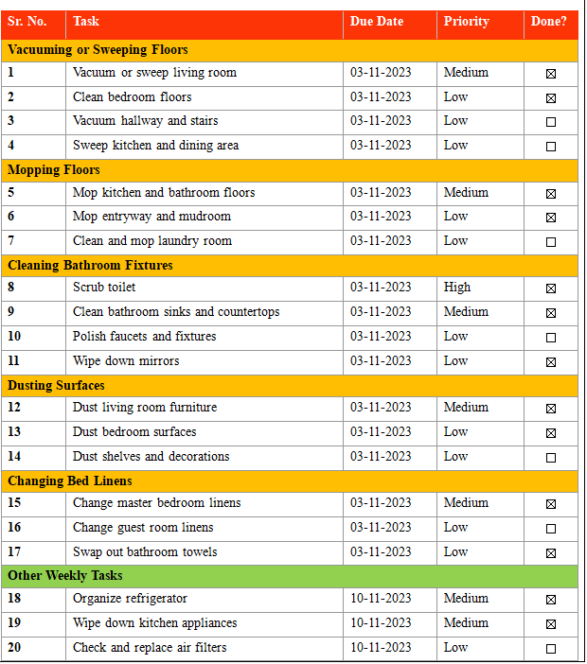

Based on your completed checklist you will need to write 500 words in essay format discussing the following:

How will you guarantee that the rooms are cleaned in accordance with brand guidelines?
The checklist procedure should coordinate general cleaning duties with Premier Inn Hotel brand criteria to guarantee that rooms are cleaned in accordance with brand standards. A detailed plan outlining how each room's surfaces, corners, floors, and amenities will be cleaned will be created in order to maintain the cleanliness of the space. The hotel will propose the equipment and cleaners to be used, and this will be included in the plan. The staff will go over the completed checklist methodically and make sure all of the tasks are up to the standards that Premier Inn has set. To provide a thorough and effective cleaning procedure, a regular training procedure will be designed to keep housekeeping informed of the hotel's needs. Any modifications to the checklist should also be shared with them (Kandampully et al., 2018).
How would you implement these changes to increase team effectiveness?
For housekeeping at the Premier Inn Hotel, increasing team performance is essential. In order to facilitate communication among cleaning workers, a clear communication channel should be established inside the hotel. In order to emphasize the vital role that cooperation plays, they will have frequent team meetings where housekeepers will talk about housekeeping procedures, difficulties, and solutions. In order to guarantee that duties are given efficiently, effective task delegation will be used. This procedure should be repeated in a cycle to avoid fatigue and motivate all team members to advance their abilities and become proficient in a variety of room cleaning activities. As a team, they will work better and be more successful if exceptional performance is acknowledged and rewarded with incentives like monthly bonuses (Jone et al, 2016).
Why do you believe your list to be the most useful?
The greatest and most efficient chores are included in the checklist since it was created with the Premier Inn Hotel brand quality in mind. Every aspect of room cleaning is covered in depth by the checklist's comprehensive methodology and directions. Thus, the accountable teams will find it easy to comprehend their jobs and how to do them carefully. There is a great deal of flexibility and adaptability that may be adjusted in the event that visitor preferences or room settings alter. Also, any modifications to the Premier Inn Hotel's cleaning standards may be promptly implemented, and any adjustments to the amenities in the rooms will be managed effectively. There is enough opportunity for the checklist to be improved continuously, and team members are welcome to provide advice on how well the checklist is working. Suggestions will be quickly taken into consideration. The checklist will be revised often in response to evolving market trends, hotel specifications, and input from visitors

References
Amos, D., Musa, Z. N., & Au-Yong, C. P. (2019). A review of facilities management performance measurement. Property Management, 37(4), 490-511.
Gomezelj, D.O., (2016). A systematic review of research on innovation in hospitality and tourism. International Journal of Contemporary Hospitality Management.
Hayes, D. K., Ninemeier, J. D., & Miller, A. A. (2017). Hotel operations management. Pearson.
Ihsan, B., & Alshibani, A. (2018). Factors affecting operation and maintenance cost of hotels. Property Management, 36(3), 296-313.
Jones, P., Hillier, D. and Comfort, D., (2016). Sustainability in the hospitality industry. International Journal of Contemporary Hospitality Management, 28(1), pp.36-67.
Kandampully, J., Zhang, T.C. and Jaakkola, E., (2018). Customer experience management in hospitality. International Journal of Contemporary Hospitality Management.
Kuo, C.M., Chen, L.C. and Tseng, C.Y., (2017). Investigating an innovative service with hospitality robots. International Journal of Contemporary Hospitality Management.
Legrand, W., Sloan, P. and Chen, J.S., (2016). Sustainability in the hospitality industry: Principles of sustainable operations. Routledge. MU
Li, X., Ma, E. and Qu, H., (2017). Knowledge mapping of hospitality research− A visual analysis using CiteSpace. International Journal of Hospitality Management, 60, pp.77-93.
Lin, N. and Ottenbacher, M., (2020). Past and present streams in international hospitality research.
Marasco, A., De Martino, M., Magnotti, F. and Morvillo, A., (2018). Collaborative innovation in tourism and hospitality: A systematic review of the literature. International Journal of Contemporary Hospitality Management. MU_Rahman
Mohsin, A., Brochado, A., & Rodrigues, H. (2023). Mind the gap: a critical reflection on hotel employee turnover. International Journal of Contemporary Hospitality Management, 35(7), 2481-2495.
Motyka, B. (2018). Employee engagement and performance: a systematic literature review. International Journal of Management and Economics, 54(3), 227-244.
Nikolskaya, E. Y., Anzorova, S. P., POTAPOV, S. V., Dekhtyar, G. M., & Lebedev, K. A. E. (2019). Methodical approaches to estimate hotel facilities’ efficiency. Journal of Environmental Management and Tourism, 9(8), 1664-1669.
Oliveira, A. S., Renda, A. I., & Correia, M. B. (2020). Online reviews: A pathway to improve hotel management. Dos Algarves: A Multidisciplinary e-Journal, 36.
Oskam, J. and Boswijk, A., (2016). Airbnb: the future of networked hospitality businesses. Journal of Tourism Futures.
Pirani, S.I. and Arafat, H.A., (2016). Reduction of food waste generation in the hospitality industry. Journal of Cleaner Production, 132, pp.129-145.
Pizam, A., Shapoval, V. and Ellis, T., (2016). Customer satisfaction and its measurement in hospitality enterprises: a revisit and update. International Journal of Contemporary Hospitality Management.
Stephenson, M.L. and Ali, N., (2018). Deciphering ‘Arab hospitality’. Routledge Handbook on Tourism in the Middle East and North Africa.
Sun, L., & Bunchapattanasakda, C. (2019). Employee engagement: A literature review. International Journal of Human Resource Studies, 9(1), 63-80.
Tuomi, A. and Tussyadiah, I., (2019). ROBOTISED HOSPITALITY-Hack Hospitality-Applications and Implications of AI in Hospitality.
Wang, Y. C., Yang, J., & Yang, C. E. (2019). Hotel internal branding: A participatory action study with a case hotel. Journal of Hospitality and Tourism Management, 40, 31-39.
Were, S. O., & Maranga, V. N. (2022). Hotel facilities’ management practices and employee performance in Kenya. Research in Hospitality Management, 12(2), 125-131.
Xiang, Z., Du, Q., Ma, Y. and Fan, W., (2017). A comparative analysis of major online review platforms: Implications for social media analytics in hospitality and tourism. Tourism Management, 58, pp.51-65.
Zhang, J., Lu, X., & Liu, D. (2021). Deriving customer preferences for hotels based on aspect-level sentiment analysis of online reviews. Electronic Commerce Research and Applications, 49, 101094.

