A review of the literature, nationally and internationally, regarding Lesson Study and the possibilities of its use in the primary classroom.

Introduction
This essay will investigate the use of Lesson Study in the primary classroom, highlighting its significant opportunities to develop teaching and learning. Lesson study is a method of teacher-led research where practitioners work together to develop learning strategies to improve teaching skills. This method is a Japanese model which has been incorporated into the UK allowing teachers to plan, observe and reflect on their teaching practice (Lewis, 2002 and Jones and Norwich, 2014). Dudley (2014, p.15) highlights that lesson study “…takes place in classrooms with the expressed purpose of enhancing student learning directly.” This model allows teachers to work collaboratively in small groups to plan and discuss lessons in order to improve teaching strategies to develop skills further in the primary classroom.
Figure 1 below shows the process of Lesson Study:
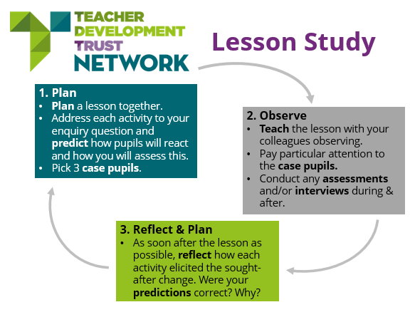

Figure 1: Lesson Study
Figure 1 above shows the full process of Lesson Study that research partners will conduct to participate in the reflective model. The process of Lesson Study is to encourage teachers to plan together, observe each other’s teaching, providing the opportunities to observe what was most beneficial or what may not have worked as well and to reflect on that lesson in order to make possible changes to that plan. This benefits teachers’ knowledge on teaching as well as motivating teachers to create exciting teaching experiences (Tanaska, Nishioka and Ishii, 2016; Cerbin, 2012). This can be done by observations through written notes from a lesson in order to complete the steps shown in Figure 1.
Literature Review
This section will critically anaylse literature, nationally and internationally, regarding Lesson Study. It has been suggested by Reilly (2006) and Dudley (2014) that Lesson Study and the use of this model in the primary classroom is a beneficial method to improve teaching development in the classroom. There is countless research of literature that supports this model as well as critical studies that may question its effectiveness, taking place outside and within the UK. This essay will consider both counterparts and consider the possibility of its use in the primary classroom from research and findings from studies presented throughout this essay.
The National Strategies (2011) published a report on teacher support programmes. This report involved conducting a wide scale study in 50 primary schools in Essex, UK. The study investigated various strategies to improve teaching, one strategy being Lesson Study. Findings from this study show that schools using the Lesson Study model allowed them to gather responses and feedback which included teachers stating that their teaching practice and strategies improved through using Lesson Study as a model in the classroom. A factor that was highlighted was the confidence and well-being in teachers whilst using the model as it gave them the opportunity to gain friendly positive feedback and to almost reassure them that their teaching practise was at a good standard providing them with this information to develop confidence further. This was especially the case if the teacher was a newly qualified teacher (NQT) where teaching strategies are still fairly new to them. Nyman (2014) further supports this aspect of NQT support through suggesting teacher feedback is a beneficial method to improve classroom practice therefore supporting the concept of Lesson Study.
Following this, The National Strategies (2011) study shows many statistics that show improvement in various schools’ performance, one example being a year 6 teacher moving from adequate to a good which was gained from using Lesson Study as a support model. The report stated that this model was adapted in schools across Essex because it was a successful way for teachers to work collaboratively in promoting reflection on teaching and learning which overall has a positive impact in the classroom for both teachers and learners. This study proves extremely relevant as the research has been conducted in the UK, but this report was dated in 2011 resulting in the findings being almost a decade old. This may have little effect but still needs to be considered whilst reviewing this literature.
To argue against this, it has been questioned whether Lesson Study really does benefit teachers’ professional development and children’s learning. Cheung and Wong (2014) carried out a wide scale study from 2000 to 2010 analysing nine previous studies based on Lesson Study to investigate its effectiveness on its use in the classroom. Through these studies, Cheung and Wong (2014) found that Lesson Study had an overall positive outlook on classroom practice and found that this model enhances student learning. Although this study has highlighted that positive feedback was considered it also states that more specific outcomes related to lessons were recommended, ensuring teachers were working together to effectively focus on what outcomes needed to be achieved from that specific lesson in order to progress learners. It was also highlighted from this study’s findings that while teachers are using Lesson Study as an approach to develop teaching, it should be considered that the focus in the reflection process is what the children have learnt, not just what the teacher has taught. It is a common misconception with Lesson Study that teachers may focus on their teaching during reflection, often missing what the students have learnt and gained from that teaching experience (Holt, 2009). Although Cheung and Wong’s study represents interesting and relevant research, it must be highlighted that this study has taken place internationally, therefore possibly limiting its effectiveness to the UK but still has relevant findings to this research. This study shows high reliability as its research has taken place over the space of ten years from nine studies providing a wide scale of results to anaylse and evaluate.
Following this, Godfrey (2018) conducted a wide scale study in London in primary as well as secondary schools focussing on the success of Lesson Study. This study involved 133 teachers in 33 schools including both primary and secondary schools. The findings from this study presents the strengths and limitations of Lesson Study, including how Lesson Study allows teachers to stop and reflect on teaching practice but notes how this model can be extremely time consuming as teachers may find it difficult to find time to do this effectively in the teaching day. This study highlights the overall positive effect Lesson Study has, linking to Reilly (2006) by noting how it can improve teaching strategies. The study noted the results apply to both primary and secondary schools, having very similar outcomes. Although this study highlights the benefits of Lesson Study, relating to Cheung and Wong (2014) this study also considers improvements to Lesson Study, suggesting more ways to record changes in the learning outcomes for children, allowing teachers to access learners progress more easily. This can be incorporated into the primary classroom more effectively to overall have more of a positive effect on teaching and learning.
From personal experiences in the classroom, teachers often share progress through the use of ICT apps such as SeeSaw, where teachers can access children’s learning and celebrate work presented through an online database. Ritchhart, Church and Morrison (2011) highlights using ICT strategies such as SeeSaw can be an effective strategy to use in the primary classroom to promote Lesson Study as this motivates collaboration in the classroom between teachers and learners. This can present teachers with the opportunity to observe each other’s lessons and presenting online feedback directly in order to improve future lessons. Through personal experience on PTE2 placement, I used this ICT strategy myself as a way of tracking children’s learning and sharing work collaboratively with other teachers. This allowed me to gain useful feedback from other practitioners who may not usually have the chance to see the work that has been carried out in the classroom.
Following this, the purpose of teachers researching their own practice has clearly been highlighted above in studies mentioned, for example, allowing teachers to reflect on their teaching styles in order to progress. The new curriculum of Successful Futures notes the significant importance of teachers researching their own practice (Donaldson, 2015). Donaldson has stated in the new curriculum that to meet the four purposes, pedagogical principles that relate to Lesson Study, such as Assessment for Learning (AfL) have an impact on teaching. This method provides regular meaningful feedback in order to help teachers meet the needs of learners, providing next steps and further guidance from teachers and from learners (Black, 2003). This further allows the development of teacher practice knowledge in the classroom. It has been argued that teachers often become blind to their teaching in the classroom throughout the teaching day, due to the fast paced demands of a teacher. Dudley (2011) notes it is hard to observe everything that happens in the day so is beneficial for someone else to observe their teaching to pick up on things that they would not notice themselves, therefore supporting the Lesson Study model.
Another way to use Lesson Study in classroom practice is to gain feedback and responses from the children as well as other teachers. It was recommended by Dudley (2011) that by conducting an informal interview with children after the lesson taught can provide extremely useful feedback in order to reflect during the Lesson Study process. Some questions can be asked such as; What did you enjoy most about that lesson? What did you learn? How could it have been better? By asking open ended questions to the learners, it allows the researcher to gain wide and detailed responses therefore providing more valid results. Children can explain what they personally enjoyed most about the lesson whilst explaining what would have worked better. This provides the researcher with direct feedback from the people who will benefit most from the lessons, the learners. These interview responses can be tracked through logging the responses on an interview table to refer back to whilst reflecting on the lesson. See Figure 2 below that shows Dudley’s (2011) example of an interview response table:
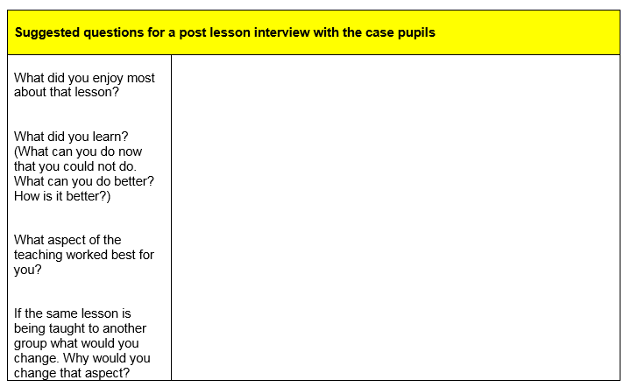

Figure 2: Interview response table (Dudley, 2011).
Through personal experience on placement during PTE2 this strategy was used by myself as an AfL strategy where I used a beach ball with these types of interview questions written on sticky notes and stuck around the ball. I included questions such as:
- What did you enjoy most about the lesson?
- What did you learn?
- What could you have done better next time?
- What could I have done differently to make the lesson better?
I numbered each question and played a game where children would answer the questions if the ball landed on them and then I would call a number and read the question that related to that number. This proved itself as a way of gaining instant feedback from the lesson as a form of reflective practice in order to improve my lesson for next time which I found extremely effective. After gaining these responses I would then make note of what feedback I had received in a notebook which I could then refer to in future planning.
It is suggested by Dudley (2011) as well as Department for Children, Schools and Families. (2008) and Takahashi (2005) that when conducting the last process of Lesson Study (reflecting on the lesson) it is recommended that this feedback and discussion takes place as soon as possible in order for the feedback to still be fresh, therefore making it more reliable and valid. There should be clear goals set out, not focussing on criticism but highlighting what could have made the lesson a better learning experience (Adamson and Walker, 2011). This allows teachers to not feel that they have done badly on their lesson but to feel motivated to benefit learners in other ways, addressing further skills that relate to children’s learning and experiences. Linking this to personal teaching practice, during personal experience I found this aspect very beneficial when gaining tutor feedback after a teaching observation. From this, the instant feedback allowed me to make notes and improve on future lessons to have a further impact on teaching practice in the classroom. This acted as a form of reflective practice as I was gaining direct feedback from a practitioner that has observed a lesson taught. Although, through this method of observation there is little focus on observing learners directly but more so on teaching practice it still lends itself to the reflection model of Lesson Study.

Lesson Study: Case Study 1
A small scale study was conducted in South Africa, exploring teachers’ experiences of teaching electricity during a Lesson Study. Ogegbo Gaigher and Salagaram (2019) selected four science teachers from different schools and were paired as partners to conduct a Lesson Study research project. Each pair conducted a lesson on electricity, then conducted semi structured interviews and completed observational notes on the lesson focussing on classroom teaching and student learning. During the lesson, the teacher observing their partner focussed on three learners to track their participation and understanding of the lesson. During feedback the study states “Participants reported on how collaborating with another teacher improved their knowledge of teaching strategies as well as content subject knowledge (Ogegbo Gaigher and Salagaram, 2019, p.5). This suggests Lesson Study provides the opportunity for partners to discuss a lesson afterwards, therefore allowing teachers to share creative teaching ideas and styles from one another and gain information that they may not have known beforehand, therefore developing teacher subject knowledge too (Cerbin and Kopp, 2006). Some teacher feedback responses from the study include:

Interview response A: “I realised that having class observations like this helped me to identify the gaps between learners’ understanding of the lesson and my method of teaching the lesson.”
(Ogegbo Gaigher and Salagaram, 2019, p.5).
Interview response B: “You know I have attended few collaboration activities, but time has not permitted me to practice what I have learnt. But this one gives you the opportunity to immediately practise what you learn or what you have done with others to see how effective it works.”
(Ogegbo Gaigher and Salagaram, 2019, p.6).
From the responses shown above from participants of the study it shows the overall positive effect Lesson Study has had on teaching. Not only can it develop self-reflection but as Interview Response A states, using Lesson Study provided them with the opportunity to identify any misunderstandings or gaps in the learner’s understanding of what has been taught. This proves itself to be a highly successful way of monitoring children’s understanding of a lesson through observational feedback.
Also, findings from this study state that collaboration through Lesson Study was the main aspect to enhancing and motivating teachers professional teaching strategies in the classroom. This further developed other skills such as lesson planning, classroom management and a positive wellbeing to teaching. Some challenges were highlighted such as lack of time to conduct all these procedures that go with Lesson Study as well as conducting Lesson Study meetings regularly due to time management restrictions. This highlights the strengths as well as considering the challenges to this model. This study was carried out in 2019 proving to be extremely recent and relevant to today’s research. However, this study was conducted outside of the UK being in South Africa so results and findings may differ to UK’s results. From studies mentioned previously, such as Cheung and Wong (2014) and Godfrey (2018), this study does relate and link well to previous findings stating the effectiveness of Lesson Study as well as highlighting the main challenge being time restraints showing its common findings in research around the research model.
Furthermore, OECD (2016) published a report focussing on PISA link data and highlights the most common teaching strategies used today in the classroom. The three include; active learning, cognitive activation and teacher-directed instruction. The OECD (2016) report explains that active learning is where children are engaged in promoting their own learning which comes under group work, collaboration and discussion. Settles (2012) also supports this strategy by noting how group discussion is crucial for learning and development of social interaction. Relating this to Lesson Study, it has been found from Lesson Study findings that this strategy is extremely effective in a learning environment as this develops learner’s discussion and peer interaction.
Following this, the OECD (2016) document explains that cognitive activation is where learner’s skills are challenged in order to motivate and develop their skills further. This can be done through problem solving and decision making. This allows learners to creatively think of ways to solve problems and to share these ideas with peers and teachers. Teacher-directed instruction is directed to how the teacher themselves deliver lessons. This can be monitored clearly through the use of Lesson Study, providing teachers with the opportunity to observe each other’s lesson delivery. Aspects such as clearly displaying learning goals and outcomes from the lesson, discussing previous lessons and asking questions to the learners throughout the lesson to assess if learners have shown a good understanding of the lesson taught (OECD, 2016 and Kunter et al. 2013).
From considering the data presented in OECD (2016) it is clear that there are various ways to conduct research and gain feedback in the form of Lesson Study. From researching relevant literature, it has been noted by Lash-Rabick, et al. (2011) Cheng (2018) that there are other ways for teachers to use Lesson Study in order to reflect on their teaching. A growing technique that is being used today in classroom practice is teachers recording their lessons to watch back afterwards, enabling the teacher to notice what went well and what possible situations could have been improved. This lends itself to the opportunity of Lesson Study as this allows the teacher to share this lesson with other teachers, allowing them to gain other responses and feedback in order to help them improve their skills (Marzano and Toth, 2013). This was recommended to myself whilst on placement during PTE2 where I was observed by my classroom teacher who decided to video record my lesson so I could watch back afterwards whilst gaining useful feedback. This allowed me to actually see what changes could have been made whilst teaching as it is common that when teaching many instances can go unnoticed. Through providing a video to revisit, this presents this block from happening and allows the teacher to watch the lesson back and have a deeper understanding of what aspects their observer is discussing with them (Sellars, 2017).
Lesson Study: Case Study 2
Jiang and Sudarshan (2019) undertook a wide scale study exploring the adaptations made to Lesson Study in Singapore schools. This study involved looking at the implementation of Lesson Study as well as undertaking research around teachers’ understanding of the model. The study questions how Lesson Study may vary in non-Japanese contexts and how this model may have a different effect in different countries, in this case Singapore. This research involved conducting nationwide surveys and case studies in four schools to investigate the effectiveness of Lesson Study and teaching experiences. Figure 3 below shows the online survey responses, part of it questioning whether these schools would continue to use Lesson Study as a reflective teaching strategy. Figure 3 shows that over 90% of these schools using Lesson Study showed that they would continue using the approach to track reflective teaching. This shows that the technique is liked and is working for professionals, further supporting Ogegbo Gaigher and Salagaram (2019) ideas of it being extremely useful in practice.
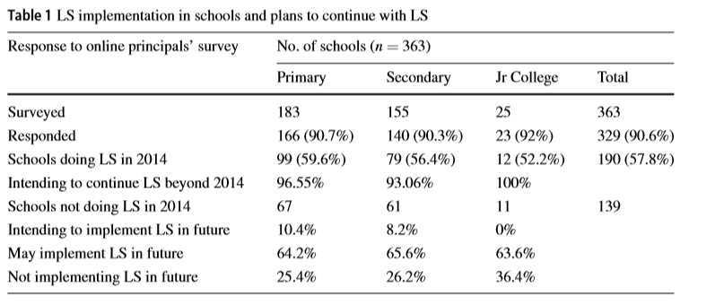

Figure 3: Table of survey results. (Jiang and Sudarshan, 2019).

As part of this study, further research was conducted by carrying out case studies of Lesson Study research in four primary schools in Singapore. Observations were carried out as well as carrying out interviews with teachers. All together 72 observations were carried out in these schools, providing a wide and vast amount of data to anaylse. Baumgarten (2012) and Kirk, Miller and Miller (1986) support the idea of a vast amount of data to fully anaylse the effectiveness of research findings.
Findings from this study show a lot of similar results to what Lewis (2002) and Jones and Norwich (2014) have highlighted previously, stating that Lesson Study is an effective model in classroom practice and provides an extremely useful method of teachers gaining direct feedback from other teachers allowing them to both learn and grow as professionals. However, a significant finding which stood out was that during interviews in the case studies teachers stated that they felt that they deserved more support from the school when carrying out Lesson Study research. They believed that time should be given within the curriculum time as having structured Lesson Study time just as teachers are provided with PPA time. One of the teacher responses were:
Teacher Response: “The scheduled time was not enough, and we had to schedule more meetings. Getting all team members at the same time was not easy at all.”
(Jiang and Sudarshan, 2019 p.9).
This supports Godfrey (2018) and Ogegbo Gaigher and Salagaram (2019) who also state that time restraints were a prominent issue with Lesson Study. This study further goes on to state that they found meeting in the school difficult to conduct as there were various interruptions, again highlighting some possible limitations to the reflective model. Although this study highlights the clear advantages to Lesson Study, in Singapore it is said that “…there is concern that schools practicing LS may do so in a superﬁcial manner and dilute the essential features that are capable of creating deep and enduring professional learning for teachers.” (p.13) This suggests that Lesson Study does still have its limitations and argues against Takahashi (2005) suggesting it may not be the most effective model to use for reflective research. This study almost questions if the use of lesson study is being used to what it is intended for in Singapore, arguing against Dudley (2011) who states that Lesson Study is the most effective reflective model to use in the classroom to improve teaching practice.
Although this study highlights further limitations to the model, there are still clear advantages to the concept being used in classroom practice. This study is an extremely recent piece of research which is relevant to Lesson Study research but is based outside of UK. However, these findings still highlight how different countries may use Lesson Study differently which is an important aspect to consider. Jiang and Sudarshan’s (2019) findings show very similar results as previous studies that have been based in the UK which shows it does have similar results around the world.

Following this, Leavy and Hourigan (2018) highlights the awareness of mathematical challenges in primary education and how many children find mathematics extremely hard. Kinnear, Lai and Muir (2017) highlight that mathematics is a common subject that children find difficult in early years and is common in education to need more focus on children showing an understanding of the subject.
Leavy and Hourigan (2018) carried out a wide scale study in New York investigating the types of mathematical content knowledge in teachers. This study involved 25 primary school teachers who planned, taught and reflected on their mathematical lessons. 5 early number lessons were carried out with aged 4-5 year old children. Findings from this study show that Lesson Study promoted subject knowledge in mathematics. Lesson Study proved to support these participant teachers in subject knowledge as teachers were able to learn from their peers and gain useful feedback on not just teaching styles but the content of the lesson itself. Bearne and Reedy (2017) note that teacher subject knowledge is an important factor of good teaching and argues that it may be the most important aspect of teaching. Without this knowledge it is suggested that teachers may not present the lesson with the right amount of understanding to deliver the concept to children effectively.
Leavy and Hourigan’s study is very recent but was undertaken outside of the UK. Although this was an American based study, this still shows from previous studies mentioned above that all countries seem to have the same findings and same main points from Lesson Study which is an interesting factor to consider. Also, this study does consider the link between teacher subject knowledge and Lesson Study and how these two factors can connect with one another.
Doig (2011) states that although Lesson Study is a Japanese model of teacher development and reflection, it clearly is no longer restricted to Japan as many countries have taken on the model in practice. Doig (2011) notes that the United Kingdom have shown an interest in the model to develop teaching within the UK and the UK are showing a positive outlook to the model. Also, there has been Lesson Study groups in the United States mostly relating to mathematic development, this has been growing for over ten years. The study also notes how other countries such as South Africa and Australia also have taken on board the use of Lesson Study in the classroom. This implies that the model is nation wide and clearly is having positive effects over the world. This has been proven through studies discussed in this essay previously as they have been from different countries, with very similar findings and results.
Gheith (2018) notes other methods of reflective practice that is not just specifically Lesson Study that can also take place in the primary classroom to develop teaching. The study notes that reflective practice can take place without the full process of Lesson Study, for example, teachers can keep track of their own lessons by filling in a diary/self-reflection journal of each lesson including what they felt went well and what could be improved. This serves as a strategy of self-reflection but is considered as a time consuming strategy which limits this slightly. During personal experience, I used a reflection journal that I would fill in every day based on a lesson taught or a learning experience that I felt I could reflect on. This proved to be helpful in identifying strengths and improvements, but I did find the strategy very time consuming which is something to consider whilst considering this as a reflective strategy.
Another form of self-reflection can include teachers having the opportunity to attend workshops or courses about different teaching strategies to allow teachers to observe their own practice as well as meeting other professionals to discuss teaching practice. Sellars (2017) also supports this noting that taking teachers outside of their everyday working environment provides them the opportunity to meet other teachers and gain other experiences and ideas from those professionals, therefore impacting their own reflective practice. However, Gheith (2018) states that although reflective practice is becoming more common, teachers often feel that having their peers observing their lessons and receiving feedback difficult and often knocks their confidence. There can be the fear of receiving negative feedback from other teachers therefore effecting their practice. This suggests Lesson Study may not always be effective and can cause stress to the teaching profession.
Gheith (2018) considers that the more experienced a teacher may be, leads to them feeling more confident to participate in Lesson Study. The study notes that highly experienced teachers may feel more inclined to be a part of self-reflection rather than newly qualified teachers due to less experience in the classroom. However, the study further goes on to discuss that this was not the case from this study’s findings as Gheith (2018) states that all participants responded highly towards self-reflection in teaching practice regardless of age or amount of experience. This suggests that the Lesson Study model can suit professionals of all ages in a fair way.
Also, following this study, Gheith (2018) considered other ways to prepare teachers around self-reflection and in some cases Lesson Study. Schools can implement interventions that support the reflection model such as Teacher Preparation Programmes which can involve teacher courses on the importance of reflective practice, including examples of Lesson Study cases where lessons have been improved and teaching has developed (Barentsen and Malthouse, 2013).
My experience with Lesson Study
Whilst completing a module on PGCE at university, it was required to conduct a Lesson Study research project with a research partner. Myself and my partner investigated how student participation was increased through the use of an ICT quiz used on iPads. In order to measure the effectiveness of this, myself and my research partner planned our lessons together, chose 3 target children that will be observed by my research partner during my lesson, observing the lesson through making written notes as well as completing an observation table which made it more easier and accessible to read notes on each target child. Following this, we also interviewed the three children on the lesson through an informal way in order to gain effective feedback. We filled in an interview response table, very similar to the example shown in Figure 2 above. After the first lesson was complete, myself and my research partner met and discussed what went well during the lesson, discussed key points from observation notes, including those about the target children and highlighted points of improvement. From this, we were able to make slight changes to the lesson prior one of us starting the lesson next time. This proved to be a good way of reflecting on teaching and allowed myself and my partner to reflect on strategies used. Some changes were minor but had an overall effect on the next lesson delivery. For example, one change was including more questions on the quiz as we found the quiz to be quite short during the first encounter of the app in the first lesson. This allowed us to discuss and decide what could have made the lesson better. During the next lesson, after changes had been made, both myself and research partner could notice the improvements and although some small, made a big difference to the lesson. This supports Dudley (2011) Lesson Study process which is shown in Figure 1 above as well as previous studies that have supported the model. Brookfield (2017) further states that Lesson Study is the most successful model to reflect on teaching, which I did find to be true from personal experiences with the model.
Although this model worked effectively for myself and my research partner, we did both find the model very time consuming. We managed to meet up to discuss the lesson and complete the reflection process of the model straight after the lesson but that was due to university providing time to allow us to complete this. This highlighted the problem to me that teachers may not be given specific time dedicated to doing this, therefore making it very difficult to meet straight after a lesson due to other teacher commitments. This supports Godfrey (2018) who stated above about time restraints being the most common problem with Lesson Study and how professionals feel like there may not be enough time to observe and feedback to other teachers. Overall, I did find the model very effective to improve teaching and learn other styles from other teachers but did consider possible limitations to the model in practice.

Conclusion
To conclude, throughout this essay Lesson Study has clearly been proved to be a successful and effective reflective model in primary classroom practice. Literature that is national and international has supported this concept as well as stating possible challenges that can be prominent around the model. From analysing literature throughout this essay, Lesson Study is a good way to anaylse reflective teaching practice but perhaps not the only way. Other ways of reflective practice has been considered such as teachers reflecting on their own practice in other ways such as video recordings or keeping a self-reflection journal. Although these are also good ways to reflect on teaching, from considering literature discussed it can be suggested that the most detailed way to gain reflective feedback from other professionals can be through Lesson Study as many forms of literature above has stated how the model provides detailed feedback in a fast and effective way.
Although Lesson Study has a Japanese history, this model is growing in the UK’s education system with a focus in developing teaching strategies and self-development in the teaching profession. Alongside Donaldson’s new curriculum of Successful Futures (2015) it is stated that teachers are expected to become vigilant in their reflective practice, providing a focus on learner’s outcomes and expectations. This can clearly be achieved through Lesson Study as mentioned previously, the new curriculum includes a clear focal point on reflective practice in the primary classroom, including AfL. From teachers participating in Lesson Study and other reflective practice, professionals can gain feedback to help their own teaching as well as meeting the needs of the learners in a valuable and useful way through providing a wide range of learning and experience for all learners.

