BUSINESS PLAN TEMPLATE:

BUSINESS DESCRIPTION / MARKET OPPORTUNITY

The company is a customised service offering prints on demand for clothing apparel and handbag products. The designs will be socially relevant and promote contemporary social causes thereby increasing the social awareness of issues among customers. The brand name of the company is DualMade, and it aims to promote "love without limits". This mission statement exemplifies the intent of participating customers in online shopping therapy, with personalised clothing and bags reflecting their unique personalities and beliefs.
Customer demand for representation in wearables and accessories products is emerging as a key market group. The brand's philosophy supports this intention as it aims to "make it possible" regarding the individual requirements and specifications for prints on demand. The brand is co-owned by the two owners who are also responsible for the daily operations of the business. As the items are printed on request, there is no concern of overstocking or wastage by producing ahead of demand, thereby maintaining sustainability as one of the ethical qualities that define the brand among sustainability-oriented shoppers. Sustainable consumption has become a common trend in the UK after Covid-19 (Granskog et al., 2020), and DualMade aims to satisfy such considerate shoppers while creating value as a business enterprise and providing the option to turn an old t-shirt into something fresh and personalised, and selling organic tote bags that are always a wise investment. This is a wonderful environmentally responsible substitute for single-use grocery bags that may be worn all year long as a distinctive accent. Reusable bags from DualMade are available in the ideal fabric and may be printed with any unique design of your choosing. We give consideration to the environment.


(Source: created by the author)

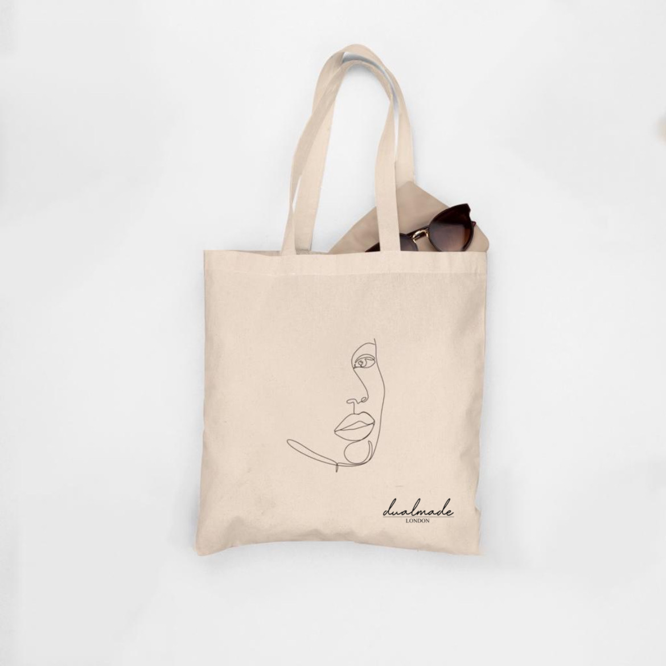 (Source: created by the author)
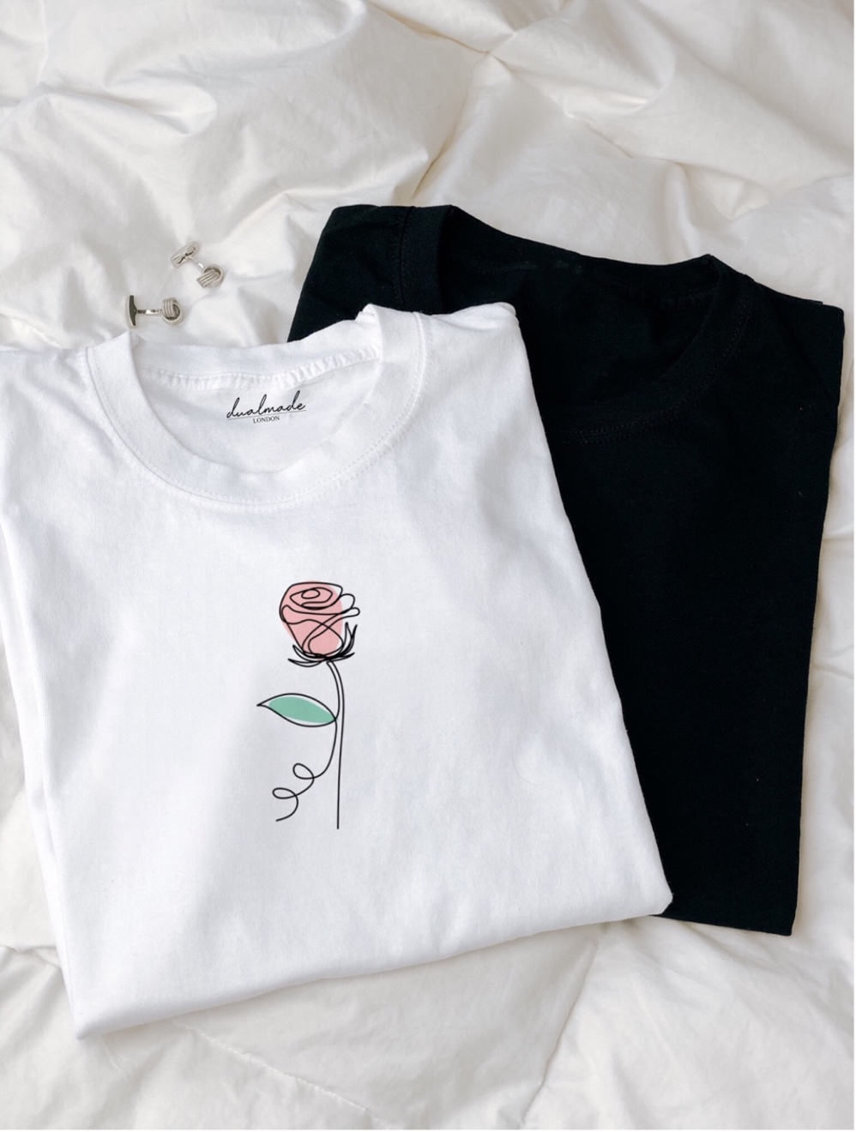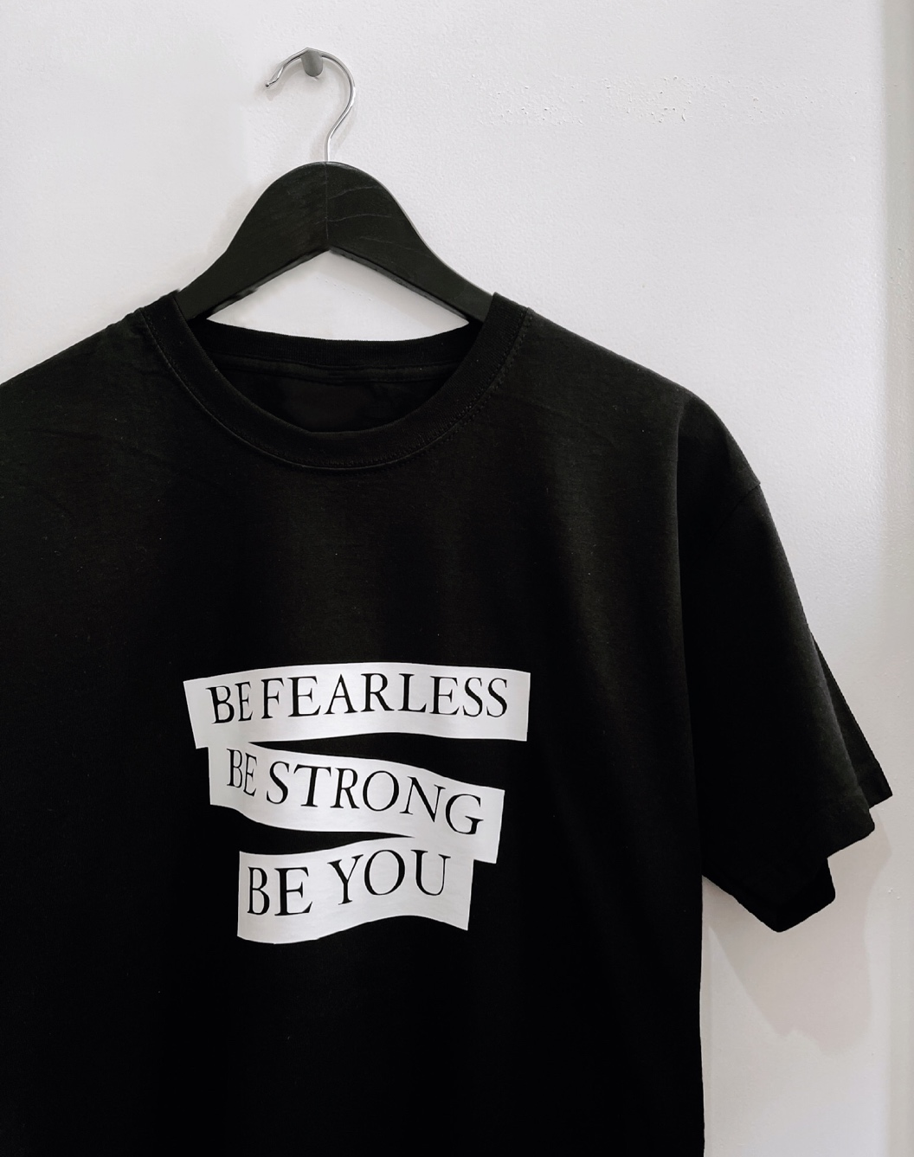
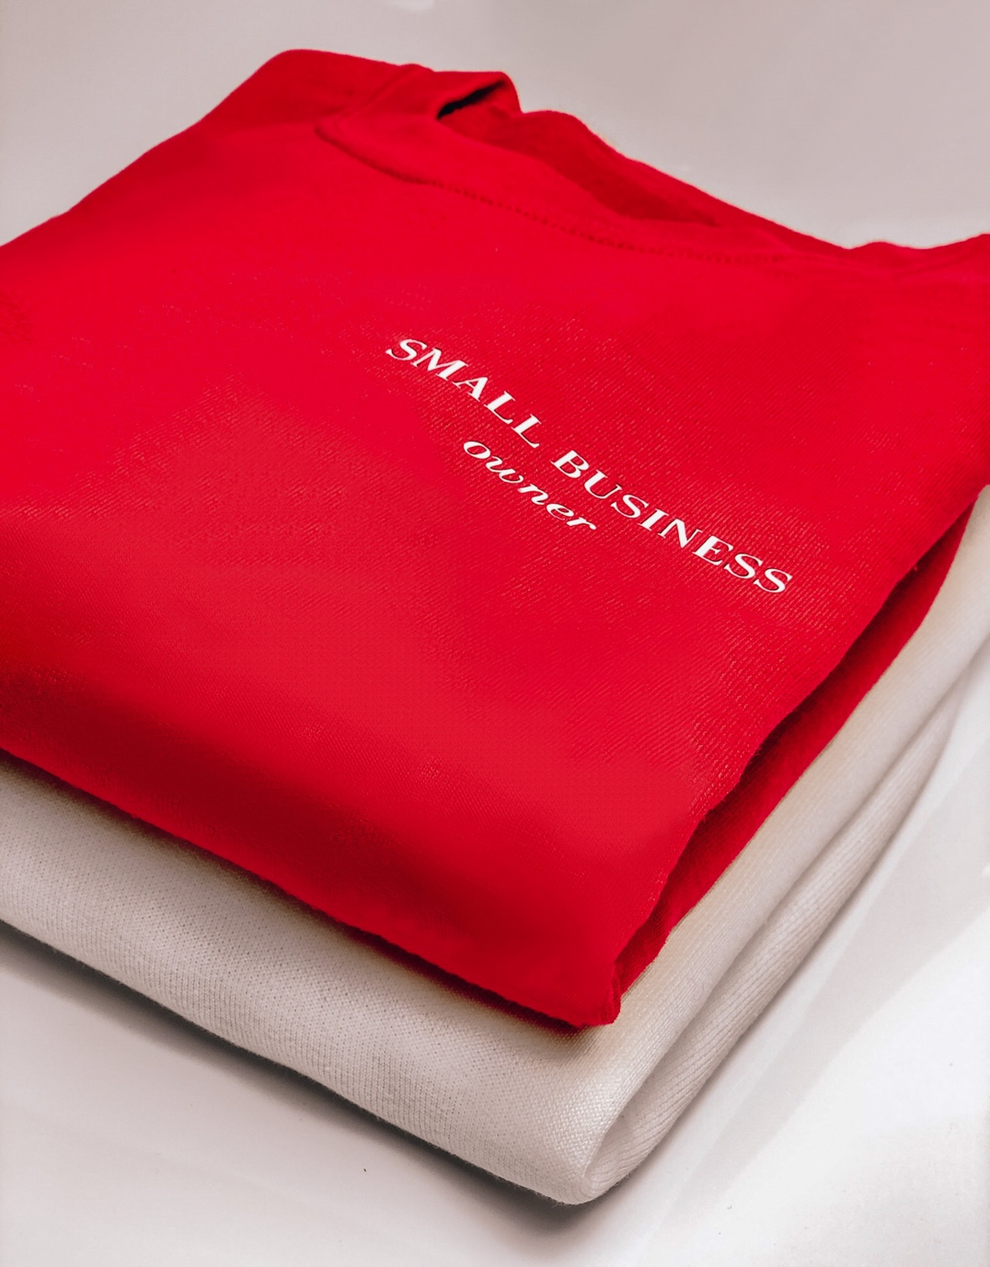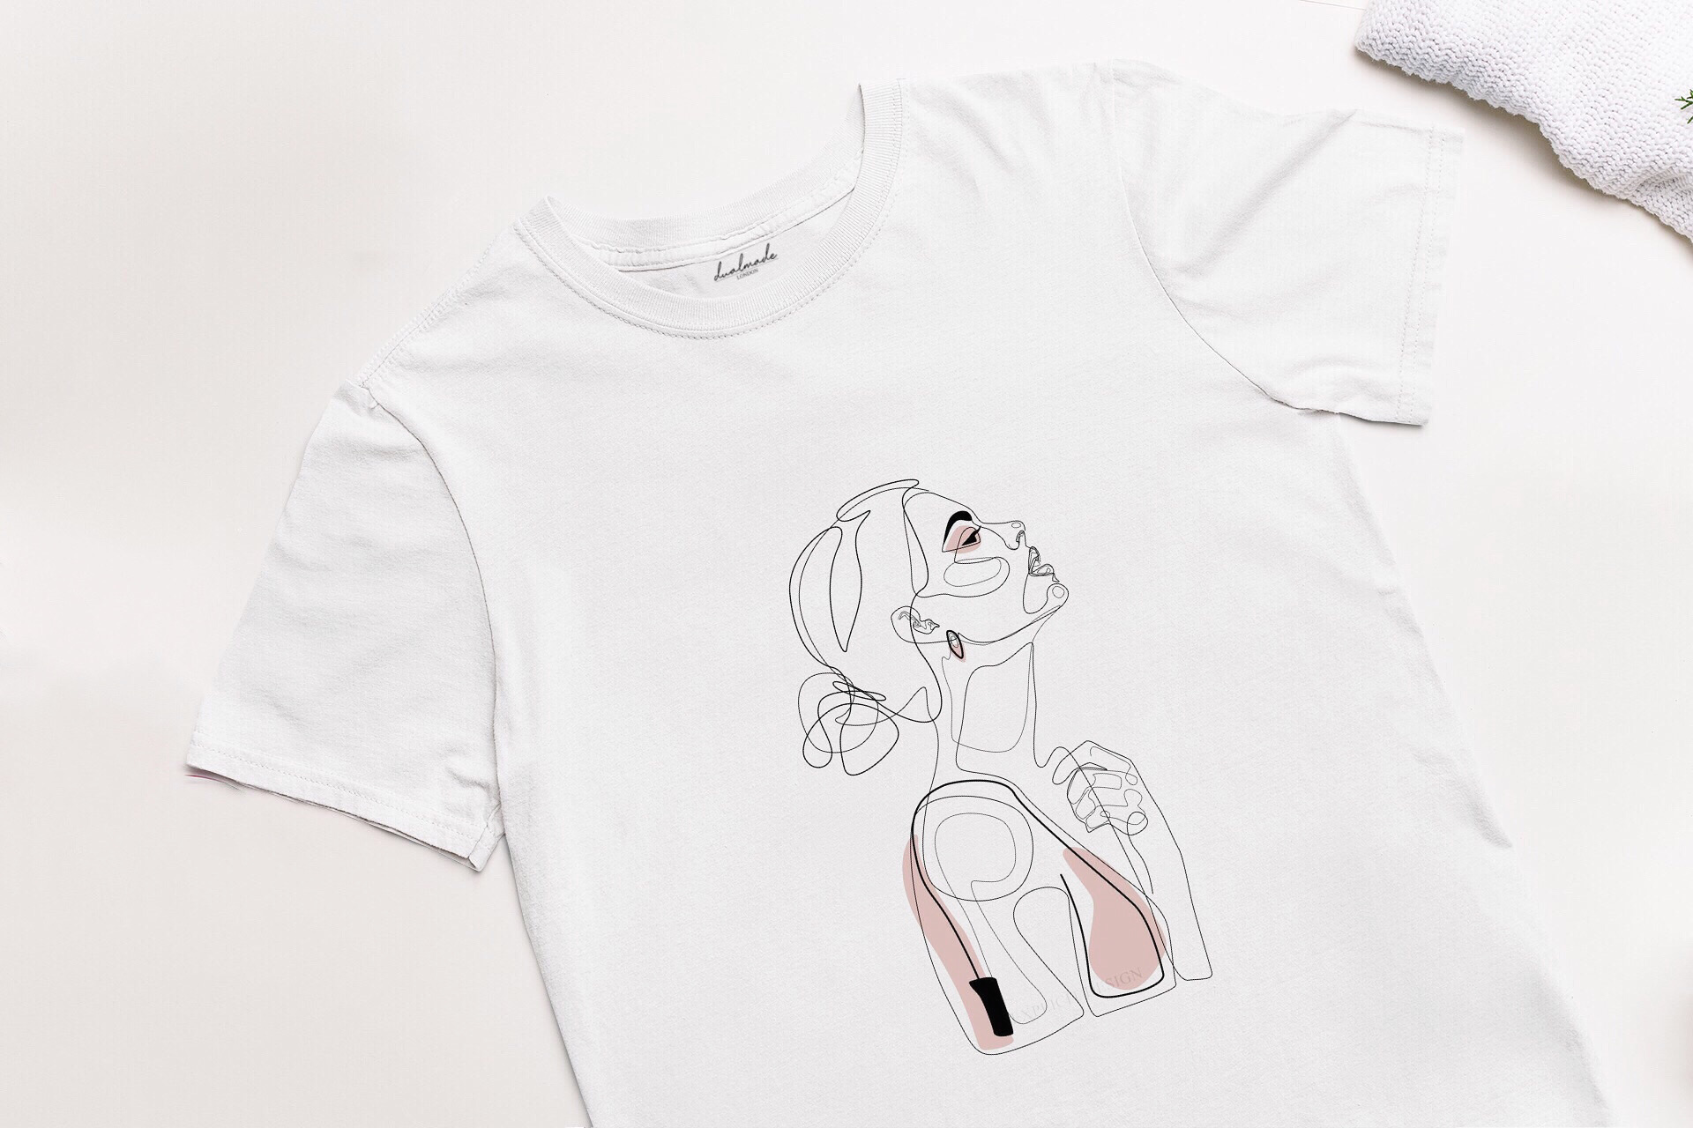

(Source: created by the author)

INDUSTRY ANALYSIS

The threat of new entry
The market for independent new retailers in the apparel industry presents the characteristics of a competitive industry. New companies can easily enter the market as different types of firms' i.e. sole traders, partnerships and private companies can equally enter the apparel industry. Competition is fragmented at the bottom and consolidated at the top (Mendelson, 1987). Therefore, the barrier to entry is non-existent as firms can sell apparel online through their brands at any time. However, competition at the top is consolidated and new entrants at that level are highly unlikely, with few recent instances being available such as Shein. As DualMade is a two-person enterprise classified as an SME, it has to compete with similar retailers who have started their ventures independently as well as through channels like Shopify and Etsy.

Threat of substitutes
The threat of substitutes is a present condition for all apparel retailers, as apparel products largely present minimal differentiation in terms of utility for the customer. Handbags and shirts are used the same way across all consumers, and substitutes are differentiated based on marketing (Levitt, 1980), brand promotion and other intangibles. For DualMade, the threat of substitutes is also high in terms of the product. However, the brand's aim and mission statement make it advantageous as customers are becoming more socially conscious apart from developing trends towards sustainable consumption. DualMade’s quality of service here will differentiate it in terms of the customer's experiences in shopping for printed apparel and bags.

Bargaining power of customers
The bargaining power of customers is significant in the apparel industry, as they have a multitude of choices between small and large brands. DualMade can secure a stronger bargaining position by developing its brand identity as a socially relevant cause through marketing strategies, as marketing can differentiate customer perception in highly differentiated products like apparel items (Melero and Montaner, 2016). When customers self-associate with a brand's identity, they will be more inclined to view the brand as a quality brand which offers them satisfaction through brand engagement and brand consumption (Belén del Río, Vázquez and Iglesias, 2001). This aligns with the business plan as DualMade aims to develop customer satisfaction among digital shoppers.

Bargaining power of suppliers

When compared to the other stakeholders, the bargaining power of suppliers is low for DualMade. In the globalised supplier market, manufacturers can easily develop acquaintances with supply chain partners from global markets such as China (Yan and Gray, 1994). Suppliers are competitive among themselves to promote their services to clients, and as the industry of apparel products is highly engaging and popular, numerous suppliers exist that can satisfy the requirements of DualMade such as fulfilling print-to-order items.

Competitive Rivalry:

Name of competitor | Differentiation
Asos | Asos is a leading brand in the UK in terms of brand voice and customer satisfaction. Brand voice is the distinctive quality that differentiates a brand based on intangible marketing factors that creates a unique self-association with the brand in the consumer’s consciousness. With an 11.69% share (Coppola, 2022), Asos competes in this dimension where brand identity becomes a core advantage that drives customer engagement in a highly competitive market such as the apparel industry.
Next | Next is the second most prominent brand with a voice that resonates with customer expectations and desires. At a share of 9.85% (Coppola, 2022), the brand voice is substantial on its own and only slightly below the 11.69% share of the brand voice market leader Asos.
Boohoo Plc | In third place, Boohoo Plc has a brand voice share of 5.76% which is markedly below the primary two competitors (Coppola, 2022).

OPERATIONS AND MANAGEMENT TEAM
OPERATIONS

The enterprise is operated in a lean design that minimises the cost of operations, ensuring the business is efficient in maximising profit margins sustainably. A single room houses the necessary apparatus enabling the fulfilment of confirmed print orders. The business model follows a just-in-time philosophy of production as operations begin in cycles after the customer has placed an order (Krishnamurthy, 2007). This ensures that resources aren't wasted or used inefficiently, which would reduce the net profits of the enterprise. When an order is placed by the customer, the business orders the apparel item online from the supplier at a lower wholesale price, which allows the business to incorporate labour charges and profit margins on the finalised product before it is sold to the customer.
The apparel and bag items are sold through digital sales channels across different websites ranging from Etsy to Amazon. DualMade also uses social media platforms such as Instagram to engage in direct sales to prospective customers. Selling through Instagram has become a popular instance of how social media platforms offer marketing and well as sales. Lastly, the products are delivered in one day or a maximum of three days, depending on the time the order was placed and the geographical distance of the sellers. Orders are despatched through Royal Mail, thereby guaranteeing secure and affordable shipping changes for them.

How would you generate revenue for your business? E.g., How would you prevent loss of revenue?

Towards the bottom of the brand voice scale, established brands like Selfridges occupy only 0.91% of the brand voice market share. As such, a small share of the market here is significant in creating a valuable brand identity that customers resonate with. Therefore, revenue is generated by promoting the brand online and creating a distinct identity for the apparel and bag customisation journey. Revenue is generated concretely by minimising waste and maximising the margin of the profit ceiling (Romero-Hernández and Romero, 2018. Orders are processed and worked upon when they are confirmed, and not before.
This prevents loss from overstocking, excess inventory storage and wasted resources in manufacturing in advance. This lean philosophy of business ensures the minimal resources of the business are used strongly with any potential for waste being eliminated through planned operations. Using Royal Mail also saves overhead from other private courier brands such as DHL which would charge more for the same essential service. By designing and making the product as per the customer's requirements, and following a lean philosophy to core operations, a threshold for positive revenue growth is secured.

MANAGEMENT TEAM

Name | Skills | What do they bring to the firm
Owner 1 Diana Roabis | Designing and printing. | Critical skills for daily operations.
Owner 2 Madalina Anghel | Technology and marketing. | Essential skills for digital growth.

MARKETING:

Product:
The products are variable in design and offers, as they are customised about what the customer has ordered. The apparel products are sold in various sizes and forms that demonstrate inclusion is practised at the company. Due to its acceptance of clothing orders regularly, each product is designed uniquely while using stable and reliable printing methods that ensure quality is maintained. Consumption with different degrees of investing. The product's digital services are offered to the buyers in terms of aftersales services, such as guidance on washing the apparel after first use to preserve the printed ink material. Lastly, the product packaging features the brand label DualMade, further solidifying the brand in the customer's consciousness.

Price:
The apparel and bag products follow a cost-plus pricing strategy as it offers the most strategic benefit for the company. The cost of operations is kept tightly streamlined, thereby incurring significant cost savings along the value chain process. This outcome makes it ideal for a cost-plus pricing strategy to be implemented, as profit margins can be secured by following such a strategy as opposed to other strategies such as price penetration strategy or other approaches (Hanson, 1992). A small discount will be offered initially to new buyers who refer the brands to their friends or peers (Guo, 2012). Customers can make payments across a multitude of options, ranging from credit
and debit cards to net banking, third-party payment gateways like Stripe as well as mobile banking.

Promotional Mix:
Direct advertising will be done on the social media platforms through which advertising is likely to work suitably, as social media marketing is particularly effective in driving brand growth. Through referral discounts as noted above, sales promotion will be fulfilled as well (Guo, 2012). Personal selling will be done by the two owners on their initiative, by marketing across their social media platforms. Through this various approach, customer relationships will be built and maintained over time in a successful manner that complements the continuity of business operations at the venture.

Place (Distribution strategy):
The apparel and bag products will be sold across digital channels to maximise profit margins for the company. Selling online is significantly economical to businesses as it bypasses retail costs associated with brick-and-mortar stores. From Amazon to Etsy and social media platforms, numerous digital channels will be maintained to increase sales of the brand across different market touch points of the market. By being present on numerous digital platforms, the brand can engage with customers across the market and has the potential to expand with ease when demand rises, due to the quality of digital technology. The apparel and bag items will be packed and shipped to the end-user consumer through Royal Mail, thereby guaranteeing timely delivery while preserving the costs of shipping.

FINANCIALS

Sources of funds: where would you be getting funds from?
The funds are drawn through the personal savings of the co-founders. By limiting capital to internal sources, the risk is minimised as the potential threat of external creditors is prevented by sourcing funds in this manner.

Use of funds

 | Month 1 | Month 2 | Month 3 | Month 4 | Month 5 | Month 6
Revenue | £2200 | £2450 | £2780 | £3500 | £4000 | £4500
Fixed Costs | £45 | £45 | £45 | £45 | £45 | £45
Variable Costs | £4 | £8 | £12 | £21 | £24 | £28
Profit | £2151 | £2397 | £2723 | £3434 | £3931 | £4427

REFERENCES

Belén del Río, A., Vázquez, R. and Iglesias, V. (2001). The effects of brand associations on consumer response. Journal of Consumer Marketing, [online] 18(5), pp.410–425. doi:10.1108/07363760110398808.

Coppola, D. (2022). Leading fashion websites in the United Kingdom (UK) in 3rd quarter 2022, by share of voice. [online] Statista. Available at: https://www.statista.com/statistics/889007/leading-fashion-websites-by-sov-united-kingdom-uk/ [Accessed 22 Dec. 2022].

Granskog, A., Lee, L., Magnus, K.-H. and Sawers, C. (2020). Survey: Consumer Sentiment on Sustainability in Fashion. [online] McKinsey & Company. Available at: https://www.mckinsey.com/industries/retail/our-insights/survey-consumer-sentiment-on-sustainability-in-fashion [Accessed 22 Dec. 2022].

Guo, Z. (2012). Optimal decision making for online referral marketing. Decision Support Systems, [online] 52(2), pp.373–383. doi:10.1016/j.dss.2011.09.004.

Hanson, W. (1992). The Dynamics of Cost-Plus Pricing. Managerial and Decision Economics, [online] 13(2), pp.149–161. doi:https://doi.org/10.1002/mde.4090130207.

Krishnamurthy, A. (2007). From Just in Time Manufacturing to On-Demand Services. In: C. Hsu, ed., Service Enterprise Integration: An Enterprise Engineering Perspective. [online] United States: Springer-Verlag, pp.1–37. doi:10.1007/978-0-387-46364-3_1.
Levitt, T. (1980). Marketing Success Through Differentiation—of Anything. [online] Harvard Business Review. Available at: https://hbr.org/1980/01/marketing-success-through-differentiation-of-anything [Accessed 22 Dec. 2022].

Melero, I. and Montaner, T. (2016). Cause-related marketing: An experimental study about how the product type and the perceived fit may influence the consumer response. European Journal of Management and Business Economics, [online] 25(3), pp.161–167. doi:10.1016/j.redeen.2016.07.001.

Mendelson, H. (1987). Consolidation, Fragmentation, and Market Performance. The Journal of Financial and Quantitative Analysis, [online] 22(2), p.189. doi:10.2307/2330712.

Romero-Hernández, O. and Romero, S. (2018). Maximizing the value of waste: From waste management to the circular economy. Thunderbird International Business Review, [online] 60(5), pp.757–764. doi:10.1002/tie.21968.

Yan, A. and Gray, B. (1994). Bargaining Power, Management Control, and Performance in United StatesChina Joint Ventures: A Comparative Case Study. The Academy of Management Journal, [online] 37(6), pp.1478–1517. doi:10.2307/256796.
‌

