

Task 1 – Reading Task Template
Upload your photo of your A3 in-class notes here:
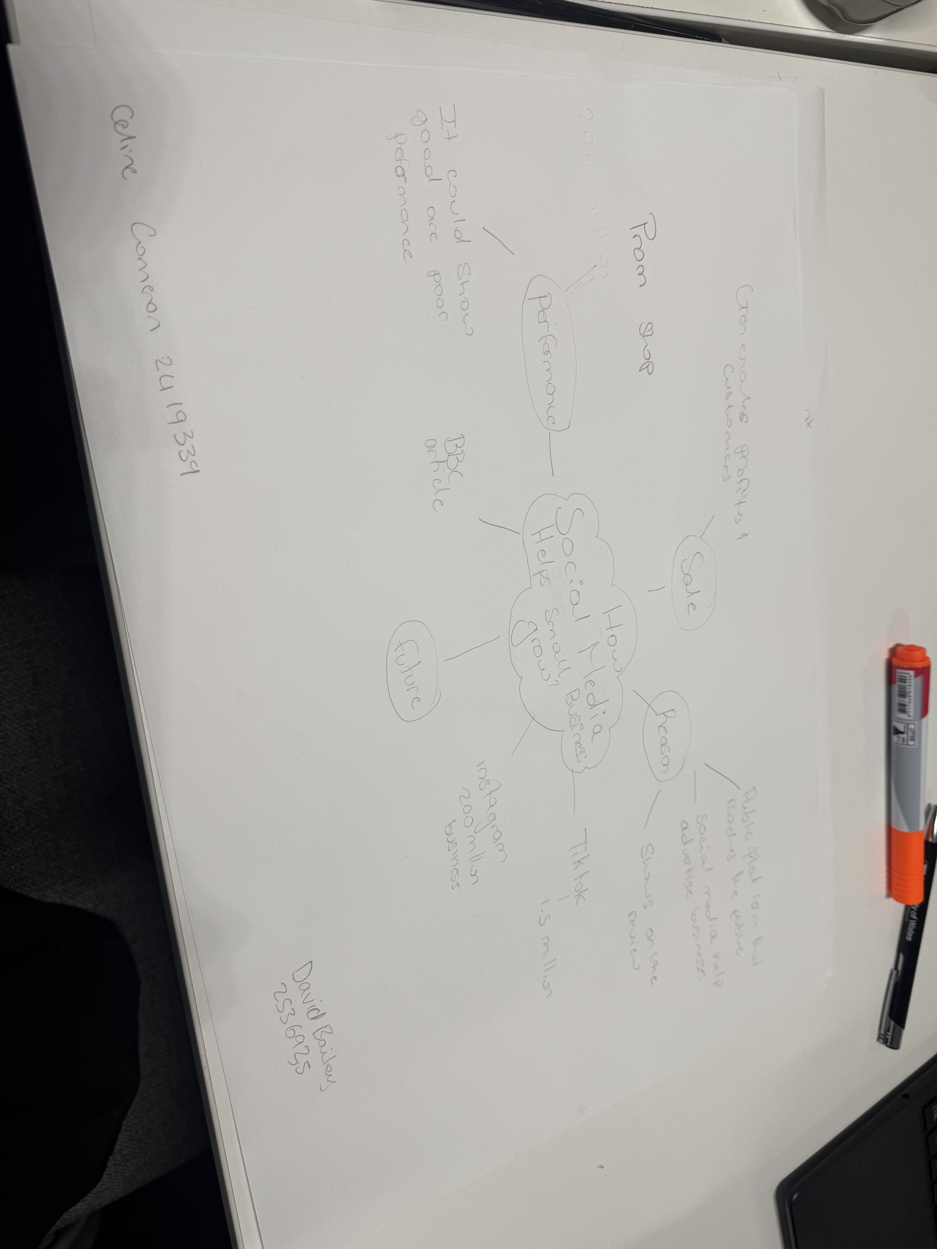

1. Answer these questions using the sentence starters below
a. What is the main idea of the text?
The main idea is that apps like TikTok and Instagram have become really powerful for small local businesses, helping them get famous, attract loads more customers, and earn way more money, mostly just from people sharing posts or videos online.
b. What are two key points?
One key point is that when a business or product gets popular online, people will travel really far to go there, like how customers travel up to three hours just to try the chicken burger at Honywood Sandwich Shop in Basildon.
Another key point is that it’s often videos or posts made by normal customers, not the business owners themselves, that make these places well-known, and this free attention makes their sales go up really fast.
c. What part of the text did you find most important? Why?
The most important part is the examples of ordinary businesses like sandwich shops, chippies and food stalls that became successful and famous all over the country just because of social media. I think this is important because it shows you don’t need lots of money or big advertising to do well; one viral post can change everything, and it proves how much online sharing can help everyday people.
d. Was anything unclear or difficult to understand?
I found it a bit confusing exactly why some things get so popular so quickly — like how a travel company’s slogan or a jacket potato stall turned into internet memes. The text says they went viral, but it doesn’t really explain what made people share them so much or why they became such a big trend.
e. How did your group help you understand the text better?
My group helped me by talking through the examples together, explaining what “going viral” and “memes” actually mean, and telling me about times they’d seen places or foods get famous online, too. They also helped me work out how customer posts helped the businesses grow, and we picked out the most important bits together.
3. One sentence reflection
Question: What did you find challenging about this task?
The hardest part was working out which details were most important to write down and making sure I explained clearly how social media helped the businesses succeed, rather than just listing examples.

Celine Cameron 2419339

