Developing Innovation and Creativity for Business Advantage

BMSW6102
Development of innovative product OR unique service proposition



Student: Elena Chita (2010916)
Lecturer: Charles Nwaogwugwu
Executive Summary
Product innovation is vital as it might help you introduce strong spaces within a currently overcrowded market. By recognizing voids and projecting oneself into a different area, you may uncover a market and serve consumer wants in a creative and original way. Understanding new product development and its advantages could help you utilize it and boost a brand's competitiveness in its market. In this report, a discussion is provided in regard to a new product that will be developed which is the Beauty Clean Makeup Bag which has an inbuilt brush cleanser.
The report consists of an introduction to the product including its segmentation, target audience, and how the producers plan to sustain the product. Next, the E-commerce or selling platforms will be discussed including payment services and platforms the product will be available. Next, the marketing of this innovative product will be discussed including promotional mechanisms and understanding the customer’s journey. Lastly, privacy and data protection will be considered with regard to the product. Information to support the report has been drafted from online articles and published journals.

Table of Contents
- Introduction 4
- Innovative product proposition 5
  - Product Description 5
  - Customer base 6
  - Selling platform 6
  - Venture name and branding 7
  - Competitive background 7
- E-commerce 7
  - Shopify 8
  - Amazon 8
  - eBay 9
  - Payment services that will be used 10
- Marketing 11
  - Promotional strategies 11
  - Target market and positioning 12
  - Customer journeys 14
- Privacy and Data Protection 16
- Conclusion 18
- Appendices 19
- References 20

- Introduction
Many individuals cannot imagine a time when technology began to advance at an alarming rate on a daily basis. People began to buy the novelty and enjoy the change by developing things that had never existed before. The period of modern technologies also increased market research since more individuals sought to develop and invent new ideas to compete. Furthermore, when modernization began to generate big profits, individuals began to create more and more organizations in order to come up with greater inspiration as well as to beat the competition. One industry that has improved with technology but has only experienced the perks of new technology very limitedly is the beauty and cosmetics industry.
The beauty business, which includes skincare, cosmetics products, hair care, perfumes, and personal care, had a monster year in 2020: cosmetics sales plummeted by 33% internationally, while total retail sales in the beauty category fell by 15%. But the business has proven to be robust in the past, and analysts foresee a return to growth in 2022 (Marchessou & Spagnuolo, 2021). With the rise of the global pandemic, most individuals became more healthy and safety continuous, and newer health regulations were imposed which made the makeup industry much more competitive and paved for more creative approaches and innovations within the industry. Appendices 01 demonstrate the current trends and growth in the beauty industry.
The following report demonstrates one of the newest concepts introduced to the beauty industry which will not only revamp the makeup and beauty industry but will also infuse the need for sanitation and consistent maintenance of health and safety prevailing as consequences of the modern world.

- Innovative product proposition
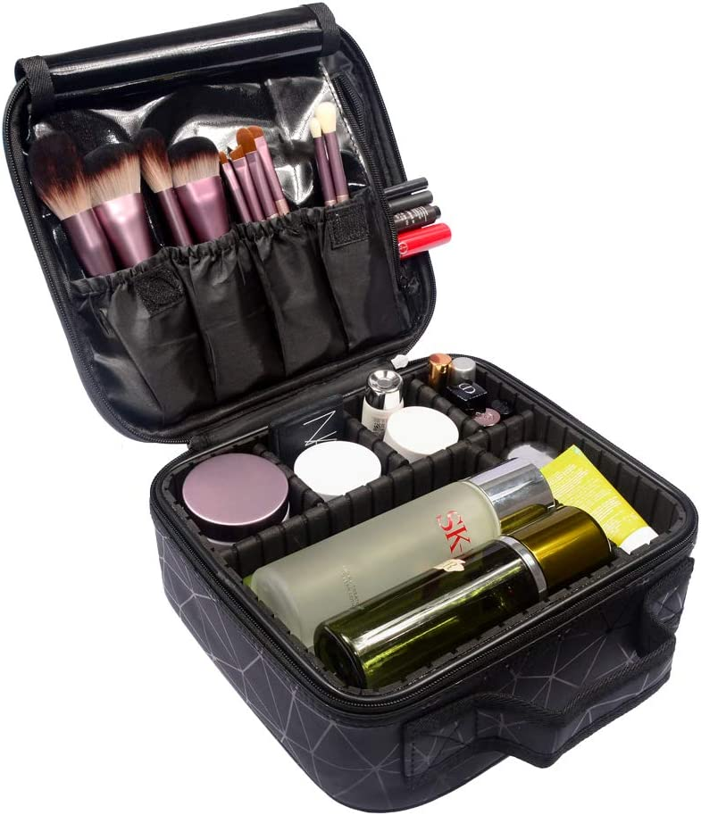
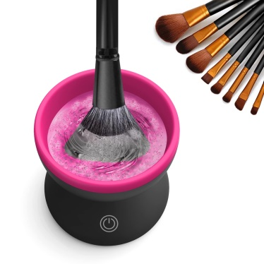
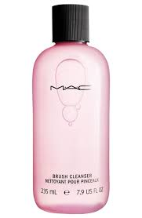
  - Product Description
SoClean Care

The Beauty Clean Cosmetic Bag is a cosmetics bag developed with an inbuilt brush cleanser. Clients who wish to purchase this will be able to keep their brushes clean and dry whilst carrying them in their bag by simply adding some water and the cleansing capsules provided. This will allow users to have clean brushers which will help eliminate skin rashes and other irritations. It is a mini portable makeup cleaning utensil as shown in the prototype above which will be a clip-on that will fit inside the cosmetics bag itself which will then be portable.
This bag is small and portable however serves a lot more than its size. The cleaner is battery-powered and once the cleaning is completed, simply dump the water out of the cleaning, vessel hold it under running water, clean it using a napkin and snap it back into the pouch. The makeup cleaner itself requires one AAA battery to function appropriately.
For the actual cleaning process, the SoClean liquid formula should be used which will be provided with the cosmetics pouch and refills can be ordered separately when required via our selling platforms. Simply squirt 2 pumps of the liquid into 100ml of water and get to cleaning. This can clean up to 6 brushes in one turn which you can then dump out and clean the brush cleaner with some cold water and a napkin in order to sterilize the equipment.

  - Customer base
The worldwide cosmetics industry is a thriving billion-dollar company, and women have historically been the primary consumer of beauty goods. Yet, as men's grooming products gain popularity, the industry is changing toward a more gender-neutral consumer.
The clientele we look forward to capturing or marketing this product to are women or men with a sense of passion and liking towards makeup and who regularly use makeup and makeup accessories for personal or professional use. The most significant features of beauty and personal care products among customers are clean, natural, and devoid of dangerous ingredients. Organic items are also essential to around one-fifth of customers. Thus, we plan on executing an innovative product to compromise these requirements of the clientele. The target audience will be presented in section 04 of the report.

  - Selling platform
Before the internet, individuals would hunt through their local paper in an attempt to get a good bargain; now, they merely go to sites like eBay and Craig's List to locate people selling stuff they want to buy. Although there are several advantages to using such sites or even looking into local sales online, there are also disadvantages to this form of buying and selling on the Internet (Lukiyanchuk et. al, 2020).
With the volatile economic situation prevailing in the world and the cost as well as other challenges involved with establishing a brick-and-mortar store, we line up to conduct all our operations online using online retailing channels. Online promotional mechanisms such as social media and digital marketing as well as web search SEO mechanisms will be the primary mechanisms of communicating the brand to the clientele. Online-based selling may assist in ensuring that all products are properly handled and delivered to the customers through inbound shipping without the additional cost allocated for a physical storefront.

  - Venture name and branding
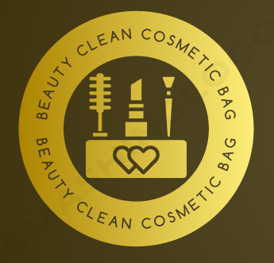
The product has been named and it will be known as ‘Beauty Clean Cosmetics Bag’. The brand name was created with the effort to demonstrate the innovative approach of the product which is the inbuilt cleaning technology of the product. The brand hopes to establish the value proposition within the mindsets of the customers through this effort and to attract customers through this approach.
Brand logo
There is a logo designed for the product and this logo will be printed at the top of each cosmetics bag to demonstrate the brand name of the product in order to create visual attraction as well as to make this new brand a more common and recognized brand within the market.
Slogan
The Slogan of the brand is ‘Clean, Chic and Creative’. Through the slogan also the brand looks to capture the attention of the clientele to the product and to create a market demand for this innovative product.

  - Competitive background
Currently, there are many cosmetic bag manufacturers including big buck bands such as Louis Vuitton to small-scale businesses and there are also a handful of brands that sell makeup brush cleaners MAC brush cleaner, Style Pro, a quick drying cleaner from ULTA beauty, etc. (Saunders et. al, 2023). However, there is no product that is similar in nature to the proposed product and thus through proper marketing as well as brand security efforts such as gaining a patent, the brand will be able to keep up with the competition in the market and also be a market leader in the product category as through security they will gain protection against copying and other issues.

- E-commerce
Following an assessment of the present turbulent economic climate and the problems associated with the 'Brick & Mortar (B&M) business model, the brand seeks to market its new product by using technological innovation. As a result, the following are some online marketing options to consider.
  - Shopify
Shopify Inc. is a global Canadian e-commerce company located in Ottawa, Ontario. The corporation's unique e-commerce platform for internet companies and retail point-of-sale devices is known as Shopify. Shopify is viewed as a leading company in e-commerce solutions, allowing it an advantage over its rivals. Shopify has developed tremendously, making it a market leader in e-commerce solutions (Fabregas, 2023). The company stands behind its product by offering outstanding service to customers, which increases customer loyalty and satisfaction (See Appendix 01). There are advantages and disadvantages associated with using Shopify as a selling platform. A few are as follows.
3.2 Amazon
Amazon is an American technology company headquartered in Seattle, Washington that focuses on e-commerce, cloud technology, digital marketing, digital media, and machine learning. By technology innovation and investing of revenues in capital expenditures, Amazon has earned a track record as a disruptive technology of well-established sectors. Amazon.com started out as a web-based bookshop but expanded rapidly into the sale of Bluray, VHSs, CDs, videos and MP3 download files, applications, video games, electronics, fashion, furnishing, food, games, and jewelry (Yasar & Wigmore, 2022). There are a variety of advantages and disadvantages of using Amazon. A few are as follows.
Pros | Cons
- Because millions of active customers visit Amazon each month to browse for items, the business will be able to capture more sales.  - Amazon can assist you in extending your consumer base because when customers go to Amazon, they are frequently searching for products instead of one specific retailer.  - Because Amazon is one of the biggest and most respected global selling and purchase platforms, it is relatively simple to eventually sell in other areas. While they have only developed sites for ten countries, they ship from over 100 destinations globally. | - If you offer the same goods as other merchants, you'll be battling with them for the Amazon Buy Box, which means you'll face strong competition.  - Amazon charges sellers a large fee on every goods sold through them.  - Amazon desires daily product regular updates. They also have extremely precise criteria. This implies that businesses must develop a specialized Amazon feed from start.

3.3 eBay
eBay Inc. is an international e-commerce enterprise headquartered in San Jose, California, that supports consumer-to-consumer and business-to-consumer trades through its website. The corporation maintains the eBay website, an online sale and shopping platform where consumers and companies worldwide can buy and sell a wide assortment of goods and services. Depending on marketplace conditions, eBay has used several methods over time. The organization first began operations, it emphasized sales and marketing by developing a revolutionary platform that allowed both buyers and sellers to have confidence in the system. It also ensures there is less likelihood of fraud (Lin, 2022). There are advantages and disadvantages associated with using eBay as a selling platform. A few are as follows.
Pros | Cons
- One of the most significant advantages of eBay is the sheer number of individuals who may view your stuff.  - When you make a transaction on eBay, you have an excellent opportunity to tell the customer about your online business. With the right techniques, you may attract them to come to your store and buy straight from you, resulting in a return client.  - You may purchase and sell any type of product or service on eBay, and no matter what your specialty is, there is an audience waiting for you. | - You operate under a set of imposed regulations on eBay, and you don't have nearly as much influence over key areas of your business, such as your return policy.  - Seller fees are one of the primary impediments to ecommerce retailers extending on eBay, particularly for small-scale firms.  - Recall that eBay has millions of active customers, and with so many sellers, selling popular items is going to be difficult.

Considering the viable Ecommerce selling platforms, the most suitable one for Beauty Clean at its initial launch is Shopify as it is less costly in comparison to the other two platforms. However, when working further and expanding in the Ecommerce platform, the company can integrate all three platforms to reach more clientele.

3.4 Payment services that will be used
As for payment services, the brand looks forward to maintaining two forms of payment which are debit/ credit card payments and PayPal services.
Debit/ Credit Payments
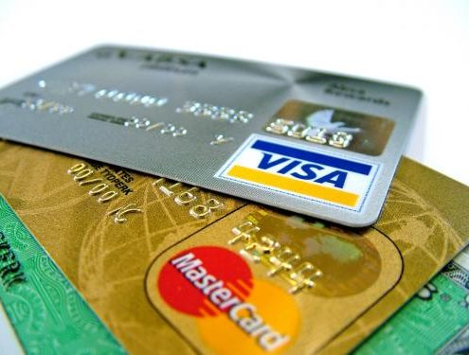
Debit and credit card payments are when customers can include their debit or credit card info to make a payment online in an effort to make the payment through a bank. Credit and Debit card payment options are highly beneficial for individuals as it allows for better and easy payment options for individuals in areas that do not have pay pal facilities.
Customers who select this option can simply include their card info on the e-commerce platform and make the payment at the point of sale.

PayPal Services
PayPal is a payment platform featuring a website and a phone app that allows for online money transactions between parties. PayPal is the quickest and safest method to pay and get paid online, on mobile devices, and in-store. Similar to Card payments, customers can simply select the Pay Pal option to make their payments when purchasing a Beauty Clean Cosmetics Bag.

- Marketing
In order to achieve the expected level of success in terms of product exposure and profitability, the product must be marketed adequately among the target market and thus a variety of marketing possibilities must be addressed and accompanied. The marketing aspect related to the innovation is addressed in the product.
  - Promotional strategies
In efforts to promote the proposed innovative product to the respective target audience, a variety of promotional strategies can be incorporated. A few that would be utilized at pre-launch and at the initial stages of a product launch are demonstrated below.
Social Media Marketing
Social media marketing is a type of digital marketing that capitalizes on the power of prominent social media channels to achieve branding and promotional objectives. In efforts to promote this innovative product, the social media marketing strategy will be used. The brand looks forward to promoting the brand on four social media platforms which are Facebook, Instagram, Twitter, and TikTok. Through the brand will be able to get an all-around advertising effort and will be able to reach a large section in fact almost the entire potential target clientele in a cost-efficient manner. While advertising posts will be created by the promotions team of the brand in an attractive manner and regularly posted on Facebook and Instagram, A Twitter thread will be created in order to have an interactive promotional campaign on Twitter. As most beauty enthusiasts and many other individuals use TikTok, the brand will not only promote the product using a company owned TikTok brand but will also engage in brand endorsements and collaborations with TikTok influencers (Buztinca et. al, 2019).
Email marketing
Email marketing is a type of marketing that may update clients on your email list regarding new products, advancements, and other offerings. Email marketing is also another cost-efficient mechanism that can be used to promote the Beauty Clean Cosmetic Bag. In order to do Email Marketing, the promotions team will partner up with a survey team to survey clientele and gather their information. Apart from that information will be gathered through beauty enthusiasts as well as data gathered from brands that customers that show interest in popular makeup brands through brand collaborations. After gathering Emails from potential target audiences, emails will be mailed to them about the brand, and the product that will be launched prior to the actual launch to create hype for the brand as well as to create awareness among the target audience. Apart from that, post-launch, email marketing will be used to keep the audience notified about sales promotions as well as what’s next about the brand and its product availability.
Paid advertising
Paid advertising is a digital marketing approach in which businesses bid to display advertising to internet users. The company prepared to spend the most has its ad displayed, and it must pay for each click that opens its ad. To increase paid advertisements in efforts to increase the brand attraction as well as the establishment in the target market and increase revenue flow for the brand. Although this will be a cost upfront, it will be an investment for the foreseeable future. In efforts to endure paid advertising, the brand will collaborate with social media influencers, especially make-up artists, and get them to promote the brand through lifestyle blog promotions as well as through affluent marketing where a promo discount code will be applicable. Apart from that paid pay per click on Google ads will also be considered for web optimization as well as to drive more clientele towards the company website where purchases can and will be made.
Sales Promotion
A sales promotion is an advertising strategy that is designed to enhance sales, inspire loyalty from consumers, or raise awareness of a brand. Sales promotions will be one of the short-term promotional strategies that the brand considers. In order to increase sales, the company will have sales promotions during the first month since the launch and will look forward to ensuring that the product appeals to the customers. Apart from that seasonal discounts will also be held whenever possible for example during Christmas. These sales promotions will be price reductions or even coupons that will be handed over by pairing similar products. Sales promotion is one way to increase sales in the short run and thus will be used to gain BEP sales as soon as the brand possibly can as it will be funded by company capital.
  - Target market and positioning
Recognizing the appropriate target market for any product is critical and in terms of the Beauty Clean Cosmetic Bag, as it is an innovative product, identifying the best target market and positioning the product properly is essential. Given below is the target marketing and product positioning of the product.

Segmentation and Target Market
Market segmentation and targeting are the techniques of identifying a company's possible clients, selecting which clientele to pursue, and delivering benefits for the targeted customers. The segmentation and targeting of Beauty Clean are as follows.
Geographic Segmentation  As for the launch, the geographic segmentation will be limited too just the UK as we will make it available for shipping across the UK. However, within the first three months since launch, the product will be made available in Ecommerce platforms and thus will be accessible to over 80 other geographic nations. | Demographic Segmentation  In terms of demographics, the product is aimed at both males and females that are middle- or high-income earners that will perceive the product as useful for them. The preferred age restriction will be above the age of 16.
Psychographic Segmentation  In terms of psychographic segmentation, the product will be targeted at individuals that are mainly involved in the make-up and beauty culture industry or have keen interest towards use of make-up and has made it a part of their daily routine. It is also for individuals that are clean freaks who like to always keep their brushes and makeup accessories clean without ruining its quality. | Behavioural Segmentation  The brand looks to sell to customers who are brand sensitive and will perceive the value of a product by its unique purpose and quality rather than the price of a product.

Thus, it is evident that the Beauty Clean Cosmetics Bag will have a strong target market and if the brand focuses its promotional and marketing efforts accurately, it will reach the target clientele thus generating revenue for the brand.

Product Positioning
Product positioning is the act of selecting and expressing how you desire your market to view and think about the good you sell. The product Beauty Clean will be positioned as an all-in-one cosmetics pouch which will not only allow efficient portability but will also help keep makeup equipment clean and thorough. It is a unique product and has no direct competitors but does still have the threat of substitution which is why it is important to position it as a revolutionized, sleek, and cost-efficient make-up pouch to fit the efficiency as well as hygienic needs of any make-up artist. The product positioning is as follows.

High Cost
Low Quality
High Quality
Low Cost

  - Customer journey
The customer journey is the series of contacts a consumer has with the company, product, or brand as they gain acquainted with a problem and make a purchase decision.

Customer Journey map
A customer journey map is a visual representation of every connection a consumer makes with an organization, good, or service. The design of a trip map positions the business immediately in the mind-set of the consumer, allowing them to see and fully understand their procedures, wants, and views of their customers (Cooper, 2019).
Stage | Awareness | Considerations | Decision | Service | Loyalty
Customer Actions | Viewing an online ad.  Social media campaign awareness. | Conduct product research.  Compare product features with pricing. | Purchase Beauty Clean Cosmetics Pouch | Receiving product.  Pre and post purchase customer services. | Sharing the experience
Touch Points | Social media  Paid advertising  Emails | Website  Social media  Emails | Website  Over the phone | Over the phone | Word of mouth  Social media reviews  Blogs
Customer Experience | Interested but hesitant | Curious and excited | Excited | Frustrated or satisfied | Satisfied
KPIS | Number of product reaches | Website visits  Post likes and comments | Conversion rates  Online sales | Reviews  Waiting time | Retention rate  Reviews
Business Goals | Create and increase awareness | Increase store traffic and purchases | Increase purchases and revenue | Increase customer satisfaction | Generate retained customers
Team involved | Marketing and promotions | Marketing and promotions | Sales  Marketing | Customer service managers | Marketing and promotions  Marketing

Role of the customer journey
A customer Journey is a plan that presents all a consumer's behaviour and relationships with a brand. Customer journey is responsible for implementing the client relationship strategy and roadmap, as well as promoting success within the company to provide a uniform and satisfying experience for every customer segment across all interfaces.
Consumers today require brands that acknowledge them as individuals. As a result, companies and stores must cultivate emotional connections with their customers by creating personal communities in which they may find themselves and buy with safety, assurance, and openness. Through a well thought customer journey, the brand aims to help people understand and buy into the benefits and solutions of a product and to become familiar with the brand. In response, beauty manufacturers have begun to develop hybrid cosmetics and skincare products, since customers prefer goods with many advantages and applications. This is what the firm and brand capitalize on.
- Privacy and Data Protection
People have a right to a private and family life online, which includes having their personal information protected and having the privacy of their correspondence and communications respected. Only where required by law or with consent should one's personal data be handled (Gellert & Gutwirth, 2013). A person has a right to know what personal information is processed, when it's done, who's doing it, and why. In general, one ought to have access to and control over personal data.
Data Protection Act 2018
The Data Protection Act of 2018 oversees how businesses, organizations, and the government employ the personal data you provide. The Act is designed to allow individuals to exercise control of their private information and to support organizations in conducting trustworthy personal processing of information. Everyone in control of utilizing sensitive information must stick to tight guidelines that are referred to as "data protection principles" (Data Protection, n.d). They must ensure that the data is:
- Fairly, legally, and transparently used for defined specific uses.
- Used in a way that is sufficient, pertinent, and limited to only what is necessary Precise and, where essential it is kept up to date.
- Handled in a way that makes sure of appropriate security, which includes protection against unconstitutional or unauthorized interpreting, access, theft, destruction, or damage.
The protection act allows the brand to ensure that it is marketing and promotional data that is being published on different promotional platforms and to ensure that there will be no backlash and legal insecurities created because of misinterpretation and use of customers’ private data. Consumers may feel more secure giving their personal information as a result of changes to data privacy, increasing their willingness to trust marketers with it. As a new brand that is not known by a large number of clients, abiding by the data protection rules and regulations is critical and can help create a better reputation for the brand.

PECR
The Privacy and Electronic Communications Regulations (PECR) are supplementary to the Data Protection Act in the UK. They provide people with certain rights of confidentiality when it pertains to electronic communications. There are limitations for.
- Marketing calls, emails, texts, and faxes
- Cookies (and related technology)
- Keeping communication tools safe
- Consumer privacy with regard to traffic and geographical information
- Itemized billing, line verification, and index listings (Bateman, 2023).
According to this protection framework, consent is critical when dealing with a client’s personal information. Users may choose the communications they would like to receive based on their tastes and areas of interest. As a result, marketers have become more able to comprehend them and may therefore create more effective, specific advertising campaigns. Consent helps brands to be more transparent, and better marketers, and since the brand is planning to use email marketing, following this is critical.
Security
Security is critical when conducting marketing and promotional activities for a new product or service. It is important to secure a brand's cloud provider; access and changes made to company-related software and data as well as traffic of the brand. Your data must be instantly accessible to a corporation in a safe manner. Cloud security makes ensuring that authorized users may easily access your data and apps. Maintaining your clients' trust and securing the resources that support your competitive edge depend on your ability to prevent leaks and data theft. Moreover, encrypting traffic is essential for a new brand. It aids in preventing unauthorized access, theft, and other security risks from sensitive information. Data encryption prevents easy reading and comprehension even if it gets into the wrong hands.

- Conclusion
There are many different methods of product creation, but they may generally be categorized into three groups: developing new goods, enhancing current products, and designing new product features. Here in this report, it was discussed about a new brand that is planning to introduce a new product to the market to grasp a niche market and to attract customers from a target audience that would show interest in the product and get the product to them through adequate promotions and marketing. This report provides an all-around view of the marketing and promotion involved with the new product in terms of selling it on an e-commerce platform rather than a storefront sale. The report also demonstrated privacy and data protection and its importance in new product development. Therefore, small companies that are capable of effectively utilizing product innovation will be enabled to expand into larger companies while collecting a competitive edge over their remaining rivals.

- Appendices

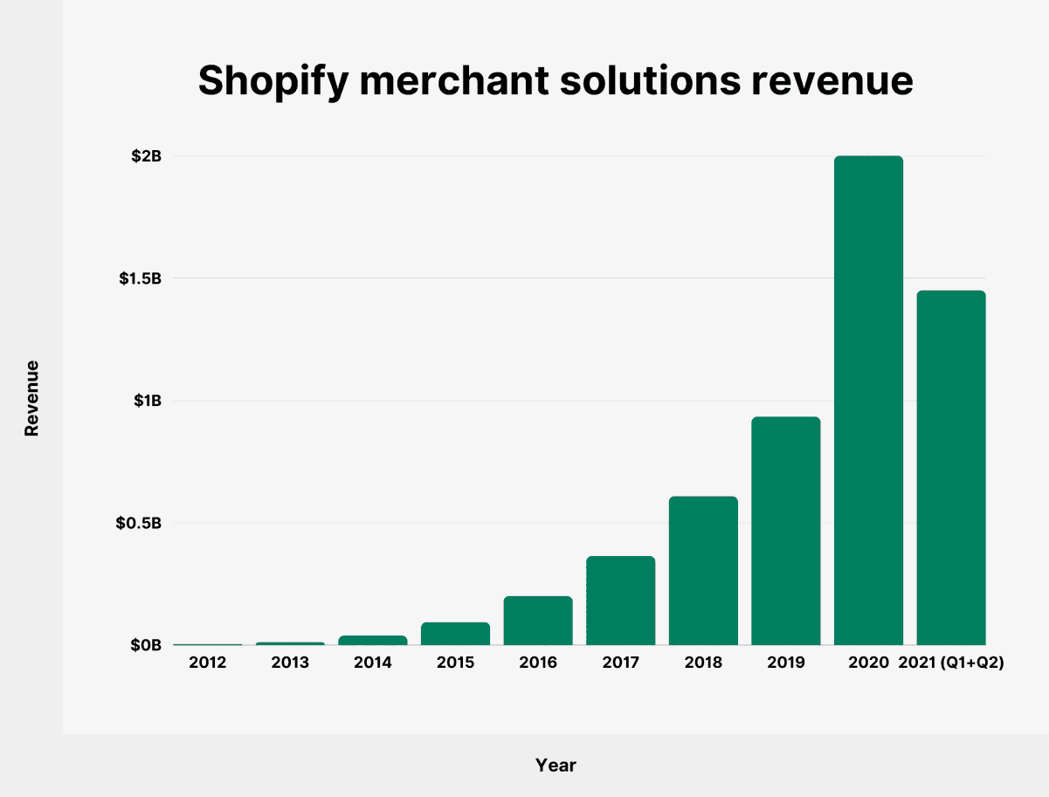
Appendices 01

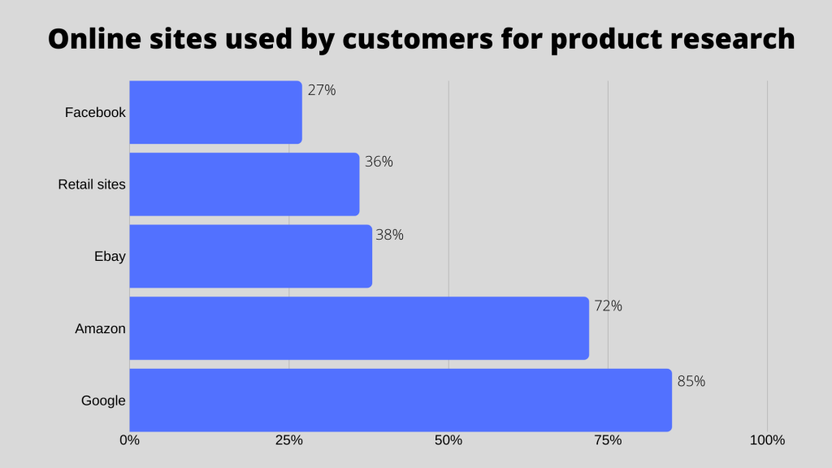
Appendices 02

8.0 References
Bateman, R. (2023) Privacy and electronic communications regulations (PECR), TermsFeed. TermsFeed. Available at: https://www.termsfeed.com/blog/pecr/ (Accessed: April 21, 2023).
Bustinza, O.F., Gomes, E., Vendrell‐Herrero, F. and Baines, T., 2019. Product–service innovation and performance: the role of collaborative partnerships and R&D intensity. R&d Management, 49(1), pp.33-45.
Cooper, R.G., 2019. The drivers of success in new-product development. Industrial Marketing Management, 76, pp.36-47.
Fabregas, K. (2023) What is Shopify & How Does It Work (2023 guide), Forbes. Forbes Magazine. Available at: https://www.forbes.com/advisor/business/software/what-is-shopify/ (Accessed: April 18, 2023).
Gellert, R. and Gutwirth, S., 2013. The legal construction of privacy and data protection. Computer Law & Security Review, 29(5), pp.522-530.
Lin, Y. (2022) 10 eBay statistics you need to know in 2023 [infographic], Oberlo. Oberlo. Available at: https://www.oberlo.com/blog/ebay-statistics (Accessed: April 18, 2023).
Lukiyanchuk, I.N., Panasenko, S.V., Kazantseva, S.Y., Lebedev, K.A.E. and Lebedeva, O.E., 2020. Development of online retailing logistics flows in a globalized digital economy. Revista Inclusiones, 7(S2-1), pp.407-416.
Marchessou, S. and Spagnuolo, E. (2021) Taking a good look at the Beauty Industry, McKinsey & Company. McKinsey & Company. Available at: https://www.mckinsey.com/industries/retail/our-insights/taking-a-good-look-at-the-beauty-industry (Accessed: March 23, 2023).
Saunders, N., Hussain, J., & McBroom, K. (2023, February 5). 10 makeup brush cleaners for grime-free beauty tools. Best Products. Retrieved April 18, 2023, from https://www.bestproducts.com/beauty/g542/best-makeup-brush-cleaners/
Service, G.D. (n.d) Data protection, GOV.UK. GOV.UK. Available at: https://www.gov.uk/data-protection (Accessed: April 21, 2023).
Yasar, K. and Wigmore, I. (2022) What is Amazon? definition and company history of Amazon.com, WhatIs.com. TechTarget. Available at: https://www.techtarget.com/whatis/definition/Amazon (Accessed: April 18, 2023).

