2020
Organisation: Techniquest
Email address: gareth.mctiffin@techniquest.org
Final Report: Consultancy Project for Techniquest
Consultancy Project (Confidential)
Mhairi Price (1708315)

Terms of Reference
Mhairi Price is an independent student consultant undertaking a market research project, for Techniquest. In order to investigate and recommend strategies that Techniquest can implement when they re-open safely, following the impacts of Covid-19.

Executive Summary
This report produces strategies and recommendations for Techniquest to implement when they re-open. Techniquest is the UK’s longest established science centre, located in Cardiff Bay. It is an independent registered educational charity that first opened its doors in 1986. Since its first opening in 1986 the science centre has welcomed over five million visitors, 1.5 million of these visitors are school groups. Techniquest’s main target market are school groups, due to the educational background of the science centre. As Techniquest is an independent registered educational charity the funding for the centre comes from a variety of sources, these sources are extremely important in order to keep Techniquest opened. Some of the sources include the Welsh Government, admission fees, grants, and other earned income such as events or conference meeting room hires. The science centre offers fun and educational interactive experiences through the form of science that are enjoyed by people of all ages. Techniquest closed to the public on the 18th of March 2020 due to the effects of Covid-19, when the science centre re-opens a lot of changes in the way they operate will have to be made.
This report has researched into primary school teachers opinions and thoughts on virtual classroom apps, what social distancing measures can be used in Techniquest when they reopen, and the best way to market the re-opening of Techniquest, through carrying out primary and secondary research. The primary research that was carried out was done via collecting data through the form of questionnaires that were handed out to primary school teachers to complete. Secondary research was carried out by using reliable and academic news articles, journals, books, and online sources to gather data for social distancing measures and finding the best way to market the reopening of Techniquest.
Research found that primary school teachers are interested in using a Techniquest virtual classroom app as a teaching tool for children. Simple yet effective social distancing measures used in attractions around the world can be used in Techniquest however will just need to be altered slightly. Facebook and Instagram were found to be the two best social media platforms to market the re-opening of Techniquest as this will reach a wide audience and both apps are free to use so therefore are cost effective.
The recommendations put forward are to create a virtual classroom app as this is something teachers are interested in and believe it will be beneficial to children’s learning and development depending on the quality of the app. Using social distancing measures that other attractions are using can be used in Techniquest and the majority of measures are simple and effective, so are easy to carry out. The last recommendation is to focus on and use Facebook and Instagram to market the reopening of Techniquest. Facebook and Instagram were found to be the two most used social media apps in the UK. With Techniquest’s already having a good social media following on these apps means that the re-opening of the science centre will reach a wide audience quickly with no cost of marketing being involved.

Table of Contents
Executive Summary 2
List of tables and figures 5
Figure 1 5
Introduction 7
Project Aim 7
Objectives 7
Research Methodology 8
Research Findings 10
Virtual Classrooms 10
Social Distancing Measures 11
Marketing the re-opening of Techniquest 13
Conclusion 14
Virtual Classrooms 14
Social Distancing Measures 14
Marketing the reopening of Techniquest 14
Recommendations 15
Reference List 17
Appendices 21
Appendix 1 21
Appendix 2 21
Appenix 3 22
Appendix 4 22
Appendix 5 23

List of tables and figures

Figure 1
Techniquest Questionnaire.
- What is your name?
- What school do you work at?
- What is your position in the school you work at?
- What age group / key stage are you responsible for?
- Early Years Foundation stage (ages 3-5)
- Key Stage 1 (ages 5-7)
- Key Stage 2 (ages 7-11)
- Key Stage 3 (ages 11-14)
- Key Stage 4 (ages 14-16)
- Key Stage 5 (ages 16-18)
- What specific subject or subjects do you teach in the school? And to what year groups?
- Have you heard of Techniquest?
- Have you ever visited Techniquest?
- If answered yes to previous question what was your motivation for visiting Techniquest?
- Have you used a virtual classroom app before?
- If answered yes to previous question how did you find it?
- If Techniquest offered virtual classroom apps to schools is this something you would be interested in?
- During lockdown only
- When schools re-open only
- Long term use
- If answered yes to previous question how often do you think you would use it as a tool for learning?
- Daily
- Weekly
- Monthly
- Yearly
- For what age group would you use it?
- For what subjects would you use it?
- Would you be interested in piloting a virtual classroom app with Techniquest?
- If Techniquest offered this app to schools would you be willing to pay for it?
- If answered yes to previous question how much would you be willing to pay? And how would you like to make payments?
- Monthly payment
- Annual payment
- Monthly payment per student
- Annual payment per student
- Do you think virtual classroom apps will be a useful tool for teaching children when they return to school?
- Would it be useful for children to use for leisure activities?
- Would it be useful for children to use for homework?
- Would it be useful for families?

Introduction
This is the final report for Techniquest. This projects main aim and focus was to conduct market research to advise strategies and recommendations for Techniquest to use when they can reopen, after the effects of Covid-19. The final report outlines the research that has been carried out in order to produce clear, brief, and actionable recommendations on how Techniquest can re-open safely and new ways they could operate.
This project first began in January 2020, following the first stages of this project a lot had to change due to the current situation businesses, organisations and individuals are facing due to the effects of Covid-19, and the UK along with many other countries going into lockdown. New clear aims and objectives of the project will be mentioned in the project aims and objectives section of this report, and moreover why the project’s direction had to change.

Project Aim
This project’s aim and objectives had to be altered and changed drastically due to the current circumstances that has taken place in the world that is Covid-19. “it is important to recognise that in this fast-moving working environment, and with projects increasing in scale and complexity, a degree of change is inevitable. Putting the right mitigation strategies in place early on can provide project managers with much-needed agility, allowing them to respond quickly to any new issues that arise”. (Al-Hillawi, 2019). The original aim was to boost outbound tourism into Techniquest, however due to Covid-19 the UK along with many other countries had gone into lockdown which meant that the original aim was no longer achievable and in turn the researcher had to respond quickly to the new issues faced, and develop a new aim for the project. Due to Covid-19 Techniquest had to close on the 18th March 2020.
The new aim of the project was created through brainstorming, discussion, and agreement between the client and the researcher and emails can be seen in Appendix 1,2,3,4 and 5.
The new aim for this project was to conduct market research to come up with new ideas, strategies, and recommendations for Techniquest to re-open when it is safe to do so.

Objectives
- Investigate “virtual classrooms” to consider if this is a system that schools would be interested in using as a form of teaching whilst schools are shut and for when schools re-open.
- Social distancing measures will be investigated, investigating Disneyland Shanghai, Universal Orlando Resort and LEGOLAND Florida Resort as research sources. These are the first big attractions to either re-open or have announced their re-opening to the public with social distancing measures in place. Researching into these attractions will provide ideas for social distancing measure that could be used in Techniquest.
- Discover the best way to market the re-opening of Techniquest so it reaches a wide audience. Publishing the new social distancing measures that are in place via social media and other marketing tools so that tourists know what to expect before visiting Techniquest.

Research Methodology
Research methodology is vital in carrying out any research project, without carrying out research there would be no reliable and validated information gathered. Research methodology is the discussion of the research methods chosen and used to carry out a project, (Expert journals, 2017). Research as described by (Wipke-Tevis, 2001) is, “a systematic investigation, including research development, testing, and evaluation, designed to develop or contribute to generalizable knowledge”. This means that research is a process used to gather new knowledge. Methodology described by (Little, 2014), “A methodology is a set of ideas or guidelines about how to proceed in gathering and validating knowledge of a subject matter”. Therefore, methodology are the methods used to gather information.
There are two different types of research methods that can be used to gather data, these are known as “quantitative” and “qualitative” methods. Quantitative methods described by (Ernst, 2003) “were originally developed in natural sciences to study natural phenomena. It’s aim is to capture relevant facts and explain them casually with empirical-analytical methods”. Quantitative methods are generally used in the form of surveys, experiments, structured questionnaires, and interviews. This method is best for measuring, categorising, and identifying patterns.
Qualitative methods described by (Ernst, 2003) “were developed in the social sciences to enable researchers to study social and cultural phenomena. This method tries to clarify the basic issue of how subjects interpret and see the world, why and how they act and in which form changes take place”. Qualitative methods and generally used in the form of case studies, unstructured interviews, participant observation and is used for describing and explanatory purposes.
The research method chosen for this project was Quantitative. Quantitative research method was the chosen method for this project because the information gathered from research needed to be categorised to identify findings and distinguish clear conclusions from the information collected. Questionnaires and the use of secondary data and documents were used to gather research for this project.
For this project both primary and secondary research were utilized to gather information. The primary research conducted was done so in the form of distributing questionnaires out to primary school teachers. Primary research is data that the researcher has collected themself and can be done so in the form of interviews, surveys, observations, and questionnaires. (Stokes and Wall, 2014), describes primary research as “those sources which you as the researcher have identified and accessed in order to develop the data. These sources might be managers or employers who are respondents and participants in your study”. In this projects case the participants used for this project as mentioned previously were primary school teachers from around the South Wales area.
On the other hand, secondary research is using data that the researcher did not originally create or write. “Secondary research is research someone else has done that can help you better understand the space you are working in” (Tajima, 2019). Sources of secondary research used for this report include reliable and academic news articles, journals, books, and online sources. Secondary research is the preferred form of research method for this project as it is known to be the most cost-effective and time saving research method, (McCrocklin, S 2018).
The questionnaire designed was simple and clear and included a mixture of open and closed questions. The questionnaires were distributed to schoolteachers who teach children from the ages of 3-11. The questionnaires were distributed to schoolteachers as information was needed on their opinions on “virtual classrooms” as a learning tool for children. Nine primary school teachers in total from different schools within the South Wales area completed the questionnaires for this project.
Where face to face interviews and meetings were meant to be carried out for research, this was no longer possible due to Covid-19. Therefore, this meant more online secondary research had to be carried out. Primary research was conducted for this project in the form of questionnaires. However, responses were very limited. Responses were limited because questionnaires had to be sent out via email to schoolteachers this meant that the researcher had to use personal links to schoolteachers that they knew, leading to a very limited number of responses. Compared to what could have been a huge response if the researcher was able to go into schools, and hand out questionnaires to get more responses, and a mixture of participants from different schools such as secondary schools. Another reason why the responses were limited is because some schools that the researcher contacted via email were closed, which meant that the email could have been missed and therefore not responded too. Originally the questionnaires were meant to be completed by primary school teachers, secondary school teachers and college lectures. However, there were no responses from secondary school teachers or college lectures, this meant that obtaining a large amount of responses was unsuccessful for this project and is not a truly reliable research sample, which the researcher has taken into consideration when carrying out this project.

Research Findings

Virtual Classrooms
Firstly to understand what a virtual classroom app is taken from (Ez talks, 2017) “A virtual classroom is typically an online learning system where both the learners and tutors/teachers communicate to each other just like the real classroom but from different geographical locations. The system comprises of all the basic tools required to run effectively a classroom. Communication among the participants can be achieved in various ways like text chat, live video, live audio, and so on.”
In total nine participants took part in completing the questionnaires, all of which worked within primary schools across the South Wales area. As all participants were primary school teachers this meant there was a mixture of teacher’s teaching different age groups and key stages, which included early years foundation stage, key stage 1 (ages 5-7) and key stage 2 (ages 7-11).
The first simple and clear questions featured on the questionnaire included “have you heard of Techniquest?” which all participants answered yes. Next “have you ever visited Techniquest?” which 8/9 participants answered yes. This meant all participants knew of Techniquest, what it is, where it is and had an idea on what is on offer there. For those who answered yes to visiting Techniquest there were then asked their motivation for visiting so the researcher could understand their intentions of visiting. There was a mixture of responses. Responses included family days out, school visits, as part of PGCE course and as part of NQT courses. However, the majority of responses were “school visits” which is no surprise as Techniquest’s main target market is school visits.
When asked the question if they had used a “virtual classroom app” before, 2 out of 9 respondents had used it. Teacher A said they found it “Good - the children were enthused” which indicates that children were entertained and interested when using the app. Teacher B responded with “Can be very difficult for children to access the classroom and problems when children do not have a computer or tablets at home. However, when it does work it does have real benefits as you can complete activities you wouldn’t be able to in a normal classroom.” Although Teacher B in some ways did find it useful and beneficial it was also mentioned that those children who may not have access to computers or tablets at home may not be able to participant and therefore miss out on the learning if required to use it at home and not just at school.
The response to the question of if Techniquest offered a “virtual classroom app” would they be interested in using it; a. during lockdown only, b. when schools reopened or c. long term use, once again another mixture of responses were apparent. However, the majority chose long term use which is a very good indication of this app being a tool teachers would want to use. In regards to why they would be interested in using a “virtual classroom app” and for what subjects the majority of participants believed it would be useful tool for teaching science and technology in schools, however, 2 participants went further and believed it would not only help science and technology knowledge but would also help with literacy, knowledge and understanding of the world, mathematics, language, communication and ICT skills. Which is again a good indication that teachers would want to use this app in aid of helping children learn within school for these particular subjects/ skills.
When participants were asked if they would be interested in piloting a “virtual classroom app” from Techniquest 7/9 participants answered yes, 1 answered no and 1 responded by stating not at this current time. However, those participants who responded with yes were then asked if they would be willing to pay for the app. 1/9 answered yes, 3/9 answered no and 5/9 stated that it would all depend on schools budget, the quality of the app, and if it was useful and beneficial to the children learning would dictate whether or not they would be willing to pay for the app.
Finally, for the last four questions featured on the questionnaire, all responses were very similar. When asked if they thought a “virtual classroom app” would be a useful teaching tool all respondents answered yes. When asked if they think the app could be used for leisure activities 7/9 answered yes, when participants were asked if the app could be useful for children to use for homework 8/9 answered yes. However, one respondent answered that they believe it would be more beneficial for homework in comprehensive schools for science and not for primary schools. The last question asked was if the app would be useful for families and all participants answered yes.

Social Distancing Measures
According to (Shaw, 2020) social distancing rules and regulations in the UK will have to be put in place for organisations and businesses, and obeyed for over a year, “Some rules could be left in place for a year after lockdown is eased in a bid to slow the spread of the new coronavirus - including home working, one-way systems in work places and plastic screens.” Meaning Techniquest will have to introduce new and safe ways of operating for the long term.
On the 24th of April 2020, a traffic light roadmap was published by the First Minister, Mark Drakeford, on how Wales could exit the Coronavirus lockdown. It is apparent from this traffic light roadmap that Techniquest along with other similar attractions will not be able to open until Wales reaches the green stage which is the last stage of the roadmap (Gov.Wales, 2020).
As Techniquest is a tourist attraction and listed as one of the “best attractions in Cardiff Bay” (Knapman, 2016), the researcher undertook research into Disneyland Shanghai, Universal Orlando Resort and LEGOLAND Florida Resort. Investigating the new measures these attractions have/ are introducing into the parks now that they have reopened/ re-opening soon.
Disneyland Shanghai closed on the 25th of January 2020 and reopened on the 11th of May 2020 (USA Today, 2020), after just over a 3 month closure the park has now reopened with many social distancing measures and precautions in place. Legoland Florida Resort has announced their reopening on the 1st of June, and Universal Orlando Resort announced their reopening on the 5th of June, (Mitchell, 2020). It is clear to see that all 3 attractions have very similar social distancing measures in place for their re-openings and are following their country’ safety guidelines. Firstly, Disneyland Shanghai now operates at 30% capacity which is around 24,000 visitors a day compared to what used to be 80,000 per day. This is a major difference in numbers and is in fact below the level the Chinese Government requests of 50% capacity (CNBC, 2020). However, this measure has been put into place to reduce the capacity in queues, ride vehicles and generally within the park so that social distancing measure can be adhered too. Andrew Bolstein the senior VP operations for Disneyland Shanghai stated that with reduced number of visitors a day means everyone should be able to see and do everything they want. "With our limited numbers of attendees every day, we believe everyone will be able to see almost everything they want", (Parker, 2020). LEGOLAND Florida Resort have announced they will be operating at 50% capacity and they are encouraging guests to plan their visits in advance and buy tickets online to avoid disappointment.
According to (Hart, 2020), upon entering Disneyland Shanghai visitors are now required to have temperature health checks to ensure they have no symptoms of Covid-19. This is done via a “fever screening system” that displays a person temperature as they walk past, instead of using an individual temperature check, which should make people feel more comfortable and less invasive, (Parker, 2020). If visitors have passed the health check, they are required to wear mandatory face mask around the park at all times to lessen the risk of potentially spreading or catching the virus. This measure is believed to make visitors feel at ease and less anxious whilst still enjoying their day out. In Universal Orlando resort the same temperature health checks are in place and mandatory face masks, stated by (Mitchell, 2020) any guests with a temperature of 100.4 degrees or higher will not be allowed to enter the park. Once again LEGOLAND Florida Resort is the same and they have published that all employees and guests will undergo temperature health checks before they are allowed entry into the park and if one member of the group has a temperature of 100.4 degrees of higher then no members will be allowed entry, (Swartvagher, 2020).
(Shanghai Disney Resort, 2020) published that they have introduced increased frequency of sanitization and disinfection on rides after every cycle, and increased frequency of cleaning the park in general. Along with this when on rides visitors are required to sit well apart and remain socially distanced when queuing. With regular audio announcements and staff members holding cards with visual instructions to remind guests of all measures to make sure they are adhering to the new social distancing measures that are in place. The park has introduced markers on the ground in the colours purple and yellow for social distancing showing visitors where they can stand when queuing for rides so that the 2-metre social distancing measure is being followed.
(Universal Orlando, 2020) published their safety measures on their website and are following CDC (Centres for Disease Control and Prevention) guidelines and recommendations of health authorities. They have stated that they ask all members to wash their hands often throughout their day. They ask all visitors to stay 2 meters apart and when present to stand on the floor markings that are provided. They have introduced hand sanitizer stations around the park and at every ride for guests to use before and after boarding.
Further changes that has been made in Legoland Florida Resort in preparations for their reopening are as follows. Taken from (Cetoute, 2020), there will be signage and markers around the attraction to ensure social distancing measures are being followed. Guests who drive will have to park spaced out. They have enhanced their cleaning regimes to comply with government advice, the requirements of health authorities and CDC. Legoland Florida Resort are encouraging guests to download the LEGOLAND mobile app prior to visiting to familiarise themselves with the new social distancing measure the park has enforced and new procedures that are in place.

Marketing the re-opening of Techniquest
Social Media platforms include apps such as Facebook, Instagram, Snapchat, and Twitter, however the two most popular and most used apps in the UK are Instagram and Facebook. According to (YouGov, 2020) statistics show that 55% of people use Facebook which is the most famous social network and 45% of people use Instagram which is the second most famous social network, therefore these are the two social platforms that UK residents use daily and are most likely to see news or advertisements on.
Throughout the closure of Techniquest their social media platforms has been kept active. This has hopefully been entertaining viewers/ followers until the reopening, evidence of this is that one respondent to the questionnaires wrote a statement at the end saying, “Excellent videos on website since lockdown – using as home learning tool”. With Techniquest having 16,130 followers on Facebook and 1,277 followers on Instagram these are the target audience they will need to focus on attracting back to the science centre once it is re-opened.

Conclusion

Virtual Classrooms
All responses from participants were very similar responses and, some valuable feedback can be taken from the participants in order to come up with recommendations. It is clear that the majority of participants would welcome the idea of using a virtual classroom app from Techniquest as this would aid them in many subject areas that they have to teach within the curriculum. As mentioned by one of the participants that using virtual classroom apps is a different, engaging, and a fun way of learning for children that may help them learn more as they find it more of a fun activity and less of schoolwork. Taken away from the research is that all participants believed this app would be useful for leisure activities and for families to use, therefore this could introduce another target market for a virtual classroom app to be accessible to individuals, not just schools which was the original idea.

Social Distancing Measures
It is clear to see that there are numerous social distancing measures that the attractions have implemented. All three attractions investigated had identical social distancing measures in place and have adapted certain measures to work within in their attraction, such as the maximum capacity of the attraction. The three attractions investigated are complying with their safety guidelines and adhering to advice from health officials so that they have been able to reopen safely. The numerous social distancing measures that are in place in all three attractions will take staff members and visitors time to get use too however it is important that everyone listens to the rules in order for everyone to firstly, have an enjoyable day out, secondly to make visitors feel less anxious and thirdly to stop the spread of coronavirus to make sure that people are safe.

Marketing the reopening of Techniquest
Advertisement for businesses taken from (Adarmymin, 2019), “The sole purpose of a business is to sell products and services to earn profits. Advertising helps a business to earn profits by enabling more people to know about the products and services and thus resulting in more sales”. This statement reads the importance of advertisement and how vital it is for businesses to do this in order for them to gain more “sales” or in Techniquest’s case more “visitors”.
From the research undertaken it was apparent that the two most effective social media apps in the UK were Facebook and Instagram. On these two social media apps Techniquest already has a good following. Therefore, advertising mainly through these two apps could attract old and possibly new visitors, the apps are free to use and therefore cost effective and with Techniquest being active on these two social media apps during closure this will hopefully make individuals want to visit more and experience what Techniquest has on offer in “real life”.

Recommendations
From the research undertaken and the data collected it is clear to see that the reopening of Techniquest will be achievable and manageable. After carrying out research on school teachers opinions on virtual classrooms, inspiration and ideas from other tourists attractions on social distancing measures and identifying the best social media apps to market the reopening of Techniquest has allowed the researcher to come up with three recommendations listed below:
- Create a virtual classroom app
- Implement the social distancing measures that other attractions are using
- Focus on, and use Facebook and Instagram to market the reopening of Techniquest
It is clear from the research findings that primary school teachers believe that a virtual classroom app will be beneficial for children’s development and learning (depending on its quality). When schools eventually re-open it is unlikely, they will be able to go on educational trips for a while, therefore designing an app like this will give them a virtual experience. Pilot the virtual classroom apps with a few selected schools in the South Wales area would be a good way to gather professional opinions on the quality of the app and if they believe it to be beneficial to children’s learning. Once this stage is done then you can decide on a price to sell this app for, the researcher is unable to give a guided price for this app as it all depends on what is included within the app. From the research gathered what teachers are looking for within the app is a lot of exciting and engaging content that is within the curriculum. The participants believed this would be a great app for families to use at home, therefore the possibility of offering the app to individuals, not just schools for the same price would give this app a larger target market.
In order for Techniquest to reopen social distancing measures, and new ways of working will have to be implemented. Some social distancing measures researched that can be implemented easily are social distancing signage around the centre, and floor markings so that visitors are always 2 metres apart. Only taking card payments, and only using the current paperless ticket system that Techniquest already has in place. Increase the frequency of cleaning in general and providing hand sanitizer stations around the centre. Another measure to be taken is due to Techniquest being an interactive science centre where young children use their hands to use many of the stations and exhibits, they should be encouraged to clean these before and after each use. This could be done by asking visitors to do this when they arrive, having signs around the centre reminding guest of this rule and to provide guests with cleaning materials in order for them to do this. Techniquest should provide visitors with facemasks if they do not have one upon entering. Instead of temperature checking visitors upon entering which can be costly to install simply ask guests of their current health status, if they have any symptoms of the coronavirus, for the safety of other visitors and staff members than they should be disapproved entry. These recommendations are simple yet effective and will make visitors experience at Techniquest enjoyable. Visitors should not feel anxious when visiting as many people may be feeling anxious and nervous when attractions begin to re-open again.
Visitors will need to know when Techniquest will be reopening therefore advertisement is vital. As research shows Facebook and Instagram are the two most popular social networks in the UK, therefore, these two apps are the ones that should be used to advertise the reopening of Techniquest. With Techniquest having a good following and engagement on both Facebook and Instagram realistically these are visitors who have visited the centre before and will be returning visitors. Similarly, to LEGOLAND Florida Techniquest should post on all their social media platforms their new social distancing measures that they are using now to inform visitors what to expect when they visit. This will help visitors familiarise themselves with the new social distancing measure that Techniquest has enforced and the new procedures that are in place.

Word Count: 4,400

Reference List
Adarmymin. (2019). Why Advertising Is Important In Today’s Economy. Available at: https://adarmygroup.com/2019/07/why-advertising-is-important-in-todays-economy/. (Accessed: 31 May 2020).
Al-Hillawi, E. Marsden, P. (2019). ‘Managing the demand for change in project management’. Consultacny.uk. 16th April. Available at: https://www.consultancy.uk/news/20973/managing-the-demand-for-change-in-project-management. (Accessed: 16 May 2020).
Allen, M. (2017). The SAGE Encyclopedia of Communication Research Methods. United States of America: SAGE Publications.
BBC News. (2020). ‘In Pictures: Shanghai Disneyland reopens’. BBC NEWS. 11th May. Available at: https://www.bbc.co.uk/news/in-pictures-52620179. (Accessed: 13 May 2020).
BBC News. (2020). ‘Lockdown update: All you need to known about new measures’. BBC News. 21st May. Available at: https://www.bbc.co.uk/news/explainers-52530518. (Accessed: 21 May 2020).
Cetoute, D. (2020). ‘Legoland Florida Resort set to reopen in June. Masks must be worn, cash won’t be allowed’. Miami Herald. 23rd May. Available at: https://www.miamiherald.com/living/travel/article242950736.html. (Accessed: 27 May 2020).
CNBC. (2020). ‘All masks, no fireworks: Shanghai Disneyland in muted reopening after coronavirus closedown’. CNBC. 11th May. Available at: https://www.cnbc.com/2020/05/11/all-masks-no-fireworks-shanghai-disneyland-in-muted-reopening-after-coronavirus-closedown.html. (Accessed: 21 May 2020).
Ernst, A. (2003). Comparison of Qualitative and Quantitative Research. Unabridged: GRIN Verlag.
Expert Journals. (2017). ‘How to Write a Research Methodology for Your Academic Article’. Expert Journals. 21st June. Available at: expertjournals.com/how-to-write-a-research-methodology-for-your-academic-article/. (Accessed: 17 May 2020).
Ez talks. (2017). Advantages and Disadvantages of Virtual Classroom. Available at: https://www.eztalks.com/elearning/advantages-and-disadvantages-of-virtual-classroom.html. (Accessed: 31 May 2020).
Gabrielle. (2020). ‘LEGOLAND FLORIDA TO REOPEN ON JUNE 1’. Interpark. 26th May. Available at: https://interpark.co.uk/legoland-florida-to-reopen-on-june-1/. (Accessed: 27 May 2020).
Gov.Wales. (2020). Unlocking our society and economy: Wales’ roadmap published. Available at: https://gov.wales/unlocking-our-society-and-economy-wales-roadmap-published. (Accessed: 31 May 2020).
Hart, L. (2020). ‘Reopening theme parks – what will work and what might not?’. Blooloop. 20th May. Available at: https://blooloop.com/reopening-theme-parks-coronavirus/. (Accessed: 21 May 2020).
Jones, C. (2020). ‘Wales’ lockdown exit plan revealed as First Minister announces ‘traffic light’ system’. Wales Online. 15th May. Available at: https://www.walesonline.co.uk/news/wales-news/coronavirus-lockdown-exit-plan-wales-18256534. (Accessed: 21 May 2020).
Knapman, J. (2020). ’11 of the best attractions in Cardiff Bay’. Wales Online. 27th October. Available at: https://www.walesonline.co.uk/whats-on/whats-on-news/11-best-attractions-cardiff-bay-12086955. (Accessed: 23 May 2020).
Li, J. (2020). ‘Photos: Shanghai Disneyland reopened its doors, with social distancing and face masks’. QUARTZ. 12th May. Available at: https://qz.com/1855803/photos-shanghai-disneyland-reopens-as-coronavirus-eases/. (Accessed: 21 May 2020).
Little, D. (2014). ‘What is methodology?’. Understanding Society. 6th August. Available at: https://understandingsociety.blogspot.com/2014/08/what-is-methodology.html. (Accessed: 17 May 2020).
MacDonald, B. (2020). ‘9 ways theme parks will be different after COVID-19’. Blooloop. 27th April. Available at: https://blooloop.com/features/theme-parks-covid-19-changes/. (Accessed: 13 May 2020).
McCrocklin, S. (2018). ‘Primary Vs. Secondary Research’. GeoPoll. [blog]. 4th October. Available at: https://www.geopoll.com/blog/primary-vs-secondary-research/. (Accessed: 21 May 2020).
Metevia, T. and Speck, E. (2020). ‘Legoland announces reopening date after receiving governor’s approval’. Click Orlando. 22nd May. Available at: https://www.clickorlando.com/news/local/2020/05/22/legoland-announces-reopening-date-after-receiving-governors-approval/. (Accessed: 27 May 2020).
Middleton, F. (2019). ‘Reliability vs validity: what’s the difference?’. Scribbr. 3rd July. Available at: https://www.scribbr.com/methodology/reliability-vs-validity/. (Accessed: 19 May 2020).
Mitchell, B. (2020). ‘Legoland Florida Resort to reopen as Merlin unveils health and safety measures’. Blooloop. 26th May. Available at: https://blooloop.com/news/legoland-florida-resort-reopening/. (Accessed: 26 May 2020).
Parker, R. (2020). ‘Disney Gives Detailed Tour of How Shanghai Park Will Operate Once It Reopens’. The Hollywood Reporter. 9th May. Available at: https://www.hollywoodreporter.com/news/disney-gives-detailed-tour-how-shanghai-park-will-operate-once-reopened-1294059. (Accessed: 24 May 2020).
Sarsfield-Hall, A. (2020). ’10 COVID-19 safety procedures we could see when attractions reopen’. Blooloop. 12th May. Available at: https://blooloop.com/features/safety-precautions-after-covid-19-reopening-attractions/. (Accessed: 21 May 2020).
Shanghai Disney Resort. (2020). Shanghai Disneyland Reopens with Controlled Capacity on May 11. Available at: https://www.shanghaidisneyresort.com/en/calendars/day/. (Accessed: 21 May 2020).
Shaw, N. (2020) ‘The social distancing rules that may have to stay in place for a year’. Wales Online. 5th May. Available at: https://www.walesonline.co.uk/news/uk-news/social-distancing-rules-stay-place-18200019. (Accessed: 23 May 2020).
Stokes, P. and Wall, T. (2014). RESEARCH METHODS. London: Palgrave
Swartvagher, J. (2020). ‘LEGOLAND Florida Resort to Reopen June 1’. RED TRICYCLE. 26th May. Available at: https://redtri.com/legoland-florida-resort-reopen-june-1/. (Accessed: 26 May 2020).
Tajima, S. (2019). ‘What is Secondary Research?’. A Medium Corporation. 16th January. Available at: https://medium.com/@seratajima/what-is-secondary-research-b88d167fdd91. (Accessed: 21 May 2020).
Tobias, L. (2020). ‘Rules and Regulations Surrounding School Trips’. GET THE RIGHT SCHOOL. 25th February. Available at: www.gettherightschool.co.uk/rules-regulations-surrounding-school-trips.html. (Accessed: 21 May 2020).
Universal Orlando. (2020). Welcome Back. Available at: https://www.universalorlando.com/web/en/us/terms-of-service/operations-update, (Accessed: 26 May 2020).
USA Today. (2020). ‘A very special moment: Shanghai Disneyland reopens with precautions after coronavirus shutdown’. USA Today. 11th May. Available at: https://eu.usatoday.com/story/travel/news/2020/05/11/coronavirus-shanghai-disneyland-becomes-first-disney-park-reopen/3107096001/. (Accessed: 23 May 2020).
Wipke-Tevis, D. (2001). ‘What is research?’. Journal of Vascular Nursing. 19(2). pp. 63-63.
YouGov. (2020). The most popular social networks in the UK. Available at: https://yougov.co.uk/ratings/technology/popularity/social-networks/all. (Accessed: 24 May 2020).

Appendices

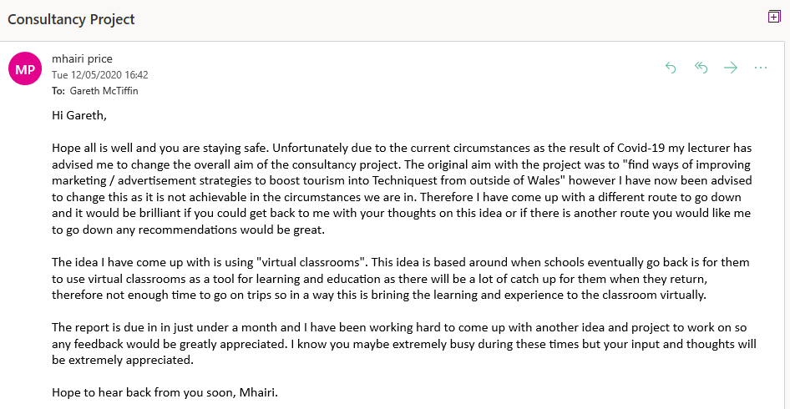
Appendix 1

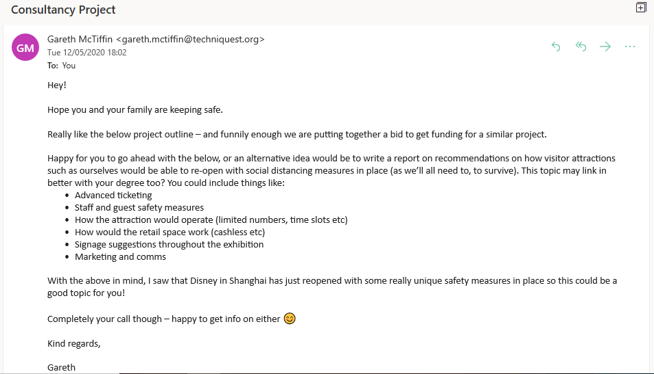
Appendix 2

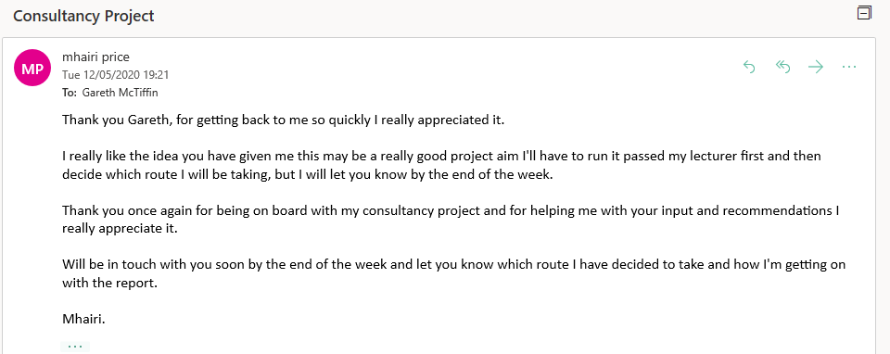
Appenix 3

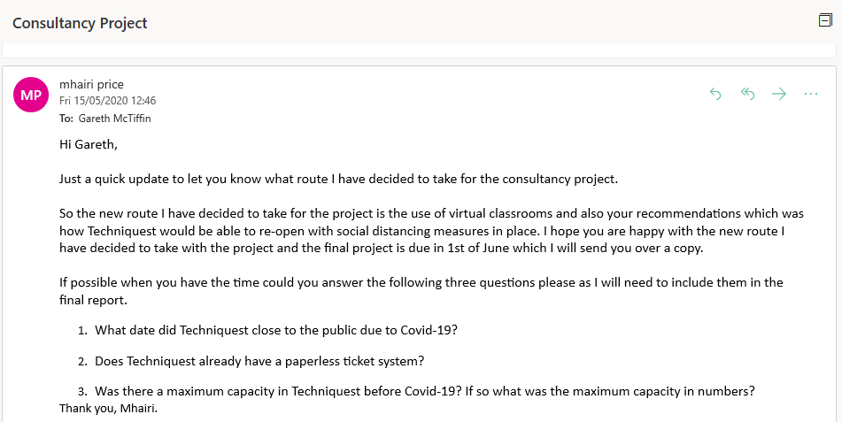
Appendix 4

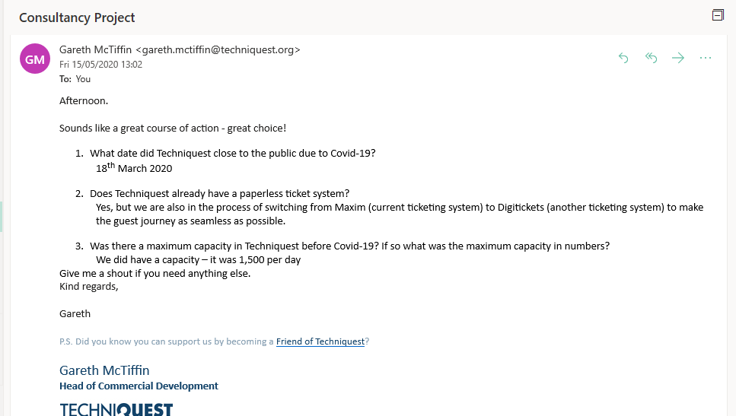
Appendix 5

