19/11/2023
E-Portfolio – How Can Marketing Assist Finance to Achieve Higher Levels of Performance?
[Company name] | [Company address]
[Document subtitle]
Robert Yeo (2000752)

Contents
Task 1 – Formulate a Research Question 1
Background 1
Finance 1
Marketing 1
Aims and Objectives 2
Methodology 2
Task 2 – Primary and Secondary Research Techniques 3
Questionnaire PDF 3
Task 3 – Present Your Ideas 4
Presentation Link 4
Feedback Reflection 4
Task 4 – Data Analysis 5
Poster PDF 5
Poster Screenshot 5
References 6

Task 1 – Formulate a Research Question

Background

Finance
In UWTSD’s financial statements 2021/2022 it says, "The University is operating in a challenging economic environment which it is pro-actively managing” (UWTSD, 2022) p.28. This challenge will require UWTSD to make a financial plan for its long-term success.
When it comes to organisations making long term plans, financial decisions are always central to whether it is successful or not. UWTSD is no exception as it too, like any organisation, requires financial planning when offering the best support for its students. The university generates 51% of its income from student tuition fees and education contracts in the year 2021/2022 according to the Annual Report and Consolidated Financial Statement for UWTSD (2022), if the university wants to improve its profitability, it makes sense to focus on affordably growing the biggest income component, student fees and education contracts. Hence the financial research question is: “Are there low-cost improvements we could make to student recruitment and retention that could grow revenue and profitability?”.

Marketing
Marketing can work with finance to drive up the organisation's revenue streams while reducing its costs (Kotler, 2018). Finance and Marketing must work closely together to be successful in long term planning for an organisation. Therefore, identifying where marketing can focus its resources best could lead to an improvement in operations for UWTSD (Gallo, 2023).
Based on UWTSD’s financial statements (2022), the university has advised that, “maintaining and being pro-active in the recruitment and retention of students” was essential for financial success (UWTSD, 2022) p.28. This means that the marketing department needs to focus on both recruitment and retention.
Recruitment involves three main drivers that students seek: the course, the university, and the location. Courses offer various value factors such as employability, qualification, entry criteria and links with professional bodies and exemptions in their exams, for example the Association of Chartered Certified Accountants (ACCA). The university is dependent on branding and offers value through ranking, quality of teaching, inclusivity, and history. As for location, students find that certain things matter such as distance from home, a nice environment, accommodation, social life, and cost of living. Revenue could be boosted if UWTSD could discover important recruitment factors valued by students and if any of these factors were also under-sold by the university in their marketing. If the marketing of recruitment drivers could be improved for low cost, such as enhancing their positioning on the UWTSD website, more students could be attracted with more revenue and hence profitability could be improved.
Therefore, the marketing research question for boosting recruitment is: “What are the most important factors students look at in the course, university and location when deciding what and where they study, and are any of these factors at UWTSD under-sold and could be easily improved on the UWTSD website?”
Reducing student drop out rates (attrition) will significantly improve profitability if the most important driver of attrition can be identified and fixed for low cost. According to WHAT UNI? (2023), the Business Management with Placement Year BA (Hons)course at UWTSD had a drop out rate of 42%. This drop out rate is a cause for concern since the university is missing out on a large amount of the total tuition fee lifetime value over a student’s undergraduate course if they drop out early.
Consequently, the marketing research question for reducing student attrition is: “What are the most important factors that could drive students to drop out of UWTSD, and are any students unhappy with any of these factors?”

Aims and Objectives
The aim of this e-portfolio is to identify how marketing and finance can work together and assist the University of Wales Trinity Saint Davids improve its profitability. This has been broken down into three steps. Firstly, the UWTSD financial statements will be researched to identify the university’s financial strategies required to reach its strategic objectives, especially those that drive profitability. Secondly, public data will be researched to identify any factors that are significantly impacting profitability, such as student drop-out rates. Finally, primary research will be conducted with current students to identify low cost, high-impact opportunities in the areas of student recruitment and retention that could boost profitability.

Methodology
Primary research will be required to find out, for UWTSD, why students select it, if they are underselling any valued factors students use in their decision to come to the university, what could cause students to drop out of their course, and if they are unhappy with any of these important “drop out drivers”.
The primary research approach is inductive since it will take its data from the business class of UWTSD as a special case and gain a general understanding of the university’s students (Wheatley, 2022). A quantitative survey will allow for identifying what is important for UWTSD marketing to focus on and if there are any opportunities for improvement. It will serve as a guide for the university as to whether it is using the correct approach when offering services to the students in relation to retention, or if it is underselling itself in some aspect when selling itself to students. A quantitative approach will help display a clear visual guide for users reading it, even for users that are not in the field of finance (Hussey, 2014). It is more precise and can identify opinion segments amongst those who are questioned. Having identified significant opinion segments, UWTSD can focus its marketing resources, especially on the website, to improve student recruitment and retention.
As for data collection, a survey targeted at the students of the year two business degree at UWTSD will be carried out as they are already existing students. Insight into what they thought both before entering the university and currently knowing the university now having been there for two years, could prove to be valuable feedback to researching the marketing student lifecycle for university (Chauncey Crail, 2022). There is an expected sample size of ten to twenty students who it is hoped will respond to the survey.
The secondary research will be mainly focused on the Financial Statements of UWTSD, and other public data sources, such as student surveys (such as What Uni?), that could aid in identifying marketing strengths and weakness for the university. This will aid a good comparison against the primary research when creating a long-term strategic plan for UWTSD.

Task 2 – Primary and Secondary Research Techniques
The primary research will be a questionnaire (see PDF link down below) and will have a combination of one to five star rating questions and multiple choice. It will be comprised of mainly closed questions requiring quantitative answers, although in each section, survey participants can nominate a factor under “other” and rank its importance. This way, the survey will not completely prescriptive. The survey group will be limited to the business students of UWTSD. This is a limitation to the research as the class is a small pool to base the research on. The survey has 2 main sections: recruitment and retention. In the recruitment section, participants will be asked to rank the importance in their decision to come to UWTSD in the areas of course, university and location. They will be then asked if any of the factors were under-sold by UWTSD in their marketing based on what they know now after 1 year of being at the university. The retention section will ask participants what factors could make them drop-out of university in the areas of course, university and accommodation. They then will be asked to rank their current satisfaction with each factor. When ranking the importance or satisfaction of any recruitment or retention factor, a star rating of 1 to 5 will be used with 1 being lowest and 5 being highest. Meanwhile a multiple-choice aspect will be used for when nominating any recruitment undersold factors or any retention factors that could cause them the leave UWTSD.
The survey will be held online using Microsoft Forms due to its compatibility with the other Microsoft 365 applications. When the data has been collected, it will be analysed using Microsoft Excel. Graphs will identify key recruitment opportunities and retention threats that UWTSD marketing could help address.
Secondary research will be done using online resources like the UWTSD online library, Google scholar and various news sources online. The key secondary research that this portfolio centres around is the financial statements for UWTSD since they define the long-term financial strategy for UWTSD. Students survey data will be also used as a source of secondary research if it could give insight into what issues to address in student recruitment of retention. This included things such as student dropout rates or even how Swansea ranks in the UK student cost of living index.

Questionnaire PDF

Task 3 – Present Your Ideas

Presentation Link
https://clipchamp.com/watch/JAtBYQjKEMf

Feedback Reflection
After showing my peers my video presentation, they said, “great use of imagery and great analysis of the primary and secondary data collected”. I felt very pleased about this as I placed a lot of emphasis on my data collection. I also felt far more confident when presenting my video presentations compared to previously due to the practice of doing it in year 1 of my degree.
Although I have received feedback saying that “maybe use a more eye-catching background for the PowerPoint” and “my slides could be more clear in displaying the data”. I could improve on trying to simplify the data displayed as it is quite complicated. I felt restricted with the limited amount of time that I received with my PowerPoint as I could have explained the graphs in greater detail for the listeners. I could have also increased the font size of some of the text to make it more readable for users being presented to. As for next time I could also choose a different slide format to make it look more visually interesting although I did not want to overwhelm the people being presented to.
Another part that I felt limited on was the pool size of my survey, as only nine students ended up answering it. I believe this does not necessarily give an accurate correlation to that what students feel.

Task 4 – Data Analysis

Poster PDF
PDF of post is accessible down below.

Poster Screenshot
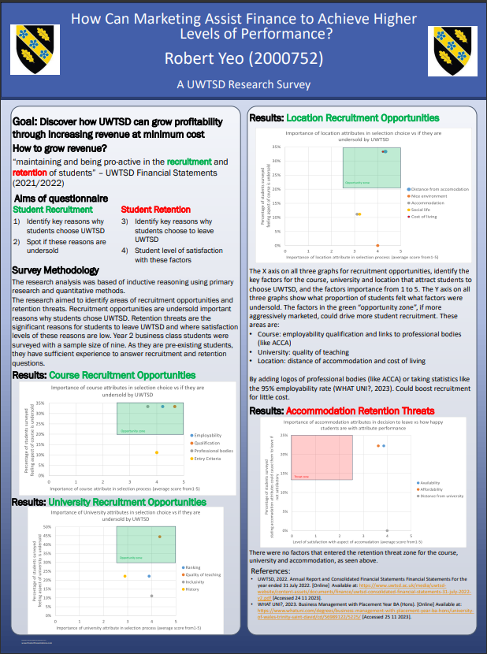

References
Chauncey Crail, K. M., 2022. Customer Lifecycle Management (CLM): The Ultimate Guide. [Online]
Available at: https://www.forbes.com/advisor/business/customer-lifecycle-management/
[Accessed 07 12 2023].
Emma Bell, A. B. B. H., 2019. Business research methods. 5th ed. Oxford: Oxford University Press.
Gallo, A., 2023. A Refresher on Marketing ROI. [Online]
Available at: https://hbr.org/2017/07/a-refresher-on-marketing-roi
Hussey, J. C. &. R., 2014. Business research : a practical guide for undergraduate & postgraduate students. 4th ed. s.l.:Palgrave Macmillan.
Philip Kotler, G. A., 2018. Principles of marketing. 17th ed. s.l.: Pearson.
UWTSD, 2022. Annual Report and Consolidated Financial Statements Financial Statements For the year ended 31 July 2022. [Online]
Available at: https://www.uwtsd.ac.uk/media/uwtsd-website/content-assets/documents/finance/uwtsd-consolidated-financial-statements-31-july-2022-v2.pdf
[Accessed 24 11 2023].
WHAT UNI?, 2023. Business Management with Placement Year BA (Hons). [Online]
Available at: https://www.whatuni.com/degrees/business-management-with-placement-year-ba-hons/university-of-wales-trinity-saint-david/cd/56989122/5225/
[Accessed 25 11 2023].
Wheatley, E., 2022. Part 1: Inductive, deductive & abductive logic. [Online]
Available at: https://www.linkedin.com/pulse/part-1-inductive-deductive-abductive-logic-ellen-wheatley
[Accessed 18 12 2023].

