Design and Implementation of a system to solve a specific Health and Wellbeing problem

Table of Contents
Introduction 2
Project Background 2
Trop Technologies to Bolster Individuals Health and Wellness 3
Wearable Devices 3
Mobile and Computer App’s 3
Social Accountability 3
Hear Rate Training 3
Online Personal training 4
Implementation of the Prototype 4
The Arduino Hardware Devices 4
Adafruit OLED 128X32 5
Buzzer 6
Maxim Integrated MAX 30102 for heart rate sensor 6
Interfacing the Components 7
Generating Bit Maps for the OLED 8
Conclusion 9
References 10

Introduction
Individuals are increasingly understanding the benefits of having a proper health, whereby such initiatives are usually guided through robust health fitness programs. However, considering the busy nature of individuals coupled with the emerging pressures in today’s daily operation where people are forced to juggle between jobs, and shuttling among different cities, citizens sometimes forget to care for their health wellbeing. To address such a concern, different health applications and Internet of Things (IoT) devices have emerged. Such projects are becoming increasingly important especially in today’s era of the Covid-19 Pandemic requiring observation of protocols laid out by the world health organization (WHO) entailing social distances, sanitizing, and wearing of face masks. Apart from the WHO guideline, an individual’s health and wellness is also becoming increasingly important. Individuals due to their busy nature are known to focus on unhealthy lifestyles, including the consumption of fast foods from restaurants. In most cases, such meals are prepared through questionable processes, and they cooking oil used have excessive cholesterol levels. As a result, people have complained of obesity and other cardiac related complications.
It is from such a rationale that the brief is going to focus on implementing a prototype of a health and wellness system. The implementation is going to be developed with the Arduino open-source hardware device. A code shall be developed to relay and translate the information being read by the device, whereby the results shall be transmitted and displayed with a typical computer system. Therefore, the principal objective of the project is to design a wearable heart rate monitor.
Project Background
Over the last decades, individuals have realized the benefits of maintaining their health and wellness conditions, and the government(s) in collaboration with other stakeholders like the academic community, the health sector, and even the media have carried out sensitization programs to its citizens. Due to the increased sensitizations of the populations, the health and fitness industry is rapidly growing. Considering that majority of the population are living sedentary lives, the same people are seeking proactive lifestyles doe to immense benefits. Currently, it is estimated the entire size of the global fitness sector, is worth an estimated USD 87 billion, which is bigger than most of the developing economies. Currently, globally, there are more than 200,000 health and fitness entities. The US is leading the market, followed by Germany and the United Kingdom, an issue that can be attributed to the increasing sensitization efforts from those countries. There are also cases where individuals hire personal trainer, however, such processes are usually not 100 percent effective, and thus individuals need to seek approaches whereby they can independently monitor their health and wellnesses. Currently, the technology is being applied where the main trend towards the fitness sector, are the trackers and wearables (Stasha, 2022).
However, through the emergence of the Covid-19 situations, the fitness industry registered a significant decline estimated at around 13 percent, whereby the western world was the largest hit. As a result, the sector was significantly affected and most individuals resorted to automated products like the mobile apps and cell phone tracking technologies to monitor their body mass index, and to create reminders regarding their fitness levels. Such technologies are today being considered as the main especially after workers were affected by the pandemic whereby, they are receiving less pay, or even being retrenched by their employers (Chow & Yang, 2020).
Trop Technologies to Bolster Individuals Health and Wellness
There are several top technologies that can be deployed to assist individuals improve their health and wellness, and they include:
Wearable Devices
There is an array of wearable devices that can be used to improve individual’s technologies, and they include clips and bracelets. Individuals only need to wear the device during instances that they want to track their health’s. After activating the devices, the gadgets relay valuable indicators that include issue like sleep patterns and other person’s activity levels (Romine et al., 2020). These bracelets can identify the level of calories that an individual has burned during a certain time of the day, by sending the data to an appropriate app. As a result, an individual can monitor the physically activities that they are engaged with and converts the fit as a normal procedure instead of a chore.
Mobile and Computer App’s
There are several freely available apps that individuals can download, install, and activate. Such apps assist with several activities like restless night to compulsive habits like excessive consumption of snacks. These apps are designed to provide detrimental issues likely to affect a person’s health. During instances when individuals understands where their weaknesses exist, it becomes easier to create a program of activities that can be initiated to help overcome specific challenges (Xie et al., 2018).
Social Accountability
Most of the wellness and fitness applications have integrated dynamic features enabling user to share their progress through social media platforms. There are also several online communities that can be joined to enable individuals share similar goals, receive, and motivations to recognize some of their achievements. There are also some apps that have exported the social media concept to a new level where users get rewarded with some cash for attaining specific milestones, and they are also billed if they fail. As a result, the user’s accountability is increased regarding their diet and exercising arrangements.
Hear Rate Training
Such a procedure is mainly applicable for individuals that are involved with different sporting events. Such trainings are important because they give precise accuracy regarding how hardworking they are, whereby concepts like interval training are effectives. There are a myriad of online training initiatives enabling individuals to meet different targets for events like triathlons and marathons. Such initiatives also set intensity levels to derive the highest experience from their body.
Therefore, its sis recommended that individuals need to invest in proper heart rate monitoring system to ensure that an individual does not underwork or overwork during the training sessions.
Online Personal training
Most of the personal trainers have shifted allegiance to online channels where they send tailored workout contents, while viewing progress via email and other instant messaging technologies. As a result, customer’s benefits from a vast array of professional trainers, instead of focusing on a trainer operating from a local fitness club. Most individuals are also using online trainers because it is flexible since the activity can be initiated at any time of the day. However, for individuals that find it challenging being disciplined, then such trainings are not advisable for their fitness workout program.
Implementation of the Prototype
To begin the project, it is viable to illustrate some of the components that are going to be used during the implementations. The devices include:
Arduino UNO hardware device
Adafruit OLED 128X32 that is going to be used for displaying the heartbeat rates
Buzzer for giving audio signals
Integrated MAX 30102 for heart rate sensor
The Arduino Hardware Devices
The Arduino is an open-source hardware single-board microcontroller that can be tailored to meet varying electronic needs like the creation of robots, thermostats, motion sensors, mobile phones, television systems, and even kitchen appliances like the microwaves and refrigerators. Through the General Public Licenses (The GNU) individuals that purchase the products are freely to modify the microcontroller together with its accompanying software’s (Lapshina et al., 2019). The project was purchased from the company’s official website and shipped to the developer’s physical address.
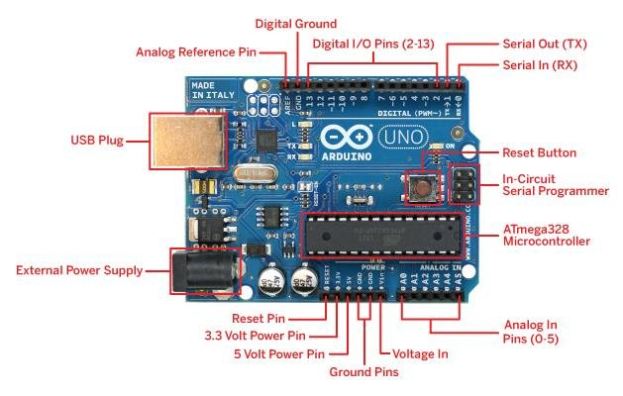
Fig 1.0 Schematic representation of the Arduino Microcontroller
According to the above image, it is evident that the microcontroller is designed with several components and sets of digital and analogue input ports that can be used for expansion purposes or creating interfaces with different expansion boards. Some of the key features are the Universal Serial Boards (USB), and serial communication interfaces. Besides, the board comes with enhanced level of flexibility, whereby it is possible to program the microcontroller using diverse programming languages like C and C++. There is also a command line interface that can be used to initiate several processes (Ardiansa et al., 2020).
Adafruit OLED 128X32
The OLED display device was selected due to its portability comprising of light-weight design that is appropriate for individuals likely to suffer from cardiac related complications. Besides, due to the portability, that is going to be presented through the microcontroller board and the Adafruit OLED 128X32, the final product shall be easy to carry.
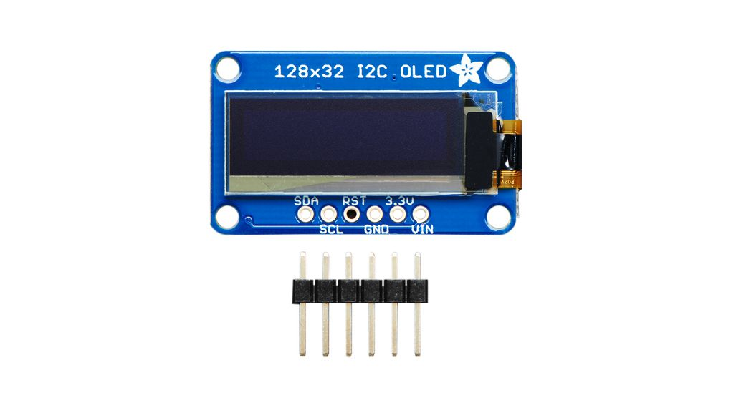
Fig 2.0 schematic representation of the Adafruit OLED 128X32
Buzzer
It is mainly used for giving audio signals, and considering the small nature, the project comes with a low sound that does not create discordance with other individuals who may be using the device.
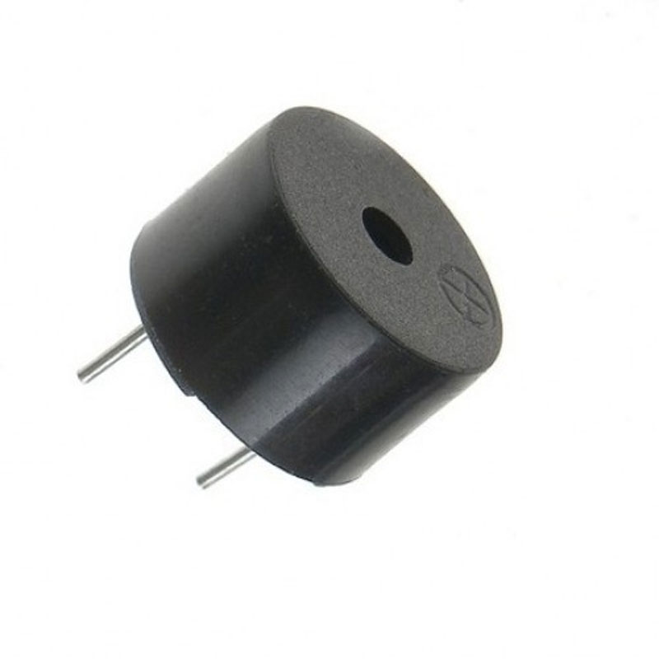
Fig 3.0 the image of the buzzer
Maxim Integrated MAX 30102 for heart rate sensor
The following product is used as an integrated heart-beat biosensor module. Some of the features bundled with the product are the photodetectors, optical elements, and internal LED. Considering the completeness of the solution, the design processes for the wearable is simplified. Besides, it is also low noise hence confirming with various quality standards like the CE, indicating that the device is free to be distributed to any area in Europe because it augers with several safeties, health, and environmental protection requirements, hence bolstering the viability of the project idea (Muller et al., 2019).
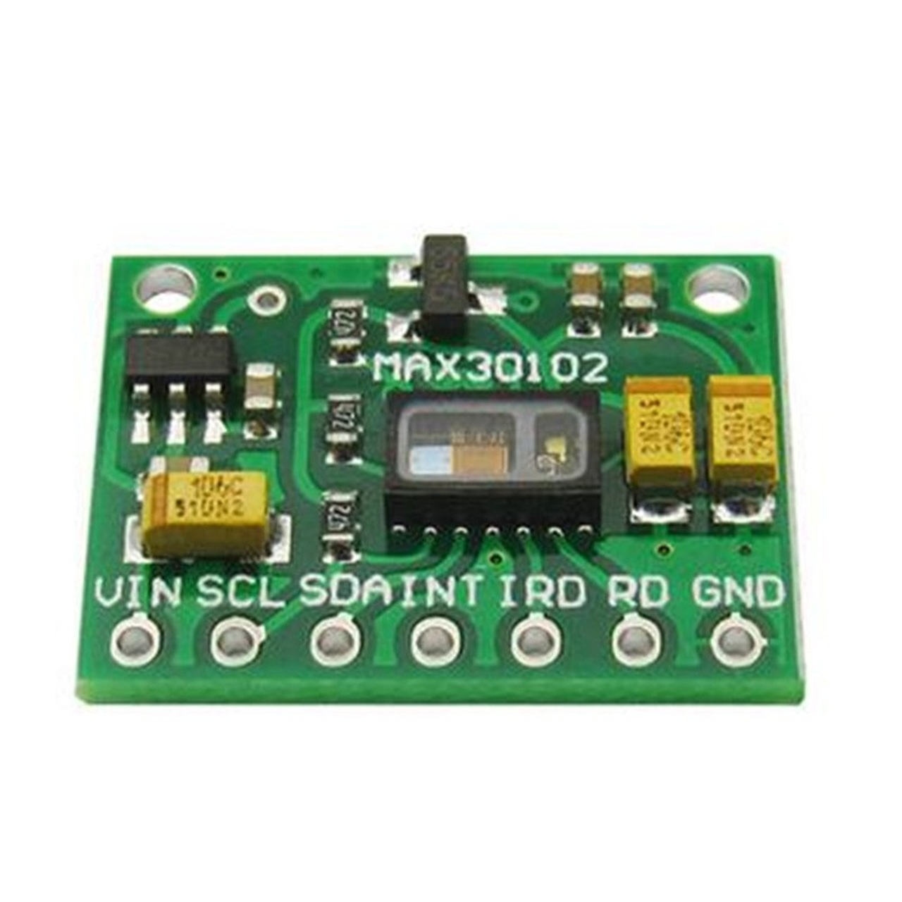
Fig 4.0: Schematic representation of the Maxim Integrated MAX 30102 for heart rate sensor
Interfacing the Components
The first process is to integrate the Max 30102 pulse rate monitor, and the Arduino microcontroller board. The code is going to be designed to synchronize with the OLED and the Buzzer, whereby an individual shall only need to place part of their finger on the sensor in order to read the results. Immediately the finger is placed onto the device, a person will only need to wait for around 15 seconds for the information to be relayed and processed by the microcontroller (Sing et al., 2020).
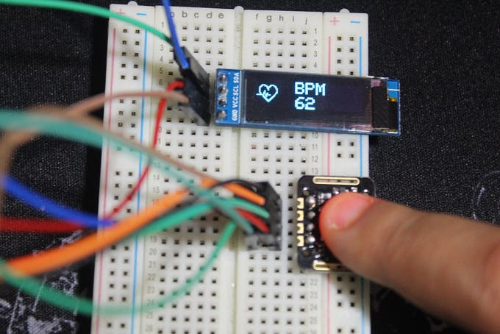
Fig 5.0 the bitmap image indicating the heart rate
Generating Bit Maps for the OLED
During the operations of the sensor, when the sensor detects the heart, there is an indication from the led showing a small heart, and a bigger heart, implying that the system is processing the information, and properly in operation. During such a process there is also some beeping sound from the sensor, implying that the system is in proper operation. Below, there is a sample bitmaps that can be later called in the code (Budig et al., 2021).
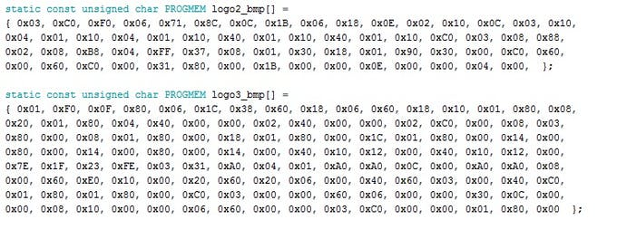
Fig 6.0 screenshots of the Bitmap images codes
The next process is launching the LCD display so that the bitmap images can be processed and converted into a manner that is easily understandable or can be interpreted by human beings. The image is then called into the code, through the following commands
“display.drawBitmap(5, 5, logo2_bmp, 24, 21, WHITE);” whereby the results that are expected include
“display.drawBitmap(Starting x pos, Starting y pos, Bitmap name, Width, Height, Color);”
From the above codes, it can be seen the way the code gets generated when a finger gets
placed at the sensor, and if the system detects the individual’s heartbeat.
Conclusion
According to the above project, it is apparent that devices that can be used to monitor the health and wellness are becoming increasingly important. The health sector is increasingly collaborating with the research community, especially the health sector in developing robust and scalable systems that can be used to improve the medical community. The governments are also playing a critical role towards rebates and recognition of such innovations. Considering the level of investments required, coupled by concepts like economies of scale, such technological breakthrough payoff in a very short period. Another factor improving the rapid development, is the uptake of such projects by the consumer. Therefore, the heart rate system is a viable venture that can be used by individuals to improve on their health wellness initiatives. However, for the system to go to full production, different tests must be initiated to make the product conform to various safety regulations that assist the medical fraternity.

References
Ardiansah, I., Bafdal, N., Suryadi, E., & Bono, A. (2020). Greenhouse monitoring and automation using Arduino: a review on precision farming and internet of things (IoT). International Journal on Advanced Science, Engineering and Information Technology, 10(2), 703-709.
Budig, M., Keiner, M., Stoohs, R., Hoffmeister, M., & Höltke, V. (2021). Heart Rate and Distance Measurement of Two Multisport Activity Trackers and a Cellphone App in Different Sports: A Cross-Sectional Validation and Comparison Field Study. Sensors, 22(1), 180.
Chow, H. W., & Yang, C. C. (2020). Accuracy of optical heart rate sensing technology in wearable fitness trackers for young and older adults: Validation and comparison study. JMIR mHealth and uHealth, 8(4), e14707.
Müller, A. M., Wang, N. X., Yao, J., Tan, C. S., Low, I. C. C., Lim, N., ... & Müller-Riemenschneider, F. (2019). Heart rate measures from wrist-worn activity trackers in a laboratory and free-living setting: Validation study. JMIR mHealth and uHealth, 7(10), e14120.
Romine, W. L., Schroeder, N. L., Graft, J., Yang, F., Sadeghi, R., Zabihimayvan, M., ... & Banerjee, T. (2020). Using machine learning to train a wearable device for measuring students’ cognitive load during problem-solving activities based on electrodermal activity, body temperature, and heart rate: development of a cognitive load tracker for both personal and classroom use. Sensors, 20(17), 4833.
Singh, D., Sandhu, A., Sharma Thakur, A., & Priyank, N. (2020). An overview of IoT hardware development platforms. International Journal on Emerging Technologies, 11(5), 155-163.
Stasha, S. (2022, March 5). Fitness Industry Statistics for 2021: Policy advice. PolicyAdvice. Retrieved May 2, 2022, from https://policyadvice.net/insurance/insights/fitness-industry-statistics/
Xie, J., Wen, D., Liang, L., Jia, Y., Gao, L., & Lei, J. (2018). Evaluating the validity of current mainstream wearable devices in fitness tracking under various physical activities: comparative study. JMIR mHealth and uHealth, 6(4), e9754.

