DISERTATION TITLE: PROJECT EVALUATION AND SUSTAINABILITY CHALLANGES

STUDENT NAME: VASILE SORIN BRICIOC
STUDENT ID: 2030895
MODULE NAME AND CODE: DISSERTATION(LCBB6000)
SUPERVISOR: AMARE DESTA
NAME OF UNIVERSITY: TRINITY SAINT DAVID (LONDON CAMPUS)
ACKNOWLEDGEMENT
I would like to thank my professors and guide for providing me this opportunity for working with research topic. I am highly obliged to them for their immense support and guidance throughout the research completion. Also, I would like to thank my fellow mates for helping me out whenever I faced any issues in this research. Lastly, I would also like to thank my parents and family members to support me for this research work.
ABSTRACT
Overview: The stairlifts has been identified as a crucial tool for the elderly generations. From this research it has been found that the products of Stannah Stairlifts has issues relating to unnecessary beeping noise, issues relating to the remote controller and poor battery health.
Aim
The proposed aim is to develop a comprehensive for evaluating the sustainability of projects, encompassing both short-term and long-term impacts. (Ross, 2019).
Proposed objectives are:
- Identify the key elements of the project sustainability.
- To establish a set of evaluation criteria for assessing the sustainability of projects across different sectors and contexts.
- To develop a toolkit of evaluation methodologies and tools for measuring and monitoring project sustainability.
- To promote the integration of sustainability evaluation into project planning and management Processes.
- To provide guidance on the use of evaluation findings to inform decision-making and improve project outcomes.
Methods: This research has followed axial coding and statistical analysis for data analysis. In addition, the researcher has followed random sampling for a survey and purposive sampling for the interview. On the other hand, the Data Protection Act 2018 and GDPR guidelines have been followed in this research. The researcher has chosen the pragmatism philosophy, deductive approach, and descriptive design which can help in analsing and guiding the project in an effective manner.
Findings and Results: From the primary quantitative results, it has been observed that the majority of the participants have agreed that Life Cycle Assessment Tools or Carbon Footprint Calculator has been used in order to measure and monitor project sustainability. Major participants agreed that Lack of consistency is a major challenge of project sustainability. The primary qualitative analysis also helped in understanding the ways where several sustainable in terms of lack of labour shortage and lack of knowledge challenges faced by project managers have helped in knowing the sustainability issues. Furthermore, the company has used six sigma’s as a methodology for dealing and maintaining with project sustainability.
Discussion: The analysis indicates the identification of key elements such as sustainability, stakeholder satisfaction, and quality of product outcomes are the measures Stannah Stairlifts need to consider for ethical project management. The use of Life Cycle Assessment Tools, Carbon Footprint Calculator, BIM and others can sustain secured business decision making supporting strong control on decision-making for balancing out sustainable goals, financial planning and robust business engagement in stairlift production.
Conclusion: It can be inferred that the project management techniques applied by Stannah has been excellent in achieving high sustainability in business. This is contributing to generate high profit margin and huge market share in the UK. This chapter further proposed that making strategic investment in energy-efficient stairlift can be an effective choice for enhancing sustainability in Stannah. Further, integrating agile project management framework will favoru Stannah in enhancing collaboration at worksite and driving work productivity to next best level.
The research will analyzing their strengths and weaknesses in the context of project evaluation. It will then investigate the challenges of implementing sustainable project evaluation, including stakeholder engagement, data collection, and long-term monitoring.
Through case studies or surveys, the dissertation will explore real-world examples of project evaluation practices with a focus on sustainability. By analyzing successes and failures, the research aims to identify best practices for integrating sustainability into project evaluation.
The ultimate goal is to contribute to a more holistic approach to project management, ensuring that projects not only meet their immediate objectives but also contribute to a sustainable future.
This dissertation examines project evaluation and sustainability challenges faced by Stannah Stairlifts, a leading provider of stairlift solutions. The project evaluation component will assess the effectiveness of Stannah's current project implementation strategies, focusing on areas such as customer satisfaction, cost efficiency, and project timelines. The analysis will identify potential areas for improvement and propose recommendations to optimize project delivery.
The sustainability component will explore the environmental and social sustainability challenges within Stannah's operations. This will involve examining the environmental impact of Stannah's products and manufacturing processes, as well as their social impact on employees and the communities they serve. The dissertation will propose strategies for Stannah to enhance its sustainability practices and contribute to a more environmentally and socially responsible business model.
By combining project evaluation and sustainability analysis, this dissertation aims to provide Stannah Stairlifts with valuable insights to improve project delivery, minimize environmental impact, and maximize social responsibility. This will ultimately contribute to Stannah's long-term success and ensure its continued leadership in the stairlift industry.

Table of Contents
Chapter 1: Introduction 12
1.1 Introduction 12
1.2 Purpose of the research 12
1.3 Research Aim and Objectives 13
1.4 Research Rationale 14
1.5 Problem Statement 15
1.6 Research Significance 15
1.7 Research Structure 16
Chapter 2: Literature Review 17
Introduction 17
2.1 Theme 1: Social responsibility, environmental efficiency and compliance are some of the key elements of the project sustainability 17
2.2 Theme 2: Sustainability assessment, logic model and data collecting methods are some of the methodologies for assessing the sustainability of projects across different sectors 18
2.3 Theme 3: Best practices for integrating sustainability evaluation toolkit into project management for measuring and monitoring project sustainability 19
2.4 Theme 4: Contemporary ways to promote the integration of sustainability evaluation into project planning and management processes by communicating with stakeholders. 21
2.5 Theme 5: Current challenges and opportunities associated with conducting sustainability evaluations in different contexts 22
Theoretical Underpinnings 24
Conceptual framework 27
Literature Gap 28
Summary 28
Chapter 3: Research Methods and Methodology 29
3.1 Introduction 29
3.2 Research Onion 29
3.3 Research Philosophy 29
3.4 Research Design 30
3.5 Research Approach 30
3.6 Research Strategy 31
3.7 Data Collection Methods 31
3.8 Data Analysis 31
3.9 Data Sampling 32
3.10 Validity and Reliability 32
3.11 Ethical Considerations 32
3.12 Research Limitation 33
3.13 Research Timeline 33
3.14 Summary 34
Chapter 4: Findings and Results 34
4.1 Introduction 34
4.2 Primary Quantitative Analysis (Survey) 34
4.3 Primary Qualitative Analysis (Axial Coding) 45
4.4 Conclusion 51
Chapter 5: Discussion 52
Chapter 6: Conclusion and Recommendation 56
6.1 Conclusion 56
6.2 Linking with objectives 56
6.3 Recommendations 58
6.4 Research Limitations 59
6.5 Future Scope 59
References 60
Bibliography 65
Appendices 66
Appendix 1: Survey Questionnaire 66
Appendix 2: Interview Transcript 69

LIST OF FIGURES
Figure 1.1: Revenue in the disability tool market 12
Figure 1.2: Research Structure 16
Figure 2.1: Sustainable project management framework 19
Figure 2.2: Development of QFD Approach for Stakeholder Engagement 21
Figure 2.3: Factors of Sustainable Human Resource Management 22
Figure 2.4: Goal-Based Evaluation 24
Figure 2.5: Logical Framework Approach 25
Figure 2.6: Conceptual Framework 26
Figure 3.1: Research Onion 28
Figure 3.2: Research Timeline 32
Figure 4.2.1 Response to Question 1 33
Figure 4.2.2: Response to Question 2 34
Figure 4.2.3: Response to Question 3 35
Figure 4.2.4: Response to Question 4 36
Figure 4.2.5: Response to Question 5 37
Figure 4.2.6: Response to Question 6 38
Figure 4.2.7: Response to Question 7 39
Figure 4.2.8: Response to Question 8 40
Figure 4.2.9: Response to Question 9 41
Figure 4.2.10: Response to Question 10 42
Figure 4.1 Axial Coding Diagram 43

LIST OF TABLES
Table 4.1: Axial Coding Theme 1………………………………………………………………...45
Table 4.2: Axial Coding theme 2 46
Table 4.3: Axial Coding theme 3…………………………………………………………………47
Table 4.4; Axial Coding Theme 4………………………………………………………………..49

Chapter 1: Introduction

1.1 Introduction
Stairlifts are an important tool for the elderly generations and this is crucial for people suffering from knee injuries. In this context, it has been observed that Stannah sells passenger lifts, platform lifts, goods and service lifts and nearly 92,000 products of the company have been installed in the UK (Stannahlifts, 2024). This study is based on the analysing the challenges and opportunities covered by the sustainability approaches of the organisation named as Stannah. Concerning the rising demand of the stairlift it has been focused that consumer demand and the new market opportunity for the stairlift is increasing in the recent days. On the other hand, involvement of the crucial project methodology and the sustainable strategy for enhancing this initiative will be discussed in this study. This chapter will consist of the purpose of the research including the aim and objectives of the research. At the same time, this chapter will reflect on the current issues related to the Stannah lifts.

1.2 Purpose of the research
The primary purpose of the research is to shed light on the importance of Stannah Stairlifts and at the same time this research will shed light on the issues related to the products. For instance, issues relating to the products (Stannah, 2024a). In addition, instances of issues relating to the remote controller and poor battery health of the product have been identified as an issue for the organisation Stannah stairlifts.
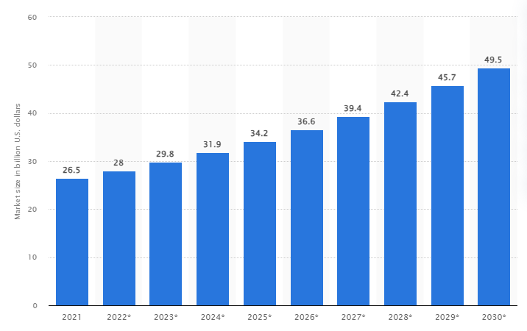

Figure 1.1: Revenue in the disability tool market
(Source: Statista, 2022)
However, the rise in the revenue of the disability tools market has been observed and it is expected to reach 49.5 Billion USD by 2030 (Statista, 2022). However, huge instances of accidents are observed relating to stair-related incidents. For instance, nearly 500 deaths per year and an estimated 250,000 non-fatal accidents occur every year relating to stair-related incidents (Sykesstairlifts, 2021). Thus, the organisation needs to ensure sustainability or high-quality products to ensure effective functioning. This will help in developing the revenue of the organisation.

1.3 Research Aim and Objectives
Aim
To solve specific problem.
To exploit an opportunity.
Respond to a pressure or demand.
To gain competitive advantage. (Ross, 2019).
Proposed objectives are:
- Identify the key elements of the project sustainability.
- To establish a set of evaluation criteria for assessing the sustainability of projects across different sectors and contexts.
- To develop a toolkit of evaluation methodologies and tools for measuring and monitoring project sustainability.
- To promote the integration of sustainability evaluation into project planning and management Processes.
- To provide guidance on the use of evaluation findings to inform decision-making and improve project outcomes.

1.4 Research Rationale
In today’s globalised era, it is the sustainability issues in the project which has become a challenge for the project managers to guide the projects with sustainability strategies and measures. Project sustainability is important to help the project reach success and help the customers become loyal partners.
It can be understood that carpenters, joiners, tool setters, and operators, building electricians also witnessed labour shortages in 2022 (Statista, 2024). There a huge skill gaps which hinder project sustainability in a significant manner. It can be understood that the inability to access skilled professionals with the proper knowledge and experience in emerging technologies (Forbes, 2023). Therefore, this leaves a higher gap in the proper knowledge and experience which can help in dealing with the gaps between their employees aiding in building competitive advantage. In this case, it can be understood that without such skills and knowledge, project sustainability could not be achieved and this can also lead to customer experience issues. Hence, it can be understood that project sustainability can help in overcoming the project sustainability issues.

1.5 Problem Statement
The problem statement of the company lies in the company background where project sustainability has been a huge issue impacting the performance and operations of the company. However, in the case of the Stannah Stairlifts company, it can be understood that the common faults in the company hindering its sustainability are beeping, the usual noise, and the company’s battery also does not last long which again acts as a drawback for the not supporting sustainability (Stannah, 2024a). However, regular servicing by Stannah engineer will also ensure batteries are well checked by the engineers.

1.6 Research Significance
The research focuses on the sustainable practices that will help in developing the quality of products for stairlifts and at the same time this research will shed light on the issues associated with the products related to Stannah Stairlifts. Thus, this research will help the organisation in developing the condition of the products and controlling the issues associated with the products. This will help in improving the quality of the product for improving the satisfaction levels of the customers. This will help in improving the revenue of the organisation. On the other hand, this research will reflect on the issues faced by the stairlifts and the opportunities that can help in developing the current issues. Thus, this will help in avoiding the accidents of individuals. This will benefit society by creating awareness regarding accidents.

1.7 Research Structure
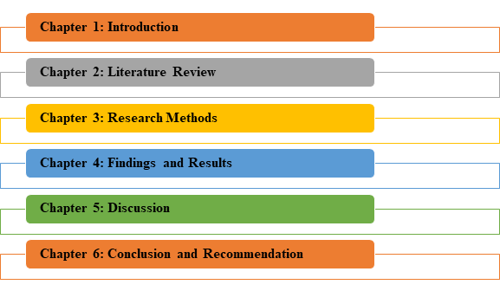

Figure 1.2: Research Structure
(Source: Self-Developed)

Chapter 2: Literature Review

Introduction
The chapter will critically cover the importance of sustainability in the process of different sectors alongside covering contemporary ways or tool kits essential for sustainable manufacturing and business practices. After covering the process of communicating with stakeholders and current challenges associated with sustainability practices, theoretical underpinning to draw literature contextuality and literature gap will be identified.

2.1 Theme 1: Social responsibility, environmental efficiency and compliance are some of the key elements of the project sustainability
In the opinion of Severo et al. (2021), Corporate Social Responsibility (CSR) in an approach that alters the perspective of 'what' comprises CSR and 'how' project handle it in practice. In terms of CSR execution, environmentally friendly development research has been especially useful for visualising developmental paths, identifying practical goals, developing metrics, and proclaiming values. This is the new standard of corporate social responsibility. According to ElAlfy et al. (2020), enterprises, which rely on resources from a common pool as systemic components, share responsibilities for contributing to society well-being. In doing so, subsequent generations' requirements are incorporated in corporate culture and business value chains. Furthermore, according to Pham et al. (2020), experts have increasingly focused on the importance of environmentally friendly human resources management techniques, which are viewed as key approaches to inspire employee green connection and behaviour while also promoting organizational environmental success. Green performance management is not often seen as an important instrument for increasing staff environmental dedication and organizational civic behaviour toward the environment, in addition to directly driving organizational environmental performance. Some published research shows that this technique has a considerable impact on environmentally conscious behaviour and an organization's environmental performance. According to Martins et al. (2019), in the larger context of sustainability, knowledge management (KM) is viewed as a novel model of development aimed at improving compliance with social, ecological, and economic sustainability requirements. Pursuant to the project's fresh demands on the needs of meeting the sustainability rules, each sustainable effort becomes extremely important, as it has the potential to generate long-term changes among those engaged and includes a variety of interested parties with diverse demands. In the opinion of Huq and Stevenson (2020), it is well recognized that suppliers' general disposition toward compliance is a significant element, which may be seen in the extent of the procedures used. Hence, from the above discussion, it can be said that, social responsibility, environmental efficiency and compliance are some of the key elements of the project sustainability.

2.2 Theme 2: Sustainability assessment, logic model and data collecting methods are some of the methodologies for assessing the sustainability of projects across different sectors
In the opinion of Wulf et al. (2019), sustainability assessment (SA) is a sophisticated approach for assessing a project's long-term economic, social, and environmental effect. SA may assist decision-makers and policymakers in determining the steps to take to improve society's sustainability. On the other hand, according to the views of Smith et al. (2020), a logic model is an illustration that depicts the logical link between the project's the inputs, actions, outputs, results, and affects. It aids in clarifying project assumptions, identifying anticipated outcomes, and planning the assessment process. A logic model can also help partners and investors understand the project's rationale and value offer. Additionally, as per the views of Kissi et al. (2019), data collecting methods are procedures used for gathering data pertaining to the project's success and effect. They might be quantitative or qualitative, primary or secondary, and derived from observations, surveys, interviews, focus groups, records, or other sources. Your assessment inquiries, metrics, assets, and ethical issues all influence the techniques you use to gather data. Some best practices for data gathering include using numerous sources and methodologies to combine and evaluate data, involving participants and beneficiaries in the procedure, and ensuring the data's dependability, validity, and trustworthiness. Hence, it can be said that, sustainability assessment, logic model and data collecting methods for assessing the sustainability of projects across different sectors.

2.3 Theme 3: Best practices for integrating sustainability evaluation toolkit into project management for measuring and monitoring project sustainability
The sustainability of a project can be measured through various kinds of evaluation practices and approaches such as a toolkit of evaluation methodologies. As per the reviews of Padilla et al. (2021), A toolkit of evaluation methodologies can be explained as a tool which would help to better understand the phases and steps which are required in order to conduct a robust evaluation. In addition to this, a toolkit of evaluation methodologies covers the conceptualisation of the approach and evaluation which is required to be used for understanding the extent of the change. Moreover, the study of Kerzner et al. (2022) has suggested that metrics and dashboards also have been used across project management in order to measure and monitor sustainability. As argued by the views of Campos-Guzmán et al. (2019), Life Cycle Assessment Tools have been widely used along with renewable energy technologies for measuring and monitoring sustainability within the projects.
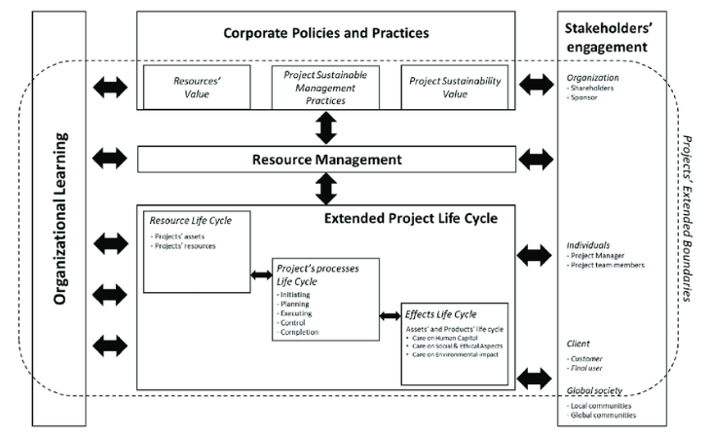

Figure 2.1: Sustainable project management framework
(Source: Armenia et al. 2019)
On the other hand, as per the ideas of Henderson et al. (2020), the project managers focus on real-time consumption of energy and generate sustainability reports with the use of energy efficiency tools and carbon footprint tools in order to reduce the emissions of Carbon footprint. As a result, a toolkit of evaluation methodologies and tools also has been playing a huge role in monitoring and enhancing the sustainability of projects. Furthermore, the ideas of Campos-Guzmán et al. (2019), multi-criteria decision-making are applied across the construction industry in their projects for complex problems typically with trade-offs and also assess sustainability within the supply chain management of the projects. Henceforth, metrics and dashboards, Life Cycle Assessment Tools, energy efficiency tools carbon footprint tools and multi-criteria decision-making techniques are some of the best practices for integrating evaluation methodologies and tools in the toolkit for measuring and monitoring project sustainability in projects.

2.4 Theme 4: Contemporary ways to promote the integration of sustainability evaluation into project planning and management processes by communicating with stakeholders.
As per Tiwari et al. (2023), sustainability refers to the significant value added by any business industry by making an uninterrupted communication process with important stakeholders such as customers, employee’s suppliers and others. In this context, Stanitsas et al. (2021) have stated that sustainable project management in the business industry can be integrated by forming a Triple Bottom Line approach (TBL) considering environmental, economic and social value creation along with the effective stakeholder involvement and management process. On the other hand, Larsson and Larsson (2020) have stated that in business project management digital communication and process management development is one the effective ways to integrate sustainability in terms of creating continuous stakeholder engagement, quality service provision and others. For better insight, Pan and Zhang (2021) have stated that IoT applications, integration of building information modelling techniques (BIM), and 4D data visualisation processes all are widely used technologies in the project planning and management process. Using IoT applications online communication can be generated among customers, and investors while using 4D visualisation customers or employees can see the project outcome from before and suggest changes which reduces the chance of error formation as a whole. Thus, it can be understood that digitalised processes and communication strategies are highly used in sustainable business management.
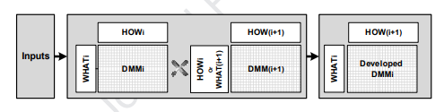

Figure 2.2: Development of QFD Approach for Stakeholder Engagement
(Source: Bahadorestani et al. 2020)
Furthermore, Lauff et al. (2020) have stated that the prototype enactment is a communication tool to connect stakeholders. In this research, it has been described that though prototypes are complex and dynamic artefacts, however, it becomes encoded with information that can be easily translated, decoded and re-encoded by stakeholder groups. In this way, fast and flexible information sharing among employees and customers or investors can be possible. Apart from this, Bahadorestani et al. (2020) have discussed that value-based management and matrix-based dependency modelling, Quality Function Deployment (QFD) approach help to develop stakeholder engagement plans in business planning or decision-making processes. It is seen that the application of these models helps to facilitate successful stakeholder engagement in project management and accelerates sustainable goal-reaching aspects.

2.5 Theme 5: Current challenges and opportunities associated with conducting sustainability evaluations in different contexts
Industry 4.0 impacted the sustainable manufacturing process by positively integrating societal and environmental value creation, easy availability of resources and others. In this context, Enyoghasi and Badurdeen (2021) have stated that using sustainable project evaluation, a positive product generation process, employee management or any decision-making system of any organisation. On the other hand, Mousa and Othman (2020) have discussed a different aspect of sustainable management in terms of the green human resource development process. From this research, it has been identified that sustainable human resources management such as flexible work culture, remote working process work from home or many other strategies increases motivation among employees. The research of Davidescu et al. (2020) have shown that 48% of employees consider remote working to be a sustainable process as they get more work-life balance.
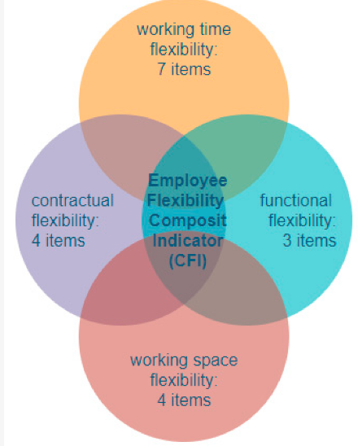

Figure 2.3: Factors of Sustainable Human Resource Management
(Source: Davidescu et al. 2020)
However, sustainable approach development also involves some potential challenges as well. Stanitsas et al. (2021) have stated that obscurities and inconsistencies are two major challenges that have been added through sustainability approaches. On the other hand, Toljaga-Nikolić et al. (2020) have stated that lack of resources, weak engagement and lack of communication between stakeholders are two significant challenges of sustainable project evaluation. Thus, it can be stated that sustainable project evaluation involves both long-term opportunities and challenges as a whole.

Theoretical Underpinnings
Goal Based Evaluation
Goal-based evaluation theory specifically addresses programme goals and objectives that can help an organisation to draw successful processes and discard unusual ones. As opined by Creemers et al. (2022), measures associated with goal-based evaluation can help tasks and procedures match with organisational requirements alongside measuring outcomes to ensure project efficacy. It is also argued by Silver et al. (2021), that goal-based evaluation specifically directs an organisation to set realistic goals. Thereby, progress or accomplishment of tasks can be tracked by meeting employee goals and job satisfaction in a systematic way.
The research has focused on the identification of the key elements of project planning and management processes to harness sustainability. In this case, integration and evaluation of findings to ascertain informed decision-making and improve project management outcomes can be addressed if an organisation sets clear goals. Clarity in goal setting can strategically enhance the decision-making process of an organisation along-side promote holistic transparency in stakeholder management. Therefore, operational and financial performance improvement, competitive advantage and strengthening stakeholder relations can be ensured by a business firm.
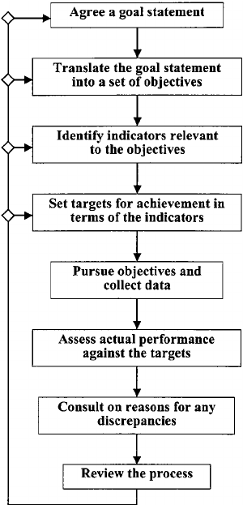

Figure 2.4: Goal-Based Evaluation
(Source: Refer to Bibliography 1)
Logical Framework Approach
The Logical framework approach (LFA) can be defined as a systematic process majorly used to consider project planning and management for changes. The framework covers designing, evaluating and monitoring the international project development as part of the project management methodology [Refer to Bibliography 2]. The key elements associated with project planning as per the logical framework approach cover the project’s hierarchy of objectives and project development pathway or intervention logic. LFA can strategically cover the purpose, goal, inputs and outputs of projects including holistic intervention, classification and structuring of ideas, and presentation of projects in standardised ways and others [Refer to Bibliography 3]. Therefore the frame covering project aspects can stipulate causes behind the actions taking place in a holistic project management practice.
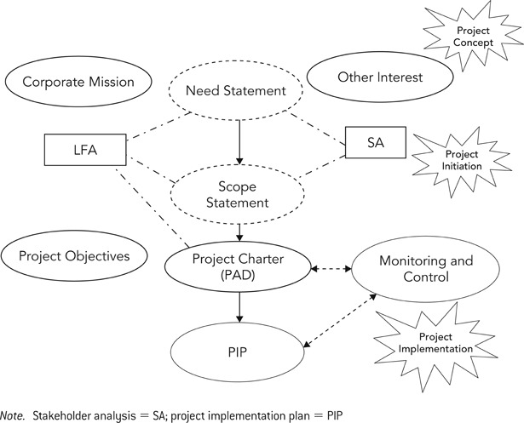

Figure 2.5: Logical Framework Approach
(Source: Refer to Bibliography)
Sustainable actions and project goals such as reduction of emissions, recycling, or addressing social needs alongside business inclusion are becoming essential to modern business. The research intends to address sustainable measures to enlist holistic ground for business improvement. Therefore innovative and informative stance to grow market share becomes possible if the stages are clarified related to sustainable practices. The project hierarchy of objectives, project development pathway or intervention logic, indicators, assumptions and risks must be clarified to ensure progressive ground for drawing sustainable measures. As indicated in the theory aligning these parameters can strategically reduce project lifecycle thereby quick results can be ascertained.

Conceptual framework
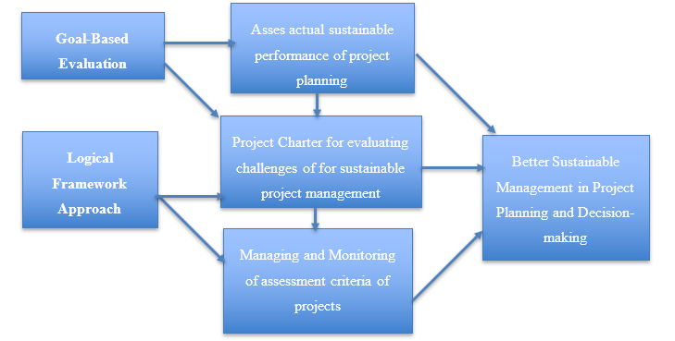

Figure 2.6: Conceptual Framework
(Source: Created by Learner)

Literature Gap
While conducting the literature review, it was observed that there is a lack of focus on empirical studies regarding the toolkit of evaluation methodologies and tools for measuring and monitoring the sustainability of the project Besides that, the existing studies also have been limited to theoretical perspectives and conceptualisation of the challenges which are associated with the sustainability of a project. In addition to this, the existing sources of knowledge also have been limited to scientific and empirical investigations and examinations. On the other hand, methodological gaps also have been observed from past studies such as measurement errors, biased selection of methodological choices and ineffective use of analysis tools.

Summary
Social responsibility, environmental efficiency and compliance have been playing a key role in ensuring the sustainability of the project. Sustainability project evaluations also consist of various kinds of challenges such as lack of resources, and lack of communication between stakeholders, whereas, opportunities for a sustainable project also include remote working. Besides that, metrics and dashboards, energy efficiency tools, and multi-criteria decision-making techniques are some of the best practices for evaluation methodologies and tools for measuring and monitoring project sustainability in projects.

Chapter 3: Research Methods and Methodology

3.1 Introduction
Research methodology can be understood as the ways in which suitable methods and methodologies can be chosen in order to conduct the study in an effective manner. In this regard, the researcher will select suitable research techniques which can help in guiding the study and achieving a robust conclusion.

3.2 Research Onion
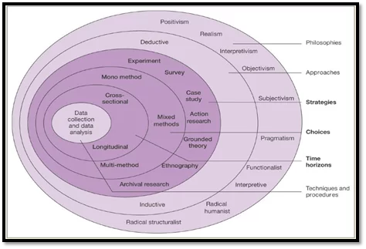

Figure 3.1: Research Onion
(Source: Saunders et al. 2007)

3.3 Research Philosophy
Research philosophy can be understood as the belief about the ways researchers gather data, interpret, and analyse them to achieve in-depth insights (Khatri, 2020). It can be understood that there are different types of philosophies such as realism, pragmatism, interpretivism, positivism, and pragmatism. It can be stated that the researcher has applied the pragmatism strategy to the research study where the researcher has been able to generalise the data yet has also gathered authentic data from primary sources on Stannah Stairlifts which can also be useful in designing and validating the data. It also helped the researcher in developing a holistic analysis in order to fully incorporate the factors triggering project sustainability into the study. As per Maarouf, (2019), pragmatism theories of truth recognise an important aspect of generalising functions among other useful roles providing a way of describing the goals and purpose of the study.

3.4 Research Design
Research design can be understood as the way to help the researcher complete the objectives of the study at any given time. It also ensures getting the best solutions for the research problems. There are different types of designs such as experimental, descriptive, explanatory, and experimental which can help in understanding the fact that these designs help in designing the research effectively. According to Siedlecki, (2020), descriptive design can help in highlighting the underlying problems of the research in an effective manner. However, the researcher has chosen the descriptive design which can highly help the researcher in identifying problems existing within a population regarding project sustainability.

3.5 Research Approach
The Research approach helps in understanding the plans and procedure for research spanning the steps from broad assumptions to detailed methods of data collection, analysis, and interpretation. It can be analysed that there are three types of approaches such as deductive, inductive, and abductive. However, the researcher has chosen the deductive approach in order to build a causal relationship between the research variables where with strategies, project sustainability can be maintained in an effective manner. The deductive approach has also helped in achieving a robust conclusion meeting the aims and objectives.

3.6 Research Strategy
The research strategy can be understood as a strategy taken by the researcher in order to adopt a particular strategy and guide the study in an effective manner. Research strategies include case studies, surveys, experiments, action research, and others which can help in facilitating the study to achieve research objectives. In this research, the case study strategy has been chosen since this study is based on the case study of Stannah Stairlifts company and majorly based on the importance of project sustainability which can help in understanding the challenges faced by the project sponsors and managers which can help in achieving a robust conclusion.

3.7 Data Collection Methods
The data can be of two types primary and secondary and this can help in understanding the fact that the data is being collected by the primary qualitative and quantitative means where the data has been collected by the survey and interview methods. For the survey, 40 customers were considered and for the interview, 4 managers were considered including two project managers and two project sponsors as the key stakeholders. Both the survey and the interview have helped the researcher to gain knowledge regarding the different challenges and issues faced by them while maintaining project sustainability along with the strategies to overcome them. The survey mode will be online through Google Forms which will be sent to the survey participants. The interview mode will also be conducted online through Zoom video conferencing while the managers will be selected from their LinkedIn profiles and those who will show their consent will be finally selected for the interviews.

3.8 Data Analysis
The data analytics technique can be classified into thematic analysis, axial coding and statistical data analysis techniques (Coker, 2022; Modgil et al. 2022). In this context, axial coding and statistical data analysis have been preferred for this research. In this research axial coding has been preferred for this research as this allowed the researcher to establish presenting the subjective information in the form of codes that help in meeting the research objectives. On the other hand, percentage analysis has been preferred as this helps the researcher in presenting the objective or quantitative information in the form of graphs for easy interpretation.

3.9 Data Sampling
The data sampling techniques include random sampling techniques, purposive sampling techniques and snowball sampling techniques (Mweshi and Sakyi, 2020; Obilor, 2023). In this research, the random sampling technique has been followed for selecting the respondents for the survey. The random sampling technique has been preferred as this allowed the researcher to generate unbiased outcomes from the survey responses from the beneficiaries of Stannah Stairlifts. On the other hand, the purposive sampling technique has been preferred in this research for selecting the participants for the interview. Purposive sampling helps in selecting the managers and sponsors depending on the research questions for collecting relevant answers for the research work.

3.10 Validity and Reliability
In this research, the survey responses have been collected from the employees of Stannah Stairlifts and this has helped in reflecting on the insights of the organisations. On the other hand, it has been seen that the survey has been conducted on over 40 employees of the organisation to ensure more reliability on the actual sustainability issues in the organisation. On the other hand, the Operations manager and Sponsors of the organisation have been interviewed to collect relevant qualitative information. In addition, the researcher has verified the information with adequate secondary information to ensure the validity of the information collected.

3.11 Ethical Considerations
The researcher has complied with the Data Protection Act 2018 to ensure the anonymity of the research participants. On the other hand, the General Data Protection Guidelines (GDPR) have been followed in this research to control the usage and ensure the confidentiality of the information in the research. Written consent has been obtained from the operation manager and Sponsors regarding the use of information in the research topic. In addition, the researcher has decided to delete the collected information after one month from the submission of the research. In addition, the researcher has not used Artificial intelligence or paraphrasing tools in the research work.

3.12 Research Limitation
This research follows primary data collection techniques and thus the process of data collection is time-consuming. Thus, the absence of secondary information is a limitation of the research. On the other hand, the survey has been conducted on 40 employees of Stannah Stairlifts and thus the sample size for the survey is too small to generate unbiased and diverse responses. Similar issues have been observed regarding the issues related to the sample size for the interview. On the other hand, the researcher did not include the managers or sponsors from the competitors which narrowed down the outcomes of the research.

3.13 Research Timeline
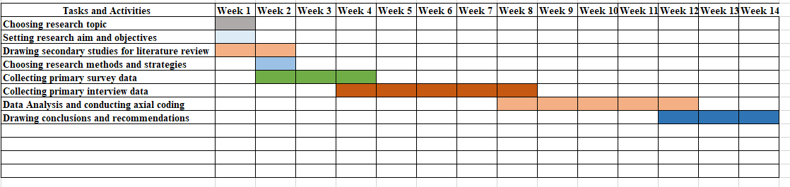

Figure 3.2: Research Timeline
(Source: Self-Developed)

3.14 Summary
The chapter has helped in understanding the importance of the research topic which helped in choosing the right and suitable methodologies such as pragmatism philosophy, deductive reasoning, and descriptive design. However, the research can help in guiding the ways in which the research aims and objectives could be achieved significantly.

Chapter 4: Findings and Results

4.1 Introduction
The chapter will shed light on the results and findings of the research for reflecting on effective project evaluation and sustainability challenges. The chapter will conduct a primary qualitative as well as quantitative analysis. The chapter will conduct interviews for qualitative analysis whereas it will use Survey analysis for the quantitative analysis within the study. The use of mixed methods in this chapter will contribute to providing subsequent insights on the research topic and will reflect on ways in which objectives will be met in the study. The chapter will also conduct a critical discussion which will lead to an in-depth understanding of different aspects of the research study.

4.2 Primary Quantitative Analysis (Survey)
4.2.1: Survey Question 1
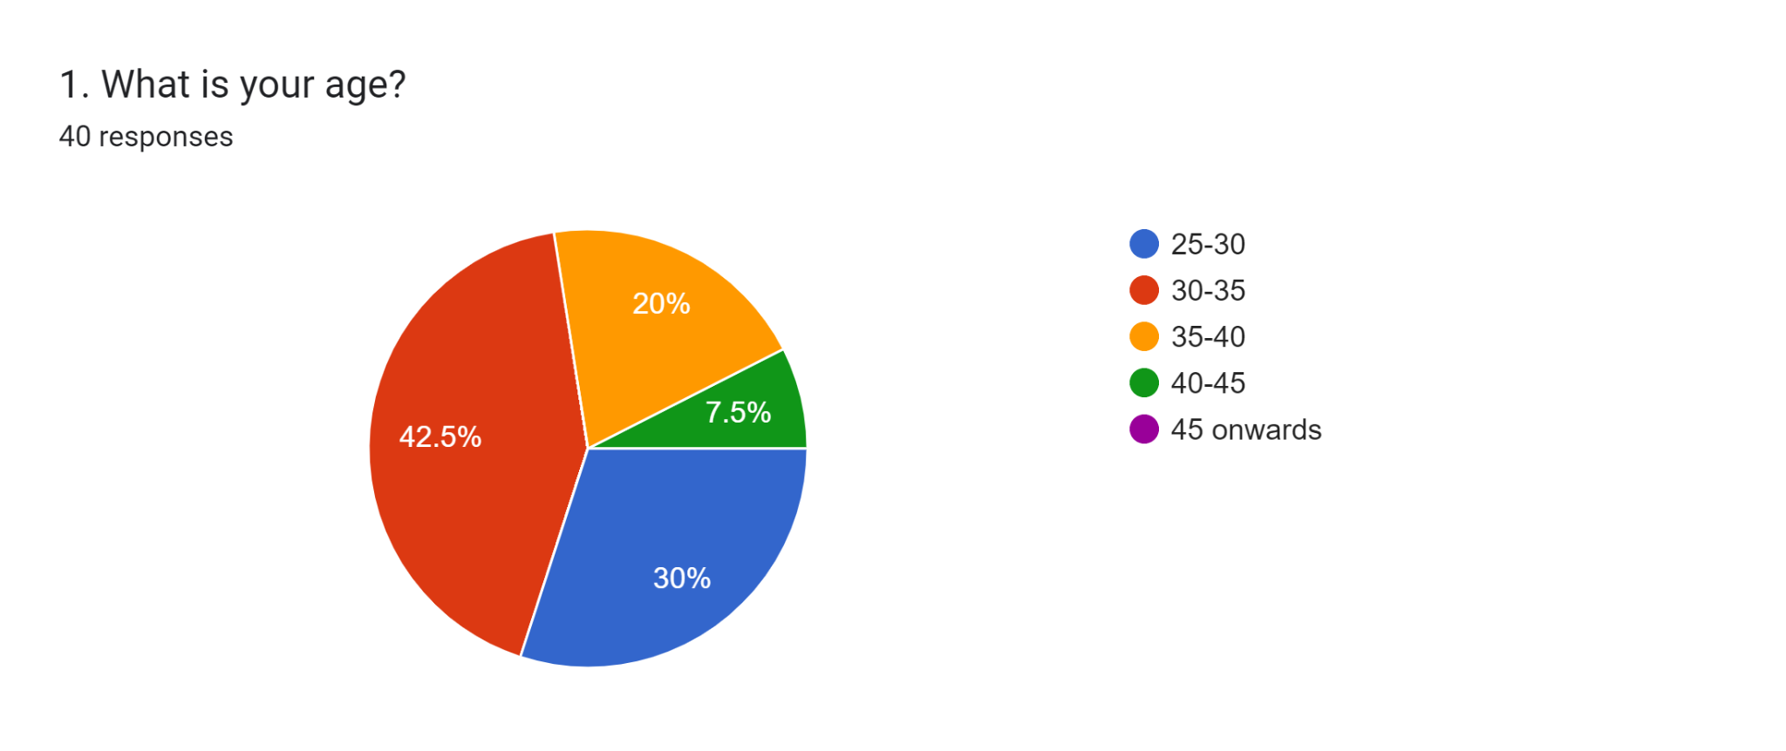

Figure 4.2.1 Response to Question 1
(Source: Created by the learner)
Survey question 1 suggested that this survey has been conducted between 40 employees of Stannah Stairlifts to identify the importance and challenges of sustainability. From the above figure, it has been identified that 42.5% of the employees are aged between 30 to 35 whereas 30% of employees stand between 35 to 40 which suggests that the employee set that is considered a senior employee of the chosen organisation.
4.2.2: Survey Question 2
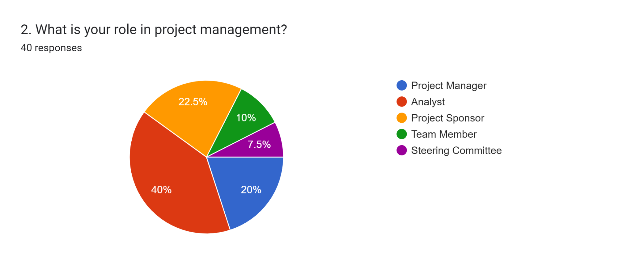

Figure 4.2.2: Response to Question 2
(Source: Created by the learner)
The second question of the survey indicates the role of the respondents. It is seen from the above figure that 40% of the participants are analyst, whereas, 22.5% of the participants are project sponsor. Additionally, 20% of them are project managers and 10% are team members. However, only 7.5% of the participants have the role of steering committee.
4.2.3: Survey Question 3
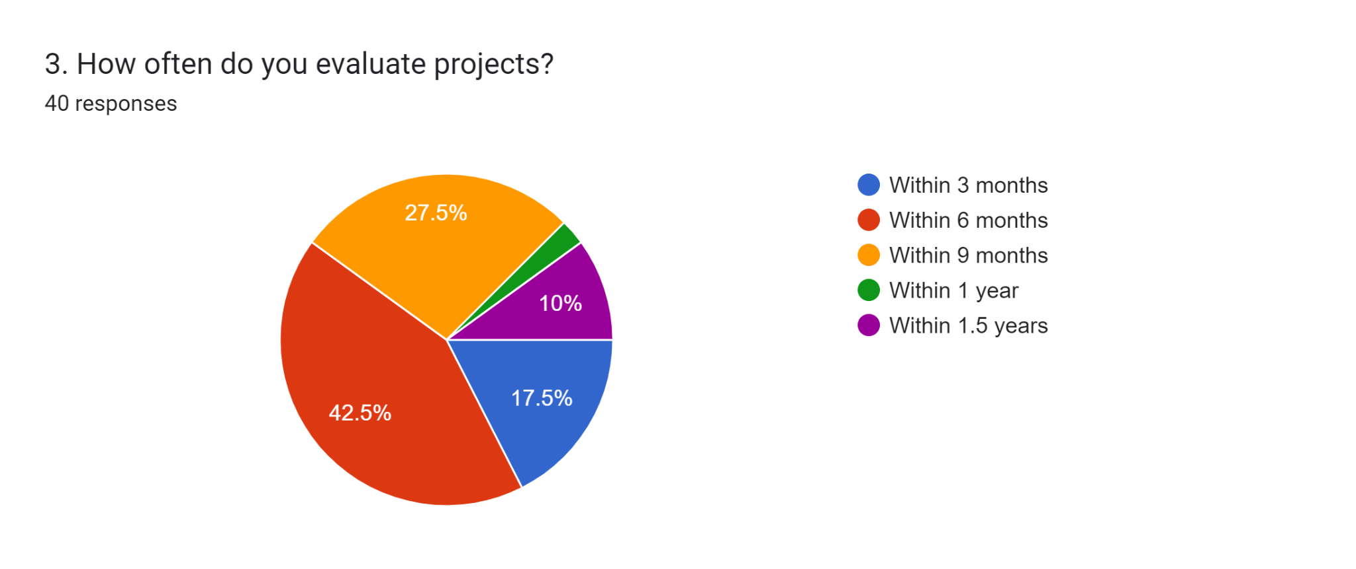

Figure 4.2.3: Response to Question 3
(Source: Created by the learner)
The third question of the survey illustrates the frequency of project evaluations in companies. From the figure above it is seen that 42.5% of the participants said that they usually evaluate projects within 6 months, where 27.5% of the participants said that they evaluate projects within 9 months. On the other hand, 17.5% of the participants mentioned that they evaluate projects within 3 months. It is also observed that, 10% of the participants said that they evaluate projects within 1.5years and only 2.5% of the participants evaluate projects within 1 year. From this, it can be said that, the project evaluation any business is done within a time-span of 3 months to 1.5 years. Therefore, from the responses gathered, it can be said that, the majority of the project evaluation process is done within 6 months in majority organisations.
4.2.4: Survey Question 4
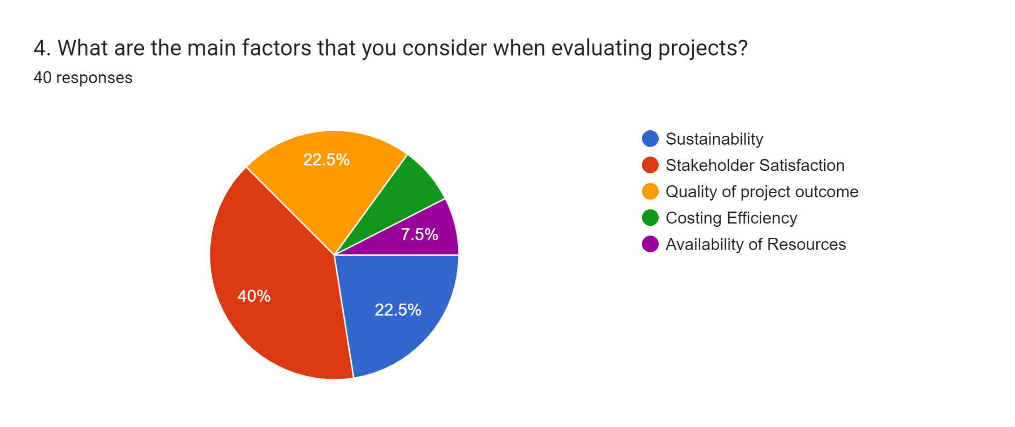

Figure 4.2.4: Response to Question 4
(Source: Created by the learner)
The fourth question of the survey illustrates the main factors that is considered when evaluating projects. From the above figure, it is seen that 40% of the participants has chosen Stakeholder Satisfaction as the main factor when evaluating projects, whereas, 22.5% of the participants has chosen the quality of project outcome. Another 22.5% of the participants have chosen sustainability as the main factor when evaluating projects. On the other hand, 7.5% of the participants has chosen the availability of resources and another identical 7.5% have chosen costing efficiency as the main factor when evaluating projects. From this, it can be said that, the main reason that companies choose to evaluate the projects are mainly in the aim of satisfying stakeholders.
4.2.5: Survey Question 5
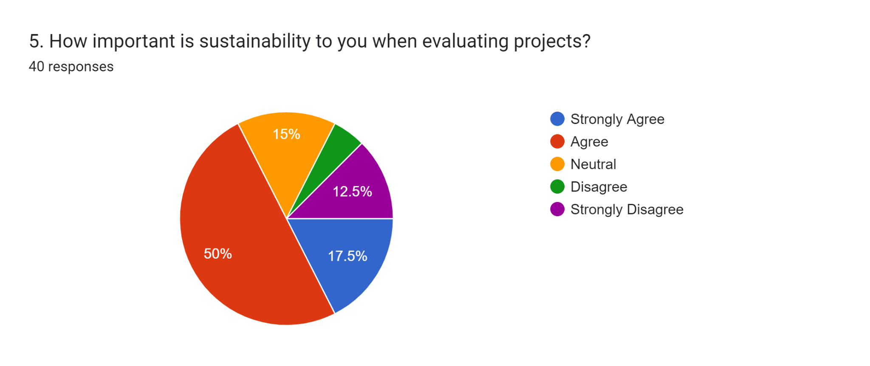

Figure 4.2.5: Response to Question 5
(Source: Created by the learner)
The fifth question of the survey illustrates the importance of sustainability when evaluating projects. From the above figure it is seen that, 50% of the respondents agreed that sustainability is important when evaluating projects, whereas, 17.5% of the participants strongly agreed that sustainability is important when evaluating projects. On the other hand, 15% of the participants remained neutral while deciding on the importance of sustainability while evaluating projects. While 12.5% of the participants strongly disagreed that sustainability is important when evaluating projects, and the remaining 5% of the participants disagreed that sustainability is important when evaluating projects. Therefore, from the data gathered, it can be said that sustainability plays a significant role in the evaluation of projects.
4.2.6: Survey Question 6
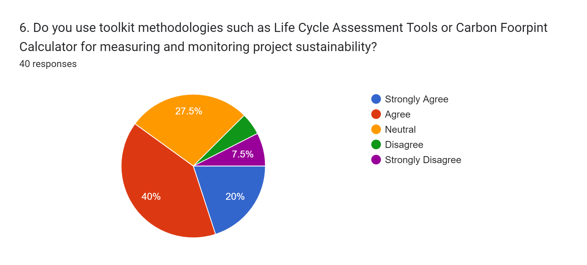

Figure 4.2.6: Response to Question 6
(Source: Created by the Learner)
From the survey results, it has been found that 40% of the members have agreed that Life Cycle Assessment Tools or Carbon Footprint Calculator are used by for measuring and monitoring project sustainability. Moreover, 20% of them strongly agreed to it and 27.5% of them gave a neutral view about it. In addition to this, it has been found that there are different types of toolkit methodologies for monitoring and measuring the sustainability of projects. The life cycle assessment has been largely used to analyse the impact of energy consumed, use of natural resources, and release of toxic substances. However, from the primary key findings, it has been noted that only 7.% of the members of the survey strongly disagreed with the statement. The carbon footprint calculator is also widely used by project managers for calculating the carbon footprint of different activities and operations. The main purpose of using a Toolkit methodology is that it helps in determining the use of energy, and wastes that have been negatively affecting the sustainability of a project. As a result, the toolkit methodologies benefit the project in reducing its negative impact on the environment.
4.2.7: Survey Question 7:
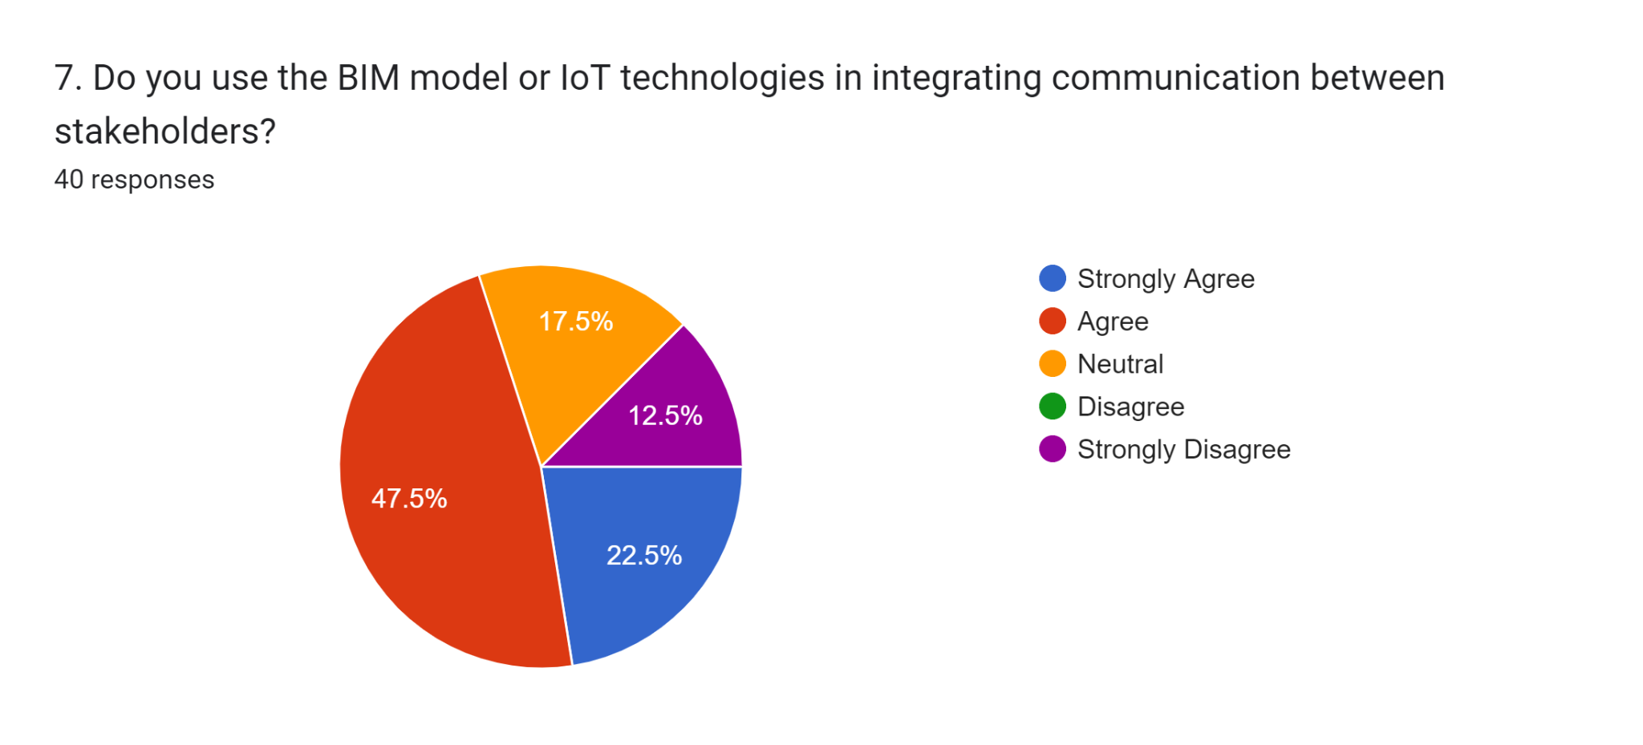

Figure 4.2.7: Response to Question 7
(Source: Created by the learner)
Figure 7 of the survey responses suggested that 47.5% and 22.5% of the employees agreed and strongly agreed respectively that the BIM model, IoT technologies widely used in project management to communicate with stakeholders. From the response generation, it has been identified that most of the employees agreed with the digital approach to the communication process for faster and more compact information-sharing aspects. Fast information sharing integrates the understanding of issues and errors in earlier which helps to reduce the unnecessary cost generation in business project planning. Only 12.5% of the employees strongly disagreed with the application of digital technologies for the communication process which is a low amount of employees from the total participants.
4.2.8: Survey Question 8:
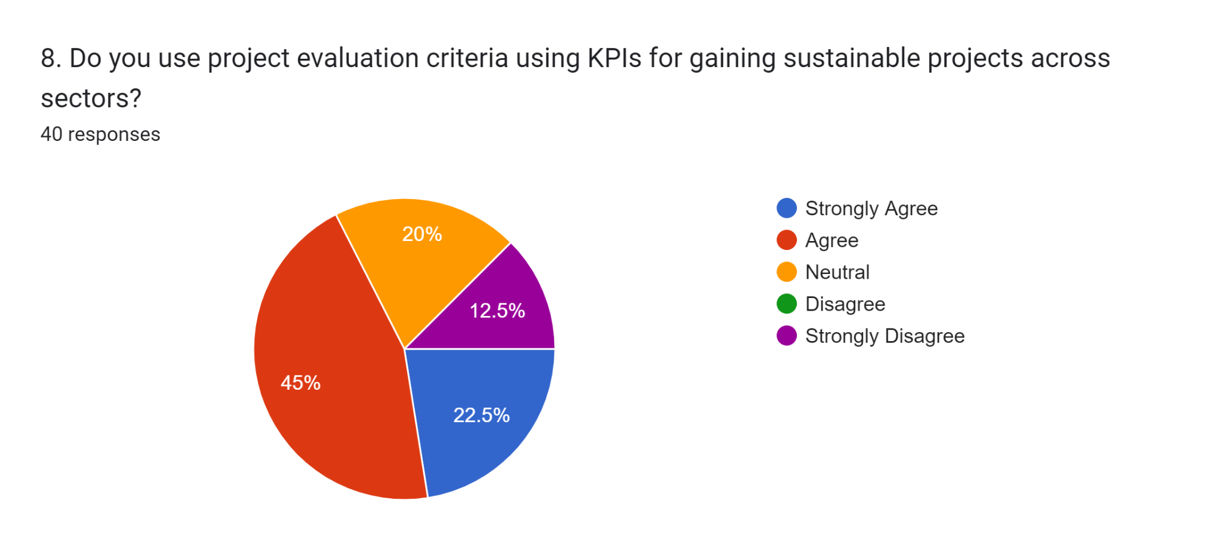

Figure 4.2.8: Response to Question 8
(Source: Created by the learner)
The survey question 8 infers the utility of project evaluation criteria for gaining sustainability projects. It has been seen that 45% of the employees of Stannah agreed that sustainability assessment criteria, and logic model are widely used criteria for gaining sustainable projects across sectors. On the other hand, it has been found that 22.5% of the people also agreed with the sustainable project application. Thus, it can be understood most of the employees positively opined for the positive project evaluation criteria selection using different KPIs. 12.5% of the employees only strongly disagreed with this evaluation criteria. 20% people remained neutral for this question.
4.2.9: Survey Question 9:
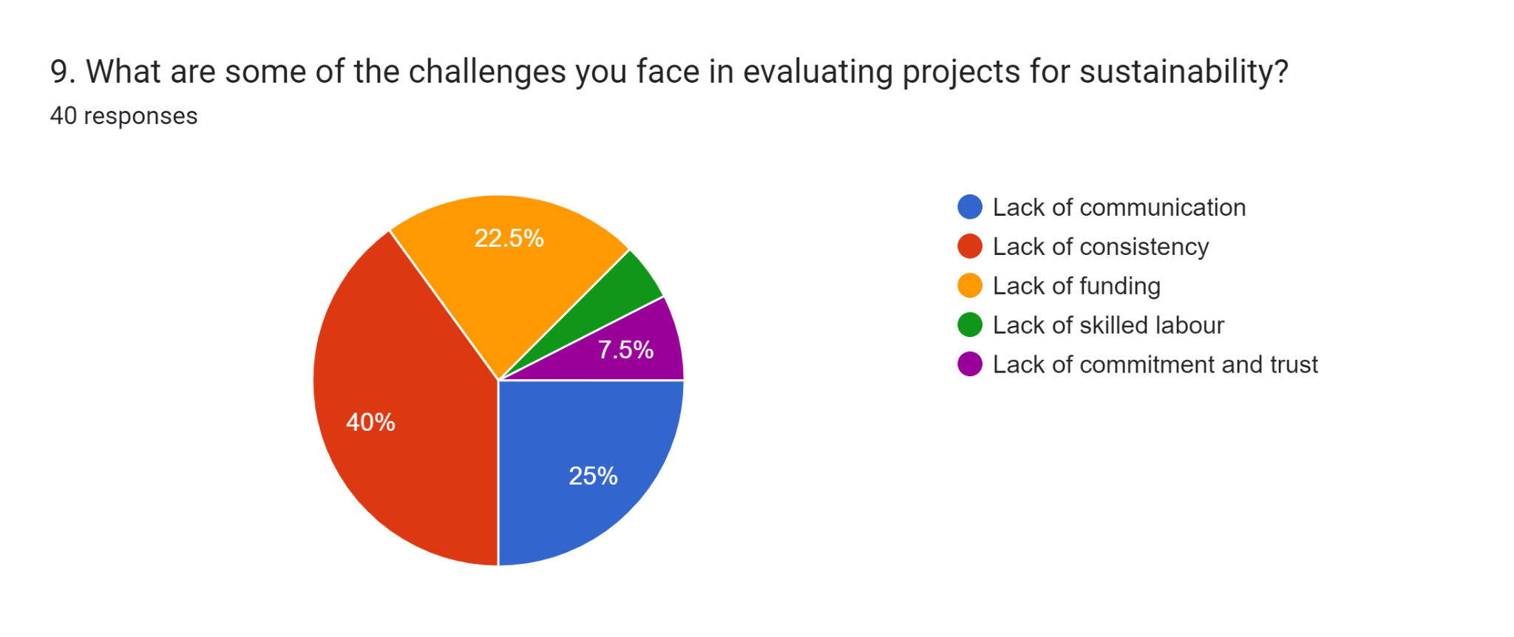

Figure 4.2.9: Response to Question 9
(Source: Created by the Learner)
There are various types of challenges which has been faced in evaluating the sustainability of projects. however, among these challenges, lack of consistency is one of the key challenges as 40% of the participants consider it. Moreover, from the survey, it has been observed that 25% of the participants believe lack of communication is a key challenge. Lack of communication can lead to unclear goals and misunderstandings among stakeholders. Besides that, it has been found that 22.5% of the members of the survey consider that lack of funding is one of the potential challenges in evaluating the sustainability of projects.
4.2.10: Survey Question 10
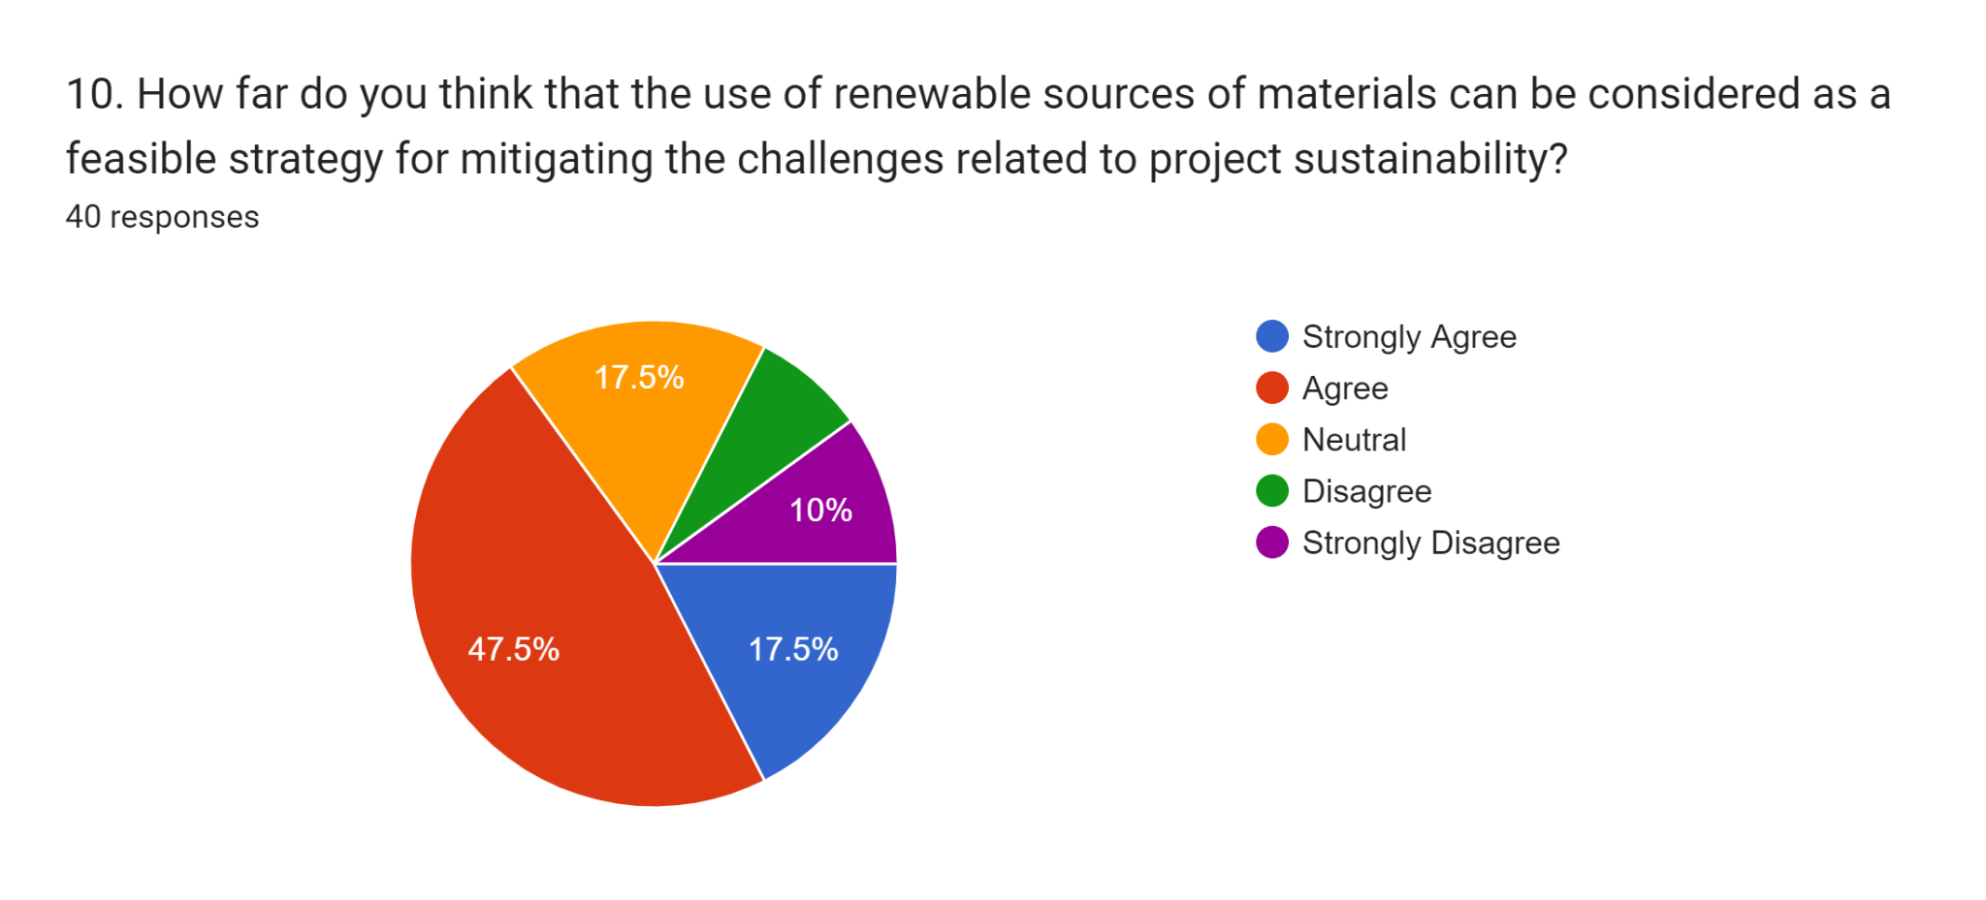

Figure 4.2.10: Response to Question 10
(Source: Created by the Learner)
From the above figure, it has been found that 47.5% of the participants of the survey consider that the use of renewable sources of materials is a feasible strategy which would help in mitigating the challenges related to project sustainability. On the other hand, 10% of the participants of the survey strongly disagreed with the survey. However, 17.% of the members have strongly acknowledged the use of renewable sources of materials for the Sustainability of the projects. Besides that, only 17.5% of them were not sure about the statement which resulted in a neutral viewpoint. As found, renewable sources of materials or energy are formed with the help of natural resources. Since renewable materials can be replenished year after year, these materials have a lesser negative impact on the environment. Furthermore, the use of renewable sources of material would help in addressing the potential risks and challenges of the environment such as climate change and the release of greenhouse gases. This is mostly because the sustainability of a project largely relies on the type of materials used, resources, equipment and consumption. Henceforth, the use of natural sources of resources is one of the feasible strategies for eliminating challenges of project sustainability.

4.3 Primary Qualitative Analysis (Axial Coding)
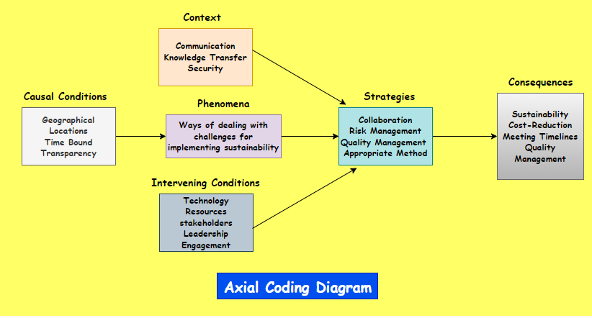

Figure 4.1 Axial Coding Diagram
(Source: Self-Developed)
Theme 1: Implementation of Six Sigma method and sustainability strategy could be critical for measuring and monitoring sustainability within the project
Interview Transcript | Codes
Project tools and methodologies utilised for measuring and monitoring sustainability within projects. | - Sustainability strategy  - Sustainability goals  - Six Sigma  - Lean  - TQM
Theme
Implementation of Six Sigma method and sustainability strategy could be critical for measuring and monitoring sustainability within the project.

Table 4.1: Axial Coding Theme 1
(Source: Self-Developed)
The table presented above indicates axial coding theme 1, which has been developed using Interview transcripts obtained from interviewing managers and sponsors. As per Manager 1, “I think that defining sustainability strategy has been one of the major techniques that is quite helpful in measurement and monitoring of project sustainability. Moreover, I feel that the development of sustainability goals helps our team to keep track of sustainability within project operations”. However, in contrast, as per the views of Manager 2, “We generally implement Six Sigma methodology within the projects which not only contributes to maintaining quality and delivery, but also has a driving role in reduction of waste and cost which leads to continuous improvement. Therefore, the adoption of this method has been transformational in minimising waste and maximising quality to a critical extent”. Hence, this indicates that strategic approach and sustainability strategy along with appropriate implementation of project management methodology has a specific role in the monitoring and measuring of sustainability within business. Furthermore, as per the response of Sponsor 1, “The lean project management methodology is of great use in projects since it is process-oriented and helps in effective monitoring of operations within the project [Refer to Appendix 2]. I think that the lean design is highly effective in reducing waste without compromising on the quality of the final outcomes of the project”. This indicates that lean has a driving role in the minimisation of waste within projects and holds substantial potential. For instance, the Lean approach is considered substantially value-driven as it leads to sustainability to a relative extent. During the development of Athlete's Village, associated with the Olympics in London, Lean construction led to 13% less waste production over a period of six months (UK Construction, 2018). In contrast, as per the views of Sponsor 2, “In my opinion, the implementation of the Total Quality Management Framework or TQM is quite effective in managing quality, eliminating waste and increasing the efficiency of the project. Moreover, the TQM framework is believed to be crucial for ensuring effective monitoring of processes, quality and sustainability within the project”.
Theme 2: Impact of shortage of labourers as a challenge for handling project sustainability
Interview Transcript | Codes
Project sustainability challenges faced by the organisation concerning the project management by the managers. | - Shortage of employees  - Fall in profits and decrease in millions  - Project sustainability  - Sponsorship
Theme
Impact of shortage of labourers as a challenge for handling project sustainability.

Table 4.2: Axial Coding theme 2
(Source: Self-Developed)
The lack of commitment and trust in the company has led to a decrease in the performance of the team members where there is a lack of labour and create a shortage in the labourers which can help in dealing with the project sustainability challenges. In this case, Project Manager 1 stated “We have faced a job loss scenario for our employees, where more than 75 employees left their jobs due to the pandemic and this is equivalent to 5% of its UK workforce. A shortage in labour means a lack of skilled labourers and information damaging the sustainability of the project.” On the contrary, Project Sponsor “I think that the lack of commitment and trust in the company has led to a decrease in the performance and this has resulted in a fall in profit by 11.5% from £5.2 million to £4.6 million. This has reduced the project's sustainability since sponsorship becomes difficult if the budget crosses over” [Refer to Appendix 2]. However, it can be opined that the Stannah Stairlifts had to witness a job loss of 75 due to the COVID-19 pandemic, which can highly help in understanding the problematic situation regarding the lack of sustainability in the project (And Over Advertiser, 2020). However, a lack of skilled labourers and with lack of information can highly interrupt project sustainability significantly.
Theme 3: Potential sustainable techniques and strategies adopted by project managers in retaining project sustainability and management
Interview Transcript | Codes
Potential strategies that the organisation took in order to mitigate the impacts of the challenges and promote sustainable strategies to better project management and maintenance. | - Potential strategies  - Sustainable strategies  - Project management  - Organisation
Theme
Potential sustainable techniques and strategies adopted by project managers in retaining project sustainability and management.

Table 4.3: Axial Coding theme 3
(Source: Self-Developed)
The above interview transcript has helped in understanding the potential techniques and strategies taken by the project managers and sponsors in controlling and managing sustainability to maintain proper sustainability and integrity within the project. In this case, Manager 1 implied that “I think, it would be favourable for the project management of Stannah Lifts Holdings Ltd. to recruit staff from the UK. The employees must essentially be fully trained on the in-house systems and work processes” [Refer to Appendix 2]. On the other hand, Project Manager 2 also stated “I think the project managers of Stannah Lifts Holdings Ltd. must have high-efficiency and high-speed machines that are installed within the production line which can, in turn, facilitate the quicker turnaround of products with precision. It is earnest to mention that diversification has been an effective strategy for the company’s growth.” While coping with the challenges of COVID-19 and Brexit it seems crucial for the organisation to focus on quality assurance. Creating a culture of quality assurance in the production units of Stannah can help maintain high output standards. In this respect, the opinion of Project Sponsor 1 holds much vitality for saying “To me, it seems essential for the project managers to track organisational commitment and offer incentives which in turn will appreciably enhance employees’ commitment level.” It can be implicated that without having a strong commitment level to work, the employees can never deliver their best performance in enhancing product quality.
Theme 4: Troubleshooting power disruption and appropriate guidance along with the lower battery for identifying unusual beeping sound to run the operation seamlessly to minimise sustainability challenges
Interview Transcript | Codes
Important lessons learned from the project experience for future improvement | - Power disruption,  - Seamless operations  - Unusual beeping sounds  - Proper guidance list  - Low battery  - Rechargeable batteries
Theme
Troubleshooting power disruption and appropriate guidance along with the lower battery for identifying unusual beeping sound to run the operation seamlessly to minimise sustainability challenges

Table 4.4: Axial Coding Theme 4
(Source: Self-Developed)
Various constraints including product issues, operational issues, low battery issues and proper guidance list are a few of the crucial lessons learned from project experience. While Stannah has been trying to ensure every stairlift is in perfect condition, factors like wear and time are resulting in critical issues (Stannah, 2024b). It implies that the project managers of Stannah Lifts Holdings Ltd. have been proficient in understanding various criticalities relevant to the stairlift product. Stairlifts have batteries which take over in case the main power is having its supply cut. However, Project Manager 1 informed “I have learnt that the products of the organisation face issues relating to power disruptions and at the same time face issues relating to seamless operations” [Refer to Appendix 2]. This can be entailed that stairlifts have significantly improved mobility for people thereby facilitating them to move freely having no risk of exerting excessive effort or falling (Elevatedmagazines, 2024). Yet, in the case of Stannah as informed by Project Manager 2 “It has been observed that unusual beeping sounds and sudden stopping have been observed as issues in the stair lifts.” On the other side, it can be implied that a low battery is possibly the critical reason for the stairlift to be slowed down. This might make the stairlift slightly slower rather than the normal speed. However, in case the stairlift becomes less charged, then it will continue to slow down. In this respect, Project Sponsor 1 stated “From the project experience it has been learnt that low battery is causing problems for patients and elderly generations.” Hence, it implies the fact that Stannah requires making use of rechargeable batteries which can be effective in delivering better service to patients and elderly people. For proper use of the stairlift, it seems essential for the organisation to provide a guidebook which will help in appropriately using the stairlift. As implied by Project Sponsor 2, “It is expected that this will help in resolving the issues related to unnecessary beeping sounds from the stairlift.” Hence, this can be extrapolated that stairlift managers and sponsors are concerned about certain critical parameters.

4.4 Conclusion
Thus from the entire discussion, it can be concluded that most of the employees along with the Project managers and Sponsors suggested that the digital process is used for the successful engagement of stakeholders. Not only that but both environmental and social ethical practices are also performed by managers in project planning and decision-making. However, lack of communication, consistency, funding and lack of trust are considered major challenges of sustainable project management.

Chapter 5: Discussion
Project sustainability is an integral part of modern-day organisations especially coming under Corporate Social Responsibility (CSR). As stated by ElAlfy et al. (2020), enterprises often rely on resources from a common pool as systemic components and share responsibilities for contributing to society's well-being. Subsequent requirements to business value chains are often exerted by environment-friendly actions to ascertain growth potential promoting green performance management. Interested parties accommodate demands of environment-friendly actions therefore social responsibilities and environmental efficiency aside business growth can be addressed. It has been found from the interview analysis sustainability strategy practised in Stannah Stairlifts is based on holistic frameworks such as the Six Sigma methodology that accommodates quality production by maintaining a transformational approach [Refer to Appendix 2]. A strategic approach with lean management also embraced the scope of the company for addressing sustainable production by reducing waste in the stairlift business. A survey conducted on a similar ground also indicates that 40% of the respondents prioritise stakeholder satisfaction while evaluating projects [Refer to Appendix 1]. Again, 42.5% of the survey participants also indicated they evaluate projects every 6 months [Refer to Appendix 1]. Therefore, project modelling, stakeholder engagement, resource pools and close monitoring are the necessary elements for addressing sustainability, especially in the case of Stannah Stairlifts.
Sustainability assessment, logic model and data collecting methodologies are very critical to address for project management. As indicated by Wulf et al. (2019), sustainability assessment is an essential approach for addressing a project's long-term economic, social, and environmental effects. Smith et al. (2020) have also supported the fact indicating a logic model is the logical link between the project's inputs, actions, outputs, results, and effects. The inclusion of ethical issues while managing participant engagement must be avoided to minimise uncertainty in decision-making. In order to mitigate conflicts in business decisions addressing sustainability is the logical ground to maintain key aspects of business accuracy and avoiding accusations of holistic competitive advantage in business practices.
According to the interview responses of managers, it is clarified resource allocation and their implementation is a crucial stake for ensuring project sustainability. Shortage of employees fall in profit, or external influences such as the pandemic caused Stannah Stairlifts to lose ground in sustainable initiatives. The absence of proper modelling of work culture, enlisting stakeholder interests, and complexity of decision-making has embraced a fall in the profit of the organisation by 11.5% with a valuation of £4.6 million [Refer to Appendix 2]. Further, 50% of the survey participants also agreed that sustainability in project management is very crucial for them to address [Refer to Appendix 1]. Hence, project regulation, monitoring and accuracy comprising of stakeholder interests are found crucial for sustainability management.
The third objective has shed light on the findings of toolkits and methodologies to measure and monitor project sustainability. From the primary survey, it has been identified that lifecycle assessment tools, carbon calculators and many others are considered as significant tools for assessing sustainability in the project management process. 40% of the employees of the chosen organisation agreed that toolkit methodologies are required for measuring sustainable project management [Refer to Appendix 1]. From the literature review section, it has also been seen that life cycle assessment tools are considered a measure and monitor sustainability for evaluating projects (Campos-Guzmán et al. 2019). Here, 40% of the survey participants identified that they are accommodating Life Cycle Assessment Tools or Carbon Footprint Calculator to ensure project sustainability [Refer to Appendix 1]. In addition, 20% of them strongly agreed to it and 27.5% of participants rendered a neutral view on the use of different types of toolkits to improve their productivity and adaptability toward sustainable goal settings in business processes.
This objective highlighted the ways of promoting the integration of sustainability evaluation into project planning and management processes through stakeholder communication. From the literature review section, it has been identified that IoT and BIM modelling are one of effective strategies which are used for communicating with stakeholders (Pan and Zhang, 2021). On the other hand, it has been also understood that prototype enactment is another communication strategy that has been used for stakeholder engagement (Lauff et al. 2020). Further, from the literature review section, it is also understood that From the quantitative interview section, it has been seen from the response of Project Sponsor 1 that technological implementation is followed to involve sustainability in the project planning and management process [Refer to Appendix 2]. From the result of the survey section, it has also been identified that 47.5% of the employees of Stannah Stairlifts considered BIM and IoT technologies for integrating communication between stakeholders [Refer to Appendix 1]. In this way, objective 4 has been met through both the literature review and the primary findings section.
The final objective also highlighted current challenges and opportunities associated with conducting sustainability in project evaluation. It has been identified from the literature review section that in the business management process, the main opportunity for sustainable human resource management is the formation of employee satisfaction (Mousa and Othman, 2020). It has been seen from the literature review section that 48% of the employees considered remote working strategy sustainable (Davidescu et al. 2020). On the other hand, for the challenge foundation, it has been identified from the literature review section that lack of consistency and lack of communication between stakeholders are considered as major challenges for sustainable project evaluation (Toljaga-Nikolić et al. 2020). In the primary interview findings, from the response of project manager 2, it has been identified that 5% of the workforce in the UK region left their jobs during the pandemic situation which created a significant shortage of labour, especially skilled labourers in implementing sustainability project management approach [Refer to Appendix 2]. On the other hand, from the survey result, it has also been seen that 40% and 22.5% of the total respondents agreed that in the sustainable project evaluation process some main challenges are lack of consistency and lack of communication respectively [Refer to Appendix 1]. On the other hand, 25% of the respondents also considered communication issues one of the major challenges. Thus, the chosen objective has been met within the literature review and findings section.

Chapter 6: Conclusion and Recommendation

6.1 Conclusion
While drawing the inferences, it seems worthwhile to mention that Stannah has been outstanding in terms of project management. The efficiency of the project management team is realised from the product offering, customer services and innovation. It can be concluded that sustainable project management has been a strategic approach taken by Stannah in ensuring that the project goals are accomplished and long-term impacts are delivered with high precision. Stannah’s strategic and sustainable endeavours in addressing customer requirements present the opportunity to improve their customers’ buying experience. Despite certain confinements like the COVID-19 pandemic crisis, which fully disrupted production operations, Stannah’s effective project management and strategic sustainability initiatives contributed to abiding by their pledges of customer safety, service and reliability and hence transformed daily living space.

6.2 Linking with objectives
Objective 1: To identify the key elements of the project sustainability.
From the existing literature, it has been seen that social responsibility is having a direct environmental responsibility. In this context, Severo et al. (2021), Corporate Social Responsibility (CSR) help in the efficient handling of the assignment. On the other hand, Pham et al. (2020), have mentioned that the organisation is focusing on environmentally friendly human resources management techniques. This states that this is a high focus on the sustainability of the organisation. Thus, the first objective of project sustainability has been elements of project sustainability been met in this research.
Objective 2: To establish a set of evaluation criteria for assessing the sustainability of projects across different sectors and contexts.
In the words of Wulf et al. (2019), Sustainability assessment (SA) has been identified as a sophisticated approach. This helps in planning the economic, social, and environmental effects in the long long-term projects. The use of SA helps decision-makers and policymakers improve society's sustainability. On the other hand, Smith et al. (2020), have stated that a logic model reflects on the logical link between the project's inputs, actions, outputs, results, and effects. This states that the sustainability of the project has been evaluated in this research. Thus the second objective for the research has been met in this research.
Objective 3: To develop a toolkit of evaluation methodologies and tools for measuring and monitoring project sustainability.
The existing literature has mentioned that the sustainability of a project can be measured through various kinds of evaluation practices such as the toolkit of evaluation methodologies. In this context, Padilla et al. (2021), have mentioned that the toolkit methodology can be defined as the step for better understanding the phases and steps which are required to conduct a robust evaluation. Thus the third objective has been met in this research.
Objective 4: To promote the integration of sustainability evaluation into project planning and management Processes.
From the words of Tiwari et al. (2023), sustainability has an important role in adding significant value to any business industry and in making an uninterrupted communication process with important stakeholders such as customers, employees, suppliers and others. On the other hand, Stanitsas et al. (2021) have stated that the inclusion of the Triple Bottom Line approach (TBL) helps in addressing the issues related to environmental, economic and social value creation. Thus, the fourth objective of meeting the integration of sustainability evaluation into project planning and management processes has been met in this research work.
Objective 5: To provide guidance on the use of evaluation findings to inform decision-making and improve project outcomes.
The existing literature states that certain challenges are faced in the process of sustainable manufacturing. In this context, Stanitsas et al. (2021) have stated that obscurities and inconsistencies are major challenges faced in the process of sustainable manufacturing. However, Industry 4.0 has been identified as the potential tool for mitigating the current issues. Thus the fifth objective has been met in this research.

6.3 Recommendations
Recommendation 1: Invest in an energy-efficient stairlift to enhance sustainability
To enhance the sustainability factor in the product offerings, it seems inevitable for Stannah to introduce innovation which can be best possible with the introduction of battery-powered DC stairlifts. Such types of lifts are not essential to be connected to the energy mains and hence the use of electricity can be lowered (Ward, 2023). The users will hardly notice any sort of changes in their electricity bills once they have installed DC battery-driven stairlifts. The only time the electricity will be used or required is while the batteries are put on charging. Offering such stairlifts will be favourable for Stannah to increase market share as the customers can save a lot of cash which is invested in battery replacement. Hence, Stannah can reach high sustainability.
Recommendation 2: Integration of agile project management model in Stannah
In the case of Stannah to enhance operational efficiency, Stannah should be focusing on agile business practices. Removing impediments is essential for successful product development and release (Kurup, 2020). It is essential to collaborate efficiently in which every team require prioritising the progress of the project which most often indicates staying flexible as well as evolving along the project needs. In Stannah, with a priority on collaboration, communication can also be made effective by holding in-person meetings, regular stand-ups, short and efficient meetings and using digital channels. Stannah’s leaders must nurture a multi-functional team that can be effective in ensuring collaboration and high efficiency as each aspect of the project will no longer be dependent on one team or person.

6.4 Research Limitations
In this study, the researcher has extensively focused on the project evaluation and sustainability factor of Stannah. However, the researcher has not focused on risk management which is a crucial aspect in every project. In addition, the researcher has focused on the opinions of managers and sponsors; however, the viewpoints of employees have been discarded. Hence, the research falls short in understanding the standpoints of employees towards their managers or leaders while pursuing every project.

6.5 Future Scope
In the future, it seems very crucial for researchers to focus on risk management in projects. In addition, the researchers should prioritise considering the opinions of employees about project management. Involving employees will further help in gaining a thorough understanding of the sustainability factor in Stannah with gaining valuable insights.

References
And Over Advertiser, 2020. Stannah expects 75 job losses due to coronavirus pandemic. Available at: https://www.andoveradvertiser.co.uk/news/18611828.stannah-expects-75-job-losses-due-coronavirus-pandemic/ (Accessed: 07 March 2024).
Armenia, S., Dangelico, R.M., Nonino, F. and Pompei, A., 2019. Sustainable project management: A conceptualization-oriented review and a framework proposal for future studies. Sustainability, 11(9), p.2664.
Bahadorestani, A., Naderpajouh, N. and Sadiq, R., 2020. Planning for sustainable stakeholder engagement based on the assessment of conflicting interests in projects. Journal of Cleaner Production, 242, p.118402.
Campos-Guzmán, V., García-Cáscales, M.S., Espinosa, N. and Urbina, A., 2019. Life Cycle Analysis with Multi-Criteria Decision Making: A review of approaches for the sustainability evaluation of renewable energy technologies. Renewable and Sustainable Energy Reviews, 104, pp.343-366.
Coker, D.C., 2022. A Thematic Analysis Of The Structure Of Delimitations In The Dissertation. International Journal of Doctoral Studies, 17.
Creemers, B.P., Peters, T. and Reynolds, D. eds., 2022. School effectiveness and school improvement. Routledge..
Davidescu, A.A., Apostu, S.A., Paul, A. and Casuneanu, I., 2020. Work flexibility, job satisfaction, and job performance among Romanian employees—Implications for sustainable human resource management. Sustainability, 12(15), p.6086.
ElAlfy, A., Palaschuk, N., El-Bassiouny, D., Wilson, J. and Weber, O., 2020. Scoping the evolution of corporate social responsibility (CSR) research in the sustainable development goals (SDGs) era. Sustainability, 12(14), p.5544.
Elevatedmagazines, 2024. Stair Lifts: Seamlessly Navigate Your Home. Available at: https://www.elevatedmagazines.com/single-post/stair-lifts-seamlessly-navigate-your-home (Accessed: 5 March 2024)
Enyoghasi, C. and Badurdeen, F., 2021. Industry 4.0 for sustainable manufacturing: Opportunities at the product, process, and system levels. Resources, conservation and recycling, 166, p.105362.
Forbes, 2023. Why Leaders Need To Close The Digital Skills Gap In The Global Economy. Avaialable at: https://www.forbes.com/sites/benjaminlaker/2023/01/06/why-leaders-need-to-close-the-digital-skills-gap-in-the-global-economy/ (Accessed: 03 March 2024).
Henderson, P., Hu, J., Romoff, J., Brunskill, E., Jurafsky, D. and Pineau, J., 2020. Towards the systematic reporting of the energy and carbon footprints of machine learning. The Journal of Machine Learning Research, 21(1), pp.10039-10081.
Huq, F.A. and Stevenson, M., 2020. Implementing socially sustainable practices in challenging institutional contexts: Building theory from seven developing country supplier cases. Journal of Business Ethics, 161, pp.415-442.
Kerzner, H., 2022. Project management metrics, KPIs, and dashboards: a guide to measuring and monitoring project performance. John Wiley & Sons.
Khatri, K.K., 2020. Research paradigm: A philosophy of educational research. International Journal of English Literature and Social Sciences (IJELS), 5(5).
Kissi, E., Agyekum, K., Baiden, B.K., Tannor, R.A., Asamoah, G.E. and Andam, E.T., 2019. Impact of project monitoring and evaluation practices on construction project success criteria in Ghana. Built Environment Project and Asset Management, 9(3), pp.364-382.
Kurup, L., 2020. Project Management in Agile Model. Available at: https://www.linkedin.com/pulse/project-management-agile-model-leeja-kurup/ (Accessed: 5 March 2024)
Larsson, J. and Larsson, L., 2020. Integration, application and importance of collaboration in sustainable project management. Sustainability, 12(2), p.585.
Lauff, C.A., Knight, D., Kotys-Schwartz, D. and Rentschler, M.E., 2020. The role of prototypes in communication between stakeholders. Design Studies, 66, pp.1-34.
Maarouf, H., 2019. Pragmatism as a supportive paradigm for the mixed research approach: Conceptualizing the ontological, epistemological, and axiological stances of pragmatism. International Business Research, 12(9), pp.1-12.
Martins, V.W.B., Rampasso, I.S., Anholon, R., Quelhas, O.L.G. and Leal Filho, W., 2019. Knowledge management in the context of sustainability: Literature review and opportunities for future research. Journal of cleaner production, 229, pp.489-500.
Modgil, S., Dwivedi, Y.K., Rana, N.P., Gupta, S. and Kamble, S., 2022. Has Covid-19 accelerated opportunities for digital entrepreneurship? An Indian perspective. Technological Forecasting and Social Change, 175, p.121415.
Mousa, S.K. and Othman, M., 2020. The impact of green human resource management practices on sustainable performance in healthcare organisations: A conceptual framework. Journal of cleaner production, 243, p.118595.
Mweshi, G.K. and Sakyi, K., 2020. Application of sampling methods for the research design. Archives of Business Review–Vol, 8(11).
Obilor, E.I., 2023. Convenience and purposive sampling techniques: Are they the same. International Journal of Innovative Social & Science Education Research, 11(1), pp.1-7.
Padilla, R., Passos, W.L., Dias, T.L., Netto, S.L. and Da Silva, E.A., 2021. A comparative analysis of object detection metrics with a companion open-source toolkit. Electronics, 10(3), p.279.
Pan, Y. and Zhang, L., 2021. A BIM-data mining integrated digital twin framework for advanced project management. Automation in Construction, 124, p.103564.
Pham, N.T., Thanh, T.V., Tučková, Z. and Thuy, V.T.N., 2020. The role of green human resource management in driving hotel’s environmental performance: Interaction and mediation analysis. International Journal of Hospitality Management, 88, p.102392.
Saunders, M., Lewis, P.H.I.L.I.P. and Thornhill, A.D.R.I.A.N., 2007. Research methods. Business Students 4th edition Pearson Education Limited, England, 6(3), pp.1-268.
Severo, E.A., De Guimarães, J.C.F. and Dellarmelin, M.L., 2021. Impact of the COVID-19 pandemic on environmental awareness, sustainable consumption and social responsibility: Evidence from generations in Brazil and Portugal. Journal of cleaner production, 286, p.124947.
Siedlecki, S.L., 2020. Understanding descriptive research designs and methods. Clinical Nurse Specialist, 34(1), pp.8-12.
Silver, D., Singh, S., Precup, D. and Sutton, R.S., 2021. Reward is enough. Artificial Intelligence, 299, p.103535.
Smith, J.D., Li, D.H. and Rafferty, M.R., 2020. The implementation research logic model: a method for planning, executing, reporting, and synthesizing implementation projects. Implementation Science, 15, pp.1-12.
Stanitsas, M., Kirytopoulos, K. and Leopoulos, V., 2021. Integrating sustainability indicators into project management: The case of construction industry. Journal of Cleaner Production, 279, p.123774.
Stannah, 2024a. Common stairlift faults. Available at: https://www.stannah.com/servicing-aftercare/stairlift-troubleshooting (Accessed: 2 March 2024).
Stannah, 2024b. Everything you need to know about stairlift batteries. Available at: https://www.stannah.com/servicing-aftercare/stairlift-troubleshooting/troubleshooting-stairlift-batteries (Accessed: 02 March 2024).
Stannahlifts, 2024. Welcome to Stannah Lifts, the UK-wide specialist lift company. Available at: https://www.stannahlifts.co.uk/ (Accessed: 2 March 2024).
Statista, 2022. Size of the disabled and elderly assistive technologies market worldwide between 2021 and 2030. Available at: https://www.statista.com/statistics/1258015/worldwide-disabled-and-elderly-assistive-technologies-market-size/ (Accessed: 2 March 2024).
Statista, 2024. Number of countries experiencing labor shortages the European Union in 2022, by occupation. Available at: https://www.statista.com/statistics/1347771/occupations-with-shortages-europe/ (Accessed: 08 March 2024).
Sykesstairlifts, 2021. Why aren’t more people using Stairlifts? Available at: https://www.sykesstairlifts.co.uk/why-arent-more-people-using-stairlifts/ (Accessed: 2 March 2024).
Tiwari, M., Tiwari, T., Sam Santhose, S., Mishra, L., Mr, R. and Sundararaj, V., 2023. Corporate social responsibility and supply chain: A study for evaluating corporate hypocrisy with special focus on stakeholders. International Journal of Finance & Economics, 28(2), pp.1391-1403.
Toljaga-Nikolić, D., Todorović, M., Dobrota, M., Obradović, T. and Obradović, V., 2020. Project management and sustainability: Playing trick or treat with the planet. Sustainability, 12(20), p.8619.
UK Construction, 2018. Why Lean is key to the future of construction. Available at: https://www.ukconstructionmedia.co.uk/features/lean-future-construction/ (Accessed: 5 March 2024)
Ward, B., 2023. Do stairlifts use a lot of electricity?. Available at: https://www.accessbdd.com/news/do-stairlifts-use-a-lot-of-electricity/# (Accessed: 5 March 2024)
Wulf, C., Werker, J., Ball, C., Zapp, P. and Kuckshinrichs, W., 2019. Review of sustainability assessment approaches based on life cycles. Sustainability, 11(20), p.5717.

Bibliography
- Boyd, A., Geerling, T., Gregory, W.J., Kagan, C., Midgley, G., Murray, P. and Walsh, M.P., 2007. Systemic evaluation: A participative, multi-method approach. Journal of the Operational Research Society, 58, pp.1306-1320.
- Gasper, D., 2000. Evaluating the ‘logical framework approach’towards learning‐oriented development evaluation. Public administration and development, 20(1), pp.17-28.
- Pitt, C., 1998. Putting the Logical Framework in its Place (No. 88). Working Paper.
- Couillard, J., Garon, S. and Riznic, J., 2009. The logical framework approach-millennium. Project Management Journal, 40(4), pp.31-44.

Appendices

Appendix 1: Survey Questionnaire
1. What is your age?
- 25-30
- 30-35
- 35-40
- 40-45
- 45 onwards
2. What is your role in project management?
- Project Manager
- Analyst
- Project Sponsor
- Team Member
- Steering Committee
3. How often do you evaluate projects?
- Within 3 months
- Within 6 months
- Within 9 months
- Within 1 year
- Within 1.5 years
4. What are the main factors that you consider when evaluating projects?
- Sustainability
- Stakeholder Satisfaction
- Quality of project outcome
- Costing Efficiency
- Availability of Resources
5. How important is sustainability to you when evaluating projects?
- Strongly Agree
- Agree
- Neutral
- Disagree
- Strongly Disagree
6. Do you use toolkit methodologies such as Life Cycle Assessment Tools or Carbon Foorpint Calculator for measuring and monitoring project sustainability?
- Strongly Agree
- Agree
- Neutral
- Disagree
- Strongly Disagree
7. Do you use the BIM model or IoT technologies in integrating communication between stakeholders?
- Strongly Agree
- Agree
- Neutral
- Disagree
- Strongly Disagree
8. Do you use project evaluation criteria using KPIs for gaining sustainable projects across sectors?
- Strongly Agree
- Agree
- Neutral
- Disagree
- Strongly Disagree
9. What are some of the challenges you face in evaluating projects for sustainability?
- Lack of communication
- Lack of consistency
- Lack of funding
- Lack of skilled labour
- Lack of commitment and trust
10. How far do you think that the use of renewable sources of materials can be considered as a feasible strategy for mitigating the challenges related to project sustainability?
- Strongly Agree
- Agree
- Neutral
- Disagree
- Strongly Disagree

Appendix 2: Interview Transcript
Q1. What project tools and methodologies do you generally use for measuring and monitoring project sustainability? (K)
Project Manager 1 | I think that defining sustainability strategy has been one of the major techniques that is quite helpful in measurement and monitoring of project sustainability. Moreover, I feel that the development of sustainability goals helps our team to keep a track of sustainability within project operations.
Project Manager 2 | We generally implement six sigma methodology within the projects which not only contributes to maintaining quality and delivery, but also has a driving role in reduction of waste and cost which leads to continuous improvement. Therefore, the adoption of this method has been transformational in minimising waste and maximising quality to a critical extent.
Project Sponsor 1 | The lean project management methodology is of great use in projects since it is process-oriented and helps in effective monitoring of operations within the project. I think that the lean design is highly effective in reducing waste without compromising on the quality of the final outcomes of the project.
Project Sponsor 2 | In my opinion, the implementation of the Total Quality Management Framework or TQM is quite effective in managing quality, eliminating waste and increasing efficiency of the project. Moreover, the TQM framework is believed to be crucial for ensuring effective monitoring of processes, quality and sustainability within the project.
Q2. What were the sustainability challenges you faced regarding maintaining projects? D
Project Manager 1 | Well, I think Brexit has posed real threats to our productivity and sustainability in a significant manner. The uncertainty created by Brexit has been able to create a challenging position for our company where decisions have been impacted by rising issues in maintaining project sustainability.
Project Manager 2 | We have faced a job loss scenario for our employees, where more than 75 employees left their jobs due to the pandemic and this is equivalent to 5% of its UK workforce. A shortage in labour means a lack of skilled labourers and information damaging the sustainability of the project.
Project Sponsor 1 | I think that the lack of commitment and trust in the company has led to a decrease in the performance and this has resulted in a fall in profit by 11.5% from £5.2 million to £4.6 million. This has reduced the project's sustainability since sponsorship becomes difficult if the budget crosses over.
Project Sponsor 2 | I think mostly Brexit and the COVID-19 pandemic have created challenging issues for our organisation with the loss of employees and this deteriorated the project sustainability in a significant manner.
Q3. What strategies did you adopt to overcome the project challenges?
Project Manager 1 | I think the project managers of Stannah Lifts Holdings Ltd. must have high-efficiency and high-speed machines that are installed within the production line which can, in turn, facilitate the quicker turnaround of products with precision. It is earnest to mention that diversification has been an effective strategy for the company’s growth.
Project Manager 2 | I think, it would be favourable for the project management of Stannah Lifts Holdings Ltd. to recruit staff from the UK. The employees must essentially be fully trained on the in-house systems and work processes.
Project Sponsor 1 | To me, it seems essential for the project managers to track organisational commitment and offer incentives which in turn will appreciably enhance employees’ commitment level.
Project Sponsor 2 | I think, the company must focus on building resilience to sustain the complexities of the COVID-19 pandemic and Brexit event.
Q4. What lessons have you learned from the project’s experience?
Project Manager 1 | I have learnt that the products of the organisation face issues relating to power disruptions and at the same time face issues relating to seamless operations.
Project Manager 2 | It has been observed that unusual beeping sounds and sudden stopping have been observed as issues in the stair lifts.
Project Sponsor 1 | From the project experience it has been learnt that low battery is causing problems for patients and for elderly generations. Thus, the organisation need to use rechargeable batteries in the products.
Project Sponsor 2 | The organisation need to provide a guidance list along with the products for helping the customers with the proper use of the stairlift. It is expected that this will help in resolving the issues related to unnecessary beeping sounds from the stairlift.
(Source: Created by the Author)

