

Warren James Griffiths
Student Number: 1916169
Friday 25th March 2022

Policing in the post pandemic era:
A critical evaluation of mental health demand on the Police

BSc (Hons) Professional Policing Practice

Acknowledgements

Firstly, I would like to thank my beautiful wife, Sarah. You are the reason I have had the confidence, ability, and mettle to complete this program. From supporting our family to giving me tips on how to cause an argument (which im confident I have been very good at!) and reading my submissions before the deadline. Your patience and expertise have not underappreciated, and I will always be grateful to you.

Following on from that I would like to say thank you to my parents Billy and Sam. You have, like Sarah, been so helpful in providing positive re-enforcement and reading my submissions for feedback, I hope I have made you proud!

Next our children Ruby, Morgan, Lewis, and Ethan. I am so grateful and proud of you all. You have been fantastic in supporting me.

I must also thank Vanesa, Jane, Kelly, my study participants and the team at the UWTSD for all your support in guiding me through the minefield of returning to education, you have been superb and In the same vein I would also like to thank Casa for all his support.

Thank you and until next time….

Warren

Declaration

This work has not previously been accepted in substance for any degree and is not being concurrently submitted in candidature for any degree.

Signed: Date: 06/10/22

Statement 1 - This dissertation is being submitted in partial fulfilment of the requirements for the degree of BSc.

Signed: Date: 06/10/22

Statement 2 - This dissertation is the result of my own independent work/investigation, except where otherwise stated. Other sources are acknowledged by footnotes giving explicit references. A bibliography is appended.

Signed: Date: 06/10/22

Statement 3 - I hereby give consent for my dissertation, if accepted, to be available for photocopying and for interlibrary loan, and for the title and summary to be made available to outside organisations.

Signed: Date: 06/10/22

Statement 4 - I hereby give consent for my dissertation, if accepted, to be available on the university’s IT system to those who have consent to use the system.
Signed: Date: 06/10/22

Introduction

The topic that the author has chosen to discuss is Policing post the COVID-19 pandemic and how the mental health crisis has affected the demand on the Police service.

The reason the author has selected this subject is that as a serving Police officer, they have witnessed the demand that the populations mental health crisis puts on Police services and what the knock-on effect that is for the communities that they service including public confidence and expectations.

To expand on this, the author believes that the evidence in the literature, and the study will show that the pressures that both services face and the problem that come with using the police as first point of contact. These include creating a distance between people with mental health disorders and the Police as this could cause them to feel apprehensive being dealt with by them as they could feel unnecessarily chastised.

This is exacerbated by the fact that Police have minimal training on dealing with mental health episodes and due to their vast complexities, could be construed as condescending and creating further perceived social standing between Police and those with mental health disorders. Having these factors In play may deplete public confidence and cause Police to be seen as out of touch with the communities they serve.

Specifically, the author will be researching and evaluating how pressures on mental health services in the United Kingdom have been impacting the demand on policing. To abstract evaluating from context, the author will be looking at if mental health has impacted on Policing demand and if so, how. This will be quantified by surveys to staff that have 3 years’ service or more in order to be able to speak for comparisons pre and post pandemic era.

The author believes in this study as it is felt that by conducting the survey, the effects of the pandemic can be further displayed up to date in to 2022 and this study could then be used to inform government for allocation of funds in 2022-2023 therefore bridging a gap from previous years.

Abstract

In this study, the author has conducted research on if the post pandemic mental health crisis has placed further demand on the Police service, specifically in Wales. Within this piece of work, you will find research that has been conducted to be able to ascertain if that has indeed been the case and what evidence there is to corroborate the authors conclusion. In reference to the type of research that has been conducted, the author has included a ratio of 75:25 split between quantitative and qualitative research to aspire to best inform the study. The reason behind the authors choice in this topic is that it will be used to inform decisions to correctly allocate funding to be able to best equip the relevant services to deal with the increased demand.

Background

Covid-19 caused unexplained cases of ill health throughout the nation that began with cold and flu like symptoms and like flu affected different people in different ways, these cases started rising massively and became a concern to the world. The virus was designated by the world’s health organisation as COVID 19. In March 2020, there where 720,00 cases were confirmed, and a reported 33,000 confirmed Covid 19 deaths (Adhikari et al., 2020). As cases continued to rise, this caused a pandemic to be announced all over the world, in order to manage the virus, lockdowns were announced by each country with certain restrictions that were enforced by agencies in the different countries and in the UK this responsibility fell to the Police (Asian J Psychiatry. 2020).

In Wales in particular the restrictions were to work from home where possible, not to attend any emergency departments, 111 contact number was introduced for people to use instead of going to A&E departments, most face-to-face services became over the phone, or through E-consultations. The Health Protection Report (Coronavirus Restrictions) (Wales) Welsh Government regulations states the below, these came into effect on 26th March 2020 (Wales.Gov 2022). The restriction changed based on what the level of Covid cases week to week, there have been 26 amendments since 2020 to 2022 (Wales.Gov 2022).

Covid 19 resulted in society being disrupted, which caused a disruption to economy and public and health services. Covid-19 and the effects of the virus to the population became prevalent to how individuals were coping throughout the lockdowns. Covid-19 also caused individuals to suffer loss of relatives, loss of employment, loss of social existence and these are all factors that can affect mental psychology in an individual. (Asian J Psychiatry. 2020).

Lockdowns

A report completed by Mind (2021) called “Coronavirus: the consequences for mental health” discusses the impact that the pandemic, particularly the “Lockdowns” had on individuals, this report looks at what barriers these individuals have faced during the pandemic being able to speak to access mental health services. Apart of the lockdown restrictions meant that individuals could no longer use face to face services, the services became contact via phone, or in some cases E consultations would have to be done online, some individuals felt barriers to using these services. Which meant that services which had no restrictions, working face to face with individuals e.g. Police, fire brigade and Ambulance for instance would be first point of contact for individuals that were struggling to access or get the help they needed, these individuals who may normally would rely of Crisis team, or other face to face services to deal with their mental health.

A review completed by National Collaborative Commissioning Unit 2020 but was then published in October 2022 due to the pandemic, corroborates what Mind (2022) is suggesting by confirming that 950 people a day in Wales contact some sort of agency regarding their welfare or mental health needs 300 of these people contact emergency services police, ambulance or fire brigade, this shows that even in the early stages of the pandemic there was a lack of mental health services available, which leads to the author questioning how much pressure was there on the emergency services throughout the pandemic, and why?

Subject Area

The mental health act 2005 means that police need to attend calls where an individual is at risk or may cause a risk to harm themselves, the expectation is that police officers then take these individuals to the hospital to for treatment needed. The collage of Policing document “Dealing with Mental Health During The Coronavirus Pandemic” chief inspector S. Baker (2020, p.2) states that “The police service is always there to keep people safe but we need to change the culture of over-reliance on this service and ensure that those in crisis are given the most appropriate care at the earliest opportunity”. But how do the individuals that work in the ambulance and police see the pressures is the question?

Table of contents

Research Proposal P8-10

Literature Review P11 - 17

Research and Methodology P18 - 19

Analysis of Results P20 - 31

Study Conclusion P32 - 35
5.1 Conclusion

Bibliography P.36 – 38

Appendices P39 - 74
Appendix 1 Gwent Police Freedom of Information Request Reply
Appendix 2 North Wales Police Freedom of Information Request Reply
Appendix 2A North Wales Police Acknowledgement Correspondence
Appendix 3 Dyfed-Powys Police Freedom of Information Request Reply
Appendix 3A Dyfed-Powys Police Acknowledgement Correspondence
Appendix 4 South Wales Police Acknowledgement Correspondence
Appendix 4A South Wales Police Freedom of Information Request Reply
Appendix 4B South Wales Police Complaints Procedure
Appendix 5 Survey Appendix
Appendix 6 Appendix Survey Results Raw Data
Appendix 7 Interview with AMHP Blank Template
Appendix 8 Interview with GWP AMHP
Appendix 9 Interview with NHS AMHP

1.1 Research Proposal

Research aims and question

The aim of this study is to ascertain if the post pandemic mental health crisis places further pressures on the Police service. Once this has been concluded, the author would like this study to be used to assist with distribution of funds and grants from local governments and other agencies. If achieved, this will be able to inform, highlight and hopefully address shortfalls in these services with the goal of being able to improve both emergency services for the benefit of the communities in which they serve.

Question

Is there greater pressure on the Police from the mental health crisis post pandemic?

Research

- Since the pandemic began in 2020, has demand on Police Services increased to attend mental health calls in Wales?
- In the view of staff, has there been an increase of dependence on Police since the beginning of the 2020 pandemic and if so, why?

Literature review

While the author has been researching the subject for the study, below are comments on existing research and what separates this study from existing research and how it bridges the gap in research.

“Policing should not be used as a substitute for mental health services” (Lloyd AM, 2019). In 2019, the National assembly for Wales health, social care and sport committee conducted an inquiry into the increased reliance on Police resources for mental health matters and the increased use of section 136 powers (drawn from the mental health act 1983) (Health, Social Care and Sport Committee, 2019).

This inquiry was done to ensure that Police stations were not being used as places of safety too often for people who suffer with mental disorders. Following on from this report, the conclusion was drawn that people found themselves in a Police cell having committed no crimes because there is nowhere else for them to go (Health, Social Care and Sport Committee, 2019).

This is relevant to the authors study as although the study doesn’t involve measuring the amount of people who have been detained under section 136, what it does involve is Police involvement with people suffering these disorders who have been brought to the attention of the Police as they have little other facilities to turn to. The inquiry elected to work with Police to understand why the number of detentions under the mental health act 1983 was increasing. Further to the same point, the same inquiry recommended that the Police services in Wales and the National assembly work together to ascertain what mental health triages were effective in providing a joined-up response to mental health calls. This recommendation further informs that there was an issue pre pandemic and the author can assist in illustrating the status of the problem post pandemic.

(National Assembly for Wales, 2019)

As illustrated in the graph above, there has been a gradual increase of the Police’s utilisation of section 136 powers in Wales and the author’s study will inform demand on Policing post pandemic to see if there has been an increase.

Methodology

The first part will be to gather data from the four Police services within Wales to look at quantitative data that has been gathered to display and analyse whether there has been any growth on calls to Police in reference to mental health calls. The author will use Freedom of Information requests or FOI, under the Freedom of Information Act 2000 in order to quantitively measure if there has been a rise in calls relating to mental health. Should there be any reason why accurate data may not be provided such as not receiving a timely response from the FOI requests, the author will base his conclusion on what accurate data he has been able to obtain to inform and conclude the study based on this therefore making it achievable by any means. These will be treated as primary and secondary data as per the questions.

Secondly, the author will distribute a short anonymous questionnaire to staff of the Police and staff of the NHS to be able to get honest and impartial feedback from the people that work for the respective services and see if there are any themes or correlations identified. Part of the pre-requisite for the survey will be the participants having 3 or more years’ service in order to be able to comment for pre and post pandemic. The author has chosen to have these surveys anonymous so that any reservations of repercussions from their respective employers can be removed so that the most accurate and impactive viewpoints can be gathered.

The qualitative method chosen will be interviews with an authorised mental health professional or AMHP within the Police to get their input from a Policing mental health perspective. To keep the study balanced, the author will then speak to an AMHP within the health service and ask the same questions so that the responses can be quantified. After analysing responses from both qualitative and quantitative aspects of the research, the author can then draw a conclusion that helps inform the study and establish if the qualitative and quantitative research methods inform each other. This will include journals, articles and books both online and printed.

2.1 Introduction

The purpose of the authors literature review is to ascertain if there are gaps in the research that the author can fill be conducting this study and then compare this to the findings of the qualitive and quantitative finding to establish if services are indeed under pressure and what the causes could be.

The primary purpose the author has chosen this topic is in order to gather information on whether these services have been placed under further strain since the pandemic and if they have, highlight this in an effective and informative way to be able to advise appropriate allocation of funding from government and also give an insight into the perception of the services from the employees as detailed in Greenberg’s theory of organisational justice (Greenberg, 2010).

2.2 Defining the mental health crisis

The term mental health crisis is a term that has been used a lot in the 21st century Great Britain. The study entitled “Working in mental health: Practice and Policy in a changing environment” (Phillips, Sandford, Johnston, 2012) was extremely relevant in that it has documented the changes in mental health and its services in the last 30 years or so in the United Kingdom up to 2012. There was a large rise of not only consultant psychiatrists and professional qualified psychotherapists, but a large increase in expenditure of 142% in the ten years following the writing and publishing of the National service framework for mental health in 1999.

This literature whilst being 10 years old in 2022, details a chronology of events in mental health in the United Kingdom and has provided the author with a plethora of information in relation to the increase in not only medical professionals such as psychotherapists but also a large rise in expenditure of 142% in the decade following its publishing. The author considered this article reliable and valid due to its contributors being stakeholders within the subject matter such as NHS lecturers and nursing directors.

As stated in the study “Beyond the call” written by the National Collaborative Commissioning Unit, a crisis is a situation whereby an incident relating to safety of the public or an individual’s welfare triggers a call to the emergency services and is linked to a person’s mental wellbeing. Furthermore articulates the responsibilities set out for all social care and emergency services in respect of their duties to the public and its welfare. The purpose of this literature is to ensure that all agencies involved approach a joined-up approach. (S.Mills, R. Bagshaw & A Watt 2020)

This document sets out expectations for the agencies and how they perform in reference to addressing crisis care and this is set out in the Crisis Care Concordat. The concordat, originally published in 2015 by Welsh government and partners, equalling a total of 23 agencies, sets out broad terms for a service level agreement between all of its members. Each organisation has its own roles and responsibilities in order to provide a comprehensive service to the public. . (S.Mills, R. Bagshaw & A Watt 2020)

However, contrary to other pieces of literature reviewed, the report argues that that a person experiencing a mental health concern does not necessarily mean that the person has a mental illness but could be a product of a welfare or social issue (S.Mills, R. Bagshaw & A Watt 2020). However Mind (2022) suggests that even individuals who did not suffer mental health before the pandemic, may now need support due to the lockdown measures creating loneliness, or anxiety, which agrees with the report form beyond a call to some extent, but further evidence that mental health is more prevalent than ever due to the circumstances of the pandemic.

A consideration with this literature is that the review “Beyond the call” was published in October 2020 after being delayed due to the pandemic. As a result this review was agreed prior to the conclusion of the pandemic whereby significant changes to services occurred such as waiting lists being increased due to cancelled appointments and the appointments that were conducted, were conducted remotely over the telephone or over the internet. (S.Mills, R. Bagshaw & A Watt 2020)

This is further expanded on in the document “National Strategy on Policing and Mental Health” (NPCC,2022, p.2) which takes an approach from a Policing perspective and states “Where Police Officers provide an initial response to a mental health crisis incident, they should seek to act in the least restrictive way and take advantage as far as they can, of any information which may be available from healthcare sources to improve the nature and quality of their response”. (NPCC, 2022 )

This confirms the obligation of Police to act in these crisis scenarios and emphasises the important role they play. This originated from the service level agreement that was set out between all social care agencies

2.3 Mental health demand on Police services

A report completed in 2018 by Her Majesty’s Inspectorate of Constabulary and Fire & Rescue Services (HMICFRS 2018) named Policing and Mental Health “Picking Up The Pieces” suggests that even in 2018 the mental health services were not sufficient enough to deal with mental demand. This is further proven due to Police services having to employ a triage team within their service control room. Evidently it suggests that there is not enough services to provide the early intervention care needed, or primary care to individuals, which could prevent crisis and as a result, reduce volume of calls to Police.

Furthermore, it argues that other services are reliant on the police due to them having the 24-hour, 365-day services, whereby mental health and social services are primarily 9-5. This is adding unneeded pressure to other departments in the police, custody for example, having a mental health patient in the back of a police car for hours whilst waiting to be seen. (HMICFRS 2018) (S.Mills, R. Bagshaw & A Watt 2020)

The report argues that 1-4 people will suffer mental health, it then goes on to say that these individuals in question, may call the police on 999 due to someone’s behaviour changing or escalating. Typically then the police will then attend as an emergency, it goes on to say that on average they can get one call like this every 12 minute, this call would then ordinarily have a Police officer taking the individual to the hospital due to the extensive wait for an ambulance or a long wait in A & E with the police officer. Further to this, it states that it could be more than one Police officer, including if the individual was sectioned under section 136 of the mental health act 1983. The report argues that mental health calls take up a large amount of Police time and resources, due to no readily available mental health services, or ambulances available (HMICFRS 2018).

This corresponds with what the author is trying to establish, this report is highlighting that there are already concerns in 2018 regarding the police being first point of contact, this further corroborated in the literature with “Beyond the call” similar issues regarding this in 2019. (S.Mills, R. Bagshaw & A Watt 2020) It begs to question that if this was already an issue in 2018, then how has this improved with the introduction of the pandemic?

2.4 Covid-19 pandemic

The literature already has highlighted the demand on policing pre-pandemic, so a question to consider is what was it like during? The literature has already shown that the lack of NHS service is a factor before and after the pandemic (NHS 2022)

The author has established what Covid is and how the pandemic came about from the introduction in the Authors study, but how have the demands of policing changed, the Author has already highlighted that demand have always been there pre pandemic, so how did the pandemic impact the police service? This is a key question.

Lockdown restrictions meant that people were unable to leave their properties. If they had any condition, they were told to self-isolate, and others were advised that they were not allowed to leave unless it was for exercise, or for essential items (Welsh.Gov 2022).

As Covid progressed, restrictions did ease at some points, but services remained consistently the same. This meant that individuals who were used to seeing people for their mental health needs, were unable too as easily as prior. The report from Mind (2022) corroborates this, they evidence that when they surveyed individuals it was established, that during covid a large number of the services that individuals may use before, were now unavailable to them and services that were available had gone from face to face to over the phone.

This exacerbated the communities mental health and this is further highlighted in the briefing conducted by the association of Police and Crime Commissioners (2022) the document called “APCC Briefing Mental Health and Covid Phase One” argues that some of the calls received for individuals for suicide or/and mental health, general anxiety calls were due to individuals not being able to contact the services, due to them being restricted during covid, which meant that it fell on the police to deal with these mental health calls. A recognition of the pandemic and the lack of services did enable a service to be introduced which was named the 111-contact line, which was introduced as a measure for individuals to contact first before calling emergency services, this was introduced to prevent an escalating demand to contact police and ambulance services. (APCC, 2022)

The literature has shown that the pandemic is adding more pressure to the police due to the restrictions that were put in place and the knock-on effect this has had on mental health services during Covid, however the report also shows that there was a dip on reports to police at the beginning of the lockdown, which caused concerns regarding people’s mental health initially, due to the restrictions to mental health services. However further to the implementation of the 111 services introduced the author results will highlight whether this service was a factor in police having less demand (APCC, 2022).

2.4.1 Covid-19 impact on mental health

An article written by the charity Mind (2022) conducted a research project called “Coronavirus: the consequences for mental health”, This report surveyed 12,000 individuals before the pandemic and after the pandemic, the survey assessed how many individuals accessed mental health support through the pandemic, 84% of individuals experience mental health at some point, out of this 84% only 72% were able to get through and access to mental health services, which means that 28% of these individuals were unable to get the support they needed.

The report also showed that 42% out of the 84% participants, who are younger, had to wait 3 months or more to get support started. (Mind 2022) The report also evidenced that some of the participants felt that the pandemic and lockdowns heightened their mental health conditions, compared to before the pandemic. Furthermore, this corresponds with what the centre for mental health (2008-2021 The Centre Of Mental Health) in it briefing called “COVID 19 and the nations mental health :May 2021” the briefing advises that due to the pandemic they can confirm that 10 million people 8.5 adults and 1.5 million children will need some sort of mental health intervention in the next 3-5 years due to the effects of the COVID 19 pandemic. (Nick O Sera 2021)

A limitation to this briefing, as it does primarily focus on England’s statistics, but it does show that the amount of people needing services will continue to increase throughout to next few years. Which shows that a lack of services being available, will cause a knock-on effect and push pressure onto other agencies.

Further to the article written by Mind, the online article entitled “Associations between dimensions of behaviour, personality traits, and mental health during the Covid-19 pandemic in the United Kingdom” (Hampshire, 2021) offers further supporting evidence on the correlation between the pandemic, the mental health crisis and the pandemics effect on people’s mental health.

The article, which as the title suggests, is bespoke to the United Kingdom, states “The Covid-19 pandemic (including lockdown) is likely to have had a profound but diverse implication for mental health and well-being”. Establishing this link is key and provides a direct correlation between the pandemic and the authors study, reenforcing that the pandemic has had a negative effect on mental health and as a result will then increase demand on mental health services and then as a result, an increase on demand to Police. (Hampshire, 2021).

However, this article goes on to say that restrictions that were Imposed in order to control infections in the UK drew a positive outlook from some of the participants of the study conducted by Hampshire, stating that the lockdown restrictions, particularly around exercise actually reduced stress, tiredness and led to fewer health concerns (Hampshire, 2021).

Although in the article, Hampshire said that people reported fewer health concerns, there is no factual evidence to confirm this claim. This then suggests that there is a profound medical link between the pandemic and the declining mental health of individuals which suggest that this would have a negative impact on emergency services, as result places pressure on the ambulance and a result police as evidenced in the report of beyond the call, that shows the rising cases before, and during. (S.Mills, R. Bagshaw & A Watt 2020)

2.5 Conclusion and opportunity for further research

The author has concluded that although it states in the “NHS Mental Health Implementation Plan 2019/20 – 2023-24” (NHS, 2019) that “an additional 2 million people will access mental health care”, this was written prior to the world health organisation declaring Covid-19 a pandemic in March 2020 whereby while the effects of this are yet to be fully established, Koziarski states that elements of the world during pandemic such as quarantines, lockdowns and physical distancing alone or in conjunction with other aspects of the pandemic, “translate into higher levels of psychological distress” (Koriarski, 2021).

The study by Koziarski, entitled “The effect of the COVID-19 pandemic on mental health calls for Police service”, therefore provides more up to date information that will therefore render the article by the NHS (NHS,2019) obsolete.

This provides the author with a further opportunity to bring the research available up to date as statistics for 2022 are not included in literature readily available. By doing this, the author can use all findings for the objective or informing funding to assist communities and correct allocation of funding for social care and emergency services.

In addition to this, as the review shows from “Beyond the call”, there was significant pressures on services prior to the pandemic, hence the inception of the review and the introduction of the crisis care concordat in 2015.

This highlighted the demand placed on Police prior to the pandemic therefore after the conclusion of the pandemic this is not likely to have eased but have sustained more pressures as a result of the pandemic. As suggested in the report Policing and Mental Health “Picking Up The Pieces” that shows that there were already pressures on the police to attend mental health call as first point of contact, or welfare checks, and detentions under Section of the 136 Mental health act 1983 (HMICFRS 2018). It therefore begs the question, what is the issue, and why is there so much pressure on the police? A report that was conducted by the NHS (2022) Called “NHS Mental health Implementation Plan 2019/20-2023/24, this report highlights that lack of services currently available to people who have mental health needs, the report s highlighting that they have bee awarded 1 million pounds to improve services in the next five years, which evidences that there is already a struggle with accessing services currently. (NHS 2022)

The report does however show that there will be an increase in work force within the NHS mental health services, which should eventually alleviate the pressures on other services in the future. The limitation to this report is that is based on England and not Wales, however the Wales “Review of the together mental health delivery plan 2019-20 in response to Covid 19” does recognise that mental health services do need to be changed to meet current demands since coming out of the pandemic which shows that they are two suggesting more services and staff need to be added to the NHS to combat the rising mental health cases (Welsh.Gov 2022).

The literature is suggesting that there are currently not enough mental health services provided. There is already a reliance on the police to pick up these calls, due to multiple factors such as police being 24/7, the legal factors of their “duty of care” to individuals. Welfare checks, taking people to mental health teams in the hospitals when there are no ambulances available, and then with the pandemic lockdown and services changing from face to face to over the phone, this has caused a lot more demand on police. This has been further evidenced with the NHS report “NHS Mental health Implementation Plan 2019/20-2023/24” which suggested the need for further services and employment of more staff to implement services in the next five years in order to combat the already strained system. Evidently this is showing that the main issue is that there are not enough mental health services readily available. This is already starting to provide evidence to answer the authors thesis that indeed the demand is more on the police due to lack of these services available pre pandemic and during (NHS,2022).

3.1 Research Strategy

A widely accepted definition of Qualitative research is a way in which people (society) view the world. It is used to gather the views and opinions of people in order to measure or establish how these individuals experience the world. In reference to this study, this will be in the form of opinions and views of people in relation to the mental health crisis and its impact on policing since the pandemic (Given, 2008).

Quantitative research is what people tend to associate with the more conventional research in the sense that it is associated with numbers, statistics and in soe ways is more tangible in its nature. Quantitative research assigns numbers to the topic under discussion and from the authors dissertation proposal, this would be collation of data from Welsh police forces in order to ascertain whether the number of calls to Police have increased in relation to mental health since the pandemic (VanderStoep and Johnston, 2008).

The author has requested data from the four Welsh Police services in Wales, United Kingdom using the Freedom of Information Act 2000 to gather accurate data from the sources directly to see if they can provide data on whether calls to Police have increased in reference to mental health.

The secondary part of the quantitative research will be short anonymous surveys distributed to staff of the NHS and Welsh Police services who have three or more years’ service with the aim of having 25-50 completed.

The qualitative research method that the author chose was in the form of interviews with Approved Mental Health Professionals or AMHPS. To be able to gain a fair incite from both perspectives (from the view of the Police and the NHS), the author will conduct an interview with an AMHP from both services and this will assist in making the study fairer and more balanced.

3.2 Limitations & Potential Issues

A main consideration that the author has made allowances for since the proposal for the study is regarding the gathering of a large part of quantitative research. As addressed earlier in the section, the data that has been requested by the author from the four Welsh Police forces.

Each Police service has an obligation under the act to release information, so long as it does not compromise any Police operations or investigations and further to that, does not have a detrimental effect on public safety.

It is therefore imperative that the author makes an application that is clear and concise for all the information that they require as this creates a risk that the information may not be returned in time for the study and as a result will reduce the amount of support for the thesis or otherwise (South Wales Police, 2022).

A further limitation could also be a lack of participation with the study. This could be in the qualitative or quantitative research with respect to participants. Should the author not be able to get enough of the surveys completed to be able to have a fair and accurate study or not identify an approved mental health professional willing to participate in the study, then this will likely reduce the quality of information gathered overall for the study.

As with all pieces or research and study, a crucial part of the basis of the conclusion is ensuring that the data is correct, accurate and ethically gathered. To be able to get the best results for the study, the author has built in eligibility questions into the surveys to ensure that the surveys completed are from the correct people representing the correct data sample.

4.1 Introduction

The author has made freedom of information requests to all four Welsh Police services which are Dyfed-Powys Police (DPP), Gwent Police (GWP), North Wales Police (NWP) and South Wales Police (SWP). (Dyfed-Powys Police, 2022)(Gwent Police, 2022)(North Wales Police,2022)(South Wales Police, 2022).

To ensure the control of the research results, all of the freedom of information requests were made on the same day, using the same text for the requests for all four services. This put the author in the best position to have the most accurate results in order to utilise them for the study and the author has included the original results unedited in separate appendices.

4.2 Research Objectives

The objectives of the research are to ascertain if they concur with the initial thesis that the author has set out in his proposal. The thesis that the author set out was that the pandemic has caused greater pressure on the NHS mental health crisis and as a result this causes further pressure on the Police services in Wales to support the communities and bridge the gap between the services when people experience mental health crisis.

4.2.1 Analysis of Results

In respect of the interviews with mental health practitioners, the author has aimed for this to be completed by a mental health professional in the Police and in the NHS in order to obtain a balance and control for the study.

As set out in the crisis care concordat in the document “Beyond the call” (S. Mills, R. Bagshaw & A. Watt 2020) that was discussed in the authors literature review, 23 agencies have agreed crisis care responses when dealing with care crisis’ however from the authors results, the demand on Police has risen for 75% of the Welsh police services.

This has been further discussed in the authors survey that was sent out to people working in Welsh Police services and the NHS in Wales (Appendix 6). These surveys offer the perspective that are on the front line dealing with the crisis care for the Welsh communities.

The survey has comprehensively shown from participants that are the people in our communities that work for these services, that the demand has increased and that too much pressure is being placed on the Welsh Police services in relation to mental health concerns.

Quantitative Research and Findings

The author wanted to be able to provide irrefutable data on the study and the data that supports it, therefore below are the results from the Freedom of information results that were obtained from the four Police services in Wales.

Gwent Police

In financial year ending 2019 (2018-2019), GWP recorded 11,560 incidents that had mental health recorded as a factor within them. What this means is the Police have identified during triaging the call received by the force control room that mental health is a significant factor in the incident.

In financial year ending 2022 (2021-2022), GWP recorded 15,684 incidents that had mental health recorded as a factor within them. What this means is the Police have identified during triaging the calls received through the force control room that mental health is a significant factor in the incident.

The information that GWP have provided, recorded mental health incidents within Gwent Police increased by 35.67%. In the context of the research, this data shows that Gwent Police have had an increased number of mental health incidents from pre to post pandemic and this is on an upward trend, this confirms the authors thesis of greater demand being placed on the Police from mental health since the pandemic. As suggested in the HMIC review conducted in 2018 which corresponds with the authors 2018 pre pandemic data, the article stated that Police should be the last port of call, the increase shown on the data gathered by the author shows a significant increase in demand on Police and suggests that the pressure has increased significantly especially if following guidance set out in the crisis care concordat in 2015 (HMICFRS, 2018), (S.Mills, R. Bagshaw & A Watt 2020).

Further to this, Gwent Police also provided to the author that in financial year 2018-2019, 67 of those incidents came directly from the Ambulance service division of the NHS.

In 2021-2022, the number of incidents reported from ambulance had increased to 121. This shows an increase of 80.59%.

As evidenced in the literature, “Beyond the call” reported, 950 people a day in Wales with 35 of those have called Gwent Police in reference to a mental health concern (S.Mills, R. Bagshaw & A Watt 2020).
.

North Wales Police

In financial year ending 2019 (2018-2019), NWP recorded 1157 incidents that had mental health recorded as a factor within them. What this means is the Police have identified during triaging the call received by the force control room that mental health is a significant factor in the incident.

In financial year ending 2022 (2021-2022), NWP recorded 4412 incidents that had mental health recorded as a factor within them.

So based on the information that NWP have provided, recorded mental health incidents within NWP increased by 281%. In the context of the research, this data shows that North Wales Police have had an increased number of mental health incidents from pre to post pandemic and this is on an upward trend, this confirms the authors thesis of greater demand being placed on the Police from mental health since the pandemic.

Further to this, North Wales Police also provided to the author that in financial year 2018-2019, 38 of those incidents came directly from the Ambulance service division of the NHS.

In 2021-2022, the number of incidents reported from ambulance had increased to 166. This shows an increase of 336.84%.

As per the Beyond the call publication, 37 people a day call North Wales Police in relation to a mental health concern (Mills, 2020).

Dyfed-Powys Police

In financial year ending 2019 (2018-2019), DPP recorded 656 incidents that had mental health recorded as a factor within them. What this means is the Police have identified during triaging the call received by the force control room that mental health is a significant factor in the incident.

In financial year ending 2022 (2021-2022), DPP recorded 1009 incidents that had mental health recorded as a factor within them.

So based on the information that DPP have provided, recorded mental health incidents within DPP increased by 53.81%. In the context of the research, this data shows that Dyfed-Powys Police have had an increased number of mental health incidents from pre to post pandemic and this is on an upward trend, this confirms the authors thesis of greater demand being placed on the Police from mental health since the pandemic.

Further to this, Dyfed-Powys Police also provided to the author that in financial year 2018-2019, 48 of those incidents came directly from the Ambulance service division of the NHS.

In 2021-2022, the number of incidents reported from ambulance had decreased to 43. This shows a decrease of 10.41%.

Similarly to other Police services, the publication “Beyond the call” states that 31 people a day call for mental health help from North Wales Police (S.Mills, R. Bagshaw & A Watt 2020) this show that there consistent evidence from both the literature and the findings from the freedom of information act show that there is a lot of call to emergency services partially the police to be first point of contact for those individuals needing meant health services.

South Wales Police

In financial year ending 2019 (2018-2019), SWP recorded 37438 incidents that had mental health recorded as a factor within them. What this means is the Police have identified during triaging the call received by the force control room that mental health is a significant factor in the incident.

In financial year ending 2022 (2021-2022), SWP recorded 21545 incidents that had mental health recorded as a factor within them.

So based on the information that SWP have provided, recorded mental health incidents within SWP decreased by 42.45%. In the context of the research, this data shows that South Wales Police have had a decreased number of mental health incidents from pre to post pandemic and this is on a downward trend, this contradicts the authors thesis of greater demand being placed on the Police from mental health since the pandemic.

A Limitation to the Freedom of Information Act data is SWP did not provide data broken down into calls received by NHS however of the average 950 people a day that seek help with their mental health, 129 of those call for help from South Wales Police. This is more that all 3 of the other Police services combined on average as only 103 people a day call the other 3 Welsh Police services.

Qualitative Research, Results and Findings

The author broke the qualitative research into two separate parts. The first part is a questionnaire that was sent out across the Welsh Police services and the NHS. The second part of the qualitative research is an interview conducted with a Mental Health professional working in the NHS sector and the same interview questions conducted with a Mental health professional working within the Policing sector.

The relevance of this qualitative data illustrates the views of the people working with the demand that the author is studying on a regular basis and benefits the authors study as offers their perspective of demand and whether it has increased or decreased from pre to post pandemic and offers points of view from those people. Therefore, the value of this data will support or argue the authors thesis and provides critical insights.

Questionnaire

32 people completed the survey and for academic honesty, the author was not one of them in order to preserve the integrity of the study. A prerequisite for the study was that the participant of the survey had worked for the NHS or Police in Wales for over 3 years in order to comment on the demand on services pre and post pandemic. One of the participants of the survey has stated that they joined the Police during the pandemic therefore their responses have been removed so not to compromise the survey and the author will not be including their responses.

From the 31 participants, 30 represented the Police service and 1 represented the NHS.

96% of the participants believed that Covid-19 had an impact on mental health services. 87.09% of the participants stated that pre pandemic Police were over utilised when it came to mental health incidents and the other 12.91% stated that they were utilised where appropriate and nobody thought Police were underutilised in regard to mental health incidents.

Nobody thought Police attendance was required less since the Covid-19 pandemic.

This data is strengthened by the literature review, Mind (2022) report “Coronavirus: the consequences for mental health” which states that only 72% of people that were seeking mental health support were able to access it therefore this could be a factor in the increase in mental health calls received by Police.

Interview with AMHP

The second part of the qualitative research that the author has conducted is the interview with the Authorised Mental Health Practioner.

To obtain a controlled interview, the author submitted the same questions to both professionals (one employed by the NHS, and one employed by the Police) in order to properly interrogate the responses from both participants.

When asked “In your opinion, who attends Mental Health incidents in the first instance?
The mental health professional stated “It is becoming more and more prevalent that public, ambulance and MH teams make contact to police to attend as the first contact and is increasing demand on police for MH incidents” however the ambulance mental health professional was not able to answer this question comprehensively by stating “Again a difficult question to answer- depending on the nature of the concern. “. A limitation to this being that the ambulance mental health professional has stated that they have only been in their role for 18 months so cannot comment for pre pandemic.

When asked “Do you feel the pandemic has had a negative effect on mental health services in Wales?”, both mental health professionals answered yes for this question.

When asked the question around the topic of mental health attendance calls, both professionals were asked “In your opinion, who is best equipped to attend mental health incidents in the first instance in terms of skills?”, both professionals agreed that it was difficult to provide a generic answer however the mental health professional for the Police stated “Again this depends upon the situation and the amount of risk/danger is being posed to the individual and public members. In terms of skills however then community MH teams /crisis teams would be best equipped given their qualifications and skills in MH” whereby the ambulance mental health professional argued and stated “ Again- all staff/ services should have a level of understanding but who / what happens next is dependent upon the complexity of the situation. mental health is everyone’s business

The author has identified through these answers that the Police mental health professional was reluctant to criticise the Police service and the same predominantly could be said for the ambulance mental health professional which the author considers to be a limitation of the study.

Both professionals identified that there were gaps in the service delivered in respect of mental health support and early intervention which supports the authors thesis of there being greater demand on the Police to plug those gaps and this is evidenced in the literature review in the articles “Beyond The Call” (S.Mills, R. Bagshaw & A Watt 2020) and the article written by the APCC (2022) on how to improve the services delivered the Police mental health professional stated “Reintroduce the working hours and contact facilities they were running pre covid, increase the numbers of staffing available also re open the smaller hospitals such as Neville Hall and Royal Glamorgan Hospital . Look into the ambulance situation and staffing so response can be met.
Also re introducing the social clubs which many people who suffer with their mental health found to be their life crutch previously.” The ambulance mental health professional offered the following ways to improve the service’s delivered in respect of mental health “I think there are several issues –
- Access to GPs and primary care
- 7 days a week services- MH problems don’t stop after 5 pm in secondary care.
- Pop up clinics – normalising MH issues – reducing stigma
- Issues with recruitment and retention – staffing across several disciplines – pressure on services
- Navigating the MH system… how people access care. Hopefully the 111 single point of access will help with this.
- Investment in estates – some MH environments are poor and not fit for purpose
- HB’s have chosen to disinvest in local services and relied upon commissioned services – often far from home – we need to support people locally with our own staff and services with better outcomes for individuals

This agrees with the authors findings regarding the limitations on mental health services being limited to office hours as well as largely suggesting that services need to be available not just outside office hours, but in person.

During the interview, the professionals elaborated on their thoughts regarding the pandemic and its effect on the service. The theme from the interview with the author was that there is a lack of funding having been put into the services.

The data that the author has gathered from these interviews with mental health professionals, a medical issue, disagrees with the article that was published by the NHS in 2019 stating that a further 2 million people would be able to access mental health support, and this is further confirmed by the Mind (2022) that stated 28% of people that sought mental health support were not able to access it.

4.3 Conclusion of Findings

In respect of the quantitative data, 3 out of the 4 Welsh Police services recorded an increase in Mental Health demand post pandemic. One force, South Wales Police, recorded a significant decrease in Mental Health demand and is the largest Welsh Police force.

Pre pandemic in 2018-2019, Welsh Police services received 50,811 calls where mental health was a factor. Post pandemic in 2021-2022, the same Police services received 42,650 calls where mental health was a factor which is a significant number and illustrates the burden to Police services to allocate resources to these incidents that don’t illicit a typical Policing response but more of a call to service in respect of the Police duty of care to the public and their welfare.

In the authors literature review, it has been established that there is no up to date data been published in relation to the authors study question and the data suggests that demand on Policing has increased with a national review supported by the National Crisis Care Concordat Assurance group, published in October 2020, post declaration of the global pandemic, stating that out of 950 a day on average, 232 contact one of the four Welsh Police services which is 24%. The study also reported that the busiest day of the year for mental health concerns is Friday which further exacerbates demand on Policing (S.Mills, R. Bagshaw & A Watt 2020).

With reference to the qualitative data, the questionnaire responses that were gained from the respondents largely agreed with the authors thesis that the mental health crisis in post pandemic Wales has placed a greater pressure on the NHS and as a result, Police resources also.

Finally, after conducting the interviews with the mental health professionals, they identified themes such as the mental health sector needs greater financial support and investment along with the fact that they are under significant pressure and that some of that pressure is then passed on to the Police.

5.1 Conclusion of literature and findings

The qualitative research was broken into two parts. The first part was for the author to design a questionnaire to submit to people working in the NHS and Police services in Wales to obtain their thoughts on whether the NHS and Ambulance service has placed a greater demand on the Police service. Similarly, to the Freedom of Information requests, to be able to obtain a controlled sample of people, the author wrote in an eligibility question to the questionnaire whereby to be able to participate, the participant had to confirm they had worked for either service over three years in order to comment pre and post pandemic.

The second part of the qualitative research was an interview with authorised mental health professionals from both the NHS and the Police in order to gain their perspective on if the pandemic has caused the NHS and Ambulance service to rely greater on the Police and if this has impacted on the service that the NHS provides to its communities in relation to the mental health crisis in the UK, specifically Wales.

Issues

The author’s qualitative research was largely dependent on the responses provided by the participants. There were 32 participants to the authors questionnaire in total. One of the responses was removed from the study’s results as in the comments they stated that they had joined their service (Police) during the pandemic and therefore this would compromise the study’s findings as the objective was to have people that could comment pre and post pandemic and if they joined during the pandemic then they would not be able to offer up a perspective pre pandemic therefore compromising the study’s results.

Further to this issue with the questionnaire, on further review of the responses, of the 31 legitimate respondents, there was a significant disparity in which service the respondents represented. As below, a large portion of the respondents represented the Police which may have impacted on the results as the author was looking for a percentage that had a degree of parity in it in order to best support the survey.

Police | NHS
30 (96.77% of respondents) | 1 (3.22% of respondents)

An issue identified from the quantitative research was on the return of the Freedom of Information request figures. North Wales Police, Gwent Police and Dyfed-Powys Police all reported increases in mental health incidents however South Wales Police reported a decrease and their incidents accounted for a large portion of incidents due to their large area and large population as their position as the largest Police service in Wales (South Wales Police, 2022).

This has directly disagreed with the authors thesis however the data has shown that there are still a huge number of incidents relating to mental health that the Police are having to deal with which supports the thesis of the author that there is still a significant demand placed on the Police for attendance at mental health incidents.

Quantitative research

75% of the 4 Welsh Police services reported an increase in mental health calls since before the pandemic in 2020 and the 25% that accounts for a large amount of the population in Wales, reported in 2021-2022 receiving 21,545 mental health incidents which is a significant number.

Qualitative Research

Of the 31 accepted participants in the study, 96% believed that Covid-19 had an impact on mental health services in Wales. 87.09% of those that participated also stated that Police were over utilised when it came to mental health incidents.

Both professionals stated that the pandemic had negatively impacted mental health services in Wales and further to this, they both said that they can see the pressure and difficulty that the NHS is under in Wales.

Conclusion

The three key pieces of existing literature showed that there has been an issue with lack of mental health services, and this was firstly evidenced in the report Policing and Mental Health “Picking Up The Pieces” conducted by HMICFRS (2018) , who evidence that there is already a gap in mental health services before the pandemic started.

This showed that there was already a demand on emergency services to pick up these mental health calls, this was then secondly further proven to be the case throughout the pandemic as mentioned in “Beyond the call”, “A National Review of Access to emergency Services For Those Experiencing Mental Health And/or Welfare Concerns” which evidenced that the pandemic has then exacerbated this further and mental health cases have risen in thousands throughout and has caused further pressures on to the police services. Even with the introduction of the 111 service being introduced this has not lessened the demand, thirdly this is then furthermore evidenced in the Mind (2022) report called “Coronavirus: the consequences for mental health” argues that mental health services were harder to access during the pandemic due to going from face to face to over the phone, which caused barriers for individuals, this is then further impacted with the reports from NHS (2022) which shows that they are actively trying to improve and provide services and are openly aware that there is.

With that being said, the author now refers back to the original question posed for the study in order to provide an answer based on the research that has been conducted for this study.

Question

Is there greater pressure on the Police from the mental health crisis post pandemic?

Answer

Yes, there is, from all the research that the author has conducted throughout the study, and the written literature comprehensively shows that the pandemic has had a negative effect on mental health and mental health services in Wales. 3 out of the 4 Police services in Wales report an increase in mental health calls since the pandemic and the 4th Police service still reported over 20,000 mental health calls in one year which still draws attention to the fact that there is an issue.

Research

- Since the pandemic began in 2020, has demand on Police Services increased to attend mental health calls in Wales?
Yes, it has
- In the view of staff, has there been an increase of dependence on Police since the beginning of the 2020 pandemic and if so, why?
Yes, there has, from comments made by participants, due to the shortages being experienced within the NHS, the Police are expected to bridge the gap when there are no resources available to deal with these types of incidents.

Study Conclusion

In conclusion, the author has found that by conducting his study using the research that he has set out throughout that the Police are relied upon a great deal in order to support their colleagues in the NHS when it comes to mental health incidents.

This has been evidenced in the literature and then further proven with the data that the author has collected, it is evident that there is a massive pressure on the police to be the first point of contact, the authors reasoning for this is due to a lack of meant health services being available even before that pandemic, which means that there was already pressure on the police before, and then this has increased the demand on police during the pandemic, some of the evidence collected from the Freedom Of Information Act 2000, has shown over a double in call throughout compare to before, and then further evidence that even after the pandemic there is an increase on calls to police to attend.

The consequences for this cannot be understated when we consider how else those resources could be allocated and if they were used to support the Police services in dealing with crime reactively and where not necessary, proactively, this could have huge impacts on reducing crime figures for Wales making it a more attractive place to live and consequently boosting the economy in one of the most trying times in recent memory.

The author’s conclusion to the question “Policing in the post pandemic era: A critical evaluation of mental health demand on the Police” is that the demand is not going to cease until mental health services increase and become more available to individuals, with this said there is evidence in the literature that this is happening and there is a plan moving forward with the NHS (2022) and Welsh, Gov (2022) , however there is also a consensus that under the community Mental Health Act 2005 police still have to attend these calls due to the “duty of care” they have legally, so it very difficult to see whether this will change in the future, without some change in law to assist the changes in how police deal with these calls.

The author has conducted a vast amount of research for this study as well as asking for input from people who have a vested interest in the research subject.

Author Recommendations

The author believes that the national crisis care concordat assurance group that wrote the national review in October 2020 should reconvene and further review the demands and pressures that are placed on all services.

By completing a further bespoke review post lockdown and post pandemic, it should allow services to present the demands and pressures that it experiences every day and as a result allow all services to get together to form a further and updated service delivery plan in order to provide a better service to its communities.

By doing so, each service will be able to present the challenges that it faces post pandemic and tailor a response that places less demand on the other services.

Further to that, using up to date data such as data from this study, the review group could present findings of all services to Welsh government in order to make a comprehensive bid to secure more funding to address the deficits and pressures.
Another recommendation that the author is making is for there to be a bespoke service set up for addressing mental health concerns that come to the attention of the police.

This is an approach that has been trialled in Welsh police services previously however has not been made permanent as of yet. That suggestion is that in each ambulance response team, a Police officer be crewed with a paramedic and they attend all calls that derive from a mental health concern. Their remit should be that any person requiring medical attention and suffering a mental health crisis. They would attend, perform an initial triage service with the patient and assess what their needs are such as if they have taken an overdose or self-harmed. Once this triage has been complete, arrange for them to attend to address any medical needs such as stitches or blood tests etc and then, or if not necessary, arrange for them to attend and see a mental health professional relevant to their care such as crisis team or attend for a mental health assessment at facilities such as St Cadocs or Ty Cafanol.

By this bespoke unit attending and dealing with these patients, then this would relieve any pressure placed on an ambulance attending which would alleviate its pressures and allow them to deal with more serious medical issues and this would also avoid these people being criminalised should minor offences have been committed such as public order offences while going through mental health episodes which would be rationalised by the attending Police officer.

Total Word Count 10912

Bibliography

- Adhikari S.P., Meng S., Wu Y.-J., Mao Y.-P., Ye R.-X., Wang Q.-Z., Sun C., Sylvia S., Rozelle S., Raat H., Zhou H.(2020) Epidemiology, causes, clinical manifestation and diagnosis, prevention and control of coronavirus disease (COVID-19) during the early outbreak period: a scoping review. Infect. Dis. Poverty. 2020;17(9):29.
- APCC, 2021. LOCKDOWN 3: POLICING AND MENTAL HEALTH SERVICES PREPARE FOR INCREASED DEMAND. [Online]
Available at: https://www.apccs.police.uk/latest-news/lockdown-3-policing-and-mental-health-services-prepare-for-increased-demand/
[Accessed 24th February 2022].
- APCC (2020) APCC Briefing : “Mental Health and Covid Phase One” pg. 6

- Asian J Psychiatr. (2020) “COVID-19 and mental health: A review of the existing literature” [Online] www.ncbi.nlm.nih.gov
- Baker, S., 2020. Dealing with mental health during the coronavirus pandemic. [Online]
Available at: https://www.college.police.uk/article/dealing-mental-health-during-coronavirus-pandemic
[Accessed 24th February 2022].
- Boulton, L. et al. (2016) ‘Calls for police service’, The Police Journal [Preprint]. Available at: https://doi.org/10.1177/0032258X16671032.
- Brinkmann, S. (2017) ‘Introduction: Philosophy and Qualitative Research’, in Philosophies of Qualitative Research. New York: Oxford University Press. Available at: https://doi.org/10.1093/oso/9780190247249.003.0001.
- Calculating percentage increase and decrease - Statistical skills – WJEC - GCSE Geography Revision - WJEC (no date) BBC Bitesize. Available at: https://www.bbc.co.uk/bitesize/guides/zpjmjty/revision/2 (Accessed: 6 August 2022).
- Charity Partners (no date) Heads Together. Available at: https://www.headstogether.org.uk/partners/charity-partners/ (Accessed: 3 July 2022).
- Cheng, Z. et al. (2021) ‘Working parents, financial insecurity, and childcare: mental health in the time of COVID-19 in the UK’, Review of Economics of the Household, 19(1), pp. 123–144. Available at: https://doi.org/10.1007/s11150-020-09538-3.
- Ethnic group, national identity and religion - Office for National Statistics (no date). Available at: https://www.ons.gov.uk/methodology/classificationsandstandards/measuringequality/ethnicgroupnationalidentityandreligion (Accessed: 3 July 2022).
- Full details and actions for Research methods for everyday life: blending qualitative and quantitative approaches (no date). Available at: https://www-vlebooks-com.ezproxy.uwtsd.ac.uk/Product/Index/5391?page=0 (Accessed: 18 June 2022).
- Given, L. (2008) The SAGE Encyclopaedia of Qualitative Research Methods. Thousand Oaks, California. Available at: https://doi.org/10.4135/9781412963909.
- Greenberg, J. (2004) ‘Stress fairness to fare no stress: managing workplace stress by promoting organizational justice’, Organizational dynamics, 33(4), pp. 352-.
- Inclusive Language Guidelines: Gender Identity | Institutional Planning & Analysis | CSUSM (no date). Available at: https://www.csusm.edu/ipa/surveys/inclusive-language-guidelines.html (Accessed: 3 July 2022).
- Hampshire, A. et al. (2021) ‘Associations between dimensions of behaviour, personality traits, and mental-health during the COVID-19 pandemic in the United Kingdom’, Nature Communications, 12(1), p. 4111. Available at: https://doi.org/10.1038/s41467-021-24365-5.
- Health, Social Care and Sport Committee, 2019. Mental helth in policing and police custody. [Online]
Available at: https://senedd.wales/laid%20documents/cr-ld12843/cr-ld12843%20-e.pdf
[Accessed 26th February 2022].
- HMICFRS, 2018. Policing and mental health. [Online]
Available at: https://www.justiceinspectorates.gov.uk/hmicfrs/wp-content/uploads/policing-and-mental-health-picking-up-the-pieces.pdf
[Accessed 24th February 2022].
- Kane, E., Evans, E. and Shokraneh, F. (2017) ‘Effectiveness of current policing-related mental health interventions in England and Wales and Crisis Intervention Teams as a future potential model: a systematic review’, Systematic Reviews, 6. Available at: https://doi.org/10.1186/s13643-017-0478-7.
- Koziarski, J. (2021) ‘The effect of the COVID-19 pandemic on mental health calls for police service’, Crime Science, 10(1), p. 22. Available at: https://doi.org/10.1186/s40163-021-00157-6
- Lloyd AM, D., 2019. Policing should not be used as a substitute for mental health services. [Online]
Available at: https://senedd.wales/senedd-now/news/policing-should-not-be-used-as-a-substitute-for-mental-health-services-dai-lloyd-am/
[Accessed 26th February 2022].
- Mills, S., Bagshaw, R. and Watt, A. (no date) ‘NATIONAL COLLABORATIVE COMMISSIONING UNIT’, p. 140.
- Mind Cymru survey reveals toll of pandemic on ambulance workers’ mental health (no date). Available at: https://www.mind.org.uk/news-campaigns/news/mind-cymru-survey-reveals-toll-of-pandemic-on-ambulance-workers-mental-health/ (Accessed: 5 October 2022).
- National Assembly for Wales, 2019. Mental health in policing and police custody. [Online]
Available at: https://senedd.wales/laid%20documents/cr-ld12843/cr-ld12843%20-e.pdf
[Accessed 26th February 2022].
- NPCC, 2020. National strategy on policing and mental health. [Online]
Available at: https://www.npcc.police.uk/Mental%20Health/Nat%20Strat%20Final%20v2%2026%20Feb%202020.pdf
[Accessed 24th February 2022].
- Oflazoglu, S. (2017) Qualitative versus Quantitative Research. Available at: https://doi.org/10.5772/65619.
- Overview (no date). Available at: https://www.south-wales.police.uk/police-forces/south-wales-police/areas/about-us/about-us/overview/ (Accessed: 9 August 2022).
- Police federation, 2021. Government must end plugging mental health service gaps. [Online]
Available at: https://www.polfed.org/news/latest-news/2021/government-must-end-police-plugging-mental-health-service-gaps/
[Accessed 24th February 2022].
- ‘Policing and mental health: picking up the pieces’ (2018), p. 59.
- Quantitative Methods in Social Science Research (no date). Available at: https://web-p-ebscohost-com.ezproxy.uwtsd.ac.uk/ehost/ebookviewer/ebook/bmxlYmtfXzI2NTQ3MV9fQU41?sid=68fba141-247a-4858-ae49-79ea884ade9b@redis&vid=0&format=EB&lpid=lp_1&rid=0 (Accessed: 18 June 2022).
- Robinson, K. (no date) ‘NHS Mental Health Implementation Plan 2019/20 – 2023/24’, p. 57.
- S.Mills, R. Bagshaw & A Watt (2020) Beyond the call “national review of access to emergency services for those experiencing mental health and/or welfare concerns.
- Stephen Gorard (2004) Quantitative Methods in Social Science Research. London: Continuum. Available at: https://ezproxy.uwtsd.ac.uk/login?url=https://search.ebscohost.com/login.aspx?direct=true&db=nlebk&AN=265471&site=ehost-live (Accessed: 18 June 2022).
- Thames Valley police federation, 2021. Police pick up pieces of social care shortages. [Online]
Available at: https://www.tvpfed.org/news
[Accessed 24th February 2022].
- The Centre of Mental Health (2008 – 2021) [Online] “Covid-19 and the nation's mental health: May 2021 | Centre for Mental Health”
- UK largest police forces 2021 (no date) Statista. Available at: https://www.statista.com/statistics/877540/leading-police-forces-by-officer-numbers-in-the-uk/ (Accessed: 9 August 2022).
- VanderStoep, S.W. and Johnston, D.D. (2008) Research Methods for Everday Life. Jossey-Bass.
- Wales.Gov (2022) The Health Protection (Coronavirus Restrictions) (Wales) Regulations 2020.
- Wave 13 summary: 9 to 15 November 2021 (no date). Available at: https://www.mentalhealth.org.uk/our-work/research/coronavirus-mental-health-pandemic-study/wave-13-summary (Accessed: 5 October 2022).
- What has the impact of the pandemic been on mental health? (no date). Available at: https://www.mind.org.uk/coronavirus-we-are-here-for-you/coronavirus-research/ (Accessed: 5 October 2022).
- What is the Freedom of Information Act? (2022). ICO. Available at: https://ico.org.uk/for-organisations/guide-to-freedom-of-information/what-is-the-foi-act/ (Accessed: 21 August 2022).
- What is the Freedom of Information Act? (no date). Available at: https://www.south-wales.police.uk/foi-ai/af/accessing-information/what-is-the-freedom-of-information-act/ (Accessed: 19 June 2022).
- Working in Mental Health : Practice and Policy in a Changing Environment (no date). Available at: https://web-p-ebscohost-com.ezproxy.uwtsd.ac.uk/ehost/ebookviewer/ebook/bmxlYmtfXzQ0NDQ5OV9fQU41?sid=448054b2-b926-43ac-b9b6-7782ad0618e9@redis&vid=0&format=EB&rid=1 (Accessed: 9 May 2022).

Appendix 1

FREEDOM OF INFORMATION REQUEST

FREEDOM OF INFORMATION REQUEST 2022/25175

Dear Requester,

Thank you for your recent request under the Freedom of Information Act 2000.

Section 1 of the Freedom of Information Act 2000 (FOIA) places two duties on public authorities. Unless exemptions apply, the first duty at, Section 1(1) (a), is to confirm or deny whether the information specified in a request is held. The second duty at, Section1 (1) (b), is to disclose information that has been confirmed as being held.

The information that you are seeking is in relation to the following:

REQUEST

I am looking for data from pre pandemic (April 2018) to post pandemic (May 15th, 2022) where Police have been called for incidents that relate to mental health in any way. I am trying to evidence if the calls for mental health to police have risen since pre pandemic and if so, how much. Statistics relating to this is the information that is sought and any qualifying information such as origins or call (broadly for example, ambulance, public, third sector such as charity)

to summarise

date period 01/04/18 - 15/05/22
requested - any call where mental health is factored Location - Force wide data in financial years please

RESPONSE

Financial Year | Total
2018 – 2019 | 11560
2019 – 2020 | 12966
2020 – 2021 | 14939
2021 – 2022 | 15684
2022 – 24/05/2022 | 2391

Freedom of Information Act is a public disclosure regime, not a private regime. Any information disclosed under the Act is thereafter deemed to be in the public domain, and therefore freely available to the public and will be published on the Gwent Police website.

If you are not satisfied, you have the right to request an internal review into the response that you have received, or, to complain about our handling of your request.

Thank you for your interest in Gwent Police.
Appendix 2

Uned Rhyddid Gwybodaeth / Freedom of Information Unit
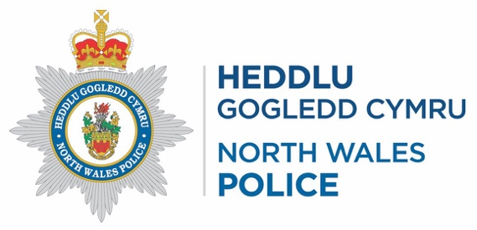
2022/437 - Mental Health
In response to your recent request for information regarding.
Response Date:06/06/2022
date period 01/04/18 - 15/05/22
requested - any call where mental health is factored Location - Force wide data in financial years please
 | 2018 | 2019 | 2020 | 2021 | 2022
999 | 654 | 2198 | 2220 | 2465 | 316
A* | 0 | 0 | 0 | 0 | 1
ALARM | 0 | 0 | 1 | 1 | 0
AMB | 38 | 187 | 158 | 166 | 17
ANPR | 1 | 0 | 0 | 0 | 1
CALLER D* | 1 | 0 | 0 | 0 | 0
CCTV | 1 | 5 | 0 | 1 | 0
COAST GD | 0 | 0 | 0 | 1 | 0
COUNTER | 7 | 34 | 25 | 17 | 2
E-MAIL | 15 | 57 | 58 | 52 | 4
FACEBOOK* | 0 | 0 | 0 | 1 | 0
FAX | 0 | 0 | 1 | 0 | 0
FIRE | 0 | 5 | 1 | 4 | 0
H* | 0 | 1 | 0 | 0 | 0
INTERNAL | 7 | 20 | 24 | 26 | 1
NON-EMER | 388 | 1339 | 1615 | 1268 | 164
Not Recorded | 31 | 183 | 215 | 272 | 28
OFFICER | 0 | 0 | 4 | 4 | 0
ONLI REC | 1 | 3 | 13 | 27 | 3
ORD CALL | 0 | 5 | 2 | 4 | 0
POL | 8 | 56 | 57 | 54 | 12
SMS | 0 | 0 | 0 | 1 | 0
WEBCHAT | 5 | 16 | 31 | 48 | 5
Total | 1157 | 4109 | 4425 | 4412 | 554

 | 2018 | 2019 | 2020 | 2021 | 2022
3RD | 298 | 350 | 347 | 283 | 13
DIS | 1 | 1 | 161 | 826 | 124
Discovered by police | 75 | 44 | 163 | 333 | 20

EMG | 2563 | 2984 | 3493 | 5366 | 323
EML | 196 | 174 | 226 | 348 | 73
NET | 129 | 5 | 1642 | 3619 | 235
Not Recorded | 1708 | 2534 | 2216 | 897 | 63
Other | 585 | 333 | 255 | 4 | 0
POR | 10 | 15 | 52 | 286 | 24
PPC | 1 | 1 | 50 | 191 | 8
RIP | 71 | 65 | 63 | 94 | 11
ROP | 0 | 0 | 1 | 8 | 0
Test incident/occurrence - ignore | 1 | 0 | 0 | 0 | 0
TXT | 0 | 0 | 0 | 2 | 0
Total | 5638 | 6506 | 8669 | 12257 | 894
Please find below a key/explanation of the Call Source / Occurrence Sources:
999 or priority call
Alarm monitoring centre
Ambulance Service
Incident created as a result of ANRP activation Incident created as result of contact from CCTV Coastguard
Created by Front Counter staff
-
-
Call from Fire Service
Call from internal member of staff
Non-Emergency call (101)
Call source field left empty; no option selected Created as result of radio transmission from an officer
Received via online form Non-Emergency call (101)
Call from another Police Service Text message/text relay Webchat
DBP Discovered by Police
EMG Emergency telephone call e.g. (999)
RIP Reported in person - Inside police station EML Email to the police
ROP Reported in person - Outside police station NET Non-emergencytelephonecalle.g.(101) POR Police on-line reporting
TXT Text message to the Police
999
ALARM
AMB
ANPR
CCTV
COAST GD
COUNTER
E-MAIL
FAX
FIRE
INTERNAL
NON- EMER
Not Recorded
OFFICER
ONLI REC
ORD CALL
POL
SMS
WEBCHAT
3RD Other 3rd party reporting
SMM Social media message to the police
PPC Parent,professional,carer3rdpartyreport DIS Disclosed as part of an ongoing investigation ORD Hist - ORD call
COM Hist - Computer
OTH Hist - Other
TDD Hist - TDD input
IGN Hist-Testincident/occurrence-ignore
*‘a’,’ H’ ‘FACEBOOK: and ‘CALLER D’ are typos.
Although the Caller Source should be selected from a drop-down list, it is still possible to free text into this field and it is possible for an I/CAD incident to be created with incorrect information entered. These catergories are not an option on the Call Source drop down list.
THIS INFORMATION HAS BEEN PROVIDED IN RESPONSE TO A REQUEST
UNDER THE FREEDOM OF INFORMATION ACT 2000, AND IS CORRECT AS AT 26/05/2022

Appendix 2A

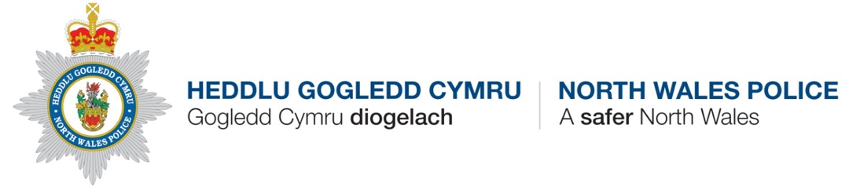
Rhyddid Gwybodaeth – y Drefn Adolygu
Os nad ydych yn fodlon ag ymateb Heddlu Gogledd Cymru i gais am wybodaeth dan Ddeddf Rhyddid Gwybodaeth 2000, gallwch anfon apêl ysgrifenedig at:
Uned Rhyddid Gwybodaeth a’r Cynllun Cyhoeddi Pencadlys Heddlu Gogledd Cymru,
Glan-y-Don,
Bae Colwyn,
Conwy LL29 8AW
Neu trwy e-bost at:deddfrhyddidgwybodaeth@heddlu-gogledd-cymru.police.uk
Bydd adolygiad mewnol yn cael ei gynnal a byddwn yn anelu at ymateb o fewn 20 diwrnod gwaith. Fodd bynnag, os na allwn gwblhau’r adolygiad o fewn y cyfnod hwn, byddwn yn rhoi gwybod i chi.
Os cafodd cais am wybodaeth sylw drwy’r dulliau arferol (e.e. drwy'r adran recriwtio) ac y derbyniwyd cwyn wedi hynny, ni ymdrinnir â’r gŵyn honno dan brosesau Rhyddid Gwybodaeth. Dim ond os cafodd cais am wybodaeth ei brosesu fel cais Rhyddid Gwybodaeth swyddogol y defnyddir y broses gwyno hon.
Os penderfynwch ofyn am i adolygiad o’r fath gael ei gynnal, ac os ydych yn parhau yn anfodlon wedi hynny, yna mae gennych hawl i ofyn i’r Comisiynydd Gwybodaeth ystyried eich cwyn.
Manylion cysylltu â’r Comisiynydd Gwybodaeth yw
Swyddfa Comisiynydd Gwybodaeth Wycliffe house
Water Lane
Wilmslow
Cheshire
SK9 5AF
Ffôn: 01625 545700
Ffacs: 01625 524510 E-bost :mail@ico.gsi.gov.uk
Freedom Of Information- Review Procedure.
If you are unhappy with a response to a request for information from North Wales Police made under the Free- dom Of Information Act 2000 then you can make an appeal in writing to:
Freedom of Information and Publication Scheme Unit North Wales Police Headquarters,
Glan y Don,
Colwyn Bay,
Conwy LL29 8AW
or via email to, FreedomOfInformation@north-wales.police.uk
An internal review will be conducted and we will aim to respond within 20 working days. However, if we are una- ble to complete the review by this date, we will advise you accordingly.
Where a request for information was dealt with by normal methods of business delivery (e.g. via the recruitment department) and a complaint is received, this will not be dealt with under the FOI complaints process. Only where the request has been processed as an official FOI request will this complaint process be utilised.
If you decide to ask for such a review to be undertaken and, following this process, you are still dissatis- fied, you then have the right to direct your complaint to the Information Commissioner who will consider it.
Contact details for the Information Commissioner
Information Commissioner’s Office Wycliffe House
Water Lane
Wilmslow
Cheshire
SK9 5AF
Telephone: 01625 545700 Fax: 01625 524510
E-mail: mail@ico.gsi.gov.uk

Appendix 3
OFFICIAL
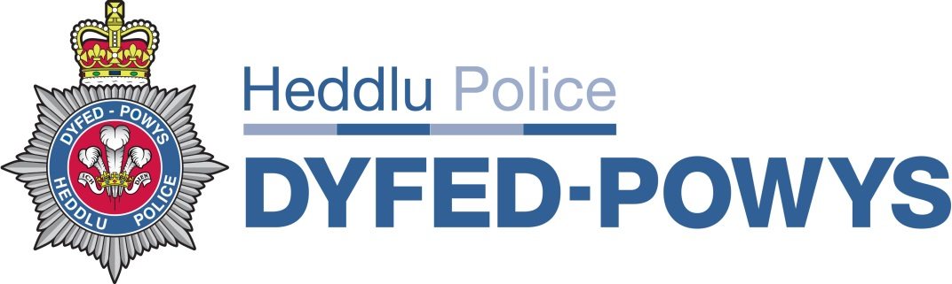

FOI Reference: 425/2022

Request:

I am a third year PCDA student and am compiling a dissertation on the demands of mental health on policing. I am looking for data from pre pandemic (April 2018) to post pandemic (May 15th 2022) where Police have been called for incidents that relate to mental health in any way. I am trying to evidence if the calls for mental health to police have risen since pre pandemic and if so, how much. Statistics relating to this is the information that is sought and any qualifying information such as origins or call (broadly for example, ambulance, public, third sector such as charity)

Any call where mental health is factored

Location - Force wide data in financial years please

Date period - 01/04/18 - 15/05/22

Response :

I can confirm that Dyfed-Powys Police does hold the information requested, as outlined below.

Origin of Notification | FY 18-19 | FY 19-20 | FY 20-21 | FY 21-22 | FY 22-23  (Up Until 15/05/2022) | Grand Total
101 | 276 | 510 | 626 | 442 | 66 | 1920
999 | 261 | 456 | 613 | 446 | 59 | 1835
101 WELSH | 2 | 4 | 4 | 2 | 0 | 12
ALARM CO. | 1 | 1 | 0 | 0 | 0 | 2
AMBULANCE | 48 | 65 | 64 | 43 | 5 | 225
CARELINE | 0 | 1 | 0 | 0 | 0 | 1
E-MAIL | 7 | 11 | 16 | 18 | 2 | 54
F/BOOK | 0 | 0 | 0 | 4 | 0 | 4
F/BOOK DM | 0 | 0 | 0 | 3 | 0 | 3
FIRE | 0 | 1 | 0 | 0 | 0 | 1
ONLINE | 1 | 11 | 7 | 0 | 0 | 19
ORLO | 0 | 0 | 2 | 0 | 0 | 2
OTHER | 1 | 4 | 10 | 3 |  | 18
POL968 | 6 | 12 | 22 | 7 | 1 | 48
POL984 | 0 | 0 | 1 | 0 | 0 | 1
POLICE | 2 | 8 | 6 | 10 | 2 | 28
PSP | 1 | 2 | 3 | 1 | 0 | 7
RADIO | 6 | 13 | 10 | 10 | 2 | 41
Single Online Home (Dyfed-Powys Police Website) | 0 | 0 | 0 | 7 | 1 | 8
TEL. | 40 | 24 | 32 | 12 | 1 | 109
VISITOR | 4 | 4 | 2 | 1 | 0 | 11
Grand Total | 656 | 1127 | 1418 | 1009 | 139 | 4349

Please note: The figures provided above are calls where a mental health tag was attached to them, indicating it was mental health related. We have no other way of tracking if an incident was mental health related on the system that records incidents.

It should be noted that as a result of the systems adopted by Dyfed-Powys Police in relation to the recording of such information that the information released may or may not be accurate.
(This is a response under the Freedom of Information Act 2000 and disclosed on 16/06/2022)

Appendix 3A

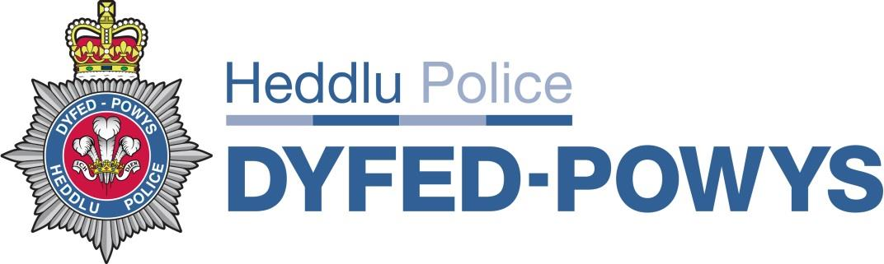
Freedom of Information Act 2000
Internal Review Process
Dyfed Powys Police have an internal review process for requestors who wish to seek an internal review regarding their requests for information. Using the internal review process will not affect the right of a requestor to appeal directly to the Information Commissioner if he/she so wishes.
Who can seek an internal review?
Anyone who has requested information from the Force can request an internal review; this includes applicants whose requests have been deemed vexatious. If a requestor has requested information and is not satisfied with the way Dyfed Powys Police has dealt with the request, the requestor can use the internal review process to have it looked at again. If someone who requested information would like to submit an internal review but cannot do so themselves another person can submit an internal review on their behalf.
What can a requestor seek an internal review about?
A requestor can seek an internal review about the range, amount and format of information Dyfed Powys Police have sent following a request. A requestor can also seek an internal review about the way a request was handled – for example, the time it took to respond, or the way letters were worded.
How can a requestor submit an internal review?
A requestor will need to contact the Freedom of Information Unit at Dyfed Powys Police. It will be helpful if the requestor can provide as much information as possible about the request made and the reason for the internal review. If possible, the original reference number provided to the requestor should be quoted. The Freedom of Information Unit can be contacted at the following address:
Freedom of Information Unit Dyfed Powys Police
PO Box 99
Llangunnor
Carmarthen
SA31 2PF
Telephone: 101 /01267 222020
Direct Line: 01267 226014/01267 226297 E-mail: FOI@Dyfed-Powys.pnn.police.uk

Time Limits
If you wish to submit an internal review you should do this within two months following the final response you receive from Dyfed Powys Police in relation to your request, this is in line with ICO (Information Commissioner’s Office) guidance. Dyfed Powys Police aims to deal with and complete your internal review as soon as practicable and in any case within twenty working days and in “exceptional circumstances” forty working days following receipt of your request for a review, this is in line with Information Commissioner’s Office Guidance.
What will happen to a request for an internal review?
- • Once the Freedom of Information Unit has enough details to identify the request the Dyfed Powys Police will begin a review of what happened and when.
- • Where Dyfed Powys Police has not followed proper procedures or has failed to provide a high quality of service, an apology and an explanation on what procedures Dyfed Powys Police will follow to ensure it doesn’t happen again will be provided to the requestor.
- • If Dyfed Powys Police should have provided information and has not provided it, the requestor will be sent the information immediately. If it is believed following review that the original response was correct, the requestor will be informed of this. The requestor will be informed of his/her options.
Appeal to the Information Commissioner
If the requestor is still not satisfied following the review, he/she can take the appeal to the Information Commissioner who may investigate the matter on behalf of the requestor. This option is open to the requestor at all times. It would be preferable to Dyfed Powys Police if matters were sorted out at a local level if possible. The Information Commissioner will decide if he/she will investigate or not.
The Information Commissioner’s office can be contacted at the following address: Information Commissioner
Wycliffe House
Water Lane
Wilmslow Cheshire SK9 5AF
Telephone: 0303 123 1113 or 01625 54 57 45 Web address: www.ico.org.uk

Appendix 4

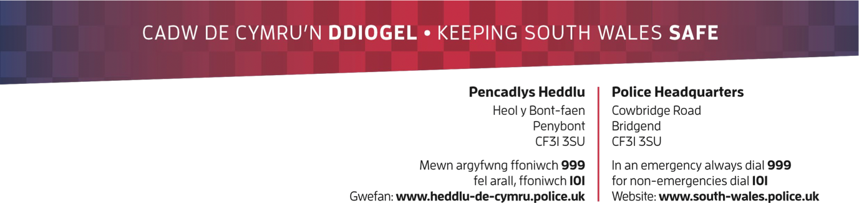
Freedom of Information Request 523/22
Response Date: 23rd June 2022
I am looking for data from pre pandemic (April 2018) to post pandemic (May 15th 2022) where Police have been called for incidents that relate to mental health in any way. I am trying to evidence if the calls for mental health to police have risen since pre pandemic and if so, how much. Statistics relating to this is the information that is sought and any qualifying information such as origins or call (broadly for example, ambulance, public, third sector such as charity) to summarise date period 01/04/18 - 15/05/22
requested - any call where mental health is factored Location - Force wide data in financial years please
Clarification: I am looking for all calls that have the mental health qualifier and their origins for example if they originated from ambulance etc.
RESPONSE
We consulted with our analysts that have provided a response to your request.
Please see attached document entitled ‘Response data 523_22’ which breaks down calls received that relate to mental health.
Please note we have provided a breakdown by method of the call but we do not record origins of the call in a retrievable format.
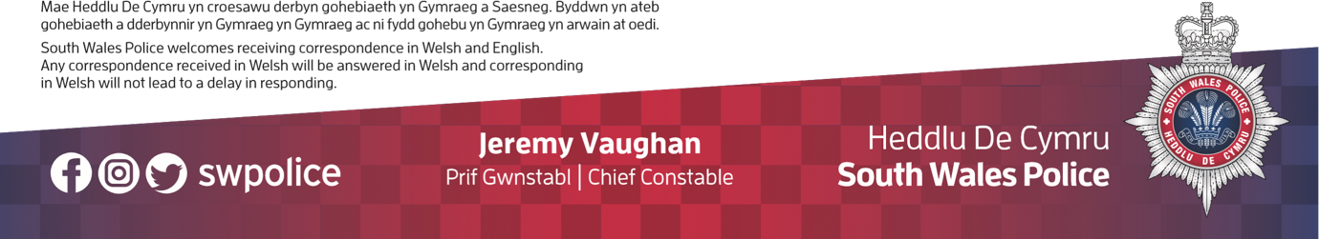

Appendix 4A

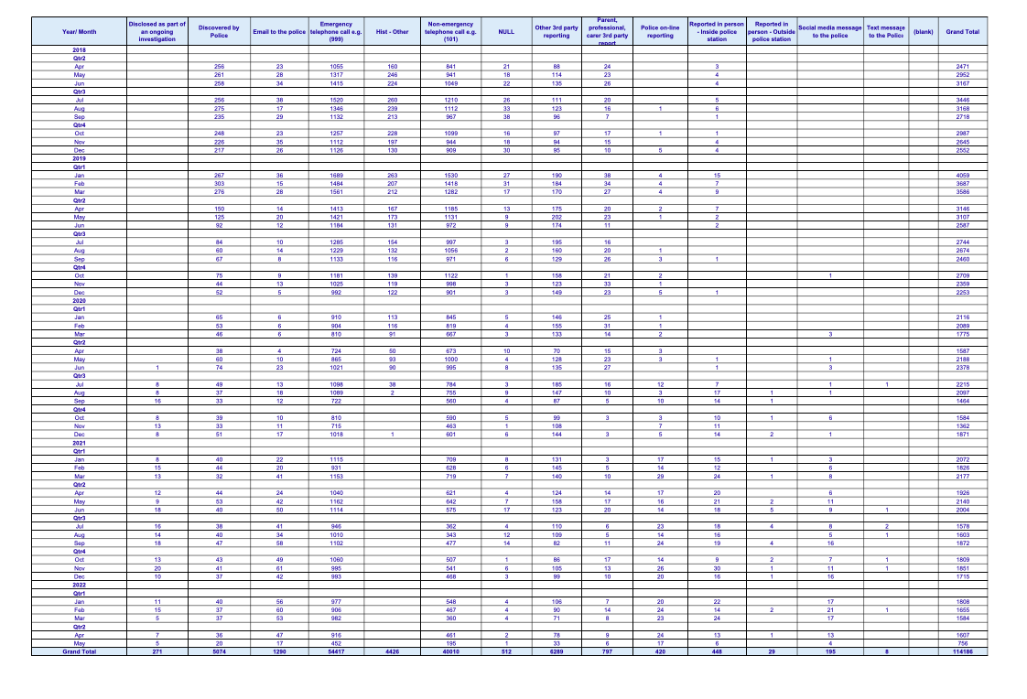

Appendix 4B

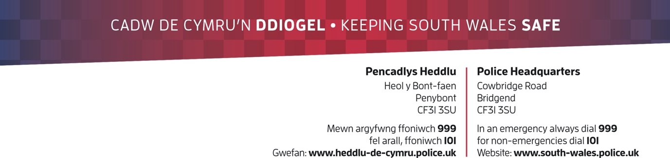
SOUTH WALES POLICE Freedom of Information Complaints Procedure
If, upon receiving a response to a Freedom of Information Request, you are unhappy with the outcome, you may request an Internal Review.
Please note, any written reply from an applicant expressing dissatisfaction with an authority’s response to a request for an information will be treated as a complaint and will automatically lead to an Internal Review.
Please send any requests for an Internal Review to: freedomof.information@south-wales.pnn.police.uk Alternatively, requests can be addressed to:
Freedom of Information
South Wales Police Data Management and Disclosure Unit South Wales Police Headquarters
Cowbridge Road
Bridgend
CF31 3SU
In order to progress your Internal Review as quickly as possible, please clearly explain the reasons for your dissatisfaction and quote your initial request reference number.
Please include full contact details including a phone number where possible, in case we need to contact you during the Internal Review process.
Receipt of your Internal Review will be acknowledged in writing. A fair and thorough review will then take place, enabling a fresh decision to be taken on a reconsideration of all the factors relevant to the issue. You will then be provided with a report containing the findings of the review and any subsequent actions takenby South Wales Police. It should take no longer than 20 working days to complete the Internal Review process.
If after the appeals procedure has concluded, you are still dissatisfied you have the right to direct your comments to the Information Commissioner (www.ico.gov.uk) who will give it due consideration.
Please note, the Information Commissioner will expect an applicant to have requested an Internal Review before they conduct an investigation into the matter.
If you have any queries in relation to this process, please contact the Freedom of Information Office on 01656 303444 or via email at the email address provided above.
This complaints procedure will also be followed if a complaint is received in relation to the South Wales Police Publication Scheme.
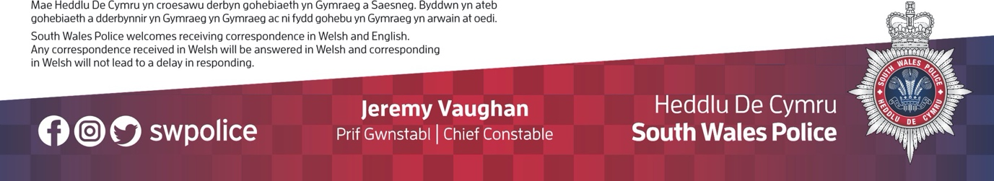
HEDDLU DE CYMRU Gweithdrefn Cwyno am Rhyddid Gwybodaeth
Os byddwch, wrth dderbyn ymateb i Gynnig Rhyddid Gwybodaeth, yn anhapus â'r canlyniad, gallwch ofyn am Adolygiad Mewnol.
Cofiwch, caiff unrhyw ymateb ysgrifenedig gan ymgeisydd yn mynegi anfodlonrwydd ynglŷn ag ymateb awdurdod i gais am wybodaeth ei drin fel cwyn a bydd yn arwain at Adolygiad Mewnol yn awtomatig.
Anfonwch unrhyw geisiadau am Adolygiad Mewnol at : freedomof.information@south-wales.pnn.police.uk Neu, gall ceisiadau cael eu hanfon at:
Rhyddid Gwybodaeth
Uned Rheoli a Datblygu Data Heddlu De Cymru Pencadlys Heddlu De Cymru
Heol y Bont-faen
Pen-y-bont ar Ogwr
CF31 3SU
Er mwyn prosesu eich Adolygiad Mewnol mor gyflym â phosib, esboniwch eich rhesymau dros eich anfodlonrwydd yn glir os gwelwch yn dda a dyfynnwch rif cyfeirnod eich cais cychwynnol.
A wnewch chi gynnwys eich manylion cyswllt llawn os gwelwch yn dda gan gynnwys rhif ffôn lle y bo'n bosibl, rhag ofn y bydd angen inni gysylltu â chi yn ystod y Broses Adolygu.
Byddwn yn cydnabod derbyn eich Adolygiad Mewnol yn ysgrifenedig. Caiff adolygiad teg a thrylwyr ei wneud, gan alluogi penderfyniad ffres ar ôl ail-ystyried yr holl ffactorau sy'n berthnasol i'r broblem. Byddwch wedyn yn derbyn adroddiad yn cynnwys canfyddiadau'r adolygiad ac unrhyw gamau dilynol a gymerwyd gan Heddlu De Cymru. Ni ddylai gymryd mwy na 20 diwrnod gwaith i gwblhau'r broses Adolygiad Mewnol.
Os byddwch dal yn anfodlon ar ôl i'r broses apelio ddod i ben, mae gennych hawl i gyfeirio'ch sylwadau at y Comisiynydd Gwybodaeth (www.ico.gov.uk) a fydd yn rhoi'r ystyriaeth ddyledus iddynt.
Noder, bydd y Comisiynydd Gwybodaeth yn disgwyl i'r ymgeisydd fod wedi gwneud cais am Adolygiad Mewnol cyn iddynt gynnal ymchwiliad i'r mater.
Os oes gennych unrhyw ymholiadau yn ymwneud â'r broses hon, yna cysylltwch â'r Swyddfa Rhyddid Gwybodaeth ar 01656 303444 neu drwy'r cyfeiriad e-bost sydd wedi'i nodi uchod.
Bydd y weithdrefn gwyno hon yn cael ei ddilyn hefyd os bydd cwyn yn cael ei derbyn yn ymwneud â Chynllun Cyhoeddiadau Heddlu De Cymru.

Appendix 5

27/07/2022, 11:51 Mental Health Demand on Policing Survey
Mental Health Demand on Policing Survey
Information Sheet
Study Title: A critical evaluation of mental health demand on the Police
Invitation
The researcher would like to invite you to take part in a research study. Before you decide
whether to take part it is important that you understand why the research is being done and
what it will involve for you. Please take time to read this carefully and ask the researcher if
you have any questions. If at any point anything becomes unclear or whether you would like
more information, please sent your questions to the researcher.
What is the purpose of the study?
The purpose of this study is to aid the researcher in their degree dissertation, it will be used
for an educational purpose. The results will also be provided to the university and public for
consideration of advising funding in Welsh Government in order to further support Police
services and the NHS.
Why have I been invited to take part?
We are hoping to recruit as many participants as possible to obtain a broad view of the
mental health crisis in Wales from the perspective of people working in either sector or the
eligibility question is built into the survey.
Do I have to take part?
No. It is up to you to decide if you wish to take part in this study. It is important that you
read this information sheet in order to understand what is involved during this study. You will
then be asked to sign a consent for to show that you agree to take part. You are free to
withdraw at any time, without giving a reason.
What will happen to me if I take part?
When taking part in this questionnaire the researcher encourages you to answer the
questions truthfully and honestly, this will help the researcher to see potential trends. The
questionnaire will not take long to complete, and your responses will be kept for no longer
than necessary. The research will be completed through Microsoft Forms and will be
* Required accessed remotely.
Information Sheet Continued
Expenses and Payments
There will be no monetary gain for yourself in taking part in this research, the participation of yourself is completely voluntary. Due to the research being conducted online there will not be any cost incurred to the participants.
What will I have to do?
The researcher would like you to read the information sheet and if you are happy, tick the consent box on the survey which is question 1, this shows that you are happy to take part in the study. After submission of the questionnaire, there will be no further action required form you. Are there any disadvantages or risks to taking part?
https://forms.office.com/Pages/DesignPageV2.aspx?origin=NeoPortalPage&subpage=design&id=-REPTm4EBUWcuNshUjEeIWIjnHUUrr1Aul8zXA6-GHBU... 1/7
27/07/2022, 11:51 Mental Health Demand on Policing Survey
Are there any disadvantages or risks to taking part?
There are no perceived disadvantages to taking part. Your assistance will greatly assist in understanding the demand of the mental health crisis on the NHS and Police in Wales. Once the research is completed and should you feel like you need support, there are many organisations that can help.
Heads Together https://www.headstogether.org.uk/partners/charity-partners/
Heads Together brings together a coalition of charities with decades of experience in tackling the stigma around mental health in the UK.
Will the information I give stay confidential?
The researcher would like to emphasise that the research will be conducted in accordance with the University of Wales Trinity Saint David regulations in accordance with research guidelines. You will not be asked for your name but will be asked for characteristics about yourself. Your response will be anonymous, and the researcher will not be able to see your email address as this will also be kept anonymous. Your force will not see your response directly, they will only see the final analysed results if they request a copy, no names will be disclosed.
All data gathered in this study will be kept confidential and anonymous in accordance with the University of Wales Trinity Saint David ethical guidelines as well as the Data Protection Act 1998. This act specifies how the information gathered should be handled and how it should be kept safe and secure. It also specifies that the data gathered should not be kept for longer than necessary.
What will happen if I don’t carry on with the study?
If you withdraw from the study all the information and data collected from you, to date, will be destroyed. If you do wish to withdraw, please ensure that your request is done before the analysis is completed as your request may not be processed before the results are published. What will happen to the results of the research study?
This research is being carried out as part of a Degree for Professional Policing at the University of Wales Trinity Saint David. The findings of this study will be reported as part of a dissertation and may also be published in academic journals or at conferences.
Who is organising the research?
This research has been approved by the University of Wales Trinity Saint David, Ethics Committee.
What happens next?
If you would like a copy of the information sheet and survey with consent for your records, please email the researcher.
Thank you for taking the time to read this information
If you decide to take part or you have any questions, concerns or complaints about this study please contact one of the research team using the details below.
Researcher: Warren Griffiths
Email: 1916169@student.uwtsd.ac.uk

https://forms.office.com/Pages/DesignPageV2.aspx?origin=NeoPortalPage&subpage=design&id=-REPTm4EBUWcuNshUjEeIWIjnHUUrr1Aul8zXA6-GHBU... 2/7
27/07/2022, 11:51 Mental Health Demand on Policing Survey
Survey Questions
- To be eligible to complete this survey, please confirm that you work for the NHS or Police service in Wales and have done so for 3 years or more (Pre Covid-19 to Post Covid-19) *
I confirm the above is true
- Which service do you work for? * NHS
Police
- Length of service *
3-5 Years
6-10 Years
11-15 Years
16 Years or more
- Which age bracket do you fall within? *
18-24 years old 25-34 years old 35-44 years old 45-54 years old
55 years old and over
https://forms.office.com/Pages/DesignPageV2.aspx?origin=NeoPortalPage&subpage=design&id=-REPTm4EBUWcuNshUjEeIWIjnHUUrr1Aul8zXA6-GHBU... 3/7
27/07/2022, 11:51 Mental Health Demand on Policing Survey
5. Choose an option that best describes your ethnic group or background
*
White (Welsh/English/Scottish/Northern Irish/British/Irish/Gypsy/Irish Traveller)
Multiple Ethic Groups (White and Black African/White and Black Caribbean/White and Asian)
Asian or Asian British (Indian/Pakistani/Bangladeshi/Chinese) Black (African, Caribbean or Black British)
Prefer not to say
Other
6. Choose an option that describes your gender identity *
Woman
Man Non-binary/Non-Conforming Transgender
Prefer not to say
7. Do you feel Covid-19 has impacted the demand for mental health services? *
Yes
No
Not sure
https://forms.office.com/Pages/DesignPageV2.aspx?origin=NeoPortalPage&subpage=design&id=-REPTm4EBUWcuNshUjEeIWIjnHUUrr1Aul8zXA6-GHBU... 4/7
27/07/2022, 11:51 Mental Health Demand on Policing Survey
8. Please explain your response to question 7 *

9. Pre Covid-19, in relation to mental health incidents, were Police *
Under utilised
Over utilised
Utilised where appropriate
10. Please explain your response to question 9 *

11. Since Covid-19, has demand for mental health *
Increased Decreased Stayed the same Unsure
https://forms.office.com/Pages/DesignPageV2.aspx?origin=NeoPortalPage&subpage=design&id=-REPTm4EBUWcuNshUjEeIWIjnHUUrr1Aul8zXA6-GHBU... 5/7
27/07/2022, 11:51 Mental Health Demand on Policing Survey
12. Please explain your response to question 11 *

- Since Covid-19, does the NHS rely on Police for attendance at mental health incidents *
More Less
The same Unsure
- Please explain your response to question 13 *
15. Pre Covid-19, in your opinion, who responded first or initially to mental health incidents? *
NHS Police Unsure
https://forms.office.com/Pages/DesignPageV2.aspx?origin=NeoPortalPage&subpage=design&id=-REPTm4EBUWcuNshUjEeIWIjnHUUrr1Aul8zXA6-GHBU... 6/7
27/07/2022, 11:51 Mental Health Demand on Policing Survey
16. Further to the previous question, since Covid-19, has this *
Increased Decreased Unsure
17. Please explain your response to question 15 & 16 *
18. Thank you for completing this survey, please use the below text box should there be any further comments or responses you would like to add

This content is neither created nor endorsed by Microsoft. The data you submit will be sent to the form owner.
Microsoft Forms

https://forms.office.com/Pages/DesignPageV2.aspx?origin=NeoPortalPage&subpage=design&id=-REPTm4EBUWcuNshUjEeIWIjnHUUrr1Aul8zXA6-GHBU... 7/7

Appendix 6
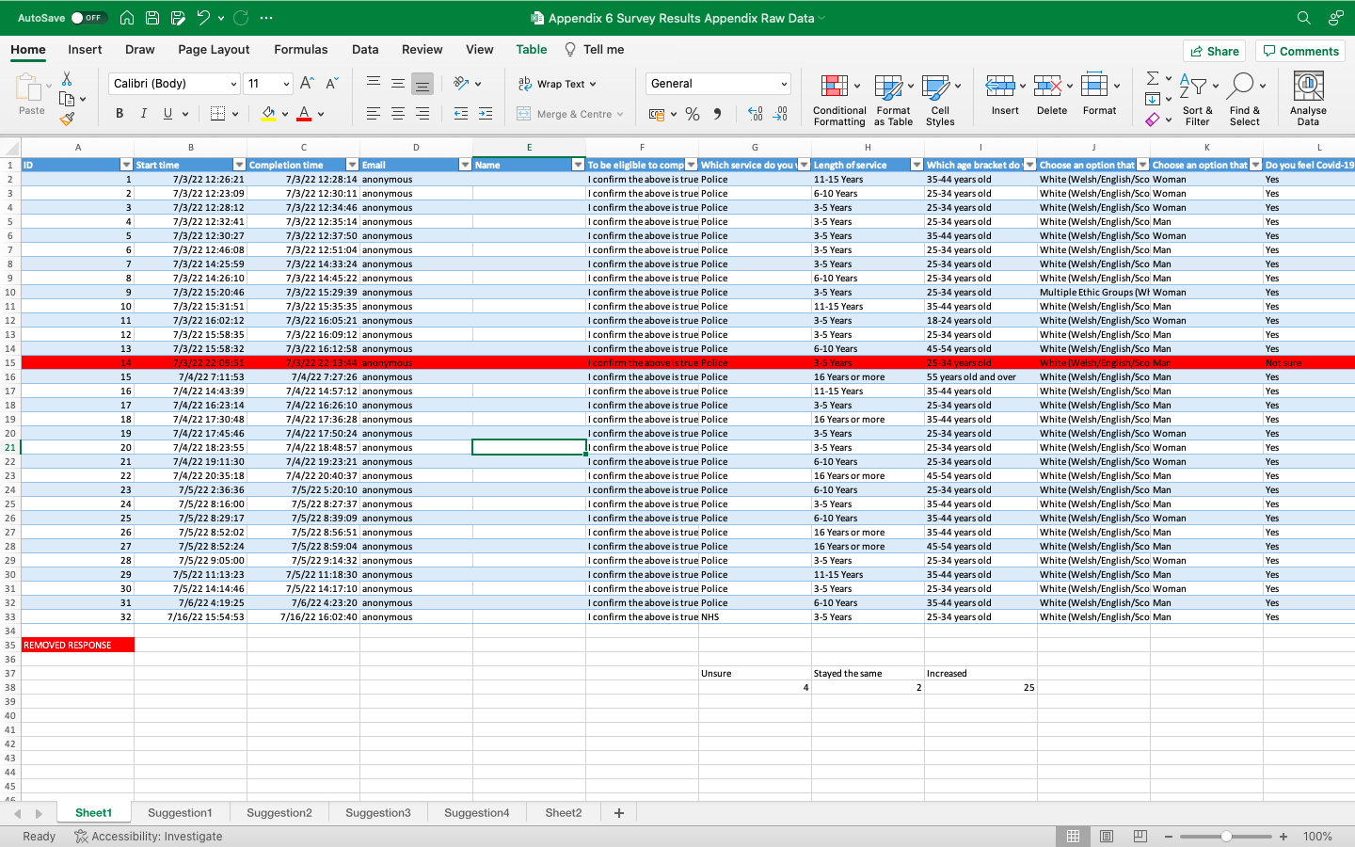
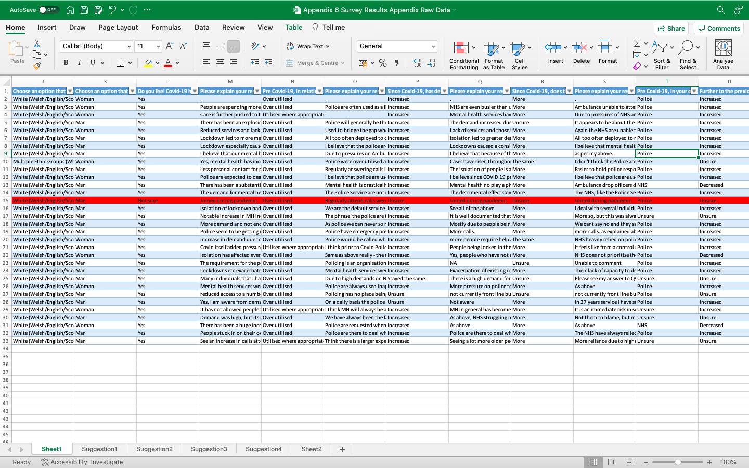

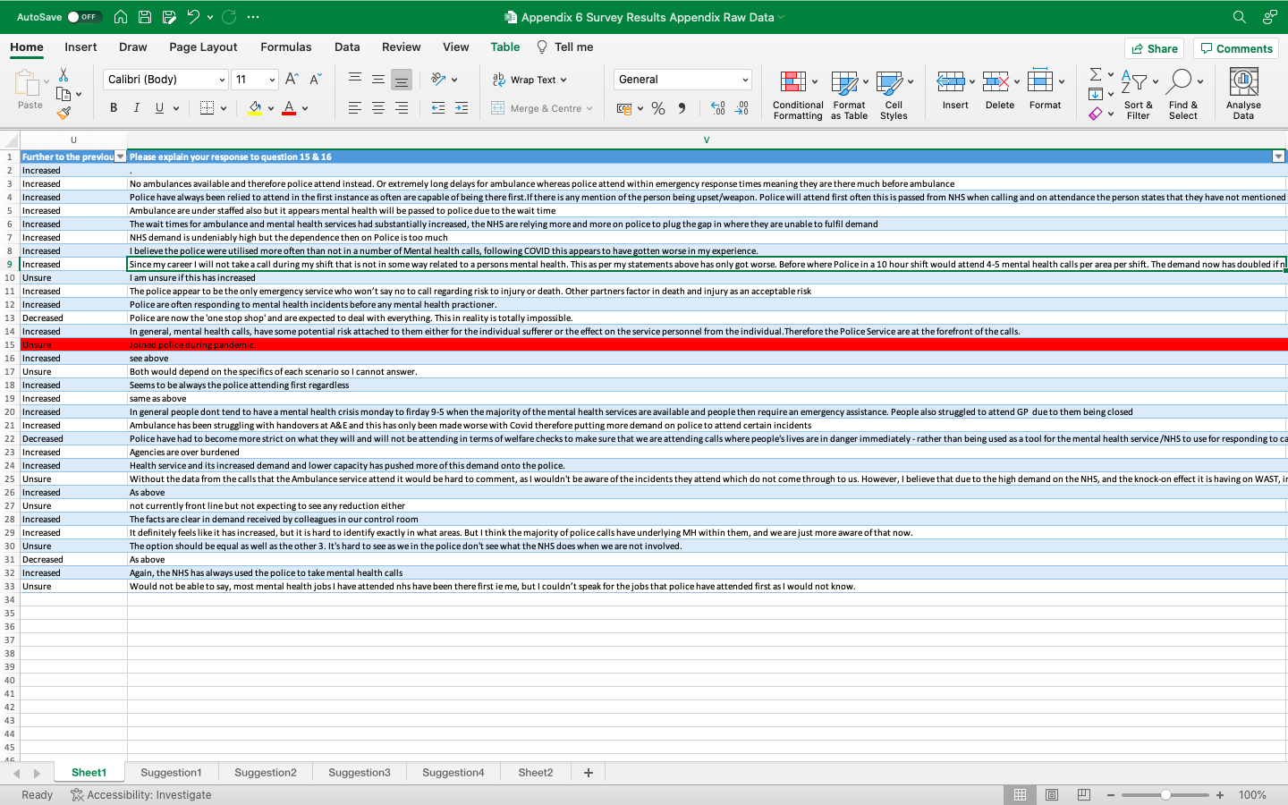

Appendix 7

Interview with AMHP’s

What is your role title?

How long have you been in your role?

What service do you work for?

Can you describe your role?

In your opinion, who should be attending Mental Health incidents in the first instance?

In your opinion, who attends Mental Health incidents in the first instance?

In your opinion, who is best equipped to attend mental health incidents in the first instance in terms of skills?

Prior to the pandemic, what was your view to the amount of calls you were getting in relation to mental health?

How has the pandemic impacted that?

Do you feel the pandemic has had a negative effect on mental health services in Wales?

Can you elaborate on your previous answer?

On a scale of 1-10 prior to the pandemic, how much did the NHS/Ambulance service rely on Police for initial attendance to Mental health calls?

Can you elaborate on your previous answer?

On a scale of 1-10, post pandemic, how much did the NHS/Ambulance service rely on Police for initial attendance to Mental health calls?

Can you elaborate on your previous answer?

In your view, what can be done to improve mental health services in Wales?

If you had a way of implementing an idea to fix the way mental health services are currently in Wales, what would that idea be?

What boundaries do you feel are in place to stop this idea being put into place?

Where do you see mental health services in 5 years?

Do you think they would have improved?

Appendix 8

Interview with AMHP’s

What is your role title?

Mental health triage professional

How long have you been in your role?

3 years

What service do you work for?

Gwent police mental health team

Can you describe your role?

The MHTP has knowledge and experience of working with people with mental health problems and read only access to information held on health and social services databases. (Of the current team, 4 are Approved Mental Health Professionals (AMHPs), 1 is a Registered Mental Health Nurse and 1 is a registered Social Worker with a background in Child and Adolescent Mental Health.

The role of the MHTP is to use their knowledge and expertise to provide advice, guidance and direction to Police Staff and Officers both in the FCR and in the community with regard to any incoming calls or live incidents where there are concerns, or possible concerns, regarding a person’s mental health. Changes to Section 136 of the Mental Health Act following the implementation of the Police and Crime Act 2016 mean that Police officers, where practicable, have a responsibility to consult certain professionals before making the decision to detain someone under Section 136. It is expected that the MHTPs who are AMHPs and the MHTP who is a registered nurse would fulfil that role when available (ward staff at Talygarn are the agreed contingency). Such consultation has been shown to lead to a reduction in the use of Section 136 and the promotion of other, less restrictive alternatives.

Input from MHT has proven to have the potential to reduce the number of occasions when Police need to be deployed to incidents and to reduce the amount of time Police spend dealing with incidents once deployed. It has also been shown to lead to better outcomes for service users through signposting and negotiating access to more appropriate services as well as through a reduction in Section 136 detentions.

Whilst it is the benefits to the Police force that have led to the funding of the MHT service, it is important to remember that the primary focus of MHT has to be on the health and wellbeing of the person rather than on saving Police time. Indeed, there will be occasions when securing the best outcome for the person will mean more Police time rather than less, at least in the short term. It is also important that MHT does not take on roles and responsibilities that are the responsibility of partner agencies in health and social services.

Any mental health incidents should be tagged for the attention of MHT on Storm. If there is any doubt into the mind of the MHTP as to what is expected of them then they should seek clarification from the AIS or call handler.

Having been tagged it is the responsibility of MHT to check the databases they have access to for relevant information and to communicate that information via entries in the STORM log as appropriate (please see the sections below on case recording and information sharing for further information). MHT should also consult the frequently presenting persons file to see if there is information that should inform the Police response (please see section on frequently presenting persons below).

MHT can speak to officers at the scene if they consider it appropriate although they should never agree to using ‘Point to Point’ contact as such calls are not recorded unlike all other calls to and from the control room. MHT can also speak directly to members of the public if they consider it appropriate. MHT would not be expected to speak directly with a person who is at imminent risk of suicide e.g. someone standing on the side of the Severn Bridge threatening to jump off. This would be a role for a trained Police negotiator.

In your opinion, who should be attending Mental Health incidents in the first instance?

It would be dependant upon the actual situation however first point of contact for MH incidents should be ambulance r the community MH / crisis teams.
However, if there is an immediate identifiable risk to life where it requires an emergency response to prevent danger to life then police would be first contact although I would still expect the police after reducing risk to be supported by community MH or ambulance to address the mental health issue and make the appropriate referral to the appropriate professionals.

In your opinion, who attends Mental Health incidents in the first instance?

It is becoming more and more prevalent that public, ambulance and MH teams make contact to police to attend as the first contact and is increasing demand on police for MH incidents.

In your opinion, who is best equipped to attend mental health incidents in the first instance in terms of skills?

Again this depends upon the situation and the amount of risk/danger is being posed to the individual and public members. In terms of skills however then community MH teams /crisis teams would be best equipped given their qualifications and skills in MH.

Prior to the pandemic, what was your view to the amount of calls you were getting in relation to mental health?

Mental health calls have always had a high prevalence with a varied degree of the types of mental health calls we were getting

How has the pandemic impacted that?

I do feel that it increased during the pandemic, however I do feel that since we’ve begun to return back to some form of normality the calls are at higher prevalence. Also, the suicide rate feels its also increased however may just be a coincidence or I’ve dealt with more than I normally would. I also feel that during the pandemic we dealt with more people who were diagnosed with serious mental illnesses such as bi polars. Schizophrenics.

Do you feel the pandemic has had a negative effect on mental health services in Wales?

Yes, I do feel that it’s had a negative impact.

Can you elaborate on your previous answer?

Due to pandemic services changed the way they worked so face to face support was ceased, services reduced their hours, some services ceased operation and this had a wider impact on the general public as they relied upon these services for social contact, making friends, gave them a purpose to their day and a reason to leave the house

On a scale of 1-10 prior to the pandemic, how much did the NHS/Ambulance service rely on Police for initial attendance to Mental health calls?

5

Can you elaborate on your previous answer?

We were generally called to assist ambulance pre covid and also contacted by community teams to assist when they had not been able to see someone or due gain access to homes for MH patients or to report missing people after a period of their engagement had failed.
On a scale of 1-10, post pandemic, how much did the NHS/Ambulance service rely on Police for initial attendance to Mental health calls?

9

Can you elaborate on your previous answer?
we are called more than ever by ambulance to attend in place of their service as they have no resource to attend, also if we attend in first instance and ask for ambo to attend to take to a+e it’s rare to never that this service happens now the demand on police has increased to police conveying like tis now the normal process. Also, we have more requests to attend people who are elf harming as ambulance don’t have the resources and advise there’s a weapon – this can be a kitchen knife or a razor which are held in every household.
We also get requests to do welfares on people who have left the hospital which I don’t recall having pre pandemic when they should be sending ambo.
Mental health community teams have reduced face to face appointments and pre covid if someone was suicidal or a concern for safety, they would attend the home to assess then call for police back up if required now they call police as primary intervention. Also they would normally attend homes for appts if they aren’t home leave a calling card and do this for a day or two then call 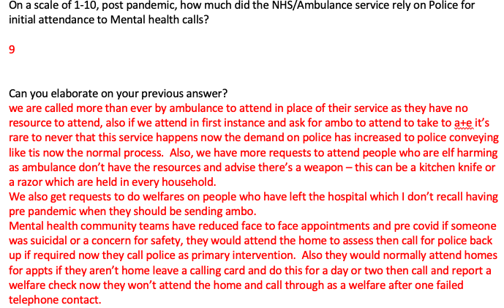and report a welfare check now they won’t attend the home and call through as a welfare after one failed telephone contact.

In your view, what can be done to improve mental health services in Wales?

Reintroduce the working hours and contact facilities they were running pre covid, increase the numbers of staffing available also re open the smaller hospitals such as nhh and rgh .
Look into the ambulance situation and staffing so response can be met.
Also re introducing the social clubs which many people who suffer with their mental health found to be their life crutch previously.

What boundaries do you feel are in place to stop this idea being put into place?

Government and finances and staff shortages and cuts to resources.

Where do you see mental health services in 5 years?

I cant see that there will be much of a change except more interventions will be done online and given to people to access and complete on their own where as pre covid these we conducted face to face.

Do you think they would have improved?

It would hard to say, I hope they will be but at this time it seems impossible to have appositive outlook on the future of mental health when its in such a dire state.

Appendix 9

Interview with AMHP’s

What is your role title?
Lead Nurse Adult mental health & Specialist services

How long have you been in your role?
Approximately 18 months

What service do you work for?
Adult mental health service – Mental health & Learning Disabilities Division ABUHB

Can you describe your role?
The lead Nurse – for Adult Mental Health services is a visible, authoritative and professional clinical leader with responsibility for the direction of nursing, implementation of the corporate nursing agenda, enhancement/modernisation of clinical practice and development of clinical staff to optimise the patient and family experience of care.

In your opinion, who should be attending Mental Health incidents in the first instance?
Difficult question to answer as this will depend on the individual and circumstances
My thoughts are that Mental health should be like physical health will all staff/ services having a basic understanding of MH issues -

In your opinion, who attends Mental Health incidents in the first instance?
Again a difficult question to answer- depending on the nature of the concern.

In your opinion, who is best equipped to attend mental health incidents in the first instance in terms of skills?
Again- all staff/ services should have a level of understanding but who / what happens next is dependent upon the complexity of the situation. mental health is everyone’s business

Prior to the pandemic, what was your view to the amount of calls you were getting in relation to mental health?
Purely my opinion but I think we experienced an increase in MH calls as GPs were more difficult to see and book appointments and Primary care services withdrew from face-to-face contact. Secondary services continued to provide assessments and interventions.

How has the pandemic impacted that?
As above- also patients were reluctant to attend and engage with staff based on their own anxieties around COVID and some became quite isolated as a result of this behaviour which has led toa deterioration in these cases. COVID ad isolation has not been beneficial for secondary MH patients

Do you feel the pandemic has had a negative effect on mental health services in Wales?
Yes.

Can you elaborate on your previous answer?
As above

On a scale of 1-10 prior to the pandemic, how much did the NHS/Ambulance service rely on Police for initial attendance to Mental health calls?

I don’t think I can answer this question
Can you elaborate on your previous answer?

What I can say is that a lot of police calls are tagged as mental health- which I don’t think needs to be the case. as a result of this Police are being drawn into situations that they may not necessarily need to be a part of.

On a scale of 1-10, post pandemic, how much did the NHS/Ambulance service rely on Police for initial attendance to Mental health calls?
Again – I’m not sure I can answer this

Can you elaborate on your previous answer?
As above

In your view, what can be done to improve mental health services in Wales?
I think there are several issues –
- Access to GPs and primary care
- 7 days a week services- MH problems don’t stop after 5 pm in secondary care.
- Pop up clinics – normalising MH issues – reducing stigma
- Issues with recruitment and retention – staffing across several disciplines – pressure on services
- Navigating the MH system… how people access care. Hopefully the 111 single point of access will help with this.
- Investment in estates – some MH environments are poor and not fit for purpose
- HB’s have chosen to disinvest in local services and relied upon commissioned services – often far from home – we need to support people locally with our own staff and services with better outcomes for individuals

If you had a way of implementing an idea to fix the way mental health services are currently in Wales, what would that idea be? 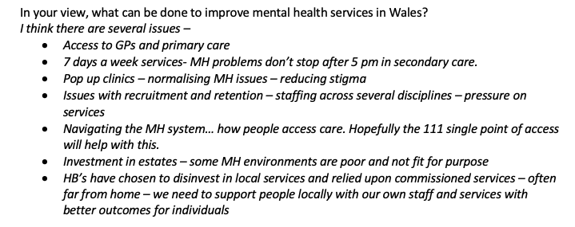

I think the 111 service would be a good start as it should reduce the complexities of the system and stop the ping pong effect from people being bounced from one service to another

What boundaries do you feel are in place to stop this idea being put into place?
- Time
- Money
- Resources- staffing/ estates
- Lack of coordinated approach between Heal boards
- Dealing with the aftereffects of COVID

Where do you see mental health services in 5 years?

I am hopeful that things will have changed ( for the better) as it often feels that we are at breaking point and that MH services are part of a wider machine that is creaking under the pressure. If we do not change – then it wont just be MH services that go into meltdown.

Do you think they would have improved?
I think the approval for the SISU build at the Llanfrechfa site would be a turning point for secondary services and that MH services will be able to focus and plan for the future as this will allow us to support more individuals in Locked rehab, low secure settings and identify a pathway for local recovery.

