PROJECT MANAGEMENT PORTFOLIO

Redevelopment of the Northbridge Central Interchange

A Project Portfolio comprising Parts A, B and C

Part A: Project Proposal Poster
Part B: Project Execution and Monitoring Plan
Part C: Project Management Plan

Student Name: Stacey Blackwood
Student ID: 2424532
Module: Project Management
Module Number: LCLM 5003
Lecturer: Rexon Nting
Date: August 2026

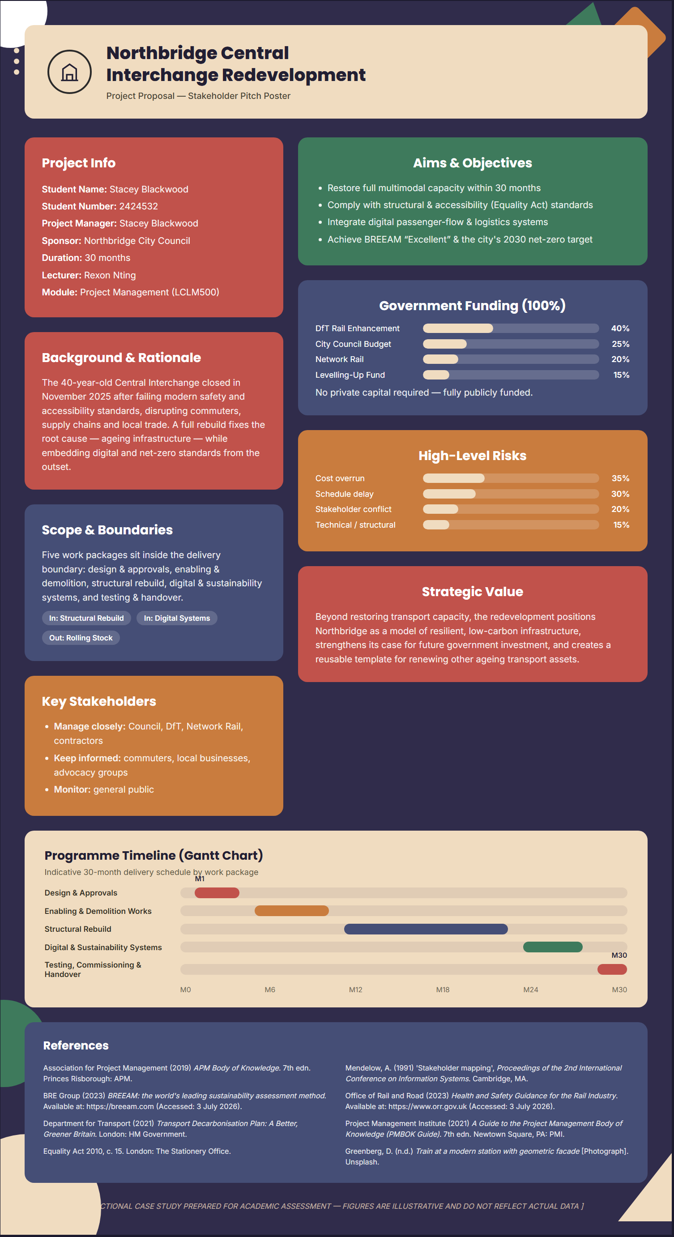
Part B – Reflection on
Feedback (Poster Project)
Student: Stacey Blackwood (2424532)
Module: LCLM5003 – Project Management

Presenting my poster to tutor and peers was a valuable checkpoint in developing my project portfolio, and the feedback I received has directly shaped how I am approaching the final project management plan.

Key strengths
The clearest positive feedback concerned the overall design and structure of the poster. My tutor confirmed that the layout itself was effective — the sections were logically arranged, visually balanced, and easy for an audience to follow. This suggests that my ability to organise information clearly and present it in a professional format is a genuine strength. Peer comments reinforced this, noting that the poster was easy to read at a glance and communicated the project's purpose without unnecessary clutter. This is an important skill for stakeholder communication, where a well-structured visual can convey complex information quickly and credibly.

Areas for improvement
Despite the strong layout, my first draft did not meet the standard expected at this level. My tutor was clear that the poster needed to go further in demonstrating the financial dimension of the project: specifically, it was missing a pie chart showing the project budget and where the funding was coming from. Without this, the poster gave an incomplete picture of project feasibility, since cost and funding source are essential information for any stakeholder assessing whether a project is viable. My tutor also gave me examples of stronger posters to benchmark against, which highlighted that mine lacked the level of detail expected — a general principle he emphasised was that a poster should always contain the full details of the plan, so that stakeholders are fully informed rather than having to seek information elsewhere.
A second, related issue was time management: I did not complete the poster in time for the presentation itself. This meant I presented an unfinished piece of work, which limited how much useful feedback I could get on the final content and undermined the professional impression I wanted to create.
How the feedback informed changes to my plan
This feedback has led to two concrete changes. First, I have added a pie chart to the poster that clearly breaks down the budget and identifies each funding source, so the financial picture is now transparent at a glance. Second, I have reviewed the poster section by section against the benchmark examples my tutor provided, adding the specific details (timelines, resource allocation, and risk considerations) needed to give stakeholders a genuinely complete view of the plan, not just a summary.
On time management, I have built in an earlier internal deadline for completing the poster ahead of any presentation, with a buffer for revisions, so that what I present is finished and polished rather than a work in progress. This same discipline is now reflected in the project management plan itself, where I have scheduled review points earlier in the timeline to avoid repeating the same lastminute pressure.
Overall, the feedback confirmed that my communication and design skills are solid, but that I need to be more rigorous about completeness, financial detail, and deadline discipline — all of which I have carried forward into the final plan.

PROJECT MANAGEMENT PLAN
Redevelopment of the Northbridge Central Interchange

Prepared for: Northbridge City Council and Programme Stakeholders

Prepared by: Stacey Blackwood, Project Manager
Lecturer: Rexon Nting
Module: Project Management

21 August 2026

Contents
1. Introduction .............................................................................................................................. 2. Project Description................................................................................................................... 3. Scope ........................................................................................................................................ 4. Work Breakdown Structure (WBS) ......................................................................................... 5. Quad Chart ............................................................................................................................... 6. Gantt Chart ............................................................................................................................... 7. Stakeholders' Involvement ....................................................................................................... 8. Allocation of Resources ........................................................................................................... 9. Risk Analysis ...........................................................................................................................
10. Conclusion ............................................................................................................................. References ....................................................................................................................................

List of Figures
Figure 1: Work Breakdown Structure for the Central Interchange Redevelopment ...................
Figure 2: Project Quad Chart: Overview, Schedule, Funding and Key Risks .............................
Figure 3: Indicative 30-Month Programme for the Central Interchange Redevelopment ...........
Figure 4: Stakeholder Power/Interest Grid ..................................................................................

List of Tables
Table 1: Stakeholder Register ......................................................................................................
Table 2: Resource Allocation by Programme Phase.................................................................... Table 3: Risk Register (Top Five Risks) ......................................................................................

1. Introduction
Northbridge's central transport interchange closed in November 2025 following a structural inspection that found the forty-year-old facility no longer met current safety and accessibility standards. The closure disrupted commuter travel, supply chains and local trade, generating measurable economic loss and public dissatisfaction. Local authorities subsequently commissioned an urgent regeneration programme and identified four possible interventions: full redevelopment of the hub, a temporary multimodal solution, digital modernisation of passenger flow, and a sustainable net-zero redesign.
This plan sets out how the chosen project, full redevelopment of the Central Interchange, is delivered using recognised project management approaches. It applies planning, scheduling, stakeholder and risk techniques drawn from established bodies of knowledge (Project Management Institute, 2021; Association for Project Management, 2019) to a live infrastructure regeneration scenario. The plan proceeds from project description and scope, through work breakdown, scheduling and stakeholder analysis, to resource allocation and risk analysis, concluding with an assessment of the project's strategic value to Northbridge.

2. Project Description
The project comprises the demolition and full reconstruction of the Central Interchange over thirty months, restoring rail, bus and freight capacity while embedding digital passenger systems and net-zero design standards from the outset. Unlike a temporary fix, redevelopment addresses the underlying cause of closure, namely ageing infrastructure, and creates the opportunity to integrate accessibility, digital and sustainability requirements into the base design rather than retrofitting them later. The project is construction-led and follows a broadly linear, plan-driven delivery approach, reflecting the sequential, physically constrained nature of major infrastructure work (Winch, 2010).
Project success is commonly assessed against the time-cost-quality triangle, though this criterion alone is increasingly viewed as insufficient (Atkinson, 1999). This plan therefore defines success across four dimensions: delivery within thirty months and an agreed capital budget with no more than ten per cent contingency drawdown; full compliance with structural and accessibility standards under the Equality Act 2010; a BREEAM 'Excellent' rating supporting the city's 2030 net-zero transport target (BRE Group, 2023; Department for Transport, 2021); and measurable stakeholder satisfaction, evidenced through the engagement approach described in Section 7.
Key deliverables include a rebuilt station structure with reconstructed platforms, concourse and freight yard; an integrated digital passenger-information and logistics-coordination system; low-carbon energy infrastructure; and full accessibility retrofits. These deliverables map directly onto the work breakdown structure presented in Section 4.

3. Scope
Scope is defined using the work breakdown structure boundary recommended by Kerzner (2017) and the Project Management Institute (2021): only activities represented in the WBS are considered part of the project baseline. Within scope are five major work packages: design and approvals; enabling and demolition works; structural rebuild of platforms, concourse and freight yard; digital and sustainability systems; and testing, commissioning and handover.
Several related activities are explicitly excluded. Wider city road-network upgrades, rollingstock procurement and long-term rail and bus operating contracts fall outside the delivery boundary, as they are managed through separate council and operator work streams. A temporary bus-bridging service, corresponding to project option (b) in the original brief, is commissioned as a parallel short-term measure to preserve connectivity during construction; it is coordinated with, but not delivered by, this project.
Defining these boundaries early reduces the risk of scope creep, a recognised driver of cost and schedule overrun in infrastructure projects (Cleland and Ireland, 2006). Any request to extend scope, for example incorporating additional retail development at the interchange, is subject to formal change control through the project board before resources are committed, consistent with PRINCE2 change-control principles (Office of Government Commerce, 2009).

4. Work Breakdown Structure (WBS)
The work breakdown structure decomposes the project into manageable, assignable units of work, providing the foundation for scheduling, costing and resource allocation (Project Management Institute, 2021). Figure 1 presents the WBS to two levels of decomposition, with the structural rebuild work package broken down further to illustrate a third level. Each terminal element is recorded in a supporting WBS dictionary, which defines its scope, owner and acceptance criteria, though the dictionary itself is held as a live project-control document rather than reproduced in full here.
At Level 1, the project decomposes into five work packages: 1.1 Design and Approvals, covering feasibility, detailed design and planning consent; 1.2 Enabling and Demolition Works, covering site clearance and removal of the existing structure; 1.3 Structural Rebuild, covering platform reconstruction, concourse and freight-yard construction, and structural steelwork; 1.4 Digital and Sustainability Systems, covering passenger-information technology, low-carbon energy installation and accessibility retrofits; and 1.5 Testing, Commissioning and Handover, covering system testing and phased reopening.
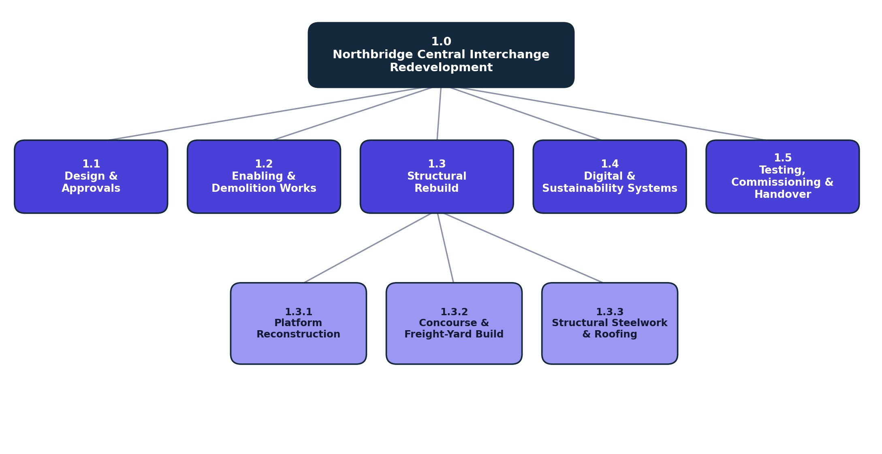
Figure 1: Work Breakdown Structure for the Central Interchange Redevelopment
As shown in Figure 1, the structural rebuild package (1.3) is decomposed further into platform reconstruction (1.3.1), concourse and freight-yard build (1.3.2), and structural steelwork and roofing (1.3.3). This level of decomposition allows each work package to be assigned an owner, a duration and a resource allocation, discussed respectively in Sections 6 and 8. The WBS also underpins the risk register in Section 9, since several identified risks are attached directly to specific work packages rather than to the project as a whole. Applying the hundred per cent rule, whereby the sum of child elements equals the full scope of the parent, ensures no work is omitted from the plan (Kerzner, 2017).

5. Quad Chart
A quad chart provides a single-page summary of a project's objective, schedule, funding and risk profile, allowing stakeholders who lack time to review a full plan to grasp its essentials quickly (Larson and Gray, 2021). Figure 2 presents the quad chart prepared for this project.
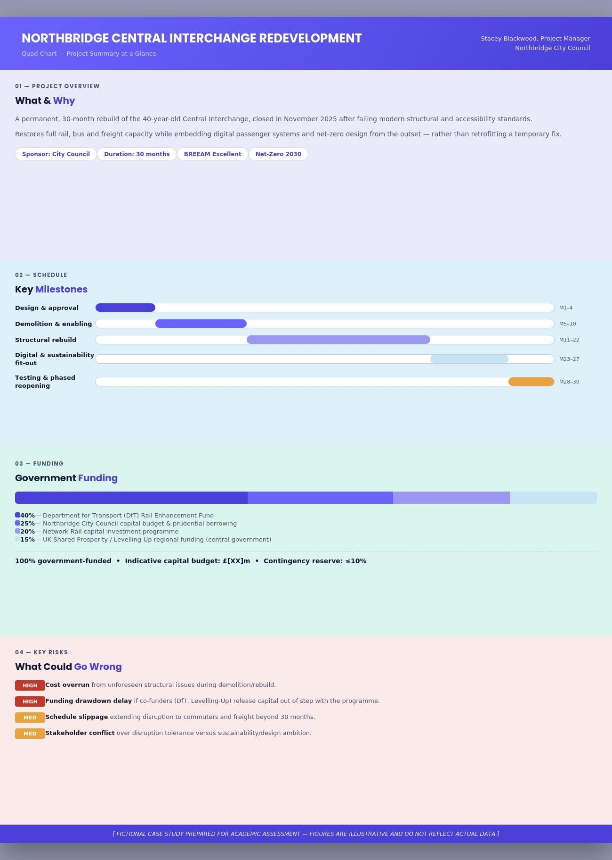
Figure 2: Project Quad Chart: Overview, Schedule, Funding and Key Risks
The top-left quadrant summarises the project objective and headline targets. The top-right quadrant condenses the thirty-month schedule, detailed further in the Gantt chart in Section 6, into five milestone phases. The bottom-left quadrant sets out the funding structure: the project is wholly government-funded, drawing on Department for Transport rail enhancement funding, Northbridge City Council capital budget, Network Rail investment and central government
Levelling-Up funding, discussed further in Section 8. The bottom-right quadrant summarises the two highest-severity risks carried forward from the risk register in Section 9. The quad chart is intended as a standing reference for the project board and is updated at each monthly steering meeting.

6. Gantt Chart
The Gantt chart translates the WBS into a time-phased schedule, showing the sequence, duration and overlap of work packages (Meredith, Shafer and Mantel, 2017). Figure 3 presents the indicative thirty-month programme.
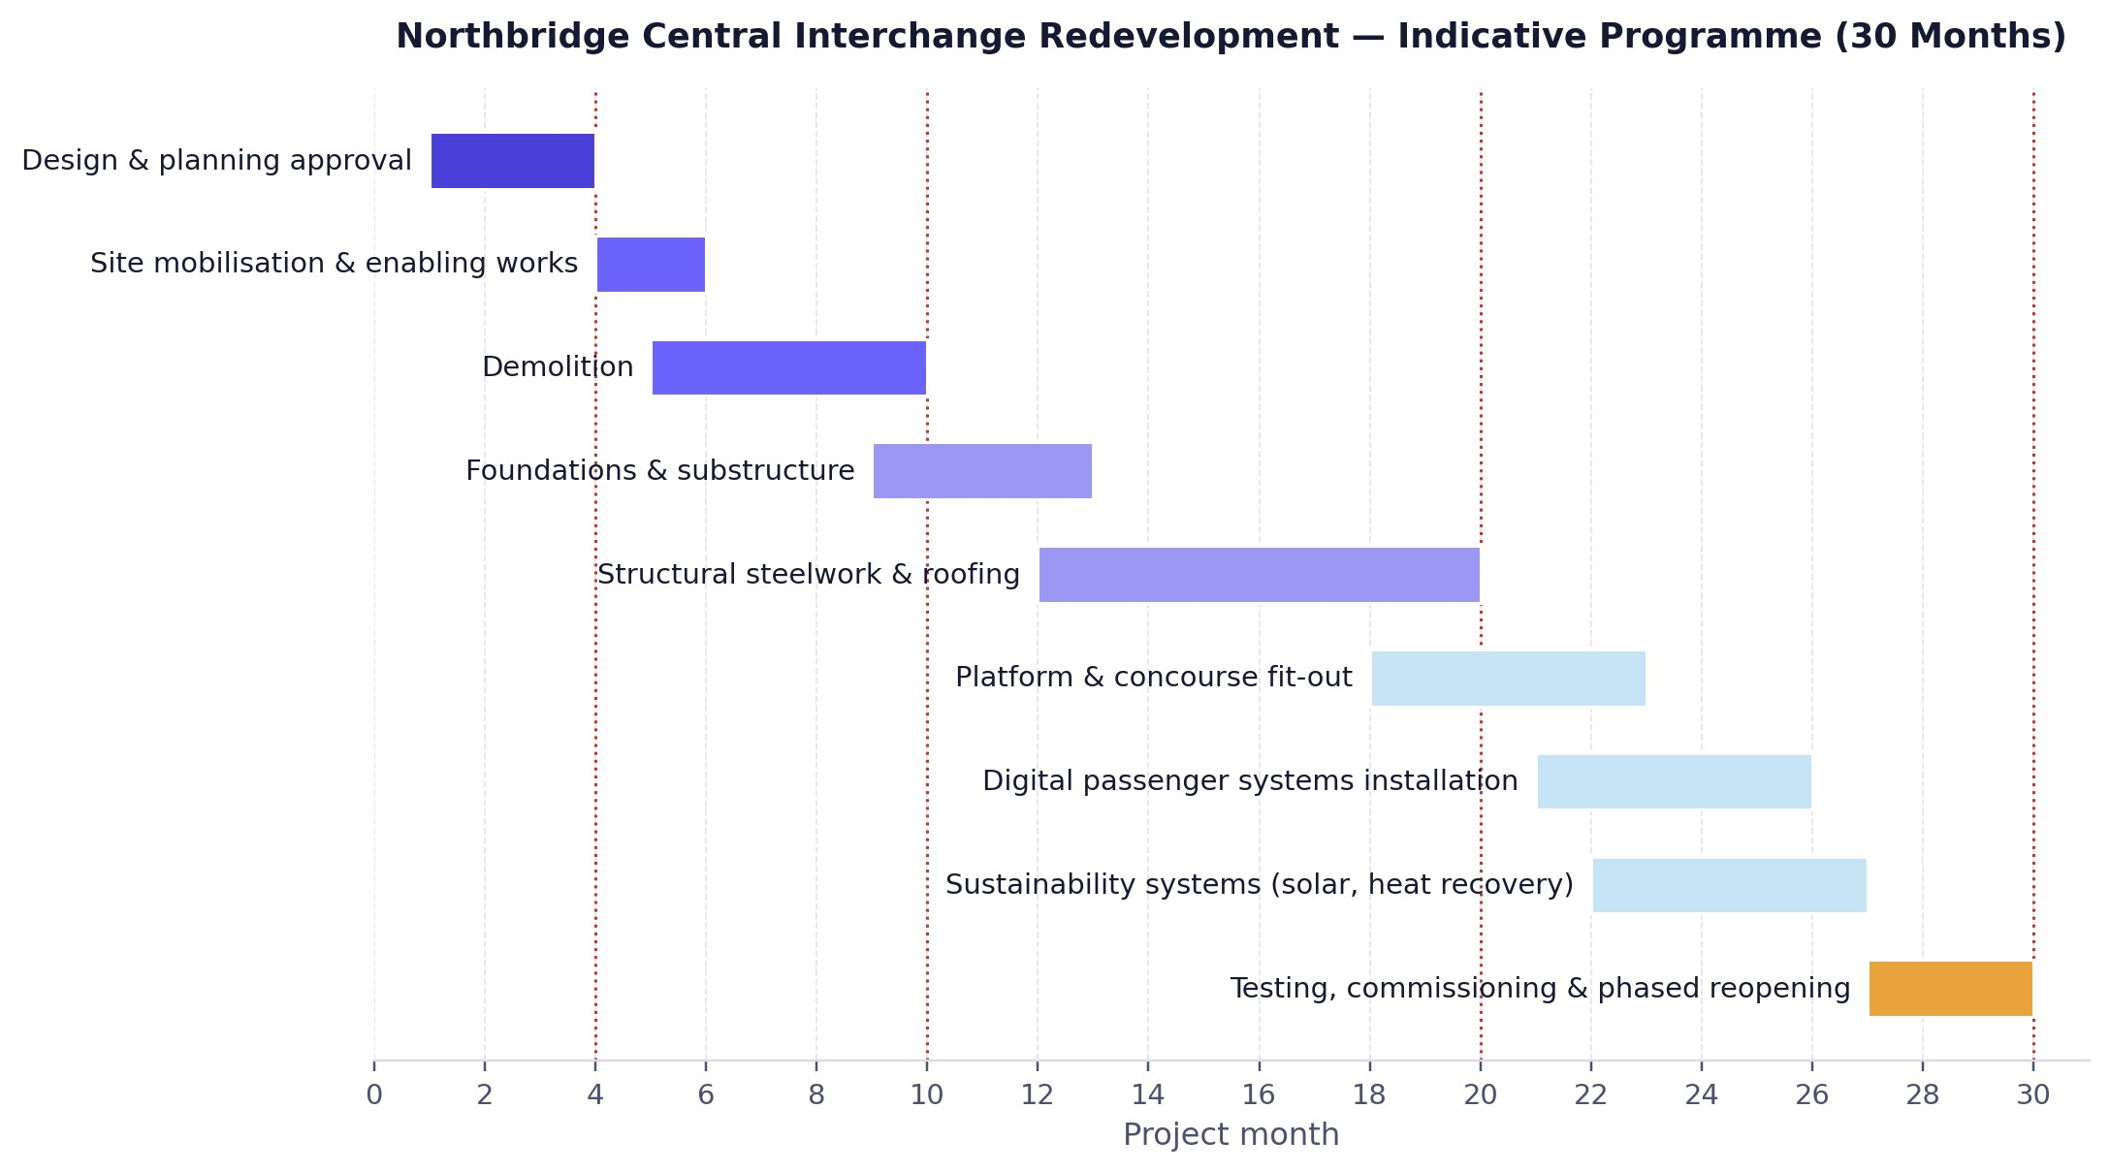
Figure 3: Indicative 30-Month Programme for the Central Interchange Redevelopment
Design and planning approval, months one to four, precedes all construction activity and represents the critical path start point; delay at this stage cascades through the remainder of the programme. Site mobilisation begins in month four, overlapping the final weeks of design approval, and demolition follows from month five to month ten. Foundations and substructure work begin before demolition is fully complete, at month nine, reflecting a fast-tracking approach commonly used to compress infrastructure schedules where the risk of resequencing is manageable (Winch, 2010). Structural steelwork and roofing, the longest single activity at eight months, runs from month twelve to month twenty and forms the critical path for the remainder of the project.
Platform and concourse fit-out, digital passenger systems installation and sustainability systems installation overlap between months eighteen and twenty-seven, since these work packages can proceed in parallel once the structural shell is complete. Testing, commissioning and phased reopening occupy the final three months. Four milestones mark schedule control points: approval at month four, demolition complete at month ten, structural completion at month twenty, and reopening at month thirty. These milestones form the basis of the monthly progress reporting cycle and are the trigger points for the decision gates referenced in Section
9.

7. Stakeholders' Involvement
Stakeholder theory holds that a project's success depends on satisfying the expectations of all parties who can affect, or are affected by, its outcomes, not solely its sponsor (Freeman, 1984). This project's stakeholders are grouped and prioritised using the power/interest grid developed by Mendelow (1991), which classifies stakeholders by their capacity to influence the project and their level of interest in its outcome. Responsibility for engaging each group is assigned through a RACI matrix, held as a project-control document, which records who is Responsible, Accountable, Consulted and Informed for each work package. Table 1 sets out the primary stakeholder groups, and Figure 4 maps them onto the power/interest grid.

Table 1: Stakeholder Register
Stakeholder | Power | Interest | Engagement Strategy
Northbridge City Council  (Sponsor) | High | High | Manage closely; monthly project board
DfT / Network Rail (Funders & Regulators) | High | High | Manage closely; quarterly funding reviews
Contractors & Design Consultants | High | High | Manage closely; weekly progress meetings
ORR / HSE (Safety Regulators) | High | Medium | Keep satisfied; scheduled compliance audits
Commuters & Local Businesses | Low | High | Keep informed; public updates, community liaison
Accessibility &  Environmental Groups | Low–  Medium | High | Keep informed; consultation workshops
General Public | Low | Low–  Medium | Monitor; standard public communication channels
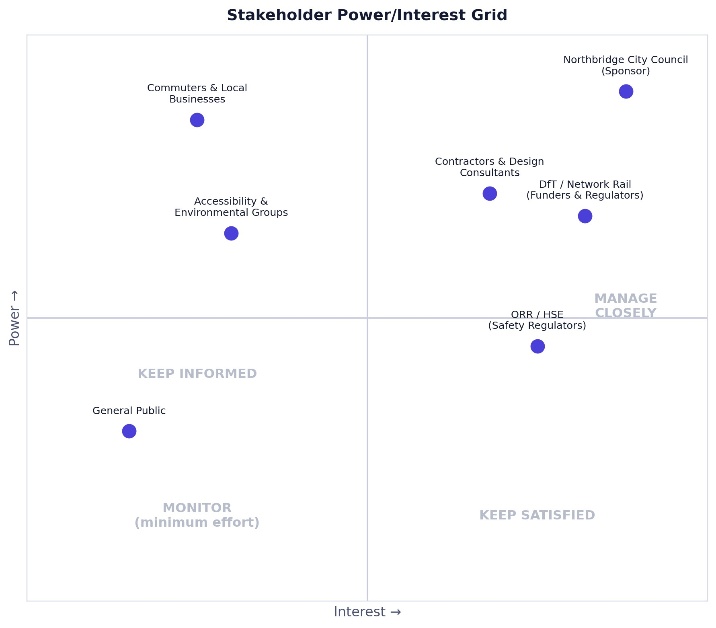
Figure 4: Stakeholder Power/Interest Grid
Northbridge City Council, as sponsor, and the Department for Transport and Network Rail, as principal funders and infrastructure regulators, sit in the high-power, high-interest quadrant and are managed closely through a monthly project board with formal reporting lines. Contractors and design consultants also fall into this quadrant during active construction phases and are engaged through weekly progress meetings and a shared programme model. The Office of Rail and Road and the Health and Safety Executive hold high regulatory power but comparatively lower day-to-day interest; they are kept satisfied through scheduled compliance audits rather than continuous involvement.
Commuters, local businesses and accessibility and environmental advocacy groups have limited formal power but high interest in the outcome, given the direct effect of construction disruption on their daily activity. These groups are kept informed through public updates, a dedicated project webpage and periodic consultation workshops, consistent with the visualisation approach proposed by Bourne and Walker (2005) for managing dispersed but vocal stakeholder interests. The public, with lower power and more diffuse interest, is monitored through standard public communication channels rather than direct consultation.
This tiered approach concentrates engagement resource where it has the greatest bearing on project success.

8. Allocation of Resources
Resource allocation assigns the human, physical and financial resources identified in the WBS to specific work packages and time periods, enabling the project manager to identify and resolve overallocation before work begins (Meredith, Shafer and Mantel, 2017). Resource demand is tracked against a resource calendar aligned to the Gantt chart in Figure 3, allowing the project team to anticipate peak demand periods in advance rather than react to them. Table 2 summarises the principal resource categories against the programme phases.

Table 2: Resource Allocation by Programme Phase
Resource | Description | Phase(s) | Approx. Allocation
Project management team | PM, planners, cost controllers | Throughout (M1–30) | 8 FTE
Design consultants | Architects, structural & M&E engineers | M1–4, reduced ongoing support | 12 FTE
Construction workforce | Demolition, groundworks, structural trades | M5–22 (peak) | 120–180 workers
Digital systems specialists | Passenger information & logistics software | M21–26 | 15 FTE
Sustainability engineers | Solar, heat recovery, BREEAM assessors | M22–27 | 10 FTE
Plant & equipment | Cranes, excavators, site plant  (hired) | M5–22 | As required
Capital budget | Government funding (DfT,  Council, Network Rail,  Levelling-Up) | Throughout | 100% government funded
The project management team, comprising the project manager, planners and cost controllers, is allocated across the full thirty-month duration to maintain continuity of control. Design consultants, including architects and structural and mechanical engineers, are concentrated in the design and approvals phase but retain a reduced ongoing role to resolve design queries during construction. The construction workforce peaks during the enabling and structural rebuild phases, between months five and twenty-two, when demolition, groundworks and structural trades are simultaneously active; this period represents the highest resource-intensity phase of the programme and the point at which resource levelling, smoothing peak demand across the available labour pool, is most necessary (Kerzner, 2017).
Digital systems specialists and sustainability engineers are engaged later in the programme, from approximately month twenty-one, once the structural shell is sufficiently complete to permit systems installation. Plant and equipment, including cranes and excavators, are hired rather than owned, reflecting standard practice for time-bound construction resource needs (Winch, 2010). Financial resources are addressed separately: as described in Section 5, the capital budget is wholly government-funded, drawn from the Department for Transport, Northbridge City Council, Network Rail and central government regional funding, with a contingency reserve of no more than ten per cent held against the risks identified in Section 9.

9. Risk Analysis
Risk analysis identifies, assesses and prioritises threats to the project's time, cost and quality objectives, enabling proportionate response planning rather than reactive crisis management (Chapman and Ward, 2003). This project applies a qualitative likelihood/impact assessment consistent with the Association for Project Management's guidance (2019), with each risk scored on a five-point likelihood and impact scale and plotted on a probability-impact matrix held as a supporting project-control document. Table 3 presents the risk register's highest priority entries.

Table 3: Risk Register (Top Five Risks)
ID | Risk | Likelihood | Impact | Response Strategy | Owner
R1 | Unforeseen structural conditions during demolition/rebuild | Medium | High | Mitigate: preconstruction surveys; 10% contingency | Construction Manager
R2 | Funding drawdown delay from co-funders | Medium | High | Mitigate: phased funding agreements with DfT | Project Manager
R3 | Schedule slippage extending disruption beyond 30 months | Medium | Medium | Mitigate: milestone decision gates; programme buffer | Project Manager
R4 | Stakeholder conflict over disruption vs design ambition | Medium | Medium | Mitigate: engagement plan; RACI escalation routes | Stakeholder Manager
ID | Risk | Likelihood | Impact | Response Strategy | Owner
R5 | Contractor capacity constraints in a competitive market | Low–  Medium | Medium | Transfer: early engagement; framework agreements | Procurement Lead
Two risks are assessed as high impact. Unforeseen structural conditions encountered during demolition or rebuild, common in ageing infrastructure of this type, could increase cost and extend the critical path identified in Section 6; this risk is mitigated through pre-construction structural surveys and the ten per cent contingency reserve referenced in Section 8. Funding drawdown delay, where co-funders release capital out of step with programme requirements, is mitigated through phased funding agreements agreed with the Department for Transport ahead of construction start, reducing the project's exposure to single-funder timing risk.
Three risks are assessed as medium impact. Schedule slippage extending disruption beyond thirty months is managed through the milestone decision gates shown in Figure 3, which allow the project board to authorise corrective action before delay compounds. Stakeholder conflict between disruption tolerance and design ambition, discussed in Section 7, is addressed through the tiered engagement plan and clear escalation routes defined in the project's RACI matrix.
Contractor capacity constraints, reflecting current competition for construction resource in the UK infrastructure market, are addressed through early contractor engagement and framework agreements that secure capacity ahead of peak demand.
Consistent with Chapman and Ward's (2003) distinction between risk mitigation, transfer, acceptance and avoidance, each response in Table 3 is matched to the risk's underlying cause rather than applied uniformly. The risk register is reviewed at each monthly project board meeting and updated as work packages close, ensuring residual risk exposure remains visible to the stakeholders identified in Section 7 throughout delivery.

10. Conclusion
This plan has set out how established project management approaches can be applied to deliver the redevelopment of Northbridge's Central Interchange within thirty months and an agreed capital budget. The work breakdown structure and Gantt chart provide a shared basis for scheduling and progress control; the stakeholder analysis directs engagement effort toward the parties most able to affect, or be affected by, the project; and the risk register ensures that the most significant threats to delivery are identified and actively managed rather than discovered during construction.
Beyond restoring transport capacity, the project offers strategic value extending well beyond the interchange itself. It positions Northbridge as an example of resilient, low-carbon urban infrastructure, strengthens the city's case for future government investment, and creates a reusable delivery template for renewing other ageing transport assets across the region. Provided the governance, engagement and risk-control mechanisms described in this plan are applied consistently, redevelopment of the Central Interchange represents a credible route to resolving the disruption caused by its closure while meeting the city's environmental and inclusive-design commitments.

References
Association for Project Management (2019) APM Body of Knowledge. 7th edn. Princes Risborough: APM.
Atkinson, R. (1999) 'Project management: cost, time and quality, two best guesses and a phenomenon, it’s time to accept other success criteria', International Journal of Project Management, 17(6), pp.337–342.
Bourne, L. and Walker, D.H.T. (2005) 'Visualising and mapping stakeholder influence', Management Decision, 43(5), pp.649–660.
BRE Group (2023) BREEAM: the world's leading sustainability assessment method. Available at:
https://breeam.com (Accessed: 3 July 2026).
Chapman, C. and Ward, S. (2003) Project Risk Management: Processes, Techniques and Insights. 2nd edn. Chichester: Wiley.
Cleland, D.I. and Ireland, L.R. (2006) Project Management: Strategic Design and Implementation. 5th edn. New York: McGraw-Hill.
Department for Transport (2021) Transport Decarbonisation Plan: A Better, Greener Britain. London: HM Government.
Equality Act 2010, c. 15. London: The Stationery Office.
Freeman, R.E. (1984) Strategic Management: A Stakeholder Approach. Boston: Pitman.
Kerzner, H. (2017) Project Management: A Systems Approach to Planning, Scheduling, and Controlling. 12th edn. Hoboken: Wiley.
Larson, E.W. and Gray, C.F. (2021) Project Management: The Managerial Process. 8th edn. New York: McGraw-Hill.
Mendelow, A. (1991) 'Stakeholder mapping', Proceedings of the 2nd International Conference on Information Systems. Cambridge, MA.
Meredith, J.R., Shafer, S.M. and Mantel, S.J. (2017) Project Management: A Strategic Managerial Approach. 10th edn. Hoboken: Wiley.
Office of Government Commerce (2009) Managing Successful Projects with PRINCE2. London: TSO.
Office of Rail and Road (2023) Health and Safety Guidance for the Rail Industry. Available at:
https://www.orr.gov.uk (Accessed: 3 July 2026).
Project Management Institute (2021) A Guide to the Project Management Body of Knowledge (PMBOK Guide). 7th edn. Newtown Square, PA: PMI.
Turner, J.R. (2014) The Handbook of Project-Based Management. 4th edn. New York: McGraw-Hill.
Winch, G.M. (2010) Managing Construction Projects. 2nd edn. Chichester: Wiley-Blackwell.

