

Assignment 1: SFF Analysis of Netflix

Contemporary Themes in e-Business:
SBUS6104

Student Name: Kristofer Allen
Student ID: 1602418

Contents
Introduction: History of Netflix 2
Main Findings: 3
External Factor Evaluation Matrix (EFE): 3
Opportunities: 3
Threats: 4
Internal Factor Evaluation Matrix (IFE): 4
Weaknesses: 5
Competitive Profile Matrix: 5
Space Matrix: 6
Quantitative Strategic Planning Matrix (QSPM): 8
Conclusion/Recommendations 9
References: 9

Introduction: History of Netflix
Netflix was founded in 1997 by Reed Hastings and Marc Randolf and involved the creation of the original programming for the site. In 1999 Netflix began offering a subscription-based service through the internet and that concept has followed the company ever since. However, at that time subscribers would email what shows they wanted to watch and then the DVD disc would be mailed to their homes along with prepaid return envelopes in the case of any issues with the product. Netflix had tens of thousands in its movie catalogue. (William L. Hosh, 2019)
In 2007 was the starting point for the influx of appeal for Netflix. They began to offer the streaming of some movies over the internet instead of sending out DVD’s and partnered up with DVD player brands to enable movies to stream through the DVD player via the internet or through their computers. (BBC, 2018)
In 2011 onwards, they have continued to launch their site throughout different countries. Starting in Latin America and the Caribbean to now over 180 countries worldwide being officially the Best current streaming service as well as hundreds of awards just in 2018. (Netflix, 2019) Netflix’s vision statement is “to become the number one mail order and live streaming movie company in the world”. And they have done just that.
This report leads to compare the changes to Netflix up to 2013 to the current version of Netflix in 2019. By creating and doing a critical analysis of SFF (Strategy Formulation Framework) an analysis can be made to determine what strategy would be best for Netflix to adopt now.

Main Findings:

External Factor Evaluation Matrix (EFE):
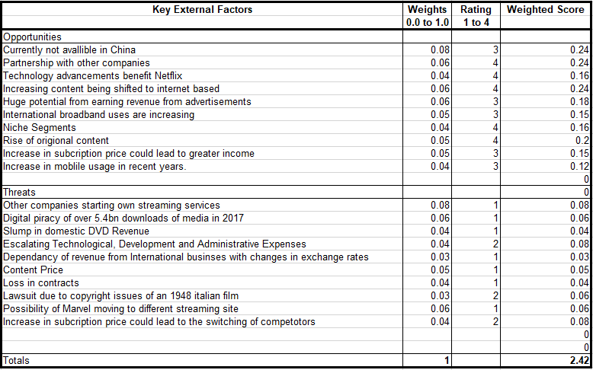
EFE evaluates how a company is doing with their potential growth and well as the threats that the company is currently facing. The weighted score of all the threats and the opportunities are used to gauge how pressing the issues are.

Opportunities:
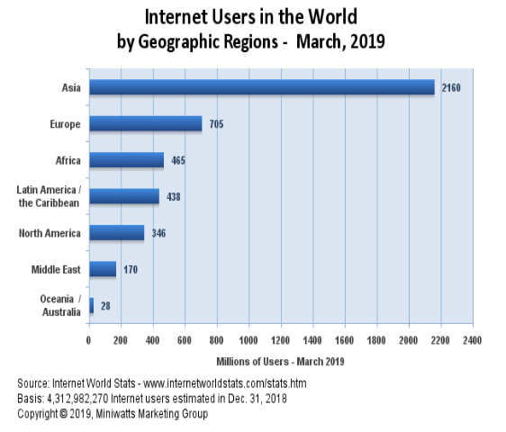
Netflix is primarily based on the internet, so any developments to the internet benefit them in return. As the world develops so does the amount of internet users. Currently there are over 4 billion internet users in the world with Asia having most of the amount of people connected to the internet. Netflix however are currently unable to access China in this part of the market due to government restrictions and are missing out on an extremely big amount of potential income and new customers. If Netflix are able to convince China to enable the access of their website for China’s citizens, it would be a promising for the company. This situation has remained the same for Netflix since 2016 and should be a critical for them to find a way to expand that market.
(Source: Internet World Stats)
In 2017 Netflix accomplished something that they never have before managed. They won their first Oscar with “The White Helmets” being an “Original” of the streaming platform in the form of a documentary. And another Oscar win for Best Documentary Feature for Icarus in 2018. With this recognition of Netflix’s “Original” series’, Netflix could improve the amount of “Original” shows that are available on the platform. This could enhance subscriptions and provide jobs for people who are new and upcoming. (Netflix, 2019)

Threats:
One of the major threats that Netflix currently has, is that of other major companies like Disney creating their own streaming platform called Disney +. (Sorrentino, 2019) Netflix decided to end the showing of 4 marvel television shows such as The Punisher and Jessica Jones. (Hughes, 2019) In response to this Disney have announced that they will be creating their own streaming platform that will provide a home for these television shows and a place where individuals can watch their films also. Due to the decision of not continuing with some television shows not only have Netflix have provided Disney with the idea of creating their own streaming service but also, they have lost a very important supplier in Marvel due to it being such a household name in media.
Digital piracy is becoming even more of a problem for not only Netflix but for all entertainment providers. Currently piracy has led to 5.4bn downloads of data alone in 2017. This threatens the whole of Netflix’s business model and ability to fund content in the future. (Opam, 2017) Companies such as Hulu are an ad based streaming service that provides free viewing on TV shows and movies in return for showing advertisements. While this might not be the avenue Netflix might want to go down due to the potential loss in profits from subscriptions, it becomes as close a company can get from eliminating the need for pirating due to the nature of the free shows.

Internal Factor Evaluation Matrix (IFE):
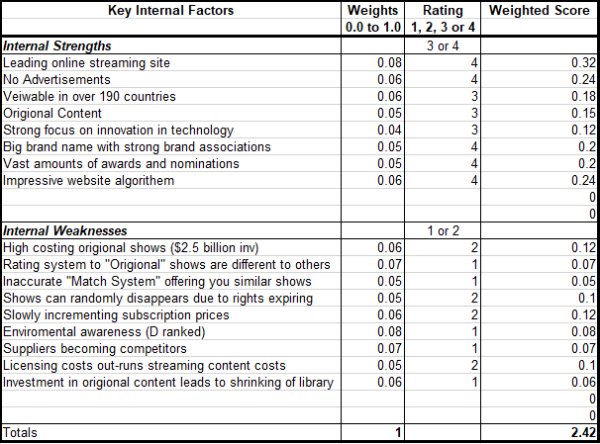
Strengths:
The major strength that Netflix has is that it is currently the leading online streaming site and as of 2017 has over 93 million viewers and offers 7,500 HD videos which currently is twice the amount that Amazon Prime have. (SWOT & PESTLE, 2019) Netflix’s ecosystem for internet-connected screens with increasing amounts of content that enable its consumers access to TV shows and movies directly is its major strength. The ecosystem is supported by rich technologies such as data which help in facilitating the company’s algorithms and analytics which in turn can help in delivering an exceptional customer experience.

Weaknesses:
Netflix has a big problem is with environmental awareness and they themselves are aware of this. In 2016 Netflix announced that the “Energy use from partners in 2016 was estimated to be 100,000 MWhs. Combined with our direct energy use, our total electricity footprint is 140,000 MWhs.” They go on to mention that “While we don’t have direct control over this energy use, we believe it is an important component to delivering our services and so include it in our energy use calculations.” (Netflix, 2017) While the energy usage of the company is very high it is comforting to see that the company is not trying to hide this fact and are hoping to change to renewable energy for its share of the energy usage in the near future. (Netflix, 2019)

Competitive Profile Matrix:

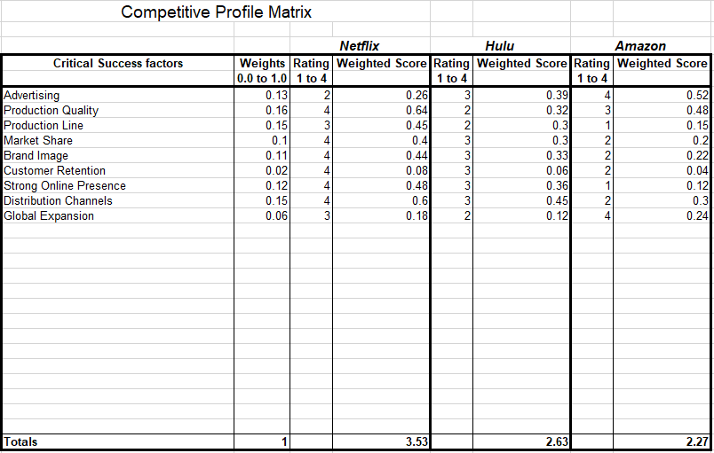
The Competitive profile matrices is to analyse how Netflix is doing compared to its major competitors in a variety of different areas. In 2013 Redbox and Time Warner where listed as direct competitors. (Gauvin, 2013) However now Hulu and Amazon are direct current competitors due to the nature of the media streaming websites.
Advertising for Amazon is minimal due to having no advertisements from the subscription service while Hulu is free but require individuals to watch adverts to watch the television shows they want to watch. Amazon have a balance of both enabling users to watch there shows via subscribing however the advertisements that they will watch are for Amazon shows. This grants Amazon with increased views of their shows on “Prime” via recommending other shows to its viewers before their intended show starts.
The competitive profile matrix shows that Netflix is currently doing the best compared to its competitors due to the its ranking on the weighted score. Which is a good sign for Netflix as it is rated “the best streaming service” currently. (Netflix, 2019)

Space Matrix:

Financial Strength |  |  | rating is 1 (worst) to 7 (best) |  |  |  |  |  |  | Ratings
1 | Gross Margin |  |  |  |  |  |  |  |  | 5.0
2 | Debt to Equity |  |  |  |  |  |  |  |  | 7.0
3 | Current Ratio |  |  |  |  |  |  |  |  | 4.0
4 | ROE |  |  |  |  |  |  |  |  | 4.0
5 | ROA |  |  |  |  |  |  |  |  | 4.0
Industry Strength |  |  | rating is 1 (worst) to 7 (best) |  |  |  |  |  | FS Total | 24.0
1 | Growth Potential |  |  |  |  |  |  |  |  | 7.0
2 | Financial Stability |  |  |  |  |  |  |  |  | 5.0
3 | Ease of entry into Market |  |  |  |  |  |  |  |  | 6.0
4 | Resource Utilization |  |  |  |  |  |  |  |  | 6.0
5 | Profit Potential |  |  |  |  |  |  |  |  | 7.0
Environmental Stability |  |  | rating is -1 (best) to -7 (worst) |  |  |  |  |  | IS Total | 31.0
1 | Rate of inflation |  |  |  |  |  |  |  |  | -2.0
2 | Technological Changes |  |  |  |  |  |  |  |  | -2.0
3 | Price Elasticity of Demand |  |  |  |  |  |  |  |  | -2.0
4 | Competitive pressure |  |  |  |  |  |  |  |  | -6.0
5 | Barriers to entry into Market |  |  |  |  |  |  |  |  | -6.0
Competitive advantage |  |  | rating is -1 (best) to -7 (worst) |  |  |  |  |  | ES Total | -18.0
1 | Market share |  |  |  |  |  |  |  |  | -5.0
2 | Product Quality |  |  |  |  |  |  |  |  | -2.0
3 | Customer Loyalty |  |  |  |  |  |  |  |  | -2.0
4 | Technological know-how |  |  |  |  |  |  |  |  | -1.0
5 | Control over Suppliers and Distributors |  |  |  |  |  |  |  |  | -6.0
 |  |  |  |  |  |  |  |  | CS total | -16.0
The space matrix is an important strategic management tool as its used for the purpose of determining the type of strategy a company should take. From the ratings found in the table, Netflix should adopt an aggressive strategy due to the vast number of competitors in the market. (Kraue Fund Research, 2017)
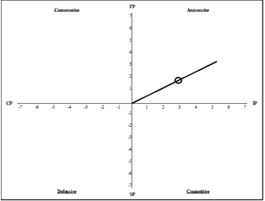
In March of 2016 Netflix the total current assets equalled $11million for that month. In comparison March of 2019 total current assets equalled $20 million just in that month. (Netflix, 2018) Due to the benefits of the extra profit Netflix can afford to invest in an aggressive strategy to expand its influence market more and hopefully eliminate some of the competition in the process. With this increase of market influence the company’s “Original” programs could provide increased amount of attention for Netflix due to them not being able to find their shows anywhere else.

Netflix’s debt to equity is rated the highest strength with the company as of the end of 2018 being $10.36bn in long term debt with Shareholder equity being $5.4bn giving it a ratio of 1.98. (Macrotrends, 2018) compared to in 2013 Netflix having $0.50bn in long term debt with $1.33bn from stake holder equity giving it a ratio of 0.38%. (Macrotrends, 2018) the difference in these numbers shows the growth of the company in just 5 years and how highly it is regarded by its skate holders.

Quantitative Strategic Planning Matrix (QSPM):
Add advertisements to website
Expand by 20% into Asia, Europe and Africa
Increase “Original” budget by 15%

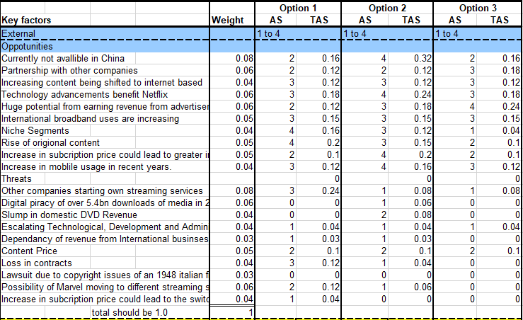

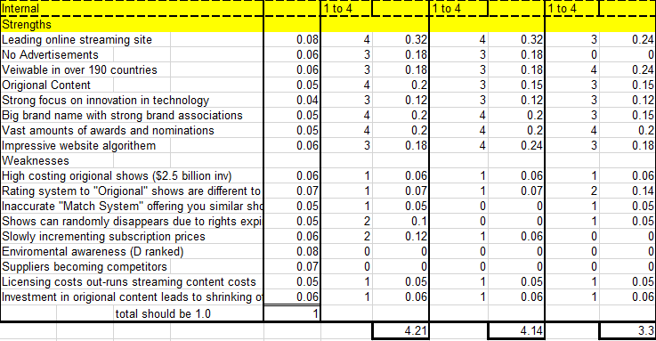

There are multiple different strategies that Netflix could adopt that would benefit the company in an aggressive manner. The first of 3 strategies that would be good for Netflix to adopted are first to increase the Netflix “Original” budget by 15%. With this increase of market influence the company’s “Original” programs could provide increased amount of attention for Netflix due to them not being able to find their shows anywhere else. With the Oscar nominations and awards via “The White Helmets” and other award-winning programs it provides recognition of quality for Netflix. (Netflix, 2019)
The second option for Netflix to adopt would be to Expand into Asia, Europe and Africa. The reason for this is that these 3 continents, currently have the most people who are using the internet and that could benefit from Netflix’s media streaming service. (Internet World Stats, 2019) this would provide Netflix with increased revenue though the amount of potential new subscribers to the website.
The third option would be for Netflix to add advertisements to their websites. These advertisements could be in many different forms. One of which could be the advertising of other Netflix shows, this would provide an improvement to the recommendation system that Netflix has been slated for in the past, possibility increasing customers experience. This option however would be highly risky for the company as having no advertisements is one of the main attractions for the site. Netflix have tried this once however and received mix criticism. (Moore, 2018)

Conclusion/Recommendations
From the Quantitative strategic planning matrix’s attractiveness score found at the bottom of the table, the best strategy for Netflix to adopt us to increase their Netflix “Original” budget and invest in drawing their competitors’ customers to themselves with an attractiveness score of 4.21.
Close behind with 4.14 and in 2016 expiation into different countries such as Asia was the recommended strategy in 2013. (Gauvin, 2013) While this strategy would highly benefit Netflix it does not however separate it from its competition but could even increase it instead.
Due to the increasing use of internet connectivity. Currently it would be better for Netflix if they focused their resources into creating Original content rather than solely expanding into different territories.

References:
BBC. (2018, 1 23). Netflix's history: From DVD rentals to streaming success. Retrieved from Newsbeat: http://www.bbc.co.uk/newsbeat/article/42787047/netflixs-history-from-dvd-rentals-to-streaming-success
Gauvin, T. (2013). Retrieved from perleybrook.umfk.maine.edu: perleybrook.umfk.maine.edu/slides/Spring13/BUS411/Netflix.pptx
Hughes, M. (2019, 3 18). The Real Reasons Netflix Is Cancelling Its Marvel Shows. Retrieved from Forbes: https://www.forbes.com/sites/markhughes/2018/11/30/the-real-reasons-netflix-is-cancelling-their-marvel-shows/#39a0b371196c
Internet World Stats. (2019, 3). Uage and Population Stastistics. Retrieved from Internetworldstats.com: https://www.internetworldstats.com/stats.htm
Kraue Fund Research. (2017, 11 10). Netflix Inc. Retrieved from Tippie.uiowa.edu: https://tippie.uiowa.edu/sites/tippie.uiowa.edu/files/documents/krause/f17_nflx.pdf
Macrotrends. (2018, 12 31). Netflix Debt to Equity Ratio 2006-2018 | NFLX. Retrieved from macrotrends.com: https://www.macrotrends.net/stocks/charts/NFLX/netflix/debt-equity-ratio
Moore, K. (2018, 8 19). The Netflix Ad Controversy and How to Turn Them Off. Retrieved from whats-on-netflix.com: https://www.whats-on-netflix.com/news/the-netflix-ad-controversy-and-how-to-turn-them-off/
Netflix. (2017, 6 14). Renewable Energy at Netflix: An Update. Retrieved from Netflix: https://media.netflix.com/en/company-blog/renewable-energy-at-netflix-an-update
Netflix. (2018). 2018 Quarterly Earnings. Retrieved from Netflixinvestor.com: https://www.netflixinvestor.com/financials/quarterly-earnings/default.aspx
Netflix. (2019, 3 18). A renewable energy update from us. Retrieved from netflix.com: https://media.netflix.com/en/company-blog/a-renewable-energy-update-from-us
Netflix. (2019, 3 18). Netflix Timeline. Retrieved from Netflix.com: https://media.netflix.com/en/about-netflix
Opam, K. (2017, 7 13). HBO, Netflix, other Hollywood companies join forces to fight piracy. Retrieved from The Verge: https://www.theverge.com/2017/6/13/15791688/hbo-netflix-hollywood-ace-fight-piracy
Sorrentino, M. (2019, 3 22). Disney+ streaming service: Release date, price, shows and movies to expect. Retrieved from cnet.com: https://www.cnet.com/how-to/disney-disneyplus-streaming-service-name-release-date-shows-movies-to-expect-fox-layoffs/
SWOT & PESTLE. (2019, 2). Netflix SWOT & PESTLE Analysis. Retrieved from swotandpestle.com: https://www.swotandpestle.com/netflix/
William L. Hosh. (2019, 03 18). Netflix. Retrieved from Britannica.com: https://www.britannica.com/topic/Netflix-Inc

