30/04/2026
University of Wales Trinity Saint David
london campus
Networks and Cybersecurity Essentials Assignment
Synthesize a Solution to a Potential Real-Life Scenario
Module Name: Networks and Cybersecurity Essentials
Module code: ACCA4024

Student Name: Maksim Zanev
Student ID: 2436811
Group: 2

Lecture’s Name: Amit Naik

Contents
Abstract 3
Introduction 3
Identification of Threats 4
External Threats 4
Internal Threats 5
Impact Through the CIA Triad 5
Security Policies 5
Information Security Policy 5
Access Control Policy 6
Password and Multi-Factor Authentication Policy 6
Data Classification and Handling Policy 6
Bring Your Own Device (BYOD) Policy 6
Incident Response Policy 6
Backup and Recovery Policy 7
Third-Party Security Policy 7
Mitigation Measures 7
Multi-Factor Authentication and Access Management 7
Data Encryption 8
Endpoint Protection and Patch Management 8
Network Segmentation 8
Backup and Recovery Controls 8
Email Security and Phishing Protection 8
Mobile Device and Remote Working Security 9
Continuous Risk Reduction 9
Monitoring and Incident Response 9
Continuous Security Monitoring 9
Incident Severity Classification 10
Incident Response Lifecycle 10
Roles and Responsibilities 12
Testing and Improvement 12
Training and Awareness Programme 12
Induction Training for New Employees 12
Ongoing Refresher Training 13
Phishing Simulations 13
Role-Based Security Training 13
Data Protection and Compliance Awareness 13
Measuring Effectiveness 13
Building a Security Culture 14
Conclusion 14
References 15
Appendix – PowerPoint Slides 16

Abstract
HealthPlus Analytics (HPA) operates within a high-risk environment due to its processing, storage, and analysis of sensitive patient information for healthcare providers across the United Kingdom. Recent incidents involving unauthorised access to cloud-stored patient data and a ransomware attack affecting analytics servers highlight weaknesses in the organisation’s current cybersecurity controls.
This report develops a comprehensive cybersecurity and governance framework designed to strengthen HPA’s overall security posture, improve regulatory compliance, and reduce operational risk. Key internal and external threats are identified, including phishing, ransomware, insider misuse, weak access management, and third-party vulnerabilities.
In response, the report recommends a combination of formal security policies, technical safeguards, continuous monitoring processes, incident response procedures, and a structured staff awareness programme. These measures are aligned with recognised standards including the NIST Cybersecurity Framework, ISO/IEC 27001, and UK GDPR principles [4], [6].
If implemented effectively, the proposed recommendations would strengthen confidentiality, integrity, and availability while improving stakeholder trust and long-term organisational resilience.

Introduction
Cybersecurity has become a strategic priority for organisations that process sensitive personal data, particularly within the healthcare sector. Healthcare organisations are frequently targeted by cybercriminals because medical records contain valuable personal and financial information, while service disruption can create pressure to meet ransom demands [1], [2]. In addition, the increasing use of cloud computing, mobile devices, and hybrid working practices has significantly expanded the digital attack surface faced by modern organisations [3].
HealthPlus Analytics (HPA) is a data-driven healthcare technology company that stores and analyses patient information on behalf of hospitals and clinics throughout the United Kingdom. The organisation has recently suffered unauthorised access to cloud-based patient data and a ransomware attack affecting analytics servers. These incidents raise serious concerns regarding data privacy, business continuity, legal compliance, and reputational damage [4].
The purpose of this report is to develop a structured cybersecurity and governance framework to address these risks. The report examines the threats facing HPA, proposes appropriate security policies, recommends practical mitigation measures, outlines a monitoring and incident response plan, and designs a staff training programme. The recommendations aim to support regulatory compliance while improving the organisation’s overall resilience against future cyber threats [5], [6].

Identification of Threats
HealthPlus Analytics (HPA) faces a diverse range of cybersecurity threats due to its dependence on digital infrastructure, cloud services, and the processing of highly sensitive patient information. As a healthcare technology provider, the organisation must protect both operational continuity and confidential data from internal and external risks. Failure to manage these threats effectively may result in financial loss, regulatory penalties, service disruption, and reputational damage [1], [2].

External Threats
One of the most significant external threats facing HPA is ransomware. Ransomware attacks encrypt organisational data or systems and demand payment in exchange for restoration. Healthcare organisations are common targets because operational downtime can create pressure to restore services quickly. A successful ransomware incident affecting HPA’s analytics servers could interrupt access to patient data and delay essential reporting functions [1], [14].
Phishing attacks remain a major threat to modern organisations. Attackers commonly use fraudulent emails, text messages, or fake websites to trick employees into revealing login credentials or downloading malicious files. If successful, phishing can lead to unauthorised access to cloud accounts or internal systems [2], [8].
Cloud-related threats must also be considered. Misconfigured storage environments, weak authentication controls, or compromised administrator accounts may expose patient records to unauthorised parties. As HPA relies on cloud storage, poor configuration management could create serious confidentiality risks [3].
A further external concern is third-party or supply chain compromise. If software vendors, contractors, or service providers are breached, attackers may gain indirect access to HPA systems or data. This risk has increased significantly as organisations become more dependent on outsourced digital services [12].

Internal Threats
Internal threats must also be considered seriously. Human error remains one of the most common causes of security incidents. Employees may accidentally send confidential information to the wrong recipient, click malicious links, or fail to follow established security procedures [2].
Weak password practices and poor access management may also expose HPA to risk. If staff reuse passwords or retain unnecessary privileges, unauthorised internal access becomes more likely. Similarly, lost or stolen laptops and mobile devices may expose sensitive data if encryption is not enabled [7].
Insider threats may arise from malicious or disgruntled employees who intentionally misuse legitimate access privileges. Although less frequent than accidental incidents, insider attacks can be highly damaging because trusted users often possess authorised system access [15].

Impact Through the CIA Triad
These threats can be assessed through the Confidentiality, Integrity, and Availability (CIA) Triad. Data breaches threaten confidentiality by exposing patient information. Unauthorised modification of analytics data threatens integrity and may lead to inaccurate healthcare decisions. Ransomware and denial-of-service incidents threaten availability by preventing access to systems and services. HPA should therefore adopt a layered security strategy designed to protect all three principles simultaneously [5], [6].

Security Policies
To strengthen its cybersecurity posture, HealthPlus Analytics (HPA) should implement a formal suite of security policies that establish clear responsibilities, acceptable standards of behaviour, and governance controls across the organisation. Security policies are essential because they translate strategic objectives into practical requirements, support regulatory compliance, and promote consistency in decision-making [4], [6].

Information Security Policy
An overarching Information Security Policy should define HPA’s commitment to protecting information assets, patient data, and critical systems. The policy should outline governance responsibilities, risk management expectations, reporting lines, and requirements for continuous improvement. Approval by senior management is important in order to demonstrate accountability and leadership commitment [6].

Access Control Policy
A formal Access Control Policy is necessary to ensure that users receive only the permissions required for their job roles. HPA should adopt the principle of least privilege, where access rights are limited to operational necessity. Role-based access control should be implemented for administrators, analysts, and general staff. Regular access reviews should also be conducted to remove unnecessary privileges when employees change roles or leave the organisation [5].

Password and Multi-Factor Authentication Policy
Weak passwords remain a common cause of compromise. HPA should therefore introduce a Password and Multi-Factor Authentication (MFA) Policy requiring strong passwords, password managers where appropriate, and MFA for remote access, cloud systems, and privileged accounts. This would significantly reduce the likelihood of compromise resulting from credential theft, phishing, or password reuse [7], [9].

Data Classification and Handling Policy
Because HPA processes sensitive healthcare information, a Data Classification Policy should categorise information according to sensitivity levels such as public, internal, confidential, and highly confidential. Patient records should be classified at the highest level and subject to enhanced encryption, restricted access, and secure transfer controls. This would support compliance with UK GDPR data protection principles [4], [10].

Bring Your Own Device (BYOD) Policy
As hybrid working increases, a BYOD Policy should regulate the use of personal laptops, tablets, and smartphones for business purposes. Devices accessing HPA systems should meet minimum security standards including screen locks, encryption, updated operating systems, and mobile device management controls. Unmanaged or non-compliant devices should not be permitted to access sensitive systems [11].

Incident Response Policy
A formal Incident Response Policy should define how security incidents are reported, escalated, investigated, and resolved. The policy should specify responsibilities, communication procedures, evidence preservation requirements, and recovery priorities. Clear reporting timelines are particularly important where personal data breaches may require regulatory notification [4], [5].

Backup and Recovery Policy
To reduce ransomware risk, HPA should maintain a Backup and Recovery Policy requiring regular backups of critical systems and data. Backup copies should be encrypted, tested regularly, and stored separately from production environments. This would improve business continuity and reduce pressure to consider ransom payments following an attack [1], [14].

Third-Party Security Policy
As HPA may rely on software vendors and cloud providers, a Third-Party Security Policy should require supplier due diligence, contractual security clauses, access limitations, and regular assurance reviews. This is important because external partners may introduce substantial cyber risk if not properly governed [12].
Overall, these policies would provide HPA with a structured governance framework that supports accountability, regulatory compliance, and consistent security behaviour across the organisation.

Mitigation Measures
To reduce the cybersecurity risks identified previously, HealthPlus Analytics (HPA) should implement a combination of technical, administrative, and physical controls. A layered security model is widely regarded as one of the most effective approaches because no single safeguard can prevent every threat. Instead, multiple controls should operate together to reduce both the likelihood and impact of security incidents [5], [12].

Multi-Factor Authentication and Access Management
Multi-factor authentication (MFA) should be prioritised and deployed across all cloud platforms, remote access systems, administrator accounts, and email services. Even if passwords are compromised through phishing or credential theft, MFA provides an additional barrier against unauthorised access [9].
In addition, HPA should implement role-based access control (RBAC), ensuring employees can access only the systems and data necessary for their responsibilities. Access rights should be reviewed regularly and removed promptly when staff change roles or leave the organisation [5].

Data Encryption
Sensitive patient data should be encrypted both at rest and in transit. Encryption at rest protects stored records on servers, laptops, and backup systems, while encryption in transit protects information transferred across networks or cloud services. If data is intercepted or stolen, encryption significantly reduces the likelihood of unauthorised disclosure. This measure is particularly important for healthcare information and regulatory compliance [4], [10].

Endpoint Protection and Patch Management
All laptops, desktops, and servers should be protected by centrally managed endpoint detection and response (EDR) or advanced anti-malware solutions. These tools can identify suspicious behaviour, ransomware activity, and malicious software before widespread damage occurs [13].
Alongside endpoint protection, HPA should establish a formal patch management process to ensure operating systems, applications, and firmware are updated promptly. Many successful cyberattacks exploit known vulnerabilities for which security patches are already available [12].

Network Segmentation
Network segmentation should be introduced to separate critical systems from general office networks. For example, analytics servers containing patient information should be isolated from less sensitive devices such as printers or guest networks. If one system becomes compromised, segmentation can limit an attacker’s ability to move laterally across the environment. This control is particularly effective in limiting ransomware propagation and lateral movement [14].

Backup and Recovery Controls
Regular backups are essential for business continuity. HPA should adopt the 3-2-1 backup model: three copies of data, stored on two different media types, with one copy maintained offline or off-site. Backups should be tested routinely to confirm successful restoration. Reliable backups reduce operational disruption and reduce pressure to consider ransom payments following a ransomware incident [1], [14].

Email Security and Phishing Protection
Because phishing remains a common attack method, HPA should implement secure email gateways, spam filtering, malicious link detection, and attachment scanning. Employees should also be able to report suspicious emails quickly and easily. Reducing phishing success rates can significantly lower the risk of account compromise and malware infection [8].

Mobile Device and Remote Working Security
Where employees use laptops or mobile devices remotely, all devices should be encrypted, password protected and centrally managed through mobile device management (MDM) solutions. Lost or stolen devices should be capable of remote wipe. Secure virtual private network (VPN) access should be used when connecting through untrusted networks [11].

Continuous Risk Reduction
Finally, HPA should perform regular vulnerability scanning, penetration testing, and security audits to identify weaknesses before attackers exploit them. Security controls should be reviewed periodically to ensure they remain effective as threats evolve [12], [16].
Overall, these mitigation measures would significantly strengthen HPA’s confidentiality, integrity, and availability while improving resilience against future cyber threats.

Monitoring and Incident Response
Effective cybersecurity requires not only preventative controls but also the ability to detect threats quickly and respond in a structured manner. For HealthPlus Analytics (HPA), continuous monitoring and a formal incident response capability are essential because security incidents may involve sensitive patient information, operational disruption, or legal reporting obligations. Early detection can significantly reduce financial damage, recovery time, and reputational harm [1], [5].

Continuous Security Monitoring
HPA should implement continuous monitoring across endpoints, servers, cloud environments, and network infrastructure. System logs should be collected centrally and reviewed through a Security Information and Event Management (SIEM) platform or equivalent monitoring solution. Centralised visibility enables the organisation to identify suspicious behaviour more rapidly than isolated manual checks [13].
Examples of activities that should generate alerts include:
- repeated failed login attempts
- access from unusual geographic locations
- privilege escalation activity
- malware or ransomware indicators
- unexpected data transfers
- unauthorised configuration changes
- disabled security software
- abnormal user behaviour patterns
Cloud monitoring is equally important because HPA stores data in cloud environments. Alerts should be configured for excessive downloads, suspicious administrator activity, failed authentication attempts, and changes to storage permissions.

Incident Severity Classification
All detected incidents should be classified according to severity. A structured classification model allows HPA to prioritise resources effectively [5].
Example:
- Low: spam email or minor policy violation
- Medium: malware detection on one device
- High: compromised user account with sensitive access
- Critical: ransomware outbreak or confirmed patient data breach
This approach ensures serious incidents receive immediate escalation.

Incident Response Lifecycle
HPA should adopt a formal incident response process consisting of six stages:
- Detection – Security tools, employees, or suppliers identify suspicious activity.
- Analysis – The security team validates the alert, determines scope, and assesses impact.
- Containment – Immediate actions are taken to limit damage, such as isolating infected devices, disabling accounts, or blocking malicious traffic.
- Eradication – Malware is removed, vulnerabilities are patched, and attacker access is eliminated.
- Recovery – Systems are restored safely from backups and normal operations resume.
- Lessons Learned – A post-incident review identifies root causes, control weaknesses, and improvement actions.

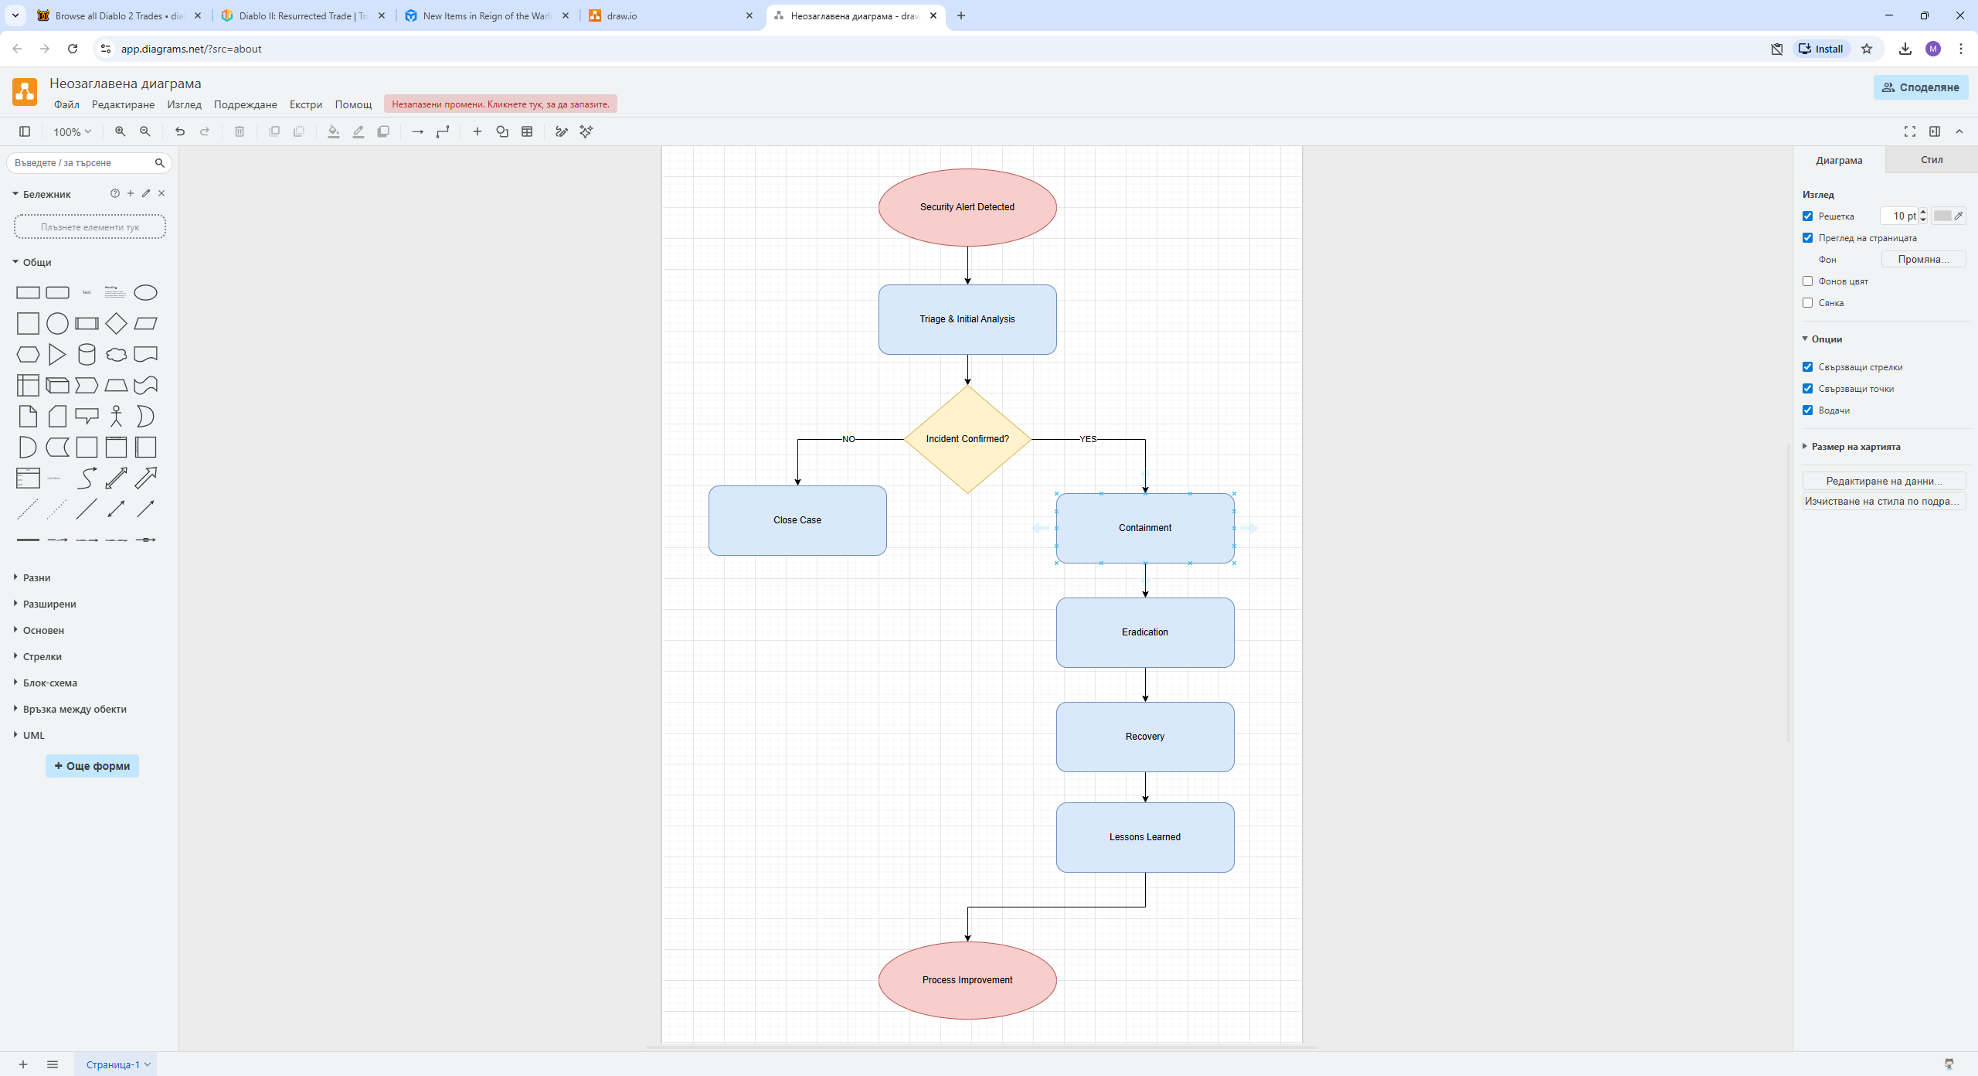
Figure 1: HPA Incident Response Workflow

Roles and Responsibilities
Clear accountability is essential. HPA should define who is responsible for technical response, management escalation, legal review, communications, and regulatory reporting. Senior leadership should be informed of major incidents quickly, particularly where patient data or service continuity is affected.

Testing and Improvement
Incident response plans should be tested through tabletop exercises and simulated cyber scenarios. This helps staff understand procedures, improve readiness, and reveal weaknesses before real incidents occur [12].
Overall, a mature monitoring and response capability would allow HPA to identify threats earlier, minimise operational disruption, and improve resilience against future attacks.

Training and Awareness Programme
Technology alone cannot fully protect an organisation if employees are unaware of cybersecurity risks. Human error remains one of the most common causes of security incidents, including phishing compromises, accidental data disclosure, weak password practices, and policy violations [2], [8]. For HealthPlus Analytics (HPA), a structured training and awareness programme is therefore essential to support compliance, strengthen organisational culture, and reduce avoidable risk.

Induction Training for New Employees
All new employees should complete mandatory cybersecurity training during onboarding. This ensures that staff understand their responsibilities before accessing systems or patient information. Induction training should cover:
- password security and multi-factor authentication
- recognising phishing emails and social engineering
- safe handling of patient data
- acceptable use of company systems
- incident reporting procedures
- remote working and device security
Completion of induction training should be recorded and linked to access approval processes [10].

Ongoing Refresher Training
Cyber threats evolve continuously; therefore, awareness training should not be a one-time exercise. HPA should provide quarterly refresher sessions to all employees. These sessions can include updated threat trends, lessons learned from recent incidents, and reminders of key policies. Short, regular training is often more effective than lengthy annual sessions [3].

Phishing Simulations
Because phishing is a major threat, HPA should conduct controlled phishing simulation exercises. These exercises test whether employees can recognise suspicious messages and report them appropriately. Staff who fail simulations should receive additional targeted coaching rather than punishment. This creates a positive learning culture while reducing future compromise risk [8].

Role-Based Security Training
Different roles require different levels of cybersecurity knowledge.
- General employees: password safety, phishing awareness, data handling
- Managers: escalation procedures, policy enforcement, risk ownership
- IT administrators: privileged access management, patching, secure configuration
- Senior leadership: governance responsibilities, breach decision-making, crisis communication
Role-based training ensures resources remain relevant and effective [5].

Data Protection and Compliance Awareness
As HPA processes sensitive healthcare information, all employees should understand data protection responsibilities. Training should explain confidentiality requirements, secure data sharing, retention rules, and the importance of reporting suspected breaches quickly. This would support legal and regulatory compliance [4], [10].

Measuring Effectiveness
Training should be monitored using measurable indicators, including:
- completion rates
- phishing simulation results
- quiz or assessment scores
- incident reporting rates
- repeat policy breaches
These metrics allow management to identify weak areas and improve the programme over time [12].

Building a Security Culture
Finally, HPA should promote a positive security culture through regular reminders, posters, newsletters, awareness campaigns, and leadership engagement. Employees should feel comfortable reporting mistakes or suspicious activity without fear of blame [11].
Overall, an effective training and awareness programme would significantly reduce human-factor risk while supporting HPA’s wider cybersecurity strategy.

Conclusion
HealthPlus Analytics (HPA) operates within a high-risk environment due to its dependence on digital systems and responsibility for processing sensitive patient information. Recent incidents involving unauthorised cloud access and ransomware demonstrate the urgent need for stronger cybersecurity governance and improved operational resilience.
This report has identified a range of internal and external threats, including phishing, ransomware, insider misuse, weak access management, and third-party vulnerabilities. In response, a comprehensive framework has been proposed consisting of formal security policies, practical technical safeguards, continuous monitoring capabilities, a structured incident response process, and an ongoing staff awareness programme.
Key recommendations include the implementation of multi-factor authentication, role-based access controls, encryption, endpoint protection, network segmentation, secure backups, and regular vulnerability management. These controls should be supported by clear governance responsibilities and regular staff training to reduce human error and strengthen security culture [8], [11].
If implemented effectively, the proposed measures would significantly improve the confidentiality, integrity, and availability of HPA’s systems and data. In addition, the organisation would be better positioned to meet legal obligations, maintain stakeholder trust, and respond effectively to future cyber threats. Cybersecurity should therefore be viewed not only as a technical requirement, but as a strategic business priority essential to long-term success [5], [6].

References
[1] IBM Security, Cost of a Data Breach Report 2024. IBM, 2024.
[2] Verizon, 2024 Data Breach Investigations Report. Verizon, 2024.
[3] European Union Agency for Cybersecurity (ENISA), Threat Landscape 2024. ENISA, 2024.
[4] Information Commissioner’s Office (ICO), Guide to UK GDPR. ICO, 2024.
[5] National Institute of Standards and Technology (NIST), Cybersecurity Framework 2.0. Gaithersburg, MD, USA: NIST, 2024.
[6] International Organization for Standardization, ISO/IEC 27001:2022 Information Security Management Systems. Geneva, Switzerland: ISO, 2022.
[7] National Cyber Security Centre (NCSC), Password Guidance: Using Strong Authentication. London, UK: NCSC, 2024.
[8] National Cyber Security Centre (NCSC), Phishing Attacks: Defending Your Organisation. London, UK: NCSC, 2024.
[9] National Cyber Security Centre (NCSC), Multi-Factor Authentication for Online Services. London, UK: NCSC, 2024.
[10] NHS England, Data Security and Protection Toolkit Guidance. London, UK: NHS England, 2024.
[11] UK Government, Cyber Essentials Requirements for IT Infrastructure. London, UK: HM Government, 2024.
[12] Center for Internet Security (CIS), CIS Critical Security Controls v8. CIS, 2024.
[13] Microsoft, Microsoft Digital Defence Report 2024. Microsoft, 2024.
[14] Sophos, The State of Ransomware 2024. Sophos, 2024.
[15] Ponemon Institute, Cost of Insider Threats Global Report 2024. Ponemon Institute, 2024.
[16] OWASP Foundation, OWASP Top 10 Web Application Security Risks. OWASP, 2024.

Appendix – PowerPoint Slides
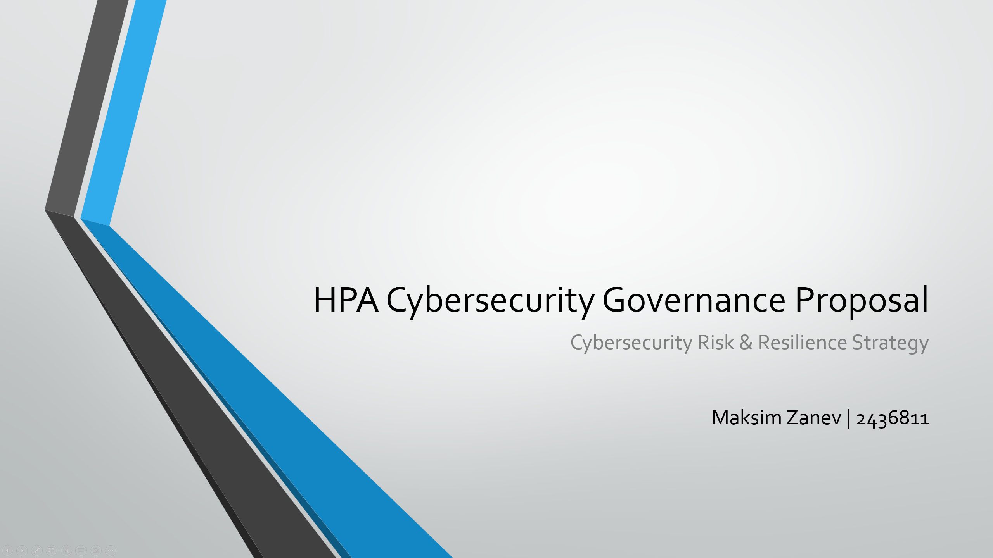
Slide 1: Title slide introducing the cybersecurity governance proposal for HPA and outlining the strategic purpose of the presentation.
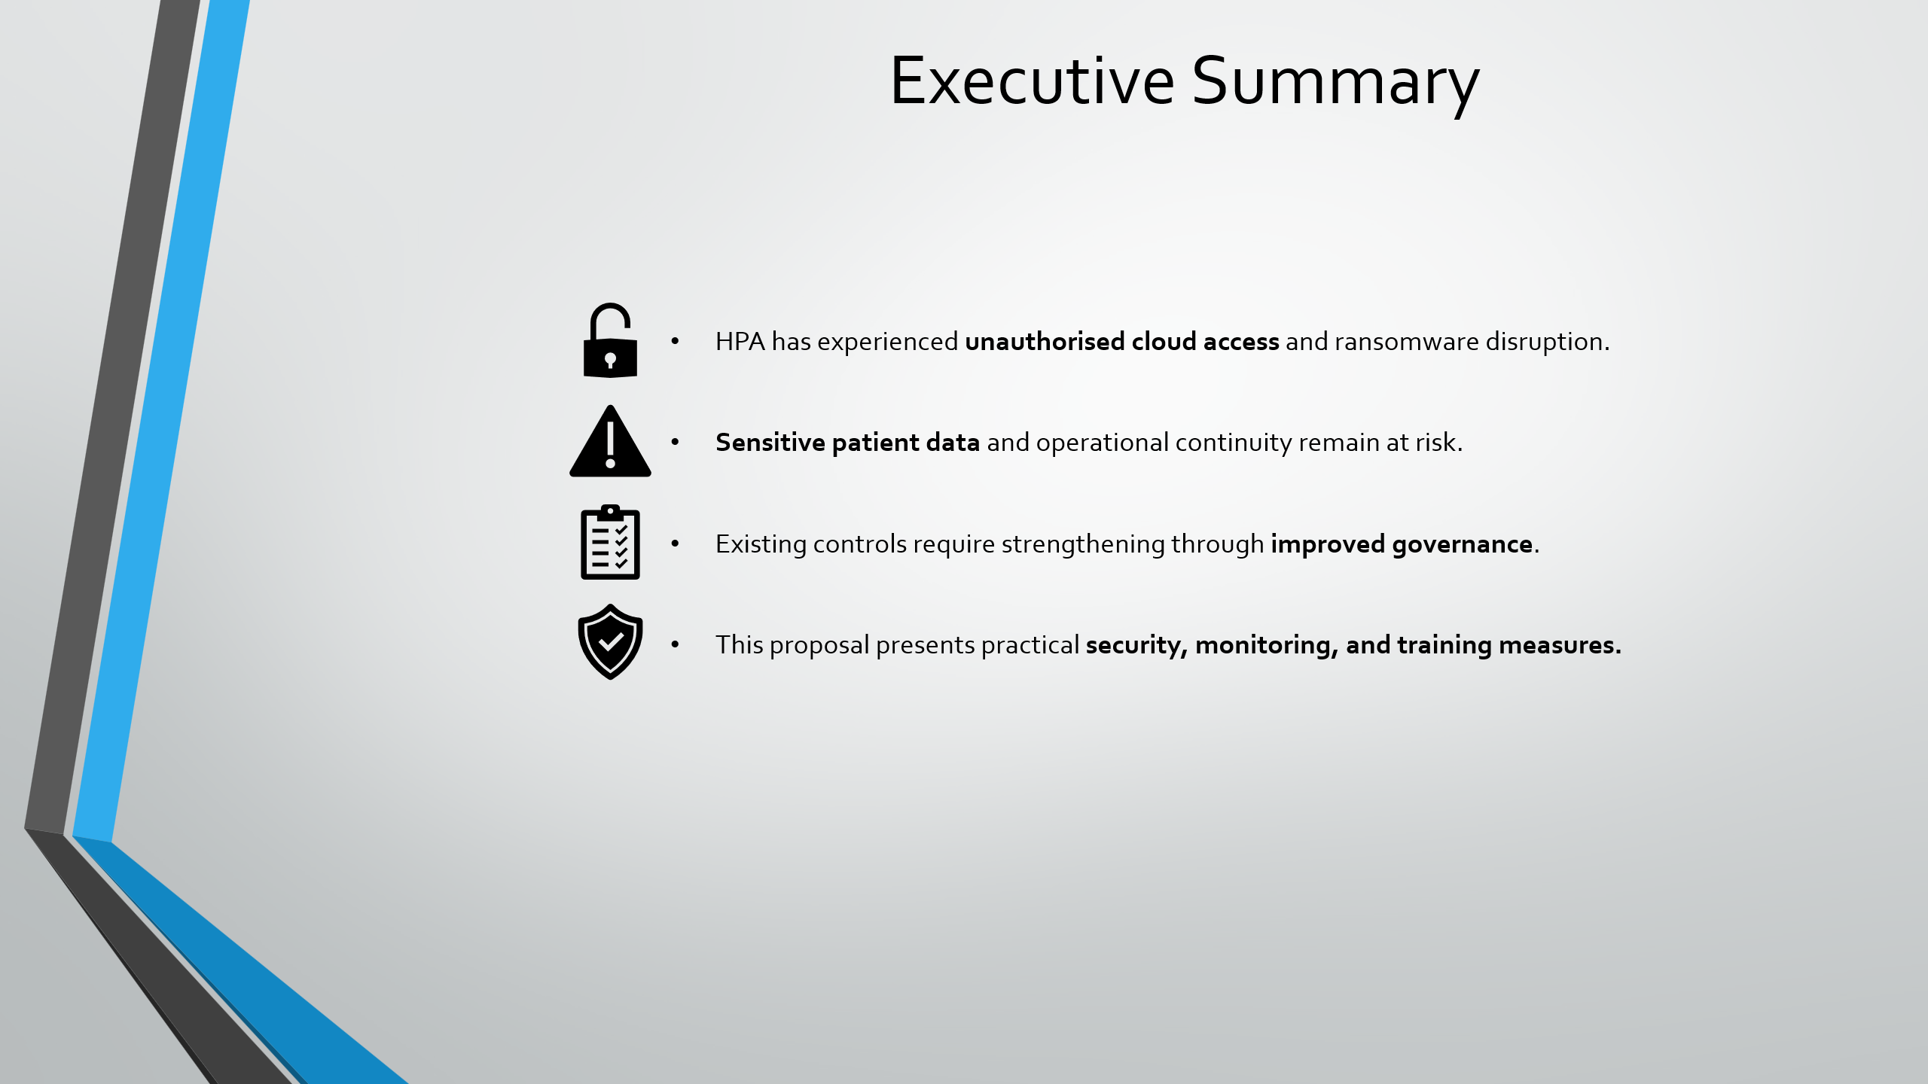
Slide 2: Executive summary highlighting ransomware exposure, patient data risk, governance weaknesses, and proposed control improvements.
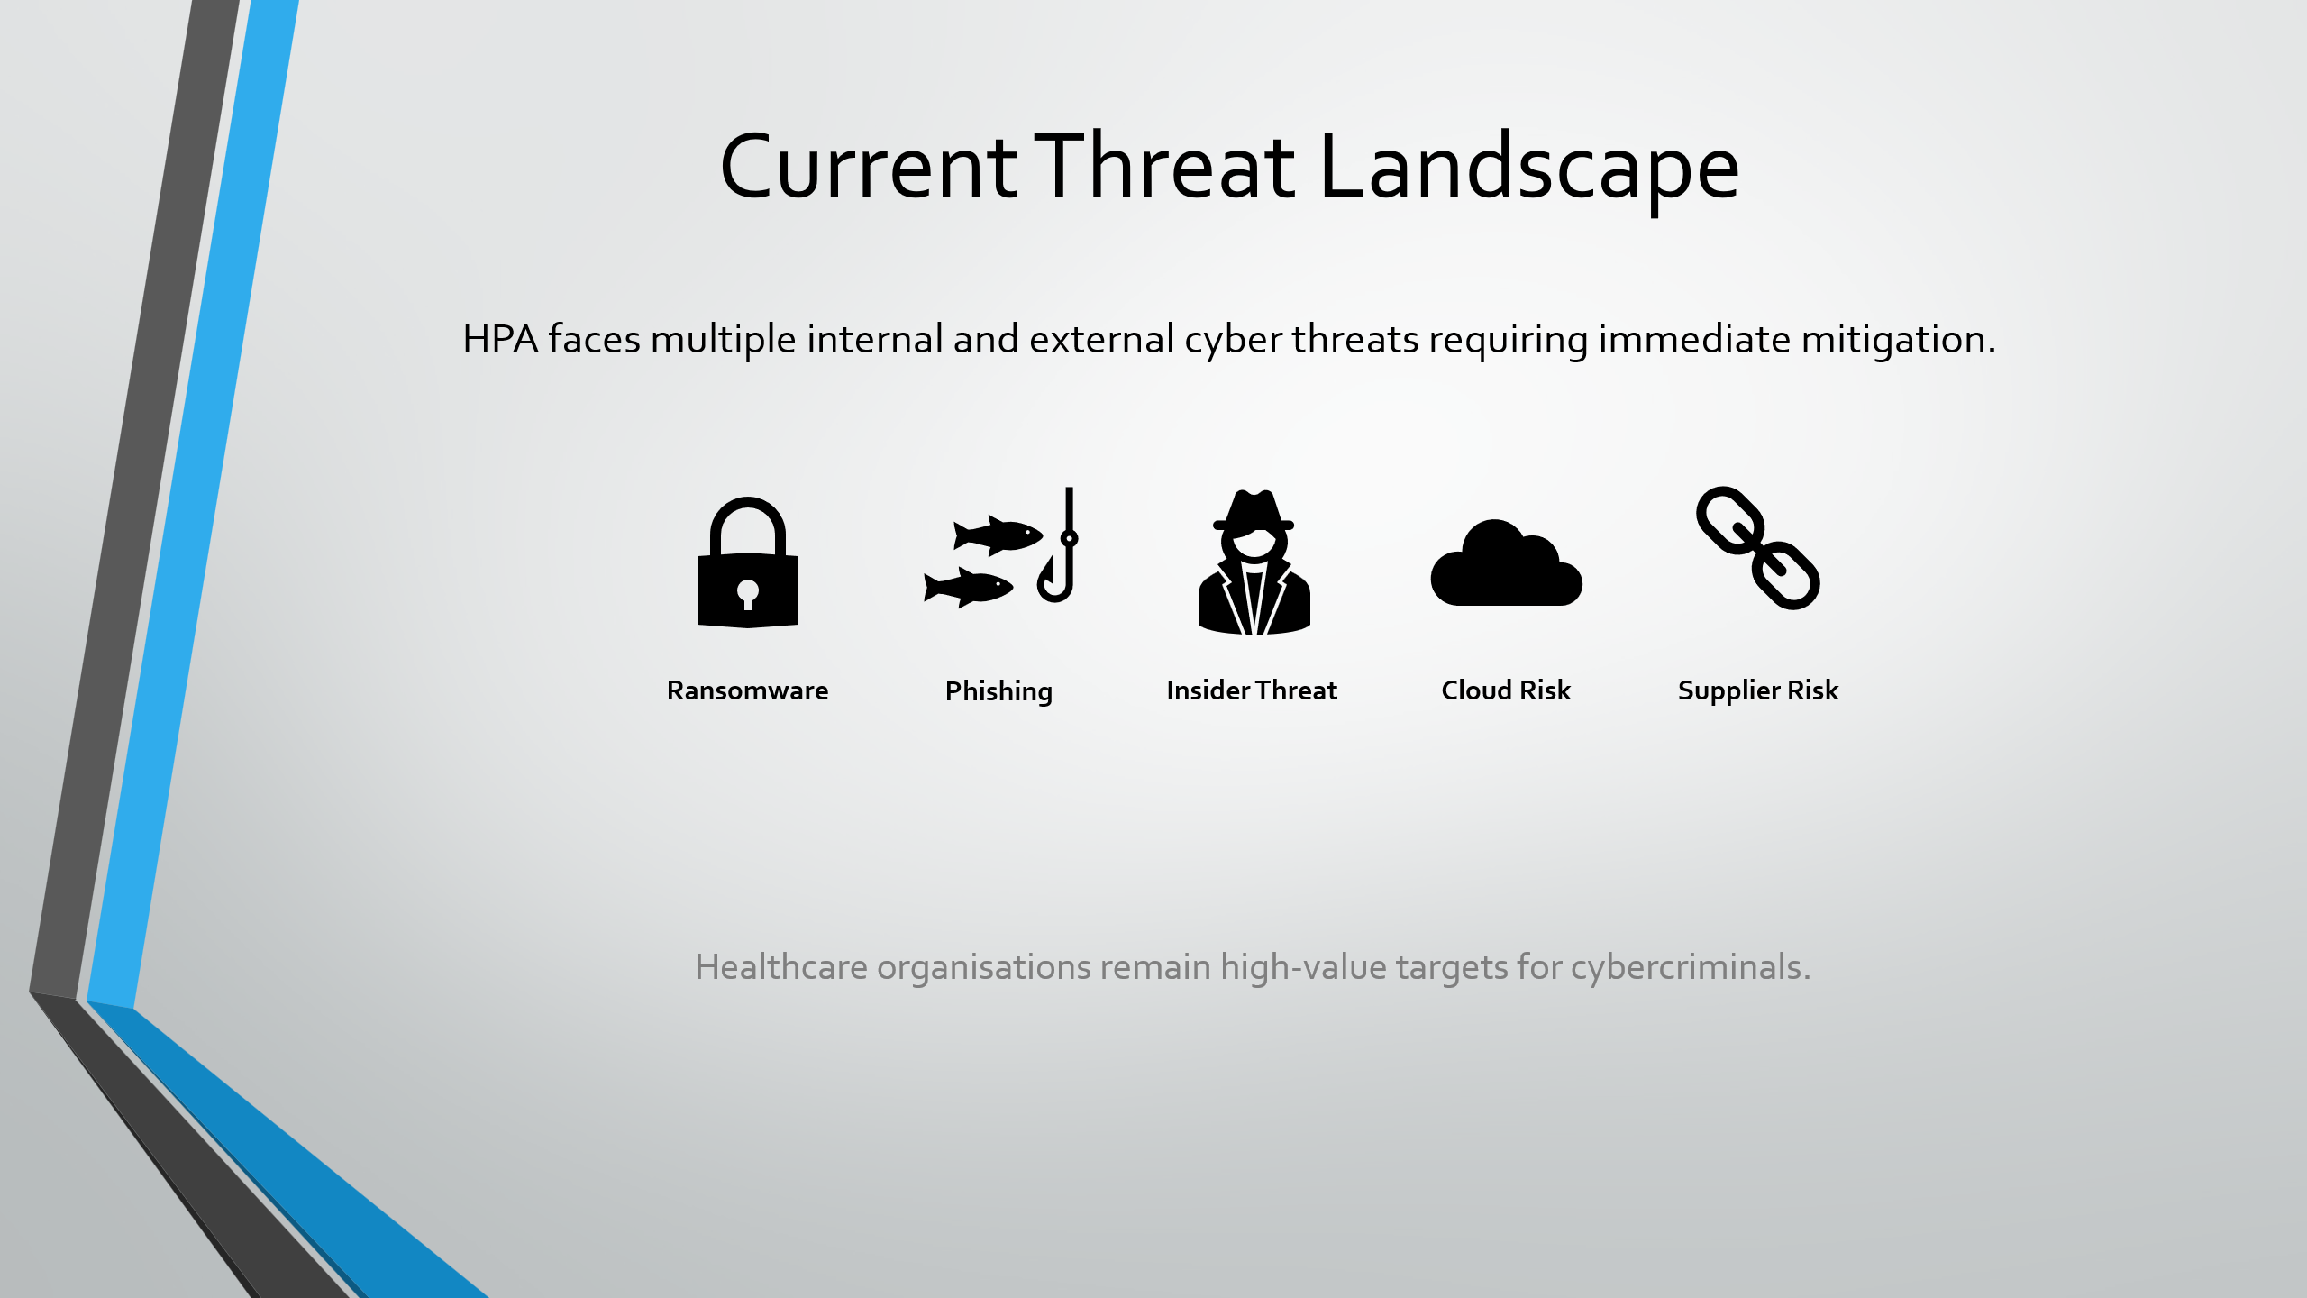
Slide 3: Overview of the current cyber threat landscape including ransomware, phishing, insider threats, cloud risks, and supplier compromise.
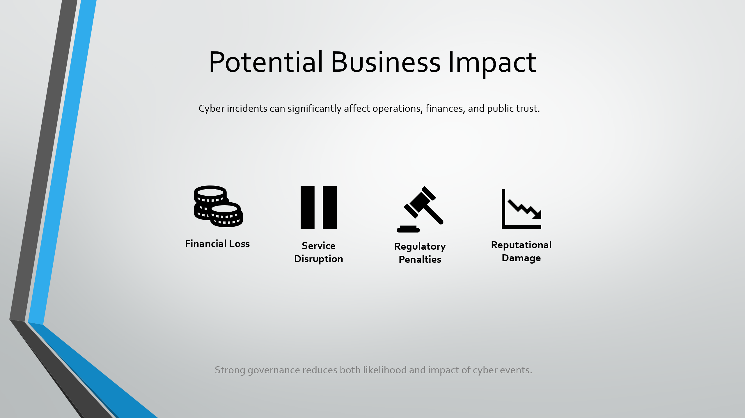
Slide 4: Summary of potential business impacts including financial loss, service disruption, regulatory penalties, and reputational damage.
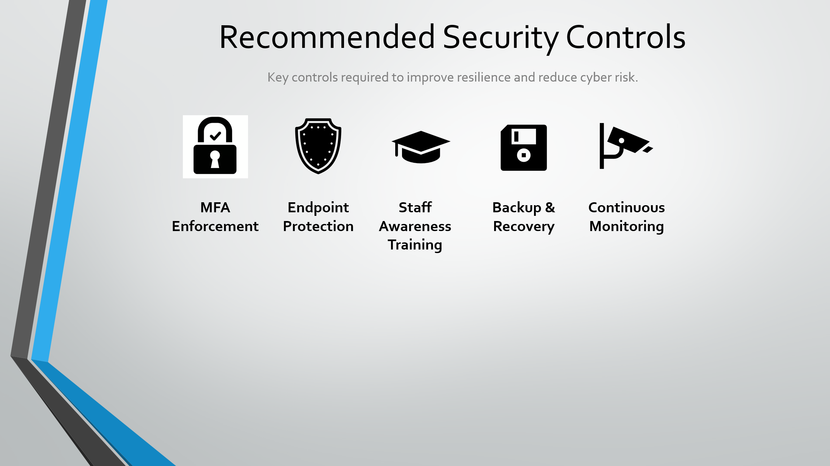
Slide 5: Recommended security controls including MFA, endpoint protection, awareness training, backup strategy, and monitoring.
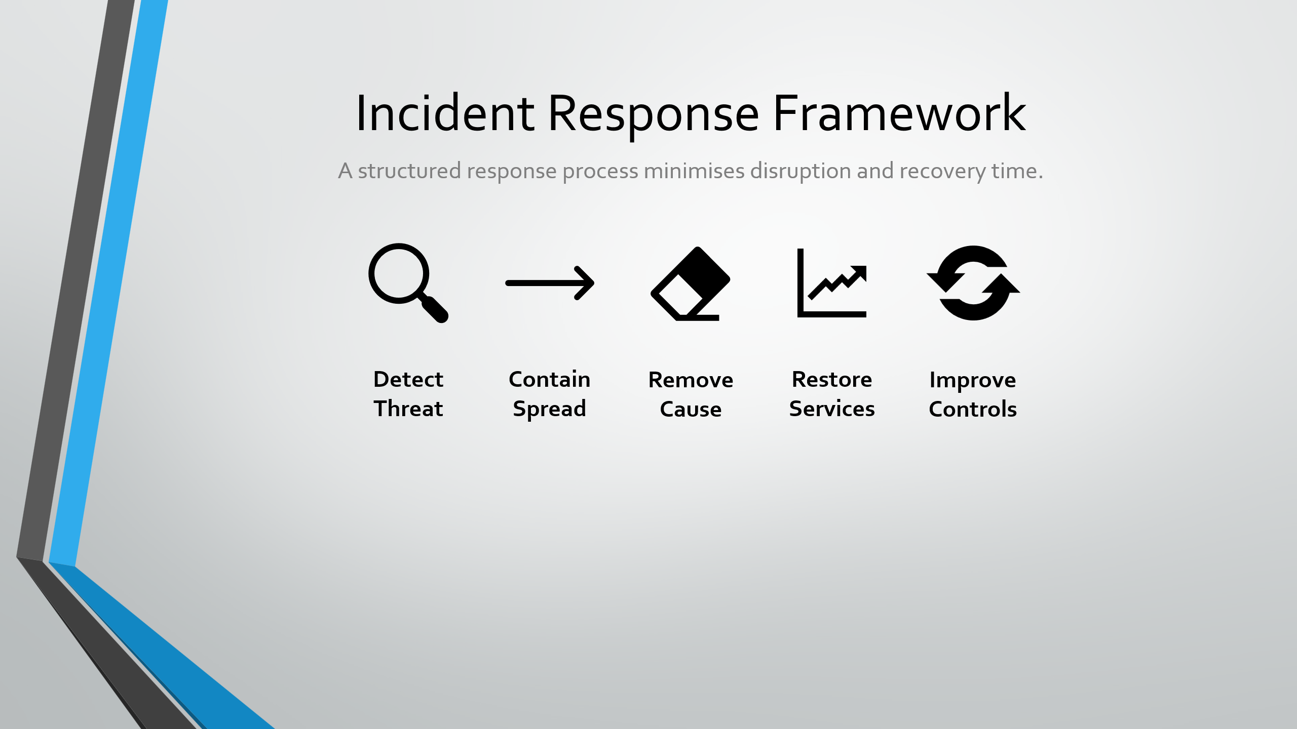
Slide 6: Incident response framework showing detection, containment, eradication, recovery, and continuous improvement stages.
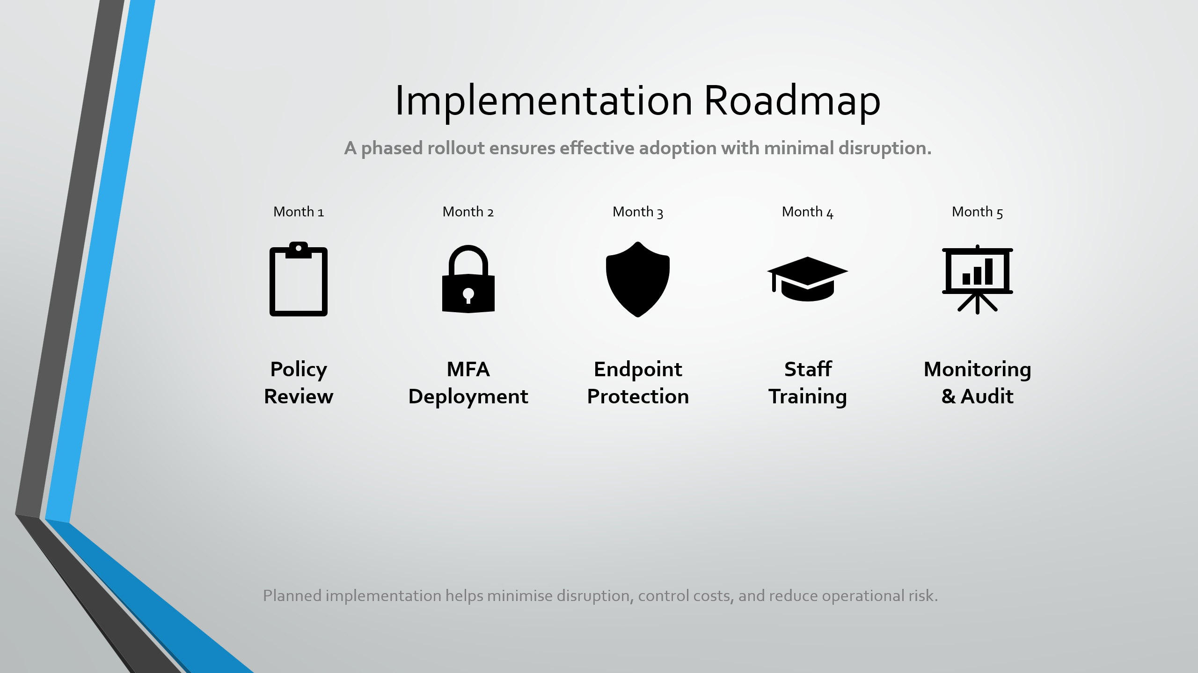
Slide 7: Five-month phased implementation roadmap for rolling out key cybersecurity controls.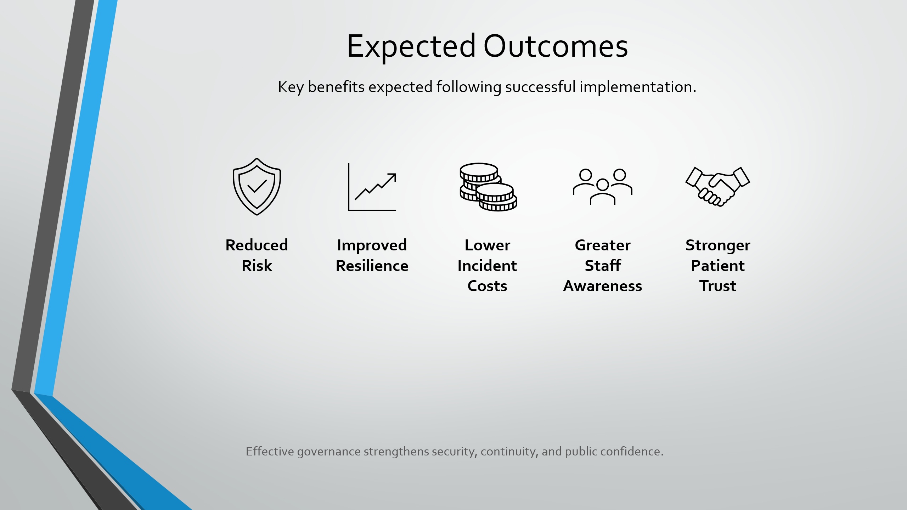
Slide 8: Expected organisational outcomes such as reduced risk, improved resilience, lower costs, and stronger trust.
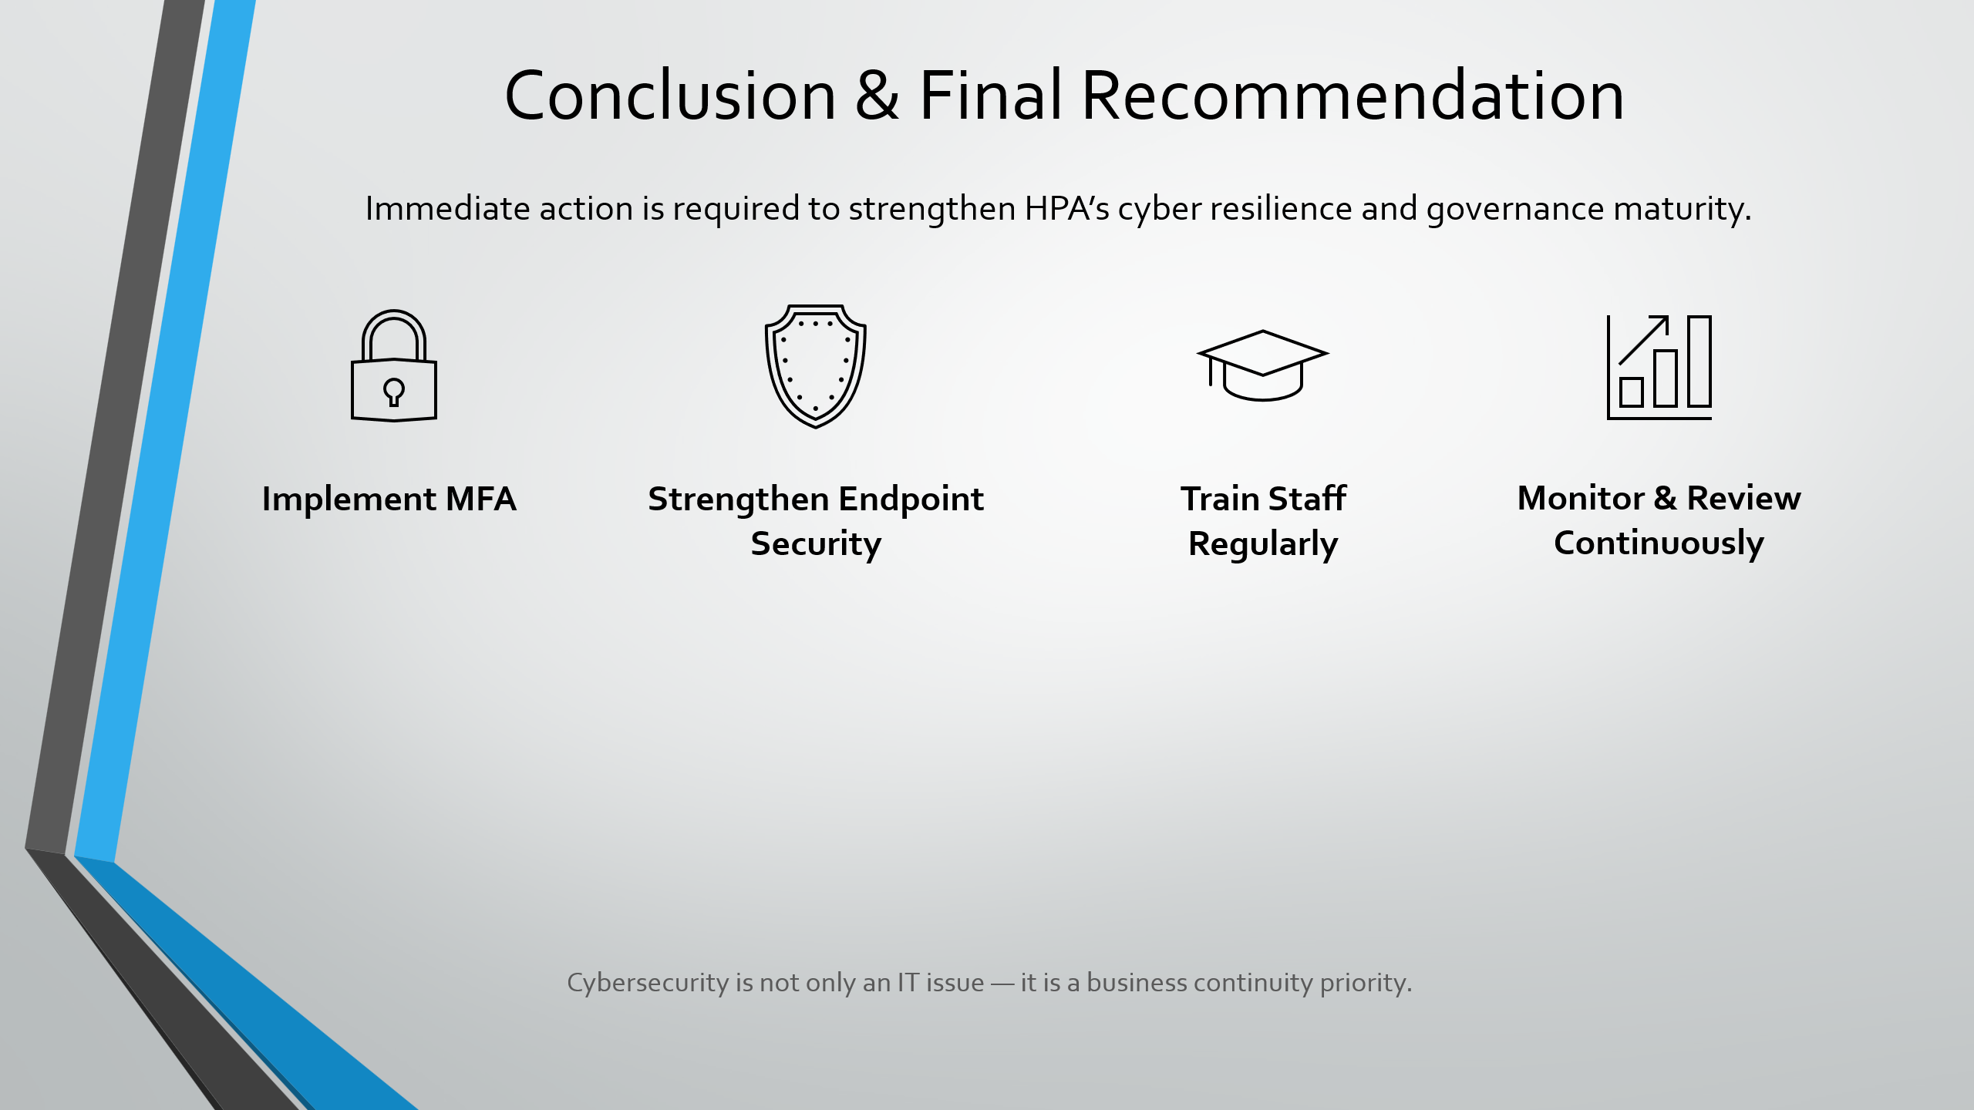
Slide 9: Final recommendations prioritising immediate action, staff training, stronger controls, and continuous review.



