BY BEN NSUKA (1816136)

RECRUITING STUDENTS WITH NEED OF ACCESSING HIGHER EDUCATION
As per Jaafari, A. (2000), Project management lifecycle is the sequence of stages that the project goes through from the Initiating to the Closure. The number and sequence of cycles are determined by management and various other factors, such as the needs of the organisations involved in the project, the nature of the project and its application areas.
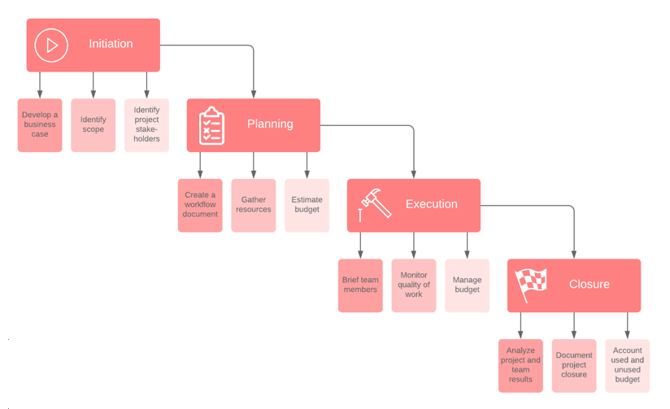
On the other hand, Bonghez & Grigoroiu (2013) acknowledge that Project management lifecycle is an option when things cannot be numbered or figured. So, it is not easy to successfully complete a project. It requires a series of tasks to meet the requirements of stakeholders and customers; this process involves many before the project reaches the completion stage. Regardless of the type of project, a complete understanding of the project management life cycle, project phase, or process group is essential. It takes the project manager organisation from conception to completion.
To make it easier, a Quad Chart is made to explain clearly and briefly what processes we have gone through to complete our project.
Quad Chart is a one-page managing tool summary of a project, visual and descriptive. This is a very simple but very effective tool for various planning and communication purposes, explaining the entire content of the project. It helps to organise a concept or idea into manageable parts so that you can define your work before you start. It is usually used to introduce new products or provide solutions to problems. Quad Chart helps to simplify the proposal or the idea. The quadrant box shows a brief snapshot of a four-quadrant study from a single PowerPoint slide.
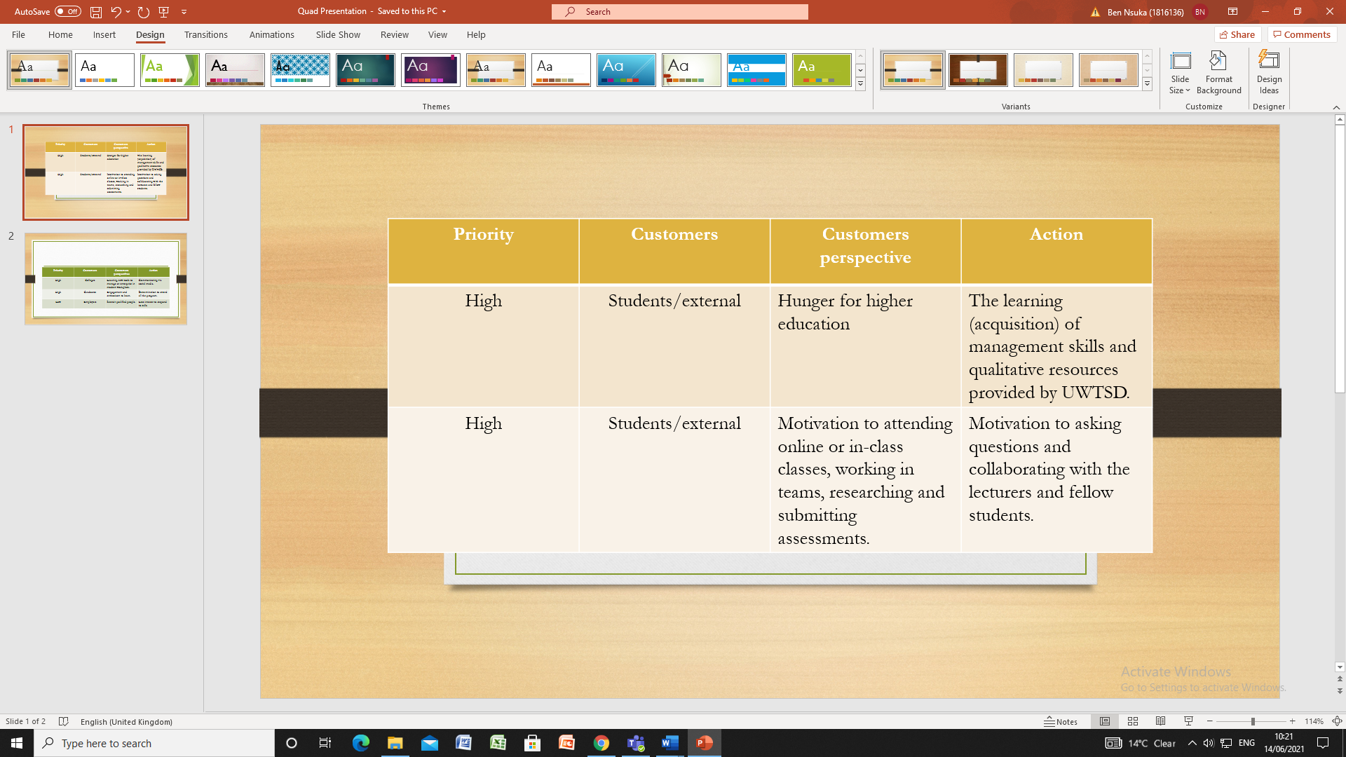

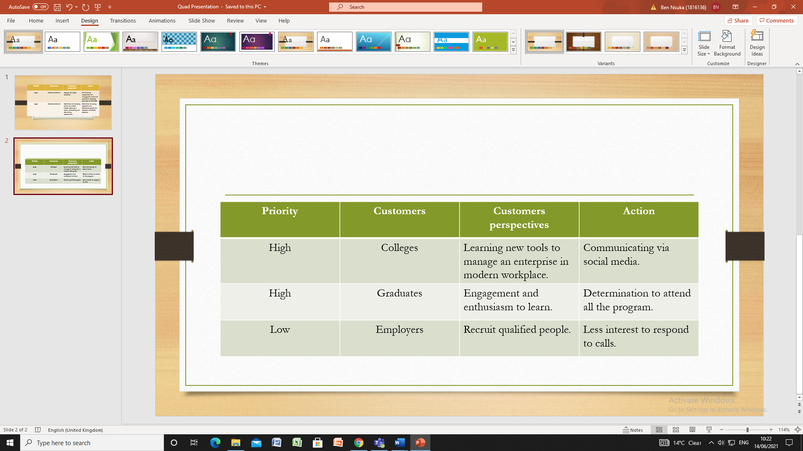
Our project consisted in recruiting students with need of accessing higher education. Its purpose is to recruit and motivate hunger for higher education by equipping new students with management tools to enable them to efficiently manage an enterprise and improve quality life. We managed to make awareness to students about the project by communicating with them through WhatsApp and Facebook.
During our recruitment process, we showed to students that UWTSD is one of the best educational institutions, providing programs and resources to encourage students to receive higher education. UWTSD has been ranked 7th in the UK for student satisfaction with teaching quality in the 2021 results. Furthermore, UWTSD is ranked 12th in the UK and 1st in Wales for Art & Design. 4th in the UK for teaching quality in Computer Science.
UWTSD received some excellent results in the Whatuni Student Choice Awards 2020 as:
- 1st in the UK for ‘Course & Lecturers’.
- 9th in the UK for ‘Student Support’.
- 4th in the UK for ‘University of the Year’.

UWTSD provides intellectual tools for future managers in the modern workplace.
In our case, amongst the tagged students (customers in need of efficient management tools), we managed to convince one student (now attending Cardiff and Vale College) to join UWTSD. The student’s details (name, e-mail, and phone number) will be emailed to the lecturer in charge of conducting the interview.

References
Bonghez, S. & Grigoroiu, A. (2013). If it can't be expressed in figures—project performance management. Paper presented at PMI® Global Congress 2013—EMEA, Istanbul, Turkey. Newtown Square, PA: Project Management Institute.
Jaafari, A. (2000). Life-cycle project management: a proposed theoretical model for development and implementation of capital projects. Project Management Journal, 31(1), 44–52.

