University of Wales Trinity Saint David
LONDON CAMPUS
Individual Report
Module Name: Digital Skills and Research Methods
Module Code: LCHS 4007
Student name: Alexsandra Oyeniyi
Student ID: 2538401
Lecturer’s Name: Dr. Ramzi Djemai

Table of Contents
Section 1: Introducing the Research Paper and Topic Development 3
1.1 Paper Details (Title, Author(s) and Year of Publication) 3
1.2 Main Topic or Problem Explored in the Paper 3
1.3 Who Is the Research About? 3
1.4 Why Is This Topic Important in UK Health and Social Care? 3
Section 2: Understanding the Purpose and Research Question 4
2.1 Research Question(s) or Objectives 4
Section 3: Understanding the Research Methods 4
3.1 Overview of Quantitative, Qualitative, and Mixed-Methods Research 4
3.2 Research Methodology Used in Your Chosen Paper and Why 6
3.3 Primary and Secondary Data: Definitions, Differences, and Application to Your Paper 6
Section 4: Conclusion 7
References 9

Section 1: Introducing the Research Paper and Topic Development

1.1 Paper Details (Title, Author(s) and Year of Publication)
This report examines a paper entitled “A qualitative study of organisational resilience in care homes in Scotland”, written by Ross, A., Anderson, J. E., Selveindran, S., MacBride, T., Bowie, P., Sherriff, A., Young, L., Fioratou, E., Roddy, E., Edwards, H., Dewar, B. & Macpherson, L. M. published in 2022.

1.2 Main Topic or Problem Explored in the Paper
The study explores how care homes in Scotland manage the complexities of caring for older adults with high support needs. Using the Resilient Healthcare (RHC) theory and the CARE Models, the researchers examined how staff adapt to constant pressures, limited resources, and unpredictable daily demands. Through extensive observations, interviews, and focus groups, they identified how “work‑as‑done” differs from “work‑as‑imagined” and how staff rely on flexible adjustments to maintain care quality. Overall, the paper highlights organisational resilience as essential for improving care, emphasising better information use, coordination, adaptable practices, and realistic family engagement.

1.3 Who Is the Research About?
The research focuses on multiple groups within the care home environment, including care home staff (8 managers, 7 senior carers / deputy managers, 12 carers / nursing assistants, 1 nutrition champion, 2 dieticians, 1 activities coordinator, 3 residents, 5 family members, 1 senior care inspectors, 12 care inspectors and multidisciplinary professionals, making the total of 75). The study involved interviews, focus groups, workshop discussions and observation, over 68 hours, across 11 care homes in Scotland. These participants were selected because they directly experience or influence everyday care processes, making them essential for understanding how resilience operates in real practice. The inclusion of residents and relatives also provides insight into lived experiences and emotional aspects of care. Altogether, this diverse group allowed the researchers to build a comprehensive picture of organisational resilience across the care home system.

1.4 Why Is This Topic Important in UK Health and Social Care?
Organisational resilience in care homes is a critical issue in the UK due to rising care demands, workforce shortages and increasing complexity in older adult care. The COVID-19 pandemic exposed significant vulnerabilities in the sector, with care homes experiencing high mortality rates and intense operational pressures (ONS, 2022). The paper highlights that in Scotland “around a third of COVID-19 deaths have occurred in care homes,” demonstrating the urgent need for stronger systems and adaptive practices. Better systems of data collection and sharing in advance of future pandemics (UK Covid-19 Inquiry 2026).
Beyond the pandemic, UK policy emphasises person-centred care, safety and quality of life for older adults. According to the Care Quality Commission (CQC), resilient care environments are essential for preventing harm, improving coordination and ensuring continuity of care (CQC, 2021). Academic research also shows that organisational resilience supports better decision-making, reduces risks and enhances staff wellbeing (Berg et al., 2018). Strengthening resilience is therefore vital for meeting national standards, supporting staff and improving outcomes for residents across UK health and social care.

Section 2: Understanding the Purpose and Research Question

2.1 Research Question(s) or Objectives
The aim of the study is to examine how care homes in Scotland deliver everyday care, with a particular focus on how staff adapt to complex, changing conditions and how these adaptations contribute to organisational resilience. To identify areas where organisational resilience could be strengthened, using the Resilient Healthcare (RHC) and CARE models are analytical frameworks.

Section 3: Understanding the Research Methods

3.1 Overview of Quantitative, Qualitative, and Mixed-Methods Research
Quantitative research methods involve collecting numerical data to analyse patterns, or outcomes in a structured and objective way. It is commonly used in health and social care to track trends such as infection rates, hospital admissions or medication errors (Cross, 2026b). Examples of quantitative research include experimental, correlational research, quasi experimental. An example of experimental research is this article “Home treatment for acute mental healthcare: randomised controlled trial” by Stulz et al, (2020) which is a randomised controlled trial study.
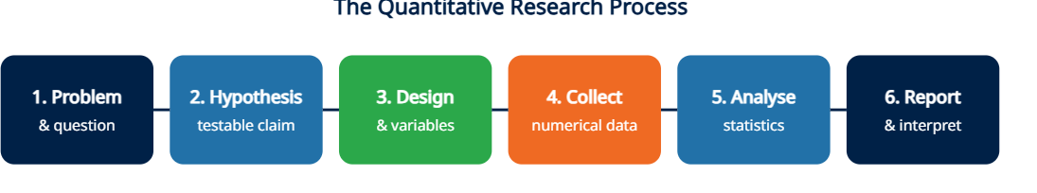
Figure 1 - Quantitative Research Process (cross, 2026a)
Qualitative research, by contrast, focuses on exploring people’s experiences, perspectives and meanings through methods like interviews, observations and focus groups. This approach is valuable in care settings because it helps researchers understand how staff and service users make sense of complex situations (Cross, 2026a). Examples of qualitative research include narrative research, ethnography, ground theory, phenomenology, action research. An example is this article titled “Assessing the Effectiveness of ChatGPT in Delivering Mental Health Support: A Qualitative Study” by Alanezi, (2024).

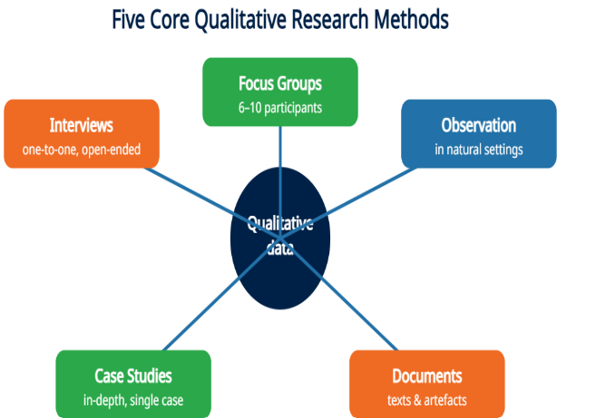
Figure 2 - Five Core Qualitative Research Methods (Cross, 2026b).
Mixed‑methods research combines both quantitative and qualitative approaches within a single study. It is particularly useful when studying complicated health or social care issues that require both statistical evidence and experiential insight. Researchers often use mixed‑methods designs to evaluate interventions, gathering numerical outcomes alongside staff or patient feedback (Khosla, 2021). An example is this article titled “A mixed methods study of an organization's approach to the COVID-19 health care crisis” by Zaghini, (2021).
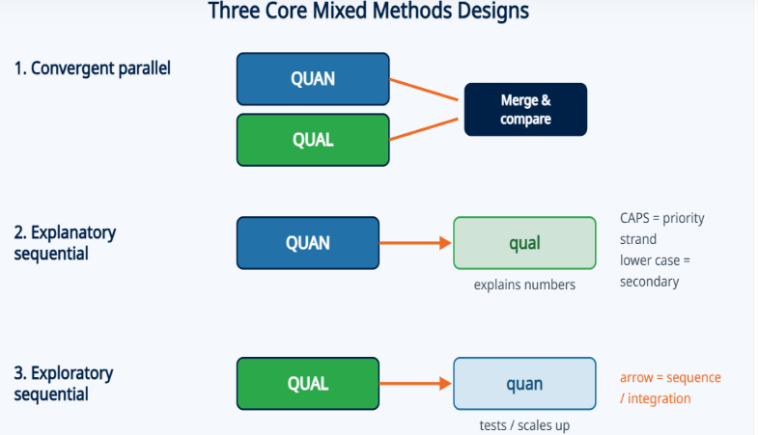
Figure 3 - Three Core Mixed Methods Designs (Mae, 2026a).

3.2 Research Methodology Used in Your Chosen Paper and Why
The paper by Ross et al. (2022) uses a qualitative research methodology because it is clearly stated in the article. Also, the paper adopts qualitative research methodology using observations, interviews, and focus groups discussions to explore how care home staff manage complex everyday demands. The I-SCOPE (Improving Systems of Care for the Older person) project employed Resilient Healthcare (RHC) theory and the CARE (Concepts for Applying Resilience) Model to study how care organisations adapt to complexity in everyday work, with the aim of exploring how to support resilient performance. This approach was appropriate because the researchers wanted to understand how the everyday care is delivered, lived experiences of staff, residents and families which cannot be captured through numerical data alone. Qualitative methods allowed the team to examine adaptations, decision‑making, and coordination in depth, revealing how resilience emerges in practice and why certain challenges persist, identify areas for potential improvement within organisational resilience care home systems and liaison teams proving focus multi-disciplinary work across homes, while applying holistic outcomes in service users’ quality of life.

3.3 Primary and Secondary Data: Definitions, Differences, and Application to Your Paper
Primary data is original, first-hand information collected directly by researchers for this specific study, while secondary data refers to existing data collected previously by others for a different purpose (Ajayi, 2023). Examples of secondary data include government reports, academic articles, organisational records, inspection reports or statistical datasets while examples of primary data used in healthcare include clinical measurements, like weight, height and vital signs (Ajayi, 2023; Mae 2026c).
This study by Ross et al (2022) collected primary data, including observations, interviews, focus groups, project workshop and round table discussions, capturing real‑time experiences in care homes. Their approach was guided by the Resilient Healthcare (RHC) theory and the CARE models, which shaped how they examined “work‑as‑done” and organisational adaptations. Data were analysed in two stages using NVivo, first describing everyday practices and then identifying broader themes related to resilience. They organise, analysed this material using QSR NVivo software to identify patterns in unstructured, non-numerical data, adaptations and themes related to resilient care practice.
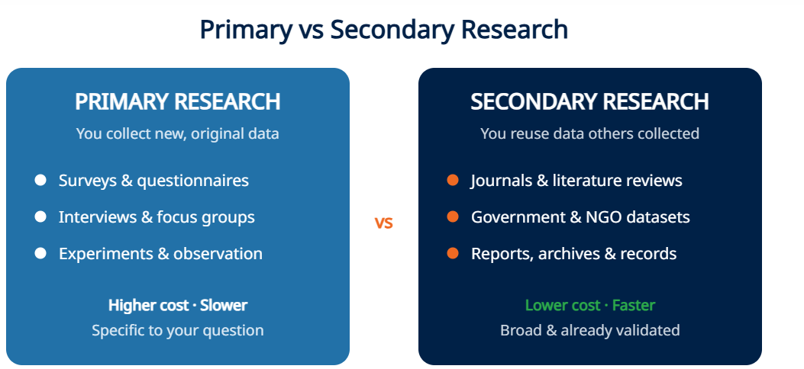
Figure 4 - Primary vs Secondary Research (Mae, 2026b).

Section 4: Conclusion
This report reviewed the 2022 study A qualitative study of organisational resilience in care homes in Scotland by Ross et al., which investigates how care homes respond to complex and shifting demands. introduced the study and outlined its central focus on organisational resilience, emphasising the experiences of staff, residents and families. It also explained the relevance of this topic within UK health and social care, particularly in relation to increasing care needs, workforce challenges and the effects of the COVID‑19 pandemic. The researchers collected primary data through observations, interviews, focus groups and workshop discussions, and analysed this material using the CARE model to identify themes linked to resilient organisational performance. Overall, the report illustrates how qualitative research can generate detailed insight into real‑world care practices and organisational functioning using primary data.
On reflection, this assignment enhanced the understanding of research, differentiating between research methodologies and recognising how data collection strategies shape research outcomes. It provides a clearer appreciation of the value of qualitative methods for exploring human experiences and complex systems, as well as the importance of distinguishing between primary and secondary data when evaluating evidence.
These skills will support future academic work and professional development by strengthening the ability to assess research, understand care processes and apply evidence‑based reasoning within health and social care settings. Developing greater confidence in analysing research will also ensure effective contribution to discussions about quality improvement and person‑centred practice.

References
Ajayi, V.O (2023). “A Review on Primary Sources of Data and Secondary Sources of Data”. SSRN Electronic Journal. doi:10.2139/ssrn.5378785
Alanezi, F. (2024). “Assessing the Effectiveness of ChatGPT in Delivering Mental Health Support: A Qualitative Study”. Journal of Multidisciplinary Healthcare, 17, pp461–471. https://doi.org/10.2147/JMDH.S447368
Care Quality Commission. A new strategy for the changing world of health and social care – CQC’s strategy from (2021) Available at: A new strategy for the changing world of health and social care - CQC's strategy from 2021 - Care Quality Commission (Accessed 1 August 2026).
Cross, E. Qualitative Research: Definition, Methods & Examples. (2026a). Available at: Qualitative Research: Definition, Methods & Examples – Research-Prospect (Accessed 3 August 2026).
Cross, E. Quantitative Research: Definition, Methods & Examples (2026b). Available at: Quantitative Research: Definition, Methods & Examples – Research-Prospect (Accessed 3 August 2026).
Khosla I. (2021) “Book Review: Social Research Methods: Qualitative and Quantitative Approaches”. Frontiers of Psychology. 12 p 696828. doi:10.3389/fpsyg.2021.696828.
Mae, A. Mixed Methods Research: Designs & Examples (2026a). Available at: Mixed Methods Research: Designs & Examples – Research- Prospect (Accessed 5 August 2026).
Mae, A. Primary Research: Definition, Methods & Example (2026b). Available at: Primary Research: Definition, Methods & Examples – Research- Prospect (Accessed 5 August 2026).
Mae, A. Secondary Research: Definition, Types & Examples (2026c). Available at: Secondary Research: Definition, Types & Examples – Research-Prospect (Accessed 5 August 2026).
Office for National Statistics (ONS). Deaths involving COVID-19 in the care sector, England and Wales (2022). Available at: https://www.ons.gov.uk (Accessed: 1 August 2026).
Ross, A., Anderson, J.E., Selveindran, S., MacBride, T., Bowie, P., Sherriff, A., Morrison, J., McFadyen, A.K., Johnston, L., McGregor, A., McKeown, A., McGill, M., McLeod, M., and Cunningham, S. (2022) ‘A qualitative study of organisational resilience in care homes in Scotland’, PLOS ONE, 17(12), https://doi.org/10.1371/journal.pone.0279376
Stulz N, Wyder L, Maeck L, Hilpert, M., Lerzer, H., Zander, E., Kawohl, W., Holtforth, M, G., Schnyder, U., Hepp, U., (2020). “Home treatment for acute mental healthcare: randomised controlled trial”. The British Journal of Psychiatry. ;216(6): pp 323-330. doi:10.1192/bjp.2019.31
UK Covid-19 inquiry. Module 1 Report in brief summary – The resilience and preparedness of the United Kingdom (2026) Available at: Module 1 Report 'In Brief' summary - The resilience and preparedness of the United Kingdom - UK Covid-19 Inquiry (Accessed 31 July 2026).
Zaghini, F., Fiorini, J., Livigni, L., Carrabs, G. and Sili, A., (2021). “A mixed methods study of an organization's approach to the COVID-19 health care crisis”. Nursing outlook, 69(5), pp.793-804. doi: 10.1016/j.outlook.2021.05.008

