Contents
Introduction 2
Overview of Duke+Dexter’s business 2
Evaluation of two EU countries 3
Netherlands 3
France 5
Hofstede Insights 6
Challenges that Duke + Dexter may face moving the business to France or the Netherlands 8
Labour laws and regulations 9
Cultural nuances 9
Business Etiquette 9
Consumer preferences 9
Language Barriers 10
Recommendations 10
References 12

Introduction
Multinational companies need to be able to communicate with each other clearly to succeed in today's globalised and competitive market (reference). Before you speak about UK culture, include a linking sentence that emphasise on how culture is important to consider in business. People in business in the United Kingdom like conversations that are short, direct, and to the point. This method encourages clear conversation, straightforward language, and less uncertainty. This way of talking affects daily tasks, making choices, and communication, so British businesses that want to grow internationally should learn it. To do business abroad, people need to understand other countries. Cultural beliefs, norms, and communication styles that are unique to a country may affect how businesses deal with each other. Just misunderstandings can lead to problems, waste, and even the failure of a business. If a British company like Tesco PLC wants to open a management office in the Netherlands or France, it needs to be aware of its cultural differences. It can be easier to work together and fit in if one can learn and follow the local market's structure, formalities, and communication norms. Tesco can improve its image, relationships, and growth in the tough EU market by learning about different cultures.

Overview of Duke+Dexter’s business

Handmade in England from sustainably sourced fabrics, this global men's footwear brand balances progressive style and great British charm. The Duke + Dexter community has grown since its inception in 2015, working with athletes, musicians, designers, photographers, and pioneers to create extraordinary collaborations (reference from the company website).
A key component of Duke + Dexter's designs has always been durability and comfort. Moreover, the brand believes in making the most of what you own, focusing on the important message of 'buy once and buy right' (reference from the company website).. This is why the brand releases its effortlessly cool styles in limited quantities to reduce waste to a minimum.

Evaluation of two EU countries
The two countries selected are the Netherlands and France. In order to succeed in this field, one must understand the way of life, the business, and how to communicate with people in the area (Brewster et al., 2022). A company's understanding of these cultural factors can enhance its management skills, ability to communicate with people from other cultures, and ability to deal with stakeholders. The company can decide where to expand using the analysis I have performed between the two countries.


Netherlands
The Netherlands is an excellent place to grow because it has a strong economy, many customers, and a European tourist country. Dutch business culture is known for its frankness, egalitarianism, efficiency, and strong dedication to work-life balance
Structure, order, and being on time are important in Netherlands society (reference). People in this culture value being accurate, self-controlled, and organised in both work and personal life. In formal social situations, people can distinguish between personal and professional ties; they respect authority, and most businesses are set up in a flat organisational structure. The official language is Dutch, which is used by the government and businesses for all interactions. Although Dutch is the dominant language, English is widespread, particularly in cities, and many Dutch people speak more than one language well. Netherland has strict rules about work and the environment aiming to foster a positive and productive workplace (reference). Dutch stores have many strong rivals in their own country and around the world (Brown, 2020). Dutch's workforce is better and more diverse because of its large immigrant groups. The Netherlands is MBO, meaning "Middelbaar Beroepsonderwijs" (Secondary Vocational Education). MBO programs are designed to prepare students for specific professions and are available in various fields, such as technology, healthcare, business, and the creative industries. A healthy workplace has both joint management and respect for authority. Individuality, success, and freedom are important to the Dutch. Professional settings, on the other hand, stress working together as a team (Brewster et al., 2023). Netherland managers value order, predictability, and accuracy, as shown by their high uncertainty avoidance score.
The Netherlands is thought to have a low-context culture. It is important to keep records in writing and communicate clearly. Shared information and nonverbal cues are not often seen or heard outside of direct conversation. Dutch business meetings are formal, punctual, and well-structured. Agendas are followed meticulously, and thorough preparation is expected from all participants. Decisions are often made hierarchically, with clear distinctions between managers and subordinates. However, input from relevant stakeholders is valued and considered (Brewster et al., 2023). Being on time is crucial in Dutch business culture. Lateness is seen as unprofessional and disrespectful. The organisational structure in Dutch leadership is often characterised by its flatness. Emphasis on authority or rank by leaders in the Netherlands is not typical, and there is a general avoidance of overt displays of power. This egalitarian method leads to leaders being perceived more as team members or facilitators rather than authoritarian figures. They are easily accessible, and employees are urged to express their opinions and ideas openly. (Brewster et al., 2023).


France
The French have always cared about culture, intellectualism, and living a good life. The French respect freedom, individuality, and living a happy life. People respect personal connections and social networks, but business social contacts are usually more formal. Since French is the official language, being able to speak it well is usually necessary to do well in business in this country. Most business people speak English, particularly in big cities and among younger workers. However, learning French can help people communicate and make more contacts (Brown, 2020). France has strict rules about taxes and work (referece). These are hard to get around in without knowing the area. There has been competition in French markets for a long time, both inside and outside of France. It's important to know what area customers want. When people don't understand how to communicate and act in business French, relationships may suffer. A lot of immigrants and foreigners work in France, which has a diverse and cosmopolitan population. Through academic and professional training, the education system encourages a skilled and varied workforce. Their high power distance shows that the French like clear leadership and hierarchical structures. Personal freedom, individuality, and accomplishments are important to France, which makes it stand out (Varner and Beamer, 2011). Leaders are expected to provide direction and make key decisions, while subordinates are expected to follow. The French are very good at avoiding uncertainty because they follow strict planning, clear rules, and controlled settings.
For the French, the culture is important. Communication depends on body language, shared knowledge, and understanding that isn't said out loud. If someone has never been to France, the language and customs may be scary and hard to understand (Brown, 2020). French business meetings are formal and can be lengthy. They often start with a small conversation to build rapport before moving to the agenda. Decision-making in France can be centralised, with senior management holding significant authority. However, there is also a consultative element where inputs from various levels are considered (Brown, 2020). Punctuality is essential but can be more flexible than in the Netherlands. Meetings may start slightly later, but lateness is still generally frowned upon. French leadership is often hierarchical but also charismatic. Leaders are expected to be knowledgeable and decisive, but also to inspire and motivate their teams. French managers are typically authoritative, providing clear directives while also valuing intellectual debate and discussion. There is an emphasis on creativity and innovation.

Hofstede Insights
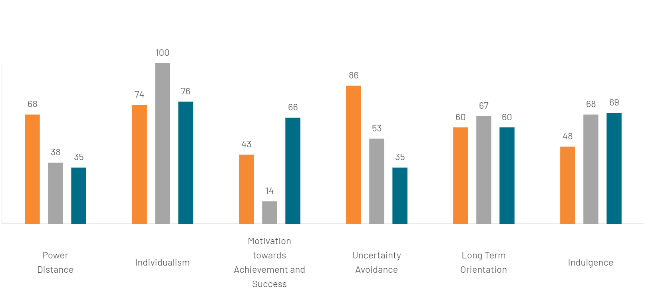

ASPECTS | UNITED KINGDOM | NETHERLANDS | FRANCE
  Power of Distance | The societal belief in minimising inequalities reveals research indicating lower PD index levels among Britain's higher class compared to the working class. It exposes a cultural tension between the significance of birth rank and the belief in unrestricted potential, driven by the value of fair play and the equal treatment of individuals. | Society values independence, equality, and accessibility to superiors. Power is decentralised, and managers rely on their team's experience. Employees expect to be consulted and prefer an informal relationship with their managers. Communication is direct and participative, while control is not favoured. | Children's upbringing fosters a certain level of emotional dependence on their parents, which eventually extends to teachers and authority figures. Consequently, this societal structure inherently accepts a fair amount of inequality, with power being centralised not only within corporations and the government but also within specific geographical locations.
  Lond Term Orientation | Due to their quite similar level of long-term orientation, all three countries can be described as pragmatic societies. People believe truth depends on the environment, context, and timing. They show an ability to adapt traditions easily to changing conditions, a strong propensity to save and invest, thriftiness, and perseverance in achieving results.
  Motivation towards Achievement and Success | At a score of 66, Britain is a decisive society driven by success. The apparent contradiction between modesty and the underlying value system can be confusing. Understanding the British requires reading between the lines, as words may not always reflect true intentions. Unlike consensus cultures, the UK emphasises work and pursues clear performance goals. | The Netherlands, with a score of 14, is considered a Consensus society. In such countries, it is essential to maintain work-life balance and inclusivity. Managers are supportive, decision-making involves everyone, and consensus is valued. Conflict resolution is through compromise and negotiation, with the Dutch known for their extensive discussions until a consensus is reached. | With a score of 43, France is a relatively consensual society, reflected in its famous welfare system, 35-hour work week, five weeks of annual holidays, and focus on quality of life. French culture has a unique characteristic where the upper class demonstrates low motivation towards achievement, while the working class reflects a decisive culture uncommon in other countries. This unique characteristic sets France apart from other countries.

Challenges that Duke + Dexter may face moving the business to France or the Netherlands

To communicate with French and Dutch business partners well, one needs to know about history, politics, and society It may be challenging for British managers who are used to working with others and adjusting to new situations to deal with the formalities and rigidities of other cultures (Clegg et al., 2016). For British companies to grow in the Netherlands and France, they need to learn about cultural differences, be flexible, and change the way they do business. By following these tips, they can improve their international management skills and make sure their business plans are successful and run smoothly.
To deal with new rules and high-level communication, Duke + Dexter might have to spend a lot of money on culture training and getting to know the area (Varner and Beamer, 2011).

Labour laws and regulations
France has more stringent labour laws and regulations, which could lead to higher costs for compliance and employee management. On the other hand, the Netherlands offers a more flexible business environment with fewer bureaucratic hurdles, making it potentially easier to navigate regulatory requirements. How Duch people think, work, and communicate with each other is closer to the British approach (Clegg et al., 2016). However, both countries have cultural nuances that must be understood and respected to ensure smooth operations.

Cultural nuances
In France, the business culture tends to be more hierarchical and formal, emphasising clear communication and respect for authority. Fewer questions from bosses and more information from the top may seem rigid (Deresky, 2022). In contrast, the Netherlands has a more egalitarian and consensus-driven culture, where open dialogue and collaborative decision-making are valued. These differences could impact management styles, employee expectations, and overall business operations for Duke + Dexter.

Business Etiquette
In France, business etiquette emphasises formality by using titles and strongly focusing on building personal relationships before discussing business. People in the British workforce who like to communicate with people directly might get these subtleties wrong (Trompenaars, 2012). In contrast, the Netherlands values direct communication and egalitarianism, emphasising efficiency and straightforwardness. Understanding these cultural nuances will be crucial for Duke + Dexter to navigate and integrate into these new markets successfully.

Consumer preferences
In France, consumers tend to appreciate high-quality craftsmanship and luxury, aligning well with Duke + Dexter's brand. On the other hand, Dutch consumers prioritise practicality and sustainability, which may require the company to emphasise its environmentally friendly practices. Understanding these cultural nuances will be crucial for the company's successful expansion into these markets.

Language Barriers
Even though English is an international language spoken in many countries, one potential challenge could be language barriers, as English is not the first language in either country. This may lead to misunderstandings or communication issues with local employees and customers. Additionally, it could affect marketing strategies and customer service, necessitating hiring bilingual staff or translation services.

Recommendations & Conclusion
A business culture is based on connections and trust, so building and keeping relationships is crucial. Learning the language and conducting cultural research in a country where you tend to move your business can help people communicate better and make long-lasting business ties.
The company could implement cultural training programs to help employees understand and adapt to local customs and business practices. Hiring local talent can also provide valuable insights and ease the integration process. Another strategy is fostering open communication and encouraging team-building activities celebrating both cultures.
A British company can do well in the European market by spending time learning the culture, communicating, and being sensitive to it (Trompenaars, 2012). The hierarchical structure of French workplaces can be complex compared to the British, who value equality and decision-making as a group. British workers need to be patient, accept that things will take time, and get used to things like long vacations and flexible hours. The Netherlands presents its own unique set of challenges, including high costs and a competitive talent market. It boasts a highly skilled workforce, but businesses face high operational expenses and intense competition in the job market. As a result, the company must provide attractive salaries and benefits to attract and keep top talent.
France is an attractive market for luxury goods due to its appreciation for high-quality craftsmanship. The country also offers valuable professional networks to support business growth and development. On the other hand, the Netherlands provides a highly sensitive market to trends and is known for its pragmatic communication style. The collaborative business culture in the Netherlands fosters innovation and operational efficiency, making it an ideal environment for businesses to thrive.
Even though France offers potential brand prestige and market opportunities for high-quality products, this report recommend that Duke+Dexer company develop its business in the Netherlands. Based on the research done, Netherland is a good option for the following strengths:
- The Netherlands boasts a highly innovative and competitive market, making it an ideal environment for business expansion.
- Its strategic location within Europe and excellent logistics infrastructure enables efficient distribution.
- The Dutch market also demonstrates strong consumer demand for high-quality, premium products, aligning well with Duke + Dexer's offerings.
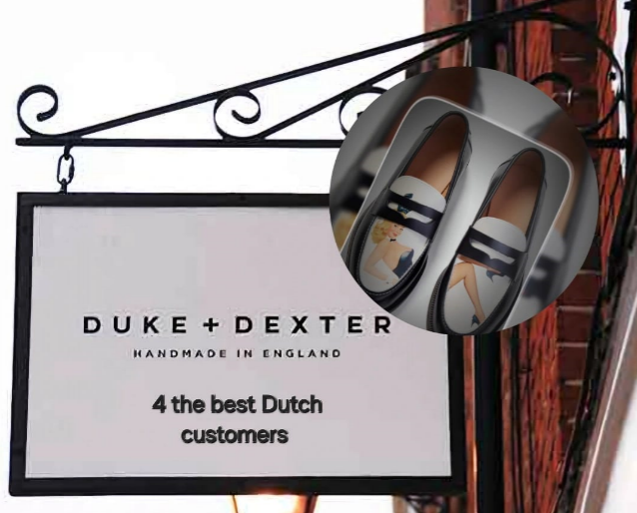
- The touristic market in the Netherlands provides a constant influx of international visitors who are often eager to purchase premium, locally available products. This can significantly boost brand visibility and sales. Furthermore, tourists are likely to spread the word about their positive experiences, enhancing the brand's reputation globally.

References
- Brewster, C., Houldsworth, E., Sparrow, P. and Vernon, G. (2023). International Human Resource Management. 5th ed. Kogan Page Publishers.
- Brown, A.D. (2020). The Oxford Handbook of Identities in Organizations. Oxford University Press.
- Clegg, S.R., Schweitzer, J., Whittle, A. and Pitelis, C. (2016). Strategy. SAGE.
- Deresky, H. (2022). International Management. Harlow: Pearson Education, Limited.
- Jackson, T. (2011). International Management Ethics. Cambridge University Press.
- Lane, H.W., DiStefano, J.J., Dietz, J. and Maznevski, M. (2013). International Management Behavior: Changing for a Sustainable World. Hoboken, N.J.: Wiley.
- Livermore, D.A. (2016). Driven by Difference: How Great Companies Fuel Innovation through Diversity. New York, NY: AMACOM/American Management Association.
- Trompenaars, A. (2012). Riding the Waves of Culture [electronic resource]. London: Nicholas Brealey.
- Varner, I.I. and Beamer, L. (2011). Intercultural Communication in the Global Workplace. New York: McGraw-Hill/Irwin.
- Hofstede Insights (2024). Country Comparison Tool. [online] Hofstede Insights. Available at: https://www.hofstede-insights.com/country-comparison-tool.

I have to add 4 more references and a few in-text citations, but I wanted to send it today because you are already busy and will soon be on holiday, too.

