LCMB7001
Marketing Management
(ASSESSMENT 1 )

* STUDENT NAME- MANDEEP KAUR SAGGU
* STUDENT ID - 2218282
* LECTURER- EFUA ADAMS

Table of Contents
Introduction 2
Current Environment Analysis 4
Porter’s 5forces analysis 4
Macro Environment Analysis 5
PEST analysis 5
Issues in Current Marketing Strategy of Restaurant 6
Target Market 6
Marketing Mix 7
Media Selection /Channels of Communication 7
Effectiveness of Communication Channels 9
Measuring success and contributors 9
Various organizations that have found success with proven marketing strategies 11
Recommendations for improving Marketing Strategies 13
Conclusion 15
References 16

Task 1

Introduction
It is an outstanding strategy that aids businesses in thriving; marketing plays a crucial role in business. Any successful business relies on customer interaction. An organization must utilize marketing strategies and concepts to maintain long-term relationships with customers and deliver the organization's promise to customers. For marketing purposes, organizations utilize a wide range of resources, including digital marketing tools, email marketing tools, design and creative tools, etc. Market resource managers decide the budget and arrange the funds for marketing activities by distributing all marketing resources for the organization (Skusa, 2023).

Additionally, most companies in the 21st century are focusing on fulfilling consumers' needs via various marketing strategies and resources. By using marketing strategies, many well-known organizations in the world have become successful. In order to increase its engagement with customers, Nike utilizes a marketing strategy known as "Just Do It". As Nike identified meaningful stories and connected them to its core values, such as motivation, inspiration, and healthy living, a success story lies within. A Nike marketing campaign that combines its value proposition with an emotionally-driven message was a resounding success. Thus, you can learn from many companies about their campaigns and how you can apply similar strategies to improve marketing efforts in your organization. Christos Greek Cypriot restaurant is highlighted as a company whose marketing strategy emphasizes personalized touch points and guarantees customer satisfaction.
Cypriot Restaurant enjoys the privilege of a Greek school, a Greek church, a food shop and a Greek store. Moreover, Christos has worked in catering & music for over 20 years, and most of that time in restaurants. For about 15 years, he was the main chef, manager, and musician at the Greek Restaurant in Tamworth (Christos, 2022). In addition, Greek Restaurant' current marketing strategy has been critically evaluated in this report. This company has been provided with one innovative new marketing strategy alongside its critical appraisal of its current strategy to evaluate and manage its customer journey across a variety of communication channels to meet stakeholders' expectations both now and in the future.
(Christos, 2022).

Current Environment Analysis

Porter’s 5forces analysis
Porter's 5forces analysis has been used to examine the current external or micro environment of marketing:

Bargaining power of buyers: Christos Cypriot Restaurant, for example, has a high level of bargaining power among their buyers. For any reason, Greek consumers can choose from a number of alternative providers. As they do not necessarily need to seek out a burger provider, they can also choose traditional foods that are more relevant to their culture rather than switching to a burger provider.
Bargaining power of suppliers: Greek's food industry also boasts high bargaining power among suppliers. In the event that retailers are unhappy with their current solution, they have a number of options to choose from, and can easily change to another if necessary (Kyriakia, 2015).
Threat of substitutes: Fast-food in Greek is threatened by substitutes. Greek Restaurant offers a number of different fast-food options, assuming you assume that burgers are the main item on the menu. Due to this, Greek consumers may purchase sandwich products, Greek souvlaki, pizzas, crepes, and bakery items, such as cheese pies. The full-service restaurants could also be considered a substitute for fast-food retailers, although they are indirect substitutes (Langkos, 2014).
Rivalry among existing brands: Providing supply chain improvements, market expansion, and international market capture is a must for new entrants in the market to compete against Christos Cypriot Restaurant. Already existing brands in particular sector will can compete with restaurants and other major brands due to consumer loyalty. The sector will become more attractive to Greek consumers, however, as incomes decline and fast-food becomes cheaper.
Threat of New entrants: Fast-food entry is difficult in Greek due to significant barriers. Greek's high startup costs and turbulent economic conditions make starting a business there difficult, as well as risky. Developing a new brand requires a lot of investment in marketing and advertising. It would also take several years to reach the level of a restaurant in terms of brand development. This company is therefore not at risk from new entrants.

Macro Environment Analysis

PEST analysis
Political and legal conditions: Greek food law is extremely strict, especially in regard to store hygiene, quality ingredients, and quality of materials. In order to determine whether restaurant kitchens and restrooms comply with health and hygiene rules, the National Ministry of Health conducts unexpected inspections in restaurants of all types. Additionally, food and ingredients are also inspected to ensure that their freshness is enhanced, and to make sure they are past their expiration dates. Christos Cypriot Restaurant's operations are affected by these legal and political constraints (Langkos, 2014).
Economic conditions: During the second half of 2008, Greek experienced an economic crisis that has characterized its economic conditions. In addition to the imposition of two austerity packages, thousands of Greek companies have closed down, resulting in a decline in disposable incomes, as well as a reduction in cash flow mainly due to the limited availability of Greek bank loans. Due to the current economic conditions in Greek, sales of fast food declined by 12% in 2012, despite lower prices charged and contrary predictions for the sector.
Social conditions: The economic crisis and accompanying increase in unemployment rates have led to a decline in disposable incomes among Greek consumers. The Greek consumer has traditionally been very sensitive to price issues, but also to health issues when it comes to food, especially when purchasing items for their children. The perception of unhealthy food is one of the reasons why restaurants like Christos Cypriot are less popular. Generally, home deliveries have increased, as Greek consumers have been gathering at home more often, while students and professionals take more home deliveries (Langkos, 2014).

Technological conditions: A major technological advancement in Greek during the last decade has been the development of broadband connections and the expansion of the use of the Internet. Online sales and promotion are becoming increasingly popular among companies, which also informs Greek consumers about their products and services. Food service providers have also benefitted from advances in information and food-preparation technologies, both in terms of operational efficiency and cost reduction. (Langkos, 2014).

Issues in Current Marketing Strategy of Restaurant
As a result of market research and analysis, Christos Greek Cypriot Restaurant has missed multiple opportunities in comparison with its market competitors when it comes to forecasting growth and product demand. The company has kept massive inventory both in its channel and in-house framework compared to its competitors because of poor market research and a lack of ability to predict market conditions and demands. Thus, the restaurant has unnecessarily stocked its inventory, engaging a large amount of capital.
Despite restaurant investments in technology, further market research needs to be done regarding technologies for international expansion. There is an inconsistency between the investment behind technical advantages and the competitors' technological advancements on the market and the restaurant's vision.
In addition, the worldwide economy has become more isolated due to the covid-19 pandemic and the financial crisis. This has had a negative impact on Christos Cypriot. The restaurant has faced challenges in growing due to the shortage of talented employees in the global market. There is also a limited reach in developing countries like India where highly profitable and demanding products are not reachable.

Target Market
Age | 18-34 Years
Gender | Both Male and Females of Greek Community
Income status | Economy, medium, high, premium
Psychographic | Offering refreshments and relaxation to people who are tired after their busy office, college, and business hours to meet Greek community members from diverse cultures.

Christos Greek Cypriot Restaurant has been targeting the upper-middle class and upper-class people as a customer base since its inception. In order for the restaurant to succeed, it must shift its focus towards targeting young people aged 18-34 and particularly youngsters, including both males and females.
Segmentation: A large part of Christos Greek Cypriot Restaurant's target audience is in the age group of 18-34 years old. Furthermore, the restaurant is also targeting food lovers.
Targeting: A broader audience is targeted by Christos Greek Cypriot Restaurant. Keeping the interests of all social groups in mind to meet their needs at an affordable price will help every member of society.
Positioning: By manipulating the marketing mix 4Ps, Christos Greek Cypriot Restaurant positions itself in the mind of customers. Various promotional activities such as E-mail marketing, Facebook markets and Instagram marketing are used by the restaurant to grab the attention of customers and make positioning in their minds. ,

Marketing Mix
- Public Relations and Publicity: To gain more population, public relations strategies use viral marketing and social media channels to advertise a brand's image. Through positive impacts of the brand value proposition and sales, Christos Greek Cypriot Restaurant must innovate its public relations strategy. Restaurants can offer loyalty cards to customers as part of their loyalty programs when purchasing food from them, thereby strengthening their publicity and public relations efforts.

- Advertising: Marketing and advertising for the restaurant must be expanded through print and communication mediums such as social media, email, push notifications, and revolutionizing the restaurant's mobile app. marketing and advertising strategies for the restaurant need to focus on the message of a premium quality food drinking experience in its outlets.

Media Selection /Channels of Communication
E Mail Marketing: In order to create brand awareness, the restaurant also needs to use social media, email, websites, and other channels to promote its products and loyalty programs. By maintaining regular communication with your customers, as well as by tracking and analyzing, email marketing can help Christos Greek Cypriot restaurant build and sustain customer loyalty. For the purpose of increasing customer loyalty, the restaurant prepares attractive posters and sends e-mails to its customers (Fariborzi & Zahedifard, 2012).
Facebook and Instagram Marketing: A second communication channel used by the Christos Greek Cypriot restaurant is Facebook marketing. This helps make it more credible and give it a higher ranking when people are looking for the restaurant online. In addition, it allows Greek Cypriot restaurants to appear higher in search engine results when customers search for the kind of food they prepare. The restaurant uses various hashtags for advertising purposes (Dosi & Tzortzaki, 2017). Moreover, Christos Greek Cypriot restaurant posts attractive content as well as posters on Facebook to attract target audiences. Furthermore, Christos Greek Cypriot restaurant shares various posts on Instagram to promote its products as well as to attract customers (Tiago & Verissimo, 2013).

Traditional Marketing: There is a decline in the global reach of traditional marketing channels such as television commercials, radio ads, newspaper ads, and outdoor advertising. TV and radio advertising are used by restaurants to promote new menu items, meal discounts, and charitable causes. Its broadcast channels and times are chosen so that most people will watch or listen. The traditional Marketing strategies used by the Restaurant help it to reach the local customers and it also helps in building creditability of the Christos Greek Cypriot Restaurant. Moreover, with the help of Traditional Marketing local area of Birmingham is targeted by the restaurant (Bharti & Kumar, 2020).

Effectiveness of Communication Channels
In spite of this, Christos Greek Cypriot Restaurant uses both traditional and modern communication channels. In addition to giving the restaurant a competitive advantage, these marketing strategies increase the restaurant's sales revenue. Additionally, using the above-mentioned communication channels increases customer loyalty for the restaurant. The communication channels still have some shortcomings, such as not being up to date with the restaurant's technology, but they are still able to attract customers.

Measuring success and contributors
With the help of marketing and communication channels, Christos Greek Cypriot Restaurant is meeting its overall mission and objectives. Social media as well as traditional marketing platforms are the major contributors to Greek Restaurant's success as the Facebook and Instagram campaigns have been successful in attracting the Greek Community. Moreover, customer feedback plays a major role in assessing a business's current marketing strategy. As a result of customer feedback, the current business strategy can be improved, as well as the requirements of customers can be identified. This shows that the restaurant is meeting its goals and values as customers are giving positive feedback. Also, the restaurant's Social Media reach increased from the past, as well as the number of followers. All these things indicate that the Mission of the restaurant has been fulfilled. Christos Greek Cypriot restaurant is able to provide Greeks with the services they need.
The restaurant, however, still underutilizes resources such as technology, modern activities, and service capes. However, these problems can all be resolved by upgrading the technical staff, and engaging social media marketing more.

Task 2

A variety of marketing strategies discussed above, such as email marketing, Facebook, and others, play an important role in achieving success as well as goodwill for Christos Greek Cypriot Restaurant. In order to gain competitive advantage over competitors, businesses can develop the appropriate marketing strategy by determining the right product, price, promotion, and place strategies and forecasting or studying the surrounding environment. (Alhadid & Al-Zu’bi, 2014).
Moreover as per the study conducted by (Aghazadeh, 2015) stated that the Intelligent Marketing Strategy and Digital Marketing as well as traditional marketing can also lead to superior performance in any organization, such as a Greek restaurant. A company's ability to cope with dramatic changes and succeed depends on its ability to maintain a competitive advantage. Through strategic management, they can build, sustain, and exploit their competitive advantage. Strategies can be developed by organizations that result in sustainable competitive advantages. A key aspect of these strategies is marketing strategies. Furthermore, using marketing strategies effectively can improve the restaurant's business performance. In this approach business performance is outcome of business performance perceived by market, business performance perceived by customers, business performance perceived by competitors and business internal performance (Aghazadeh, 2015).
Christos Greek Cypriot Restaurant is also using social media marketing tactics such as Facebook and Instagram to market the restaurant. As a result of the widespread use of smart phones and the internet, with most people now relying on social media branding, sharing brand information and consumer experiences has become a new avenue for brand marketing. As a result of social media activities, customers are satisfied because of implementation confirmation theory. According to this theory, satisfaction is the level of satisfaction a consumer expects from the service. Comparing the satisfaction previously experienced with the current satisfaction is usually the best method of determining customer satisfaction (Jamil, et al., 2022).
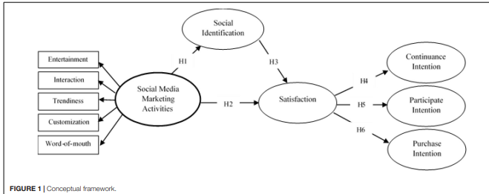
(Jamil, et al., 2022).

Various organizations that have found success with proven marketing strategies
Among the most famous companies in the world, Domino's uses social media marketing to capture its target market. Firstly, Domino's redesigned their website to give customers a fresh and new ordering experience. People were able to create their own websites using this new website. Pizza ordering became more personalized with profiles and saved preferences, a move that was well ahead of its time. As a second initiative, Domino's created the Domino's Tracker, an app and website that can be used to track orders. Consumers could not only see who was preparing their pizza and when it went into the oven, but they could also track its delivery. Another way Domino’s Pizza built customer loyalty and created a personalized buying experience was by digitizing its rewards program. Thus, Domino’s has been successful in the food chain industry by using different marketing strategies and activities even in this competitive time ( ProServeIT, 2021).

McDonald's practices "global" marketing efforts as well, while keeping its overall branding consistent. Various regional menu items are offered by McDonald's in different countries. In its restaurants in the Middle East, McDonald's serves the McArabia sandwich, a flatbread sandwich. This strategy helps the company attract many customers. (Fleishman, 2021).
A similar campaign was developed by Dunkin' Donuts in South Korea. It was Dunkin' Donuts' goal to overpower their rivals, Greek Restaurant, in the food business in Seoul, the "City of Food. Using radios in public transportation, they created an innovative campaign called "Flavor Radio." Aroma atomizers were put in the radios Every time the company's jingle played on the radio, the machine released the aroma of food. This resulted in a 29% increase in sales (Haasshim, 2021)
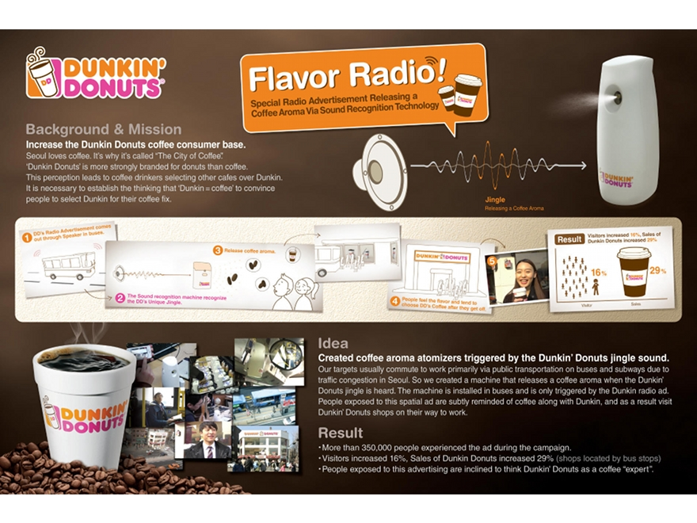
(Haasshim, 2021).
In addition, Indian milk company Amul has also become successful through its marketing activities. A multibillion dollar dairy brand in India produces the most milk and milk products in the world. The White Revolution was started by the company in India. Amul's mascot, the Amul girl, was one of their most famous and influential marketing strategies. In response to Polson's butter girl, Amul created their own girl. The Amul girl's regular appearances in newspaper strips highlighting international and political events have greatly benefited Amul. A mascot and newspapers are used to communicate using a traditional marketing strategy. (Haasshim, 2021).
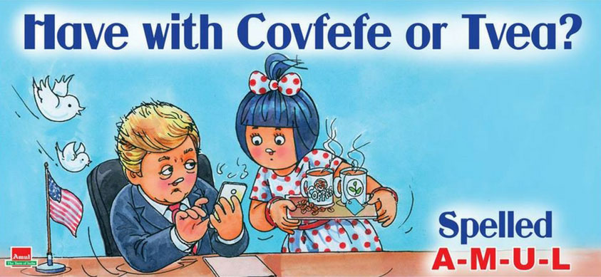
(Haasshim, 2021).

Task 3

Recommendations for improving Marketing Strategies
- Research on Consumer Lifecycle Value: In order to implement a loyalty program, Christos Greek Cypriot Restaurant first has to research customer acquisition costs for a particular period and compare these costs with the total revenue they generate from each customer. Christos Greek Cypriot Restaurant can determine customer lifetime value in this way, and by estimating CLV, they can measure the affordability of their offers, discounts, and reward programs against the value of their customer database (Grebitus & Bruhn, 2011).
- Product Innovation: In addition to the world's best in terms of quality and taste, Christos Greek Cypriot Restaurant should use a formula that emphasizes food and other beverage items more, which has several advantages in attracting young consumers. Among the most important pillars of the brand image in the market are the superior quality and the great taste of food. Customers' requirements, however, have changed over time regarding diversifying items on the market from one brand. More creative food items including sandwiches, burgers, muffins, pastries, mocktails of various kinds, refreshing beverages, food-based desserts, other dessert items, etc. should be offered at Christos Greek Cypriot Restaurant outlets. This will strengthen the company's customer base, giving it the opportunity to expand its market reach in emerging markets, which will raise sales and boost brand recognition (Baker, 2022).
- Attractive Brand Loyalty and Reward Programme: By designing the theme as a loyalty or reward program, Christos Greek Cypriot Restaurant can build a potential brand loyalty program. In order to spread an optimistic vibe in the market, the company must heavily focus on a reward and loyalty program designed to encourage premium customers who account for 80% of revenue. (Coolman, 2022).
- Implement Lean methodology: The Lean methodology entails developing hypotheses and prioritizing them based on their expected impact during planning sessions. In order to test these hypotheses, we devise bare-bones methods. Through data-driven feedback, we can make more investments in winners and eliminate losers quickly at Christos Greek Cypriot Restaurant (Lynn, 2021).
- Review existing Marketing Strteagies: Christos Greek Cypriot Restaurant can benefit from taking the big picture into account when reviewing its existing digital marketing channels and assets to determine what it should incorporate into its marketing strategy — this will help restaurant to avoid feeling overwhelmed or confused. Getting a clear picture of the existing owned, earned, and paid media is as simple as gathering what you have, and categorizing each vehicle into a spreadsheet.
- Demand Forecasting: As a result of market research and analysis, Christos Greek Cypriot Restaurant has missed multiple opportunities to forecast product demand and growth in comparison with its competitors. Poor market research and poor forecasting of demand and requirements have resulted in the company keeping massive quantities of inventory in the channel and in-house, compared to its competitors. In order to research the demand more effectively, Christos Greek Cypriot Restaurant needs to implement demand forecasting.
- Needs to invest more in Advertising and research: Market research and technologies have been underinvested in by Christos Greek Cypriot Restaurant. The international expansion and the operation of Christos Greek Cypriot Restaurant in different demographic locations require more investment in technology to reach a global market. At the moment, the company is not investing enough in technical advantages in comparison to competitors' technological advancements in the market and its vision for the future (Viebrock, 2021).
Overall, Greek Cypriot Restaurant is affected by the entry of a new low-cost retailer into the fast-food industry in Greek, a scenario described in the assignment. It is possible for the restaurant to respond to this situation in two ways. As a first step, it has to continue to differentiate itself from the low-cost competitor (and others) by focusing on the nature of its products. This strategy calls on businesses to provide goods and services, or aspects of goods and services that consumers will perceive as unique. The marketing campaigns of Greek Cypriot Restaurant will specifically highlight the fact that the company's food products are produced with locally sourced and high-quality materials and ingredients, which is why their prices are more expensive than that of low-cost rivals, and the truly innovative one that has emerged in particular, and also take into account Greek consumers' emphasis on eating healthy foods. Furthermore, the campaigns could discuss the quality control mechanisms employed by Greek Cypriot Restaurant, thus ensuring that the food products it offers are of really high quality. In addition, Greek Cypriot Restaurant emphasizes its long history and presence on the Greek market, which has earned it the trust and confidence of Greek consumers, as well as its innovative home delivery service that is unmatched by any other fast food chain of its type. Goodies would also continue to maintain its long-term position in the Greek market if it followed a differentiation strategy.

Conclusion
The business of Christos Greek Cypriot Restaurant has evidently grown tremendously as major food and beverage markets have emerged. Christos Greek Cypriot Restaurant's marketing plan begins with high-end goods. Christos Greek Cypriot Restaurant's growth is mostly fueled by its superior brand and cuisine's flavor. The quality business differentiation strategy has been used by this restaurant to set its food apart from that of its competitors. Christos Greek Cypriot Restaurant, however, has been advised to adapt its marketing strategy in order to maintain its high market position going forward.

References
ProServeIT, 2021. Domino's Pizza Success Story: Technology Framework and Roadmap. [Online]
Available at: https://www.proserveit.com/blog/technology-framework-and-roadmap-dominos-story
Aghazadeh, H., 2015. Strategic marketing management: achieving superior business performance through intelligent marketing strategy. Social and Behavioral Sciences, pp. 1-10.
Alhadid, A. Y. & Al-Zu’bi, H. A., 2014. The Impact of Marketing Strategy on Organization Reputation: Analytical Study on Jordanian vegetable oils companies listed on the Amman Stock Exchange. American Academic & Scholarly Research Journal, 6(5), pp. 1-6.
Baker, L., 2022. 10 ways to improve your marketing strategy. [Online]
Available at: https://makeitclear.com/10-ways-to-improve-your-marketing-strategy/
Bharti, P. K. & Kumar, A., 2020. TRADITIONAL VS. DIGITAL MARKETING: A COMPARATIVE STUDY. International Journal of Multidisciplinary Research, 10(12), pp. 1-11.
Christos, 2022. Christos. [Online]
Available at: https://www.letsgochristos.co.uk/
Coolman, A., 2022. 15 Suggestions to Improve Your Marketing Operations from Leaders. [Online]
Available at: https://www.wrike.com/blog/improve-your-marketing-operations/
Dosi, C. & Tzortzaki, A. M., 2017. Managing social media as a marketing tool in the Greek business environment. International Journal of Decision Sciences Risk and Management, pp. 1-12.
Fariborzi, E. & Zahedifard, M., 2012. E-mail Marketing: Advantages, Disadvantages and Improving Techniques. International Journal of e-Education, e-Business, e-Management and e-Learning, 2(3), pp. 1-5.
Fleishman, H., 2021. 13 Businesses With Brilliant Global Marketing Strategies. [Online]
Available at: https://blog.hubspot.com/marketing/global-marketing-and-international-business
Grebitus, C. & Bruhn, M., 2011. A Way to More Effective Marketing Strategies: Analyzing Dimensionality of Cognitive Structures Quantitatively. SAGE Journal, pp. 1-11.
Haasshim, 2021. Top 10 Companies With The Best Marketing Strategies. [Online]
Available at: https://www.enalito.com/blogs/top-10-companies-with-the-best-marketing-strategies
Jamil, K., Dunnan, L., Gul, R. F. & Shehzad, M. U., 2022. Role of Social Media Marketing Activities in Influencing Customer Intentions: A Perspective of a New Emerging Era. Frontiers in Psychology, Volume 12, pp. 1-12.
Kyriakia, K., 2015. Strategic Analysis of the Greek Postal Market: a case study for Hellenic Post. Procedia - Social and Behavioral Sciences , p. 464 – 472.
Langkos, S., 2014. Strategic Analysis of Greek fast food industry: Case study of Goody's SA. Research gate, pp. 1-18.
Lynn, R., 2021. 3 KEY CONCEPTS OF LEAN PROCESS IMPROVEMENT. [Online]
Available at: https://www.planview.com/resources/guide/business-process-improvement/lean-process-improvement/#:~:text=It%20helps%20you%20maximize%20value,a%20part%20of%20daily%20work.
Skusa, M., 2023. Everything you need to know about marketing resource management. [Online]
Available at: https://filestage.io/blog/marketing-resource-management/
Tiago, T. & Verissimo, J. M. C., 2013. Marketing and Social Media: Benefits, and Ways Forward. Research gate, pp. 1-26.
Viebrock, S., 2021. 15 Tips for Improving Your Marketing Department. [Online]
Available at: https://www.o8.agency/blog/15-tips-improving-your-marketing-department

