Peter Rees Evans (1810610)
1810610@student.uwtsd.ac.uk
Abstract
Worksheet 4 involves configuring and securing FTP service, routing using RIP between different networks and deploying IP filtering. Finally, a draft network policy highlighting high availability and security.
Network Operating Systems
Worksheet 4

Contents
Introduction 3
1.0. Task 1 – ARP and Routing Tables 4
2.0. Task 2 – Deploy Core Services (FTP) 6
2.1. Installing FTP Service 6
2.2 Create Local FTP User 6
2.3. Client 2 FTP Files 8
2.4. Testing Connection 9
3.0. Task 3: Installing and configuring the Routing and Remote Access Service 10
3.1. Configuring Routing 10
3.2. Testing Connection and Routing 12
3.3. Observation: How do Routers reference which networks they are able to connect to. 13
4.0. Task 4: IP Packet Filtering 15
4.1. Blocking Ping 15
4.2. Restricting FTP Access 17
4.3. Limiting access to FTP Service 19
Task 5. Failover Clustering for High availability systems/services 23
5.1. High Level 23
5.2. Servers 24
5.3. Domain Controllers 24
5.4. Negatives 26
5.6. Forest Domains 26
5.7. Conclusion 26
Task 6 – Observation Task 27
6.1. High Level 27
6.2. On Premises Services 28
6.3. WAN Links 29
6.4. Firewalls (Security) 29
6.5. Content Delivery Network 30
6.6. Security 30
7. References 31

Introduction

A domain environment allows administrators to manage users, groups and computers from a central location. It allows user authentication to be managed while the user can roam onto any domain connected device. This Worksheet follows the configuration of additional services such as FTP and securing it.
So far Server 1 and Client 1 network is isolated from Server 2 and Client 2 network. Enabling Routing Services on Windows Server 2019 allows both networks to communicate with one another. Expanding on this design IP packet filtering is configured and put to the test. The final part of the worksheet theorises high availability while exploring the pros and cons of HA in a domain environment.

Task 1 – ARP and Routing Tables

ARP or Address Resolution Protocol is used to map IP addresses to a physical machine address. Using the Windows Server 2019 the command ARP -a is entered into a command prompt which displays the information in Figure 1. Each Interface has it’s own ARP table identified by the IP of the interface. The IP address is displayed in the left most column followed by physical address known as the MAC address and finally the type.
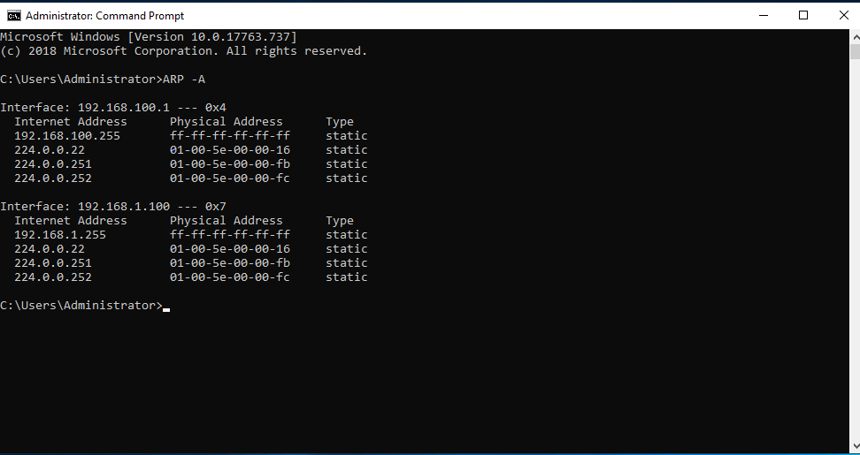
Figure 1 – ARP look up on Windows Server 2019
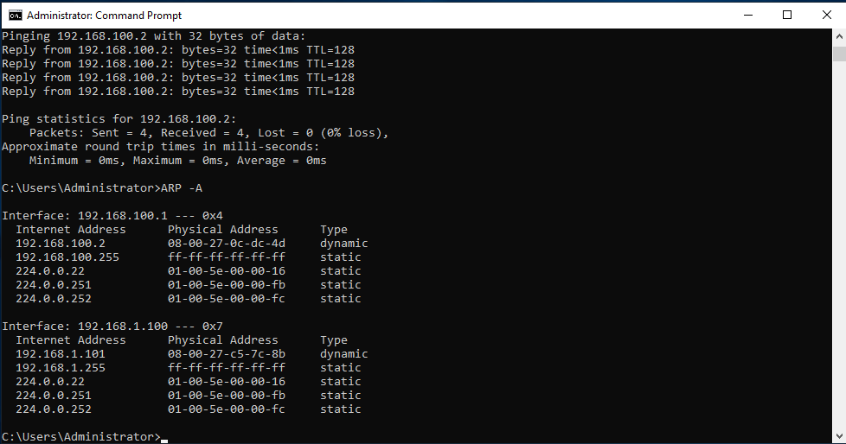
Figure 2 – ARP look up on Windows Server 2019 after a ping to other devices
Figure 2 above shows the updated ARP table of the Windows Server 2019 after successfully pinging other devices connected to the Public and Private network interfaces. The additional entries of both Windows Server 2019 VM 2 and Windows 10 Client 1 can be seen in the ARP table identified by their IP address and MAC address. The type is dynamic as the route is learnt rather than having being statically assigned.

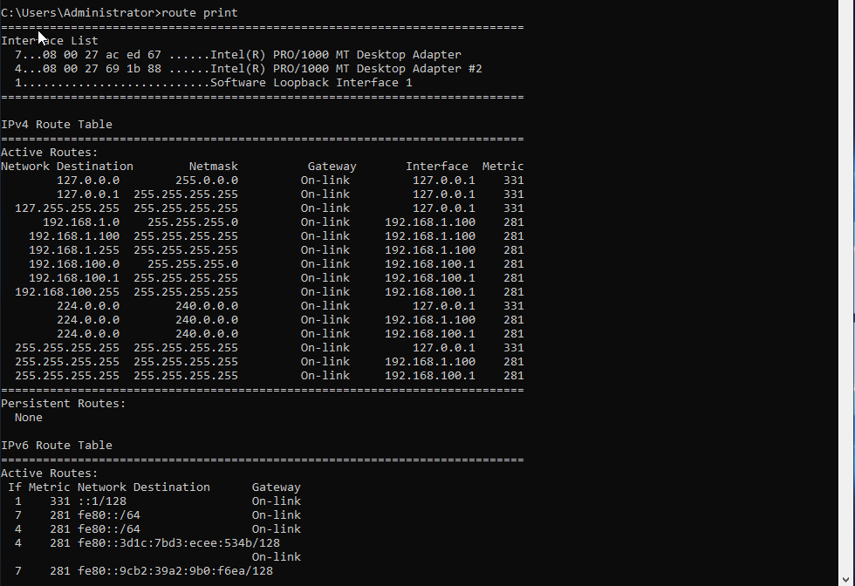
Figure 3 – Routing table on Windows Server 2019

2.0. Task 2 – Deploy Core Services (FTP)

2.1. Installing FTP Service

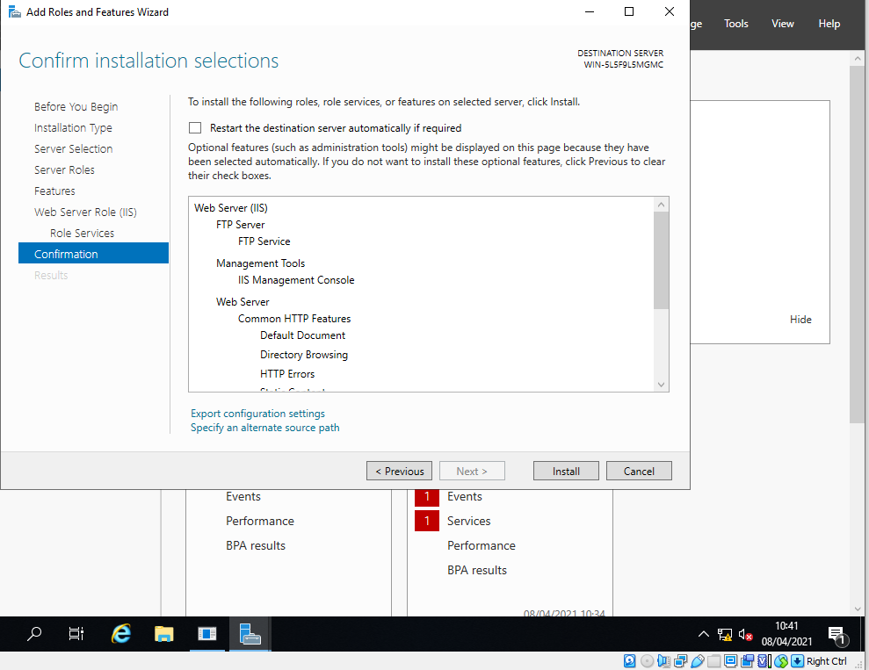
Figure 4 – Installing Web IIS services and FTP Server on Windows 2019 Server 2

2.2 Create Local FTP User
Windows Server 2019 machine 2 provides an easy to use GUI to install additional roles and features. To install a FTP service, Web Server IIS is required. The installation confirmation is shown in Figure 4.
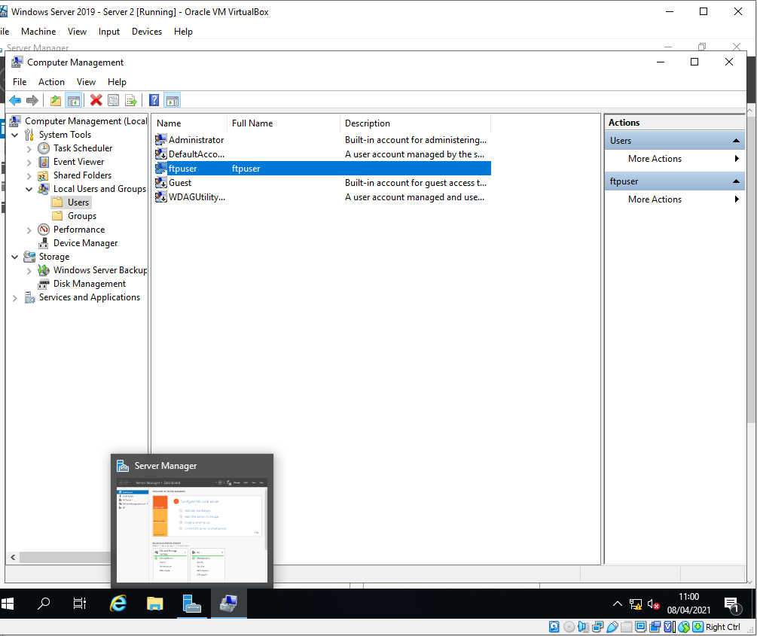
Figure 5 – Creating a Local FTP User
A local user account is required to allow a user on Client machine 2 to connect to the FTP Server. A local user is created because Server 2 and Client 2 aren’t part of the Domain NWT-Traders. While configuring the FTP Service an Authorisation rule was created to only allow the user ftpuser to connect to authenticate to the FTP Server with Read and Write permissions.
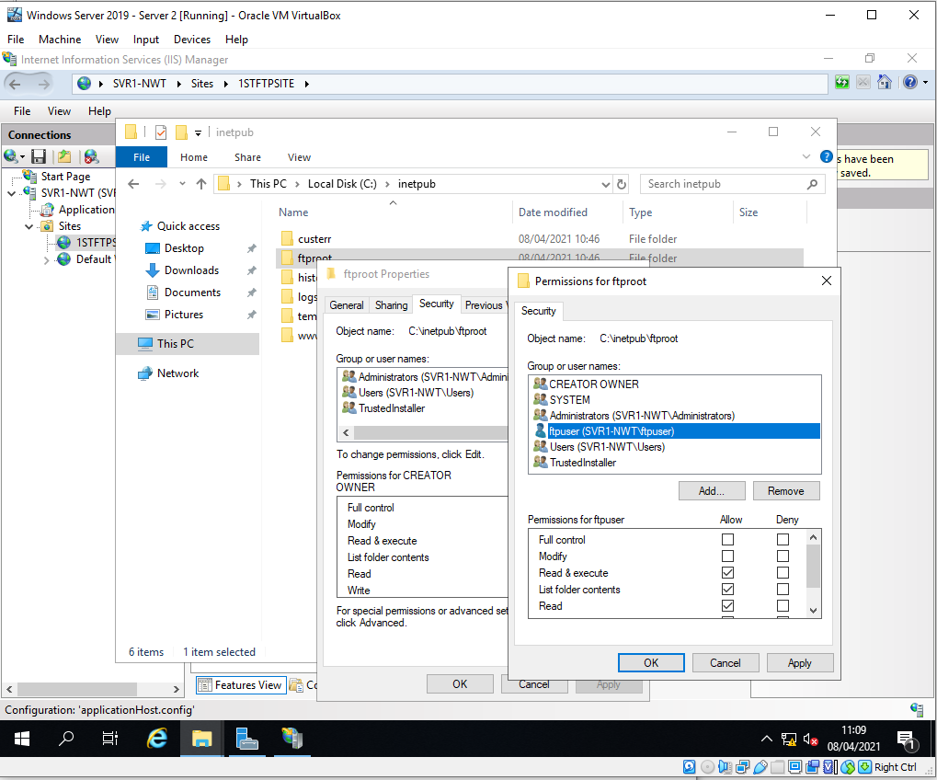
Figure 6 – Adding ftpuser permissions the to the ftproot folder
To allows the local user account ftpuser to access the FTP folder, the account is added to the security permissions.
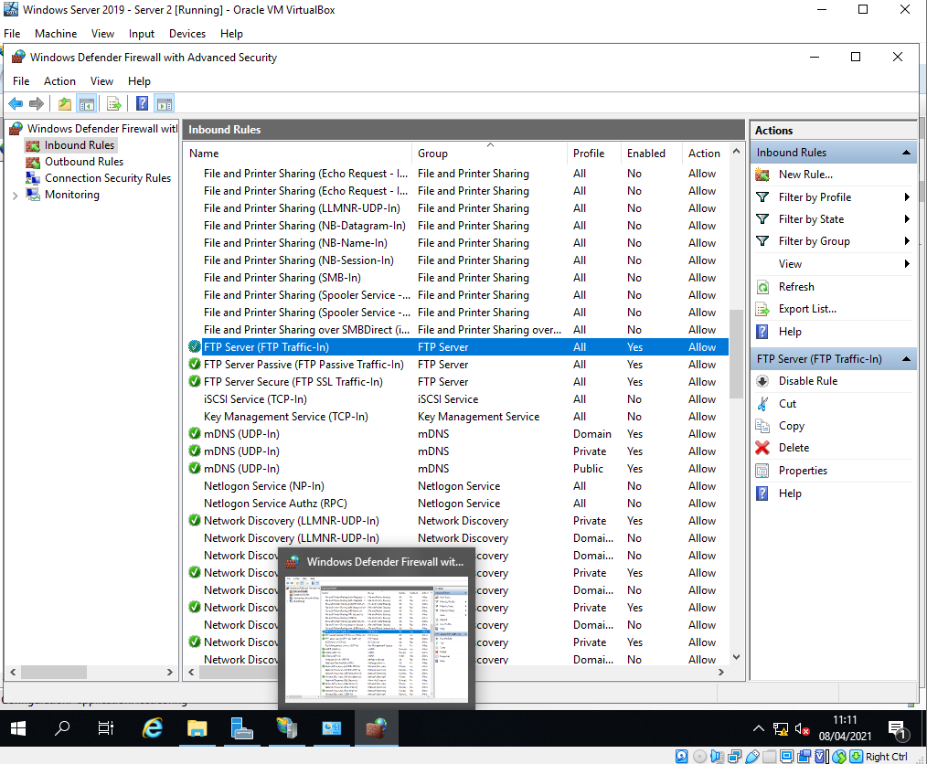
Figure 7 – Firewall Settings
By default, Windows Firewall blocks FTP traffic. Disabling the Firewall is a quick way to allow the traffic however, this opens the Server to all sorts of attacks. An alternative solution showing in figure 7 is to enable the Windows Firewall and add a rule to allow the FTP Server on port 21 on the inbound and outbound rule list.

2.3. Client 2 FTP Files

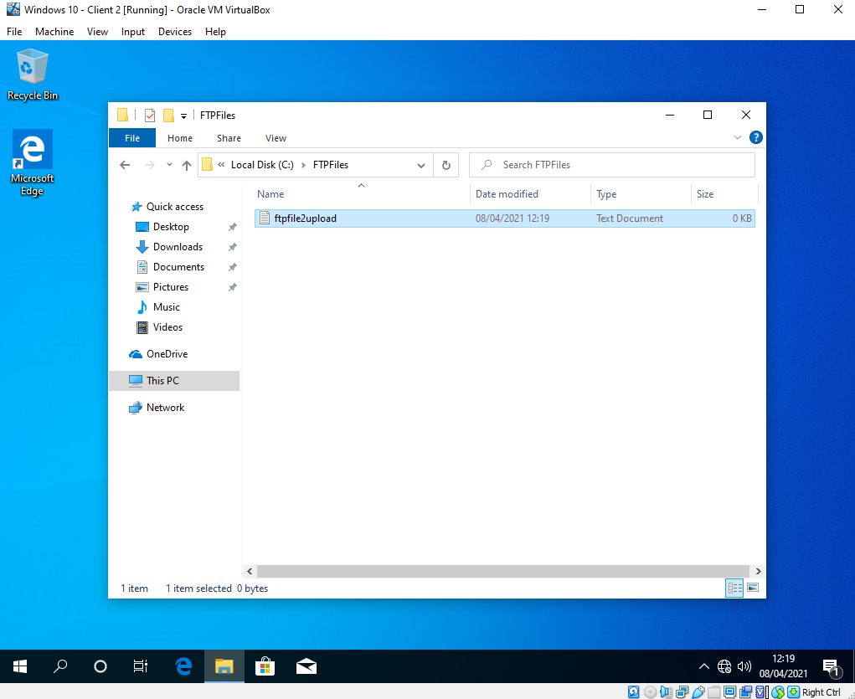
Figure 8 – Windows 10 Client 2 machine, FTP Folder and Files.
A test folder and File is created on Client 2. This is to test sending a file from Client 2 to the FTP Server on Server 2.

2.4. Testing Connection
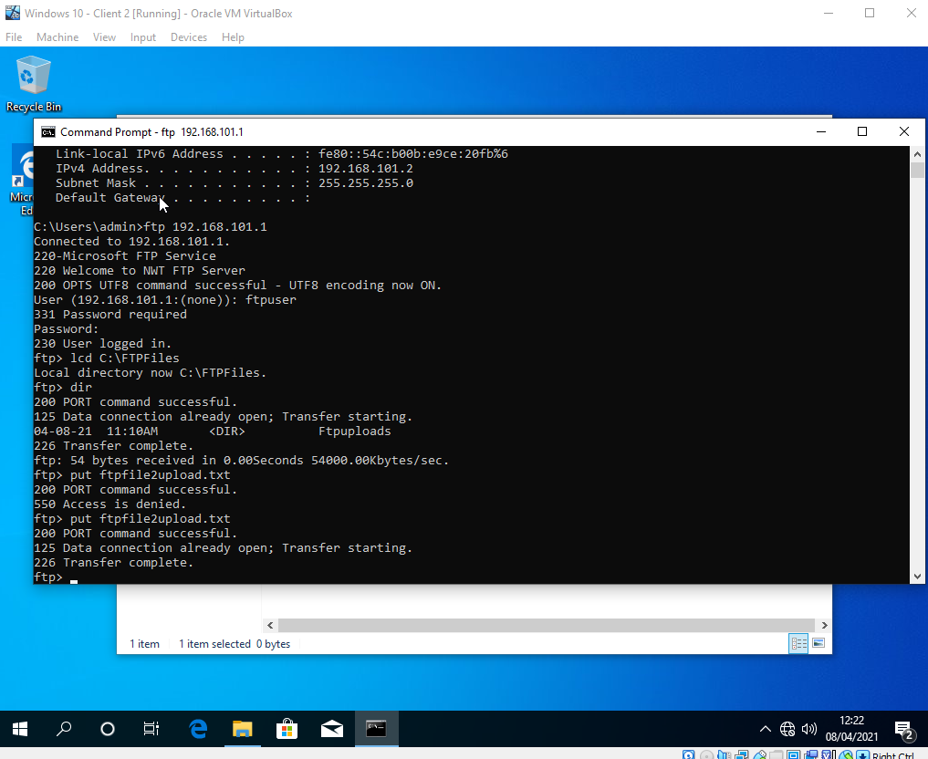
Figure 9 – FTP Connection Successful, however file upload failed.
Windows 10 Client 2 PC is able to successfully connect to the FTP on Server 2. However, the initial file transfer failed with the error 550 access is denied as shown in figure 9. This error happened because the ftpuser on Server 2 only has read & execute rights on the ftproot folder. Adding write permissions to the folder for ftpuser enabled Client 2 to successfully upload the files as shown at the bottom of Figure 9 and confirmed on Server 2 shown in Figure 10.
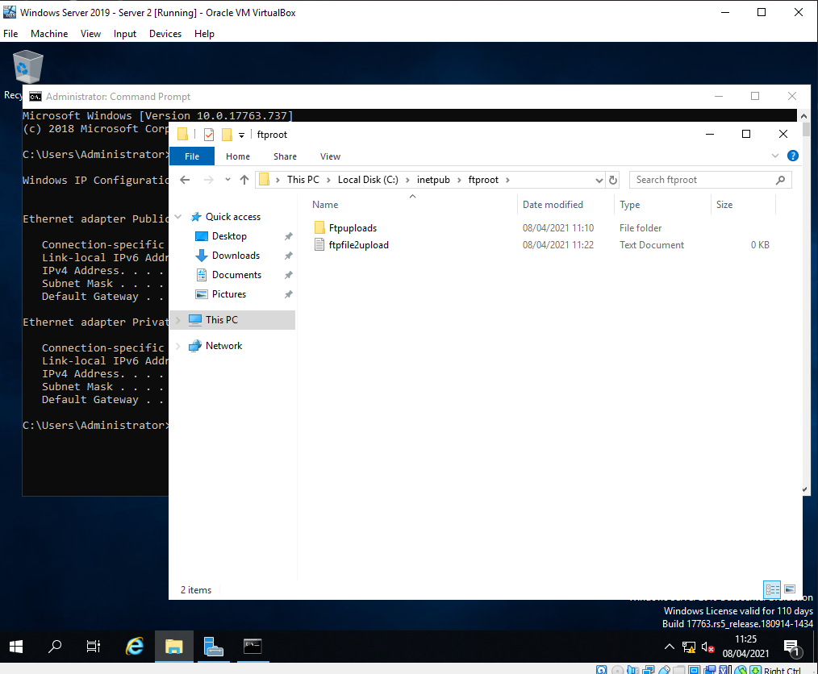
Figure 10 – FTP File transfer successfully completed.

3.0. Task 3: Installing and configuring the Routing and Remote Access Service

3.1. Configuring Routing

On the Windows Server 2019 (Server 1) a new role and feature is installed – Remote Access. As with the other roles and features Windows offers a GUI led installation where Remote Access and Routing were installed as per Figure 11.

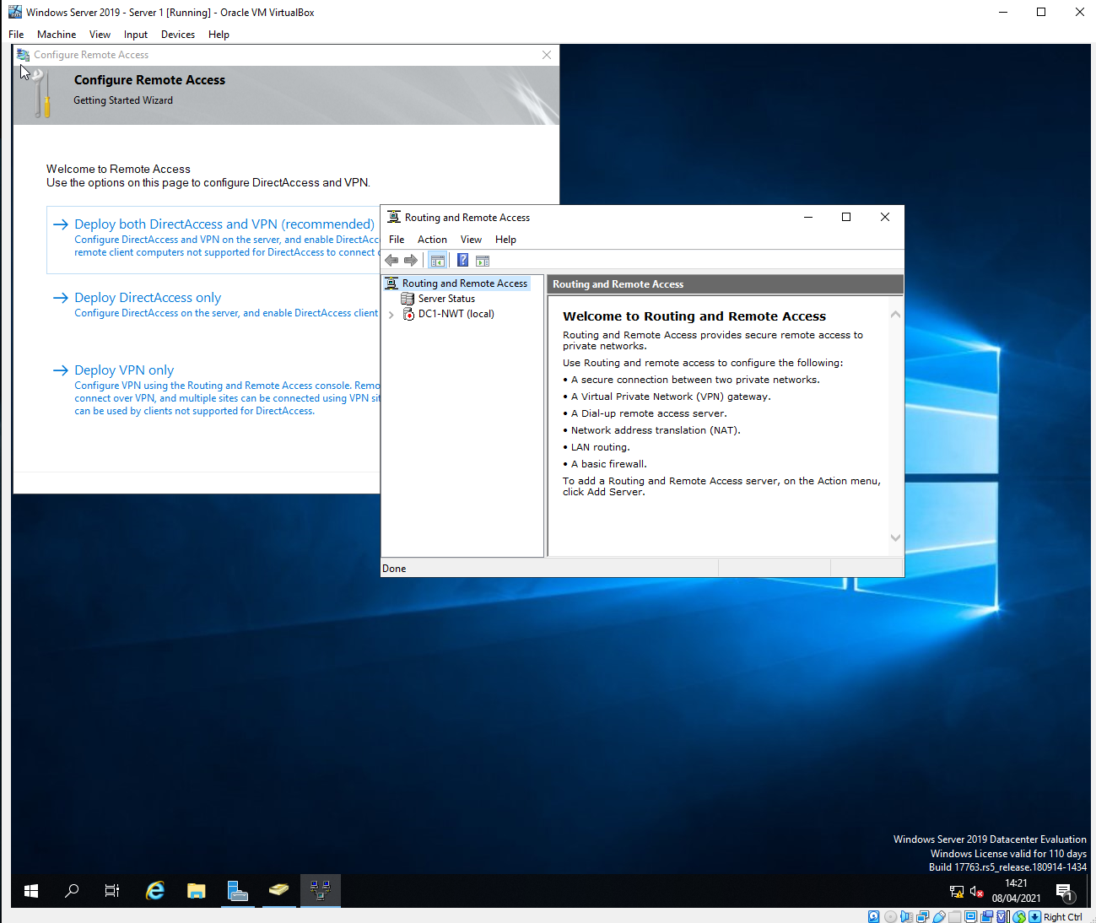
Figure 11 – Installing Routing and Remote Access feature.
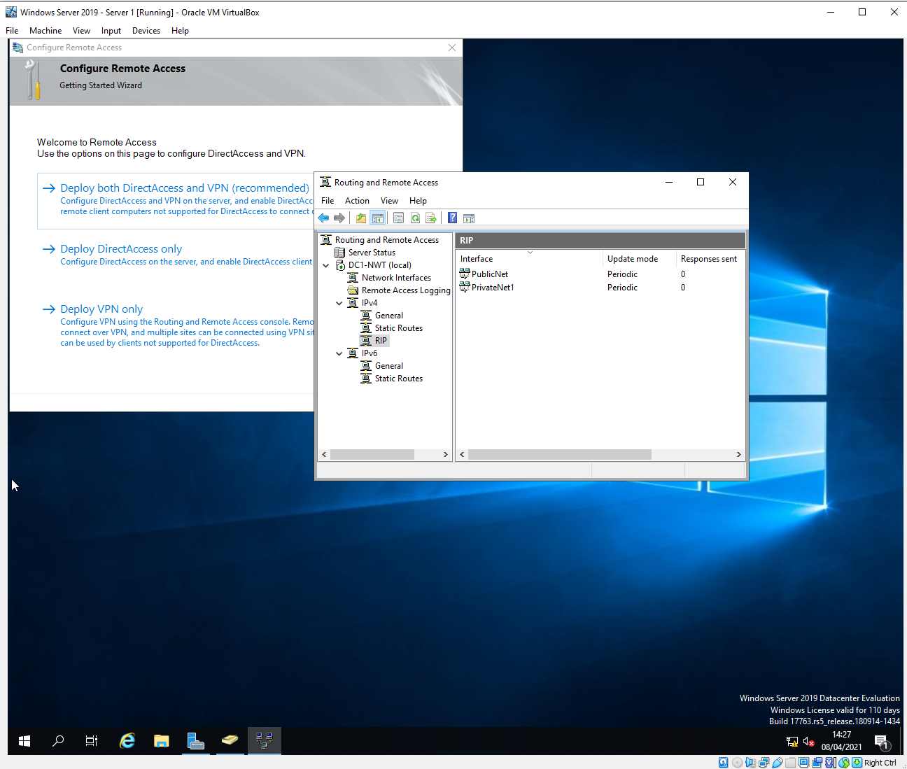
Figure 12 – Adding RIP routing protocol to both interfaces.

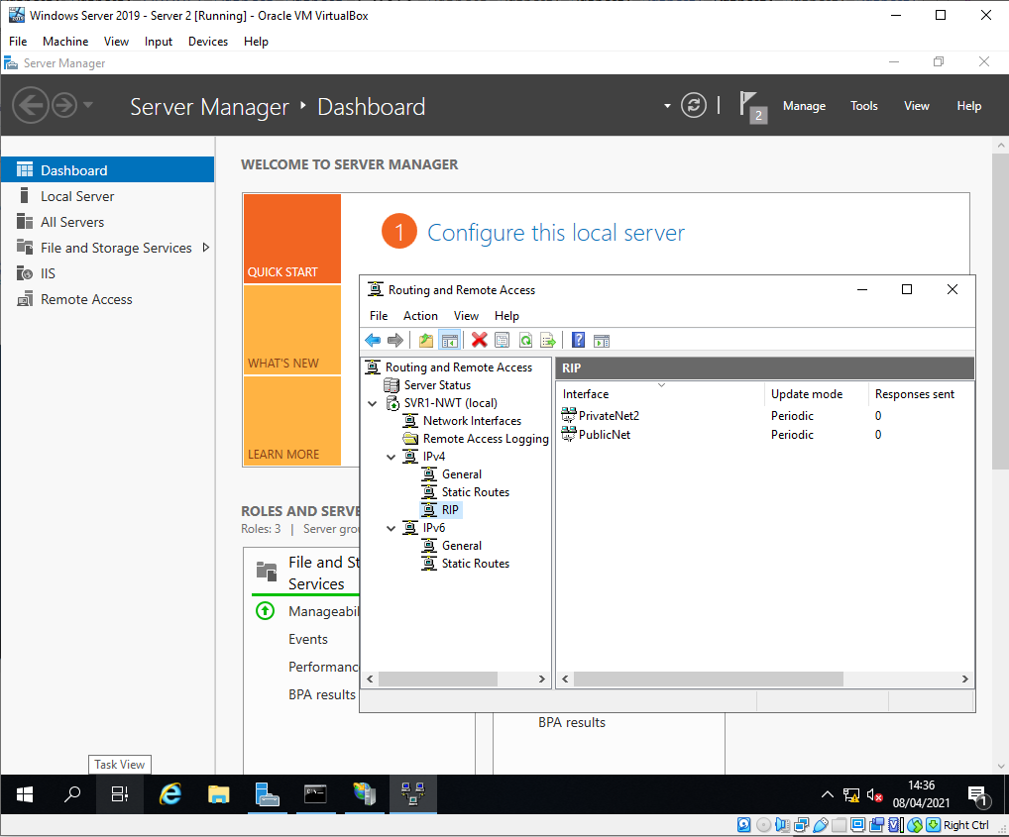
Figure 13 - Adding RIP routing protocol to both interfaces on Server 2.

3.2. Testing Connection and Routing

After configuring RIP routing protocol on both Servers, a simple test to confirm they are working is to use the ping command. Ping sends ICMP packets to its destination which if successful the destination responds to the request.
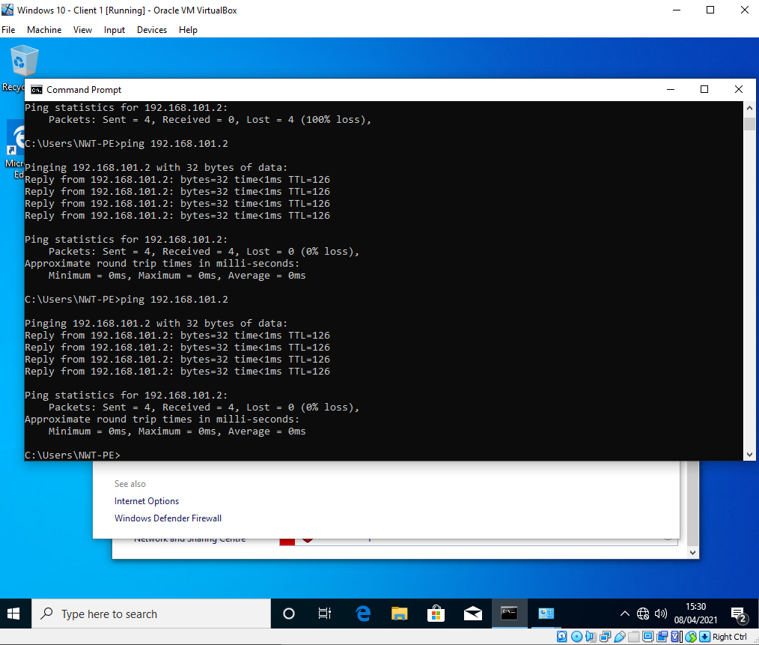
Figure 14 – Successful ping from Client 1 to Client 2
Figure 14 shows Client 1 – IP 192.168.100.2 successfully pinging Client 2 – IP 192.168.101.2. This proves that the routing between the 2 servers is working correctly. Figure 15 shows the same however Client 2 pinging Client 1.
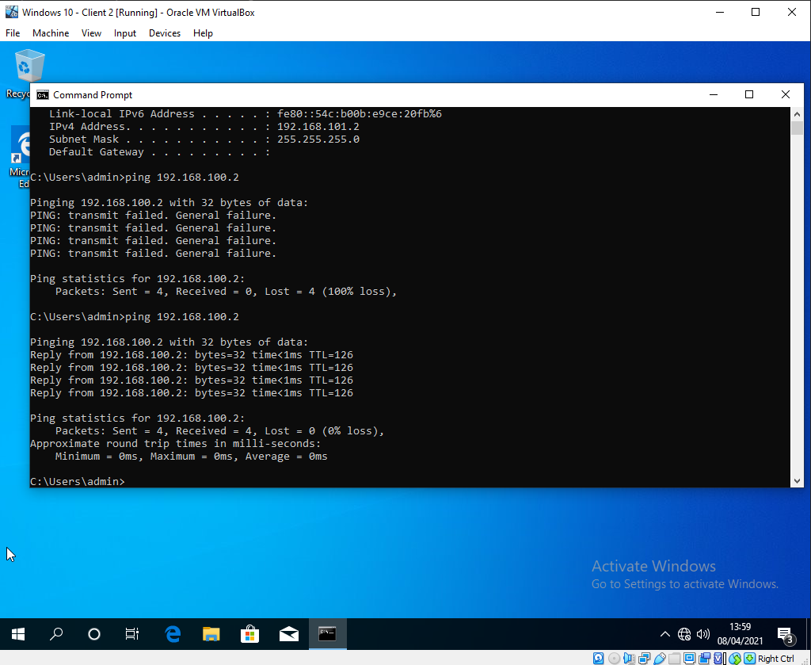
Figure 15 – Successful ping from Client 2 to Client 1

3.3. Observation: How do Routers reference which networks they are able to connect to.

Routers use a routing table to identify what networks they are able to connect to. Using Microsoft Windows Command Line and the command Route Print, it will display all known routes.
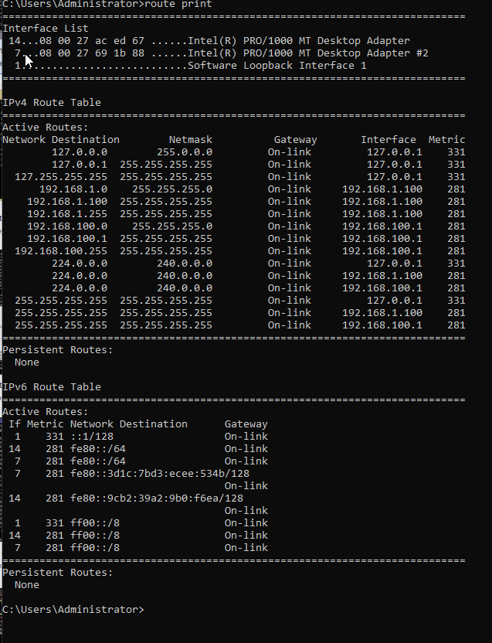
Figure 15a – Windows Server 1 Routing Table.
Figure 15a displays the routing table of server 1. The information present in the table identifies where the server needs to send packets in order for them to reach their destination. For example, any packet destined for the 192.168.100.0/24 subnet will exit at interface IP 192.168.100.1.
In a previous task RIP or Routing Information Protocol was configured on both Server 1 interfaces. RIP is a distance-vector protocol. The adjacent router (in this case Server 2) informs Server 1 of what networks it contains in its routing table. The information is passed bi-drectionally so that both Server 1 and Server 2 routing tables contain the information. RIP limits the number of hops to 15 to prevent routing tables growing uncontrollably. Now Server 1 knows a route to Client PC 2 and vice-versa. Image in Figure 15b and 15c explains this as a diagram.
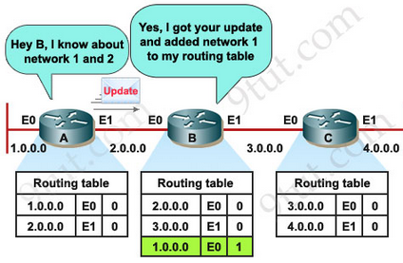
Figure 15b – RIP updated taken from 9tut [1].
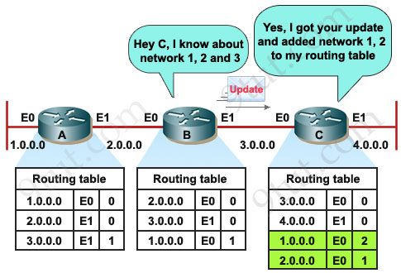
Figure 15c – RIP updated taken from 9tut [1].

4.0. Task 4: IP Packet Filtering

4.1. Blocking Ping
Using the featured added previously, Routing and Remote Access a inbound filter can be applied to block ping.

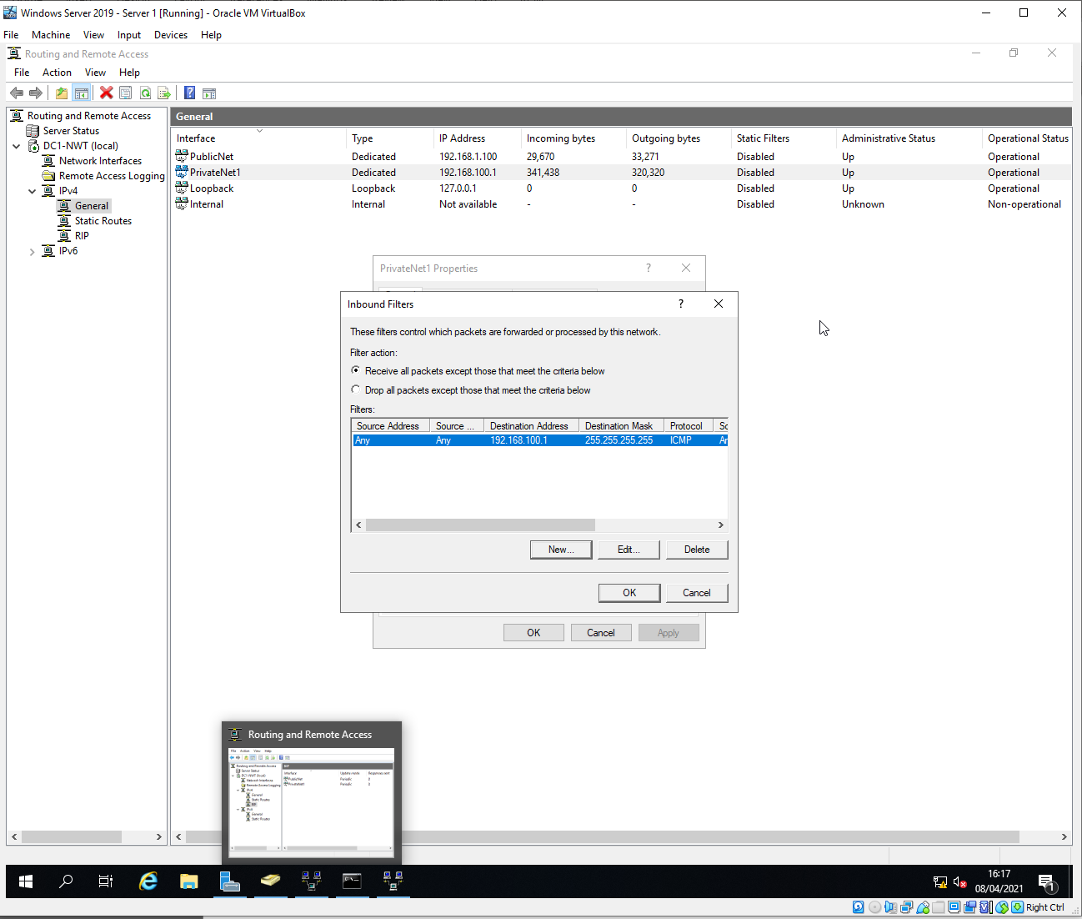
Figure 16 – Inbound Filter to block ping
Creating a filter rule on the PrivateNet1 to block ICMP from the destination IP address 192.168.100.1 will stop Client 1 from getting a ping response. The rule is created in the Routing and Remote access section, IPv4 and General as shown in figure 16.
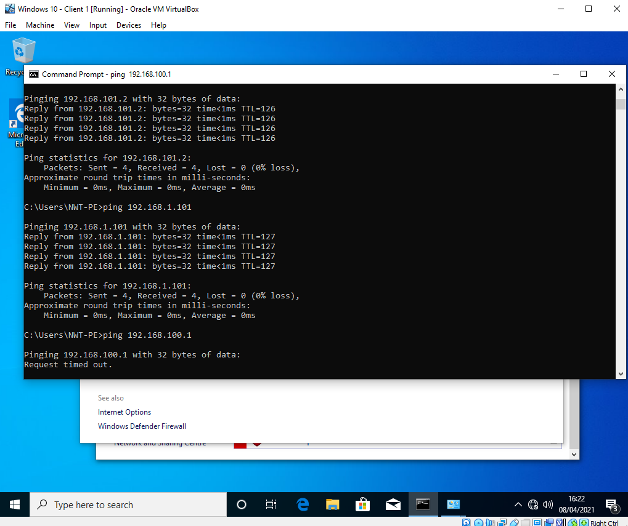
Figure 17 – Successfully blocking ICMP
Once the filter has been applied a test is carried out from Client 1 attempting to ping Server 1. Figure 17 shows that the filter is working correctly.

4.2. Restricting FTP Access

As above with creating a filter to block ICMP packets from Client 1 to Server 1. Next a second filter is created this time restricting access to FTP service by creating a outbound filter.
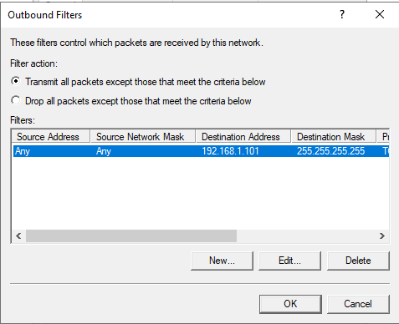
Figure 18 – Outbound Filter blocking port 21 to destination 192.168.1.101
Using the Routing and Remote Access GUI a new filter was create on the Public Network. The filter is on the outbound traffic to block packets that match the criteria, destination network 192.168.1.101/32 on port 21.

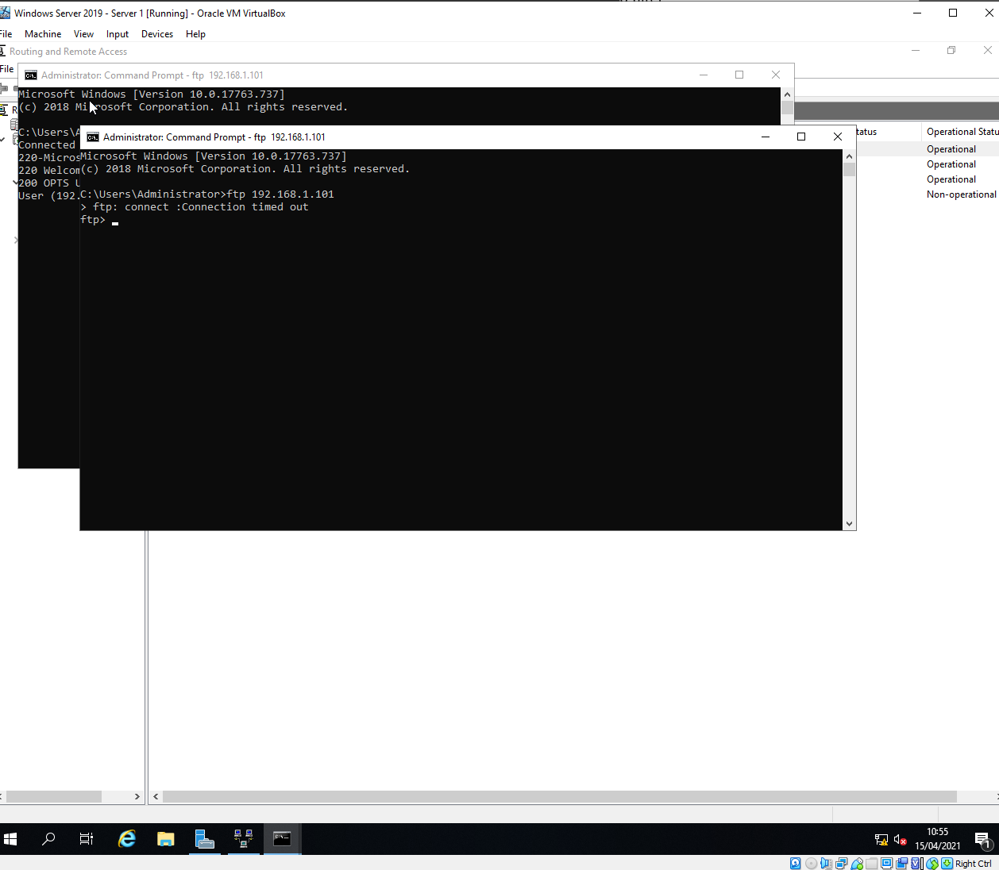
Figure 19 – Successfully Blocking FTP Service to Server 2 on Port 21

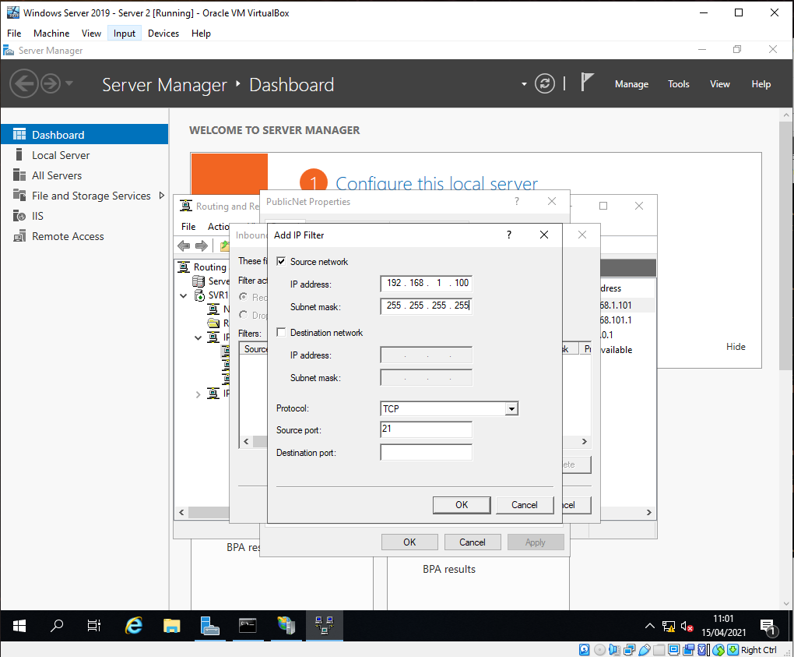
Figure 20 – Server 2, Inbound Rule to block FTP Service
Another option to block FTP access is to create a filter on Server 2 where the FTP Service resides. The filter differs from the previous as now it’s classified as an inbound rule and blocking access from a Source network or device. In this case the Source is Server 1 IP 192.168.1.100 as shown in figure 20.

4.3. Limiting access to FTP Service

N.b. The task instructions say restrict access to FTP for everyone except 192.168.100.1 (Client 1)
192.168.100.1 is Server 1
192.168.100.2 is Client 1.
For the Purposes of this task I assume you want me to block Client 1 IP 192.168.100.2 which is what is shown below.

The simplest way to accomplish this is to create 2 filters on Server 2.
Filter 1
PublicNet
Inbound Filter
Drop all packets except those that meet the criteria below
Source: 192.168.100.2
Network Mask: 255.255.255.255
Destination: any
Protocol: TCP
Destination Port: 21

This rule blocks all packets except those originating from the source 192.168.100.2 on port 21.

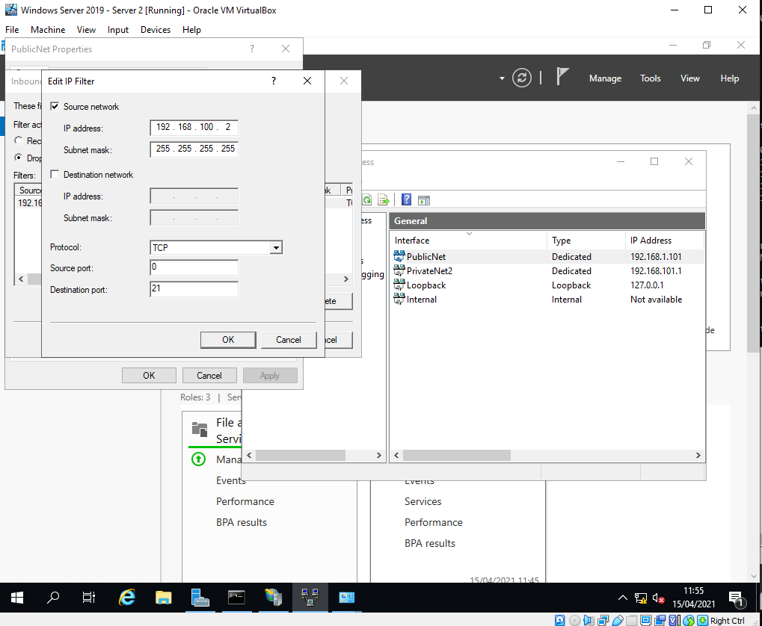
Figure 21 – Server 2, PublicNet Inbound Filter

Filter 2.
PrivateNet2
Inbound Filter
Receive all packets except those that meet the criteria below
Source Address: Any
Source Network Mask: Any
Protocol: TCP
Destination Port: 21

This filter will block any source network 0.0.0.0/0 coming into Server 2 on port 21. This will continue to allow access on other ports from networks attached to PrivateNet2.

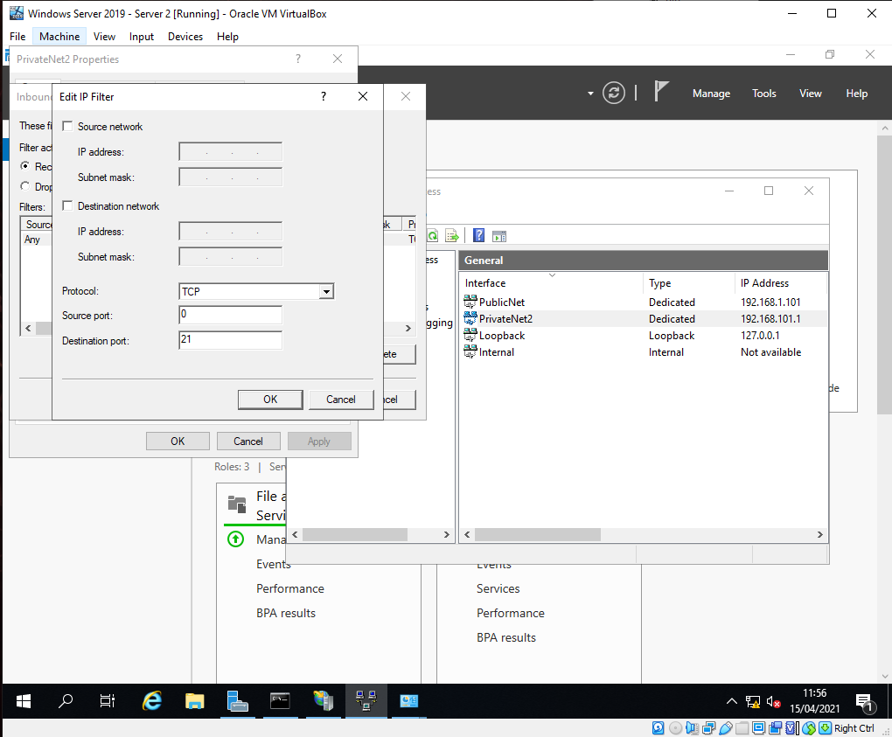
Figure 22 – Server 2, PrivateNet2, Inbound Filter.

The above configuration successfully allows FTP access from Client 1 192.168.100.2 to Server 2 192.168.1.101 on port 21. However, the caveat is that all packets arriving from PublicNet destined for Server 2 are blocked except FTP from Client 1. For example ICMP, SMB etc traffic is blocked as shown in figure 21. This shows the limitation of packet filtering. An alternative would be to use Windows Firewall to block access to port 21 form any any except 192.168.100.2.

Figure 22 shows any packets Originating from PrivateNet2 are allowed except for packets on port 21, thus blocking FTP Service on any device originating from PrivateNet2 no matter what their IP address is yet still allowing ICMP, SMB, HTTP etc.

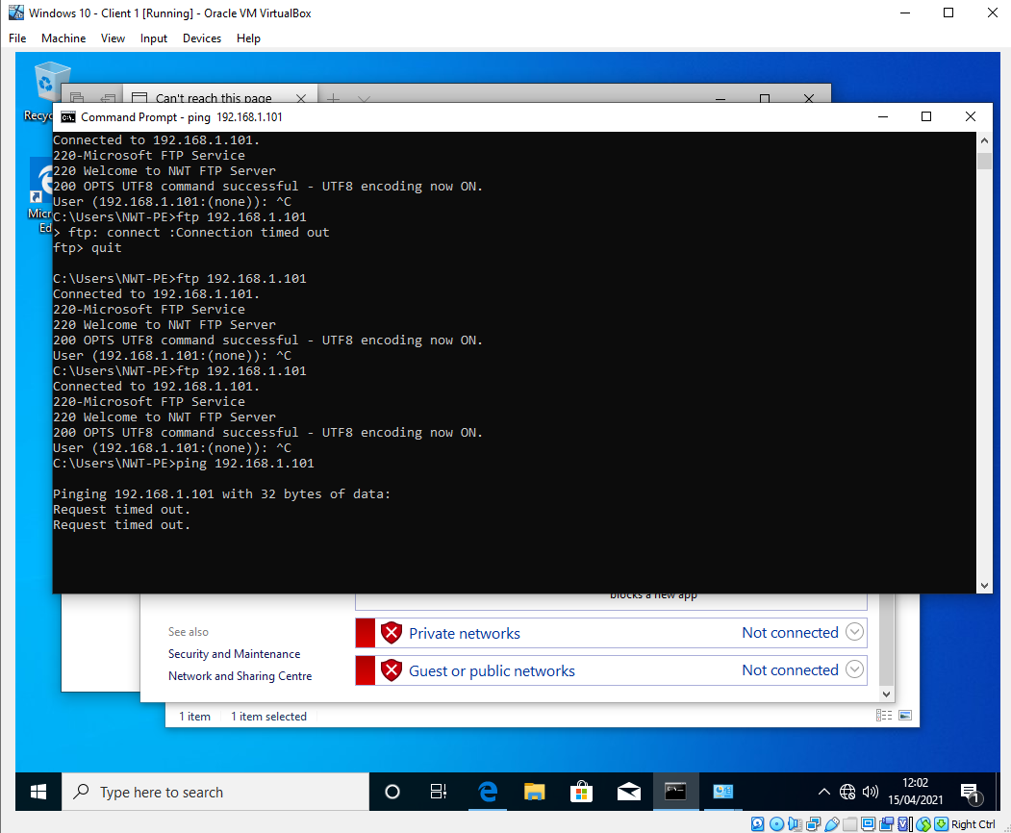
Figure 23 – FTP Service successfully connected however ICMP traffic is blocked due to the rule configuration in Figure 21.

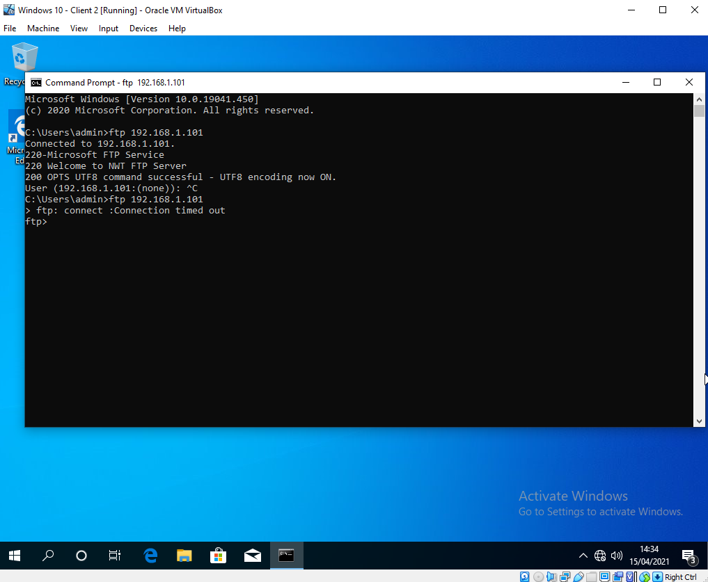
Figure 24 – Client 2 unable to connect to FTP Service

Figure 24 shows Client 2 before the filter was applied it was able to connect to the FTP services and then demonstrates attempting to connect to FTP after the filter was applied. It was successfully blocked.

Task 5. Failover Clustering for High availability systems/services

Clustering Servers is the process of having 2 or more servers which both provide the same services in case of failure. Clustering can be a group of physical devices such as 2 or more servers or a group of virtual servers spanning multiple physical servers.

High availability is the process or design in which an environment can survive in the event of a single system failure or removing single points of failure. A Continuous availability covers the above but also protects against planned system downtime such us updates and upgrades.

When designing a domain environment, it’s important to consider ‘what if’ scenarios. The 4 worksheets completed so far have demonstrated setting up a single domain controller with active directory and an authorative domain name service. Several domain users with different permissions were able to authenticate using the domain joined client machine.

5.1. High Level

In a domain environment a single domain controller/dns is a single point of failure. In the event of the domain server failing, all domain connected devices will fail to resolve DNS names (unless cached) both internally on the LAN and any external Internet address. If users have network drives mapped using FQDN then users would also lose access to these.

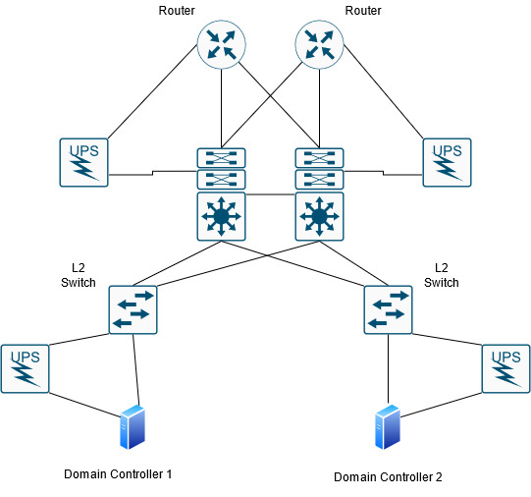
Figure 25 – A basic high-level design

Figure 25 shows an oversimplification of what an enterprise network may look like. The above provides both High Availability and Continuous Availability. The design is based on a Cisco best practice model [2]. A single or in some cases multiple devices can fail or be scheduled for downtime without affect access to critical services. In the example above the hardware as well as cabling and power are considered.

5.2. Servers

Type 1 hyporvisorssuch as VMWares ESXI or Proxmox KVM are an idea solution to creating High Availability clusters without investing heavily in physical server hardware and space. VMWare identifies the benefits as minimizing downtime, provide uniform access without the cost and complexity of failover systems [3].

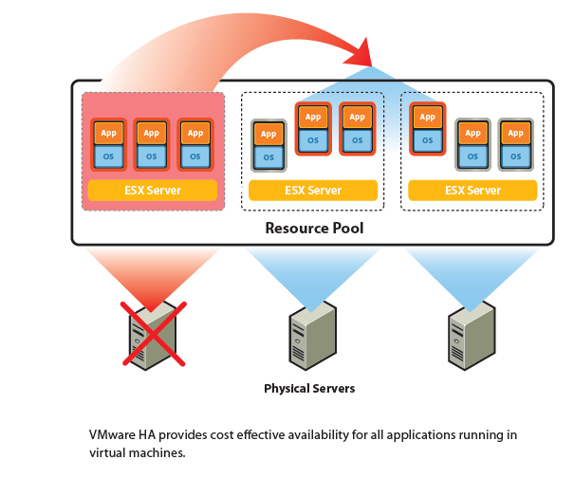
Figure 26 – VMWare Server Clustering

Figure 26 is taken from the VMWare ha datasheet showing how virtualization can benefit the user to create a cost effective HA service. Because the resource pool is shared, a single hardware failure has minimal impact to the service.

5.3. Domain Controllers

The design in figure 25 shows a single site configured as a single domain. The site contains 2 or more domain controllers. When configuring 2 separate servers as domain controllers, the Windows 2019 Add Roles option guides the administrator to configuring a second domain controller and adding it to the domain. Both Servers are then kept in sync.
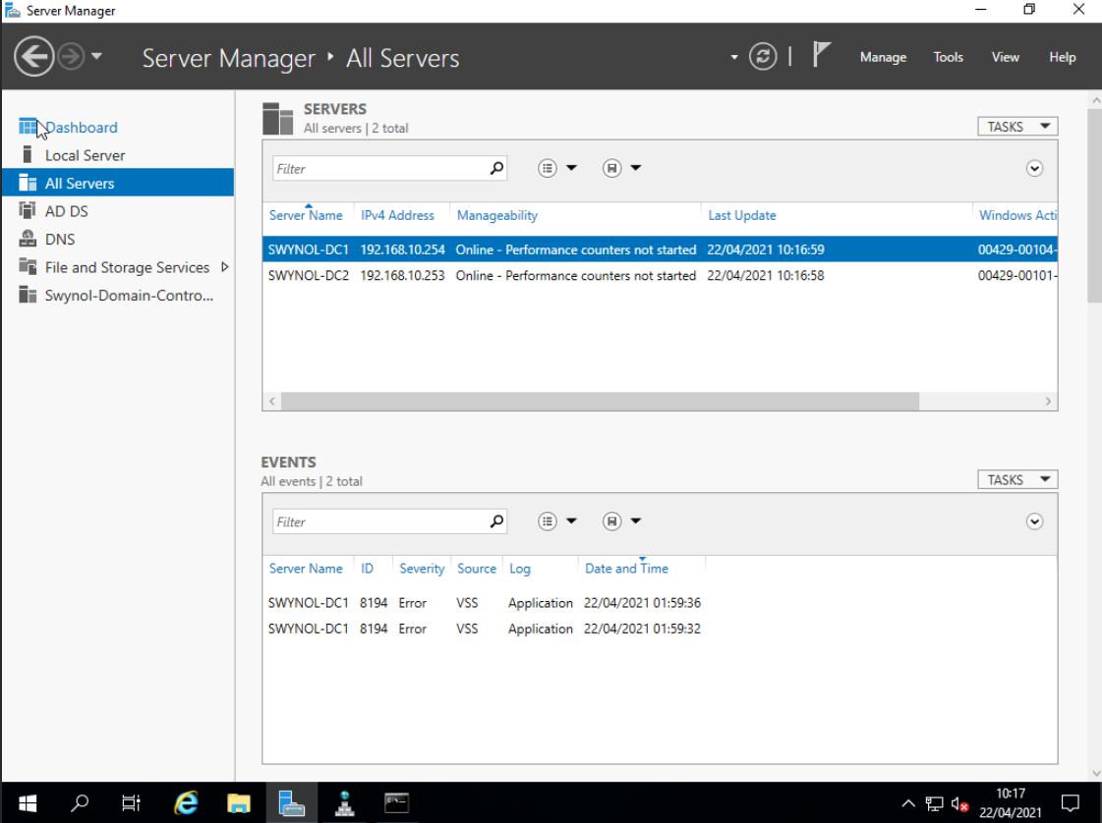
Figure 27 – A single domain with 2 Domain Controllers
Figure 27 shows 2 Domain controllers synchronised in a domain environment. This provides both High availability and continuous availability as they are both virtual hosts on separate physical hardware. Both servers contain the role of AD DS, DNS and File and Storage Services. Microsoft provide a document to aid in configuring an additional domain controller [4].
Microsoft Windows Server allows as many DNS servers as required associated with a domain or zone. One of the servers will become the authorative primary server responsible for the administrative tasks. This is the writeable DNS server. Any additional DNS server become secondary servers, while these are read only from the user’s perspective, they get their updates from the Primary Server. Even as a secondary server it can perform the same tasks to spread the load and take over in case of a fault [5].
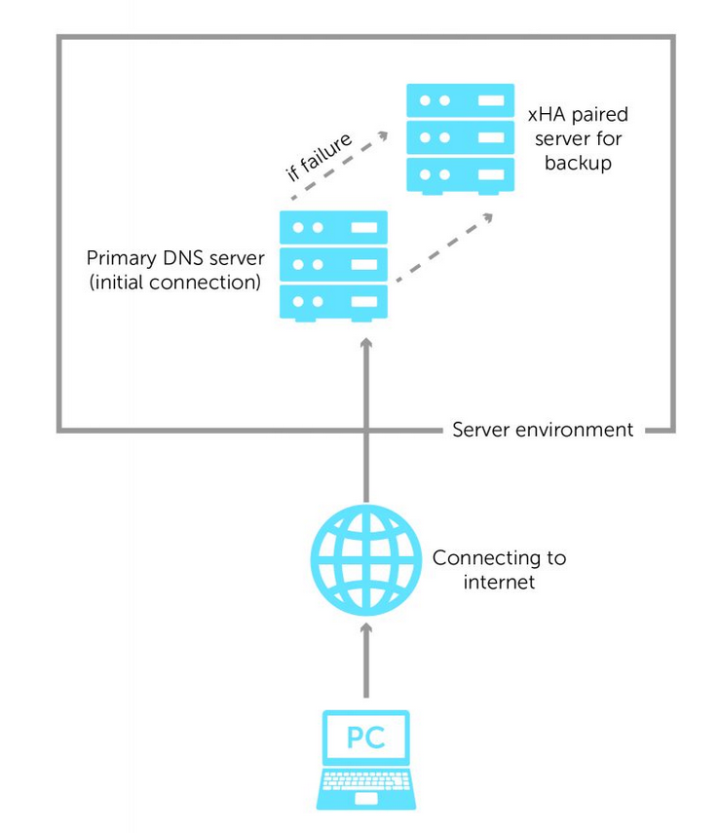
Figure 28 – Simple DNS High Availability (image from BluecatNetworks [6])

5.4. Negatives
The above covered the Pro’s of what high availability means in a domain environment. However, there are negatives. Hardware, licencing, monitoring and manpower to maintain additional infrastructure all adds to the cost of creating a high availability service. Also hidden costs such as electricity, cooling and space all need to be factor in the design.

5.6. Forest Domains

If an enterprise network grows then a single Forest can contain multiple domains. In this case Microsoft [7] suggest that Domain Controllers for the Forest Root should span across multiple sites/regions. Each Domain should span domain controllers at other sites to provide High Availability. The complexities of Forest domains is out of scope of this task but was mentioned due to the possibility of High Availability across sites and regions.

5.7. Conclusion

Configuring a high availability set of servers is essential in any organisation. The benefits far out way the negatives and while cost is always a factor the initial investment will pay for itself if it limits downtime. The added benefit of being able to update and upgrade software and hardware with no downtime alleviates pressure on IT teams while maintaining the service.

Task 6 – Observation Task

Network Policy, Critical Business applications with High Availability and best Security Practises

6.1. High Level

A high-level design for a company that operates in multiple locations nationwide needs to incorporate a high availability platform. The design below shows 3 locations however the design is easily scalable.

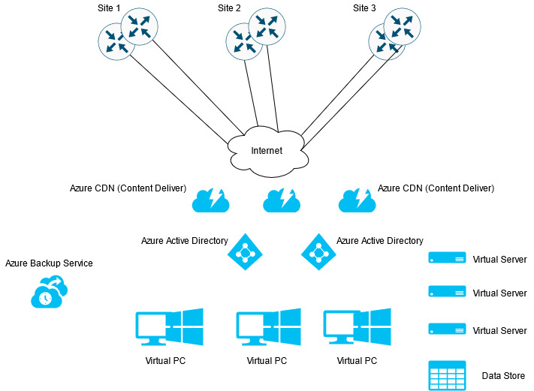
Figure 29 – High Level WAN connecting multiple sites.
Figure 29 shows 3 sites, each site has 2 or more WAN routers with dual links to the internet. This provides redundancy at each site.
All services are provided by a cloud supplier such as Microsoft Azure. Azure cloud service can provide everything an organisation needs remotely accessible from anywhere [8], more detail below.

6.2. On Premises Services

At each site a collapsed core design would provide each site with a powerful core/distribution layer providing intervlan routing. Finally, x number of access edge switches scalable depending on the number of users. Each access switch would be dual homed to 2 or more collapsed core switches providing internal redundancy and high availability. This is referred to as a Cisco Campus architecture [9]. Figure 30 shows a high-level design.
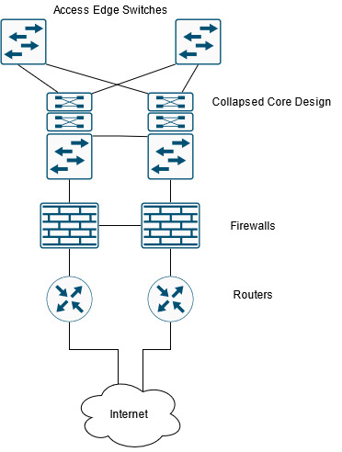
Figure 30 – Cisco Campus core architecture design.
Configuration and security of these devices is outside of this Policy and is covered in a separate policy.

6.3. WAN Links

Each site will require a minimum of 2 Internet Connections. These could be configured as an Active/Standby or Active/Active pair. This again would provide redundancy in case of failure and upgrades. Each site would require an Internet link to access the Cloud Services, the type of connection would depend on number of staff at the site.
An alternative for smaller satellite sites is a site to site VPN. This is a permanent encrypted link between sites often used as a hub and spoke design with for example a head office in the centre and remote sites all connected to the head office. The benefits of this are usual cost. A site to site VPN is cheaper than private circuits. However, the negative is limited bandwidth [10], and therefore only suited to small remote sites.

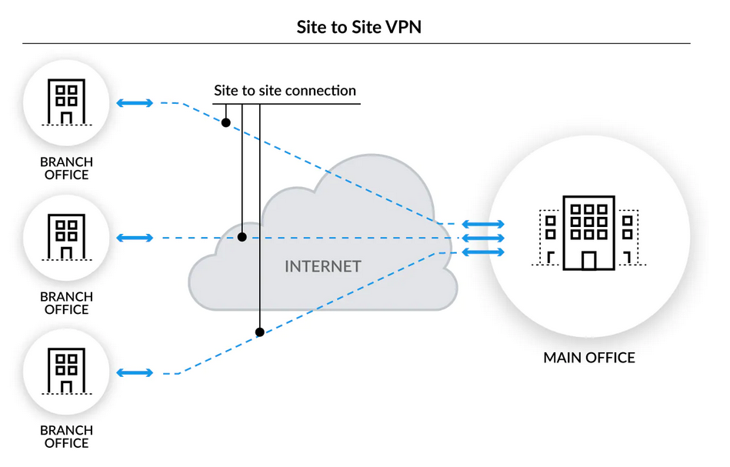
Figure 30 – Palo alto networks site to site VPN example

6.4. Firewalls (Security)

As per the other items each site will have a minimum of 2 local firewalls. This provides high availability in case of failure or upgrades. However, as all services and storage will be cloud based a Cloud Firewall will also be necessary.
As part of the cloud services, the company would invest in an IaaS or Infrastructure as a service. The cloud provided would provide a firewall as a managed service [11]. The connection from each site to the Cloud service could use the Forced Tunnelling feature whereby the company’s sites traffic meeting a certain criteria would be tunnelled to the Cloud Services.
SLAs (Service Level Agreements) would be in place with the Cloud Service for any amendments to Firewall rule, maintenances and issue resolution. These will be determined by the contract.

6.5. Content Delivery Network

CDN or Content Delivery Network brings the services closer to the users. For example, in an on-premises solution the data centre would be centrally located. Users connecting from other continents would have to transverse the internet to gain access to the datacentre. A CDN alleviates the issues of distance by replicating the data to CDN servers closer to the user, improving speed but also strain on the origin server by providing load balancing. A Cloud Service such as Azure provide CDNs as part of their package. An example of a CDN is displayed below.

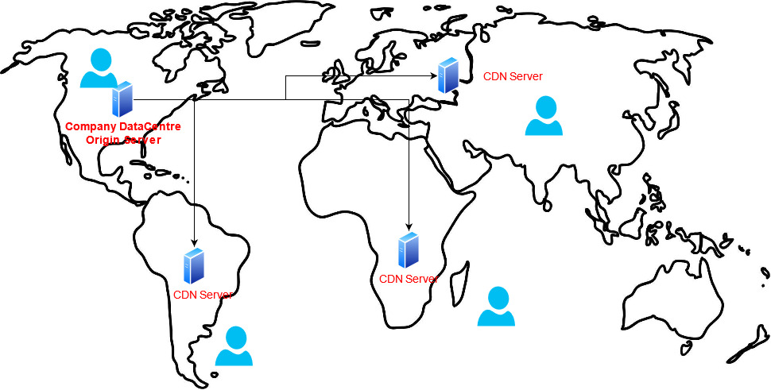
Figure 31 – An example of a Content Delivery Network replicating data from an Origin Server.
An added benefit of a CDN provides reliability and redundancy. In the event of a failure, scheduled maintenance, or a potential DoS attack (Denial of Service) the CDN network provides anycast routing to route users to the next available server. More info on anycast routing available from Cloudflare [12].
Active Directory – Azure Active Directory is a SaaS (software as a service). The AD will be cloud based.

6.6. Security

Domain security will be managed by the Cloud Providers Active Directory. In this case Azure Active Directory will be deployed. This will provide High Availability as multiple instances of Domain Controllers will exist in the Cloud.
Authentication will be users email address and password followed by a Multi Factor Authentication in the form of either an approved mobile app or a one-time code send to the users device.
The password will conform to the password policy.
Most service will use SSO (single sign on).

Backup\Redundancy

All services will be configured for high availability. As well as the CDN network, Critical servers will be replicated to a secondary server in either an active/active situation or active/standby. For example, there will be at least 2 Domain controllers located in each region that there is an office. These will be run as active/active and provide DNS services.
With regards to Domain controllers, this will run in a hybrid environment were local Domain Controllers will exists at physical sites however these will be sync’d with the Cloud Service Providers Domain controllers to create a Hybrid AD [13].
Non-Critical servers in the event of a failure will have there most recent backups restored to another instance and brought online. The lead time will vary but will be agreed with a Service Level Agreement with the Cloud Service Provider.

Software

Cloud Applications will be provided by Cloud Service. SaaS will provide software but also virtual desktops terminals that run in the Cloud. An example is Citrix Workspace which can provide a remotely accessible desktop operating system [14]. Please refer to Software and SaaS policy.

7. References

[1] “CCNA Training » RIP Tutorial.” https://www.9tut.com/rip-routing-protocol-tutorial (accessed Apr. 22, 2021).
[2] “Campus Network for High Availability Design Guide - Cisco.” https://www.cisco.com/c/en/us/td/docs/solutions/Enterprise/Campus/HA_campus_DG/hacampusdg.html (accessed Apr. 22, 2021).
[3] VMware, “How is VMware High Availability Used in the Enterprise? How Does VMware HA Work? VMware High availability Cost effective high availability for virtual machines,” 1998, [Online]. Available: http://www.vmware.com/.
[4] “Step 2 Configure the Multisite Infrastructure | Microsoft Docs.” https://docs.microsoft.com/en-us/windows-server/remote/remote-access/ras/multisite/configure/step-2-configure-the-multisite-infrastructure (accessed Apr. 22, 2021).
[5] “DNS Servers - Win32 apps | Microsoft Docs.” https://docs.microsoft.com/en-us/windows/win32/dns/dns-servers?redirectedfrom=MSDN (accessed Apr. 22, 2021).
[6] “Banish network downtime with DNS high availability | BlueCat Networks.” https://bluecatnetworks.com/blog/banish-network-downtime-with-dns-high-availability/ (accessed Apr. 22, 2021).
[7] “Active Directory : Design Considerations and Best Practices - TechNet Articles - United States (English) - TechNet Wiki.” https://social.technet.microsoft.com/wiki/contents/articles/52587.active-directory-design-considerations-and-best-practices.aspx (accessed Apr. 22, 2021).
[8] “Create your Azure free account today | Microsoft Azure.” https://azure.microsoft.com/en-gb/free/search/?&ef_id=Cj0KCQjwvYSEBhDjARIsAJMn0ljVFvHo_8GtnQdcoGsHf_Q-uxJnEvVjMxLNvh9iSTZE2JsexlEUpKYaAkfiEALw_wcB:G:s&OCID=AID2100128_SEM_Cj0KCQjwvYSEBhDjARIsAJMn0ljVFvHo_8GtnQdcoGsHf_Q-uxJnEvVjMxLNvh9iSTZE2JsexlEUpKYaAkfiEALw_wcB:G:s&dclid=CIis6vuVkvACFS0W0wodecEB_g (accessed Apr. 22, 2021).
[9] “Enterprise Campus 3.0 Architecture: Overview and Framework - Cisco.” https://www.cisco.com/c/en/us/td/docs/solutions/Enterprise/Campus/campover.html (accessed Apr. 22, 2021).
[10] “What Is a Site-to-Site VPN? - Palo Alto Networks.” https://www.paloaltonetworks.com/cyberpedia/what-is-a-site-to-site-vpn (accessed Apr. 22, 2021).
[11] “What Is Firewall as a Service? - Palo Alto Networks.” https://www.paloaltonetworks.com/cyberpedia/what-is-firewall-as-a-service (accessed Apr. 29, 2021).
[12] “What is Anycast? How does Anycast Work? | Cloudflare.” https://www.cloudflare.com/learning/cdn/glossary/anycast-network/ (accessed Apr. 29, 2021).
[13] “What are the 4 types of Microsoft Active Directory?” https://blog.bemopro.com/cybersecurity-blog/azure-active-directory-vs-azure-hybrid-active-directory (accessed Apr. 29, 2021).
[14] “Citrix Workspace – Cloud Workspace for Modern Workforce - Citrix United Kingdom.” https://www.citrix.com/en-gb/products/citrix-workspace/ (accessed Apr. 29, 2021).

