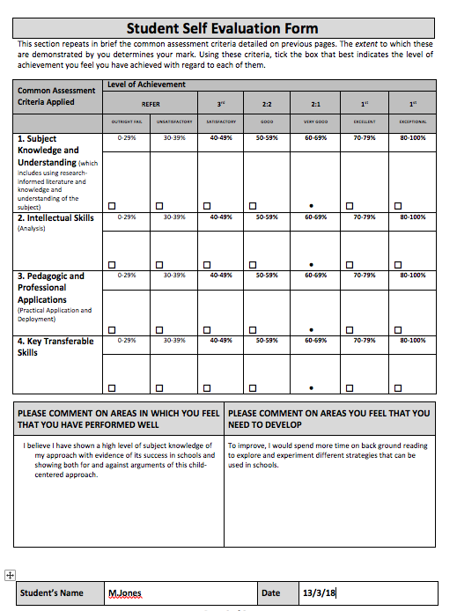
Consider how you might be able to develop the creative or enterprising skills of learners through your own pedagogy
https://youtu.be/R3chzLvCUlU
There has now been more emphasis and value placed on creativity in education and teachers and the development of creative skills within learners (Craft, 2005). Creativity is an important part of human development and is said to be innate within children. One of the most popular viewpoints on creativity have stemmed from Sir Ken Robinson. Robinson believes creativity involves imagination and innovation. Vygotsky supports this and believes that imagination is the basis of all creativity. Schools tend to be so focused on rigid routines that it automatically takes away the creativity within the child. Meador (1992) found that children are more creative before they start school. This is also supported by George Land (1968) longitudinal study where he tests children’s creativity. The results shown drop-in percentages, however a school’s philosophy should be to promote creativity not to hinder it which it is currently doing based on these results.

Teaching for creativity is the ability to use a range of approaches to make sure the environment and activities will allow children’s creativity to flourish. It focuses on the development of children’s creative skills and innovation. Furlong (2015) suggest that teachers must take responsibility for a child’s innovation. Most schools now are in agreement that developing creative skills in children is just as important as developing numeracy and literacy skills. Donaldson (2015) recognises that these creative skills will be beneficial for children in playing a positive and active role in society as they grow up. This view is also supported by Ofsted (2010) who states that from creativity children will develop other skills such as confidence and independence. In addition, Russ (1996) devised a model that suggest that for children to be able to express creativity they need a combination of personality traits, emotional processes and cognitive abilities.

One of Montessori belief is how creativity is stemmed from freedom of expression from each individual. The Montessori hands on approach will allow children to express themselves in various of ways, however, the child must have and understand the purpose of the activities. The main criticism of the Montessori approach is that children find it difficult to transition from a Montessori class to a traditional classroom if parents choose to move their children, however this can be changed by involving parents in the learning process where they can see the positive impacts Montessori.
One of the biggest debates in education involving developing creative skills within learners is Structure vs. Freedom. For children to develop and progress they need a balance of both. Bridgeman (2014) agree and states that in order to gain proficiency children need structure to develop discipline but freedom will give the children the opportunity to be motivated and engaged in what they are learning and have the willingness to try new things. Adopting a Montessori style classroom will allow children to make creative decisions in their learning in an environment designed to meet the needs of the children and further their holistic development. The prepared environment will allow the children who work independently whilst using materials deliberately chosen that are applicable to the developmental stage of the child (Prowant, 2017). Spielgaben (2013) stated that one criticism of this approach due to the costly demands of having this type of furniture however the idea of having a prepared environment is also supported by Froebel (1837) who states that this is the best atmosphere for children to learn in.
Teachers ultimate objective is to give children the opportunity to be independent and retain their intelligence, curiosity and creativity. Their own creative willingness will act as a scaffolding to emotional, intellectual growth whilst promoting new thinking and learning. Due to the freedom when developing children’s creative skills, the teacher may not always be involved in what the child is doing. With this in mind, there may be a danger that children may not work towards the learning objective. Therefore, this shows how the balance between structure and freedom is needed for a creative classroom. Davidson (2011) suggest that all children should produce work that pleases their own creative urges rather than just to please the teacher. This is where the teacher can encourage innovation within children to be confident to come up with their own and original ideas.

Having a child-centred curriculum allows flexibility and time to learn at their own pace. Linking back to the new curriculum, this is one of the biggest success in supporting Donaldson (2015) four purposes of children becoming lifelong, capable and ambitious learners. Constructivist theory acknowledges how non -rigid time allocated is needed for deepen learning to take place which supports creativity within a classroom (Brooks and Brooks, 1993). Antes and Mumford (2009) also suggests having time limits will have a big impact on the teachers’ ability to enhance children’s creativity. It is also important that children are given time out of the activity so that their creative ideas and divergent thinking will have time to incubate (Perkins, 1981). This will give children the opportunity to come back and engage with new ideas after making new connections from other contexts. Many years of research and work has been completed to help promote play in Montessori classrooms resulting in supporting creativity, language and social skills (Isaacs, 2018).

To conclude, adopting a Montessori philosophy and child centred approach in my classroom will certainly ensure the development of creative skills in children. It is also clear that combination of internal and external factors all have an impact on the child and how creative skills are needed across the curriculum to develop and progress.

References
Antes, A.L., and Mumford, M.D. (2009) Effects of time frame on creative thought: Process versus problem-solving effects. Creativity Research Journal, 166-182.

Bridgeman, L. (2014) Structure or Freedom? The Perennial Debate in Education. Available at: https://www.bible-bridge.com/structure-freedom-debate-education/ [accessed on 5/3/18].

Brooks, J., and Brooks, M. (1993) In search of understanding: The case for constructivist classrooms. Alexandria, VA: Association for Supervision and Curriculum Development.

Carter, C. (2008). 7 Ways to Foster Creativity in your Kids. Available at: https://greatergood.berkeley.edu/article/item/7_ways_to_foster_creativity_in_your_kids [accessed on 8/3/18].

Craft, A. (2005) Creativity in Schools: Tensions and Dilemmas. Psychology Press.

Daily Montessori. (2014) Montessori and Children Creativity. Available at: http://www.dailymontessori.com/self-development/montessori-children-creativity/ [accessed on 9/3/18].

Davidson. P (2011) Creativity and Montessori Education. Available at: http://www.mariamontessori.com/2011/03/19/creativity-and-montessori-education/ [accessed on 1/3/18].

Dewey, J. (1961). John Dewey on education (selected writings). London: Macmillan Publishers.

Donaldson,G. (2015). Successful Futures Independent Review of Curriculum and Assessment Arrangements in Wales.

Furlong, J. (2015) Teaching Tomorrow’s Teachers. Available at: http://gov.wales/docs/dcells/publications/150309-teaching-tomorrows-teachers-final.pdf [accessed on 6/3/18].

Grainger, T. and Barnes, J. (2006) Creativity in the Primary Curriculum in J. Arthur, T. GRAINGER and D. Wray. (eds.) Learning to Teach in the Primary School London: Routledge.pp.209-225.

Isaacs, B. (2018) Understanding the Montessori Approach: Early Years Education in Practice. Routledge.

Jaquith, D.B. and Hathaway, N.E. (2012) The Learner-Directed Classroom: Developing Creative Thinking Skills Through Art. Teacher College Press.

Lucas,B., Claxton, G. and Spencer, E. (2013) Progression in Student Creativity in school: First steps towards new forms of Formative Assessments. Available at: https://moodle.uwtsd.ac.uk/pluginfile.php/111429/mod_resource/content/2/Lucas%20Claxton%20Spencer%20creativity%20assessment.pdf [accessed on 9/3/18].

Meador, K.S. (1992). ‘Emerging rainbows: a review of the literature on creativity’, Journal for the Education of the Gifted, 15, 2, 163–81.

Montessori Academy. (2017) How does Montessori Education Cultivate Creativity? Available at: https://montessoriacademy.com.au/montessori-cultivate-creativity/ [accessed on 6/3/18].

Montessori Group. (2013) Montessori Nurtures Curiosity, Creativity and Imagination. Available at: http://www.montessorischools.org/blog/montessori-nurtures-curiosity-creativity-imagination/ [accessed on 4/3/18].

Montessori, M. (1997). Çocuk Eğitimi: Montessori Metodu (Education for Child: Montessori Method ). Çev. Güler Yücel, Özgür Yayınları, İstanbul.

Montessori Northwest. (2017) What is Montessori Education? Available at: https://montessori-nw.org/what-is-montessori-education/ [accessed on 2/3/18].

Ofsted. (2010) Learning: Creative approaches that raise standards. Available at: http://www.creativitycultureeducation.org/wp-content/uploads/learning-creative-approaches-that-raise-standards-250.pdf [accessed on 8/3/18].

Perkins, D. (1981) The minds best work. Cambridge, MA: Harvard University Press.

Prowant, A. (2017) Freedom within Limits: The Structure of a Montessori Learning Environment. Available at: http://www.suzukischool.com/suzukispeaks/2017/1/19/freedom-within-limits-the-structure-of-a-montessori-learning-environment [accessed on 5/3/18].

Robinson, K. (2015) Sir Ken Robinson: Creativity is in Everything, Especially Teaching. Available at: https://www.kqed.org/mindshift/40217/sir-ken-robinson-creativity-is-in-everything-especially-teaching [accessed on 10/3/18].

RUSS, S.W. (1996). ‘Development of creative processes in children’. In: RUNCO, M.A. (Ed.) Creativity from Childhood through Adulthood: The Developmental Issues (New Directions for Child Development No. 72). San Francisco, CA: Jossey-Bass.

Schmidt, D. (2009) Undertsanding Montessori: A Guide for Parents. Dog Ear Publishing.

Sharp, C. (2001) Developing Young Children’s Creativity through the Arts: What does research have to offer? Available at: https://www.nfer.ac.uk/publications/44420/44420.pdf [accessed on 1/3/18].

Skillicorn, N. (2016) Evidence that children become less creative over time (and how to fix it). Available at: https://www.ideatovalue.com/crea/nickskillicorn/2016/08/evidence-children-become-less-creative-time-fix/ [accessed on 11/3/18].

Spielgaben. (2013) Comparison among Froebel, Montessori, Reggio Emilia and Waldorf-Steiner Methods – Part 1. Available at: https://spielgaben.com/comparison-froebel-montessori-reggio-waldorf-part-1/ [accessed on 5/3/18].

Sweet, J. (2013) How might we inspire young people to cultivate their creative confidence? Available at: https://challenges.openideo.com/challenge/creative-confidence/inspiration/innovation-engine [accessed on 2/3/18].

Ultenir, E. (2012) An epistemological glance at the Constructivist approach: Constructivist Learning in Dewey, Piaget and Montessori. Available at: http://disde.minedu.gob.pe/bitstream/handle/MINEDU/5415/An%20Epistemologic%20Glance%20at%20the%20Constructivist%20Approach%20Constructivist%20Learning%20in%20Dewey%2c%20Piaget%2c%20and%20Montessori.pdf?sequence=1&isAllowed=y [accessed on 3/3/18].

Vygotsky, L. (2004) Imagination and Creativity in Childhood. Available at: http://lchc.ucsd.edu/MCA/Mail/xmcamail.2007_07.dir/att-0503/Vygotsky__Imag___Creat_in_Childhood.pdf [accessed on 3/8/18].

Young, G. (2014) Creativity in the Classroom. Available at: http://enablingenterprise.org/archives/8089 [accessed on 4/3/18].

