ACMA5009

Reflective project report

Barrie John 1811176

Group Project Review.

Process monitoring introduction.
Abstract.
This report looks at a group project which was carried out to introduce process monitoring onto the core build section of one of the production lines I work on. It also reviews where I believe the project was successful and where I believe there are areas still to make gains.

Contents.

- Introduction…………………………………………………………………………………………………
- Literature review (a look at the project and its aim) …………………………………
- Results and discussion (did the project achieve its aims) …………………………….
- Conclusion (is there any more to be gained from the project) …………………….

Introduction
A cross functional team was formed with the goal of reducing scrap in the plant. The plant scrap was measured in PPM (defect parts per million). At the start of the project the plant scrap was 49,709 ppm with an internal goal of 8,000 ppm. The aim was to complete this with little to no investment. A B-Improve team was set up to achieve this. Historically Marelli have had a good defect rate with supply to the customer with FY 16 result being 3ppm. While we continued to maintain a good supply to our customers it was clear there was a need to reduce our internal failure rate.

Literature Review
We started by forming a cross functional team with members from Quality, manufacturing, mechanical engineering and line super vision. The teams aim was to reduce scrap to 8,000 ppm which was the plants internal target for FY17. In order to understand where the most gains could be made a pareto chart completed to show where the biggest defects were in the past twelve months.
What is a Pareto Chart?
A Pareto Chart is a graph that shows the frequency of defects, as well as their cumulative impact. Pareto Charts are useful to find the defects and how to best prioritize them in order to gain the greatest overall improvement. (Lamarre, 2019)
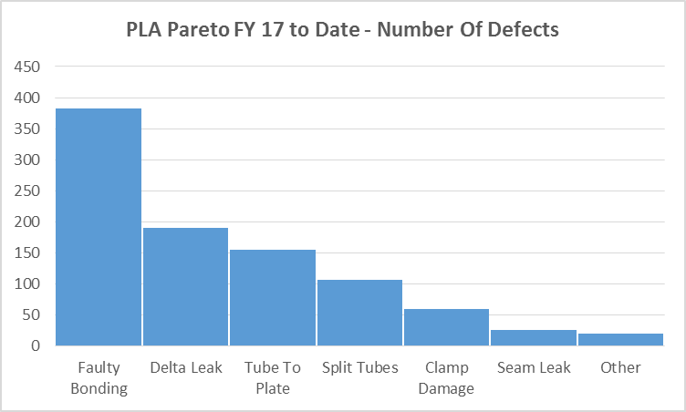

From the pareto chart it was clear that faulty bonding was the top concern, and this would be the team’s main area of focus.
What is faulty bonding?
Faulty bonding is when components fail to braze together during the manufacturing process. (John, 2017)
The team decided that the first product that would be the area of focus would be the PLA 27mm radiator that is produced for the Range Rover Sport as this is one of the highest running products with an average weekly volume of around 3500 parts.
The issue of faulty bonding is a result of our core build process. This is where raw material (aluminium) is used to form tubes and airways that are assembled along with tube plates and side casings by a core build machine to produce the assembled radiator. This core is then held together by a braze clamp to keep it packed tight while the core goes through the braze process. If the tubes or airways are not within specification, then there is a high degree of likelihood that faulty bonding will occur.
The two key points here are the tube minor and the airway height.
Tube minor is the measurement of the height of the tube after it has gone through the forming process this is also the same for the airway height. (John, 2017)
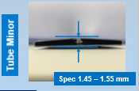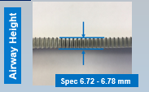

The spec for the tube for this product was 1.45 – 1.55mm while the spec for the airway was 6.72 – 6.78mm.
These are key components to providing good bonding with this component.
It was decided to use the DMAIC approach to problem solving.
What is a DMAIC?

The DMAIC Process
- Define the problem, improvement activity, opportunity for improvement, the project goals, and customer (internal and external) requirements.
  - Project charter to define the focus, scope, direction, and motivation for the improvement team.
  - Voice of the customer to understand feedback from current and future customers indicating offerings that satisfy, delight, and dissatisfy them.
  - Value stream map to provide an overview of an entire process, starting and finishing at the customer, and analysing what is required to meet customer needs.
- Measure process performance.
  - Process map for recording the activities performed as part of a process.
  - Capability analysis to assess the ability of a process to meet specifications.
  - Pareto chart to analyse the frequency of problems or causes.
- Analyse the process to determine root causes of variation and poor performance (defects).
  - Root cause analysis (RCA) to uncover causes.
  - Failure mode and effects analysis (FMEA) for identifying possible product, service, and process failures.
  - Multi-vary chart to detect different types of variation within a process.
- Improve process performance by addressing and eliminating the root causes.
  - Design of experiments (DOE) to solve problems from complex processes or systems where there are many factors influencing the outcome and where it is impossible to isolate one factor or variable from the others.
  - Kaizen event to introduce rapid change by focusing on a narrow project and using the ideas and motivation of the people who do the work.
- Control the improved process and future process performance.
  - Quality control plan to document what is needed to keep an improved process at its current level.
  - Statistical process control (SPC) for monitoring process behaviour
  - 5S to create a workplace suited for visual control.
  - Mistake proofing (poka-yoke) to make errors impossible or immediately detectable (ASQ.Org, 2021)
Before we analysed the process, we had to ensure that our measuring systems were capable.
- We reviewed the equipment that were historically used to measure the parts.
- Following R&R studies we could see that the current measuring equipment were not statistically capable.
There were 2 key items that needed improving.
1st, The resolution of the gauging was not adequate as we were gauging to two decimal places. It was decided for better accuracy that gauging to three decimal places would be introduced. This would improve distinct categories when carrying out gauge R&R studies.
What is an R&R study?
Gage R&R, which stands for gage repeatability and reproducibility, is a statistical tool that measures the amount of variation in the measurement system arising from the measurement device and the people taking the measurement.”
This statement is true – the methodology will give you the value for variation due to the measurement system and the people taking the measurement. But you need to compare this value to something to answer the question of “how good” your measurement system is.
For any process, the total process variance is the sum of the parts variance and the measurement system variance.
σ_{x}²= σ_{p}²+σ_{e}²
where σ_{x}²= total variance of the product measurements, σ_{p}² = the variance of the product, and σ_{e}² = the variance of the measurement system. (McNeese, 2012)
2nd Operator Dependency
- Both gauges previously used had a significant reliance of the operator
- We re-designed both gauges to reduce this operator reliance.

Both measurement systems are now at an “acceptable” level

Now that we had established our method of measurement, we needed to understand how capable our processes were.
We undertook Machine Capability Studies on both Tube Minor and Airway Height
30 consecutive parts were measured.
Then “Normality Tests” and Machine Capability Tests were completed.

Tube Minor
- All parts were within tolerance.
- Results show a capable process.
- The process variation is good.
- The setting of the process is well centred within the tolerance band.
- The process was statistically capable.
- This was not seen as the immediate focus area.
- Ongoing measurement was introduced to monitor the process.

Airway Height
- All parts were within tolerance.
- However, the process variation was not acceptable.
- The results were using up the whole tolerance band.
- The process was not statistically capable.
- This was our immediate focus area.

Both Tube Minor and Airway Height were monitored on an ongoing basis by the Production Operators.
Both Run Chart and Process Capability Analysis were used.
Parts were measured every hour.
After each “Core” was build – it was marked with a unique number.

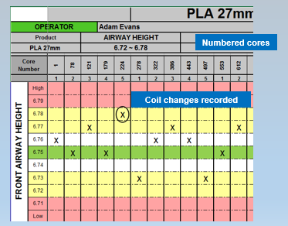

At the end of the assembly line, all parts are thoroughly inspected.
If a defective part is found at the final assembly line, the core number of that part is recorded.
The core number is traced back to an hour production window.
The measurement data captured at Core Build at this time could be reviewed.

This cross reference enabled the team to understand what the best dimensional “mix” was at Core Build to give the best quality part.

To verify the dimensional mix and to ensure the core compression (tube and airway spec) is stable, a pull-out test was introduced.
This check uses a force meter to evaluate the resistance of the airway when removed from a pre-braze core.
This would verify if the core were under enough compression.
This again supported the conclusion regarding the best dimensional mix between the parts.

Process analysis tools were used to identify the root cause of the airway inconsistency.

Tools used included: -
- Ishikawa diagram
The fishbone diagram or Ishikawa diagram is a cause-and-effect diagram that helps to track down the reasons for variations, defects, or failures.
The diagram looks just like a fish’s skeleton with the problem at its head and the causes for the problem feeding into the spine. Once all the causes that underlie the problem have been identified, we can start looking for solutions to ensure that the problem does not become a recurring one.
The diagram can also be used in product development. Having a problem-solving product can provided people care about the problem you are trying to solve. The fishbone diagram strives to pinpoint everything that is wrong with current situation so that you can develop a product that does not have these problems.
The fishbone diagram is also a great way to look for and prevent quality problems. You can also use it to troubleshoot before there is trouble, and you can overcome all or most of your teething troubles when introducing something new. (Pearson, 2012)

- Fault Tree Analysis

The meaning and function of FTA
FTA can be a convenient to find out the direct and indirect reasons and combinations of these failings.
Qualitative analysis can identify and prioritize the reasons of a hidden hazard and can predict the probability of accidents occurrence. The FTA is a close combination of mathematics and professional knowledge. The formulation and analysis of the fault tree need a solid mathematical foundation and considerable professional skills.
FTA is the logical relationship between potential accidents and corresponding reasons can be represented by tree diagrams. Analyzing an FTA, we can find the main reasons that can provide a reliable basis for determining safety countermeasures, in order to predict and prevent accidents. (Kritzinger, 2017)

- Process Flow Review
This guide outlines a simple and generic approach, based on a set of principles, that allows any person to get started with process improvement and see immediate benefits without the need for costly training or investment. (Jisc, 2003)

- Failure Mode and Effects Analysis
Failure mode effects analysis (FMEA)
Also called: effects and criticality analysis (FMECA), potential failure modes and effects analysis; failure modes.
Failure modes and effects analysis (FMEA) is a step-by-step approach for identifying possible failures in a manufacturing or assembly process design, or a product or service. It is a commonly known process analysis tool. Manny believe it begun in the 1940s by the U.S. military.
- "Failure modes" means the ways, or modes, in which something might fail. Failures are considered to be any errors or defects that could affect the process or customer and can be categorised as potential or actual.
- "Effect’s analysis" refers to looking at the possible consequences of those failures.
The purpose of the FMEA is to take actions to eliminate or reduce failures. Failures are prioritized according to how serious their consequences are, starting with the highest-priority ones and how frequently they occur, and how easily they can be detected.
. FMEA is used during design to prevent failures. Failure modes and effects analysis also documents knowledge and actions about the risks of failures, for use in continuous improvement. FMEA begins during the earliest conceptual stages of design and continues throughout the life of the product or service. (ASQ, 2021)

- Process Control Plans.

What is a Control Plan?
The Control Plan is a document that describes the actions for monitoring of process parameters. In simpler terms, the Control Plan provides the operator or inspector with the information required to properly control the process and produce quality parts or assemblies. required at each phase of a process to assure the process outputs will conform to pre-determined requirements. The Control Plan does not replace detailed operator instructions. The Control Plan helps assure quality is maintained in a process by establishing a standard for quality inspection and process monitoring. Control Plans are living documents that should be periodically reviewed and updated. (One, 2020)

These tools helped identify the root cause for the Airway Height variation as the inconsistency in the Airway Roll Setup.

The Team then further evaluate this process and created a detailed instruction that was issued as a standard for all Airway Roll changes.
This ensured that a consistent approach was then taken.

Working Standards / Setting Sheets were introduced to control the inputs into the process and reduce variation at source.
These were developed for each of the variables identified during the process flow / FTA analysis.
This gives a pro-active process control philosophy.

Operator training.
As well as creating a technical standard for the setting of airway rolls, the team also looked at the skill levels of the operators and a training programme was developed using on the job training and classroom-based training to bring all the operators to a level standard.
The training was based around.
- Problem solving tools.
- Gauging and measurement
- Basic Statistical Process Control and Process Capability

The Production Operators have also been training in computer skills that has enabled them to move from using “Paper” copies for recording measurement results to “Computer Based” systems.

Results and discussion.
With these new practices in place, we now have a tighter control of the process and are using a smaller amount of the tolerance band, resulting in less variation.
Through the feedback from final assembly and the study of our numbered cores, we have also been able to “optimise” the size of the airway height to give the lowest level of defects.
We found that the best quality parts were produced when the process setting were maintained towards the top specification limits.
This improvement activity has also given us an opportunity to use real time data as a design for manufacturing exercise. We have established the best dimensional condition to run our parts with the best overall quality being achieved and We could then theoretically modify out the tolerance to reflect this condition.
This improvement programme has therefore enabled us to use data to give valuable inputs into future product and process development.
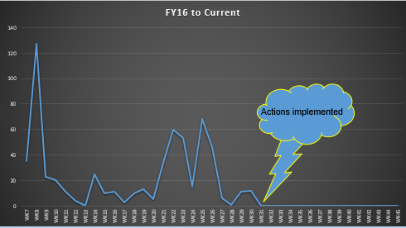
As the above graph shows there has been no instances of faulty bonding since the actions have been implemented. It also shows that there has been no negative impact to the product since the activity has taken place. Since the activity has taken place there has been a saving of £6.5 k. (FY 17).
We have introduced improved process monitoring techniques via Control Charts and Process Capability analysis.
This is being maintained by our Production Operators, who given their added training are now more confident and have a better understanding of process monitoring and the need to stay within the set process diameters.
Charts showing the set controls are displayed in the cells and we have extended the measurement to other part features.
We now plan to carry this process monitoring technique across all core builds to give a consistent and stable measuring process to all components manufactured.
Lessons Learnt.
Data accuracy is dependent on measuring equipment accuracy.
Process improvement is only possible through good data analysis.
Structured tools and techniques must be used to gather to right data.
Decisions must be made be a cross functional team.
Process improvement is possible without significant investment.
While the team did not hit our target of 8,000 ppm. A reduction from over 49,000 ppm to 11,000 ppm (at the time of the project completion) it is clear to see that the main aim of the project has been archived. where with a limited amount of money spent and resources the team managed to introduce a stable and repeatable process for measurement of key components to ensure the best quality product could be produced on a repeatable basis.
Structured tool and techniques were introduced to make it possible for the operators to record and report any changes in the process in real time so adjustments could be made to avoid any rejects being produced.
Before the introduction of this project the first-time lack of bonding would be seen was when the cores would be coming off the braze furnace. This would mean that there could be anywhere from 60 to 120 cores as work in progress with the possibility of faulty bonding as the only way of detection would be a visual one post braze.
Now with the introduction of the process monitoring and the correct set up of the airway rolls any change in the airway height are greatly reduced thus greatly reducing the chance of lack of bonding occurring as any change found will be reacted to much sooner using tools such as a pull test can be implemented to help reduce the chances of rejects being produced.

Conclusion.
While I feel there was a lot archived by the project and the brief was met as the team managed to reduce scrap and introduce a stable and repeatable process monitoring system which is still in practice and giving sustainable results, I think that if given more money and resources the team could of investigated and possibly introduced tools to automate the data recording and airway height adjustments. The team could have also investigated external training for the operators. I have shown below some of the possible improvements that could still be introduced to the project to make it even more robust.

Automation.
Airway height recording is currently a manual process where the operator will take an airway from the machine and using a digital gauge they will measure and record the airway height.
Automation of this could involve adding a digital gauge to the airway machine so the recordings could be made while the machine is running.
There are several companies who offer this type of service.
Increase data visibility.
Quickly make informed decisions with a global overview of all manufacturing test and repair data in a single portal.
Automate process monitoring.
Quickly make informed decisions with a global overview of all manufacturing test and repair data in a single portal.
Continuously improve quality.
Use WATS' top-down approach to detect frequent test or product failures where they first appear and fix them there.
(Wats, 2021)
Your organization’s data is an asset that can be optimized to drive greater success. Because of this, it is imperative that the quality of your data is high and data policies are adhered to.
Data monitoring software proactively analyzes your data to ensure that it is accurate and fit for purpose. Data monitoring services include automatic alerts, audit trails, issue resolution, and data policy enforcement.
Monitoring and resolution tool features allow you to have round-the-clock control over the quality of your data. (EDQ, 2021)
As well as automating the data recording, I have also investigated the possibility of Automating the tension adjustment should the airway height need adjusting.
Maintain a constant, optimum felt/wire tension.
JUD’s fully automatic tension controllers maintain a constant, optimum felt/wire tension. The electronic tension controllers are available as individual units or as modular systems for controlling and monitoring all tensioners on the paper machine.
>Maximum operating safety.
>Precise adjustment of pre-set fabric tension.
>Full system surveillance.
>Menu-driven operation.
>Linked to customer’s DCS.
(IBS Performance, 2021)

Shimpo Digital Tension Meter DTMX is devised for precision testing of tension with digital gauging sensor and measurement data output combination. With Shimpo's line of highly versatile DTMX Series, you can have a complete measurement system capable of handling the most precise testing applications by using method similar with tensile testing. The unit can measure standard wire such as string, steel, snare, copper, tape, film, chains, plastic fibres wire, flux, and especially rare and expensive material such as gold wires.

Your investment on Shimpo Digital Tension Meter DTMX Series, will allow you variety of measurement modes on various type of material. The data can also be transferred to a personal computer for data analysis on spreadsheet or for direct print through a USB port. The sturdy enclosure is made of casted aluminium for lightness, resistant against shock and static electric with rigidity for both mounted and hand-held application. For cheaper alternative without data connectivity, you can also opt for DTMB series.

Major application for this versatile tension meter includes Elastic string, Gold & Silver metal string of φ0.15 or smaller, Coated optical fibre, Synthetic fibre wire winder, Optical fibre, Optical fibre binder, Carbon fibre, Copper wire binder, Steel wire binder, Film for capacitor, Food film Brass wire of up to φ0.3, Copper coil, Magnetic tape, Carbon fibre, wool-textile string, Steel wire of up to φ0.1, Copper filament of W20×0.1t. and Tire cable.
(LCF,PTE LTD, 2019)
Training.
As well as looking into automation for data recording, I would investigate further training for the operators to improve their skills and knowledge.
Six sigma training.
Six Sigma is a Globally Recognised, data-driven methodology that aims to eliminate defects through successive business process improvement. highly experienced and capable trainers apply an interactive and engaging approach for teaching.
By attaining this Six Sigma certification provides delegates will know how they can implement each step of Six Sigma DMAIC methodology from root to solve the real-life problems in their company.
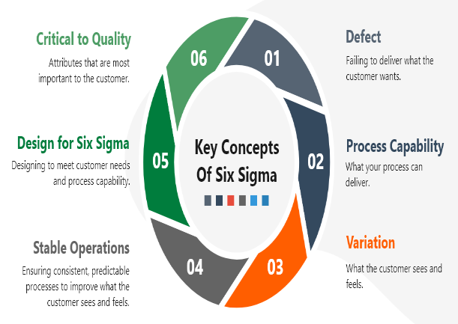 (Six Sigma, 2021)
8D.
The Quality-One 8D problem solving training course follows the steps of 8D in a dynamic, instructor-led environment. Each participant will be able to interact with all of the elements of the 8D process, the course describes to participants the methodologies and best practices for effective 8D development. including the use of tools such as: Ishikawa/ Fishbone, Affinity Diagrams, Is / Is Not, Process Flow. All activities will include industry-specific examples and terminology.

Participants will learn how to follow the 8D process steps while working in a Cross Functional Team (CFT). They will also practice how to best use problem solving tools to identify a root cause and eliminate it through permanent counter measure. Participants can expect team activities and relevant exercises in a workshop format. (Quality one - international, 2020)

Excel Training.
Learn best practice from expert tutors and Become familiar with Excel spreadsheet basics.
This course is designed to familiarise the inexperienced user with the basic concepts of Excel and its business uses. The essentials of building and editing a spreadsheet, identifying different types of data, correcting mistakes and copying formulae within the spreadsheet are covered, as is the ability to print information. You will learn how to make a colourful and informative series of charts from your data.
(Computer aid, 2021)
Future Improvements.
I believe that up skilling of the operators is a key component in improving both the quality of the product and the quality of the workforce. This is the one area that I would recommend to the management that as a company we should focus on in the future as improving the skills of the work force will carry across all aspects of their role. While Automation of the of data recording and automating any adjustments to the machinery will be beneficial, I believe the best long term and sustainable gains will be made with improving the technical skills of the employees.
We have recently introduced the role of setter operators to our core build area, and I believe this is a good step in the right direction as this will help the operators to gain skills that will give them a better knowledge and understanding of the need for critical issues such as setting up airway rolls and ensuring the correct tension. It will also help them identify issues on the machines and incorrect set ups which will intern reduce the number of rejects produced.
As the presentation says: THE POWER OF THE PEOPLE.

Work Cited.
ASQ. (2021, March 14). What is a FMEA. Retrieved from ASQ.org: https://asq.org/quality-resources/fmea
ASQ.Org. (2021, March 14). American society for quality. Retrieved from https://asq.org/quality-resources/dmaic
Computer aid. (2021). Excel level 1 introduction. Retrieved from computer aid wales.com: https://www.computeraidwales.com/scheduled-courses/excel-level-1-introduction-course.asp?Select_Category=25&
EDQ. (2021, 04 07). EDQ.COM. Retrieved from EDQ.COM: https://www.edq.com/data-monitoring/
IBS Performance. (2021, 04 07). IBS Paper performance group. Retrieved from IBS-PPG.com: https://www.ibs-ppg.com/en/products/detail/automatic-tension-controllers
Jisc. (2003, october 5th). process improvement. Retrieved from Jisc.ac.uk: https://www.jisc.ac.uk/full-guide/process-improvement
John, H. (2017, January ).
Kritzinger, D. (2017). Fault tree analysis - an overview. Retrieved from Science direct: https://www.sciencedirect.com/topics/engineering/fault-tree-analysis
Lamarre, C. (2019, august 6). What is a Pareto Chart?A Pareto Chart is a graph that indicates the frequency of defects, as well as their cumulative impact. Pareto Charts are useful to find the defects to prioritize in order to observe the greatest overall improvement. Retrieved from tulip.com: What is a Pareto Chart?A Pareto Chart is a graph that indicates the frequency of defects, as well as their cumulative impact. Pareto Charts are useful to find the defects to prioritize in order to observe the greatest overall improvement.
LCF,PTE LTD. (2019). LFC. Retrieved from LFC.com.sg: https://www.lfc.com.sg/products/detail/Shimpo-Digital-Tension-Meter-DTMX-Series
McNeese, B. (2012, March 13). What is a gauge R&R study. Retrieved from spcforexcel.com: https://www.spcforexcel.com/spc-blog/what-gage-rr-study
One, Q. (2020). Control plan - control plan development. Retrieved from Quality-one.org: https://quality-one.com/control-plan/
Pearson, S. (2012, 03 14). Definition - what is a fishbone diagram. Retrieved from Tallyfy.com: https://tallyfy.com/definition-fishbone-diagram/
Quality one - international. (2020). 8D Training. Retrieved from quality - one.com: https://quality-one.com/8d/8d-training/
Six Sigma. (2021, 04 07). Six Sigma Training. Retrieved from Six sigma .co.uk: https://www.sixsigma.co.uk/top-selling-lean-six-sigma-certification-training-courses?utm_term=six%20sigma%20training&utm_campaign=%5BSixSigma.co.uk%5D%5BCorona%5D&utm_source=adwords&utm_medium=ppc&hsa_acc=1984714232&hsa_cam=10030915824&hsa_grp=10238650407
Wats. (2021, 04 07). WATS. Retrieved from Wats.com: https://www2.wats.com/Manufacturing_Intelligence_for_Electronics_Testing?gclid=EAIaIQobChMItKD0vqfs7wIVk7myCh1nUg4vEAAYBCAAEgJr1PD_BwE

