

Design and Implementation of a Relational Database System

Program: CertHE Computing Skills for Workplace
Module Name: Introduction to Web and Database Concepts
Module code: ACCA4023
Name: Yonatan Grmay
Student Number: 2433740
Lecturer: Sadhana Jha
Submision Date: March/06 /2025

Task 2
Module code: ACCA4023
0
Scenario Analysis 2
Entities and Attributes 2
Relationships and Cardinality 4
Entity-Relationship Diagram (ERD) 4
References 9

Scenario Analysis
Within the framework of the database of the so-called MediLink Pharmacy, the main elements are Medicines, Suppliers, Customers, Prescriptions, and Sales Transactions.[1] They will contain and handle important information concerning the operations of the pharmacy. The following is an analysis of each entity, its attributes and the relationship among the entities.

Entities and Attributes
- Medicines
  - Medicine_ID (Primary Key): Unique identifier for each medicine.
  - Medicine_Name: Name of the medicine (e.g., Paracetamol, Ibuprofen).
  - Brand: Brand name of the medicine (e.g., ABC Pharma).
  - Quantity_In_Stock: Number of units currently available in the pharmacy.
  - Price: Price per unit of the medicine.
  - Supplier_ID (Foreign Key): Reference to the Suppliers table to identify which supplier provides the medicine.
- Suppliers
  - Supplier_ID (Primary Key): Unique identifier for each supplier.
  - Supplier_Name: Name of the supplier (e.g., PharmaSupplies, HealthTech).
  - Contact_Phone: Phone number of the supplier.
  - Contact_Email: Email address of the supplier.
  - Address: Physical address of the supplier.
- Customers
  - Customer_ID (Primary Key): Unique identifier for each customer.
  - Name: Full name of the customer.
  - Address: Customer’s delivery address.
  - Phone: Customer’s contact phone number.[2]
  - Email: Customer’s email address.
- Prescriptions
  - Prescription_ID (Primary Key): Unique identifier for each prescription.
  - Customer_ID (Foreign Key): Reference to the Customers table, indicating which customer the prescription belongs to.
  - Date: Date the prescription was issued.
  - Medicine_ID (Foreign Key): Reference to the Medicines table, indicating which medicine is prescribed.
  - Quantity_Prescribed: Number of units of the medicine prescribed.
  - Dispensed_Quantity: Number of units dispensed from the prescription.
- Sales Transactions
  - Transaction_ID (Primary Key): Unique identifier for each sales transaction.
  - Date: Date the transaction occurred.
  - Customer_ID (Foreign Key): Reference to the Customers table, indicating which customer made the transaction.
  - Total_Price: Total value of the transaction.
  - Payment_Method: Method of payment used (e.g., Cash, Credit Card, Online).

Relationships and Cardinality
- Suppliers → Medicines: There are also several-to-many relationships where a single supplier supplies a variety of medicines (One-to-Many relationship). A supplier can be the only provider of a medicine, whereas a medicine can be supplied by a number of suppliers.[3]
- Customers → Prescriptions: A Customer may have several prescriptions throughout time (One-to-Many relationship). The individual prescription is associated with a single customer, albeit multiple prescriptions.
- Medicines → Prescriptions: A prescription includes a certain medicine, and the same medicine can be found in numerous prescriptions (Many-to-One relationship). This means that there is only one prescription of a particular medicine, but that medicine may have many prescriptions.
- Customers → Sales Transactions: There is a possibility of having more than one sales transaction between a customer (One-to-Many relationship). The customer will have the option to purchase the medicines at various hours, and this will lead to numerous sales.[4]
- Sales Transactions → Medicines: There can be many medicines in one transaction (Many-to-Many relationship). To solve this, you can add a junction table, Sales Medicines, which captures the medicines sold in each transaction, and the quantity sold.

Entity-Relationship Diagram (ERD)
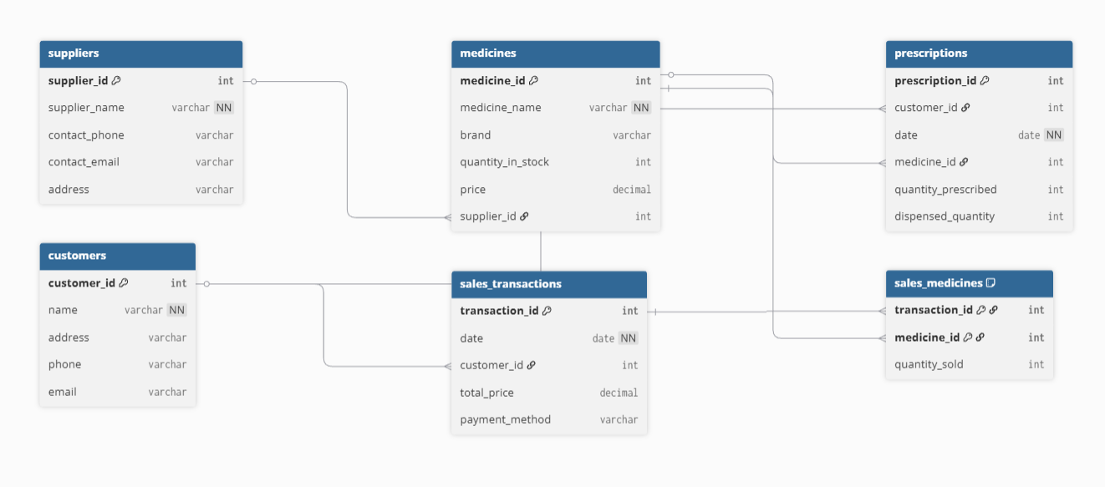
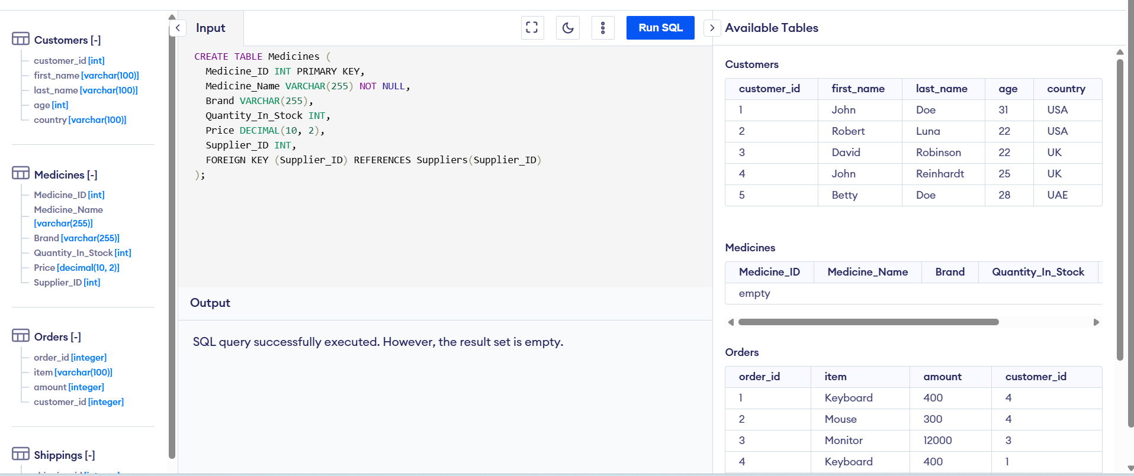
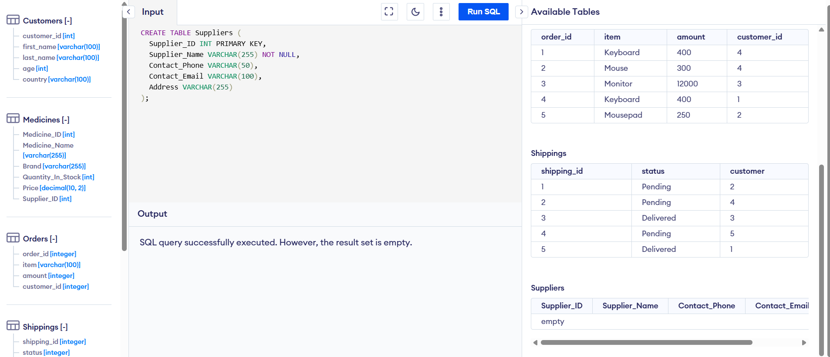
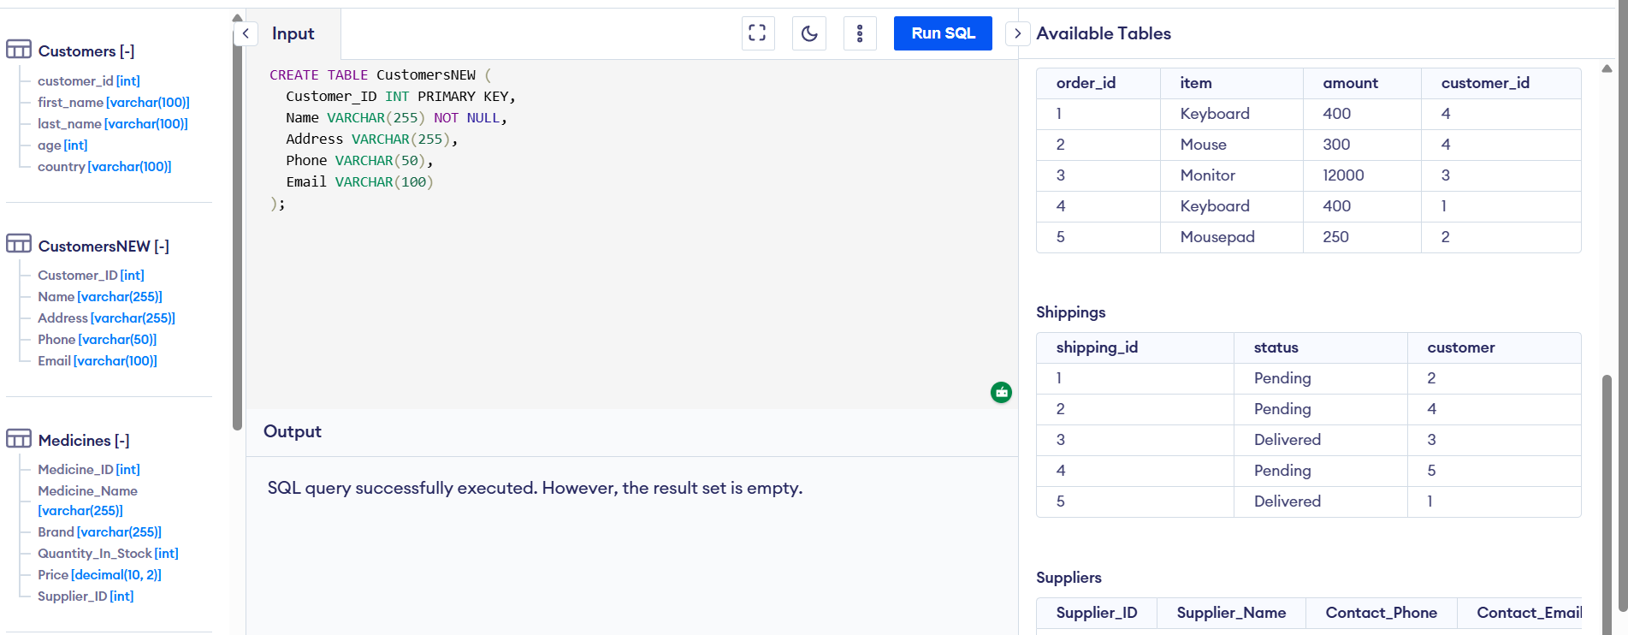
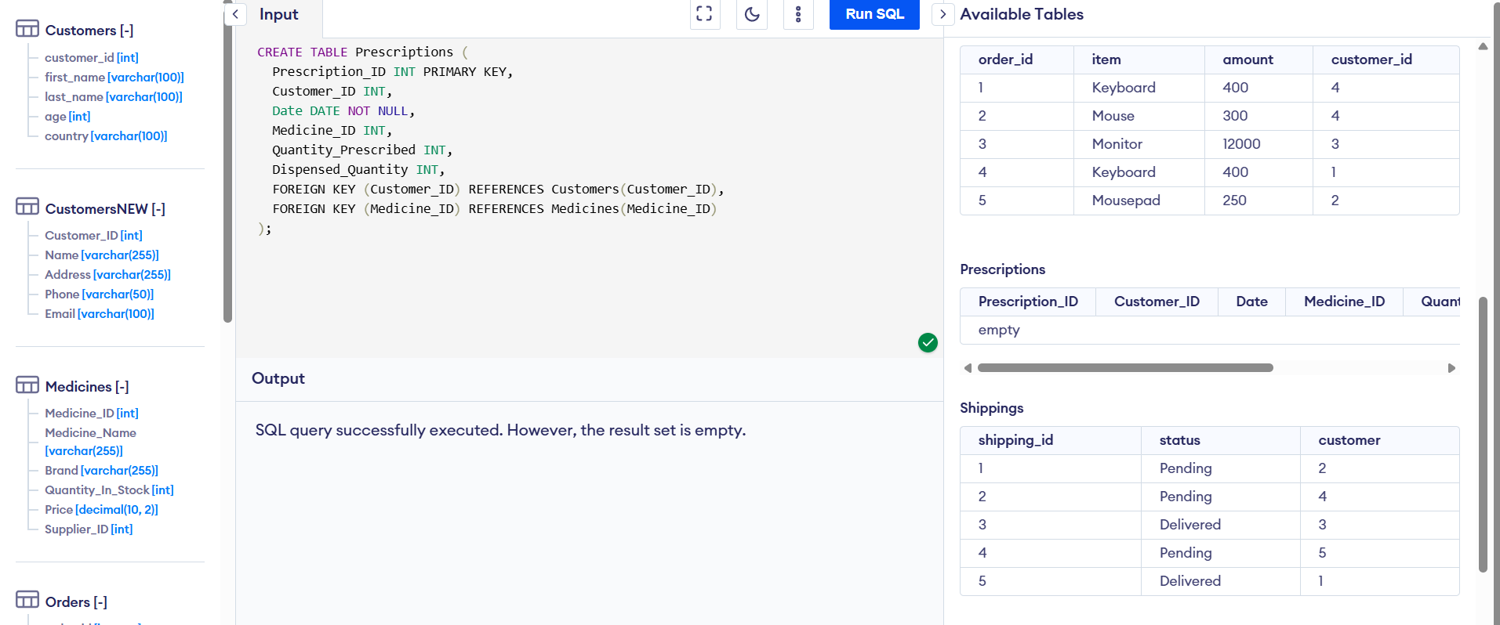

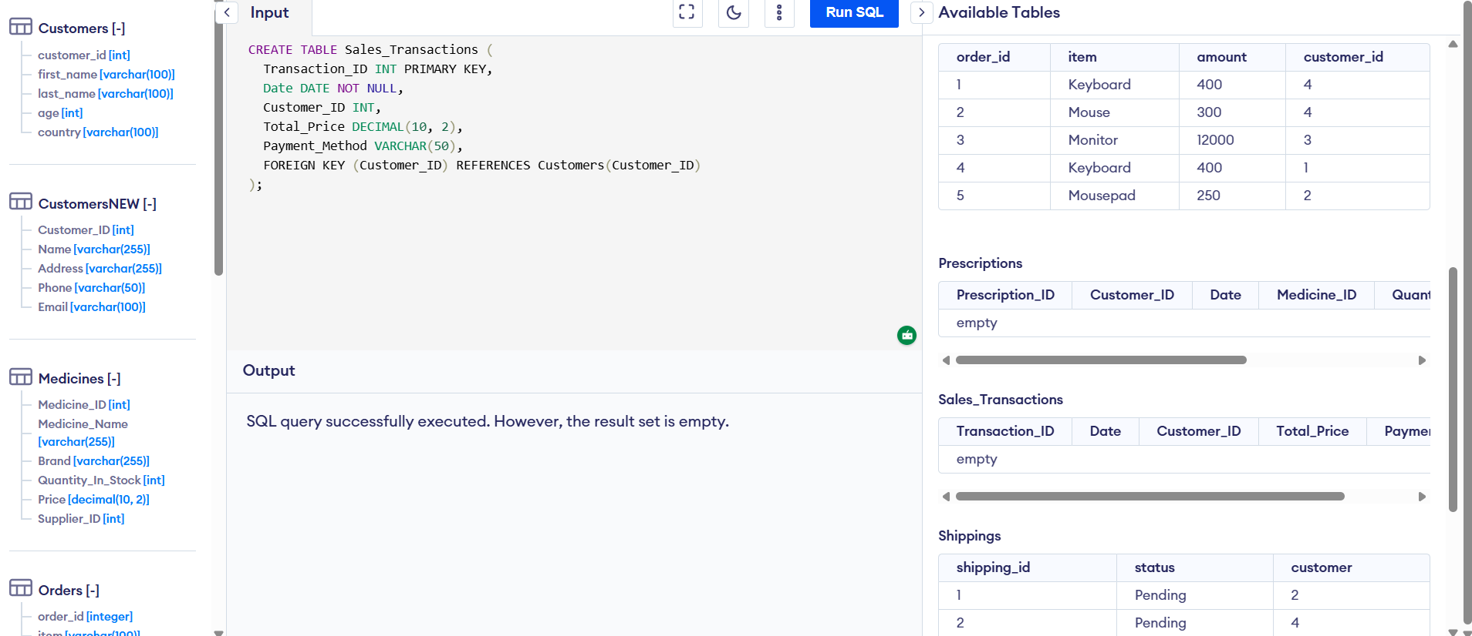
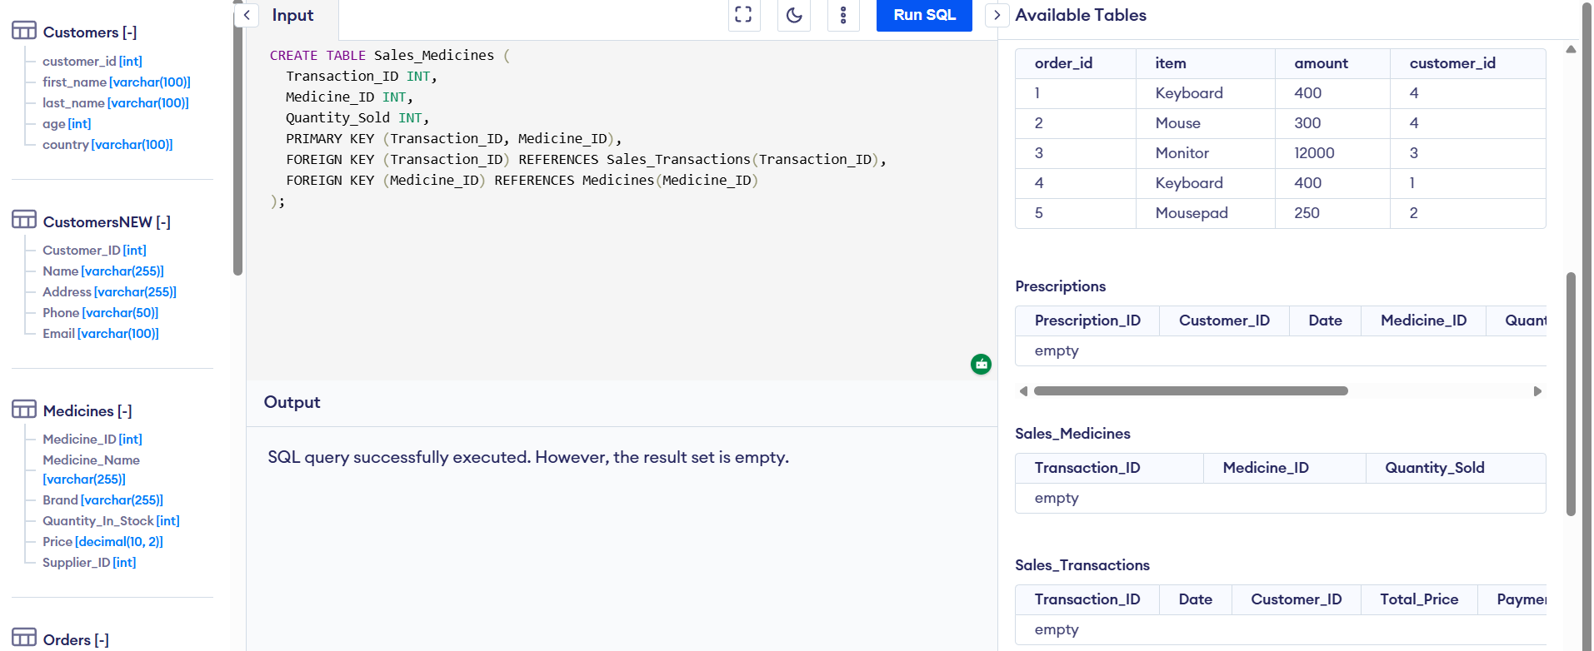
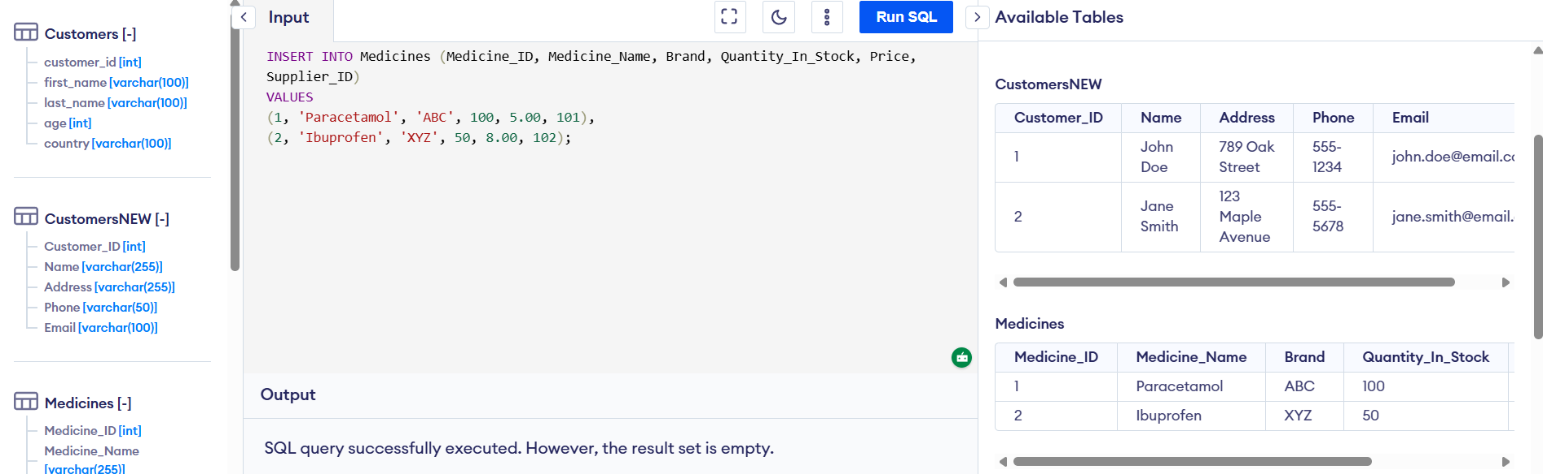
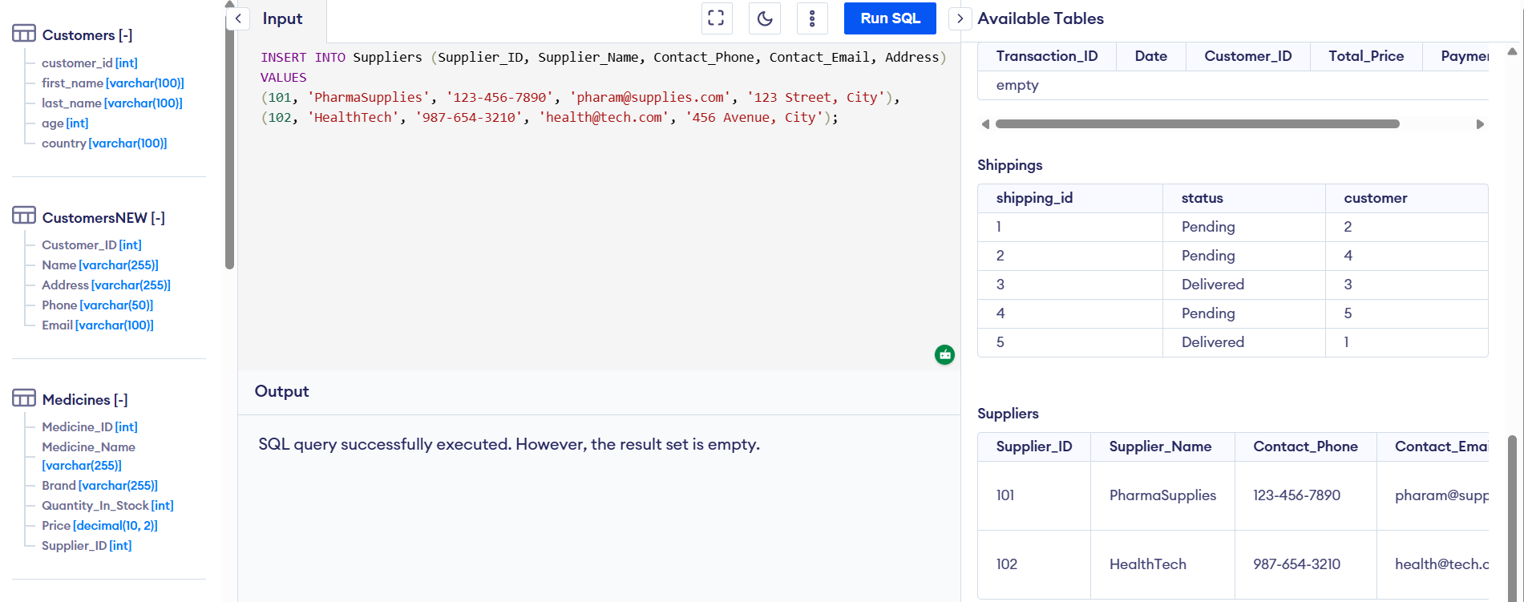
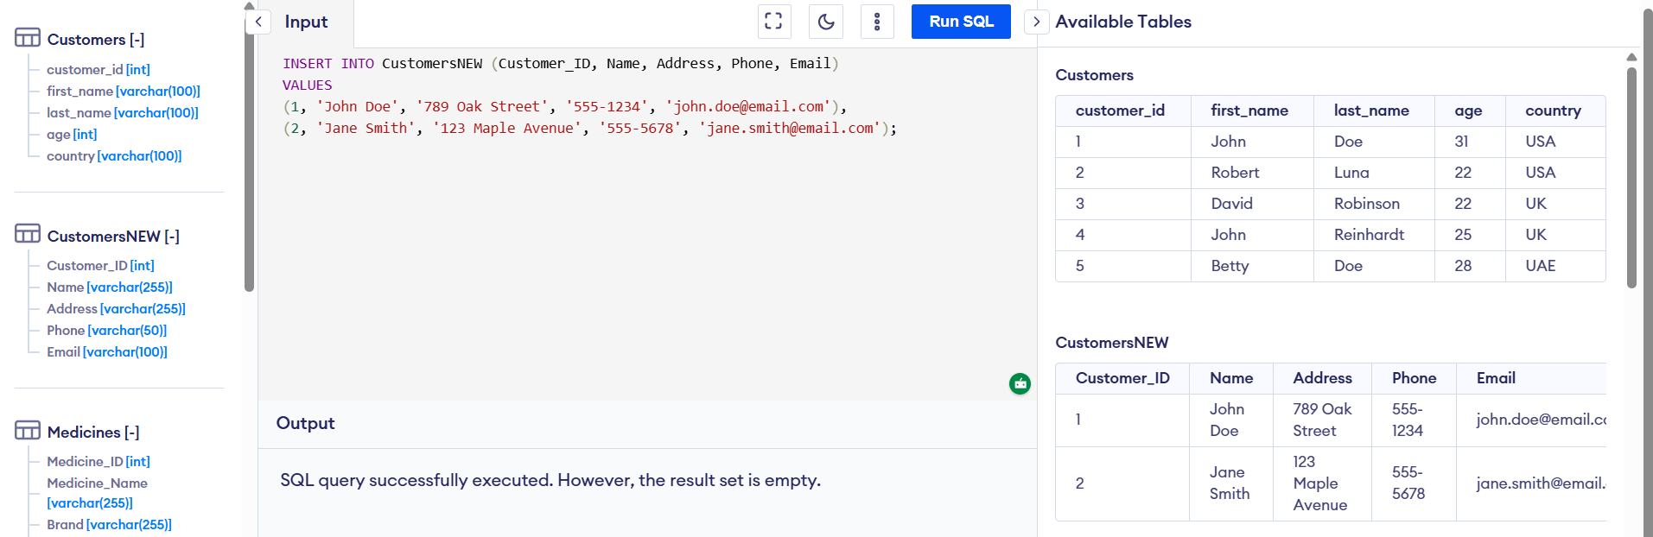
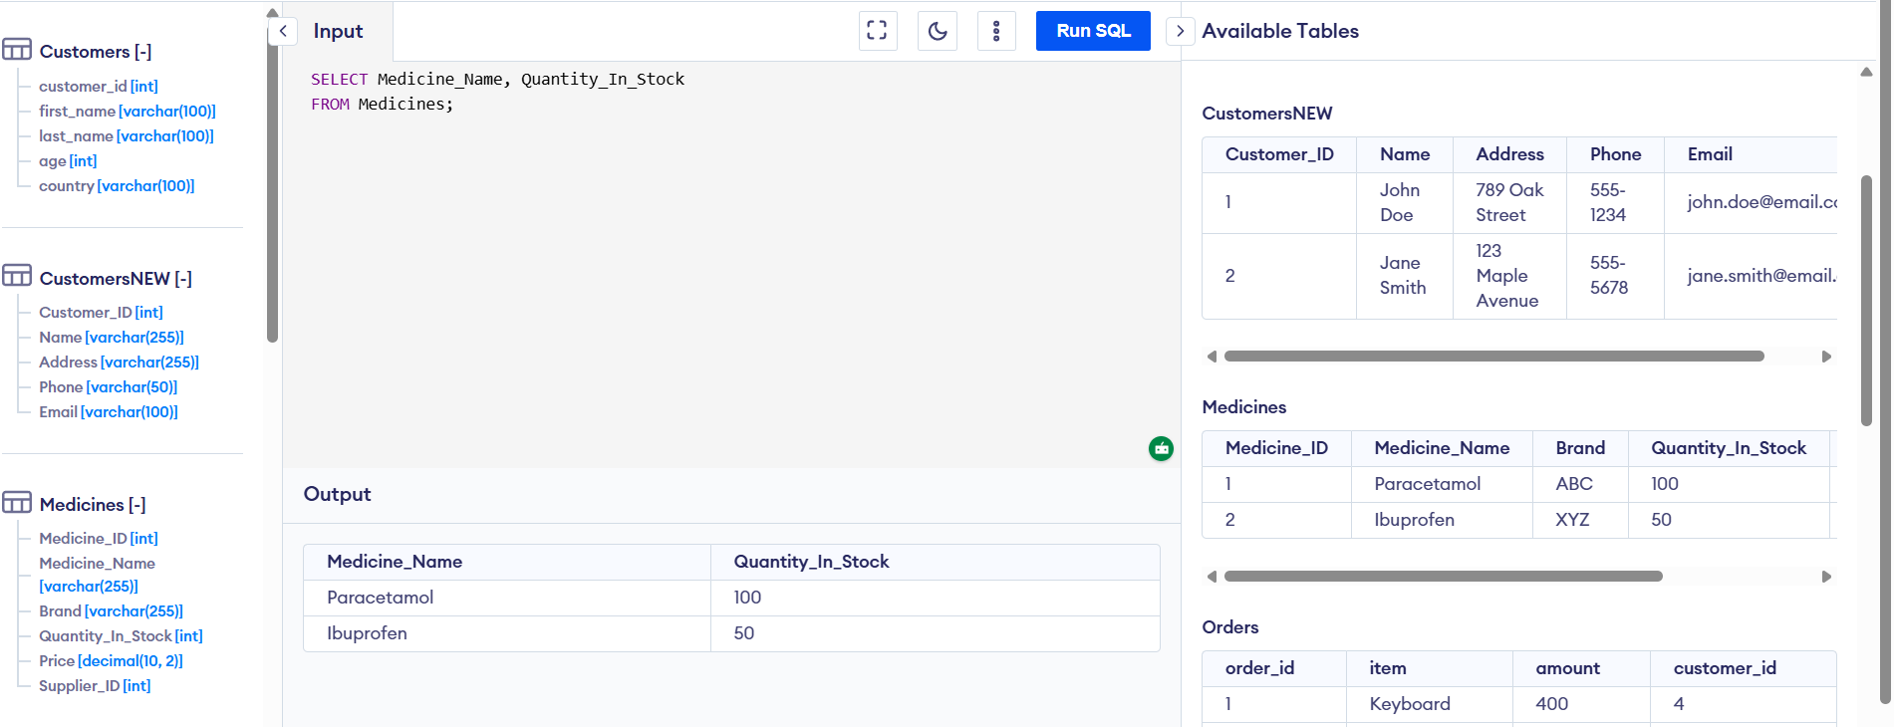
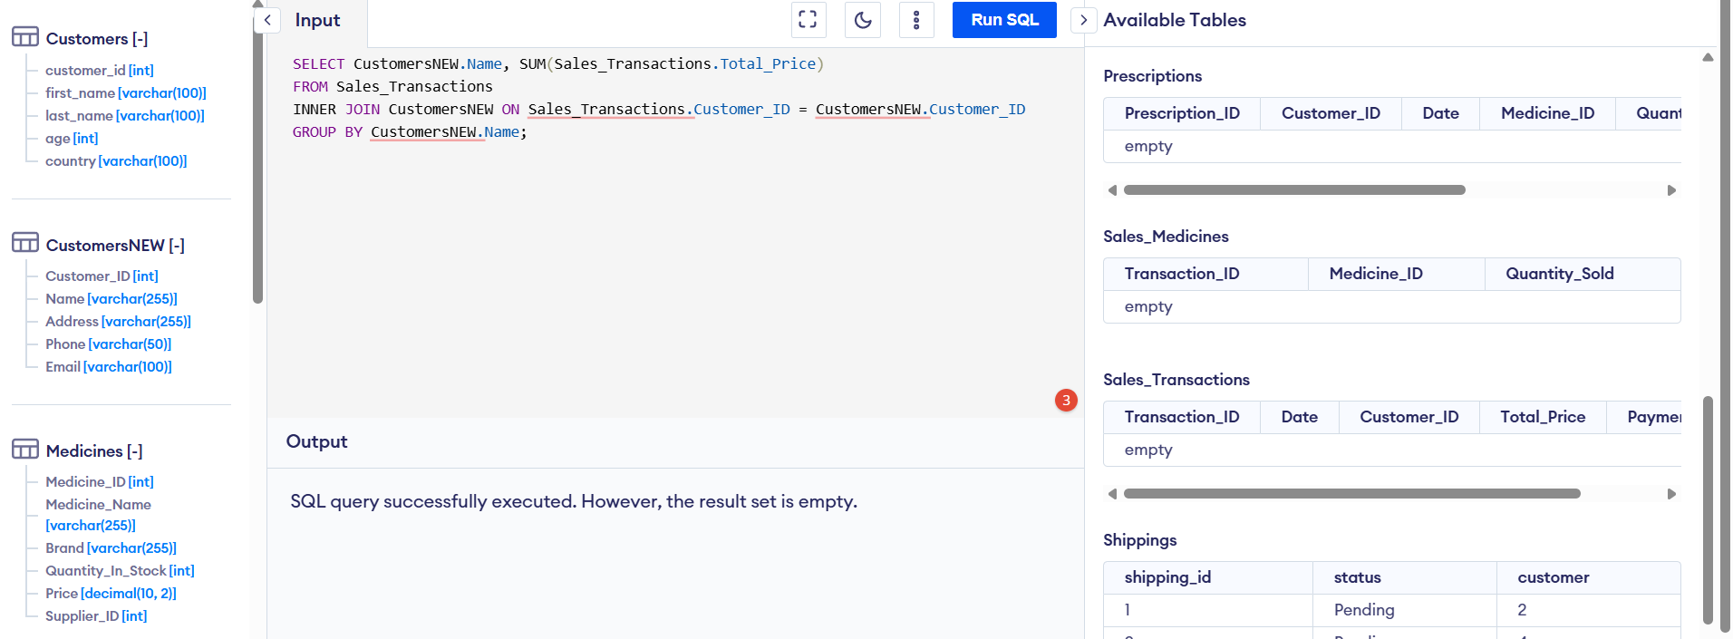

References
[1] P. P. Chen, “The Entity-Relationship Model: Toward a Unified View of Data,” ACM Transactions on Database Systems, vol. 1, no. 1, pp. 9–36, 1976.
[2] T. Connolly and C. Begg, Database Systems: A Practical Approach to Design, Implementation, and Management, 6th ed. Pearson, 2014.
[3] C. J. Date, An Introduction to Database Systems, 8th ed. Pearson Education, 2004.
[4] R. Elmasri and S. B. Navathe, Fundamentals of Database Systems, 7th ed. Pearson, 2015.
[5] J. Frye and D. Kim, Database Management and SQL Fundamentals, 5th ed. McGraw-Hill Education, 2022.
[6] H. Garcia-Molina, J. D. Ullman, and J. Widom, Database Systems: The Complete Book, 2nd ed. Pearson, 2008.
[7] J. A. Hoffer, M. B. Prescott, and F. G. McFadden, Modern Database Management, 12th ed. Pearson, 2021.
[8] W. Kennes, Database Design for Mere Mortals: A Hands-On Guide to Relational Database Design, 2nd ed. Addison-Wesley, 2003.
[9] J. Melton and A. Simon, SQL: 1999 – Understanding Relational Language Components. Morgan Kaufmann, 1993.
[10] Microsoft, “Introduction to database normalization,” 2021. [Online]. Available: https://docs.microsoft.com/en-us/sql/relational-databases/tables/database-normalization?view=sql-server-ver15. [Accessed: Feb. 20, 2026].
[11] E. Navarro, The Database Design and Implementation Guide, 2nd ed. Pearson, 2020.
[12] Oracle Corporation, “Understanding Referential Integrity Constraints,” 2020. [Online]. Available: https://docs.oracle.com/cd/B28359_01/server.111/b28318/consist.htm#CNCPT86849. [Accessed: Feb. 20, 2026].
[13] P. Robinson, Data Integrity and Database Normalization: A Guide to Building Reliable Databases. Wiley, 2018.
[14] K. Siau and X. Tan, “Database Design: Theory and Practice,” Journal of Database Management, vol. 28, no. 4, pp. 55–67, 2017.
[15] D. Steinberg, SQL Queries for Mere Mortals: A Hands-On Guide to Data Manipulation in SQL, 4th ed. Addison-Wesley, 2019.

