
Module Number: LCMB7003
Module Name: Strategic Management
Title of the assignment: Strategic Management (Tesla)
Name of student: Nabeel Ahmed Khan
Student Number: 2125539
Submission Date: 13-Jan-2023
Word Count: 6000 Words

Executive Summary
Tesla has entered the United States in the year 2003 and they have established themselves in the electric vehicle market. It is noted that Tesla has created the model of business to customers while dividing the firm into three sectors such as automakers, hard ware and technological development. It is found that company has been finding it challenging to achieve exceptionally quality which makes the structure cost higher. The company is also facing the issue in achieving confidence in the brand which affects the level of competition. It is noted that company has been driven towards focusing on differentiation strategy which has helped them in establishing their business in the competitive industry. The company is therefore recommended to establish super charging stations, drive focus on supply chain, establish diversification, decentralised system application and achieving transparency in the operations.
Table of Contents
Executive Summary 2
Introduction 4
Business Model of Tesla 5
Strategic Issues Being Faced by Tesla 7
Porter Five Forces 7
SWOT Analysis 8
Stakeholders Analysis 10
Resource Based View Strategy 11
McKinsey 7S Model 12
Value Chain 12
Factors Affecting the Strategic Management Decision 13
Strategic Options for Tesla 15
Ansoff Matrix 15
Porter’s Generic Strategy 15
Bowman Strategic Clock 17
Conclusion 19
Recommendations 20
References 22

Introduction
Engineers established Tesla Motors Inc. in the United States in 2003. They started this business to show others that they shouldn't skimp on electric driving. The business creates electric vehicles that are quicker and additional pleasurable to energy than gasoline-powered automobiles. Tesla Motors produces scalable energy production, storage products, and all-electric car manufacturing. Tesla favours abandoning fossil fuels in favour of zero-emission goods. California serves as the company's primary location (Carlier, 2022). The firm acquired the manufacture of solar panels, solar rooftop slating, and solar cities to specialise in residential to utility scale projects, among other things.
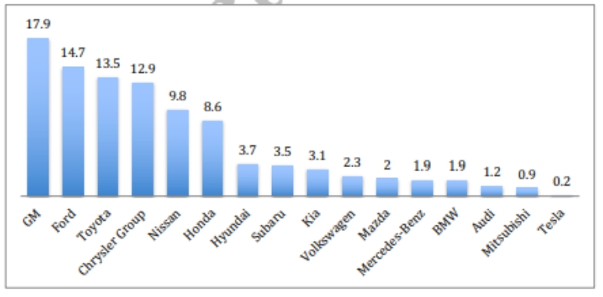
Figure 1: U.S. Car Manufacturer Market Share (by %, March 2018)
(Source: Sull and Reavis, 2019)
In July 2003, Martin Eberhard and Marc Tarpenning established Tesla as Tesla Motors. Nikola Tesla, an electronics plot and scientist, is honoured in the business designation. Elon Musk developed the world's biggest participant in February 2004 afterwards manufacturing a $6.5 million worth. Since 2008, he has been the CEO. Tesla, in Musk's belief, happens to accelerate the change to ecologically approachable energy and transportation, utilising solar energy and electrical vehicles. 2009 saw the launch of Tesla's first vehicle, the sports automobile Roadster. The Model S sedan, Model X SUV, Model 3 sedan, Model Y crossover, and Semi truck were released after this in 2012, 2015, 2017, and 2020, respectively (Britannica, 2022).

Business Model of Tesla
Tesla has been using direct business to customer model through which they have eliminated the intermediaries through their charging postings. Tesla is renowned by having a firm that is fundamentally divided into three commercial representations: an automaker, a hardware provider, and a tech company (Teece, 2018).
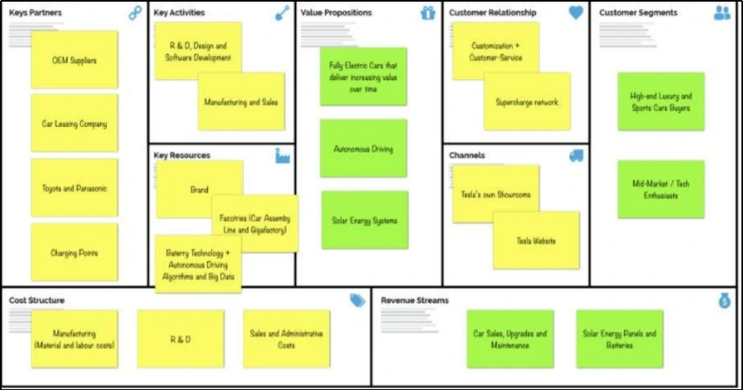
Figure 2: Tesla Business Model Canvas
(Source: Pereira, 2022)
Value Proposition: Tesla's valuation provided to the society includes offering auto vehicles which are greener and that enhances extraordinary presentation, project, functionality, competence, extended range, tractability, and low-cost (or free) refreshing.
Customer Segment: Tesla has focused on manufacturing cars while considering all customer types such as from mid-range vehicles with sensible values to extravagance and sports cars with high price tags that contend with Porsche or Ferrari (Chen and Perez, 2018).
Channels: As stated through case study, Tesla services its own storefronts, its website (a self-service online store), sessions, and auctions proceedings as possibilities for getting its spectators.
Customer Relationship: Additionally, Tesla is putting more money into its charging infrastructure so that its vehicles can be charged more rapidly and for free. The public has a highly good perception of Tesla and its brand, which is consistently connected with luxury and technology (Liu and Meng, 2017).
Revenue Stream: Solar panels, batteries, maintenance, and car sales.
Key Resources: Technology, innovation, long-time battery, software’s, designs and engineering
Key Activities: Cars manufacturing, building & maintenance, sales & marketing, designs, R&D and software development
Key Partners: Suppliers, government, alliances and charging points
Cost Structure:
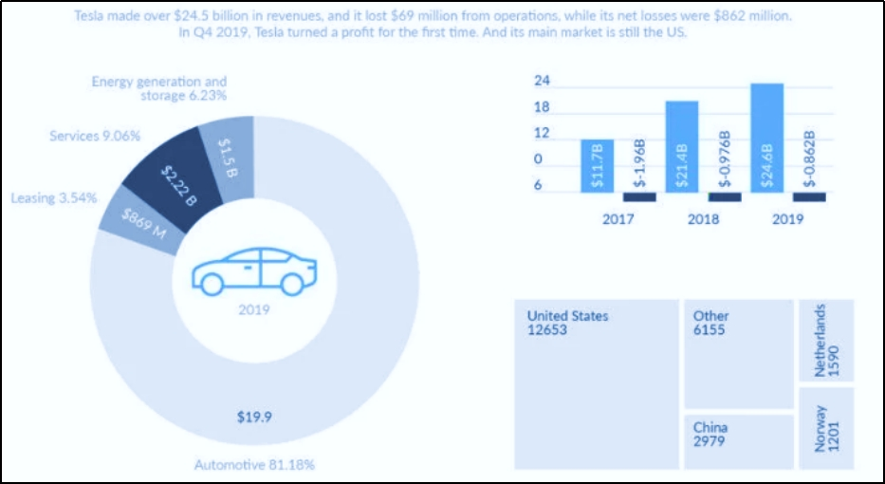
Figure 3: Tesla Cost Structure
(Source: Pereira, 2022)

Strategic Issues Being Faced by Tesla

Porter Five Forces
Competitive Rivalry: High - Nearly 46% of the total market shares for the US automotive industry was held by three American manufacturers in 2018. Ford was second with a 14.7% market share, while Chrysler was third with a 12.9% share. General Motors (GM) held the top spot. 14 With a volume share of 13.5%, Toyota was the top non-American producer. Market share for Tesla was 0.2% (Sull and Reavis, 2019). The profits on capital operations for automakers, often known as original equipment vendors or OEMs, had typically been minimal. Ford, GM, and Chrysler all had operating margins that were 7.4%, 6.4%, and 3.2%, respectively (operating income as a proportion of sales).
Threat of New Entrant: High - The car sector has strict entry requirements. In addition to acquiring the money necessary to design and produce a new automobile, which might charge up to $6 billion and take up to six years, new applicants also had to cope with building engineering amenities and workshops, expanding dealer networks, and cultivating brand loyalty. 19 For OEMs situated in the United States, research and development (R&D) costs accounted for around 5% of sales (Sull and Reavis, 2019). Six automobile manufacturers made the list of the top 100 most important brands around the world, including Toyota ($45 billion), Mercedes-Benz ($34 billion), BMW ($31 billion), Honda ($26 billion), Audi ($14 billion), and Ford ($14 billion).
Bargaining Power of Suppliers: Moderate - Over 11,000 businesses worldwide supplied components (tyres, batteries) and systems to the vehicle industry (braking, electrical). 7 million individuals were employed by these suppliers, who managed 60,000 industrial sites. The $2.2 trillion leading automobile supply market was incredibly fragmented. 8.1% of total sales came from the top five competitors, which were Robert Bosch, Continental, Magna, Denso, and ZF Friedrichshafen (Kim, 2020).
Bargaining Power of Buyers: Low - In the United States, 113 million passenger vehicles have registrations in 2018. A record-high 11.6 years were spent keeping an average automobile. 35 These autos were parked most of the time—about 95% of the time. Americans who travel alone by automobile make up around 75% of the workforce. There were 75 million members of the millennial generation, and at their age, fewer of them had cars than persons in earlier generations. In 1983, 92% of those aged 20 to 24 possessed a driver's licence; by 2014, that number had fallen to 77%, according to one survey (Mehta and Bhavani, 2018). Millennials were the fastest-growing demographic of automobile consumers, and J.D. Powers anticipated that by 2020 they will account for 40% of new car sales, even if the Great Recession of 2008 delayed their entry into the market.
Threat of Substitutes: Moderate - The number of new automobile dealerships in the United States in 2018 was over 18,000, down from around 22,000 in 2007. Dealers made around 2% of the new car purchase price in profit, which was about 30% of a dealership's total revenue from new car sales. Although such revenues were anticipated to dramatically decline with EVs that obligatory a smaller amount of care and fewer maintenances, dealerships generated between 45% and 60% of their profits from maintaining automobiles and providing replacement components (Dai, 2020). According to a 2016 survey, dealers discouraged buyers from EVs by not prominently exhibiting them, not offering EVs for test drives, failing to highlight the tax incentives and rebates that were available, and failing to have a basic understanding of EVs.

SWOT Analysis
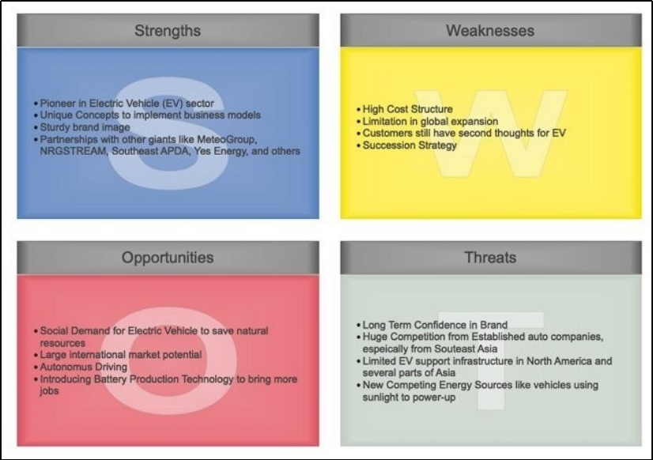
Figure 4: SWOT Analysis of Tesla
(Source: Edrawmax, 2022)
Strengths
Elon Musk, the CEO of Tesla, is recognized for appreciating ability over speculative experiences. This is also evident in Tesla's staff. The corporation is an important owner and energetically pursues for progressive mark pouches. Tesla employs a varied staff and promotes innovation. They must routinely featured on Forbes lists of top employers throughout the years in a range of productions. Statistics show that for the previous several years, Tesla has dominated the market for electric vehicle deals in the United States. Three of the top seven electric car sales in 2019 were from Tesla models (Mas, 2018). As a outcome, market and start will be more persuaded to belief Tesla and buying automobiles based on recent trades.
Weaknesses
Tesla has derived a extended method since its inception but Elon Musk remains the one person who can guarantee its achievement. Tesla goods are in extraordinary claim due of its renowned variety. However, Musk has other initiatives to achieve, and it would be exciting for him to achieve Tesla alone. It costs a lot to deliver exceptional quality. The great charge of invention, however, confines Tesla's aptitude to production on a huge measure. Budgets related with manufacturing, organization possessions, and accessible spaces are major confines. The well-founded company is incapable to capitalise on the larger available possessions in other countries, though, as a result of its limited global presence (Alghalith, 2018). Without a doubt, the aforementioned factors will make it impossible to meet demand.
Opportunities
Tesla's products cost an exorbitant amount since they are luxury automobiles with reducing technology. However, there is still of possibility to grasp a broader viewer by offering inadequate functionality and a larger variability of prototypes. The Tesla Model 3 is an excellent place to begin because it is a less expensive model of the Model S with fewer amenities. Both the need for more electric vehicles and the need to use fewer fuel vehicles are growing as consumers become more worried about the environment (Jiang, 2022). Tesla has the ability to generate its own battery cells, which will lessen its reliance on Panasonic, the business's main battery supplier. This move, if applied, may totally alter Tesla's business model will provide profitable results.
Threats
Aluminium, iron, nickel, and other premium metal alloys are used by Tesla in their product manufacture along with other premium metals and alloys. These materials are expensive and occasionally hard to come by. The output of Tesla might be significantly impacted by changes in these materials' prices. Tesla offers unique solutions, but customers might not accept them right away. Furthermore, Tesla's experience with product responsibility cases is detrimental to its objectives. As a consequence, a lot of people continue to be afraid to buy Tesla products, which are a major obstacle for Tesla (Guangul and Chala, 2019). There aren't many regulations governing the use of self-driving cars because they are still a relatively new technology in most places.

Stakeholders Analysis
Mendelow's Matrix was developed in the year 1991 for analysing the stakeholders of the company by evaluating the influence and level of interest they have on company operations. The analysis is used for assessing their probable amount of influence on a significant business choice (Farshid, et al., 2020).
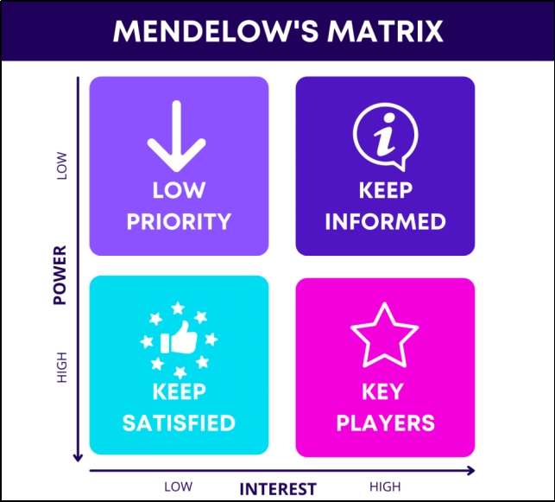
Figure 5: Mendelow’s Matrix
(Source: Farshid, et al., 2020)
Tesla's customer engagement is advantageous, particularly for new companies. The business may build a devoted and content client base thanks to their unique offering and additional complimentary charges, programming, and data communication capabilities. Equal stakes in the business' success exist among the alliance partners (Biradawada, 2022). The success of the firm depends heavily on their relationship because it is essential for prompt development, manufacturing, and support.

Resource Based View Strategy
Resource-Based View (RBV) is a model used by businesses for gaining competitive advantage by organising the resources which are operating internally and are appreciated, unusual, non-imitable, and geared to worth withdrawal. Instead of concentrating on the viable situation, societies find advanced approaches to use internal possessions to take benefit of external properties and create competitive benefit using this strategy (Nason and Wiklund, 2018).
For Tesla Motors, the property is a corporal store that includes all of the zones it possesses or rents for the purpose of housing engineering units and for loading. For Tesla Motors, equipment is another physical property that encompasses all of the machinery held by the business for use in manufacturing, shipping, and other operating processes. Materials refer to each and every materials and additional cartons that Tesla Motors employs to successfully produce and package its goods. In relation to Tesla Motors, infrastructures are another tangible resource that is easily recognisable by rival players. In relations of technology, buildings, workplace materials and upkeep, and the circulation of electrical resources, this includes all the property and substructure (Chen, et al., 2021).
Tesla Motors' appearance as a trademark is grounded on its modern distinctiveness, during which period the corporation has endeavoured to compromise top-notch belongings and success the self-assurance of clients. Intellectual property privileges protect Tesla Motors' industrial procedures and the uniqueness of+ its products, averting imitation or access by other corporations to these processes or to the company's exclusive active ingredients and supplies. Once again, historical singularity has allowed for the formation of enduring goodwill for Tesla Motors, and the brand's image and customer satisfaction have made this possible (Galpin, 2019). Due to its trade secrets, Tesla Motors is also prosperous in its operations and companies and enjoys a sizable fan base of repeat customers.

McKinsey 7S Model
The model is the framework which is based on the design presented by organisations which helps in depicting how a change in leadership can help in managing the company operations which is discussed through seven elements (Gechkova and Kaleeva, 2020).
Strategy: The products and services being provided by Tesla using the competitive strategy is considered value for money which helps in competing for prices. The company must not cut the cost as such can impact their brand image (Embapro, 2022).
Structure: Company must change the structure by reducing the dependency on China as pandemic disrupted operations in a big way. The company must have smaller teams which make it easy to report things to headquarter.
Systems: Tesla focus on the continuous improvement on internal process such as management of risks and customer relationship help company in improving system (Masfi and Sukartini, 2022).
Staff: The people are working from remote location which makes the people feel more inclusive in the process of decision making thus helping the top management in establishing the direct interaction with the employees.
Skill: Company providing the training and development programs to employees has been known to be fruitful for company as such helps in motivating them towards working more progressively.
Style: The managers are given the right to share the inputs which help them in keeping close check on operations as well as getting the required outcome from operations (Datta, 2022).
Shared Value: The model is being built by the company which shows their vision and extensive core values showing the world their focus thus enhancing the nrand image of the company.

Value Chain
Primary Activities
Tesla is an engineering corporation; hence a variety of rare resources are needed to produce its produces. Collecting fresh ingredients, packing supplies, and within allocating supplies and constituents are completely parts of inbound logistics, which are essential for the start of production. In addition to other locations, Tesla has manufacture accommodations in Shanghai, China, Lathrop, Fremont, and other cities. As a result, they need management among different operating divisions as well as corporate business organisation (Perkins and Murmann, 2018). Tesla's supply chain must make absolutely sure that its customers are getting reliable products in addition to delivering its items on time and at the lowest feasible cost.
The motor vehicle sales atmosphere has been completely transformed by Tesla's internet retail. Tesla Motors created a multi-channel purchasing approach to replace the conventional dealership. The business follows the "Zero Dollar Marketing" policy, according to Tesla Motors' supply chain research. Tesla's unconventional business model, which relies heavily on word-of-mouth advertising and sales from satisfied customers, is its main area of operation (Liu, et al., 2022). The provision centres for Tesla offer post-purchase support. On-demand provision fronts will too be incorporated in Tesla's supply sequence analyses across the country in order to facilitate quick servicing.
Support Activities
Problems with management, law, finance, money, and organizational strategy are all measured to be portion of organization and company infrastructure also provides assistances in charge regulator as well. Tesla must endure to protect its viable advantage given its innovative product portfolio and skilled workforce. Finding, developing, and then retaining talent in this area is the goal of the human resources division. Tesla has developed a exclusive location in the automobile industry as a result of its slashing automotive technologies. A number of vendors were bought for thousands of components as part of the examination into Tesla's supply chain (Edrawmax, 2022). To achieve effective purchasing, the Tesla supply chain relies on keeping up activities and contact with each of these providers.

Factors Affecting the Strategic Management Decision
In this segment of strategic operational business decision, meeting quality service standards is the primary goal. By conducting frequent quality inspections, quality improvement projects, and market research on auto, transit, and renewable technologies, Tesla Inc. satisfies this strategic purpose. Work processes, in addition to associated expenditures, manpower, and regulations, are the main considerations in this area of activities managerial decision making. Company Tesla the directors of Tesla's operations take usage of its global network influence (Thompson, 2018). For the firm's electric cars and other properties, for instance, merchants in the United States, Europe, and Asia supply some of the fundamental parts incorporate automated in response to this issue.
At Tesla, selections about inventories are founded upon business management ideas that prioritise quality. For example, organization demand that stock retention not have an influence on the quality of resources exploited in the manufacture of the business's electric automobiles. Tesla, on the other hand, usages just-in-time inventory for selected provisions as portion of its business plan to exploit competence and reduce inventory costs. Business planning mixed with process automation are used by operations managers at Tesla, Inc. to handle these issues and achieve optimum efficiency (Furrier, 2020). For business planning, the business tracks real market demand and bases the manufacturing schedule for cars on the ensuing data.

Strategic Options for Tesla

Ansoff Matrix
Ansoff Matrix is a business master plan that advises businesses to combine their growth strategy for their product lines and markets. The corporation may expand its market and product offerings with the aid of this grid, and if the situation is right, it might also broaden its commercial operations (Dawes, 2018). The thorough Ansoff Matrix study of Tesla Motors is shown here.
Market Penetration: Utilizing this tactic entails marketing to current markets with existing items. A portion of Tesla's occupational preparations include market expansion. The stable corporation is concentrating on advertising its Model S, X, and 3 which are related to electric vehicles, Powerwall 2 and Powerpack 2 vigour storing goods, as well as lunar cells, inverter, cabling, technical equipment, and generation includes in the US and 35 other nations (Dudovskiy, 2021).
Product Development: The formation of original substances for existing marketplaces is indirect by this strategy. Tesla seldom everything on developing innovative products and it is typically a result of the exceedingly luxurious emerging new costs in the electric car and energy store businesses.
Market Development: Tesla Motors used this approach and increased its attendance in China and India. When the firm unveiled the Model S, it concentrated on the wealthy, high-end customer assembly that is environmentally and naturally conscious. The corporation had an active strategy for promotion and publicising that was centred on producing tutoring and branding as an ideal item with great value.
Diversification: In order to diversify its non-automotive product portfolio, Tesla Motor created its battery line. The corporation's economic report does not, however, give it much prominence. The business is concentrating more on development of products and development strategies for power and mobility solutions (Ansoff, 2020). The firm's strategy goal of diversification and increased R&D spending on finding new commercial prospects is related to these.

Porter’s Generic Strategy
One of the two important deliberations that support the results industries make concerning their modest policy is addressed by Porter's Generic Strategies. Cost leadership, differentiation, and focus are the three key approaches for producing above normal outcomes in a segment that are founded on the double chief classes of viable edge and the variety of tasks that a occupational seeks to achieve it (Ali and Anwar, 2021).
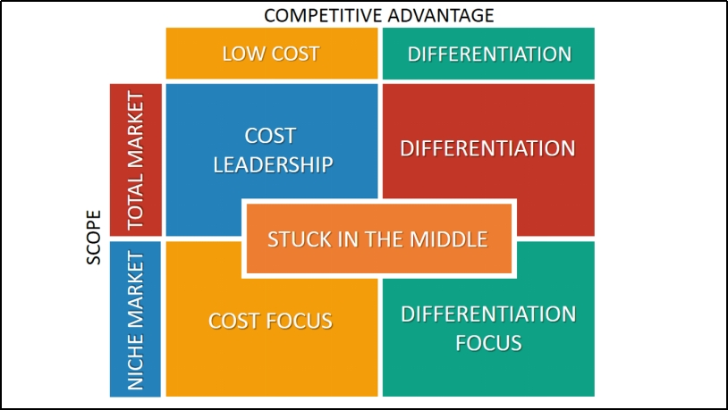
Figure 6: Porter Generic Strategy
(Source: Bruin, 2021)
Broad differentiation is Tesla's standard method of competing. With the assistance of the formation of goods that set the commercial separately from other corporations in the marketplace, this overall approach generates a viable benefit. In divergence to the fact that the great popularity of cars on the road nowadays still has incineration machines, Tesla Inc.'s vehicles, for illustration, are reasonable because they use cutting-edge environmentally friendly techniques. The company efficiently enticements in all conceivable customers by retaining this overall economic method, as more and more individuals are fetching concerned in purchasing recyclable stuffs (Rowland, 2018).
Differentiation has been Tesla's go-to general approach. Very few companies sell completely electric automobiles, and Tesla has further distinguished its brand by giving its vehicles more opulence. Its vehicles are exceptional in terms of both realism and grace. Model S and Model X are the two EV versions that it produces. While the second is a sporting usefulness vehicle, the first is an electric car. While maintaining performance and energy economy, the Model S offers a distinctive blend of utility, comfort, safety, and style. The Model X's spectacular falcon wing door instrument flawlessly reproduces the character of the car (Pratap, 2017). The brand's aesthetic factor is increased by additional components including a 17-inch touch screen driver interface.
To appeal to early investors in the wealthy sector, the company created the sporty Tesla Roadster and svelte luxury Model S in 2013. After becoming a well-known brand, Tesla changed its competitive approach to wide differentiation. In this instance, the business made use of its standing and little manufacture prices to yield goods at a subordinate charge for the conventional marketplace, such as the low-cost Model 3 (Rowland, 2018). R&D to create and create higher belongings and advertise growth through companies with businesses in other countries is the primary goals underlying Tesla's broad differentiation method. To uphold its commercial expansion, Tesla also employs product diversification, i.e., home storing series like the Powerwall 2 (Britannica, 2022). Market share by forceful marketing is its alternative intense growth method.

Bowman Strategic Clock
The Bowman's Strategy Clock is a detailed and user-friendly approach that compromises replacements for introduction within a market reliant on appraising and apparent value. It is commonly used in amalgamation with tools like the Ansoff Matrix and may be viewed as an substitute to or an development of Porter's generic competitive strategies (Desai, 2019).
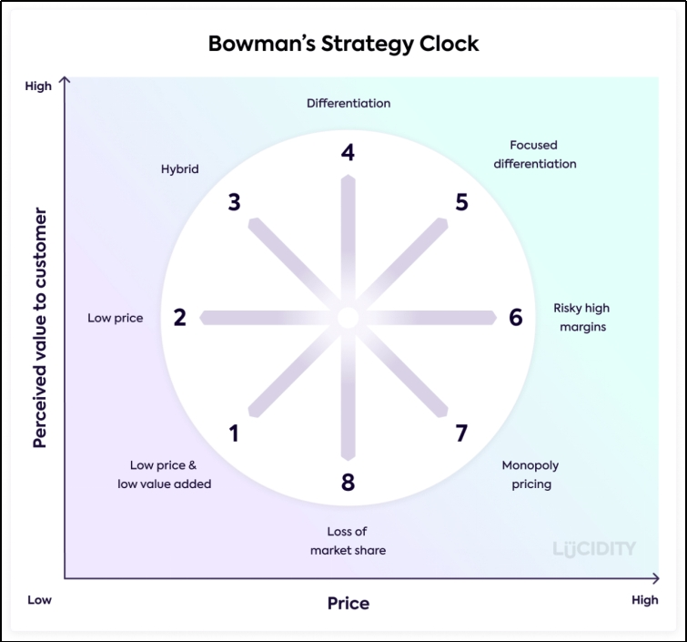
Figure 7: Bowman Strategy Clock
(Source: Get Lucidity, 2022)
Tesla Inc is at position four, with the use of high perceived value additions, a company may set itself apart from its rivals via the differentiation approach. This strategy covers a wide range, from complete product diversification to distinctive elements inside a main product when entering a market (Gali, 2020). Tesla uses a differentiation- and diversification-focused strategy. According to Bowman's Strategy Clock Frameworks, Tesla's tactic falls underneath the segmentation style because it functioned in the EV industry and produce a product that concentrate, who are prepared to pay more for them (differentiation), interpret as distinctive and revolutionary (focus). Tesla seamlessly transitions to a Differentiation strategy style and enters the centre segments of the market by releasing the Model 3. Instead of repositioning its brand, Tesla somewhat broadens its product offering in the hopes that the Model 3 would be well-received by consumers (Chen, et al., 2019). If not, the company strategy will revert to differentiation emphasis on the marketing of other cars, such as the Model S.
For a typical client, it is quite difficult to purchase a car costing more than $60,000. Tesla Motors' primary differentiation strategy is on those who are wealthy, environmentally conscientious, drawn by fashionable and gorgeous cars. Due to their limited capacity for production and financial resources, Tesla is unable to compete on a low-cost basis. As a result, the company focuses on developing products with distinctive designs and cutting-edge technologies that encourage customers to purchase its vehicles, giving it a stable position in the market and key competitive advantages. Tesla is presently employing a broad differentiation strategy, and the Tesla Model 3's launch is the main driver of this. With a starting MSRP of $35,000, the Model 3 competes with other vehicles in the semi sedan sector, demonstrating Tesla's aim to appeal to the general public who purchases automobiles (Han, et al., 2021). Lowering the company's operating costs (Tesla vehicles don't need gas, for example) and introducing tangibly appealing consumer features are a few important aspects of a comprehensive differentiation approach.

Conclusion
It is found that by utilizing solar power and electric automobiles, Tesla, in Musk's opinion, occurs to expedite the shift to environmentally friendly energy and transportation. The Tesla Convertible sports car made its debut in 2009. It was the company's first vehicle. Through its charging postings, Tesla has been operating under a direct business-to-customer model, eliminating the need for middlemen. Tesla is well-known for having a business that is basically split into three economic representations: a carmaker, a hardware supplier, and a tech giant. Tesla's commitment to its customers is helpful, especially for start-up businesses. Thanks to their distinctive product and extra complimentary fees, programmers, and data connection possibilities, the company may develop a loyal and satisfied customer base. Tesla has consistently used differentiation as its overall strategy.
There are very few firms that sell all electric cars, and Tesla has further positioned its brand by making its cars more opulent. Its cars are extraordinary in terms of both elegance and realism. It produces two electric vehicle versions: Model S and Model X. The first is an electric vehicle, while the second is a sports utility vehicle. The focus of Tesla Motors' principal differentiating strategy is on affluent, environmentally conscious consumers who are lured to chic and stunning vehicles. Tesla is unable to compete on a low-cost basis because of their constrained production capacity and financial resources. In order to attract people to buy its cars, the firm concentrates on creating goods with distinctive designs and cutting-edge technology, providing it a secure position in the market and significant competitive advantages.

Recommendations
In the next 10 to 15 years, according to Elon Musk, and by 2030, 50% of all new automobiles will be electric. That is merely his best assumption. The percentage might reach 80% by 2035. It may possibly be greater than those figures, he claims. If Elon Musk is correct and Tesla sells 20 million vehicles by 2030, with a fleet of about 100 million, what percentage of brand-new vehicles would Tesla have in 2030, with 50% of all vehicles sold being electric? This is based on an annual sales total of 90 million. This implies that by 2030, Tesla may control around half of the automotive industry (Johnson, 2022).
Establishing Super Charging Stations: In line for to the wild growing claim for electric vehicles, Tesla must grind to develop the foremost or a significant manufacturer of EVs in command to help US market. Additionally, there are scarce to no charging amenities in many of the central states of the United States, thus EV usage is not as extensive. The business really ought to try concentrating on investing some of their money in additional Supercharger stations in these residences as well as more in the areas of their highest deals. Furthermore, accumulation extra promotion will increase consciousness of their carriage and the distinctive offerings they make in contrast to other industries in the manufacturing.
Diversification: Additionally, they have increased the range of their creation contributions to improved ensemble a diversity of clienteles, particularly low-income ones. Tesla presently grips a leading location in their marketplace, making it modest for them to surpass it and implement their overall objective for innovation and a safer, cleaner world with the switch to EVs. Every time one of their rivals released a promotion or accessory for their hybrid or electric vehicle, Tesla observed the move and organized a progression of achievement. Every plan of action developed was carefully thought out, well-funded, and vital for the corporate to type improvements to its goods that would make them superior to those of its rivals.
Focus of Supply Chain: To cut costs and ensure that the proper parts are delivered at the appropriate time and location, Tesla has boosted production while also making improvements to its supply chain network. Through improved supply chain management alone, they were able to minimize logistical costs and save $30 million in the first quarter of 2013. Additionally, they have minimized their biggest risk of production interruptions by agreeing to a agreement with Panasonic to make batteries, a important manufacture preventive component, in excess of 1.8 billion cells over a 4-year period. Tesla has complete tactics to shape two battery amenities on its own, which will meet all of their battery supplies and surpass existing request. Batteries make around 25% of the cost of their cars, thus this perpendicular addition will empower extra price reductions.
Transparency: The number of Model 3s on queue hasn't been updated by Tesla in much more over one year. Finding a number that would provide investors with additional information about the firm's moderate prospects and if demand for Tesla vehicles is waning as other automakers introduce electric vehicles like Chevrolet's Bolt is challenging. The Bolt, on the other hand, launched in December 2016 and has already sold roughly 8,000 units. Approximately 400,000 Model 3 orders are pending. Chevy said on Monday that it was prolonging a production outage at a Bolt factory because of a broad selection (Mullaney, 2017).
Decentralisation System: An increasing the strength with several nodes that lack a strong unified control is referred to as a decentralized system. Decentralized systems often take the form of remote servers in the area of electronics and computer technology. The Internet is a decentralized system, for instance, despite the fact that over time it has centralized more and more. Decentralization is the division of tasks among various entities. No one entity has total control over the system since it is interrelated (Christiano, 2022). The workloads hardware and software are divided as one of a number of monitors in this design.

References
Alghalith, N., 2018. Tesla: innovation with information technology. International Journal of Business Research and Information Technology, 5(1), pp.37-51.
Ali, B.J. and Anwar, G., 2021. Porter’s Generic Competitive Strategies and its influence on the Competitive Advantage. Ali, BJ, & Anwar, G.(2021). Porter’s Generic Competitive Strategies and its influence on the Competitive Advantage. International Journal of Advanced Engineering, Management and Science, 7(6), pp.42-51.
Ansoff. 2020. Ansoff Matrix of Tesla Motors. [Online]. Available at: https://ansoffs.com/ansoff-matrix-of-tesla-motors/ [Accessed on: 31.12.2022].
Biradawada, S. 2022. TESLA PART 4: IDENTIFYING STAKEHOLDERS – INTERNAL AND EXTERNAL. [Online]. Available at: https://biradawada.com/2020/08/27/identifying-stakeholders-internal-and-external-part-4/ [Accessed on: 31.12.2022].
Britannica. 2022. Tesla Motors. [Online]. Available at: https://www.britannica.com/topic/Tesla-Motors [Accessed on: 31.12.2022].
Bruin, L. D. 2021. Porter’s Generic Strategies: Differentiation, Cost Leadership and Focus. [Online]. Available at: https://www.business-to-you.com/porter-generic-strategies-differentiation-cost-leadership-focus/ [Accessed on: 31.12.2022].
Carlier, M. 2022. Tesla - Statistics & Facts. [Online]. Available at: https://www.statista.com/topics/2086/tesla/ [Accessed on: 31.12.2022].
Chen, M.J., Michel, J.G. and Lin, W., 2021. Worlds apart? Connecting competitive dynamics and the resource-based view of the firm. Journal of Management, 47(7), pp.1820-1840.
Chen, Y. and Perez, Y., 2018. Business model design: lessons learned from Tesla Motors. In Towards a Sustainable Economy (pp. 53-69). Springer, Cham.
Chen, Y., Chowdhury, S.D. and Donada, C., 2019. Mirroring hypothesis and integrality: Evidence from Tesla Motors. Journal of Engineering and Technology Management, 54, pp.41-55.
Christiano, T., 2022. Why Does Worker Participation Matter?: Three Considerations in Favour of Worker Participation in Corporate Governance. In Wealth and Power (pp. 127-144). Routledge.
Dai, R., 2020. The Analysis of Tesla's Competitive Strategy for the Chinese Market. The University of Nottingham, (199).
Datta, P.M., 2022. Strategic Analytics for Decision-Making. In Global Technology Management 4.0 (pp. 91-109). Palgrave Macmillan, Cham.
Dawes, J., 2018. The Ansoff matrix: A legendary tool, but with two logical problems. But with Two Logical Problems (February 27, 2018).
Desai, C., 2019. Strategy and strategic management. In Management for Scientists. Emerald Publishing Limited.
Dudovskiy, J. 2021. Tesla Ansoff Matrix. [Online]. Available at: https://research-methodology.net/tesla-ansoff-matrix-2/ [Accessed on: 31.12.2022].
Edrawmax. 2022. SWOT Analysis of Tesla. [Online]. Available at: https://www.edrawmax.com/article/swot-analysis-of-tesla.html [Accessed on: 31.12.2022].
Edrawmax. 2022. Tesla Value Chain Analysis. [Online]. Available at: https://www.edrawmax.com/article/tesla-value-chain-analysis.html [Accessed on: 31.12.2022].
Embapro. 2022. Tesla Mckinsey 7S Analysis. [Online]. Available at: https://embapro.com/frontpage/mckinsey7scoanalysis/7755-tesla [Accessed on: 31.12.2022].
Farshid, M., Goharrostami, H.R. and Ramezani Nejad, R., 2020. Analysis the amount of power and interests of Talent Management system stakeholders in Guilan province sport based on Mendelow matrix. Sport Management Studies.
Furrier, A. 2020. Tesla: Business Model and Strategic Analysis. [Online]. Available at: https://alecfurrier.medium.com/tesla-business-model-strategic-analysis-c7d00bdc0339 [Accessed on: 31.12.2022].
Gali, G.R., 2020. Corporate and Business Strategies of Tesla Company. NOLEGEIN-Journal of Entrepreneurship Planning, Development and Management, 3(2), pp.10-23.
Galpin, T., 2019. Strategy beyond the business unit level: corporate parenting in focus. Journal of Business Strategy.
Gechkova, T. and Kaleeva, T., 2020. The mckinsey 7s model in the airport system protection. KNOWLEDGE-International Journal, 42(5), pp.843-848.
Get Lucidity. 2022. Bowman Strategy Clock. [Online]. Available at: https://getlucidity.com/strategy-resources/introduction-to-bowmans-strategy-clock/ [Accessed on: 31.12.2022].
Guangul, F.M. and Chala, G.T., 2019, January. Solar energy as renewable energy source: SWOT analysis. In 2019 4th MEC international conference on big data and smart city (ICBDSC) (pp. 1-5). IEEE.
Han, J., 2021. How Does Tesla Motors Achieve Competitive Advantage in the Global Automobile Industry?. Journal of Next-generation Convergence Information Services Technology Vol, 10(5), pp.573-582.
Jiang, T., 2022, March. A Business Model to Analyze the Tesla Based on SWOT Analysis and POCD. In 2022 7th International Conference on Financial Innovation and Economic Development (ICFIED 2022) (pp. 2896-2899). Atlantis Press.
Johnson, J. 2022. By 2030, You'll Be Astonished Where Tesla Will Be With Master Plan Part 3. [Online]. Available at: https://www.torquenews.com/14335/buy-2030-youll-be-astonished-where-tesla-will-be-master-plan-part-3 [Accessed on: 31.12.2022].
Kim, H., 2020. Analysis of How Tesla Creates Core Innovation Capability. International Journal of Business and Management, 15(6), pp.42-61.
Liu, J.H. and Meng, Z., 2017. Innovation model analysis of new energy vehicles: taking Toyota, Tesla and BYD as an example. Procedia engineering, 174, pp.965-972.
Liu, Y., Shen, Y., Zhang, L. and Zhang, Y., 2022, December. A Comprehensive Analysis of Tesla. In 2022 2nd International Conference on Financial Management and Economic Transition (FMET 2022) (pp. 344-356). Atlantis Press.
Mas, S.M., 2018. Tesla Motors. SWOT analysis and corporate strategy. GRIN Verlag.
Masfi, A. and Sukartini, T., 2022. Effectiveness Of Using The Mc Kinsey 7s Framework Model In Assessing Organizational Performance: A Systematics Review. Journal of Pharmaceutical Negative Results, pp.6589-6598.
Mehta, A. and Bhavani, G., 2018. Financial statements analysis on Tesla. Academy of Accounting and Financial Studies Journal, 22(6), pp.1-9.
Mullaney, T. 2017. 6 things Elon Musk must do now to keep Tesla on track. [Online]. Available at: https://www.cnbc.com/2017/07/19/6-things-elon-musk-must-do-now-to-keep-tesla-on-track.html [Accessed on: 31.12.2022].
Nason, R.S. and Wiklund, J., 2018. An assessment of resource-based theorizing on firm growth and suggestions for the future. Journal of management, 44(1), pp.32-60.
Pereira, D. 2022. Tesla Business Model. [Online]. Available at: https://businessmodelanalyst.com/tesla-business-model/ [Accessed on: 31.12.2022].
Perkins, G. and Murmann, J.P., 2018. What does the success of Tesla mean for the future dynamics in the global automobile sector?. Management and Organization Review, 14(3), pp.471-480.
Pratap, A. 2017. Tesla Motors Generic and Intensive Strategies. [Online]. Available at: https://www.notesmatic.com/tesla-motors-generic-and-intensive-strategies/ [Accessed on: 31.12.2022].
Rowland, C. 2018. Tesla, Inc.’s Generic Strategy & Intensive Growth Strategies. [Online]. Available at: https://panmore.com/tesla-motors-inc-generic-strategy-intensive-growth-strategies-analysis [Accessed on: 31.12.2022].
Sull, D. and Reavis, C. 2019. Tesla’s Entry Into the U.S. Auto Industry. [Online]. Available at: https://mitsloan.mit.edu/sites/default/files/2021-01/Tesla%27s%20Entry%20into%20the%20U.S.%20Auto%20Industry.IC_.pdf [Accessed on: 31.12.2022].
Teece, D.J., 2018. Tesla and the reshaping of the auto industry. Management and Organization Review, 14(3), pp.501-512.
Thompson, A. 2018. Tesla, Inc.’s Operations Management: 10 Decisions, Productivity. [Online]. Available at: https://panmore.com/tesla-motors-inc-operations-management-10-decisions-areas-productivity [Accessed on: 31.12.2022].

