L5 - APPLICATION dEVELOPMENT (acca5012)
Assignment 1
Austin Hooper (1700481)

BSc Software Engineering

14/12/2018
Table of Contents

1. Introduction 1
2. Application Development Concepts 2
2.1. Website Design Principles 2
2.2. Website Usability and User Experience 4
3. Requirements 5
3.1. Site Introduction 5
3.2. Content Breakpoints 5
3.3. Content Display Strategy 6
3.4. Software Requirements Specification 7
4. Design 8
5. Implementation 9
5.1. JavaScript Implementation 9
5.2. Page Screenshots 10
6. Evaluation and Conclusion 13
6.1. Testing 13
6.1.1. Responsiveness and Mobile Functionality 13
6.1.2. JavaScript Interactivity 15
6.1.3. Browser Independency 18
6.1.4. W3C Validation 19
6.2. Recommendations 19
6.3. Overall Evaluation and Conclusion 20
References 21
Bibliography 23
Appendices 24

Introduction

This report describes application development concepts along with detailing the design and implementation of a website using HTML (Hypertext Markup Language), CSS (Cascading Style Sheets) and JavaScript using the JQuery library.
Section 2 describes application development concepts while sections 3, 4, 5 and 6 detail the website’s requirements, design, implementation and evaluation respectively. Finally, References, Bibliography and Appendices sections conclude the document.

Application Development Concepts

Website Design Principles

When designing a website, the designer must first determine the purpose, theme and image of the site – for example, whether it will look professional, fun and welcoming. The target viewer should also be identified in order to target the design towards what may appeal to them.
Jenkins identifies that the home page sets the theme for the site as it is the first thing the viewer sees, and should include a company name and logo, along with information about the rest of the site [1].The home page must be appealing to grab the viewer’s attention and keep them interested in the site.
When designing a website, it is fundamental to either develop a grid system, or use a framework such as the 960 grid system [2]. A grid system allows content to be arranged into many rows, each made up of columns (often 12 or 24 per row). This gives the designer more control over the positioning of elements, allowing them more design options such as using the rule of thirds or the golden ratio, as discussed by Beaird [3].
Another significant element of design is consideration of dynamic content – the site may need to be designed differently if dynamic content is loaded in. The dynamic content must be able to fit into the page – it must fit not only within the page dimensions, but also fit visually and have the same theme, not to look out of place.
Some guidelines for successful web design, as discussed by Redish [4] are:
- Each individual element of a page should be instantly obvious and distinguishable. For example, logos, navigation and content should all be identifiable.
- Each page should use a theme and visual style which is consistent across the site
- Linking to usability and user experience, sans-serif fonts should be used where possible as they are generally more readable
- Active space, being intentional space left between elements [5], should be incorporated into the design to separate page elements

Colour is a significant design element, Beaird comments that it is often overlooked. He identifies that colour can be used to effectively convey emotion. Colour combinations should be used which contrast well in a way that allows content to still be legible. Beaird also questions “What color do you associate with ice? Why? The answers are obvious, and are enforced by both culture and nature.” [3]. Implications of colour temperature should also be considered when designing a site – cooler colours often have a calming effect, while warmer colours pop out and have a more dramatic effect.

A website design project should have a planned development process throughout in order to run smoothly. One such process is the V-model – a form of waterfall development method, as illustrated by Zhu [6].
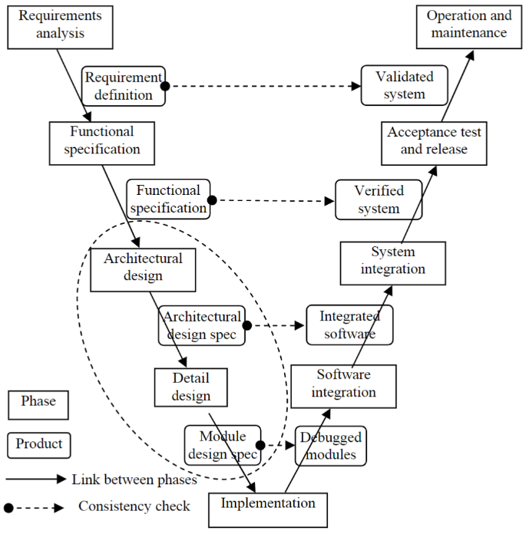

Figure 1 - V-model, as illustrated in "Software Design Methodology: From Principles to Architectural Styles", p56

Website Usability and User Experience

When designing a website, usability must be taken into consideration. Users should be able to easily understand and navigate the site.
A key principle of usability in web design is intuitiveness. A site should be entirely self-explanatory, all its content and interactive elements being easy to identify and use. For example, links should be easily identified. Many typical site elements have classic appearances – a search icon being a magnifying glass, or the “play video” triangle icon. Standard appearances are followed because users have become familiar with archetypal web design. Responsive web design allows a device’s content to be more accessible and intuitive across a wider variety of devices [7] and thus improves the user experience.
Navigation should be clear and easy to understand – the user should be able to easily tell which page they are on and access other pages. One way to achieve this would be to use visual tabs, where the tab corresponding to the current page is emphasised or using a different background colour or similar differentiating factor. On sites with many pages and sub-pages or where pages are organised hierarchically, breadcrumbs should be used in order to show the user exactly where they are.
Krug suggests that trade-offs should be considered in order to make content easier to understand and more obvious, while not over-simplifying it or losing its purpose or meaning [8]. The user of a website should not need to think much about the content on the page or how to interact with it. For example, headings should be clear in what their content is about, and links should be clear in where they take the user.
Similarly, user experience can be improved by using visual hierarchies, which can indicate the significance of content and its relation to other content. An example would be font size or weight to represent titles, and background colour to represent sections and sub-sections. Another way of achieving this is by visually nesting content to show its relationship to other content. Active space has a role in usability and user experience in that it helps the user identify sections of content and their relevance to each other.
Text should be organised and styled appropriately. Headings should be spaced appropriately, the content visually linking to the headings. With few exceptions, large segments of text should not be centered on the page, but left-aligned.
Font choice is a design decision which heavily impacts the user experience. Fonts should be legible to all users. Sans serif fonts are recommended for web content. In a study of fonts appropriate for people with dyslexia, Rello and Baeza-Yates identify that sans-serif, monospaced, and roman (upright) fonts are more readable than serif, proportional and italic fonts. Their report also states that “what is good for people with dyslexia regarding font types is also good for people without dyslexia,” consolidating the idea that font choice affects everyone [9].

Requirements

Site Introduction

The site is a photography shop, which retails camera bodies, lenses and accessories as well as providing information about the company. The target audience are photographers of any level. Its aim is to display relevant content and products to prospective buyers.

Content Breakpoints

The following are breakpoints used for the column width setting. The widths used are the same as that used in Bootstrap 4 [10]. These breakpoints are used in many sites, while also being appropriate for this site’s content.
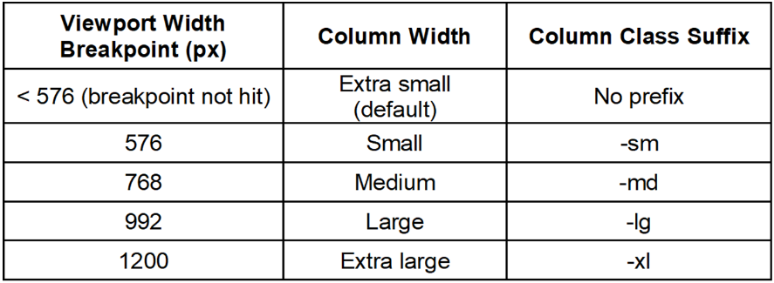
Table 1 - Column width breakpoints

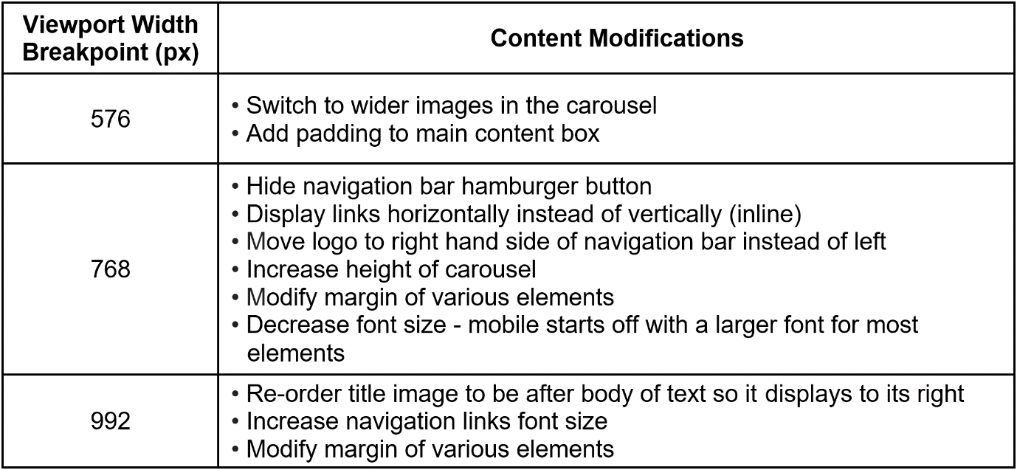
The following are additional breakpoints used throughout the site:
Table 2 - Content modification breakpoints

Justification of additional breakpoints listed on the previous page:
- At 576 pixels, wider images are used for the carousel as more content can fit horizontally
- At 768 pixels, the navigation menu changes to accommodate varying screen sizes
- At 992 pixels, images and text are re-ordered to suit taller devices – mainly tablets and smartphones
Although these breakpoints line up with the column size breakpoints, they were chosen because they appear to be the most appropriate for the site’s content.

Content Display Strategy

Larger images (primarily carousel images) were created in two sizes. At a specific breakpoint (see 3.2), one image is replaced with the other. On mobile, a narrower image is displayed whereas on desktop, the wider image is displayed.
Where appropriate, images and text have been re-ordered. For example, on mobile an image may precede a body of text, whereas on desktop they may be adjacent to each other.
A grid system was created from the ground up as is explained in section 4, allowing content to be scaled and fitted into rows depending on the viewport size.
Text size was managed using VW units in CSS to scale text with the page width.
The navigation menu collapses into a hamburger button at a certain breakpoint (see table 2) and the navigation items change to display underneath each other on mobile, as opposed to side by side.

Software Requirements Specification

The following website requirements specification was derived from guidelines produced by Garbar of Belitsoft [11] and We Make Websites [12], detailing relevant requirements for this website project:
Table 3 - Website requirements specification
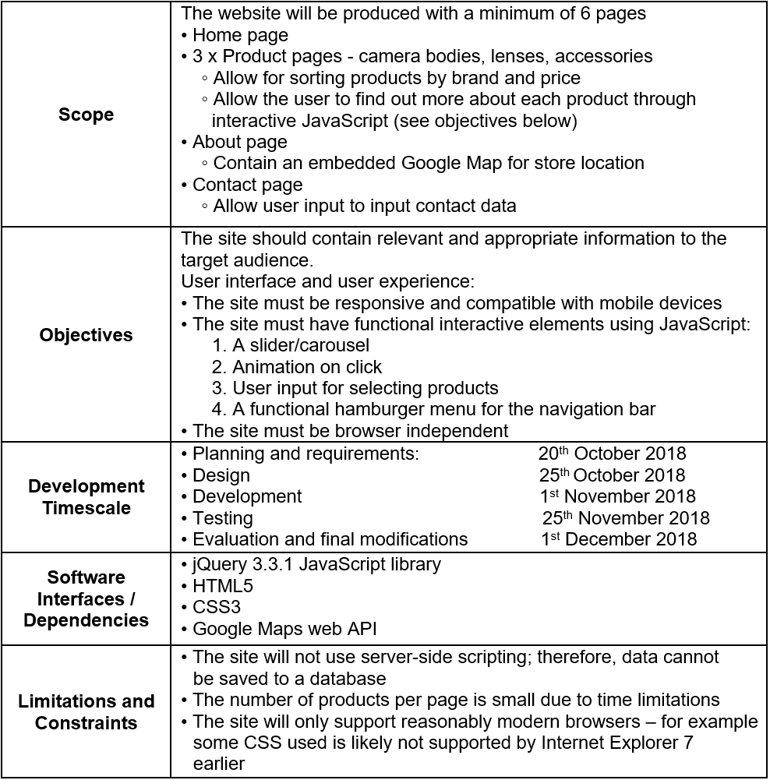

Design

A grid system was developed using containers and rows, with each row containing 12 columns to span content across. This allowed content to be responsive, as well as simplifying the manipulation of active space. This was achieved by implementing media queries to adjust the width of elements with specific CSS classes.
The font chosen was Segoe UI as it is a sans serif font with increments for font thicknesses, allowing the text to be clearer.
The main colours used for the site were blue, black, and several shades of light grey. This combination was chosen as blue is often seen as a calming, non-threatening colour while black was used as it can convey a sense of professionalism and elegance. Light grey was used for backgrounds as it is easier on the eyes and contrasts well with the black text, improving its readability.
Visual hierarchy was used in order to organise and group the content of the site.
See page designs in the Appendix.

Implementation

Product images were taken from manufacturer websites and social media icons from their brand resources pages [13]–[24].

JavaScript Implementation

- Smooth scroll: Smoothly scrolls to the top of the page on clicking the back to top button
- Menu sliding: Slide up and down navigation menu, and social media row in footer
- Load product category: Loads a group of products’ JSON data into HTML elements on the page
- Load specific product: Gets product name from URL and loads that product’s data
- Carousel functions: Transitions images left and right inside the carousel
- Flip card: animates a product card flipping over
- Product sorting and selecting:
  - Order products by price highest to lowest or vice versa
  - Toggle a product brand on or off
  - Show products only within a user-entered price range

Page Screenshots

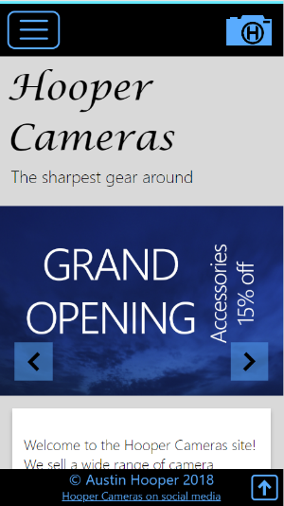
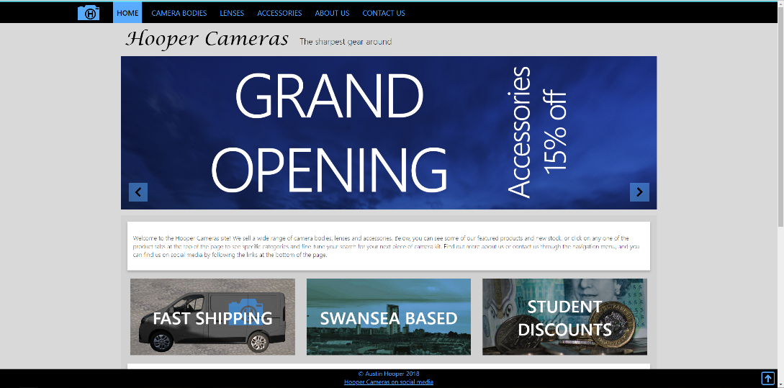
Home Page
Figure 3 - Home page mobile screenshot
Figure 2 - Home page desktop screenshot

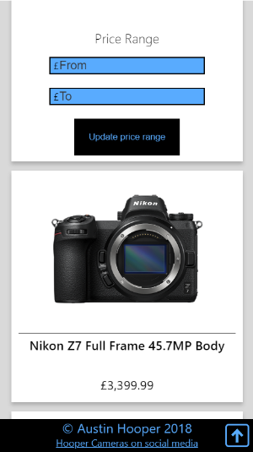
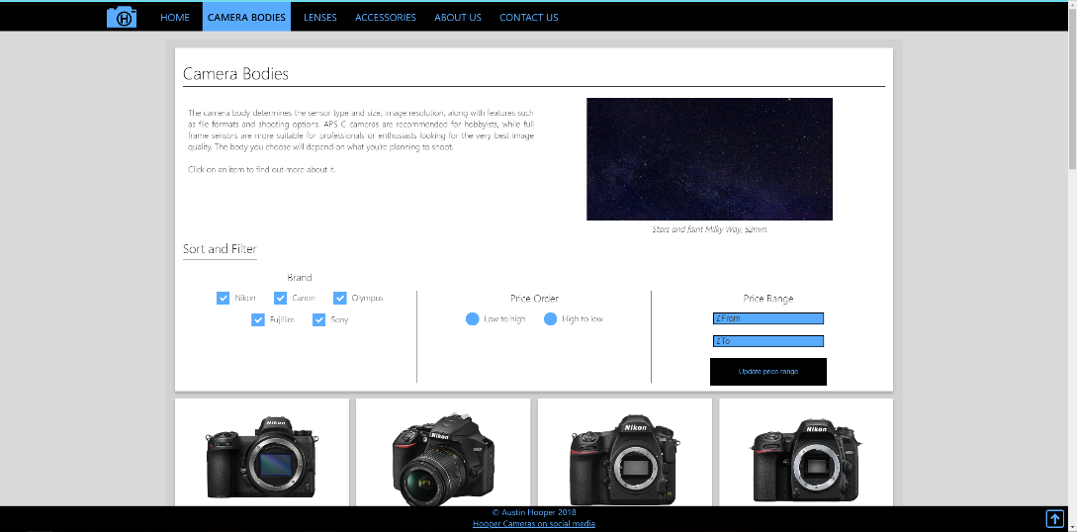
Cameras, Lenses and Accessories Pages (x3)
Figure 5 - Products pages mobile screenshot
Figure 4 - Products pages desktop screenshot

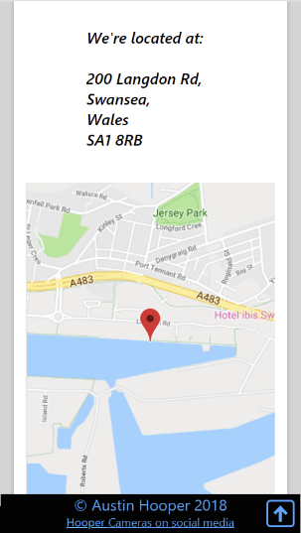
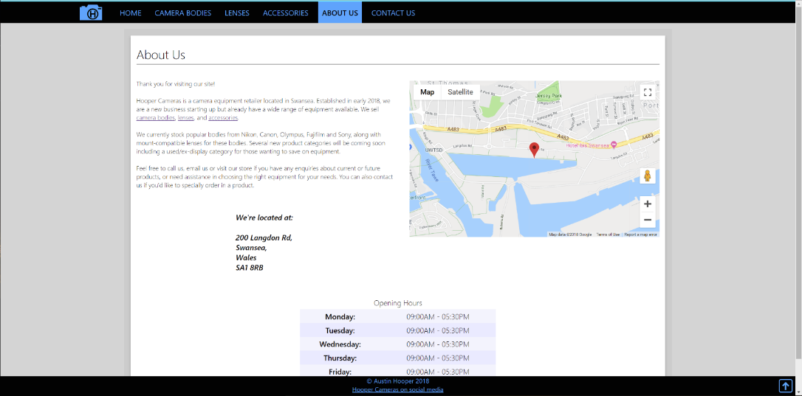
About Page
Figure 7 - About page mobile screenshot
Figure 6 - About page desktop screenshot

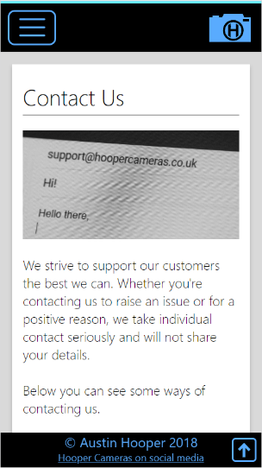
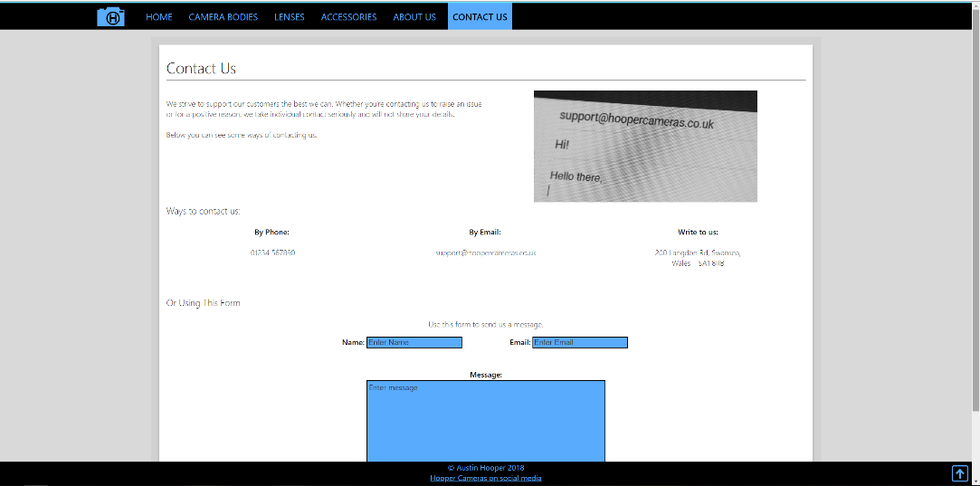
Contact Page
Figure 9 - Contact page mobile screenshot
Figure 8 - Contact page desktop screenshot

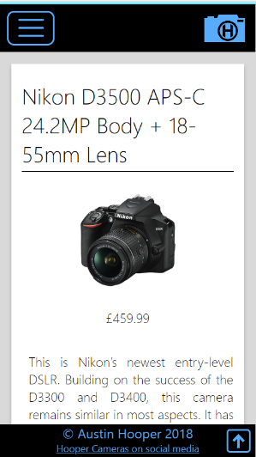
Specific product page
Figure 11 - Specific product page mobile screenshot
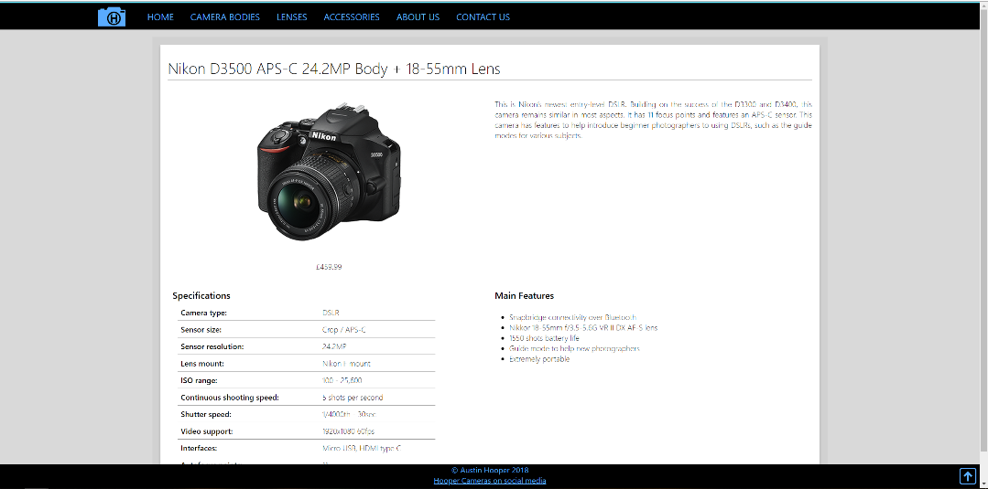
Figure 10 - Specific product page desktop screenshot

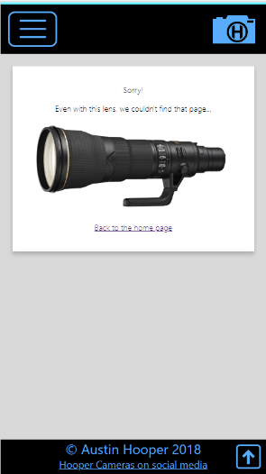
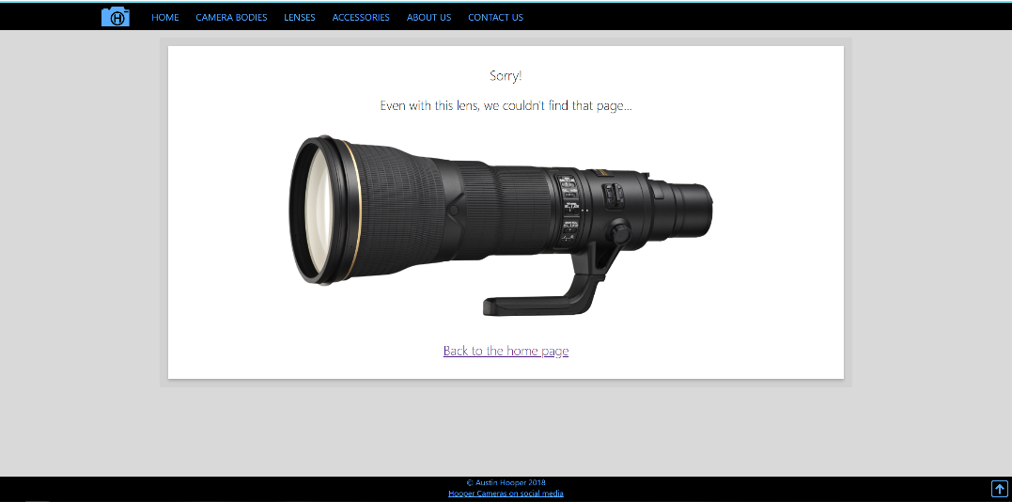
404 page
Figure 13 - 404 page mobile screenshot
Figure 12 - 404 page desktop screenshot

Evaluation and Conclusion

Testing

Responsiveness and Mobile Functionality

The site was found to be responsive across a range of screen sizes as seen below.

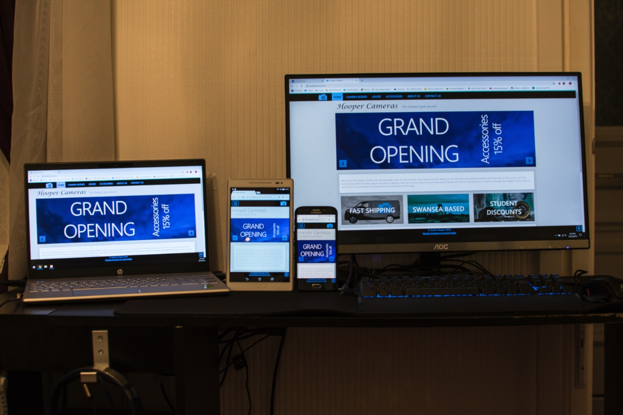
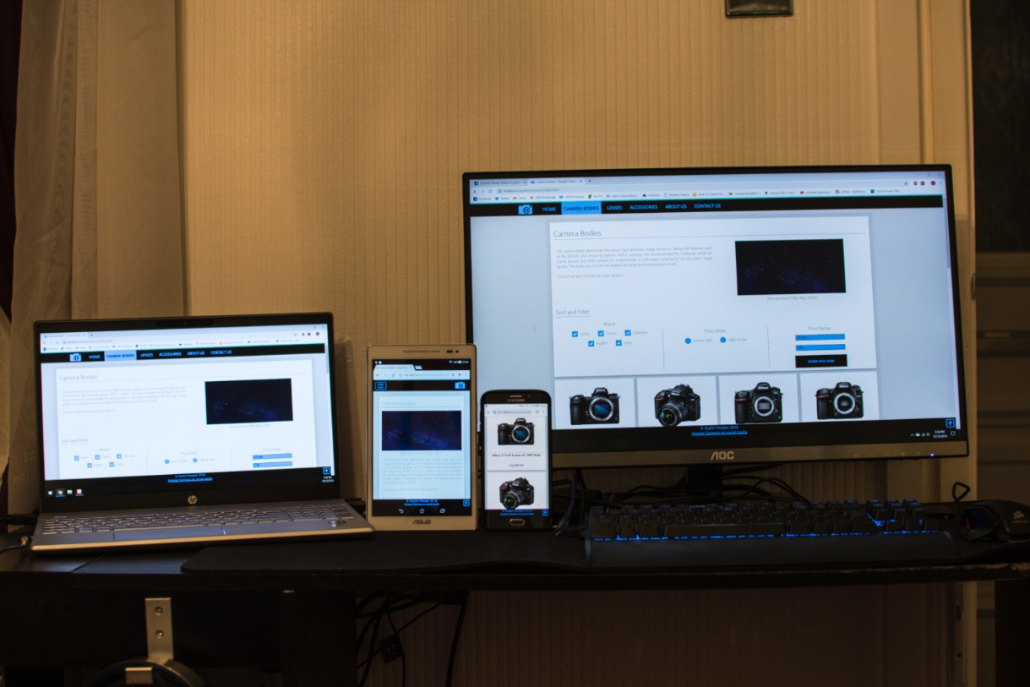
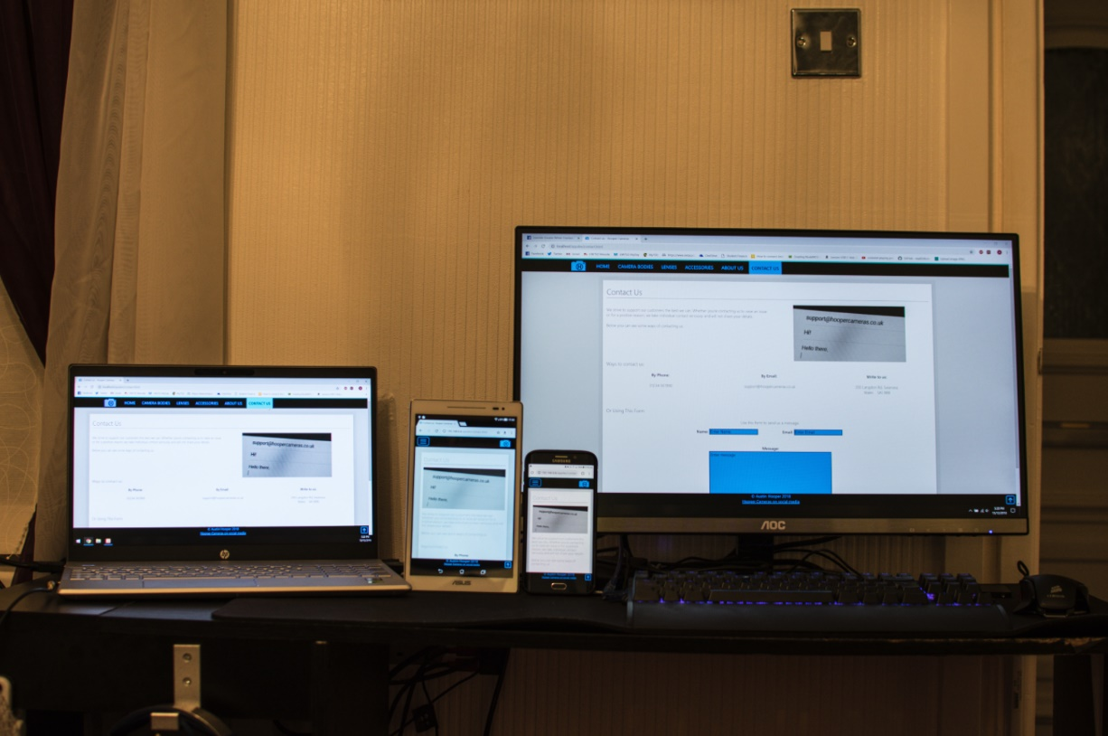
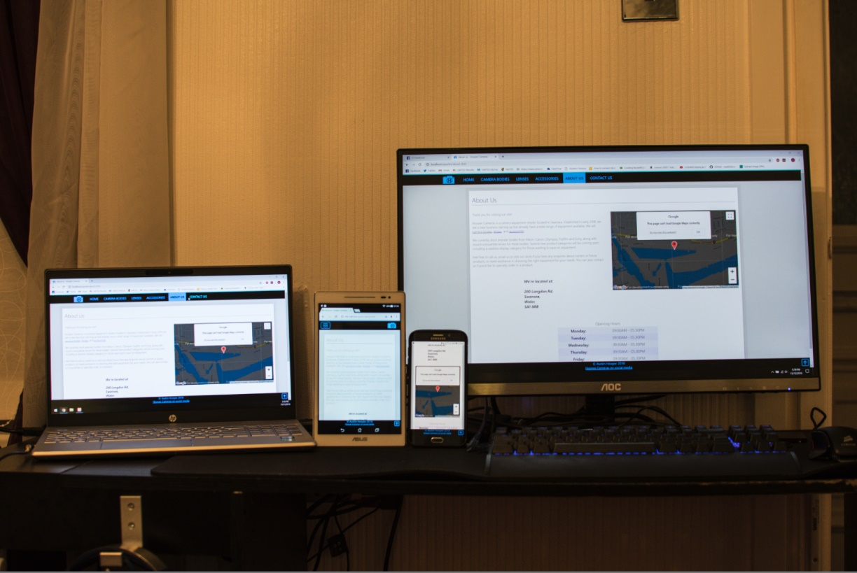
Figure 14 - Homepage on a range of devices
Figure 15 - Products page on a range of devices
Figure 17 - Contact page on a range of devices
Figure 16 - About page on a range of devices

JavaScript Interactivity

- A slider/carousel

Figure 18 - Carousel functionality

The carousel functions as intended on clicking the buttons – images slide sideways.

- Animation on click
Animation on click of a card rotating in 3D space functions as expected.
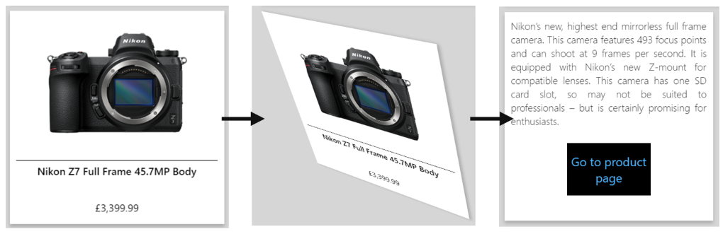
Figure 19 - Card flip animation

- User input for selecting products
Selecting brands:
Brand selection functions as expected.
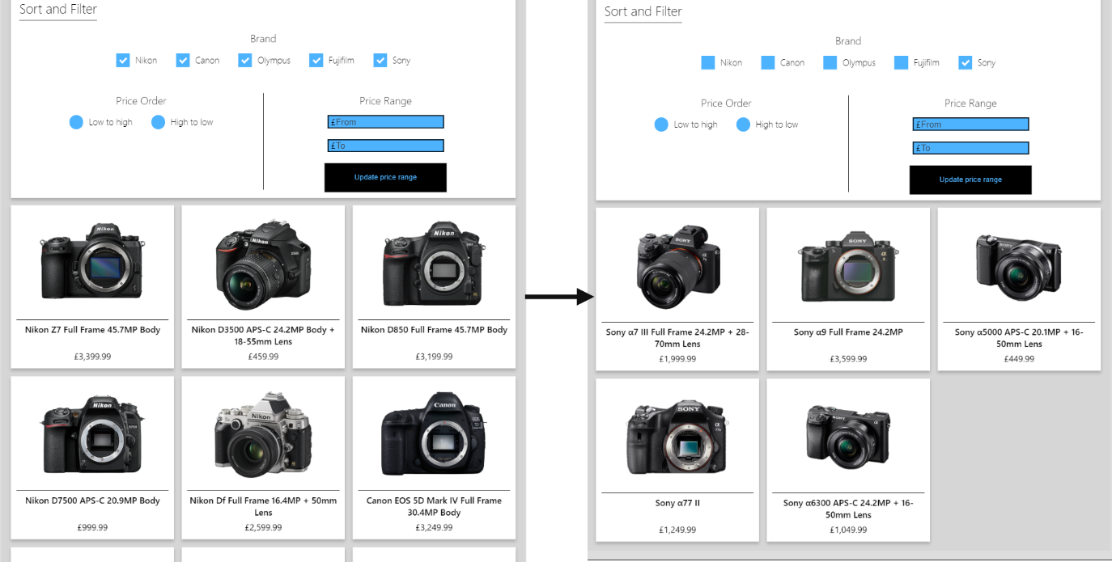
Figure 20 - Brand selection

Price range selection:
Assuming valid input is given, choosing a price range functions as intended.
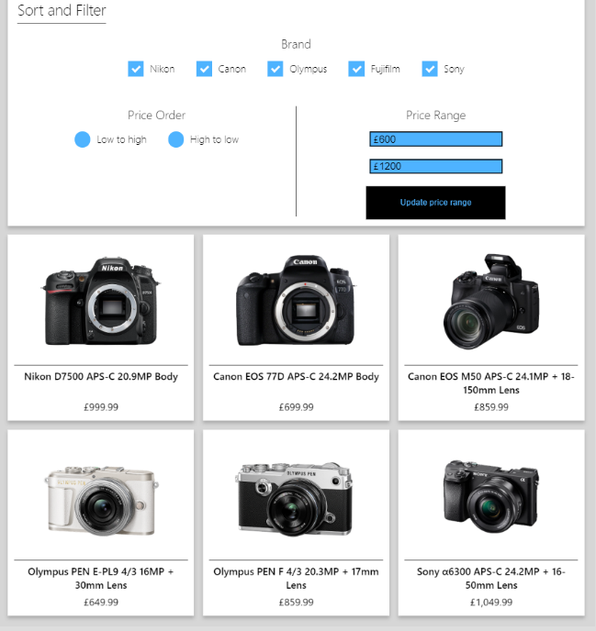
Figure 21 - Price range
Ordering by price:

On testing, products did not correctly order by price as intended. This was resolved by making a copy of each price and removing any commas before comparing.
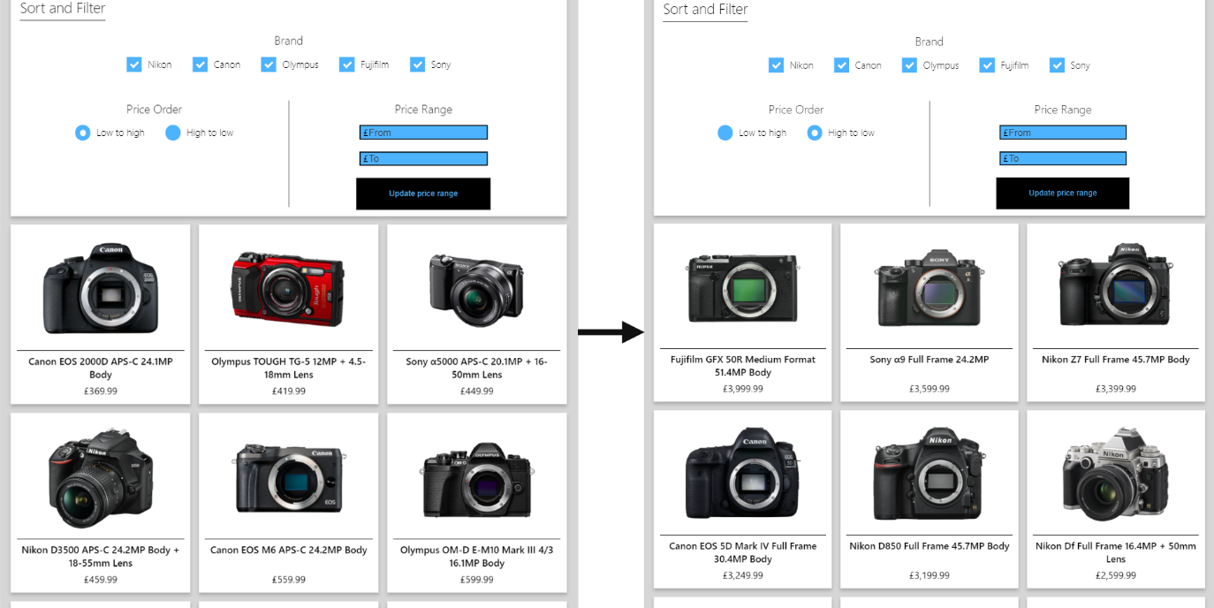
Additionally, if a price range was defined and brands were later toggled, the price range would be ignored. This was resolved by calling the price range function on brand toggle.
Figure 22 - Order by price

- A functional hamburger menu for the navigation bar

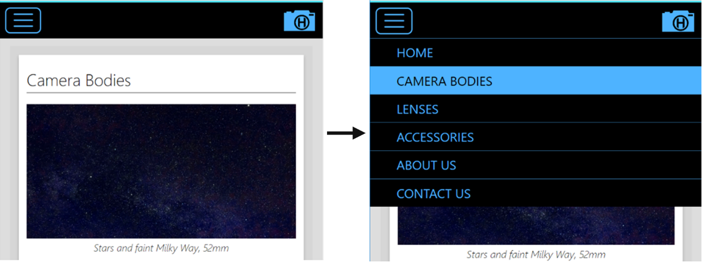
As seen below, the hamburger navigation menu functions, sliding down when the button is tapped to display navigation links.
Figure 23 - Hamburger menu

Browser Independency

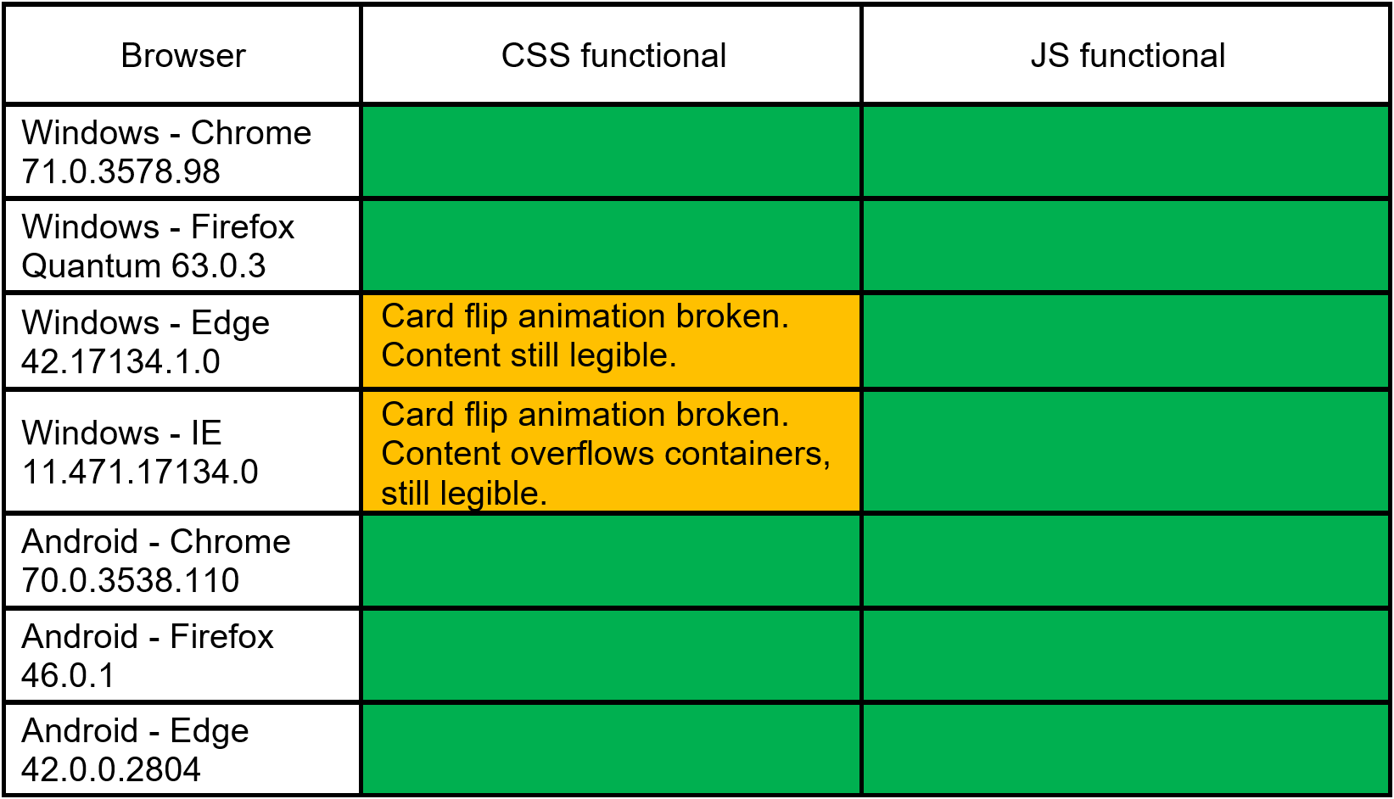
The site was tested and found to be mostly browser independent, mainly through use of browser specific CSS prefixes. See the table below for browser testing results.
Table 4 - Browser testing

W3C Validation

The W3C HTML and CSS validators were used to validate the site [25], [26].
There were no errors flagged from the validation, however CSS validation provided warnings about browser-specific prefixes.

Recommendations

The following are recommendations for possible future iterations of the site:
- Pagination could be implemented for the product pages. This would be more appropriate as more products are added.
- Using server-side languages, the products could be loaded from a database and user contact input could be saved to a database
- The JavaScript code to take in data (price range and user contact data) could have more data validation, for example, restricting values to two decimal places
- A search feature could be implemented to find specific products and direct the user to their page
- More parameters could be added to filter products such as lens focal length, aperture, focus modes
- A font size option could be implemented to change the font size of the entire site to improve accessibility

Overall Evaluation and Conclusion

Overall, the site functions as intended. CSS media queries make the site responsive and usable on all devices, while JavaScript makes the site more functional and interactive, improving the user experience.
The site meets the intended visual theme and style, which is considered appropriate for the target audience and content of the site. The site’s visual design aids with accessibility, and is appropriate for the purpose.
For the purpose of demonstration, 60 products were added. This was an appropriate amount to show scaling and arranging of product cards on each page.

References

[1] S. Jenkins, Web Design All-in-One For Dummies, 2nd ed. New Jersey: John Wiley & Sons, 2013.
[2] N. Smith, “960 Grid System.” [Online]. Available: https://960.gs/. [Accessed: 19-Nov-2018].
[3] J. Beaird, The Principles of Beautiful Web Design, 2nd ed. SitePoint, 2010.
[4] J. Redish, Letting Go of the Words: Writing Web Content that Works. San Francisco: Elsevier, 2007.
[5] S. Bradley, “How To Activate Space In A Design - Vanseo Design,” 2010. [Online]. Available: https://vanseodesign.com/web-design/active-space/. [Accessed: 17-Nov-2018].
[6] H. Zhu, Software Design Methodology : From Principles to Architectural Styles. Oxford: Butterworth-Heinemann, 2005.
[7] A. Schade, “Responsive Web Design (RWD) and User Experience,” 2014. [Online]. Available: https://www.nngroup.com/articles/responsive-web-design-definition/. [Accessed: 27-Nov-2018].
[8] S. Krug, Don’t Make Me Think, Revisited A Common Sense Approach to Web Usability, 3rd ed. Berkeley: New Riders, 2014.
[9] L. Rello and R. Baeza-Yates, “The Effect of Font Type on Screen Readability by People with Dyslexia,” Barcelona, 2016.
[10] Bootstrap, “Grid system · Bootstrap.” [Online]. Available: https://getbootstrap.com/docs/4.0/layout/grid/. [Accessed: 14-Nov-2018].
[11] D. Garbar, “Custom Software Requirements Specification Document | 2018,” 2018. [Online]. Available: https://belitsoft.com/php-development-services/software-requirements-specification-document-example-international-standard. [Accessed: 16-Nov-2018].
[12] We Make Websites, “How To Write A Website Specification | We Make Websites,” 2018. [Online]. Available: https://wemakewebsites.com/blog/how-to-write-a-website-specification#. [Accessed: 23-Nov-2018].
[13] Zeiss, “ZEISS Cleaning Products | Optimal Optical Surface Care.” [Online]. Available: https://www.zeiss.co.uk/camera-lenses/photography/products/accessories/cleaning-products.html. [Accessed: 10-Dec-2018].
[14] Kenko Tokina Co Ltd, “HOYA | The Difference is Clear,” 2018. [Online]. Available: https://hoyafilter.com/. [Accessed: 10-Dec-2018].
[15] Fujifilm, “Digital Cameras | Fujifilm Global,” 2018. [Online]. Available: http://www.fujifilm.com/products/digital_cameras/. [Accessed: 03-Nov-2018].
[16] Sony, “SLT & DSLR-Like Cameras | Digital SLR-Like Cameras for Professionals | Sony UK,” 2018. [Online]. Available: https://www.sony.co.uk/electronics/interchangeable-lens-camera-products/t/interchangeable-lens-cameras. [Accessed: 03-Nov-2018].

[17] Vitec Imaging Solutions Spa, “Manfrotto UK | Camera Tripods & Photography Accessories,” 2018. [Online]. Available: https://www.manfrotto.co.uk/. [Accessed: 10-Dec-2018].
[18] Facebook, “Facebook Brand Resources,” 2018. [Online]. Available: https://en.facebookbrand.com/assets/f-logo/. [Accessed: 30-Nov-2018].
[19] Instagram, “Instagram Brand Resources,” 2016. [Online]. Available: https://en.instagram-brand.com/assets/glyph-icon. [Accessed: 30-Nov-2018].
[20] Twitter, “Brand Resources,” 2018. [Online]. Available: https://about.twitter.com/en_gb/company/brand-resources.html. [Accessed: 30-Nov-2018].
[21] YouTube, “Brand Resources - YouTube,” 2018. [Online]. Available: https://www.youtube.com/yt/about/brand-resources/#logos-icons-colors. [Accessed: 30-Nov-2018].
[22] Nikon, “Nikon: DSLR, Compact Cameras, Action Cameras &amp; Accessories,” 2018. [Online]. Available: https://www.nikon.co.uk/en_GB/products/catalogue.page. [Accessed: 03-Nov-2018].
[23] Canon, “Cameras — Canon UK Store,” 2018. [Online]. Available: https://store.canon.co.uk/cameras/. [Accessed: 03-Nov-2018].
[24] Olympus, “Cameras,” 2018. [Online]. Available: https://shop.olympus.eu/en_GB/cameras/. [Accessed: 03-Nov-2018].
[25] World Wide Web Consortium, “The W3C CSS Validation Service,” 2009. [Online]. Available: https://jigsaw.w3.org/css-validator/. [Accessed: 30-Nov-2018].
[26] World Wide Web Consortium, “The W3C Markup Validation Service,” 2013. [Online]. Available: https://validator.w3.org/. [Accessed: 30-Nov-2018].

Bibliography

Acart Communications, “WCAG - Contrast Checker,” 2017. [Online]. Available: https://contrastchecker.com/. [Accessed: 24-Nov-2018].
J. Duckett and J. Wiley, HTML & CSS Design and Build Websites. Indianapolis: John Wiley & Sons, 2011.
B. Frain, Responsive Web Design with HTML5 and CSS3 - Ben Frain, 2nd ed. Birmingham: Packt Publishing, 2015.
Google, “Adding a Google Map with a Marker to Your Website | Maps JavaScript API | Google Developers,” 2018. [Online]. Available: https://developers.google.com/maps/documentation/javascript/adding-a-google-map. [Accessed: 12-Nov-2018].
J. Marah, B. Jakobus, M. Lambert, and S. Moreto, Bootstrap 4 - Responsive Web Design. Birmingham: Packt Publishing, 2016.
Mozilla, “URLSearchParams - Web APIs | MDN.” [Online]. Available: https://developer.mozilla.org/en-US/docs/Web/API/URLSearchParams. [Accessed: 24-Nov-2018].
The jQuery Foundation, “jQuery,” 2018. [Online]. Available: https://jquery.com/. [Accessed: 03-Nov-2018].
ymatuhin, “Autoprefixer CSS online,” 2017. [Online]. Available: https://autoprefixer.github.io/. [Accessed: 03-Nov-2018].
World Wide Web Consortium, “Web Content Accessibility Guidelines (WCAG) 2.1,” 2018. [Online]. Available: https://www.w3.org/TR/WCAG21/. [Accessed: 24-Nov-2018].
W3Schools.com, “JavaScript Tutorial.” [Online]. Available: https://www.w3schools.com/js/default.asp. [Accessed: 19-Nov-2018].

Appendix

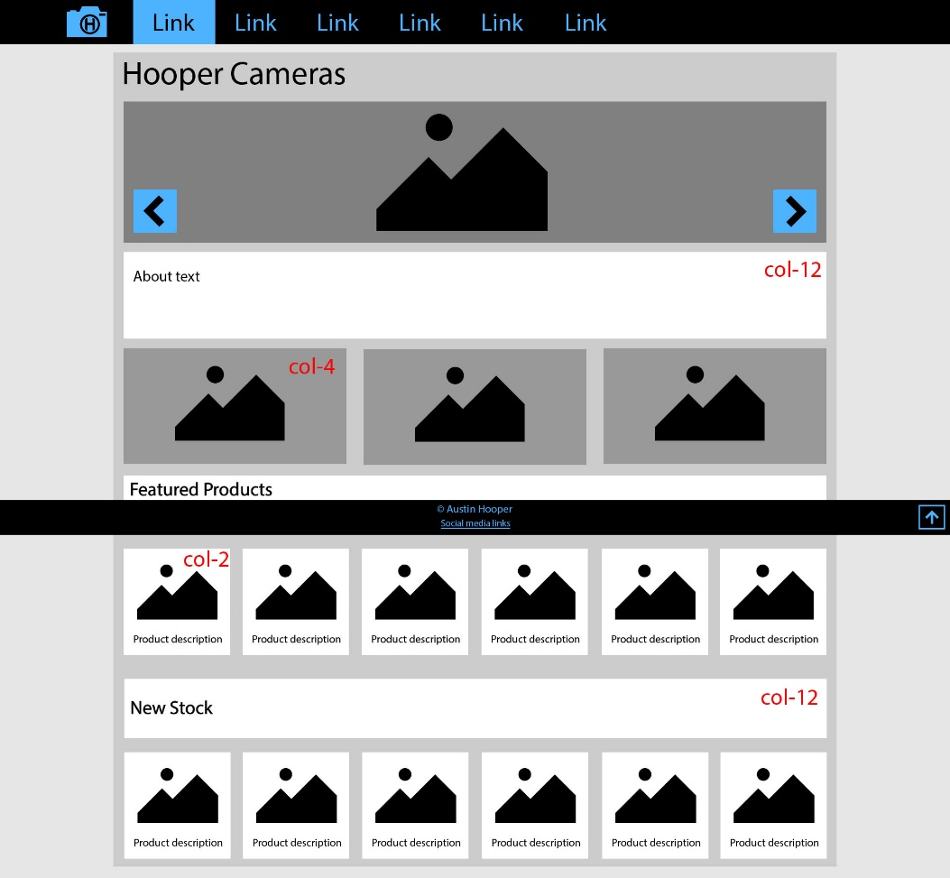
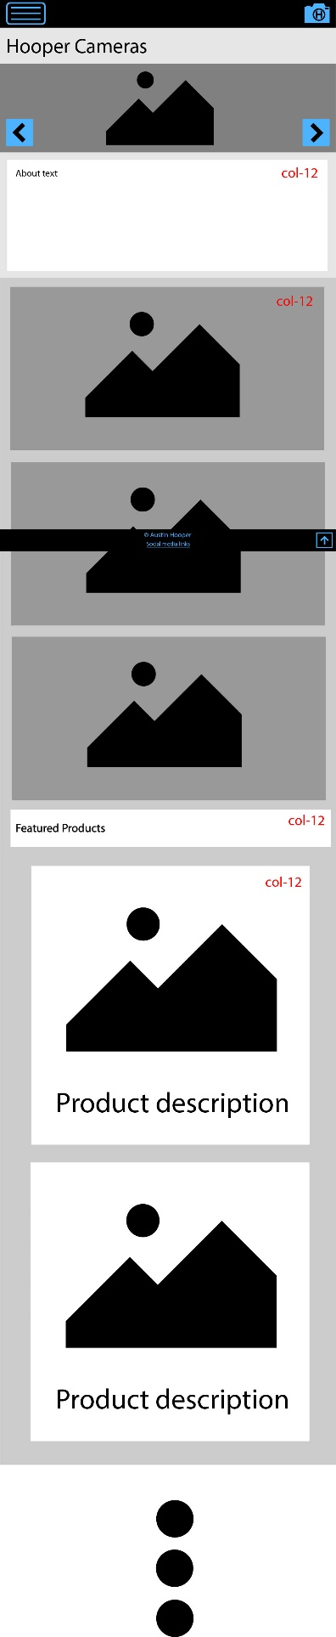
Homepage

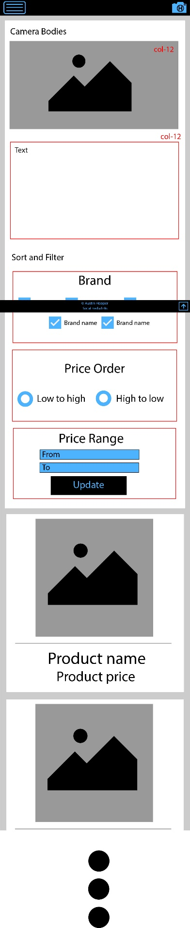
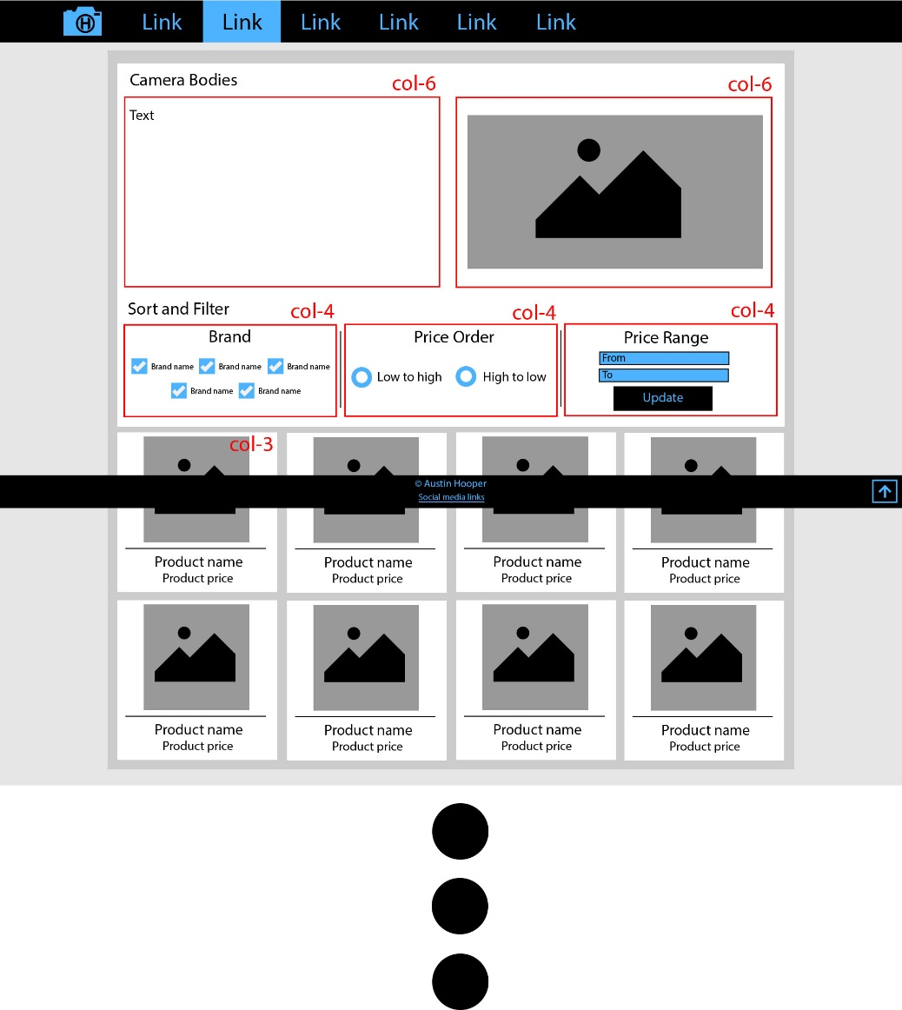
Products pages

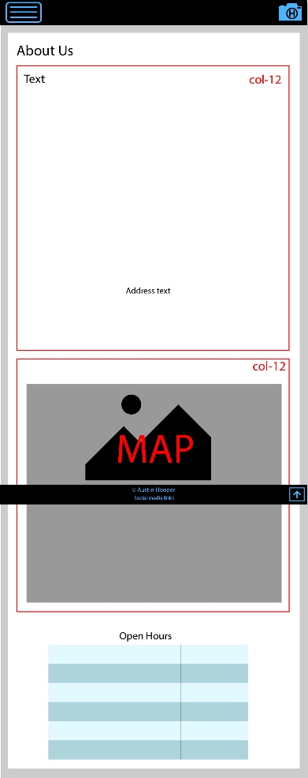
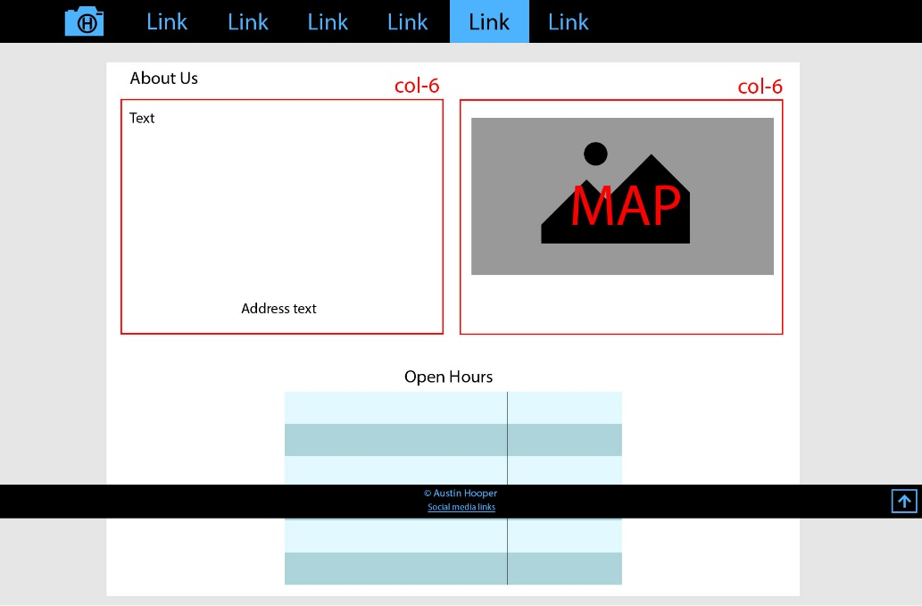
About page

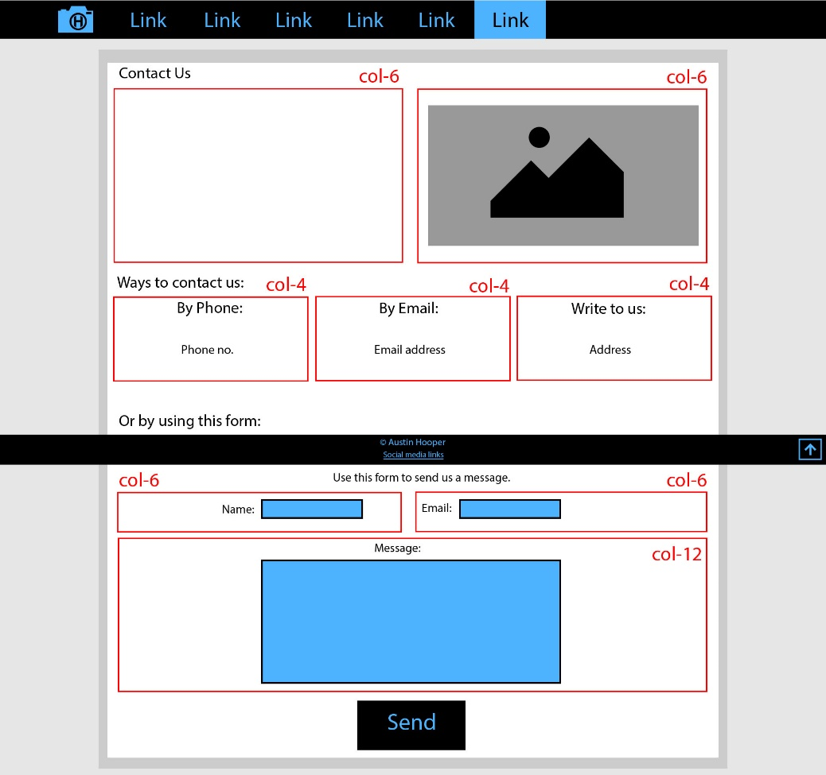
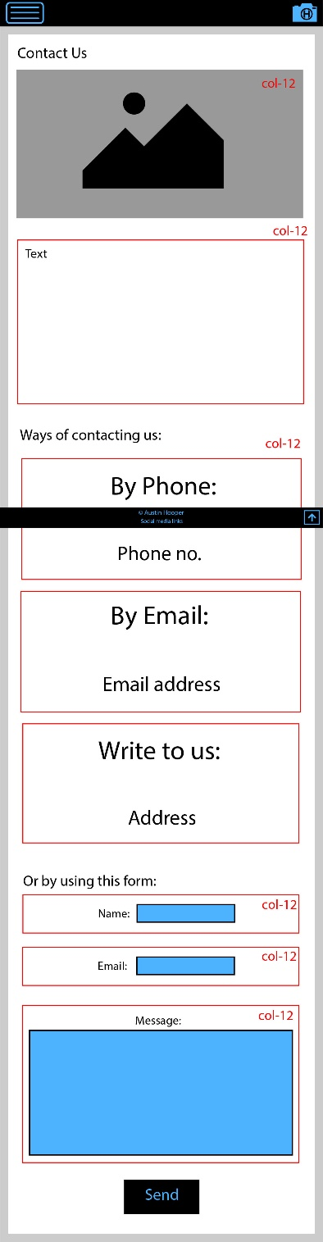
Contact page

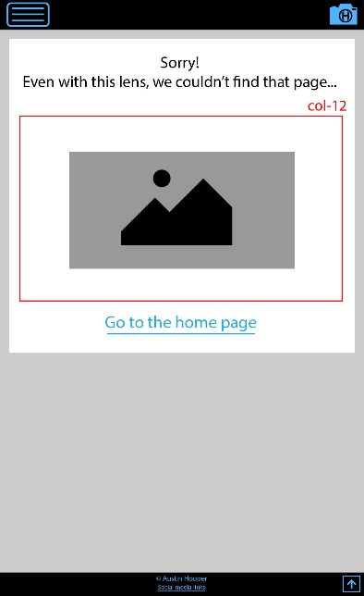
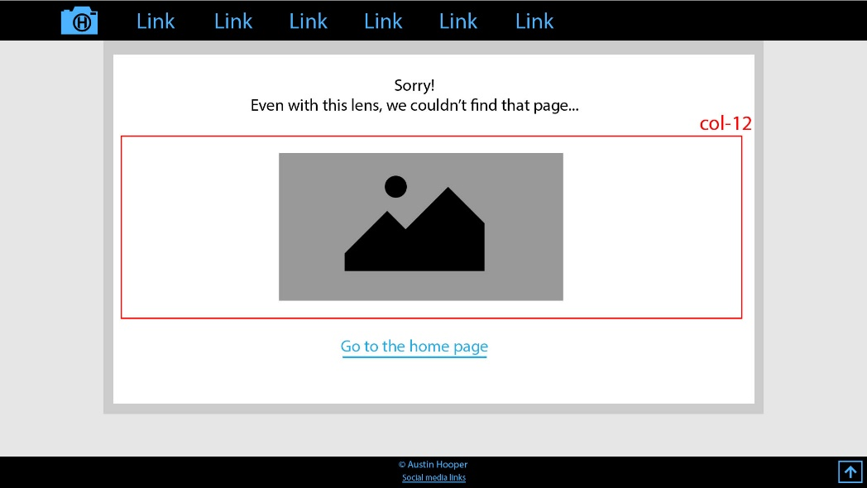
404 page

