
APPENDIX GA36d

LEVEL 7 ASSESSMENT SPECIFICATION

Student name: | Briony Rees | Student ID number: | 1803821
Programme: | Secondary PGCE
Module: | Curriculum Development and Enhancement
Module code: | ECSP7002 | Contribution to Overall Module Assessment (%): | 100%
Lecturer: | Helen Denny | Internal Verifier: | Ishmael Lewis
Assignment Title: | Research Study including Ethics Form | Word count (or equivalent): | 10.000 words in total including an Ethics form (to be given in on January 11th 2019)
Submission deadline: | May 13th 2019 | Return date of provisional marks & written feedback: | June 10th 2019
Submission method: | All written assessments, where practical and possible, must be submitted via Turnitin unless otherwise instructed by the Lecturer. (Please DO NOT put this assessment specification into Turnitin or it will match many similarities with other students’ submissions.)  Alternative submission method (if applicable):  Late submission of the assessment will result in a late penalty mark. Penalties for late submission: Up to one week late, maximum mark of 50%. Over one week late, 0%. Only the Extenuating Circumstances Panel may approve a change to submission dates.
Academic honesty / referencing: | Academic honesty is required. In the main body of your submission you must give credit to authors on whose research and ideas your work is based. Append to your submission a reference list that indicates the books, articles, etc. that you have used, cited or quoted in order to complete this assessment.

Curriculum Development and Enhancement

The Effect of Slow Writing as a writing frame to support Non-Fiction Writing

Introduction

School is an 11-16 comprehensive school in Carmarthenshire with around 500 pupils on roll. Around 35% of school X’s pupils are entitled to Free School Meals (FSM) which is considerably higher than the national average. Despite this perceived disadvantage, an impressive 92% of school X’s pupils achieve a level 5 or above in English at the end of KS3. School X is therefore producing impressive results that suggest pupils to have a sound grasp of literacy.
Despite the majority of pupils generally producing a high standard of work and being clearly very capable learners, pupils’ lack of self-belief in the classroom and confidence in their work hinders them considerably, especially during extended writing tasks. During my time in the school, many of the pupils in the middle sets and mixed ability classes had low self-esteem levels which reflected starkly in their ability to work independently and trust in their instinct and ability. Despite my encouragement to believe in themselves and their working ability, all too often, the initial 5 minutes of a writing activity involved myself checking work by pupils’ request to ensure they were “on the right track” and/or helping pupils to get started in their writing. Consequentially, this research project aimed to identify whether using a more structured scaffolding, in particular slow writing, as a technique would aid pupils to write extensively during writing tasks. Equally, I wanted to identify if the writing frame would aid pupils to write in a more confident manner and gain a sense of enjoyment from writing. Furthermore, I hoped that pupils would find the frame useful in encouraging the development of a growth mindset and belief in their ability (Dweck, 2015), therefore aiding pupils to achieve a higher level.
This investigation will be conducted over 3 – 6 lessons and will use a pre and post diagnostic test to assess the effect that slow writing has on pupils’ non-fiction writing. The pre-diagnostic test will require pupils to write a short piece of non-fiction writing with minimal support from myself as a teacher. After delivering a short sequence of lessons using Slow Writing as an intervention to enhance pupils’ writing, they will write another non-fiction piece which will act as a post diagnostic test to identify if pupils’ writing has improved and whether slow writing was a successful intervention.
In recent years, there has been a significant increase in pressure to improve pupils’ literacy skills in light of the PISA test results of 2009. These pressures are often felt by teachers and pupils in the classroom due to time constraints of exams and timetabling limitations meaning that pupils’ writing in school time is often rushed. Slow Writing is a term coined by David Didau in his book The Secret Literacy (2014), which is a writing tool designed to slow pupils down during the writing process, allowing pupils to focus on their choice of language carefully and thoughtfully leading to more effective writing responses.
Further online reading indicates that Slow Writing has become a classroom staple for many teachers, with rave reviews claiming that this writing tool has transformed their pupils’ writing ability. Whilst this writing tool appears to be very useful to many, this research will deduce whether Slow Writing can be equally effective when used for non-fiction writing in a rather limited time frame.
To add context to the research, this intervention was staged on a year 9 set 2 English class. The class had a range on writing abilities with levels ranging from 5-7, and although undoubtedly a class of capable writers, many pupils were often plagued with self-doubt which hindered their ability to write at great length in the allocated time given in lessons. I felt that this class would benefit most from using Slow Writing as a technique as the presence of a clear structure and expectations would allow pupils to focus on the quality of their writing, therefore boosting their confidence that their work was correct and fit to purpose rather than getting lost in the form of their writing.

Literature Review

According to an Estyn (2008), reading and writing are vital skills at the heart of pupils’ learning. Without the mastering of these skills, pupils would struggle to progress through education successfully and would hinder pupils’ employment prospects significantly and could in fact damage Wales’ future as a learning country. This emphasis on writing ability as a vital life skill being extremely prevalent for employability resonates with each of Cox’s five models of English (Cox, 1989). Regardless of the stance that each English teacher takes on their role within the classroom and indeed their pupils’ education journey, it seems that developing pupils’ writing competencies could be considered perhaps the most fundamental element of literacy that we have a duty to ensure that pupils confidently grasp during their time in education. Furthermore, the Programme of Study for English, Key Stages 2-4 (Welsh Government, 2015) displays clear expectations for progression of pupils in their writing abilities. For example, at Key Stage 3 before beginning their GCSEs, to achieve an “on target” level 5 for writing, pupils’ writing should be “varied and interesting”, able to write in a “range of forms for different readers”, use “imaginative language” and use paragraphs and a range of punctuation accurately (p. 29, Welsh Government). Despite this acknowledgement in literature that writing is a skill that should not be left to chance, it seems that the reality within some schools had been the opposite, with this area of literacy often overlooked with no guidance on how teachers should go about honing these skills in their pupils.
Following Wales’ startling underperformance in literacy, numeracy and science tests (PISA 2012, 2015), the Welsh government were forced to introduce reforms in education to address the weaknesses in pupils’ education made apparent by the tests. Furthermore, the aim of the Literacy Numeracy Framework (LNF) was stipulated to support pupils to become accomplished in oracy, reading and writing across the curriculum and all subject areas. The content of the curriculum was developed to ensure that there was abundant opportunity to develop and refine the skills set out in the LNF across all subjects (Welsh Government, 2014). For all teachers in primary and secondary sectors, this meant that it was their duty to integrate literacy and numeracy into their teaching and provide opportunity for assessment for learning encouraging pupils to learn with more autonomy in all of their lessons. This encouraged the notion that all teachers, regardless of subject, are teachers of literacy and numeracy.
However, the damning results of the PISA literacy tests are not surprising considering Estyn’s (2008) findings of pupils’ writing competencies. Their findings unearthed a number of worrying failings of the education system and curriculum in both primary and secondary sectors and how this has had a detrimental effect of the writing capabilities of young people across Wales and are detailed as followed:
- Of the three key strands of literacy (reading, writing and oracy) pupils underperform most substantially in writing. The gap in standards between reading and writing that becomes evident in KS1 widens considerably throughout Key Stages 2 and 3.
- The attainment gap between girls and boys is widest in writing.
- Pupils’ of all abilities usually show inaccuracies in spelling punctuation and grammar.
- Less bale learners’ general learning progress is hindered due to poor literacy skills.
- More Able and Talented (MAT) pupils are rarely challenged and tested during writing tasks.
- The curriculum generally fails to develop learners’ communication skills.
- Some teachers do not commit sufficient attention to improving the quality and accuracy of pupils’ writing.
- Assessment information is not used meaningfully to improve pupils’ written performance to the same extent as data is used to improve reading.
(Estyn, 2008)

This appears to suggest that schools assume that writing ability is inherent and does not need to be taught as explicitly or guided to the same extent as other literacy skills, leading to a detrimental effect on pupils writing abilities (Welsh Assembly Government, 2010). Indeed, the Welsh Government aims to raise awareness of the need to explicitly teach pupils to write suggesting that pupils need to grasp a number of skills in order to master writing effectively. Alongside the LNF, there has been a series of documents released to guide teachers how to explicitly teach pupils how to write by encouraging pupils to become aware of the content of their writing including their ideas, arguments and plot and how to present their writing depending on the purpose and audience of their written work. In addition, the documents iterate the expected outcomes of pupils’ effective instruction of writing skills. The documents suggest that adopting the strategies enclosed will ensure that pupils can:
- Communicate and develop ideas through writing
- Communicate effectively with a range of audiences for different purposes
- To succeed and achieve in the many assessments they will undertake throughout their time in education
- To meet the writing demands they may encounter upon leaving school with regards to employability and personal matters
(Welsh Assembly Government, 2010)

Within these documents there are many ways in which teachers are guided to support the development of pupils’ writing abilities including the use of writing frames to support and scaffold pupils’ work.

A writing frame can be defined as a template or skeleton framework that
teachers use in order to show children how to structure their writing and to prompt them to include certain features such as starters, connectives and modifiers (TheSchoolRun.com, 2019) and is commonly used as a staple scaffolding technique in improving pupils’ writing skills in the classroom. This method of scaffolding has been found to be very effective when teaching writing skills to pupils of all ages and abilities (Department of Education, 2012). Though considered effective for a wide range of abilities, writing frames have been considered perhaps most useful for those who struggle with writing creatively or logistically. It has been suggested that these learners benefit most from explicit and targeted instruction in word, sentence and paragraph level. Additionally, it can also improve pupils’ vocabulary choice and sentence construction (Santangelo and Olinghouse, 2009). Of course, like all scaffolding techniques and differentiation methods, they are not intended to be used as a permanent and constant writing tool for pupils. This is an important factor of the success writing frames as they have been found to be an effective strategy for familiarising pupils with a wide range of writing styles and purposes until these written structures have become fully internalised into pupils’ independent writing repertoire (Wray and Lewis, 1996).
Furthermore, the use of writing frames is thought to have not only improved the academic quality of pupils’ writing, but their own belief and confidence in their writing capabilities. For many pupils who are plagued with low confidence or find completing extended writing a difficult task, the prospect of writing a lengthy piece of work completely independently with no guided structure could seem overwhelming, sending pupils straight into the “panic zone” (Hattie, J and Yates, G., 2013) where effective learning would become almost impossible. The use of writing frames then, could be a useful tool in ensuring that pupils remain in the “struggle zone” of the zone of proximal development (ZPD) model. The “struggle zone” is thought to be the optimal frame of mind in which learning is more likely to take place effectively by striking the right balance in exposure to new material, a suitably challenging pitch and existing prior knowledge of the pupils. The use of writing frames coincides with Vygotsky’s (1978) ideas of how children learn successfully and internalise information. A pupils’ first experience of a particular topic or skill will typically take the role of an observer or spectator, whilst the expert (teacher or parent) leads the learning cognitively doing all the work. In most classrooms, this will be conveyed to pupils through explanation and modelling. Pupils will then become more familiar with the topic/skill under the close supervision. As the pupils become more able and confident, the teacher will give greater responsibility and independence to pupils when completing tasks whilst remaining a source of support close by. Eventually, pupils will have a sound grasp of the topic/skill and will be able to work independently from the teacher with no support, i.e. in exam condition. This notion makes theoretical sense and is indeed evident in most, if not all, classrooms and resonates with the intended uses and purposes of writing frames.
Whilst different forms of writing frames have been used in classrooms for many years, the use of Slow Writing has become far more prevalent in classrooms, thanks to the coining of the term by David Didau in 2014 in his book “The Secret Literacy. Making the implicit explicit”. Like all writing frames, Slow Writing is used as a scaffold to improve pupils’ writing abilities by providing more explicit structures and instructions during writing tasks. However, this writing frame aims to deliberately slow pupils down when writing, hence its name, forcing pupils to craft their writing more thoughtfully and carefully. As noted by Didau, the limitations of modern-day school life in terms of timetabling and exam pressures, means that pupils are inevitably rushed when writing in classrooms day to day. This in turn, means that pupils are not able to meaningfully consider their use of writing techniques and/or language choice therefore not producing writing tasks to the best of their ability. This prompted Didau to experiment with the notion of Slow Writing. Pupils are given double spaced paper and are then given a series of instructions that will relate to the purpose of their writing. Pupils will then be given specific instruction for each sentence that they write (Didau, 2014). For instance, when writing a persuasive advert, their first instruction may look like this:
1. Your first sentence must begin with a rhetorical question.

And so on. Pupils are encouraged to edit their work, hence the double -spaced paper, and to critically review their writing until it’s at the best quality that it can be. This idea of self-reflection and criticality of work resonates with the Welsh Government’s (2010) guidance that pupils should view writing as a process that will involve a series of stages of editing and redrafting until the final product is the best it can be. Not only can slow writing improve and broaden pupils’ command of their writing skills, it can internalise writing techniques and deepen pupils’ understanding of certain techniques and their usefulness within writing. This frame intends to force pupils to consider how they craft their writing, rather than focussing on what they are writing and subsequently producing simplistic vocabulary and sentence structure. It could also be suggested that the use of slow writing would nurture pupils to develop a “growth mindset” (Dweck, 2015). As pupils begin to consciously improve their writing competencies, pupils’ mindset towards their work will benefit and in turn, their writing abilities will continue to flourish. Slow writing is a perfect example of an exercise to promote pupils to adopt a growth mindset as it clearly demonstrates to pupils what positive results can be reaped from putting effort and thought into their work. Individuals with a growth mindset are defined by Dweck (2015) as harbouring the belief that effort or training results in successful learning. They are aware that with maximum effort and practise, they will master many skills and improve their overall performance. On the other hand, pupils can be plagued with a “fixed mindset” and do not believe that their success is dependent on their input, or their effort, to learn. These learners are suggested to believe that certain skills, for example writing ability, are innate and therefore beyond their achievement range if they lacked a natural flair for writing. This could be largely influenced by pupils’ social groups and peers, as Nuthall (2005) noted that pupils care more about the approval of their peers than they care about their teacher’s opinion and their personal progress of learning. The teenage angst experienced by those in our classrooms is often prioritised over their education, therefore, if committing effort to your schoolwork is not approved by the majority in the class then pupils will hesitate to go against the crowd and prefer to follow the status quo rather than oppose it. Worryingly, Dweck suggests that fixed mindsets are a serious hinderance not only in pupils’ progression of learning through education and their academic achievements but may affect broader issues in life and employment (2015). It is undeniable then, that as teachers we have a responsibility to encourage a growth mindset in every pupil we teach and ensure that pupils are not disadvantaged by a fixed mindset. It could be easier than anticipated and could be easily implemented by the way we praise pupils. Rather than suggesting that pupils’ achievements or failures are down to innate abilities, we should attribute them to the effort and practice that pupils invested in a certain skill. For example, when pupils use slow writing as a writing frame and produce a successful piece of work, they should be praised for dedicating their thought and effort to crafting an effective piece of writing by editing and evaluating their work until it had reached a high and perfected standard. It seems that slow writing has been effective for reiterating the reward of hard work to pupils and showing pupils what they are capable of if they commit themselves to their learning and embedding writing skills in pupils’ achievements.
Didau has credited this writing frame as being extremely successful in internalising writing structures and language choice and ultimately improving their performance in exams. The online education sector reveals that slow writing has been extremely well received by teachers. Didau owes its success to the way in which it allows pupils to access their working memory. As pupils are often using their long-term memory to write habitually in the most simplistic way possible, they’re so busy thinking about what to write that it is increasingly difficult to use their working memory to consider how it may be written. Therefore, the sentence prompts free their working memory, so they can divulge what they know in a far more fluent and sophisticated manner (The Literacy Shed Blog, 2017). Though it is most commonly used in English classrooms, Didau details its usefulness in all subjects and education settings. This is evidently true for most teachers, as it has been used even in subjects where writing skills aren’t a necessary skill for success. Even in subjects such as Design Technology, slow writing can be used to elicit more sophisticated answers from students. Rather, as Didau reiterates, Slow Writing aims to communicate to pupils that writing is a skill that should be carefully and thoughtfully crafted, regardless of the purpose or subject.
Although slow writing is undoubtedly a roaring success, it is not without its criticisms. The Literacy Shed acknowledges the notion that the restriction of independence means that moderators in exams will be able to identify similarities in pupils work. However, the blog simultaneously points out this exercise is not or exams or to be assessed by teachers (2017). It is merely a way in which pupils can practise and hone their writing skills. Therefore, by the time they reach their exams and are required to write independently, they will have acquired the necessary skills in writing and self-assessment/reflection to write thoughtfully crafted responses in a more fluid and natural fashion.

School Policy and Practice

Although school X did not have an explicit policy in terms of developing pupils’ writing skills, when consulting the scheme of work, each lesson offered explicit opportunity for pupils to write in an effort to develop their writing skills in accordance with the Literacy and Numeracy Framework (LNF). This was in fact evident across the school in all subject areas with a general whole school push to develop pupils’ literacy skills by ensuring pupils were given opportunity to develop their reading, writing and oracy skills several times a day. The school in which the research was based had a lenient and relaxed approach to how teachers delivered their lessons in terms of teaching methods and approaches. The teachers were certainly given autonomy in how they taught and assessed their pupils, and this was very much reflected within the English department. Whilst a scheme of work existed and was adhered to by the Head of Department, it was seldom followed by others in the department. Although all teachers were expected to complete three core tasks with pupils as a means of assessment each term, each teacher was given the freedom to teach and deliver lessons in the style they felt most suited their pupils.
In terms of enhancing the pupils’ writing abilities, again teachers addressed this their own way using their own unique styles and methods. Although I had seen use of sentence starters as a method of differentiation and giving pupils a starting point, I had not witnessed the use of Slow Writing as a frame or writing technique. This freedom in teaching styles meant that I had free reign when using Slow Writing as an intervention.

Methodology and Ethics

To ensure that my research project would be conducted meaningfully to produce useful results for my future and professional development, it was vital that the variables that were measured were thoughtfully considered and recorded (Vanderstoep & Johnston, 2008). Therefore, prior to undertaking the research project, I explored the research methods that are frequently used when collecting qualitative data in the education sector to best investigate my chosen focus: Research into the effect of slow writing to create a piece of non-fiction writing.
Having taught in School X for a considerable time period prior to the research taking place, I had completed assessed pieces with my chosen class as well as a considerable amount of classwork. The work they had produced clearly indicated to me where pupils lacked in their writing abilities but equally where their strengths and potential lay within their writing. Due to the nature of my research with Slow Writing being an intervention method, I chose to use the pre and post-test method as the most reliable, inexpensive and straightforward research method to adopt (Bhanji, et al., 2012).
Furthermore, Cohen at al (2011) considers this research method to be effective as the pre-test before the study gives the researcher the most accurate representation of pupils’ “starting abilities” followed by the post-test after the intervention to “measure achievement” of pupils (p. 481) and the apparent effectiveness of the intervention. To consider data qualitatively, I noted my reflections of each lesson in a journal and consulted my formal feedback as reflection is thought to be crucial for effective learning for teaching practitioners (Clark, 2009).
School X were also supportive of the research and had informed parents and carers earlier in the year via letter that pupils’ work was likely to be involved in research projects throughout the year. All partnership schools have been provided with a letter from Dr. Jane Waters outlining the ethical procedures for this research. This can be found in the Secondary PGCE partnership book on page 30. This letter asks the school to inform parents and guardians of the research so that informed consent can be given or a request made to withdraw from the research undertaken.
Before beginning the project, I ensured that pupils knew that I had to conduct research as part of my training course, and that they were fully entitled to withdraw from the research at any time. Pupils were also assured that their details would be stored and written up in the final report confidentially, and their details would not be shared. Confidentiality of the participants will be undertaken by using pseudonyms such as pupil A, class B, school C, making the participants anonymous in the write up pf the research. Only the researcher will know the identity of the participants.
Participants may feel pressure to participate in the research from their peers and my authoritative position as both teacher and researcher. To reduce this risk, informed consent will be explained to pupils and will be reassured that their progress and attainment will not be impacted by their involvement in the research. Participants will be reminded that their participation in the research in voluntary and they can withdraw at any time and there will be no repercussions if they chose to do so as a result of this research. As there was a risk that pupils would not be wiling to participate, I ensured that a sample could be used from a different class. Feedback from the research will be available to the school and participants, and the written-up report of the results if requested.
For the pre-test of the intervention, I used the levels from a previously assessed piece and using these levels and the work the pupils had produced, deduced that Slow Writing would be the most effective intervention to stage in order to improve their writing abilities. After delivering a planned sequence of lessons, using the writing frame, pupils would complete another written assessment that would act as a post test of the intervention and would identify if the intervention had been of any success in improving their writing ability and levels. Using the curriculum’s levelling guidelines (Welsh Government, 2015), I levelled both pieces of work and recorded and stored the data on a password protected memory stick in accordance with The Data Protection Act (2018).
Having rather limited time in which to complete the research with the delivery of the intervention and corresponding lessons, the pre and post-test method seemed the most efficient and straightforward research method to adopt. The simple sequence of the methodology suited the time constraints and purpose of the research and meant there were less variables and workloads to manage to ensure valid results. Although pupil questionnaires and interviews may have offered an interesting insight into the pupils’ opinion on the effectiveness of slow writing, this would not have been viable in the time left in School X or indeed a completely valid source of research information due to the small size of the sample, the complexity of my research and my relationship with pupils as they may have answered with what they believe I would like to hear, rather than what they truly felt about the intervention (Denscombe, 2010). Instead, I chose to record my thoughts on each lesson during the research, in terms of apparent pupil engagement, resources used etc, along with the comments written into my feedback book, to reflect on the research process. I hoped this would help to make clear indications about the strengths and weaknesses of the research and of my teaching practises. Additionally, it would identify any changes in the pupils and how they responded to different elements of the research and slow writing intervention. By adopting the pre and post-test method of research, there is little consideration for how the pupils’ lives and external factors will undoubtedly affect the post test, meaning that the intervention is very unlikely to be the sole contributing factor if there is a notable improvement or decline in the quality of pupils’ work. Akin to Nuthall’s findings on the effect that pupils’ personal lives on their classroom experiences and learning (2005), by reflecting on the pupils’ engagement and general mood each lesson using my own notebook and lesson feedback, I hoped to eliminate the possibility of pupils’ own experiences being overlooked and not acknowledged in their potential effect in the final post test result. As noted earlier on, I did not want to underestimate the effect that a multitude of pupils’ personal factors can have on the standard of work that pupils can produce, even noting the time of the day that lessons occurred.

Evaluation

In order to track pupils’ progress fluidly during the intervention, I chose to complete the investigation within a topic that I was teaching continuously. With my research class, I was covering the novel “Stone Cold” by Robert Swindells, so the theme driving the scheme of work was homelessness. Akin to Cohen’s (2013) stress on the importance of the pre-test as a use of a baseline indicator for each individual pupils’ ability without support from writing frames, my pupils’ “cold task” (Cohen et al, 2013, p.421) required pupils to write an article about homelessness at Christmas time to persuade readers to show kindness to those on the streets during the festive period. In preparation for this task, pupils were instructed on what persuasive techniques exist, why they are used and how to recognise them within a text. Pupils were also taught the features of an article and their purpose within the text. Pupils’ final piece of work was then marked and levelled using the programme of study for English (2015).
Due to the nature of my timetable, I had 3 lessons to deliver a short and focussed scheme of work in preparation for the intervention to be introduced and to complete the post test. Following the pre-test, I planned a scheme of work to deliver the intervention and to complete a persuasive letter to a local councillor urging them to address the issue of homelessness in their local area as their post-test task.
The first lesson in my planned sequence for the post-test revisited persuasive techniques which proved to be a useful stimulus of assessment of learning for the pupils and me as a teacher. Building on Dweck’s stress on the importance of pupils adopting a growth mindset to learning (2015), this re-cap of persuasive techniques was a helpful reassurance that committing full attention to lessons is vital for recall and progressing in English. Furthermore, this use of assessment of learning proved to be a useful skill in improving pupils’ confidence as they are made aware of what they are expected to know of that topic and what gaps in their knowledge they must address (Black, P., Harrison, C and Lee, C., 2003). Pupils were able to identify persuasive techniques from a new text and were able to recognise independently which persuasive techniques they felt most confident in recognising and using and which techniques they needed to build competence in, giving them a sense of control of their learning. The activation of prior knowledge was invaluable when introducing the topic, as pupils were introduced to the expectations of the lessons ahead and were placed in the optimum state of mind for successful learning to take place, striking the balance between exposure to new material and familiar content (Hattie, J and Yates, G., 2013). Additionally, according to Bloom’s Taxonomy, the recall of persuasive techniques and recognising them in a new text moves pupils up the ordering of cognitive skills and successful learning (1956). Within the first lesson, pupils also activated prior knowledge when considering features of a formal letter. As an exercise, pupils were given a draft letter that was written informally and worked in pairs to change the style from informal to formal. Whole class feedback was used to discuss why pupils made the changes they did and what effect this had on the formality of the letter.
The second lesson in the sequence focussed considerably on modelling and communicating to pupils the clear expectations of the work they would be producing. It showed pupils the effective use of formal features and persuasive techniques within text and its purpose when delivering the desired effect. Throughout the lesson, pupils were reminded to consider the purpose and audience of the letter, and how this should be the driving factor when making conscious decisions about your writing. Pupils were given a formal letter example which consisted of much of the variables that had been discussed and covered in the previous lesson. They then worked their way through the letter and noted the persuasive techniques and formal features of the letter. This was then discussed through whole class feedback. Otherwise known as a WAGOLL (What A Good One Looks Like), whilst useful in communicating expectations to the class, it has been criticised for “spoon-feeding” pupils and stripping the originality out of pupils’ work as they may be inclined to replicate the model identically to please the teacher (Spalding, 2017). To handle this risk, after discussion the model letters were taken away from pupils to begin their planning. The second half of the lesson is where I introduced the intervention of slow writing in the pupils’ planning process of their letter. Rather than using the slow techniques line by line, to encourage originality and challenge the pupils, the pupils were given guidance paragraph by paragraph. For example, in the first paragraph, pupils were prompted to use a formal greeting and a rhetorical question and so on. Pupils were also given prompts by aiming to include trigger words within each paragraph to guide the topic of writing to further encourage originality from the pupils and avoid the scaffold from guiding the pupils to produce a heavily prescribed piece (Spalding, 2017).
The third and final lesson in the sequence was set aside for pupils to write up their letter using their plan to help and guide them through the task. Pupils wrote up their letter on a piece of paper and were encouraged to take the time to consider the plan they had written out and edit and re-evaluate the choices they had made when writing up the final piece. They were also reminded about the purpose and audience of the letter, and how this should be the main influence when writing the letter. Pupils had the duration of the hour-long lesson to complete the task, as I wanted the pupils to really engage with their writing and re-drafting of their plan. As slow writing focusses on slowing pupils down and viewing writing as a consciously crafted and thoughtful process, I didn’t want to give pupils a rigid and rushed time constraint in which to finish the task. Upon completion of the task and the end of the lesson, pupils’ work was collected in and levelled using the Key Stage levels of writing for the curriculum for Wales.

The levels are detailed in the following table:

Pupils | Pre-test result | Post-test result
A | 5C | 5A
B | 5A | 6B
C | 5A | 6B
D | 5B | 5A
E | 6C | 5A
F | 6C | 5B
G | 4B | 4A
H | 5A | 5A
I | 5B | 5A
J | 5B | 5B
K | 6B | 6B
L | 6C | 6C

Although the levels are pleasing, the most notable and valuable difference in both pieces of work was the increase in the amount written by each pupil. This class is overall a very bright and hardworking class who undoubtedly want to do well in their work, however this is not always reflected in the amount of work the class completes in a lesson, mostly owing to pupils’ low self-esteem and confidence in their abilities. However, this did not appear to be the case following the intervention. Most pupils wrote considerably more during their post-test task in comparison to their pre-test task where some pupils had barely managed to get beyond a few lines. (See appendix 1 and 2). Upon reflection of the lessons and my formal feedback, this was incredibly promising to witness and was evident in the productiveness of the lesson and the pupils’ behaviour in terms of chattiness and low-level disruption between the both lessons. When completing the pre-test, some pupils were very slow to begin the task as they were checking with myself and other teachers that they were on the right track. Additionally, as pupils seemed to feel overwhelmed at completing an extended writing independently, their lack of confidence of how to structure their writing in content etc throughout the task meant that they soon began to lose focus and interest in the task and resorted to chatting with friends around them. However, during the slow writing task when pupils were planning their letter, most, if not all, pupils were fully focussed on the task and completed their plan with apparent ease and independence. Upon reflection, I noted during the lesson that I was not questioned about the task and pupils worked independently comfortably. This positive change in engagement continued when pupils wrote the final product. Pupils remained focussed and engaged with the task throughout, again working independently. With a clear guide, pupils worked extremely well and did not have to question or doubt themselves about which direction to take their writing throughout the task and could instead focus on the content and quality of writing.
The change in levels of the pupils is not massively significant with only half of the pupils achieving a higher level in the post-test in comparison to the pre-test. Whilst 4/12 pupils’ levels stayed the same, pupils E and F achieved a lower level in their post-test than their pre-test.

Conclusion

The biggest change in levels in the pre-test and post-test came from pupils B and C. Both pupils were given a level 5B for their pre-test piece and a level 6B for their post-test improving by almost one whole level. Both pupils not only improved the quality of their writing but the amount they wrote increased, therefore allowing themselves more opportunity to showcase their writing ability to the teacher and achieve a higher level. Other pupils who had achieved the same level also wrote significantly more in the post-test than the pre-test and worked effectively with far more independence. The observation that pupils worked more independently when Slow Writing supports the Dweck’s (2015) notion of the importance of a “growth mindset” to successful learning, as the use of Slow Writing seemed to boost pupils’ confidence and assure pupils that they can write effectively providing they invest effort into their work, as pupils worked independently without relying on the teacher to read their work numerous times during the lesson to assure them that they were “doing it right”. Pupils did not display the self-doubt they had had in previous lessons and appeared to take on the task in a more positive manner without one exclamation of “I can’t do it”. Perhaps it could be suggested then, that scaffolding in English lessons, particularly Slow Writing, can be an extremely beneficial exercise when promoting pupils to adopt a “growth mindset” approach on their learning, as providing pupils engage thoughtfully with the task in hand, then they will write an effective writing piece.
Although the results were indeed pleasing and suggested that Slow Writing did benefit most pupils’ when completing extended writing tasks, it is important to consider that there are some variables that could not be controlled. For example, the pre-test and post-test were completed on different days and different times of day, which can affect pupils’ concentration considerably. Indeed, pupils’ engagement and the amount written by pupils improved dramatically, however, it is impossible to owe this boost in concentration entirely on Slow Writing as an intervention. Akin to Nuthall’s (2005) findings that pupils are more concerned with their own personal and social world than their learning, the lives of teenagers and pupils in our classroom are more complex than we see in the classroom and this can have a huge effect on pupils’ engagements with lessons. I had noted that pupils’ concentration was low during the completion of their pre-test and although I had taken this as a sign of low self-esteem form pupils as they were finding it difficult to engage with the task. However, considering Nuthall’s findings, could this have been due to social happenings at the time? One of Nuthall’s observations found that pupils often spent much of the lesson whispering, passing on notes, spreading rumours and “continued arguments that started outside school.” (Nuthall, 2005., p.903). Perhaps the change in pupils’ focus from the pre-test to the post test had less to do with Slow Writing, and more to do with a calm and quiet social front.
However, if looking at the results in isolation and considering the quantitative data (pupils’ levels) and qualitative data (observations, reflections and pupils’ feedback) Slow Writing enhances the quality and, most notably, the amount that pupils write during extended writing tasks. It seems that Slow Writing is a useful and effective writing frame that supports pupils’ writing for a variety of genres. In answering my research question, Slow Writing positively impacts pupils’ ability to write non-fiction effectively and extensively.

Limitations and future development

Although this particular investigation points towards there being a positive relationship between the use of Slow Writing and pupils producing successful extensive writing pieces, it cannot be assumed that this will be true of every class and pupil who uses the writing frame. It is important to consider that this intervention was staged on just one class, and student absences on pre and post-test days meant that I had an incredibly small sample of 12 pupils from whom I could draw results. Additionally, this particular class was year 9 and rather high ability so in terms of their cognition and maturity, they are are usually very different to other year groups, so these results are not comparable to pupils in other year groups. Furthermore, the pupils in this class are bright, driven and eager to learn. Their lack of confidence in their ability meant that Slow Writing worked well when supporting their extended writing. However, high ability pupils who show command in their writing and are assured in their ability may find that Slow Writing is too restrictive and stifles their originality. I this sense, it could be suggested that Slow Writing could work particularly well with lower confidence classes, however this is only a conclusion that could be suggested from this particular study and is impossible to decide indefinitely unless a larger scale and varied sample investigation is undertaken.
When conducting similar research in the future, a far bigger sample would be necessary to ensure that more conclusive data is obtained. The sample itself would need to be far more varied in terms of age group and ability range to investigate its impact and usefulness across all pupils. This would allow for a more conclusive set of data from which to deduce a more valuable and useful conclusion about Slow Writing and its usefulness in the classroom and explicit teaching of writing.

References

Bhani, F., Gottesman, R., de Grave, W., Steinart, Y., Winer, L., (2012) The Retrospective Pre-Post: A Practical Method to Evaluate Learning from an Educational Program. Academic Emergency Medicine. Volume 19, Issue 2
Black, P., Harrison, C. and Lee, C., (2003). Assessment for learning: Putting it into practice. McGraw-Hill Education (UK).

Bloom, B (1956) Bloom’s Taxonomy. Accessed from teachthought.com 07/05/19

Clark, P.G., (2009). Reflecting on reflection in interprofessional education: Implications for theory and practice. Journal of Interprofessional Care, 23(3), pp.213-223.

Cohen, L., Manion, L. & Morrison, K., (2011). Research Methods in Education. 7th edition. New York: Routledge

Cox, B (1989) The Cox Report. London: Her Majesty’s Stationery Office

Denscombe, M (2010) The Good Research Guide For small-scale social research projects. Maidenhead: Open University Press
Department for Education, (2012). What is the research evidence on writing? Education Standards Research Team, Department for Education. Research Report DFE-RR238
Didau, D. (2014) The Secret of Literacy: Making the implicit explicit. Wales: Crown House Publishing
Dweck, C., 2015. Carol Dweck revisits the growth mindset. Education Week, 35(5), pp.20-24.

Estyn (2008) Best practice in the reading and writing of pupils aged 7 to 14 years. Retrieved from: www.estyn.gov.uk (09/05/19)
General Data Protection Regulation (2018) The Data Protection Act Retrieved from: https://www.gov.uk/data-protection (11/05/19)
Hattie, J and Yates, G. (2013) Visible Learning and the Science of How We Learn. Abingdon: Routledge

Nuthall, G. (2005) “ The Cultural Myths and Realities of Classroom Teaching and Learning: A Personal Journey. Teachers College Record, 107 (5) pp.895-934
PISA Data (2009, 2012, 2015) Retrieved from: http://www.oecd.org/pisa/ (10/05/19)
Santangelo, T. and Olinghouse, N. (2009) Effective writing instruction for students who have writing difficulties. Focus on exceptional children.
Spalding, C., (2017) 'Are you modelling good work in English, or are you just spoon-feeding your students?' TES Retrieved from: https://www.tes.com/news/are-you-modelling-good-work-english-or-are-you-just-spoon-feeding-your-students 07/05/19
The Literacy Shed Blog, (2017) On Slow Writing… Retrieved from: https://www.literacyshedblog.com/blog/on-slow-writing (10/05/19)
TheSchoolRun.com, 2019 What is a writing frame? Retrieved from: https://www.theschoolrun.com/what-is-a-writing-frame (10/05/19)
Vanderstoep, W. & Johnston, D., (2008). Research Methods for Everyday Life: Blending Qualitative and Quantitative Approaches. San Francisco: Jossey Bass Ltd.

Welsh Assembly Government (2010). Guidance on the teaching of writing skills. Retrieved from: https://dera.ioe.ac.uk/11324/7/100524writingen_Redacted.pdf (02/05/19)

Welsh Government (2015). Curriculum for Wales: Programme of Study for English, Key Stages 2-4. Retrieved from: www.gov.wales

Wray, D and Lewis, M. (1996) An approach to scaffolding children's non-fiction writing: the use of writing frames. Department of Education. Pages 7-13. Available from: https://www.academia.edu/31836363/An_Approach_to_Writing_Non-fiction (10/05/19)

Appendix 1: Post-test example completed using Slow Writing as a scaffold.
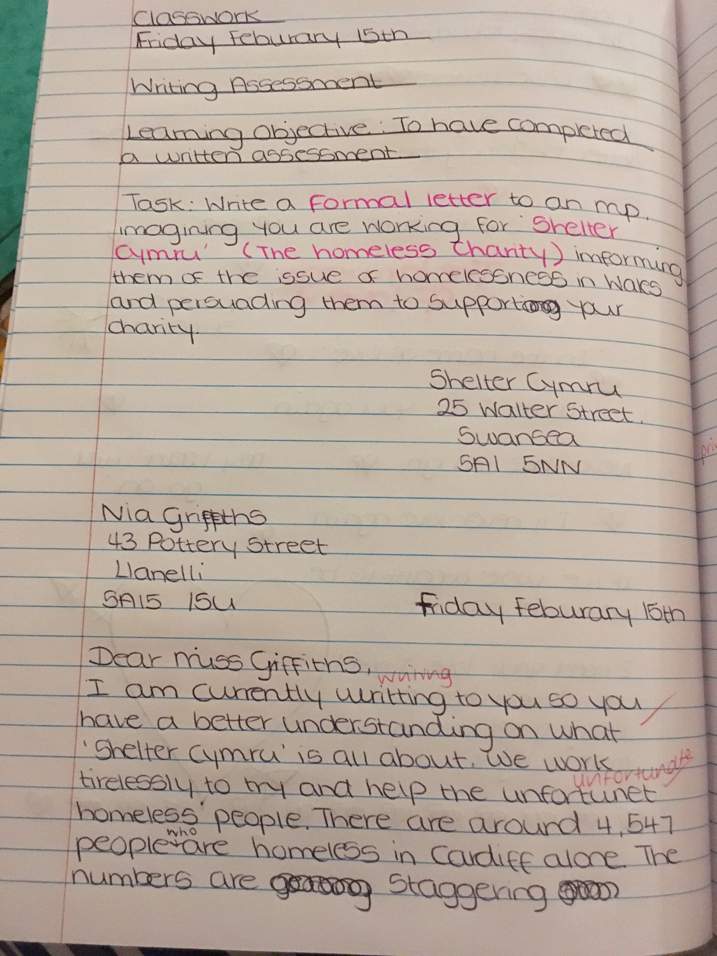

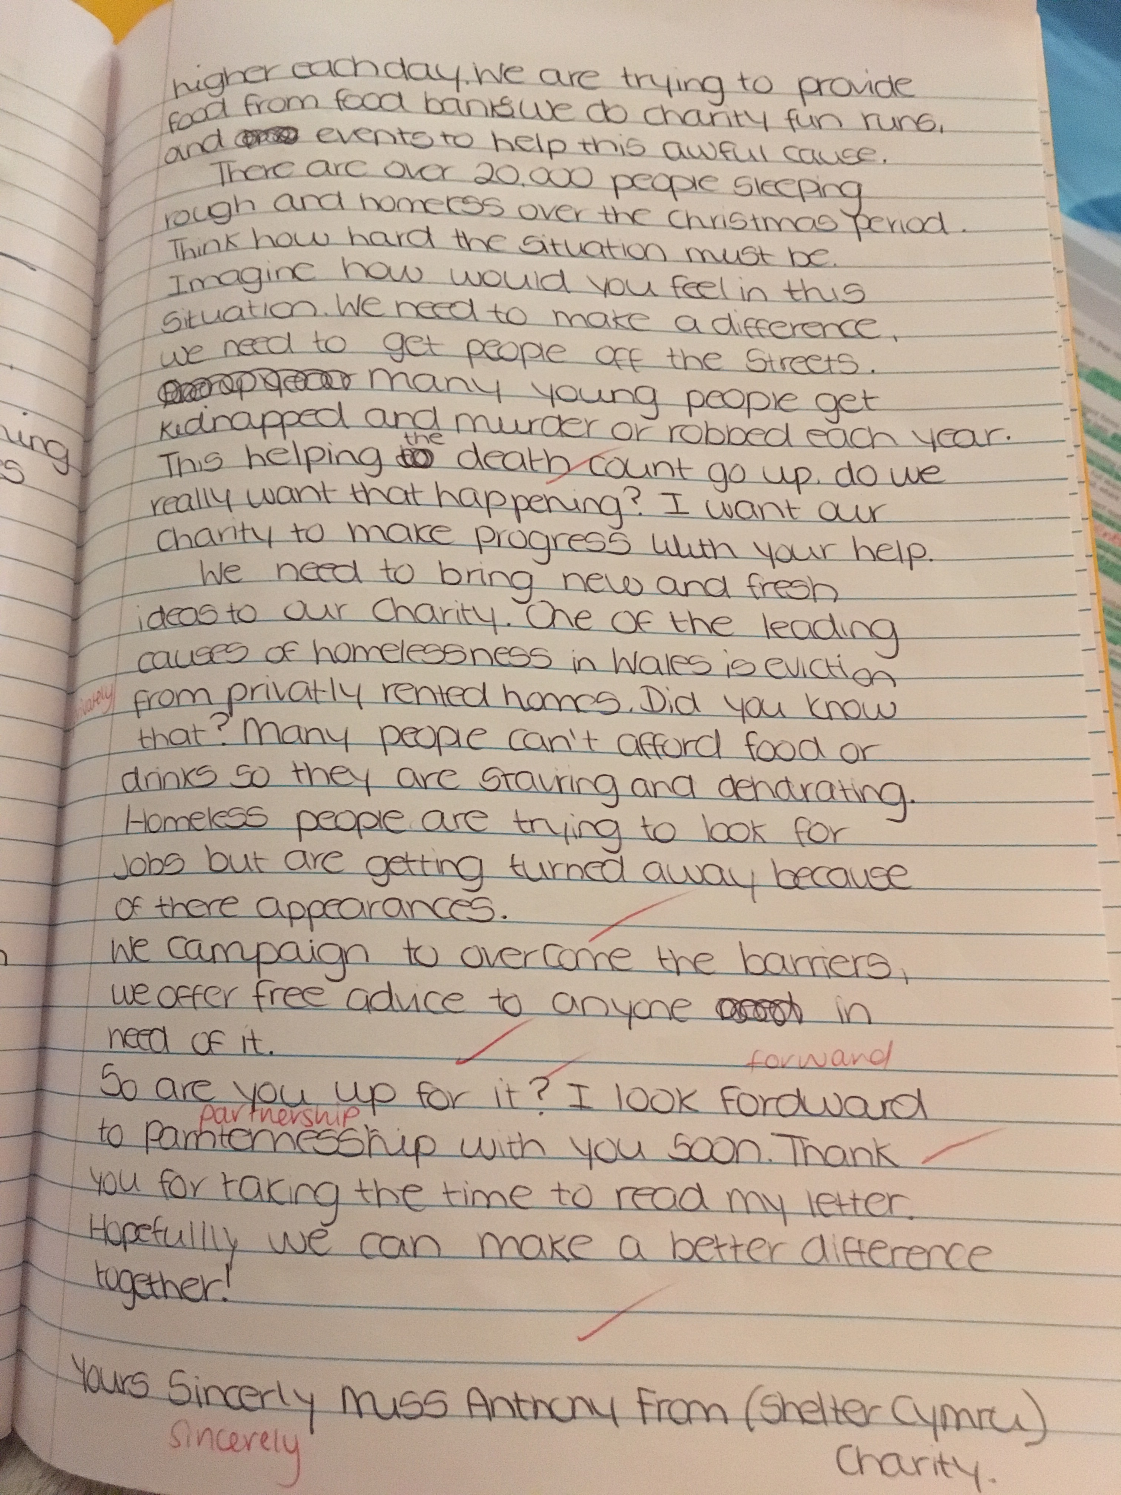

Appendix 2: Pre-test example written without writing frame support.



