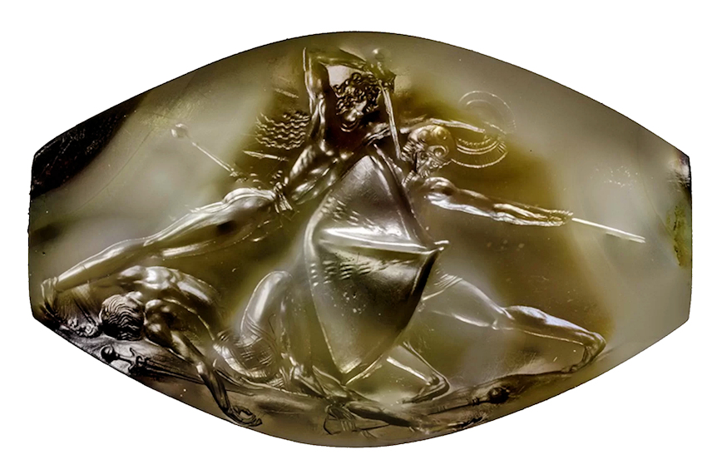
Pylos, agate sealstone from Griffin Warrior Tomb, 16th century BC

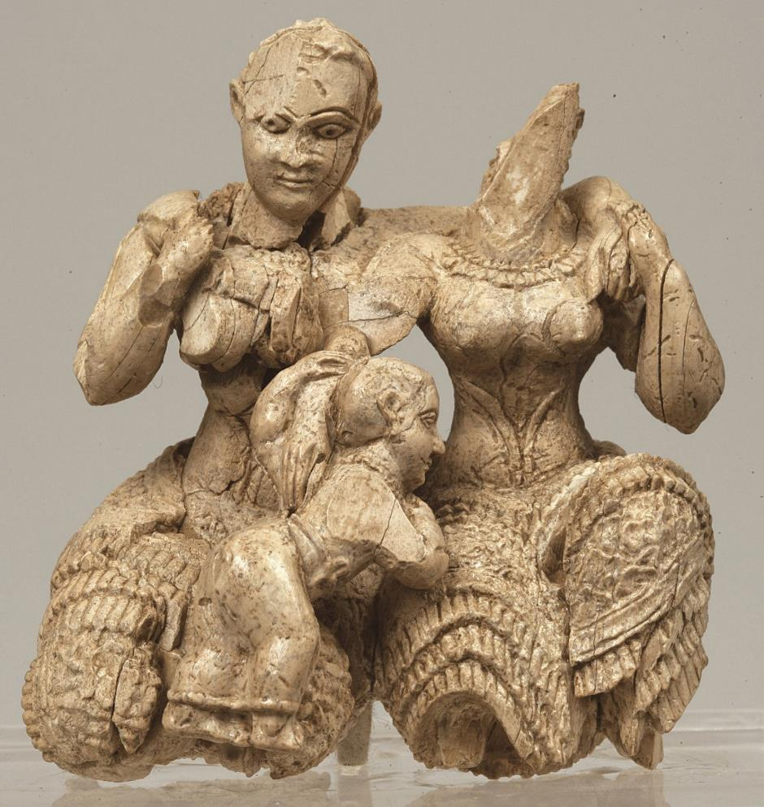
Ivory triad sculpture, cropolis of Mycenae, palace area, 15th-14th c. BC.
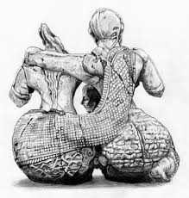 (detail of back)
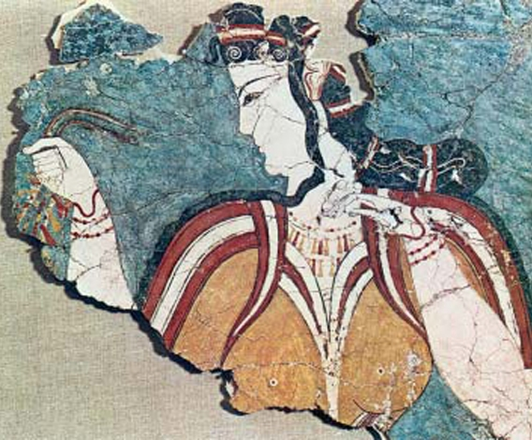
“Mykenaia”, wall painting from the Cult Centre, Mycenaean acropolis, 13th century BC

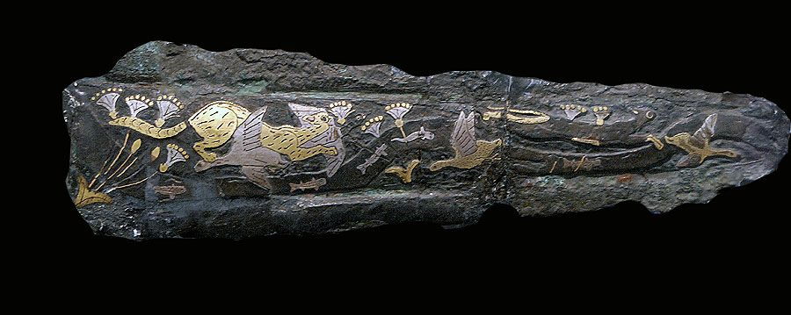
Inlaid dagger, Mycenae Grave Circle A

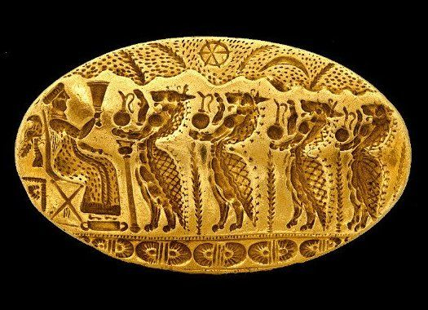
Gold signet ring, Tiryns, 15th century BC

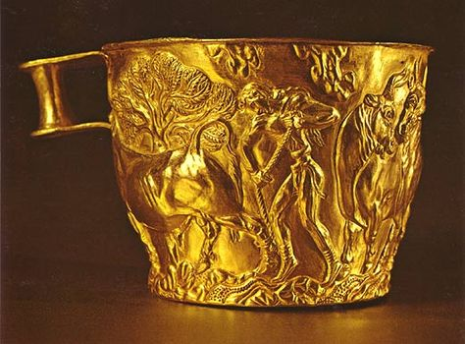
Gold cup, Vapheio tholos tomb, 15th century BC

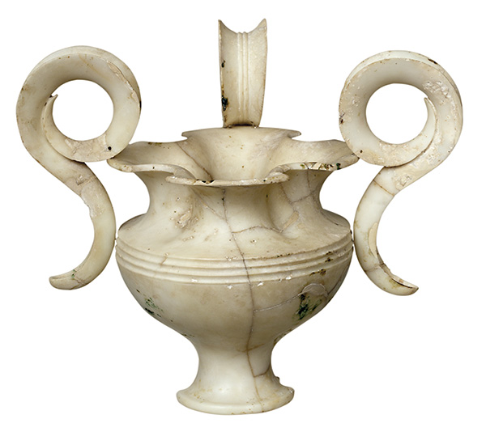

Three-handled jar (rhyton), Mycenae, Grave Circle Α, Grave IV, 16th century BC

