Exploring Sustainability in the Hotel and Hospitality Sector: Impacts, Industry Responses, and Future Directions

Student name: Marina Ancuta
Student number: 2122372
Module: BMIH6001 Contemporary Themes in the Hotel and Hospitality sector

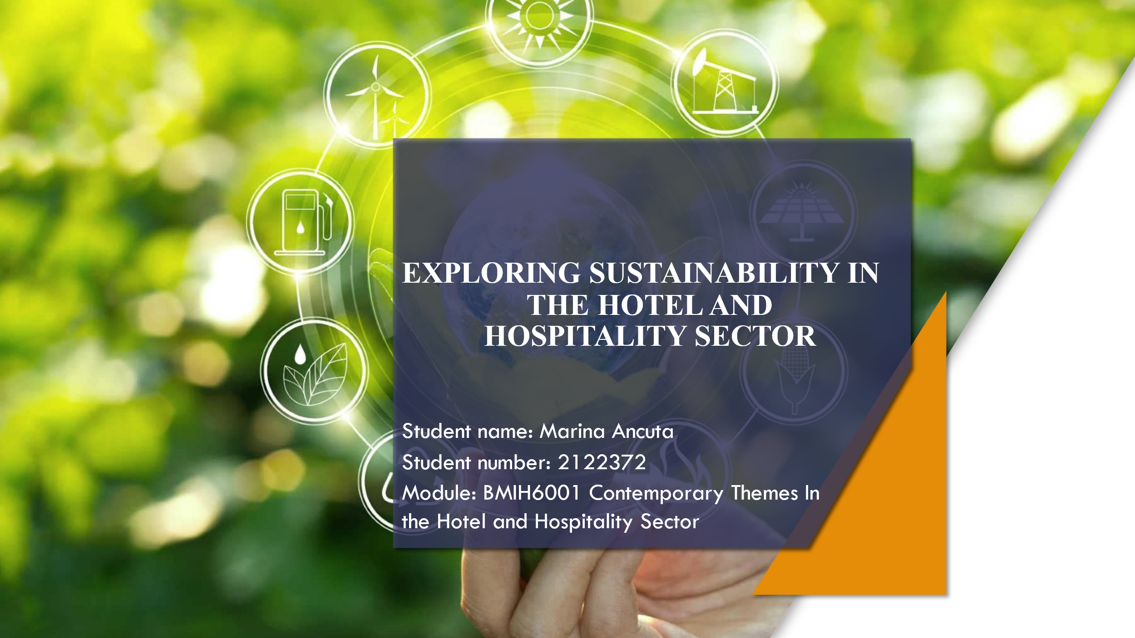
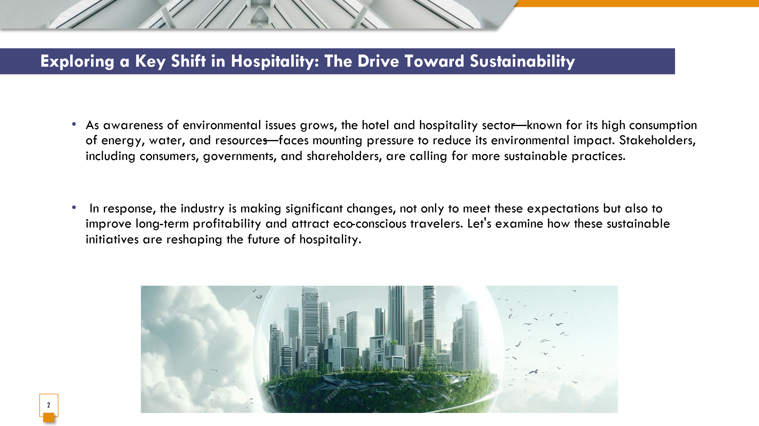
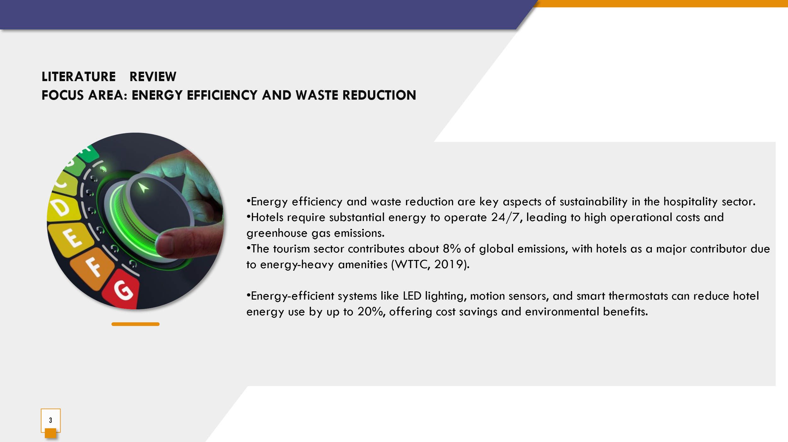
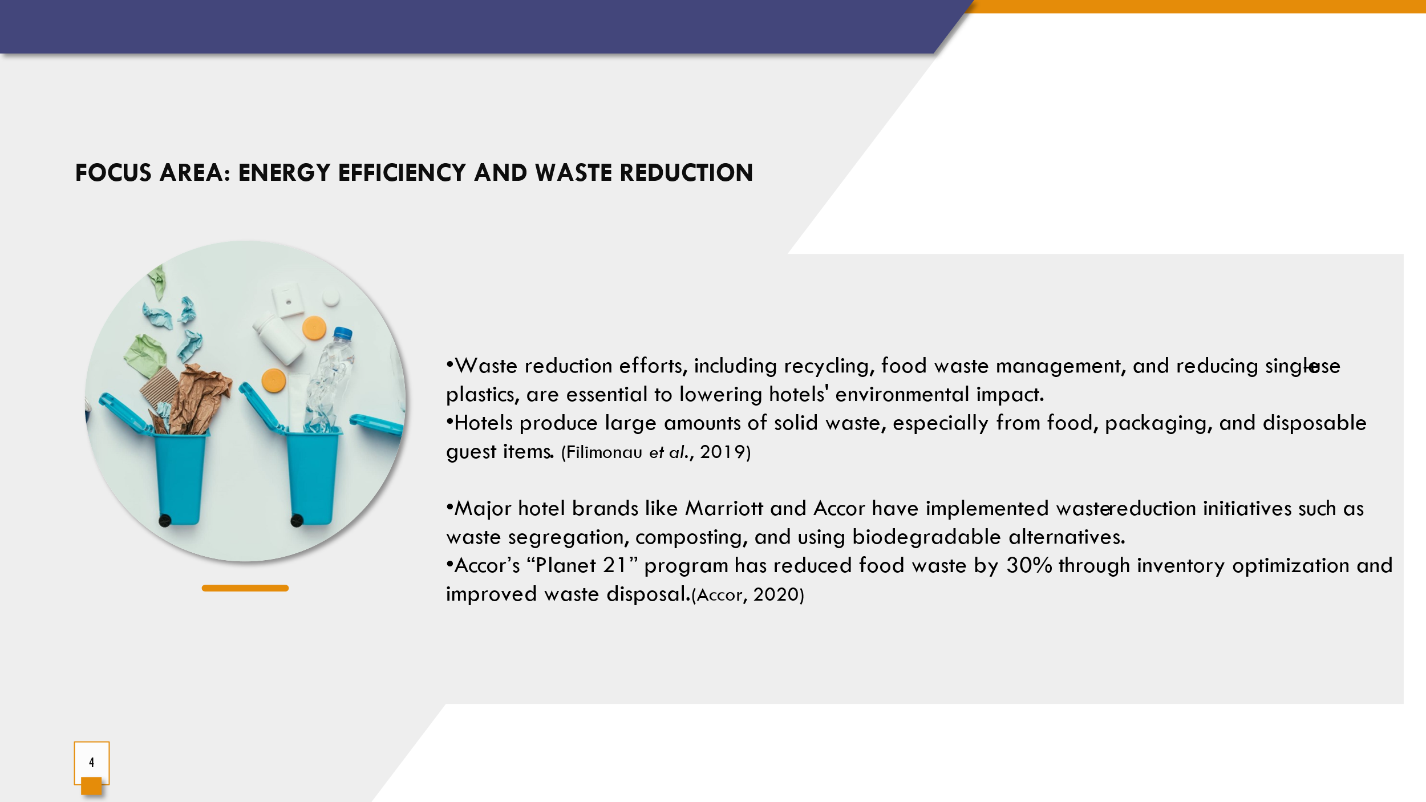
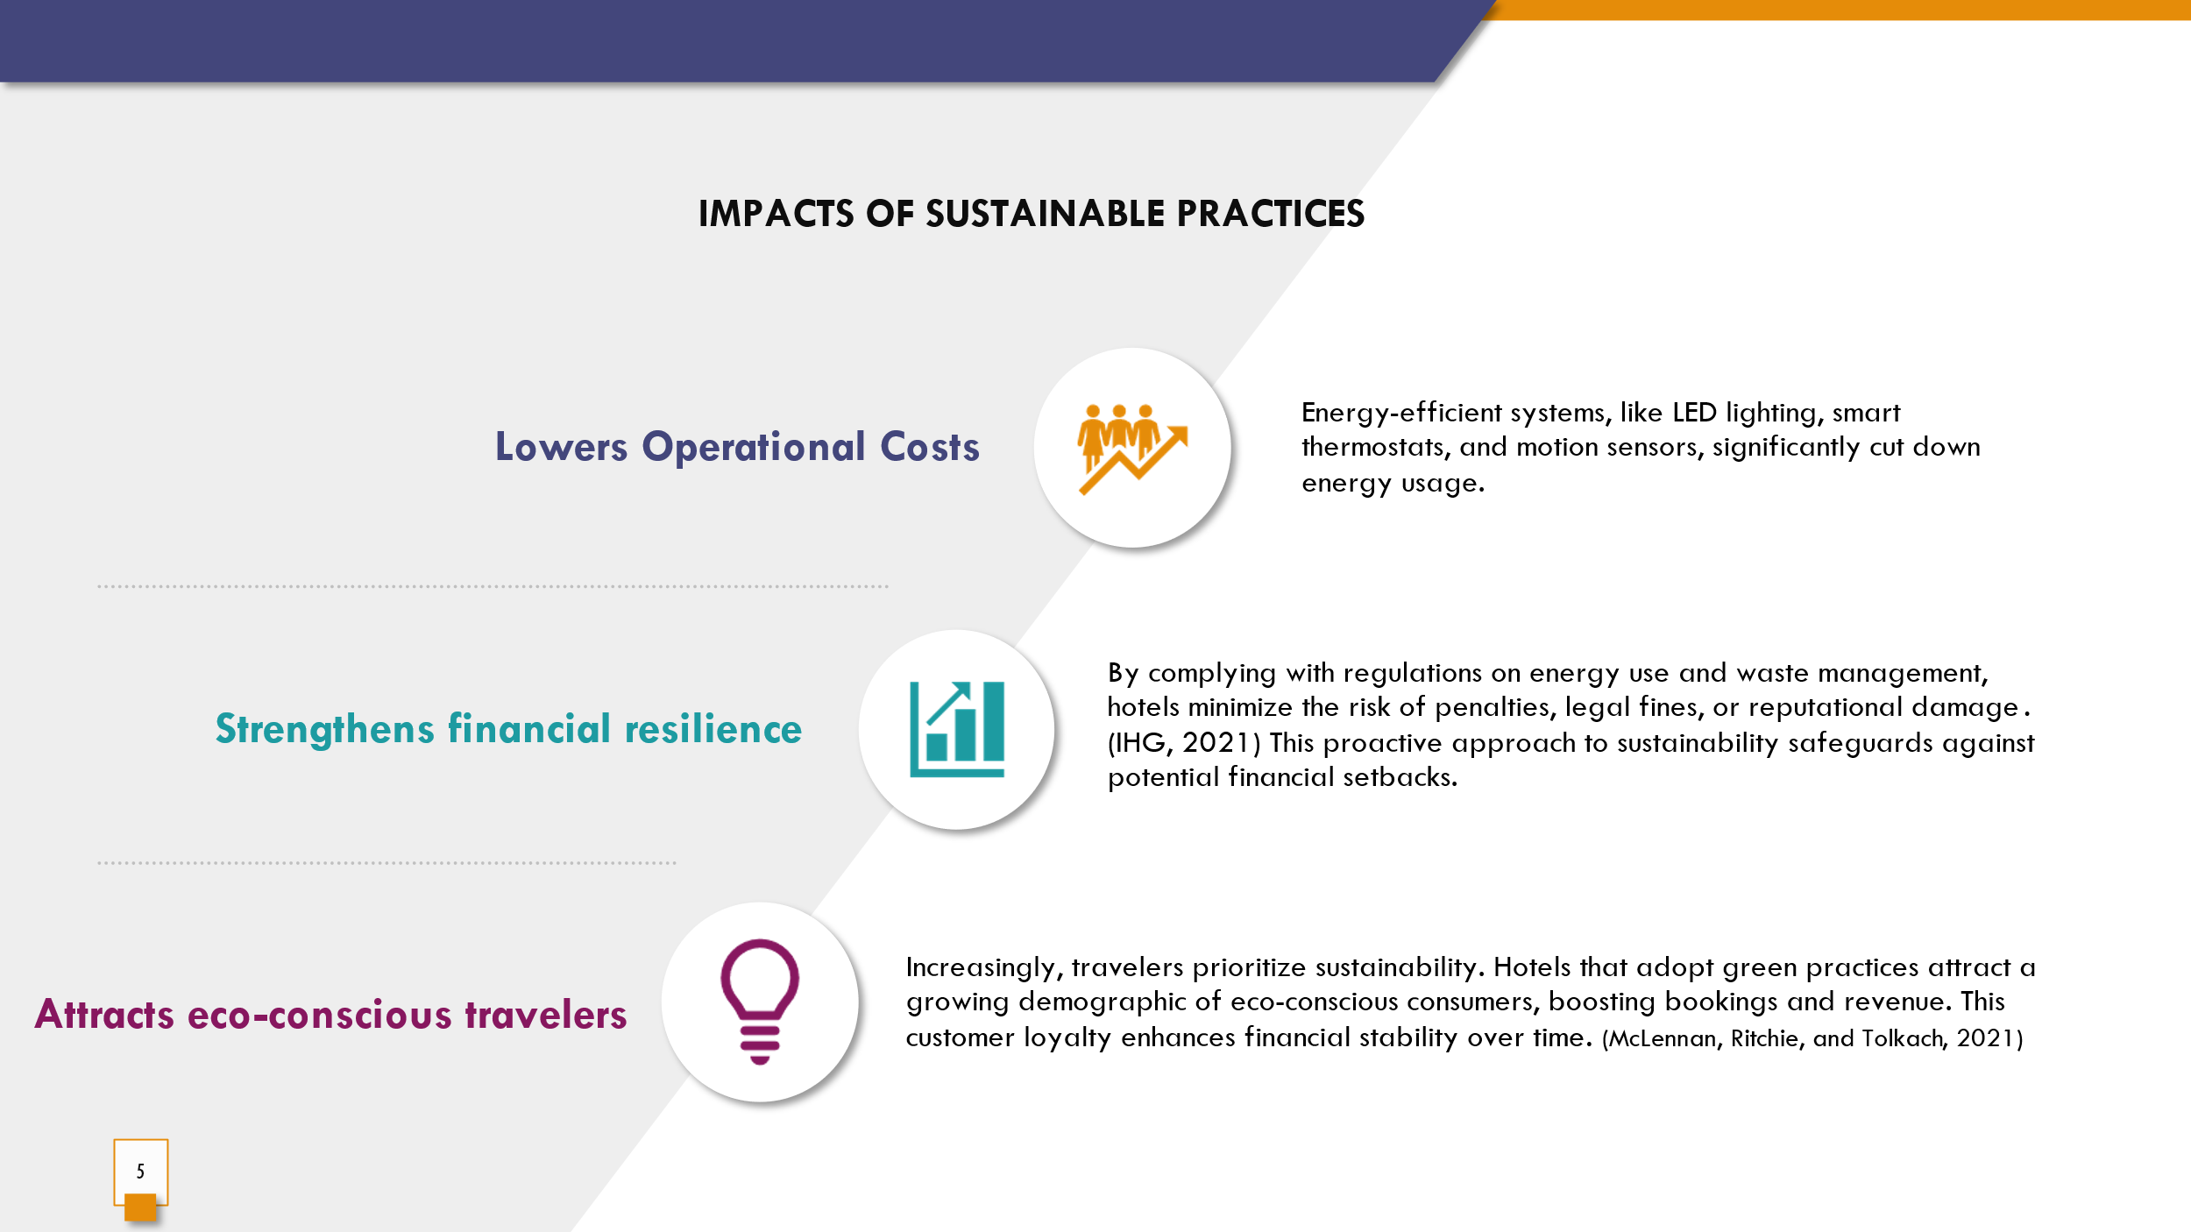
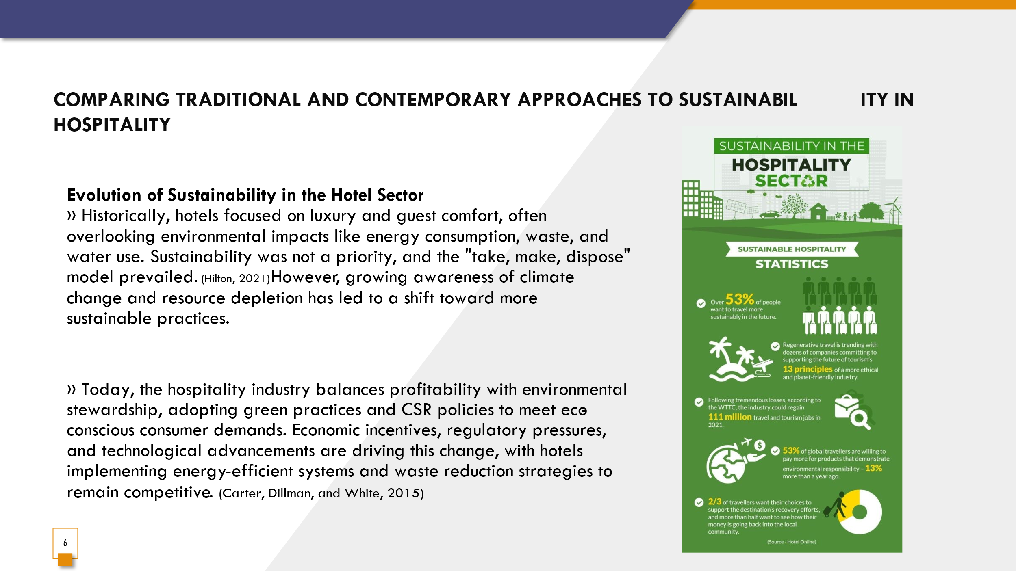
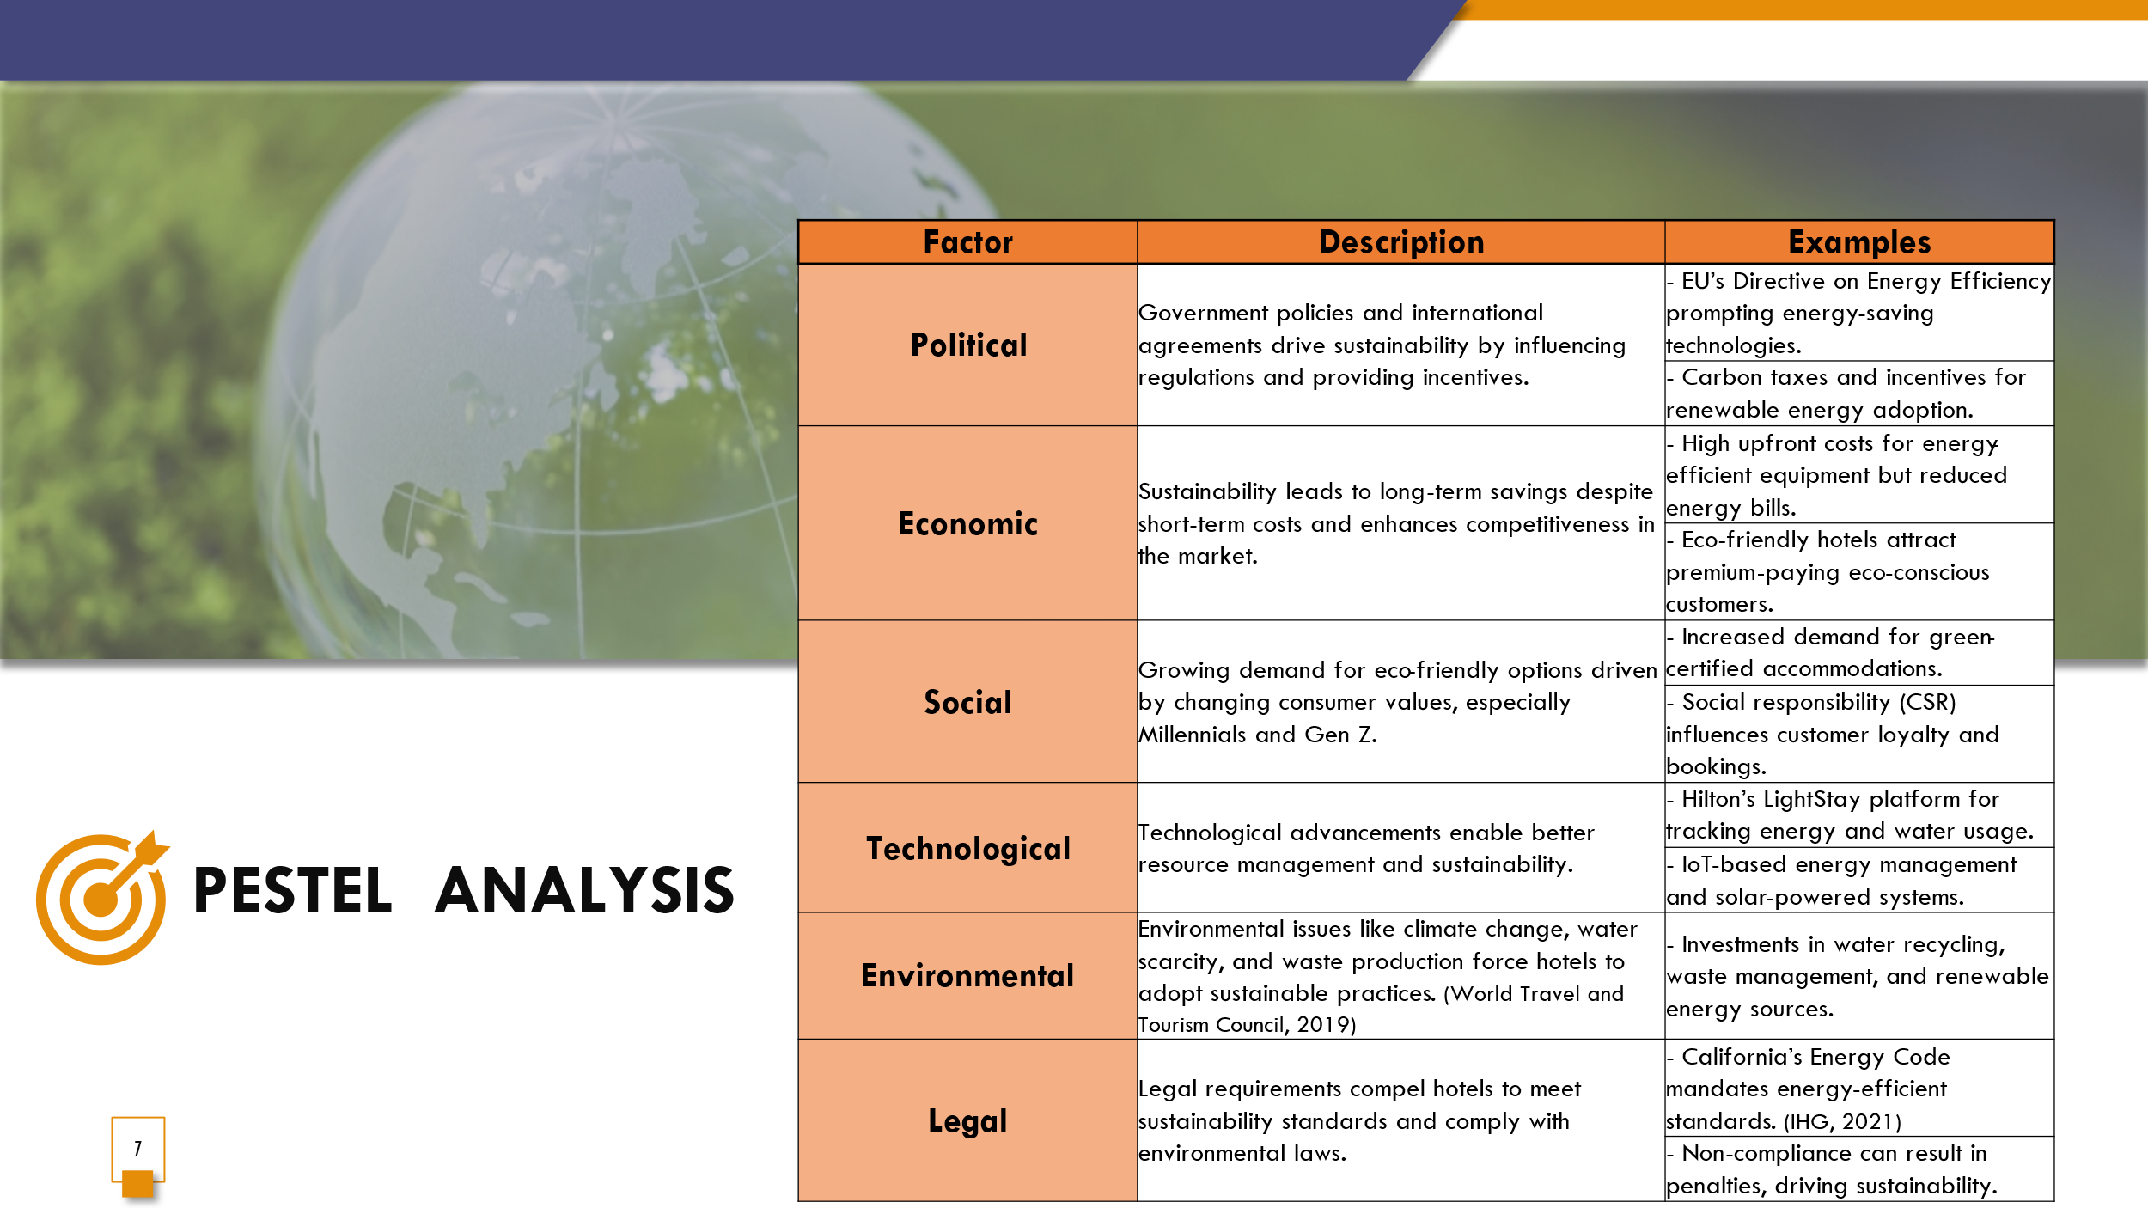
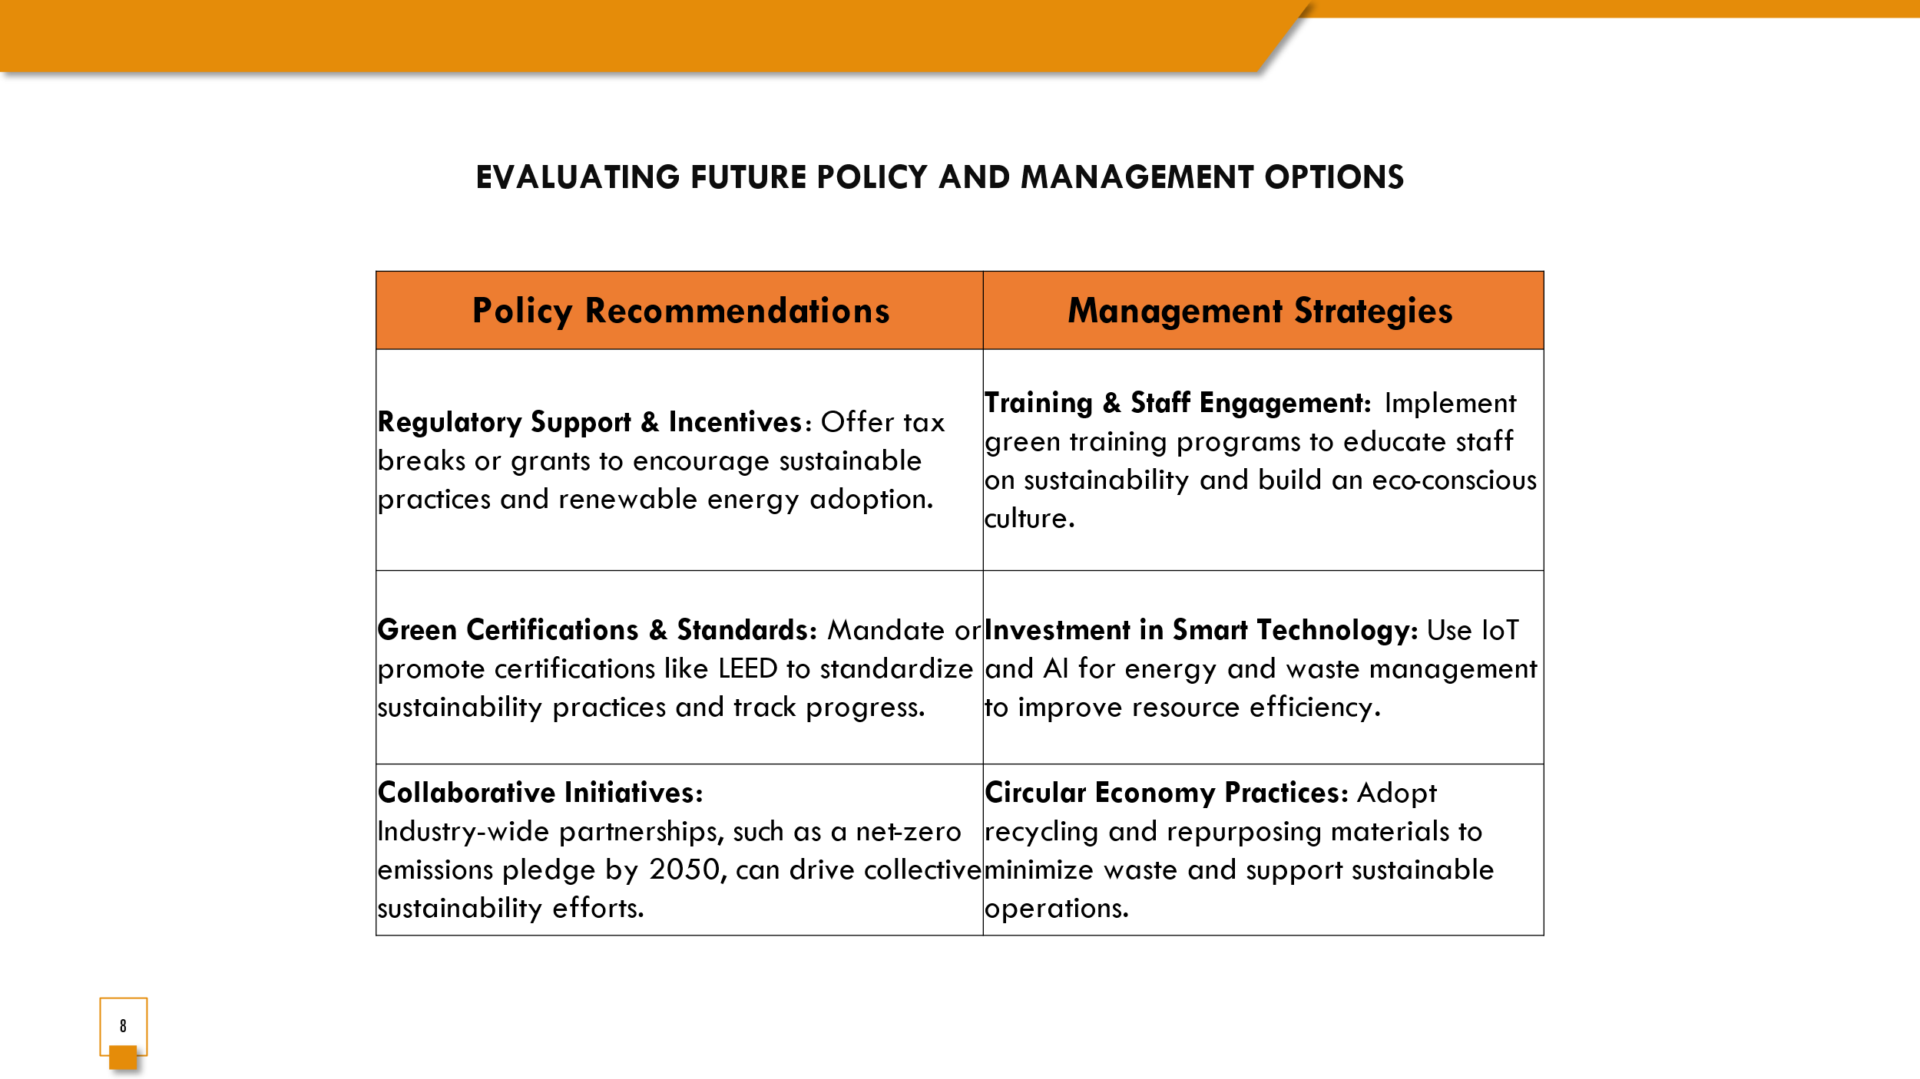
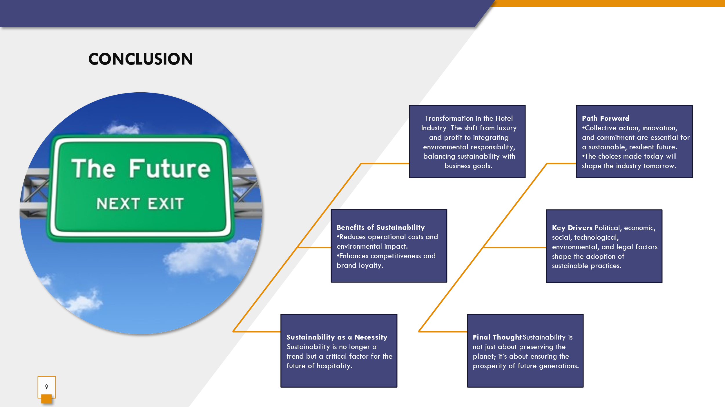

Reference list
- Accor. (2020) Planet 21 Program Report. Available at: https://group.accor.com (Accessed: 30 October 2024)
- Carter, R., Dillman, B. and White, L. (2015) Green regulations and hospitality: How environmental policies shape hotels. London: Routledge
- Filimonau, V., Fidan, H., Alexieva, I., Dragoev, S. and Marinova, D.D. (2019) 'Restaurant food waste and the determinants of its effective management in Bulgaria: An exploratory case study of restaurants in Plovdiv', Tourism Management Perspectives, 32.
- Hilton. (2021) Travel with Purpose: Environmental, Social and Governance Report. Available at: https://hilton.com/en/corporate-responsibility (Accessed: 30 October 2024).
- IHG. (2021) Green Engage Program Overview. Available at: https://www.ihgplc.com/en/responsibility (Accessed: 18 October 2024).
- World Travel and Tourism Council (WTTC). (2019) Environmental Impact of the Travel & Tourism Sector. Available at: https://wttc.org (Accessed: 12 October 2024).
- McLennan, C.J., Ritchie, B.W. and Tolkach, D. (2021) 'Tourism and the sustainable development goals: Covid-19 as a turning point?', Journal of Sustainable Tourism, 29(7), pp. 1027-1044.

