Digital safety
It’s very essential as a digital user that you are protecting yourself from any type of digital threat to your personal information, as digital users we need to make sure we have smooth online experience, and to protect ourselves from hackers, identify theft and malware. These are 4 ways of digital safety that prevent that from happening.

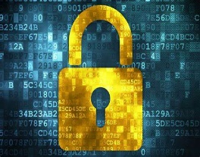
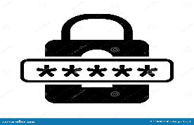
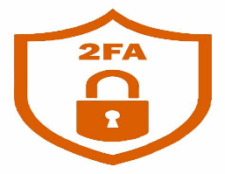
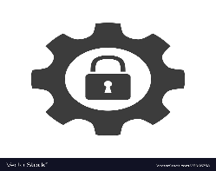
Data encryption is extra layer of security that makes it difficult for others to access your information, by making a cypher or a code that is made and known by the user. Exchanged between the sender and the administrative receiver to enable data encryption (Jacob,2019).
Private settings are tool that protect you as a user any personal information within social media platforms and prevent anyone besides the user from obtaining them. Digital users lack the capacity to sustain their privacy settings to protect their personal data (Lipford et al., 2008).

2FA are a second protection layer added to your password, like a code sent to your personal number, to ensure that your information is safe. The method where an individual requests access gets authenticated by the two characteristics. (Ali, Ally Dida and Elikana Sam, 2020).

Ali, G., Ally Dida, M. and Elikana Sam, A. (2020). Two-Factor Authentication Scheme for Mobile Money: A Review of Threat Models and Countermeasures. Future Internet, 12(10), p.160. doi: https://doi.org/10.3390/fi12100160.
Florêncio, D., Herley, C. and Coskun, B. (2007). Do Strong Web Passwords Accomplish Anything? [online] Available at: https://www.usenix.org/legacy/event/hotsec07/tech/full_papers/florencio/florencio.pdf.
Lipford, H., Besmer, A., & Watson, J. (2008). Understanding Privacy Settings in Facebook with an Audience View. Available at: https://www.usenix.org/legacy/event/upsec/tech/full_papers/lipford/lipford.pdf.
Jacob, N. M. (2019). Review Of Various Encryption Algorithms. Global Journal Of Computer Science And Technology, 19(E1), 1-3

Passwords are the main and the first line of defensive regarding your personal information or files. Users are repeatedly informed on how to spot fraud and create secure passwords. (Florêncio, Herley and Coskun, 2007).
Strong passwords
Double authenticator(2FA)
Private settings
Data encryptions
It’s essential to avoid digital damage that can affect your personal information or cause real life issues, it’s important to be safe while online.

