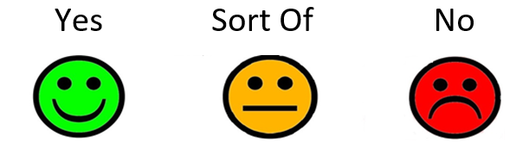
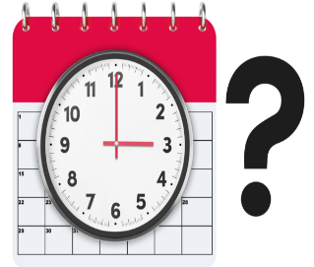
1. Was the social worker on time?

Would you like to say more?


If they were late, did they let you know?

Would you like to say more?

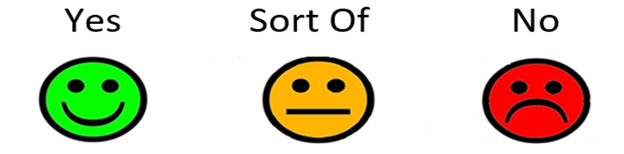
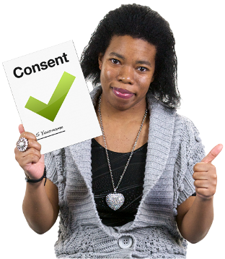
2. Did the social worker ask if it was okay for someone to watch the meeting?

Would you like to say more?


3. Did they tell you why the meeting was being watched?

Would you like to say more?


4. Did you understand why the social worker met with you today?

Would you like to say more?


5. Did you think the social worker was ready for their meeting with you?

Would you like to say more?


6. Did the social worker listen to you?

Would you like to say more?


Did they respect your views and wishes?

Would you like to say more?


7. Did you understand the social worker?

Would you like to say more?
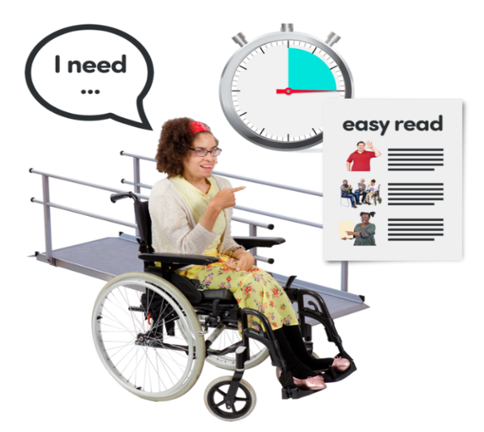
8. Did the social worker think about your language needs?

Would you like to say more?


9. Has the social worker done what you thought they would?

Would you like to say more?

10. Is there anything else you want to say?



