University of Wales Trinity Saint David
Wales Institute of Science & Art



Kinetic Energy Recovery
Alternative Propulsion Systems ACHA5010
Mark Sanford

Parry Hill
2004858
15/10/2022
Table of Contents
1. Introduction 2
2. Literature Review 3
2.1 Suzuki GSX-R 600 5
2.2. Kinetic Energy Recovery Systems 7
2.3. Flywheel 7
2.4. Suspension Electromagnetic Harvester 8
2.5 Regenerative Braking 9
3. WLTP Results 10
4. WLTP Analysis 13
4.1 WLTP Conclusion 13
5. Kinetic Energy Recovery System Implementation 14
6. Conclusion 16
7. References 17

Figure 1 - 2018 Suzuki GSX-R 600 (Motorcycle Specs, 2018) 6
Figure 2 - GSXR-600 Frontal Area Measurement 7
Figure 3 - GSXR-600 (Ilminem,2014) 7
Figure 4 - Suspension Electromagnetic Harvester (Touairi and Mabrouki, 2020) 9
Figure 5 - Acceleration and Aerodynamic Resistance 11
Figure 6 - Total Resistance 11
Figure 7 - Tractive Power 12
Figure 8 - Braking Power 12
Figure 9 - Total Cumulative Tractive and Braking Energy 13
Figure 10 - Potential Return to the Wheel 13
Figure 11 - WLTP Energy Recovery 16

Table 1 - WLTP Testing cycle for Hybrid and Electric Vehicles (DieselNet, 2019) 4
Table 2 - WLTP data for Suzuki GSX-R 600 5

Introduction
This report will research the use of kinetic energy transfer systems (KERS) for a Suzuki GSXR-600. To complete this an excel spreadsheet will be used to simulate both the tractive and braking energy available on the Worldwide Harmonized Light Vehicles Test Procedure (WLTP) to attain data of where motorcycle efficiency can be increased.
Currently within the motorcycle industry, KERS are limited to electric motorcycles with few manufacturers such as Zero and Fonz utilizing regenerative braking systems.

However, KERS are not a new technology to motorcycles. With the first recorded use by KTM in the GP125 class at the end of the 2008 season. With the manufacturer claiming it delivered the equivalent of 2.6 extra horsepower (5% increase), this system was powered using rear wheel braking and stored using supercapacitors (Oxley, 2009). MotoGP later banned the use of these systems, with technical direction stating it was too expensive for implementation.

Literature Review
The WLTP is a cycle test designed to equate emissions and fuel consumption of a vehicle and is carried out using a chassis dynamometer (Transport Policy, 2018).
The WLTP cycle was designed as a more accurate replacement for the New European Driving Cycle (NEDC), which relied on theoretical driving opposed to real driving data such as the WLTP; this allows for a further accurate insight to emissions and consumption data for simulation of average daily driving. (Dimoratos et al, 2016)
The WLTP cycle splits lightweight vehicle classes into 3 categories dependant on power (W) to kerb mass (kg) ratio (PMR), with each class having alterations to the test with regards to maximum velocity (Vmax) these are:
- Class 1 – Vehicles with a power to mass ratio of below 22 W/Kg
  - If Vmax is equal to 70km/h low phase is repeated after middle
  - If Vmax is under 70km/h middle phase is replaced with low
- Class 2 – Vehicles with a power to mass ratio of between 22- 34 W/Kg
  - If Vmax is less than 90km/h high phase is replaced with low
- Class 3 – Vehicles with a power to mass ratio of above 34 W/Kg
  - If Vmax is below 135km/h extra high phase is replaced by low
(Transport Policy, 2018)

The WLTP cycle also provides a special provision for hybrid and electric vehicles, giving them a comparable insight to traditional internal combustion engine (ICE) vehicles, this is shown in table 1 below.
Table 1 - WLTP Testing cycle for Hybrid and Electric Vehicles (DieselNet, 2019)
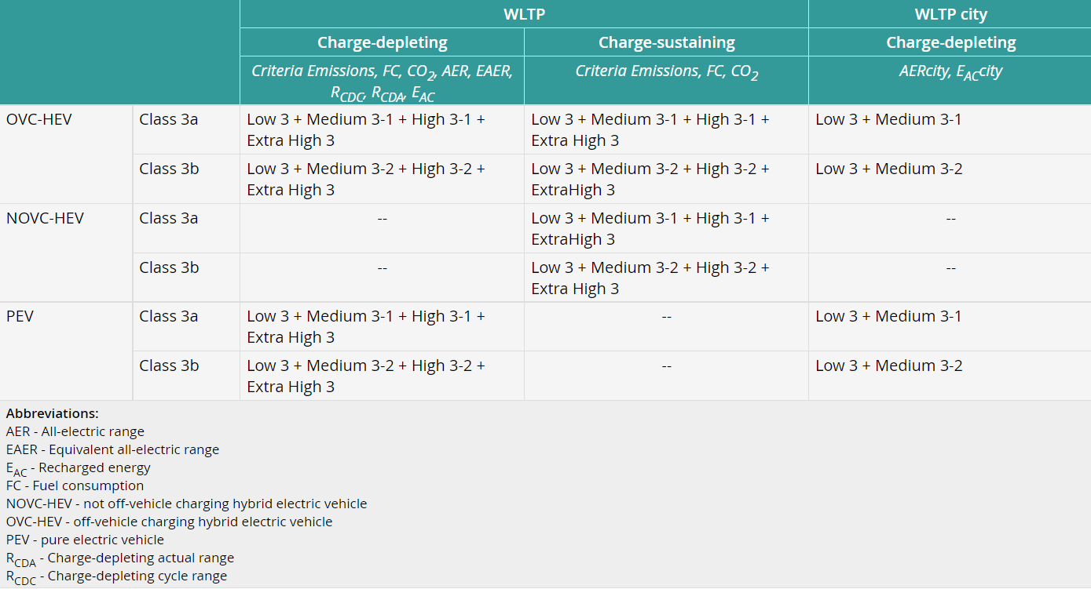

2.1 Suzuki GSX-R 600
The Suzuki GSXR-600 has been selected for this report due to a lack of kinetic energy recovery devices and technology within the motorcycle industry. It is also commonly known that the current emission standards for motorcycles are much further behind than that of other road going vehicles, with motorcycles following euro 5 guidelines compared to cars and heavy goods vehicles following euro 6.
With the implementation of Euro 5 emissions standards in 2020, this saw the end for many high performance, inline four motorcycles, such as the GSXR-600 as they couldn’t meet the new required standards. The implementation of KERS has the potential to increase fuel efficiency by 32%, as well as increase performance (Sampurno, Abdurrakhman and Hadi, 2015) which with development could bring back the production of classes such as the 600cc super sports.
Table 2 - WLTP data for Suzuki GSX-R 600
Vehicle | Suzuki GSX-R 600 2018 | 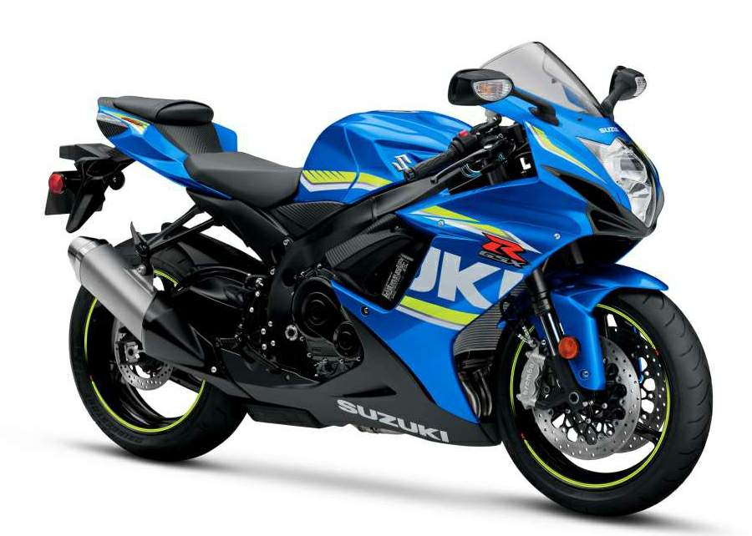  Figure 1 - 2018 Suzuki GSX-R 600 (Motorcycle Specs, 2018)
Vehicle Kerb Mass (Kg) | 187  (Motorcycle specs, 2018)
Power (KW) | 93.2  (Motorcycle specs, 2018)
PMR | 498.93
Frontal Area | 0.4023m²
Rolling Resistance Coefficient | 0.02 (Wikiwand,2022)
Coefficient of Aero Dynamic Drag | 0.6  (Cossalter,2006)

To obtain the frontal area of the GSXR, Solidworks was used to create a drawing (figure 2) from the image shown in figure 3 which was then scaled to size and the area measured.

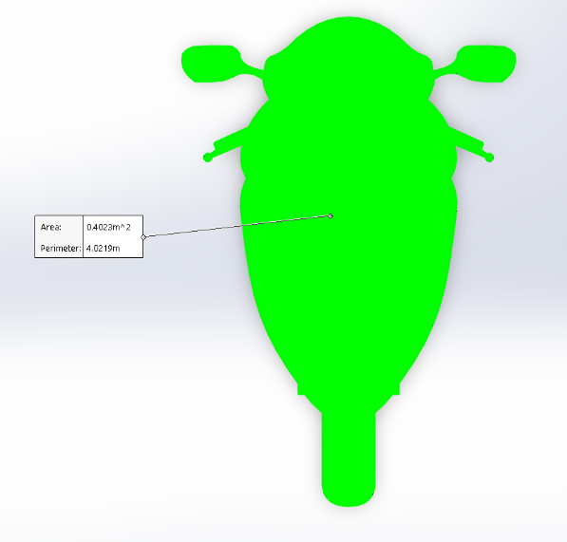
Figure 2 - GSXR-600 Frontal Area Measurement
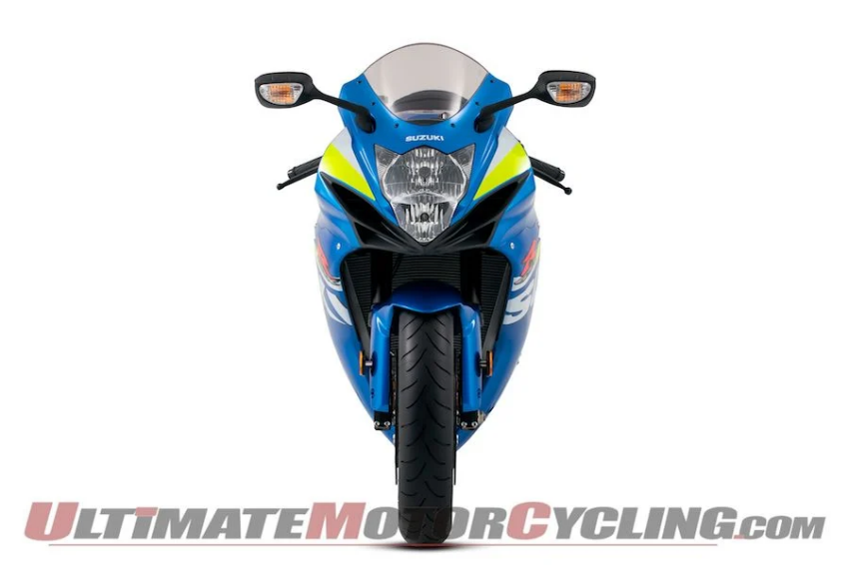
Figure 3 - GSXR-600 (Ilminem,2014)

2.2. Kinetic Energy Recovery Systems
Kinetic Energy Recovery Systems (KERS) are devices that allow for kinetic energy (KE) otherwise being lost under deceleration and braking at the wheels, to be stored either electrically or mechanically and used later to increase efficiency under acceleration (Sampurno, Abdurrakhman and Hadi, 2015).
KERS are typically comprised of three main components, these are:
- An electric motor, often connected directly to the crankshaft to utilise the additional power.
- A high voltage lithium-ion battery or super capacitor, to store and release the energy as and when its needed.
- A KERS control box, to monitor and control the electric motor when charging and releasing energy.
(Naveen, et al. 2014)
KERS Systems were first predominantly used within Formula 1 by converting the otherwise lost KE into electricity via a carbon fibre flywheel and storing it, enabling the driver to utilise a “boost” of power (Energy Education, 2015).
This section will look at potential KERS that could be integrated onto the motorcycle to increase efficiency.

2.3. Flywheel
One system for potential use would be a flywheel connected to either the front or rear wheel. In this design, a clutch is engaged as the motorcycle slows, therefore rotating the flywheel, the energy is then stored within the flywheel to be used when the motorcycle begins to accelerate. The flywheel will also assist in the deceleration of the motorcycle, therefore creating regenerative braking. However, when the brakes are applied, the clutch disengages (Menon, et al.).
A generator that converts this energy from kinetic to electric can be attached to the flywheel to charge a battery or supercapacitor enabling the stored energy to be used at a later point in the drive cycle.

2.4. Suspension Electromagnetic Harvester
In this system, an electromagnetic harvester is used on the suspension to recover KE losses. It does this by converting the linear movement of the suspension into electricity, which can then be stored and used to either power auxiliary devices or to assist in the motorcycles acceleration with a motor attached to the wheel/crankshaft (Touairi and Mabrouki, 2020), this device is shown in figure 4 below.
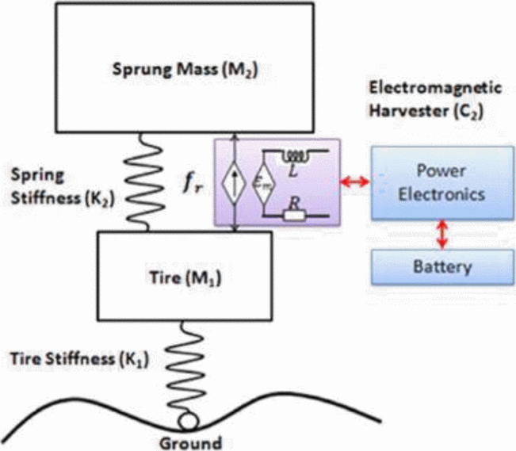
Figure 4 - Suspension Electromagnetic Harvester (Touairi and Mabrouki, 2020)

2.5 Regenerative Braking
Regenerative Braking works by utilising an electric motor to convert KE into electricity as the vehicle decelerates, this electricity is then temporarily stored in a device (such as a super capacitor) for later use (Clegg, 1996).
Regenerative braking on ICE motorcycles has been previously attempted by KTM, with the introduction of KERS on their 2008 GP125 motorcycle shortly before MotoGP race direction banned the use of the systems in 2009. Almost no details of the system were released by KTM, other than a brief overview of how it worked; utilizing the rear brake and power figures produced.
An alternative to this is currently being developed by Honda, a hybrid motorcycle that is ICE driven at the rear wheel with the front driven by an electric motor, allowing for the introduction of a regenerative braking system at the front wheel (Purvis, 2021).

WLTP Results
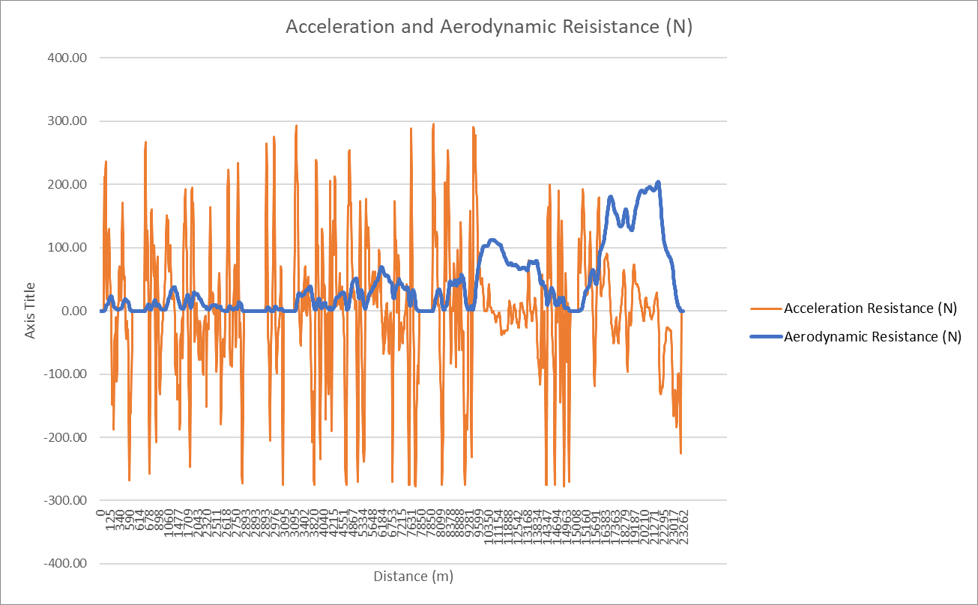
Figure 5 - Acceleration and Aerodynamic Resistance

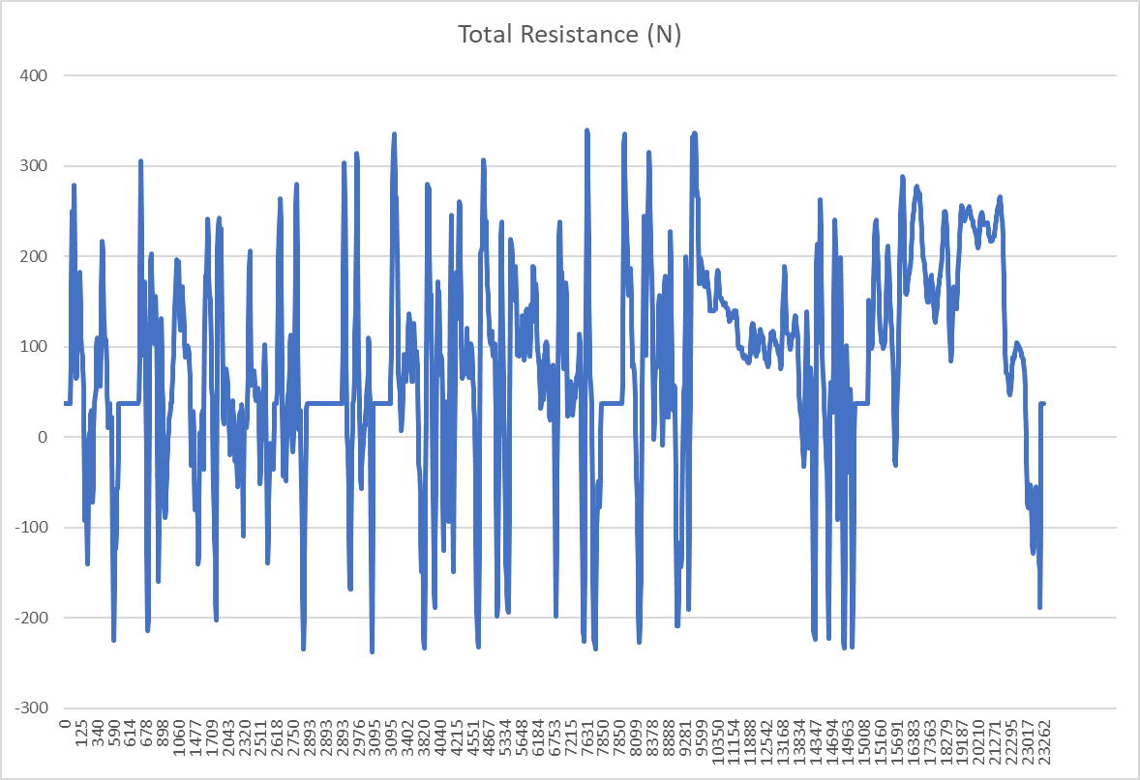
Figure 6 - Total Resistance
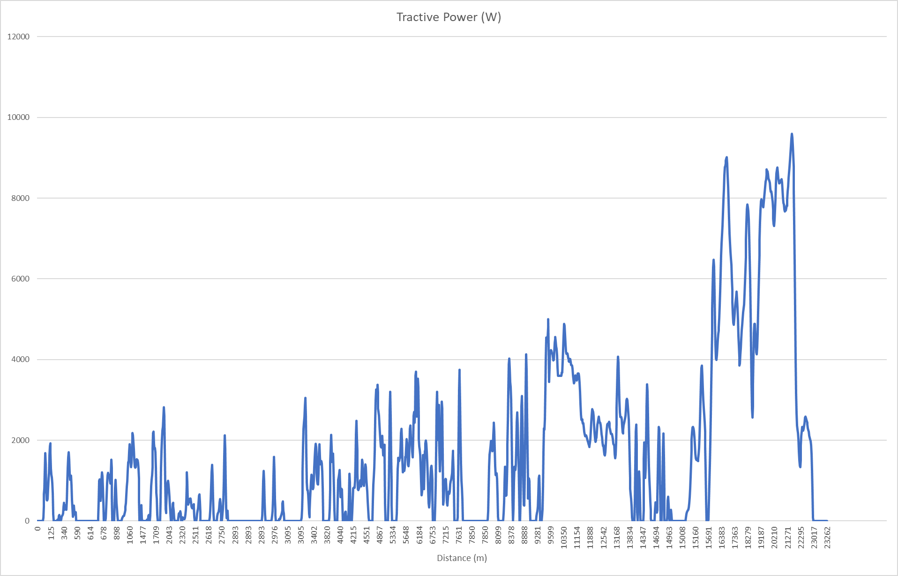
Figure 7 - Tractive Power
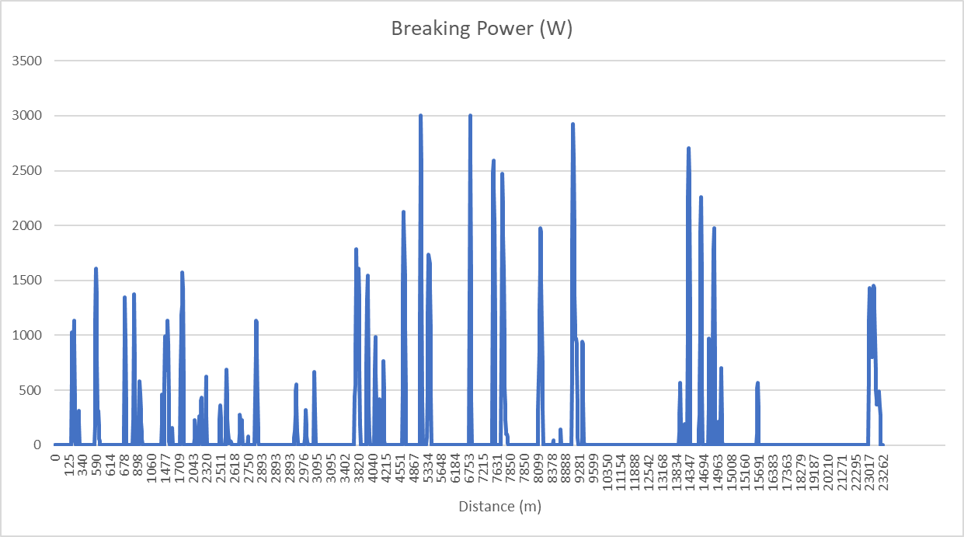
Figure 8 - Braking Power
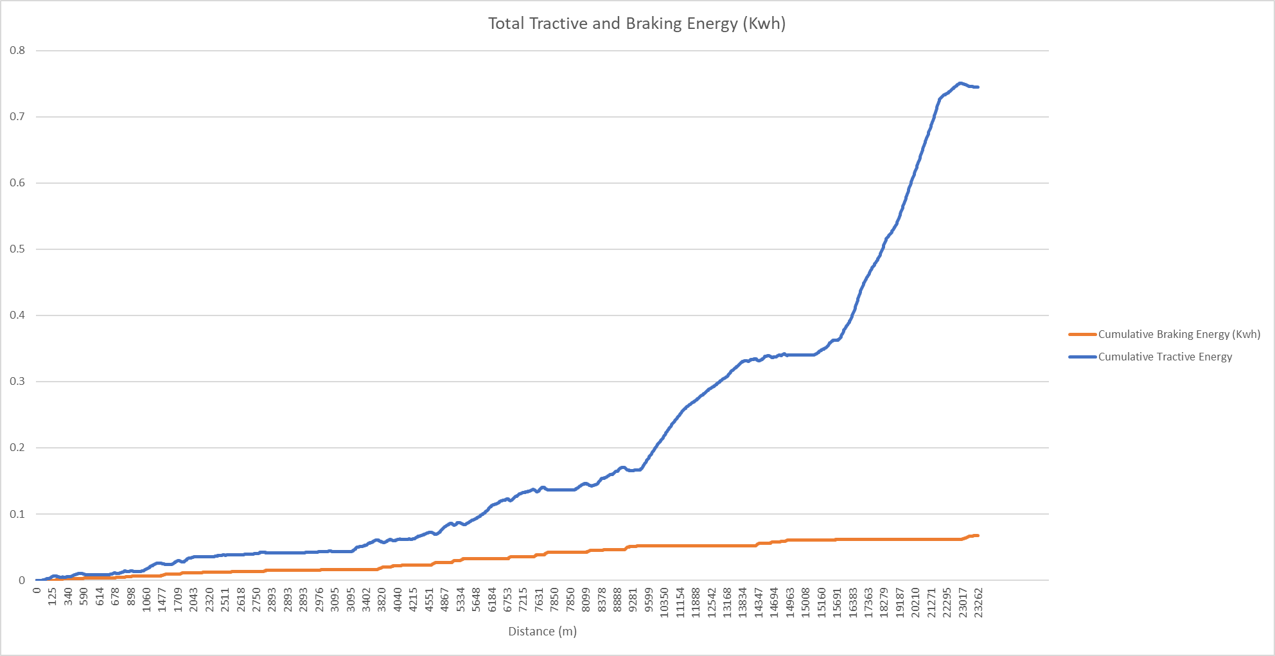
Figure 9 - Total Cumulative Tractive and Braking Energy
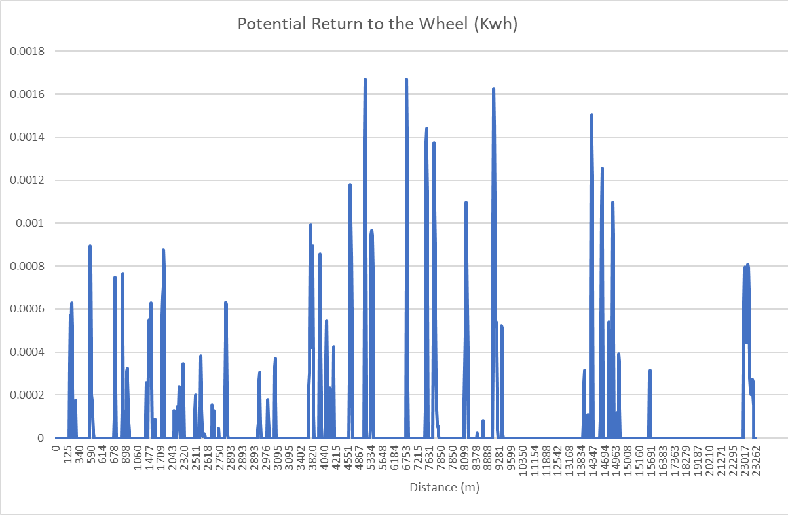
Figure 10 - Potential Return to the Wheel

WLTP Analysis
Using an Excel spreadsheet, data for the WLTP cycle for the GSXR-600 was obtained and a series of graphs were created to display the findings and analyse the data available.

Figure 5 displays the acceleration and aerodynamic resistance on the motorcycle throughout the WLTP cycle, this data was then combined with the rolling resistance to create figure 6 showing the total resistance in N for the GSXR-600, the total resistance was then used to calculate the power required (W) by the vehicle using the equation $Power=F×V$.
Using the power required, both tractive and braking power were calculated by using IF statements to determine whether the vehicle was accelerating or decelerating, for braking power the result was multiplied by -1 to show a positive figure. From this figure 7 and figure 8 were created.
Following this Tractive and braking energy were converted to Kwh by using the equation $Energy (Kwh)=P÷1000÷3600$, this data was used to calculate the cumulative tractive and braking energy throughout the WLTP as shown in figure 9.
The tractive and braking energy were then used to identify where energy recovery could take place, to complete this an if statement was used to identify where the vehicle decelerates, the difference between tractive and braking was calculated for these points as shown in figure 10.
The max losses were also equated for cumulative tractive and braking, the cumulative loss over the WLTP cycle was 0.683557469 Kwh.

4.1 WLTP Conclusion
The results from the WLTP cycle show a large difference in tractive and braking energy resulting in significant losses in energy throughout the test, this highlights the potential for the implementation of a KERS on the GSXR-600, with the data obtained using the spread sheet a maximum of 0.014192572 Kwh (51093.26003 W) could be returned to the wheel therefor increasing efficiency.

Kinetic Energy Recovery System Implementation
Using the findings in this report a regenerative braking system at the front wheel of the motorcycle could be implemented to recover up to 0.014192572 Kwh for later use within the drive cycle.
To successfully implement this system several challenges would need to be addressed, these challenges can be split into Three main categories:
- Packaging
In order for the regenerative braking system to work a small motor on either the front or rear wheel would need to be fitted. To overcome this a possible solution would be placing the motor at the front wheel and therefor creating an all-wheel drive motorcycle such as the one Honda is currently developing. This is a practical and viable solution as on a motorcycle the majority of the braking effort is performed using the front brake as the rear wheel is prone to locking under heavy braking.
- Energy Storage
Traditional energy storage in a battery would present an issue due to the battery size needing to be increased, often motorcycle batteries are housed under the seat with little to no excess room. A possible solution to this would be the use of supercapacitors, supercapacitors can charge and discharge quickly with the added benefit of being lightweight and much smaller than a lithium-ion battery (Kouchachvili, Yaici and Entchev, 2017).
- Rider Feel/ Weight
Motorcycles are designed to be as lightweight as possible therefore the effect of the added weight on the centre of gravity and therefore the handling of the bike would need to be addressed.
Another area for concern would be the deceleration effects of a regenerative braking system, heavy front braking can cause the rear of the motorcycle to lift, to accommodate for this the motor would need to be limited in its deceleration of the front wheel, this however could in turn effect the efficiency of the system.

Regenerative braking systems have an average of 60-70% efficiency (Toll, 2018), assuming the KERS implemented on the GSXR-600 would have an efficiency of 70% the resulting energy recovery over the WLTP cycle is shown below in figure 11, this shows a maximum of 0.01 kwh being recovered by the system which could then be used to drive the front wheel, aiding in acceleration.

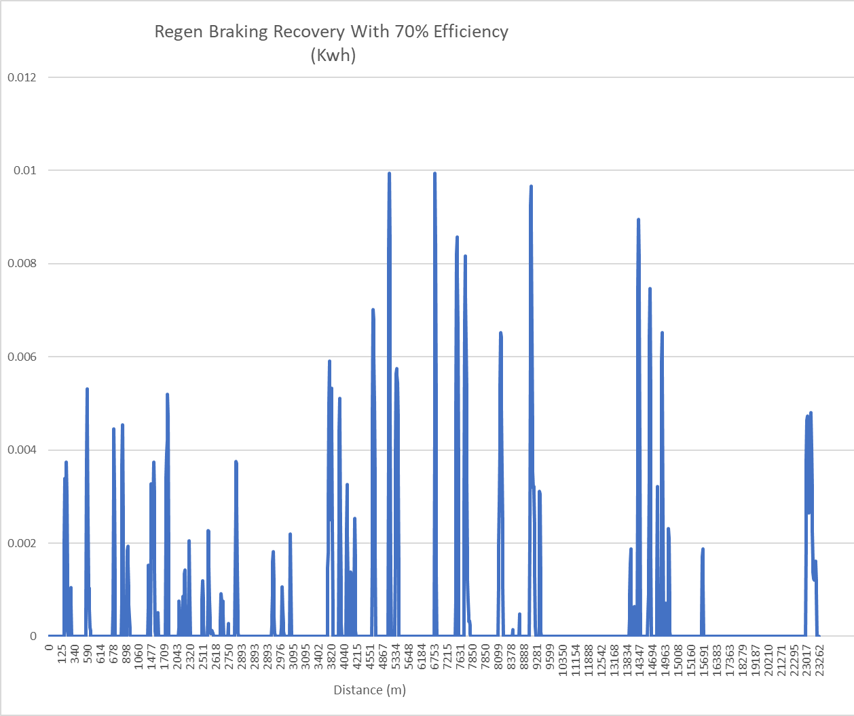
Figure 11 - WLTP Energy Recovery

Conclusion
To conclude, the findings of this report showed the Suzuki GSXR-600 to be largely inefficient with large KE losses under deceleration.
Currently there is very little research and development of energy recovery systems for motorcycles however with Honda’s new developments and the introduction of electric motorcycles utilizing these systems shows the potential for hybrid motorcycles with technology such as regenerative braking to become widely available in the future, the use of these systems would increase efficiency allowing for better emissions and the potential for discontinued classes such as the 600cc inline four super sports to be developed for production once more.

References
- Cossalter (2006) Motorcycle Dynamics 2nd edition, Morrisville, Carolina: Lulu
- Clegg (1996) A Review of Regenerative Braking Systems Leeds: Institute of Transport Studies, University of Leeds
- Dimaratos, Tsokolis, Fontaras, Tsiakmakis, Ciuffo and Samaras (2016) ‘Comparative evaluation of the effect of various technologies on light-duty vehicle CO2 emissions over NEDC and WLTP’ Transportation Research Procedia 14, pp.3169 – 3178
- DeiselNet (2019) Worldwide Harmonized Light Vehicles Test Cycle (WLTC) [Table] Available at URL: https://dieselnet.com/standards/cycles/wltp.php (Accessed 20/10/22)
- Energy Education (2015) Kinetic energy recovery system Available at URL: https://energyeducation.ca/encyclopedia/Kinetic_energy_recovery_system (Accessed 8/11/22)
- Kouchachvili, Yaici and Entchev (2017) ‘Hybrid battery/supercapacitor energy storage system for the electric vehicles’ Journal of Power Sources, Vol.374, pp.237-248
- Motorcycle Specs (2018) Suzuki GSX-R 600 [Image] Available at URL: https://www.motorcyclespecs.co.za/model/suzu/suzuki_gsxR600_18.htm (Accessed 5/12/22)
- Menon, et al.(2013) ‘Design And Analysis Of Kinetic Energy Recovery System In Bicycles’ International Journal of Innovative Research in Science, Engineering and Technology Vol.2 (8) pp.3701-3709
- Naveen, Ranga Roa, Krishna, Ambekar, Naga Sai Latchireddy (2014) ‘Kinetic Energy Recovery System’ International Journal of Scientific & Engineering Research, Vol. 5 (1) pp.1860
- Oxley (2009) MotoGP bans use of "expensive" KERS Available at URL: https://www.motorsportmagazine.com/archive/article/june-2009/33/motogp-bans-use-expensive-kers?v=79cba1185463 (Accessed 5/11/22)
- Purvis (2021) Honda’s New 2WD and Regen Braking Designs for Bikes, Available at URL: https://www.cycleworld.com/story/bikes/hondas-new-2wd-and-regen-braking-designs-for-bikes/ (Accessed 13/12/22)
- Sampurno, Abdurrakhman and Hadi (2015) ‘Development of electrical Kinetic Energy Recovery System (KERS) on motorcycle’ 2015 International Conference on Advanced Mechatronics, Intelligent Manufacture, and Industrial Automation (ICAMIMIA), Surabaya, Indonesia, October 15-17 2015, New Jersey: IEEE, pp.131-136
- Toll (2018) Regenerative braking: how it works and is it worth it in small EVs? Available at URL: https://electrek.co/2018/04/24/regenerative-braking-how-it-works/ (Accessed 10/1/23)
- Touairi and Mabrouki (2020) ‘Mechatronic modeling and control of energy recovery in motorcycle tires’ 2020 IEEE 6th International Conference on Optimization and Applications (ICOA), Beni Mellal, Morocco, April 20-21 2020, New Jersey: IEEE
- Transport Policy (2018) International: Light-Duty: Worldwide Harmonized Light Vehicles Test Procedure (Wltp) Available at URL: https://www.transportpolicy.net/standard/international-light-duty-worldwide-harmonized-light-vehicles-test-procedure-wltp/ (Accessed 18/10/22)
- Ilminen (2014) 2015 Suzuki GSX-R Lineup & Hayabusa | First Look Available at URL: https://ultimatemotorcycling.com/2014/10/07/2015-suzuki-gsx-r-lineup-hayabusa-first-look/ (Accessed 10/10/22)
- Wikiwand (2022) Motorcycle tyre Available at URL: https://www.wikiwand.com/en/Motorcycle_tyre (Accessed 20/10/22)

