MBA- Masters of Business Administration
Human Resource Management
Module:LCMB 7000
Assessment 1
Student ID: 1711420
Names: Sarah Kokunda

Table of Contents
Introduction 3
Part 1 4
Evaluating the present and prediction of the changes in the external environment due to Covid-19 and Brexit 4
Existing and predicted changes in the external environment of HP as a result of Brexit 5
Evaluating the current and predicted changes in the external environment of HP due to Covid-19 6
Impacts on the external environment of HP because of Brexit 8
Part 2 9
Evaluating of HP’s response due to changes in the external environment factors 9
Employee resourcing strategies that affect the performance of HP 10
Conclusion 12
References 13

Introduction
Covid-19 and the United Kingdom's secession from the European Union, nicknamed "Brexit," are two of the most highly disputed subjects in the world today. Covid-19 is a scientific conference that takes place every two years. Several substantial changes have occurred in the external environment of a firm that have a bearing on the organization's human resource planning as a consequence of the Covid-19 and Brexit treaties, respectively. Human resources have the potential to be a significant asset for a company if they are properly exploited and managed. Organizational performance may be improved in both the short and long term via the use of appropriate human resource development methods. Tvaronaviien (2018) argues that there are too many influences in the company's external environment that force it to react and adapt.
To accomplish the requirements of this module, the author has selected HP, Hewlett-Packard Development Company, L.P., to demonstrate different strategies, tools, and implications of its human resource department (HP, 2021). HP manufactures products for both family, corporates and gaming society. Some of the products are printers, scanners, Tablet computers, pocket computer, desktop computer, mobile phone personal computers etc. (HP, 2021).

Part 1

Evaluating the present and prediction of the changes in the external environment due to Covid-19 and Brexit
External Environment
Because organization does not operate in a vacuum, each organization must be cognizant of the most important parts of its environment in order to function properly. They have interactions with other objects and are impacted by a variety of uncontrollable events, situations, and the actions of other players. No matter how effectively a company conducts its internal operations, there are a number of additional elements that influence productivity and, eventually, profitability and growth (Shital et al., 2019).

Figure 1: Factors of External Environment
Source: (Liang et al., 2021)

For example, the corporation ought to be informed of government actions, competitive tactics, and alterations in the socio-economic environment, to name a few aspects (Coleman, 2018). As a result of discovering and understanding these elements, it will be possible to conduct a more comprehensive evaluation of risks and hazards (Ivani, 2019). When businesses keep an eye on trends and forecast events, they may enhance their strategy and maximize the opportunities presented by good circumstances while minimizing the negative repercussions of adversity (Habib et al., 2020).
Existing and predicted changes in the external environment of HP as a result of Brexit
Even if current EU ideas for digital markets are reduced throughout the legislative process, the United Kingdom would be able to implement these changes as a result of the potential of a gradual separation envisaged by the Brexit referendum. On the other hand, there are real worries about higher expenses, uncertainty, and inconsistencies as a consequence of having two norms in place at the same time. While it may not be feasible for business decisions, large-scale online technologies and global collaboration have the potential to effectively address a number of global concerns in the near future. Under a clause of the Undertaking Act of 2002, the United Kingdom may resort to the kind of open-ended inquiry that it used to conduct until recently, when the Labor government decided to strengthen competition policy (Guest, 2019). Those who wish to turn the United Kingdom into an unregulated market have a good chance of succeeding in leveraging Brexit to apply the same shaky antitrust laws that have existed in the United States for a long time (Ivančić et al., 2017).
Due to the uncertainties and anticipated revenue consequences, the study resulted in income and job changes in more susceptible firms, which were then used to test the effect of Brexit. While both routes may have an effect, we have determined that the biggest influence, and so far as study findings reveal, is associated with uncertainty. Businesses who see Brexit as a significant source of instability have seen their business investment decelerate significantly since the vote (Dyer and Reeves, 2019). Businesses in the Uk market that trade more products with the EU, manufacture more resources from the EU, and employ more EU workers were the naive, anticipating Brexit to jeopardize their arrangements. Additionally, these more well-publicized enterprises are more profitable than the norm. Brexit's effect on trade deals is projected to be more negative to profitable enterprises than to less profitable ones.

Evaluating the current and predicted changes in the external environment of HP due to Covid-19
As COVID-19 spread across the United Kingdom in late January, rates of infection surged, causing HP to close all of its retail outlets, corporate offices, and contact centers in the country for two to three weeks. Some businesses opened in early February, whereas others did not reopen until March 2021. Those who did reopen in Feb 2021 did so only for a brief period of time before closing again (Hepburn, 2018). On the 13th of March, all shops reopened their doors. As a result of shop closings and reduced hours of operation, as well as government-imposed travel restrictions and quarantines, as well as public concern about catching a coronavirus in public places, HP’s sales in stores around the nation have suffered as a result (Carnegie, 2021).
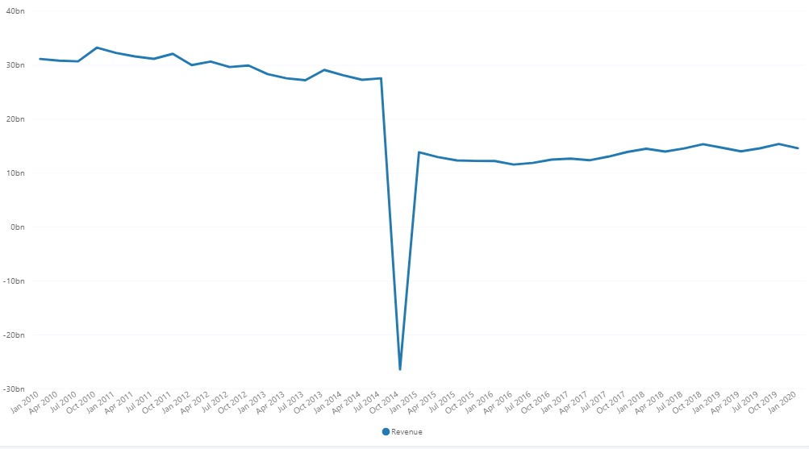
Figure 2: Revenue stream of HP during 2020
(Source: O’Leary, 2019)

Based on the information published by HP, on 14th March, it would shut all future retail shops in the US and other countries, possibly impacting sales. Commencing with their lone Indian store, HP started refurbishing stores in April with limited hours before expanding in May. More than 140 HP Stores worldwide have reopened, with security precautions including required masks, limitations on the amount of people allowed in, social distance, and temperature checks. Due to COVID-19 outbreaks, several shops in the US and abroad started closing in June. HP has limited in-store access in several places, but many stores stay open for maintenance and online purchases (Davis, 2021). The pandemic has a significant influence on the external environment.
According to the provided graph, Announcing the second quarter results on May 27th, 2020. This quarter concluded on 30. Production halts and supply chain issues have hampered the company's income. Revenue fell 11.16 percent year-on-year in Q2 2020 (Dugar, 2021).
Q2 2020 sales was $12,469 million, down 11.16 percent from Q2 2019. The company's Q2 2020 gross profit was $2,493 million, down 9.46 percent from Q2 2019 (Dugar, 2021). HPQ gross margin was 19.99 percent in 2020 and 19.44 percent in 2019. The firm spent $11,643 million in Q2 2020, down 11.17 percent from $13,108 million in Q2 2019 (Dugar, 2021). Operating income was $826 million in the 2nd quarter of 2020, down from $928 million a year earlier. HPQ's operating margin was 6.62 percent in 2020 and 6.61 percent in 2019. Cash and cash equivalents were $4,054 million at Q2 2020. HPQ's net profit for the second quarter of 2020 was $764 million, down from $786 million last year (Dugar, 2021).
HP has enabled most workers from home during this crisis to safeguard their health and safety. The organization has created social distancing standards and a cleaning process to safeguard the health and safety of employees who work on output and cannot work remotely.
HPQ has invested $2.3 million on 3D printed face shields, ventilators, masks, respirators, and other medical supplies. HP and HP Foundation have provided millions in technology to support teacher and student distant learning.

Impacts on the external environment of HP because of Brexit
In its newest set of profit and loss reports for the year ending 31 October, submitted with Companies House this week, the world's second-biggest PC manufacturer – and the largest in Britain – made the bold remark which is "We have been studying the possible effect of Brexit on HP Inc UK since the vote in 2016," the company stated (Paul, 2021). "While the date and form of the UK's withdrawal from the EU remain unpredictable, we do not anticipate Brexit will represent a substantial risk to our company."
The EU has given the UK until October 31 to prolong its exit, although it is unclear if this will happen. Under departing Prime Minister Theresa May, Britain was compelled to petition the trade organization twice to prolong D-Day. The two remaining contenders for the Conservative Party's future leader seem hellbent on convincing the British people that they can deliver the most difficult Brexit conceivable (Paul, 2021). Boris Johnson has said that the UK will leave the EU by the end of October, whereas Jeremy Hunt believes the UK will leave by the end of the year. To yet, the effect of Brexit on IT has been price increases from suppliers in response to the dropping value of the pound against the US dollar, as well as the persistent uncertainty over when or if the UK will leave.
More recent supply difficulties (Q1 and Q2) may be more concerning for the corporation, customers are printing fewer pages, and HP underestimated this in a significant degree (Paul, 2021). Paul said that, as a result of Brexit, IDC expects sales to be flat or even negative in the next couple of quarters as compared to the same period the previous year. However, HP's ties to the UK are clear: in calendar 2018, the business sold 2.6 million PCs in the UK, up 2% year on year, giving it a market share of 29.9%, according to IDC. Lenovo was the next closest competitor, accounting for 21.8 percent of total sales. A year before, HP had posted a £27.22m operational profit on sales of £1.532bn, up from £1.399bn the year before (Paul, 2021).
As a consequence of the Brexit referendum and its conclusion, it is expected that the EU HP operations in the United Kingdom would have a severe economic and financial impact. A detailed description of HP's hiring strategy can be found in the resource plan. It is possible to do this via external recruitment or the development of existing personnel; interaction with the whole firm to identify future requirements; and resourcing strategies, among other methods. Monetary, economic, and legal repercussions, as well as labour mobility, are the three principal effects of the abolition of the death penalty. When it comes to human resource planning, the most difficult challenges HP faces are reducing the amount of time and money spent on training new hires, preserving historic and cultural content developed in-house and by third parties, lowering onsite training costs in order to reach a large and widely spread workforce, eliminating unfruitful new employee wait periods, and enabling new hire training in the local market.

Part 2

Evaluating of HP’s response due to changes in the external environment factors
- Executing Administration Handle Coaching Effectively- HP suggests that authorities undergo frequent in-depth execution coaching sessions rather than presenting annual results;
- Short- and Medium-Term Pilot Opening- Activates like revolution assignments, hands-on initiatives, and short-term extension parts allow HP workers to develop their skills in a short-term manner;
- Coaching- HP’s online guide connects coaching-friendly devices. Using this application, people may instantly connect as a coach or discover a tutor who meets their needs (Kratz, 2020);
- Inside Advancement- Colleagues may identify and apply for HP jobs.
- Learning and Improvement- Learning and Growth Opportunities for advancement include leadership and management skills, mechanical and specialized training, common financial investigation, fabrication, fund, and specialist abilities (Dyer and Reeves, 2021);
- Self-development Process- Colleagues work with directors to design a precise career plan that addresses HP’s goals as well as the commerce interface and desire.

Employee resourcing strategies that affect the performance of HP
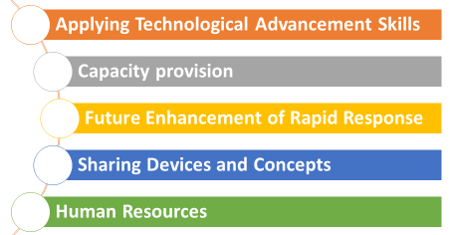
Figure 3: Resourcing strategies that affect the performance of HP
Planned resourcing for company staff an investigation into how staff resourcing techniques effect HP was conducted, and it was determined that when the business utilized employee resourcing tactics, its profits increased. The efficient use of human resources may help to increase the organizational performance of a corporation. This result is consistent with the findings of those who established a relationship between human resource management and organizational effectiveness (Hepburn, 2018). The purpose of hiring employee strategy is to discover qualified candidates who possess the necessary characteristics, abilities, and knowledge, as well as the possibility for further training. According to, the two most significant parts of employee resourcing are the performance of the workforce and the management of the workforce.
Thus, selection and recruitment of employees who are best matched to the organization's requirements should be considered an essential task on which most other human resource management strategies targeted at development and motivation may be built (Eaton, 2021). In the course of this investigation, it was observed that hiring and selection had a positive influence on improving commercial bank profitability in Kenya (Dwivedi et al., 2020). In other words, when successful recruitment and selecting processes are established or improved, the profits of the business will grow (Vande, 2019). Because of the increased services supplied by this group of employees, the company was able to gain new customers, resulting in increased sales and profits. To assist researchers in speeding up the usage of therapies and immunizations to safeguard mankind from this rapidly spreading illness, HP has made five pledges that will position the firm to better react to other global technology problems in the future.
HP is committed to share technological developments and managerial skills in order to assist the most qualified candidates from these firms.
Applying Technical Advancement Skills- Using its excess production capacity, and in some cases, transferring production to others as soon as possible, HP, as one of the world's largest manufacturers of the giant tach, aims to get breakthroughs into the hands of others as soon as possible and to spread the technology throughout the world.
Capacity provision- When HP creates useful gadgets that are open source-based and made accessible to a bigger and more consistent audience, the company exchanges data and data with other companies in real time in order to accelerate technological developments and solutions (Allen et al., 2018).
Sharing Devices and Concepts- In a business, a company's human capital is the most important asset it has. As part of its effort to bring this widespread disease under control, HP has assembled a SWAT team of beet virologists and other experts from various fields, including scientists, chemists, doctors, infectious diseases specialists, vaccination specialists, pharmaceutical researchers, among others. This organization brings together enthusiasm, dedication, and abilities in one place to prepare for disclosure and improvement in order for patients to obtain treatment and antibodies as soon as possible after being diagnosed (Miller et al., 2019).
Human Resources- Employees are a company's most precious asset, and they are called human capital. As part of its effort to bring this widespread disease under control, HP has assembled a SWAT team of beet virologists and other experts from various fields, including scientists, chemists, doctors, infectious diseases specialists, vaccination specialists, pharmaceutical researchers, among others (Miller et al., 2019). This organization brings together enthusiasm, dedication, and abilities in one place to prepare for disclosure and improvement in order for patients to obtain treatment and antibodies as soon as possible after being diagnosed.

Conclusion
According to HP’s top management, effective HR management is essential to the achievement of business objectives. External forces cannot be disregarded, but they can be managed to a certain extent. To begin with, firms must be kept up to date on current events and developments. A great deal of knowledge is necessary to keep up with everyday developments in business, the economy, and society (Allen et al., 2018). The Human Resources team is primarily concerned with mergers, as well as divestiture planning models. HP has a global human resources team that aids with the incorporation of strategy and the subsequent execution of those plans. Findings from the study indicate that recruitment strategies have a considerable influence on performance. As a consequence, the strategies used in the recruiting process have such a direct impact on the overall effectiveness of a business.

References
Carnegie, D., 2021. Fiscal policy effect on the UK economy. Bulletin of the Economy of Western Society, p. 260.
Coleman, J., 2017. Economic factors and achieving competitive advatage in business enviroment Harlow Pearson. British Journal of businessand Ecomomics, 7(5), pp. 45-74.
Davis, C. M., 2021. Readiness and resilenence ofthe health systems of the UK and Russia during Covid-19 epidemic in 2020-2021:impact of priorities shortages and rationing. Post communist Economies, 1(33), pp. 1-63.
Dugar, A. & HP Inc, 2021. revenue down by 11% Due to COVID-19 Business Quant. [Online]
Available at: <https://businessquant.com/hp-inc-revenue-downby-11due-to-covid-19>
[Accessed 25 December 2021].
Dwivedi, Y. K. et al., 2020. Impact of covid 19 pademic on information management research and practice :Transforming education work and life. International Journal of information management, pp. 102-211.
Dyer, L. & and Revees, T., 2019. Human resource strategies and firm performance :what do we know and where do we needto go. International Journal of human resource management , 3(6), pp. 656-670.
Gibb, S., 2011. Human resource development: foundation process,context 3rd edition. Basingstoke, Pagrave Macmilian.
Guest, D. E., 2017. Human resource management and employee well-being: Towards a new analytic framework. Human resource management journal, 1(27), pp. 22-38.
Hepburn, E., 2020. Uncharted waters The social and equality impacts of Brexit. Scottish Affairs, 2(29), pp. 141-178.
Ivancic , V., Mencer, I., Jelenc, L. & and Dulcic , Z., 2017. Strategy implementation- external environment alignment. Journal of contemporary management issues, pp. 51-67.
Kraatz , M. S. & Zajac , E. J., 2017. how organisational resources affect strategic change and performance in turblent enviroments Theory and evidence. organizational science, 12(5), pp. 632-657.
Lanier, J. D., Wempe, W. F. & and, S. M., 2019. Supply chain power and real earnings management : stock markets perceptions financial performance effects and implications for suppliers. Journal of Supply Chain Management, 55(1), pp. 48-70.
Miller, A. L. et al., 2017. Analysis of behavioral skills utilized by suidical adolescents receiving dialectical behavior therapy. Cognitive and Behavioral Practice, 2(7), pp. 183-187.
N, B. A. B. A. a. S., 2018. Areview ov value chain analysis as astrategic cost management tool. Journal Of Accounting and Financial Managment, 5(1), pp. 80-92.
Phillip, C. & Bryant (ed), 2018. Managing employee turnoverdispelling myths and fostering evidence- based retention strtegies. 1st ed. new york: Business expert press.
Vande Vusse, L. K., Ryder, H. F. & and Best , J. A., 2021. Maximizing career advancement during the COVID-19 pademic : recommedendations for postgraduate training programs. Academic Medicine, 96(7), pp. 967-973.

