Design Criteria – Water Supply and Waste Drainage

Built Environment Services
MX051836
Level 5 Semester 2 Current Date

Submitted By: Submitted To:
Cameron Hockaday Allan Nantel
1706551 School of Architecture, Built and Natural Environments
Date Due: 24/01/19 Submitted on 24/01/19

Question 1
The Thames Tideway Tunnel otherwise known as the London ‘Super Sewer’ Project is a major project currently being undertaken. Central London’s combined sewer system means both wastewater and stormwater runoff goes to the same sewer. This is a serious problem during heavy rainfall where the sewers rapidly fill, and as per the original London Sewerage System opened ‘in 1865’ (Brewer t, 2015), ‘Instead of flooding our streets and bathrooms, the sewers are designed to overflow into the Thames.’ (Bell S, 2017). A final report by The Steering Group comprised of: The Mayor of London, The Water Services Regulation Authority (OFWAT), The Environment Agency, and Thames Water was published stating ‘the preferred solution is a large diameter storage-and-transfer tunnel’ (Steering Group, 2005) to replace the outdated Victorian system currently in use first created after the ‘Great Stink of 1858’ and growing pressure from the public after cholera present in the polluted Thames caused ‘the epidemic of 1853/54, which cost the lives of some 12,000 people in the city area’ (Tynkkynen K, 1995).
As a result of the ‘Great Stink of 1858’, in which the air quality was so low as a direct result of continuous dumping of the cities’ sewage into the Thames river that parliament was moved to Oxford, Joseph Bazalgette was given the responsibility of creating a modern sewage system. Along with Colonel William Haywood, they found the problem was that the Thames is tidal meaning anything entering the Thames would go downriver only to return on the next incoming tide. Due to this issue four large pumps were created to make it possible to discharge sewage ‘into the Thames at Barking Creek (northern) and Crossness (southern), via outfall sewers’ (Cook GC, 2001) therefore circumventing the length of the Thames that is tidal. The overall project of the original Victorian-era sewer system took nine years, 318 million bricks and 670,000m3 of concrete to complete. Bazalgette knowing how large the scale of the project was used the densest population having the most ‘generous’ sewage production to estimate the size of the pipe needed, ‘he then said, "We're only going to do this once and there's always the unforeseen" and doubled the diameter of the pipes he wanted to be built.’ (Institute of Civil Engineer’s 2017). Given such foresight, Bazalgette’s sewer system allowed for large population increases until the turn of the 21st first century. Even the shape of the pipes themselves was chosen to increase total life span, the actual shape of the pipes is that of an inverted egg. ‘The inverted egg-shape means that the scouring velocity is relatively high even when the overall water quantity is small’ (Hassel C, 2010). Scouring velocity is the velocity at which solid waste within the pipe causes abrasions to the pipe itself.
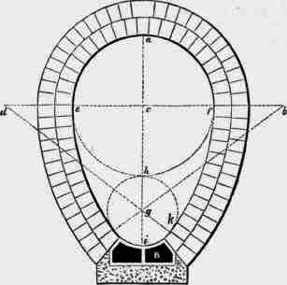London’s inverted-egg sewer tunnels
Joseph Bazalgette 1819-1891
An 1861 census showed the population at the time to be ‘2,803,034 souls, occupying 362,890 inhabited houses’ (Cruchley G, 1861) therefore the London Sewerage System was built to accommodate a population of 4.5 million people. Given that ‘The population of London at 30 June 2015 (the most recent year of data available) is estimated to be 8,674,000’ (Office for National Statistics, 2016) despite having been added to and updated over time London still relies mainly on Bazalgette’s original system. The system struggles during heavy rainfall as both foul water and rainfall use the same sewers. When these sewers reach capacity, the excess water is discharged into the Thames. In 2017 it was reported ‘Thames Water has been fined a record £20.3m’ (Plimmer G,2017) after it ‘pumped 1.4 billion litres of unfiltered human waste into the water in 2013 and 2014’ (Simpson F, 2017). Waterborne diseases such as Cholera, Tetanus, and Leptospirosis, thrive in raw sewage and given the Thames is tidal the raw sewage pumped in when the sewers are at capacity goes downriver but returns at the next high tide. Even the discharging of the mix of water and foul water into the Thames doesn’t always happen quick enough and can cause localised flooding. The Thames is also a highly biodiverse area being a habitat to fish, birds, mammals, invertebrates, and bats. Storm sewage released into the Thames it was reported that ‘Thousands of fish have died after large amounts of storm sewage flooded into the River Thames’ (BBC, 2011), large scale population death of a species has a knock on effect on other species within the food web either directly or indirectly as prey of the affected species or the predator.
The Thames Tideway Tunnel often referred to as the London ‘Super Sewer’ Project, is a large construction project currently being undertaken in and around Greater London in after being the preferred solution for the Steering group as stated in their 2005 Thames Tideway Strategic Study. The purpose of the Tideway Tunnel is to intercept sewage heading through overflow to the Thames and instead divert it to pumping stations, it starts in Acton West London and joins with the Lee Tunnel at Abbey Mills Pumping Station in the east. It is one of three schemes being carried out concurrently to improve the London sewage system and of the three ‘is the most complex at 25km long and 65m deep’(CH2M, 2015). The project is the deepest set of tunnels to avoid the London Underground and it will ‘be a 7.2m diameter’ (Bell S, 2017) tunnel having considered future population growth has an inner and outer layer giving it a 120-year design life. It was originally budgeted to ‘cost £4.2bn to build’ (Smulian M, 2015), however, it was revealed by the Bazalgette Holding Group in November 2018 that ‘the total project spend so far has reached £1.48bn amid unforeseen cost pressures early on in the project.’ (Morby A, 2018), given that the project is only in it’s second year of a 7 year construction schedule the project is expected to run over budget and into the reserve budget the Government put into place in case of such an event. The tunnel is being built concurrently from several locations along the confirmed route to fit the timeline with the 25km long tunnel where it’s expected to reach a state of ‘All works completed’ (Tideway, 2018). Currently sewer overflow is released in to the river Thames when the tunnel is complete it’s predicted to be able ‘to care of over 95% of that discharge and reduce the number of discharges a year from more than fifty to around four’ (CH2M, 2015), so the Thames Tideway Tunnel won’t be able to completely stop sewage discharge into the Thames but does dramatically reduce the scale to which it is.

The Thames Tideway Tunnel scheme is a divisive topic, as is any major project, with a press release in 2014 by The Department for Environment, Food, and Rural Affairs stating, ‘Evidence has shown that a tunnel is the best solution to address this failing sewerage infrastructure.’ The project was therefore the favourite solution for the Government, but not everyone else was convinced. The main reason the tunnel was commissioned was to bring the River Thames in line with the Urban Waste Water Treatment Directive, a European Environment Agency (EEA), Directive regularly published every few years, which is concerned with ‘the collection, treatment and discharge of urban waste water and the treatment and discharge of waste water from certain industrial sectors’ (EEA, 2017).

Public response to the Thames Tideway Tunnel during its proposal was generally negative with the cost of the project drawing the most criticism. The tunnel is being funded by private investor groups at a cost of £4.2bn, but with private investors expect returns for their investment. This will be paid by Thames Water users who during the proposal period faced the prospect that ‘their bills are likely to rise by as much as £80 a year’ (BBC, 2012) at 2011 prices and inflation not taken into account. This drew much public disapproval from Thames Waters’ 15 million customers. This estimate has since been revised the Financial Times reporting in 2017 will see ‘an increase of £12 to £15 a year currently, rising to £20 to £25 by the mid-2020s’ (Plimmer G, 2017). It’s not just been the public who have been critical of the Thames Tideway Tunnel with members of assessment groups who supported a “super sewer” decades ago voicing their disagreement with the project. Professor Chris Binnie who used to be the chairman of the Steer Group, a group who in 2005 wrote a report recommending the project, was quoted as saying ‘it is almost certainly a stupendous waste of money for very limited benefit’ (Binnie C, 2014).
Thames Water Utilities Ltd (Thames Water) is the regional monopoly utility company responsible waste water treatment and the supply of public water to Greater London, Kent, Wiltshire, Surrey, Thames Valley and Gloucestershire (among others) and is privately owned as a result of privatisation by the Government. Being a privately owned company the pay money out to private investors. Many people believed that Thames Water should have put money aside to fund the project, including Ian Byatt who was the Director General of OFWAT from 1989 to 2000 ‘argues that Thames Water should have carried the project on its own balance sheet’ (Plimmer G, 2017).

Question 2
There are two main types of water supply in residential properties: Direct and Indirect.

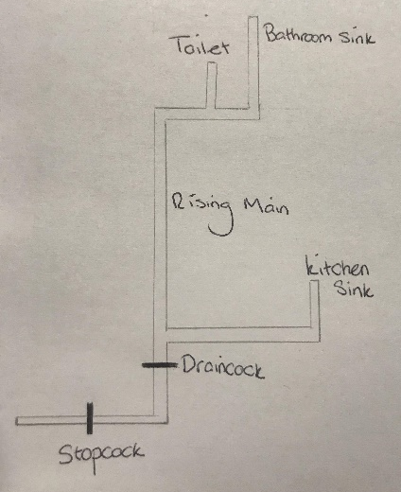
Direct Cold Water: Relies on pressure directly from the mains to supply water directly to the cold water taps and toilets, it also supplies cold water directly to a cistern in the attic of the property or in the top of a closet with a minimum requirement that the cistern must be able to hold 115Litres. The cistern in turn feeds water into the properties hot water cylinder of the property.

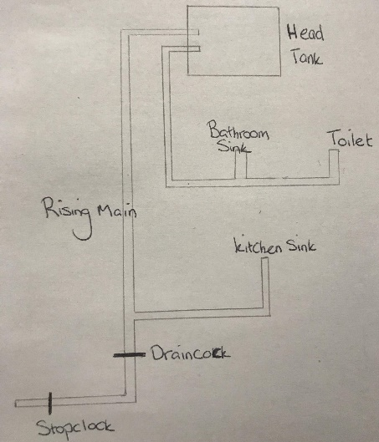
Indirect Cold Water: All sanitary fittings are indirectly supplied by the cold water storage cistern (main tank), except for the kitchen sink. Cisterns for indirect supplies need to be approximately double that of direct cold water systems and given their relatively large size are often stored in the attics of residential buildings.

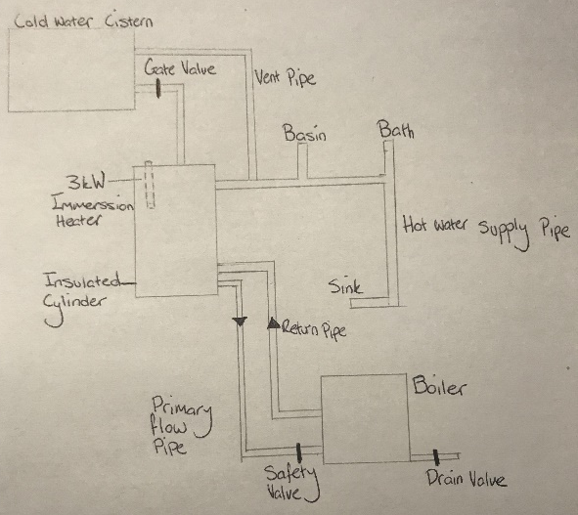
Direct Hot Water: The system is only designed for hot water, central heating is not supplied off this system as gasses can enter the system through the cisten causing damage to the ferrous metals (metals containing iron) in the pipes. Water can be heated quickly using this system as water is transferred directly between the boiler and the cylinder.

Indirect Hot Water: Unlike Direct hot water supplies, this system provides hot water for both the central heating system and the hot water supplies. Water from the boiler circulates through a calorifier to heat the water in the cylinder indirectly. Unfortunately, this does mean if the boiler breaks neither system will work. Pressure in the system is vented into the cistern in the attic of the property.

Reference List
- Binnie C, 2014, Planned London super sewer branded waste of time and taxpayer money, The Guardian, Available at https://www.theguardian.com/environment/2014/nov/27/london-super-sewer-branded-waste-time-money, Accessed on: [21/01/19]
- British Broadcasting Company, 2011, Thousands of River Thames fish killed by storm sewage, BBC, Available at https://www.bbc.co.uk/news/uk-england-london-13693265, Date Accessed: 21/01/19
- Brewer T, 2015, Beyond Bazalgette: 150 years of sanitation, The Lancet, Volume 386,
- CH2M, 2015, Thames Tideway Tunnel - Transforming the ecology of London’s river, Jacobs, Englewood USA
- Cook GC, 2001, Construction of London’s victorian sewers: the vital role of Jonathon Bazalgette, Postgraduate Medical Journal, Volume 77
- Cruchley G, 1865, London in 1865: a handbook for stranger’s, Unknown Publisher
- Department for Environment, Food, and Rural Affairs, 2014, Thames Tideway tunnel gets go ahead, Gov.UK, Available at https://www.gov.uk/government/news/thames-tideway-tunnel-gets-go-ahead, Date Accessed: [21/01/19]
- Hassel C, 2010, Touring the sewers of London and Paris, Green Building Magazine, Carmarthenshire
- Institute of Civil Engineer’s, 2017, London sewer system, Available at https://www.ice.org.uk/what-is-civil-engineering/what-do-civil-engineers-do/london-sewer-system, Date Accessed: 20/01/19
- Morby A, 2018, Super sewer contingency budget raided due to cost pressure, Construction Enquirer, Available at https://www.constructionenquirer.com/2018/11/26/super-sewer-contingency-budget-raided-as-costs-soar/, Date Accessed: [20/01/19]
- Office for National Statistics, 2016, Freedom of information (FOI) London and UK population, Available at https://www.ons.gov.uk/aboutus/transparencyandgovernance/freedomofinformationfoi/londonandukpopulation, Date Accessed: [21/01/19]
- Plimmer G, 2017, London super sewer causes stink over opaque funding structure, Financial Times, Available at https://www.ft.com/content/bb99abb4-7203-11e7-aca6-c6bd07df1a3c, Date Accessed: [20/01/19]
- Plimmer G, 2017, Thames water fined record £20m for sewage dump, Financial Times, Available at https://www.ft.com/content/b121a9e6-0a68-11e7-97d1-5e720a26771b, Date Accessed: [19/01/19]
- Simpson F, 2017, Thames Water faces record fine over pumping 1 billion litres of sewage into river, Evening Standard, Available at https://www.standard.co.uk/news/crime/thames-water-faces-record-fine-over-pumping-1-billion-litres-of-sewage-into-thames-a3492811.html, Date Accessed: [19/01/19]
- Smulian M, 2015, Case study: Tunnel vision - the Thames Tideway tunnel, The Planner, Available at https://www.theplanner.co.uk/features/case-study-tunnel-vision-the-thames-tideway-tunnel, Accessed: [21/01/19]
- Steering Group, 2005, Thames Tideway Strategic Study, London
- Tynkkynen K, 1995, Four cholera epidemics in nineteenth-century London, US National Library of Medicine, Available at https://www.ncbi.nlm.nih.gov/pubmed/11609122, Date Accessed: [18/01/19]

