

Name: Katerina Mezova
Student ID: 2246854
Module code: LCBB4004
Module name: Marketing Fundamentals
Lecturer: Dr Piyumika Kithulgoda Gamage

SUBMITTED ON THE 26th November 2023

SAMSUNG BLOG

Contents
1. Introduction 3
2. STP ( Segmentation, Targeting and Positioning) 3
3. Segmentation of Samsung 3
4. Targeting of Samsung 5
5. Positioning of Samsung 6
6. Marketing Mix of Samsung 6
7. Conclusion 7
8. Reference list 8

Table of Figures
Figure 1 5
Figure 2 6
Figure 3 7

1. Introduction

Electronics is a very competitive, fast-growing sector that necessitates massive R&D spending. This blog will evaluate Samsung's STP and marketing mix. Samsung is among the industry's most important, renewed and powerful companies. Samsung is a South Korean technology giant that was founded in 1969. The company produces mobile phones, televisions and other household items. Samsung is often regarded as a trailblazer in the electronics industry. Effective segmentation and positioning strategies have played a vital role in the company's growth and success in achieving a unique marketing position.

2. STP ( Segmentation, Targeting and Positioning)

To determine whether an idea will work for a business and how the team can create the perfect product for the target market, it's essential to develop a marketing model using the STP strategy. Research of (Mind Tools Content Team, no date), this simple three-step strategy involves segmentation, targeting, and positioning and can help businesses identify and capitalise on their unique benefits.
STP suggest for:
- Segment your Target
- Target your best customers
- Position your offering

This model is beneficial because it helps to identify the most valuable types of customers and develops the products for them. Some businesses have different groups of customers. And they can have products with standard or expensive prices for different groups.

3. Segmentation of Samsung

According to Nayak (2012), Segmentation means the splitting of the market into groups of end users who are:
1. Maximum similarity within each group
2. Maximum difference between groups.
Samsung segmentation is one of the critical elements of this electronics company's marketing strategy. Every segmentation type is an integral part of the marketing process. The blog will introduce all of Samsung's segmentation types.
- Geographic: The region of Samsung is about 80 different countries worldwide. Samsung has a global target audience through the sale of smartphones and tablets in all parts of the world. The population density is Rural and Urban Coverage.
- Demographic: The demographic criteria for Samsung segmentation comprises the age, gender, lifestyle, and occupation of Samsung mobile phone users. Dudovskiy (2017) states that, Samsung smartphones cater to all lifestyle choices. Whether you're a realist, an innovator, an adventurer, an idealist, a high achiever, or a conformist, Samsung's mobile device brand satisfies your lifestyle needs. The Samsung Galaxy series is a great smartphone option for the self-employed, executives, senior managers, and upwardly mobile professionals.
- Behavioural: According to Wells, et al. (2010, pp. 176-198), a segmentation approach is presented using both traditional demographic segmentation bases (age, social class/occupation, and working status) and a segmentation by benefits sought. In this aspect, Samsung targets all potential and ex-users. The primary objective is to utilise marketing techniques to promote the company's newly innovated product and increase customer acquisition. According to WePapers (2020), the chief goal of Samsung is to convert all its customers to become hard-core loyal with its newly innovated smartwatch. The company must ensure consumers are delighted and enthusiastic towards their product lines.
- Psychographic: Exploration of Mialki (2023) says that Psychographic segmentation divides buyers into segments based on internal characteristics—personality, values, beliefs, lifestyle, attitudes, interests, and social class—so you can market accordingly. The classes who can use Samsung products are the working class, middle class, and upper class.
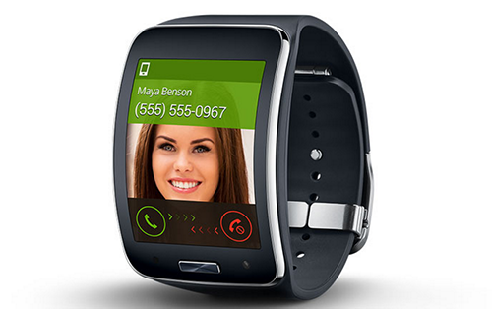
The Samsung Gear S suites all four groups of higher resources. The smartwatch helps active individuals maintain order in their daily lives. Users can make and answer calls and view messages on their Samsung smartwatch without needing to access their smartphones. (Figure 1)

Figure 1

4. Targeting of Samsung

According to Kotler and Keller (2011, p. 231), many statistical techniques exist for developing market segments. Once the firm has identified its market-segment opportunities, it must decide how many and which ones to target. Marketers are increasingly combining several variables to identify smaller, better-defined target groups. According to Dudovskiy (2017), most of the time, Samsung chooses its target audience from the identified segments based on feasibility studies. Typically, the target consumers of the mobile division of Samsung Electronics include:

- Impressionable, trendy, fashionable teenagers and socially active teenagers.
- Big corporations.
- Regular mobile phone users are looking for a cost-effective but functional handset.
- Government organisations, including public utility and safety agencies
Samsung's targeting strategy is designed to acquire new customers and retain existing ones for the long haul, demonstrating a savvy and confident approach to customer acquisition and retention. (Figure 3)

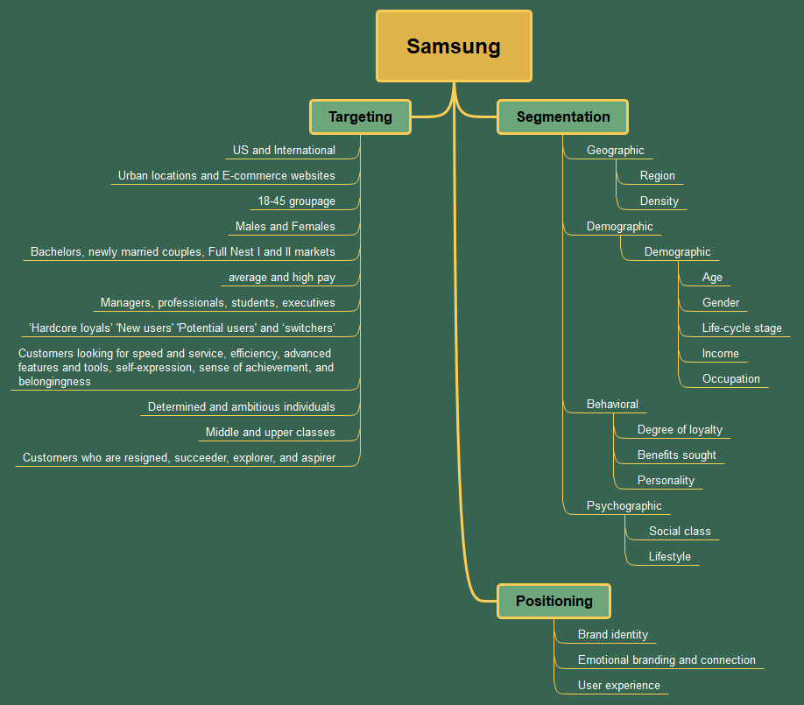
Figure 2

5. Positioning of Samsung

When positioning a brand within a target market, the third part of the STP process involves segmenting the market, determining the size and potential of market segments, and selecting specific target markets. Effective positioning consists of two crucial elements. The first element revolves around the physical attributes, functionality, and capabilities that a brand offers. The second element of positioning is focused on how a brand is communicated and how consumers perceive the brand compared to other competing brands in the market. Brands can create a strong and compelling positioning strategy by leveraging these two elements, resonating with their target audience and driving their success in the marketplace. This communication element is vitally important as it is ‘not what you do to a product, it is what you do to the mind of a prospect’ (Ries and Trout, 1972) that determines how a brand is positioned in a market.
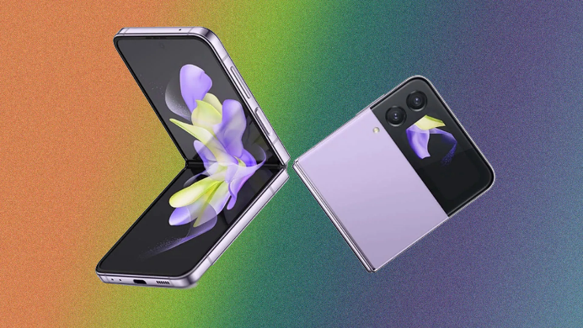
The demand for new and innovative products is constant in the electronics industry. To stay ahead, companies must continually brainstorm fresh ideas, explore better options, and implement innovative product features. Samsung successfully does this and manages to differentiate itself from its customers continuously. According to Darbinyan (2020), To create a point of parity, Samsung frequently introduces new technologies as a response to competition. A recent example of an entirely new concept introduced by Samsung can be the Galaxy Z Flip. This product boasts a one-of-a-kind foldable screen that is bound to revolutionise the electronics industry. By incorporating this innovative technology, Samsung successfully garnered customers' attention and inquisitiveness. (Figure 3)
Figure 3

6. Marketing Mix of Samsung

The Marketing Mix comprises a powerful set of tactics that effectively attract customers and promote products. The four Ps of the conventional Marketing Mix - Price, Product, Promotion, and Place - are the key drivers of a successful marketing campaign. Let's discuss Samsung's 4Ps of the marketing mix in detail.
Product: In a highly competitive market, companies must constantly innovate, add new features, and improve performance to stay ahead. According to Aditya Shastri (2023), Samsung earns revenue by selling smartphones, home appliances, and sound devices, excelling in product diversification. Their products can be classified into different categories, which include:
- Mobile devices- Smartphones like Samsung Galaxy series, Tablets, Wearables, phone accessories
- Samsung Home Appliances- Refrigerators, Cooking Appliances, Washing Machines, Air conditioners, Vacuum cleaners
- TV/AV – Samsung Television, Accessories, Audio and Video Accessories
- Information Technology – Printer and Multifunction, Monitor
- Memory/Storage- SSD, Portable SSD, Memory cards, USB Flash drives

- Price:
Samsung is a leading brand in smartphones and home appliances, utilising two distinct pricing strategies. Research by Bhasin (2023), shows that the two price schemes of Samsung are the Competitive and Skimming Price Strategy.
The skimming price strategy helps the brand maintain its premium position in the market. When Samsung launches new products in the market, it responds to competitors' identical products by lowering its own product rates through incentives, offers, and discounts.
The competitive pricing strategy of Samsung positions it at the top of the industry and attracts consumers to its top-quality mobile devices.
- Place:
Samsung has implemented an effective place and distribution strategy as part of their marketing mix, which has contributed to their overall success.. They heavily rely on large retailers, their website, and a network of sales and service dealers The company has established an extensive distribution network to ensure prompt dispatch of goods.
Most retail outlets worldwide distribute Samsung Electronics products due to high brand value and market loyalty.
- Promotion:
Promotion is the key component of the Samsung marketing mix (4Ps) due to intense market competition. According to Shah (2023), Samsung advertises via social media, newspapers, billboards, television, etc., to capture new customers.
Sales promotions often offer discounts, deals, and bundles to create urgency and encourage purchases. Samsung has a strong presence on various platforms such as Facebook, Twitter, Instagram, and YouTube. It uses these platforms to engage with consumers, share product information, and showcase their latest innovations.
Samsung is an official partner of the International Olympic Committee (IOC) and often sponsors significant events. Its contract with IOC extended until 2028 (International Olympic Committee, 2022).

7. Conclusion

Samsung's unparalleled success is largely attributed to its customers, who hold an unwavering position at the core of the company's growth and development. Thanks to a meticulously crafted segmentation and positioning strategy, the company has attained a remarkable degree of influence and power. Such a strategy was selected with great care, taking into account the unique needs and challenges of the company, and has proven to be highly effective. As a result, the company has distinguished itself among its peers and established itself as a force to be reckoned with in its industry. The company's unwavering dedication to innovation, coupled with its powerful advertising campaigns and highly effective social media marketing strategies, have all played a critical role in capturing the attention of consumers and maintaining a dominant position in the market.

8. Reference list:

Bhasin, H. (2023) Samsung Marketing Mix - 4P of Samsung. Available at: https://www.marketing91.com/marketing-mix-of-samsung/#google_vignette (Accessed: 25 March 2023).

Darbinyan, M. (2020/2023) Segmentation Strategy of Samsung. Available at: https://thesocialgrabber.com/segmentation-strategy-samsung/ (Accessed: 17 December 2020).

Dudovskiy, John. (2017) Samsung Segmentation, Targeting, and Positioning. Available at: https://www.pdfagile.com/blog/samsung-segmentation-targeting-and-positioning (Accessed: 18 December 2017).

International Olympic Committee (2022) Samsung. Available at: https://olympics.com/ioc/partners/samsung (Accessed: 05 April 2023).

Kotler, P. and Keller, K. (2011) Marketing Management. New Jersey: Prentice Hall, One Lake Street, Upper Saddle River. 14th edition

Mialki, S. (2023) Psychographic Segmentation: The Variables Involved to Get to Know Your Audience Better (Examples). Available at: https://instapage.com/blog/psychographic- segmentation/?utm_source=google&utm_medium=cpc&utm_campaign=20630943985&utm_content=158033663247&utm_term=&gad_source=1&gclid=Cj0KCQiApOyqBhDlARIsAGfnyModUGaHe_wPruEsuej2RemZEUvjIobl1Wl048aIQnCFb86liBUrDeIaAmAdEALw_wcB (Accessed: 2023).

Mind Tools Content Team (no date) The Segmentation, Targeting and Positioning (STP) Marketing Model. Available at: https://www.mindtools.com/a5llt9t/segmentation-targeting-and-positioning-model (Accessed on: 25 November 2023).

Nayak, N. (2012) STP of Samsung Mobiles. Available at:
https://stpsamsungmobiles.blogspot.com/ (Accessed: 12 December 2012).

Ries, A. and Trout, J. (1972), ‘The positioning era cometh’, Advertising Age, 24 April, 35–8.
Shah, F. (2023) Marketing Mix of Samsung (4Ps of Samsung). Available at: https://www.howandwhat.net/marketing-mix-samsung/ (Accessed: 05 April 2023).

Shastri, A. (2023). Extensive Marketing Mix of Samsung - 4Ps with Full Explanations. Available at: https://iide.co/case-studies/marketing-mix-of-samsung/ (Accessed: 05 October 2023).

Wells, V., Chang, S., Oliveira-Castro, J., & Pallister, J. (2010). Market segmentation in behavioral perspective. Journal of Organizational: Behaviour Management, 30(2), 176-198. https://doi.org/10.1080/01608061003756505

WePapers (2020). Good Samsung Segmentation And Target Market Essay Example., viewed November 20 2023, https://www.wepapers.com/samples/good-samsung-segmentation-and-target-market-essay-example/

